

Task 1 – Pass Submission

Student Number: Truong Ngoc Gia Hieu
Student Name (VietNam/Australia): SWS01217/ 105565520

Task Pass1a
Feature | Query | Filter
Primary Purpose | Build a reusable, custom dataset or perform actions to data | Temporarily narrow down records in an existing view.
Permanence | Saved as a permanent object in the database navigation pane. | Temporary, frequently disappears when the form or table is closed.
Multi-Table Support | Can combine and link data from multiple related tables. | Works only on the currently active table, form, or report.
Data Alteration | Can calculate fields, group data, or update/delete records. | Can only hide or show existing records; cannot alter data.
As a Data Source | Can be used as the data source for forms, reports, or other queries. | Cannot be used as a standalone data source for other objects.

Based on the comparison table above, it is clear that the Query method has various advantages that over using filters:
- Due to the permanent nature, once a query is generated and saved, it remains forever until it is modified or latest update while filter is temporary which constrast to Query.
- Secondly, Query supports multi-table connect and support function that helps to combine and link data from multiple related tables into the only single view.
- Finally, regarding of data alteration, Query performs calculations, group data, or update/delete records to create new information on the fly while filter can only hide or show existing records.
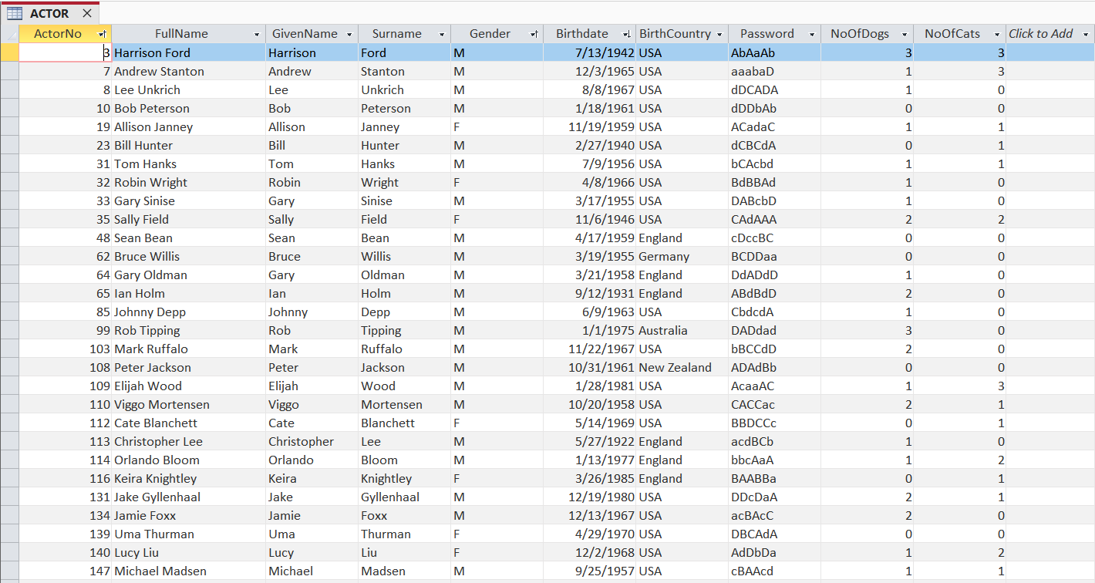
After that, I opened the file named moviedatabase DAD.accdb which donwloaded from Canvas in the Datasheet View according to the requirement.
Figure 1: ACTOR Table Datasheet
In terms of Filter, there are several ways to filter but I decide to choose any record in the Gender attributes equal to “M”(Male). Subsequently, in the Sort & Filter group in Home tab, I choose Selection and select “Equals M”.
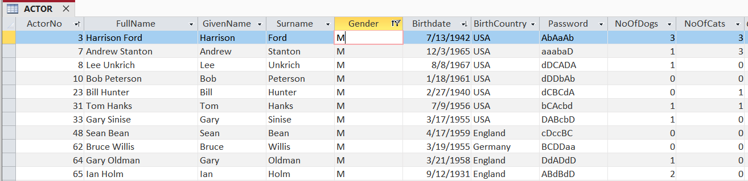
Figure 2: Filter field Gender with criteria M

Regarding the query, choose the Create tab, click Query Design, add the ACTOR table, drag all fields to the design grid as shown in the image below, and enter "M" in the Criteria row of the Gender field.
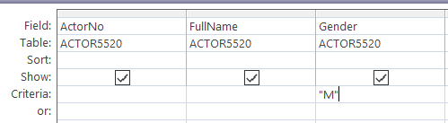

Figure 3: Query Design showing all actors with Gender = "M"
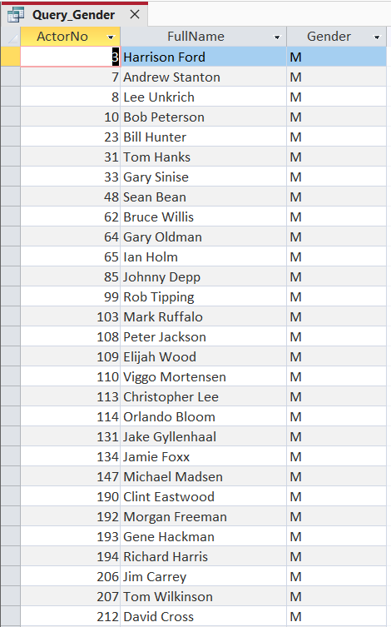

Figure 4: Query Result Showing Male Actors from the ACTOR Table

Task Pass1b
After downloading the file moviedatasetDAD.accdb, I renamed the following tables including ACTOR, CASTING, COLOURTYPE, MOVIE, RATING into ACTOR5520, CASTING5520, COLOURTYPE5520, MOVIE5520, and RATING5520.
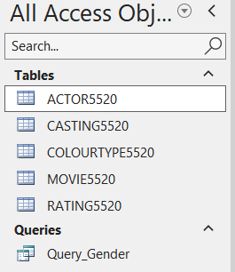

Figure 5: Renamed Database Tables with Student ID Suffix (5520)
Next, according to query description, required field must be contain MOVIENO, TITLE, RATINGCODE, RELYEAR (Must be in 2012), RUNTIME (Descending Sort). After finishing query, save query to named T1PB_5520.
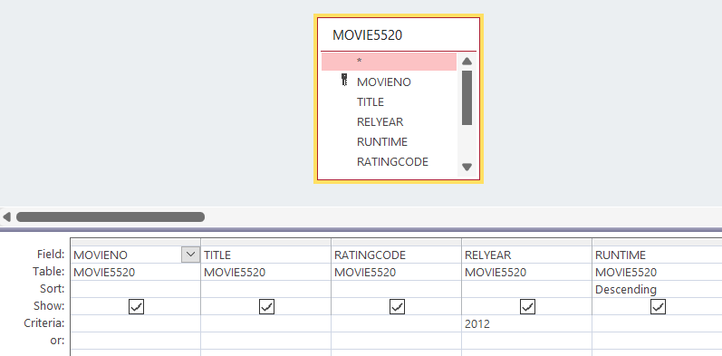
Figure 6: Query Design for Movies Released in 2012 Sorted by Runtime in Descending Order
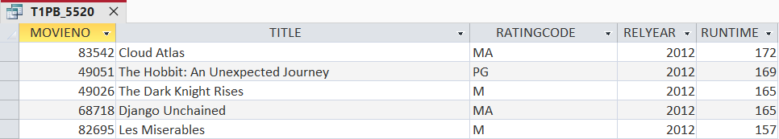
Figure 7: Query Result Showing Movies Released in 2012 Sorted by Runtime (Descending)

Task Pass1c
Based on the assignment requirement, task Pass1c require a query named T1PC_5520 which must be display all he MOVIENO, TITLE RATINGCODE, RELYEAR, RUNTIME, and TMDB_SCORE for all movies that were made in the period 2002-2010 (inclusive), have a runtime less than 120 minutes, are rated "G" or "PG", and have a TMDB score greater than or equal to 6.9. The list must be in ascending Movieno sequence.
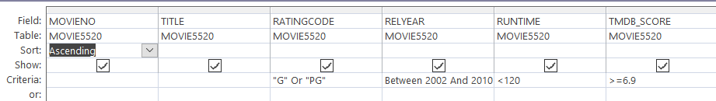
Figure 8: Query Design for Filtered Movies (Pass 1c)
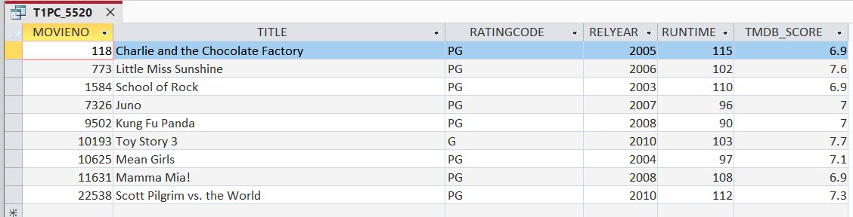
Figure 9: Query Result Showing Filtered Movies (Pass 1c)

Task Pass1d
According to the requirement of Task1d in the assignment, the query returns all columns from table named MOVIE5520 with following criteria:
- The movie title should match with this criteria: Like "*man*" Or Like "*boy*" Or Like "*miss*" Or Like "*girl*" Or Like "*ms*".
- The movie must have fewer than 2700 TMDB votes (Criteria of TMDB: <2700) and Descending
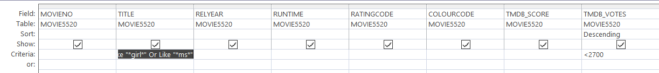
Figure 10: Query Design for Movie Titles Containing Specific Keywords (Pass 1d)
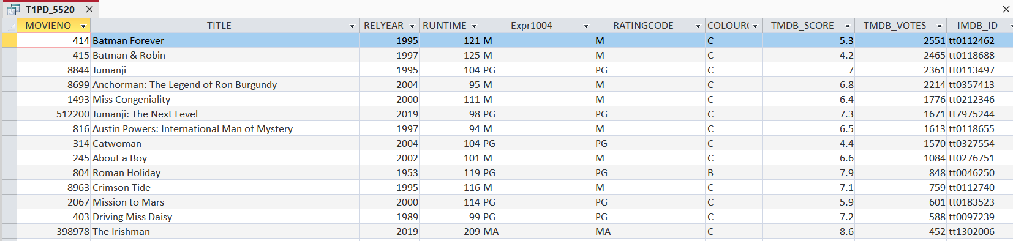
Figure 11: Query Result Showing Movie Titles Containing Specific Keywords (Pass 1d)

Task Pass1e
According to description of task1e, the task requires me to generate a table named Member_5520 with following configure:
Field Name | Data Type
Membid (Primary Key) | Number
Surname | Short Text
GivenName | Short Text
Birthdate | Date/Time

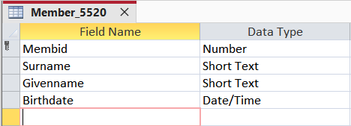
Figure 12: Table Design Screen for Member Table
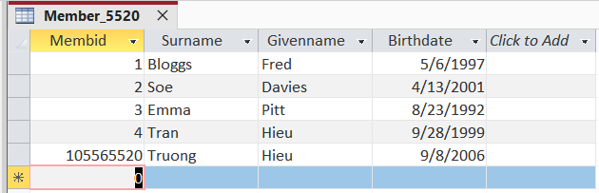
Figure 13: Data Rows in Member Table

Task Pass1f
For creating relationship, click on the Databse Tools and then choose Relationsships. After that, pull out all five tables in the left side to the center and then create relationships. For instance, connecting the primary key ActorNo in ACTOR5520 table with foreign key ActorNo in CASTING5520 table.
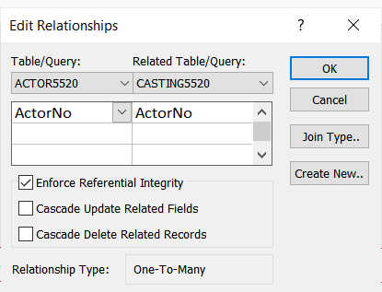

Figure 14: Edit Relationships Dialog Box
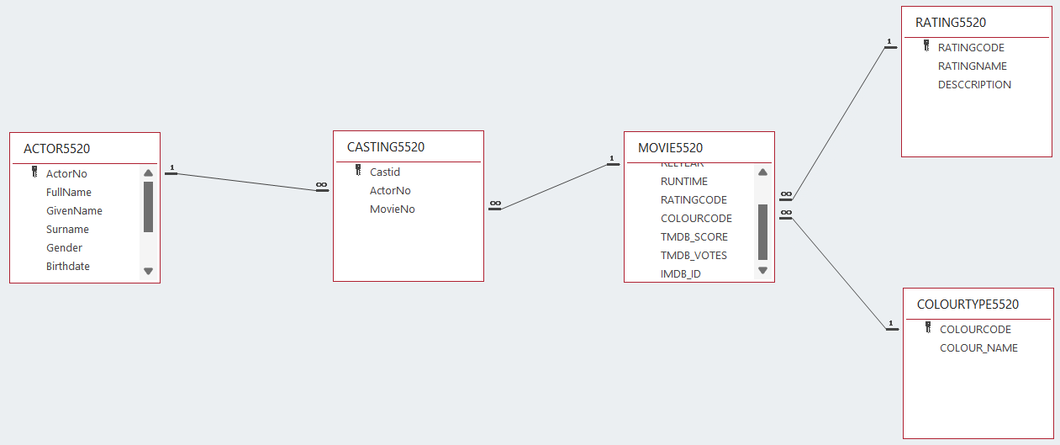
Figure 15: Table Relationships Diagram

Task Pass1g
In detail, task Pass1g requires student to query which must include following column (attributes): MOVIENO (from table MOVIE5520), TITLE (from table MOVIE5520), RATINGCODE (from table RATING5520), DESCRIPTION (from table RATING5520), and COLOUR_NAME (fromt table COLOURTYPE5520).
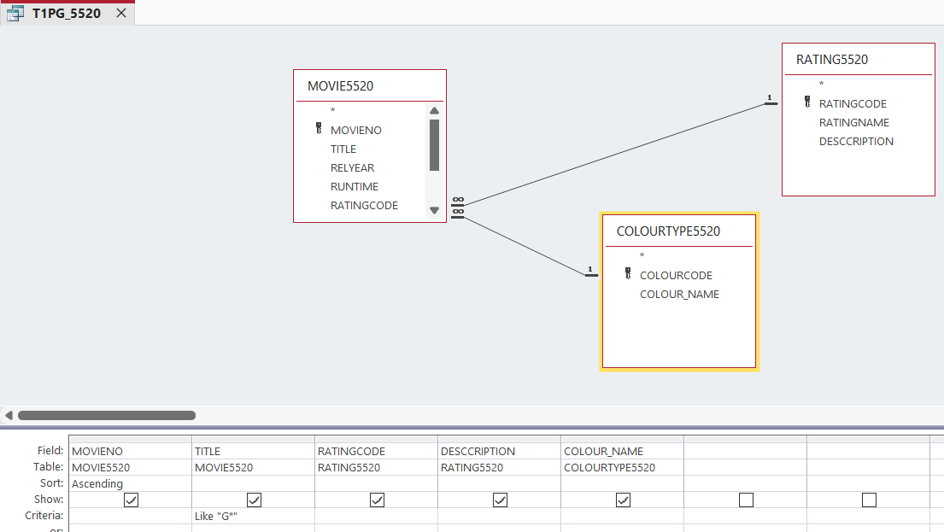
Figure 16: Query Design for Movies Beginning with "G" (Pass 1g)

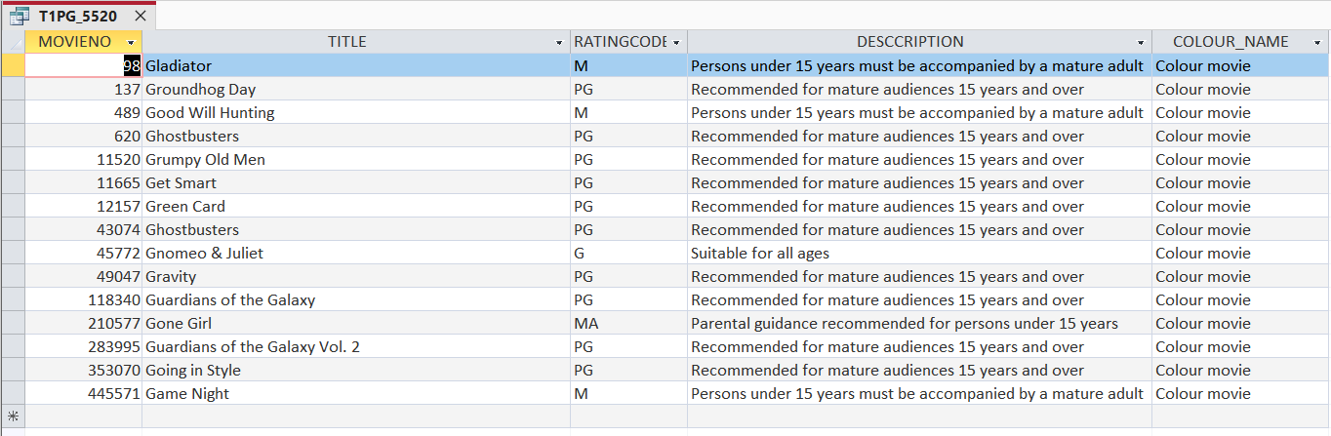
Figure 17: Query Result Showing Movies Beginning with "G" (Pass 1g)

Task Pass1h
In the task Pass1h, the task description asks students to create a query named T1PH_5520 that requires Totals with display the actor no, actor fullname, and the count of CastId with Descending and display the first 15 rows.
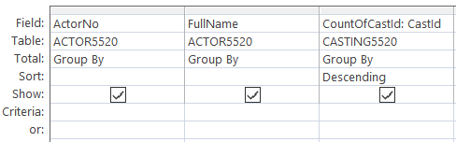
Figure 18: Query Design with Totals for Actor Movie Count (Pass 1h)

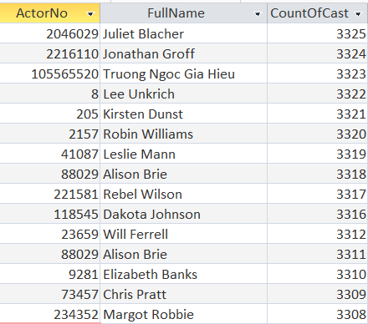

Figure 19: Query Result Showing Actor Movie Counts (Pass 1h)

Task Pass1i
In the description of the task Pass 1i, it requires grouping by gender and calculating the total number of each gender. Therefore, the query will include two columns: the first is Gender, and the second is CountOfGender.
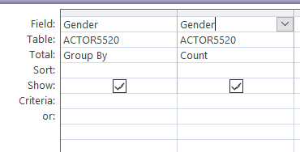
Figure 20: Query Design Grid for Pass 1i (T1Pi_5520)
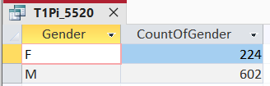
Figure 21: Query Results for Pass 1i (T1Pi_5520)

Task Pass1j
In this part, the Indexed property of the Surname change to Yes (with duplicate).
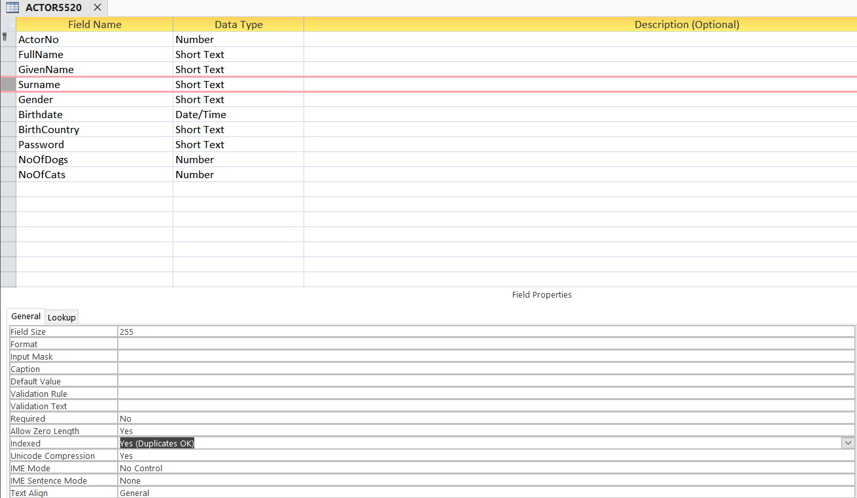
Figure 22: Modified Indexed Porperty of Surname Attribute

Task Pass1k
Firstly, I added new record at the bottom of the ACTOR5520 Table.
Figure 23: New record in Table ACTOR5520
Secondly, I added new record at the bottom of the MOVIE5520 Table.
Figure 24: New record in Table MOVIE5520
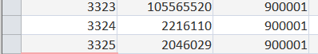
Figure 25: Add new three records in the table CASTING5520 Table
Figure 26: Query Design Grid joining Casting, Movie, and Actor tables

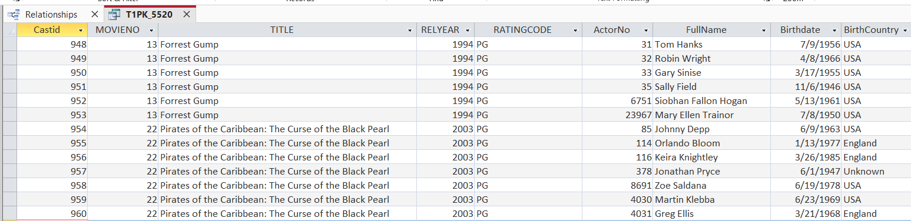
Figure 27: Query Results for T1PK_5520 (Casting, Movie, and Actor Information)

