1. Find the mean, median, mode and range of the following data: 10, 7, 14, 23, 15, 7, 32

- Mean =

- Median: 14

- Mode: 7

- Range = 32 – 7 = 25

2. Find the mean, median, mode and range of the following data: 15, 21, 59, 15, 37,59, 11, 41

- Rearrange: 11, 15, 15, 21, 37, 41, 59, 59

- Mean: 32.25

- Median:

- Mode: 15, 59 => biomodal

- Range: 59 – 11 = 48

75%

25%

50%

100%

0%



Q2  
(Median)

Q3

Q1

MAX

MIN

7, 11, 14, 5, 8, 27, 16, 10, 13, 17, 16

* Organise:

5,7,8,10, 11, 13, 14,16, 16, 17, 27



27

17

16

14

16

7

8

11

10

5

13

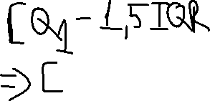



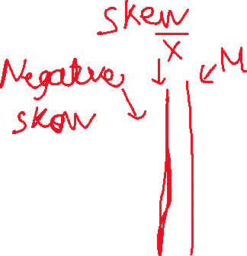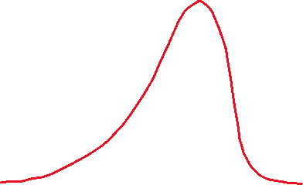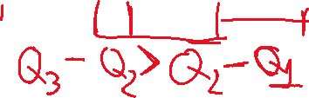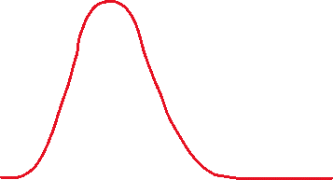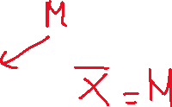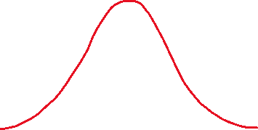

5, 8, 3, 7, 1, 5, 3, 2, 3, 3, 8, 5