Group Assessment Contribution Form

Form No.: 1
Course: Introduction to Artificial Intelligence
Project/Assignment Title: Machine Learning and Software Integration

1. Group Members:
Please list down all members of the group, including yourself:
- Name: Truong Ngoc Gia Hieu, Student ID: 105565520
- Name: Huynh Trong Hieu, Student ID: 105551833
- Name: Duong Nguyen Dang, Student ID: 105508444
- Name: Pham Nguyen Minh Hoang, Student ID: 105543500

2.Team Task & Contribution Log
To be completed and signed by all group members. This section documents the specific tasks each member was responsible for and provides evidence of their work. All members must reach a consensus on the described contributions
Group Member | Tasks
Truong Ngoc Gia Hieu | - Served as Team Leader .  - Developed the Gantt chart to establish and control project milestones .  - Refined LSTM and GRU model parameters based on training loss analysis .  - Finalized the backend data integration and model deployment.
Huynh Trong Hieu | - Served as Vice Leader for quality oversight and supervision .  - Monitored technical consistency and report formatting on a weekly basis  - Established and maintained quality standards for all project documentation and figures.
Duong Nguyen Dang | - Designed the User Interface (UI) for traffic forecasting and data visualization .  - Integrated AI backend results into the main frontend visualization components .  - Maintained Team Assessment Contribution records to track member performance
Pham Nguyen Minh Hoang | - Managed and updated weekly Meeting Minutes .  - Consolidated technical drafts into the main report (Sections B & C) .  - Tracked action items and ensured all documentation deadlines were met.

3. Team Member Contributions:
As a group, discuss and evaluate the contributions of each team member in the table below. The final evaluations must represent a consensus agreed upon by the entire team.

Group  Member | Contribution  (100% in total) | Quality of Work  (1-5) | Timeliness  (1-5) | Collaboration  (1-5)
Truong Ngoc Gia Hieu | 100% | 5 | 5 | 5
Huynh Trong Hieu | 100% | 5 | 5 | 5
Duong Nguyen Dang | 100% | 5 | 5 | 5
Pham Nguyen Minh Hoang | 100% | 5 | 5 | 5

Contribution and Grading Policy:
- Normal Grade: Members contributing 33% or more will receive the full project mark.
- Penalty: Members contributing less than 33% will incur a penalty. Their grade will be calculated as follows:
  - (Contribution Percentage/33)×Group Mark
Example: If the total group mark is 15, and a member contributes 20%, their grade will be (20/33)×15 = 9

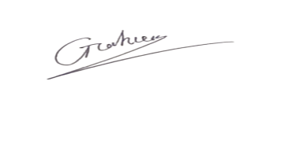
Gia Hieu’s Signature:

Trong Hieu’s Signature:
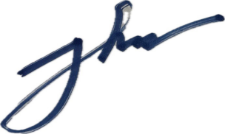
Nguyen Dang’s Signature:


Minh Hoang’s Signature:

Date: April 4th, 2026

