Assignment 2b
Machine Learning and Software Integration

Authors

Truong Ngoc Gia Hieu 105565520
Duong Nguyen Dang 105508444
Huynh Trong Hieu 105551833
Pham Nguyen Minh Hoang 105543500

TABLE OF CONTENT
Part A: Abstract 3
1.1 Assignment Requirements 3
1.2 Roles and Responsibilities 3
1.3 Assignment Scope 4
Part B: Exploratory Data Analysis (EDA) 4
2.1 Dataset Overview 4
2.1.1 Glossary of Symbols 4
2.1.2 SCATS Site Classification 5
2.1.3 Road Classification and Hierarchy 5
2.1.4 Raw Traffic Data Records 6

Part A: Abstract

Assignment Requirements
In the subsequent phase of the second assignment, the primary purpose is to develop a fully functional Traffic-based Route Guidance System (TBRGS) by implementing advanced Machine Learning models with the graph-based search algorithms developed in the first part. In detail, the system must process provided datasets and materials, including the Boroondara traffic flow data, to train and evaluate models with LSTM, GRU, and a third team-selected algorithm. As a result, these predictive models are utilized to estimate travel times from the start to the destination location by converting traffic volume and subsequently suggesting a suitable speed based on the current traffic flow. Notably, our team designed the system to update every 10 minutes which allows the GUI to visualize up to five optimal routes based on the most recent predictions while ensuring high accuracy and real-time responsiveness

Roles and Responsibilities
Furthermore, this section highlights specific roles and responsibilities assigned to each team member to ensure the seamless integration of advanced Machine Learning models with the route guidance logic. Specifically, the table below illustrates the detailed breakdown of individual contributions and task allocations designed to meet the core milestones of Assignment 2b.
Team Member Name | Student ID | Roles and Responsibilities
Duong Nguyen Dang | 105508444 | - Designs the Graphical User Interface (GUI)  - Manages parameter configurations  - Leads the technical documentation
Huynh Trong Hieu | 105551833 | - Manages Data Pre-processing  - Structures the Boroondara dataset  - Implements travel time estimation logic
Truong Ngoc Gia Hieu | 105565520 | - Oversees the project lifecycle  - Develops core LSTM & GRU models  - Implements real-time update logic
Pham Nguyen Minh Hoang | 105543500 | - Implements the GUI frontend  - Visualizes the top-5 optimal routes  - Ensure all crucial documents are completed

Assignment Scope
Moreover, the assignment scope emphasizes the development and integration of a Traffic-based Route Guidance System (TBRGS) using the Boroondara dataset. Specifically, the following key areas define the boundaries of our implementation:
- Machine Learning Development: Developing and training three predictive models including LSTM, GRU, and a third selected algorithm to forecast traffic flow based on historical SCATS data.
- System Integration: Embedding the predictive outputs into the graph-based search algorithms developed in Part A to calculate the top 5 optimal routes dynamically.
- Real-time Data Processing: Implementing a backend logic that processes traffic volume and converts it into estimated travel times and suitable speeds for each road segment.
- User Interface & Interaction: Building a functional GUI that allows users to input origin/destination points, visualize routes, and adjust system parameters as required by the brief.
- Evaluation and Testing: Conducting a comprehensive performance analysis of the ML models and executing at least 10 software test cases to ensure system reliability.
In summary, the first part has indicated the foundational requirements and the strategic scope of the TBRGS. To ensure the predictive models are built on a solid understanding of the underlying traffic patterns, the subsequent section will focus on Exploratory Data Analysis (EDA). Therefore, the EDA is essential to perform a rigorous analysis of the Boroondara dataset, which examines the traffic patterns and data distributions while providing the necessary insights to optimize our Machine Learning architectures.

Part B: Exploratory Data Analysis (EDA)

2.1 Dataset Overview

2.1.1 Glossary of Symbsols
First and foremost, our team received a dataset which contains various abbreviations under the Location or Type attributes. Moreover, our team decided to use the file Symbols.csv as a reference data dictionary. Specifically, the following figures indicate how our team processed and saved these unique symbols using Python, ensuring that every professional traffic term is correctly mapped for the analysis phase

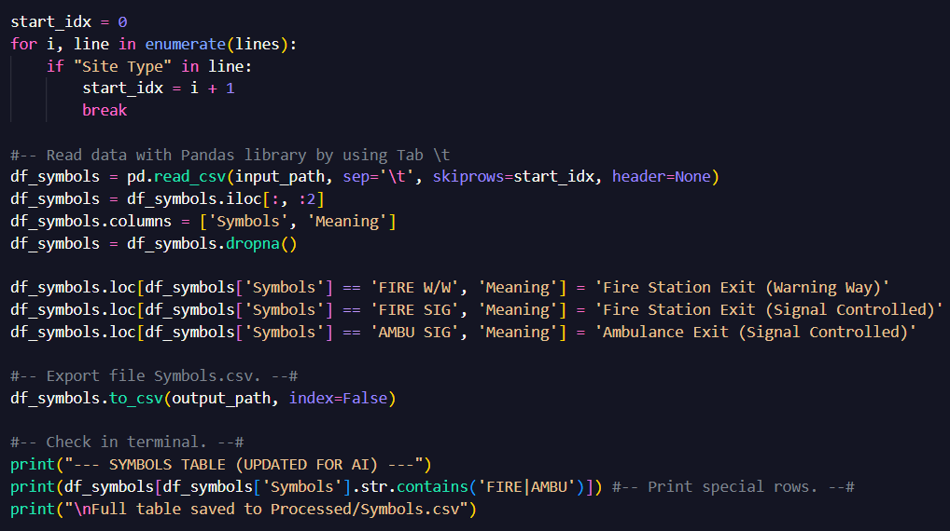
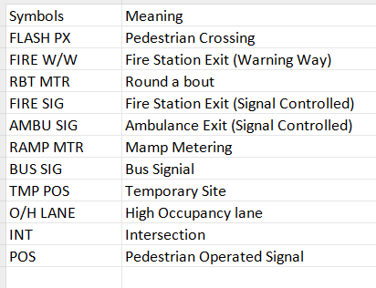
Figure 2: Loading and preprocessing the symbol dictionary to handle special characters.
Figure 1: Data in file Symbols.csv

2.1.2 SCATS Site Classification
Next, the assignment provided a valuable dataset named SCATSiteNumbers.csv which functions as a comprehensive directory. Specifically, this dataset contains over 1,000 unique entries mapping Site Numbers to their respective physical locations. The key characteristics of this dataset include:
- Granularity: Detailed street-level descriptions such as the intersection of ABBOTTS/CLELANDS, providing high-resolution spatial data.
- Categorization: Sites are classified into functional types including INT (Intersections) and POS (Pedestrian signals).
- Spatial Reference: Integrated directory and map references, such as Melway coordinates which are essential for geographic verification and network analysis.
By implementing this directory, our team can transform raw IDs into meaningful geographic context that process is vital to ensure the BLSTM model captures location-specific behaviors while verifying that all processed data is accurately tied to verified physical sites

2.1.3 Road Classification and Hierachy
Subsequently, the third metadata component from second assignment Traffic_Count_Locations_with_LONG_LAT.csv, providing technical specifications regarding road hierarchy and traffic volume capacity. Consequently, this approach allows our team to categorize monitoring sites based on their strategic importance within the transport network. In particular, the key characteristics include:
- Traffic Volume Metrics: Attributes such as AADT_ALLVE (Annual Average Daily Traffic) and AADT_TRUCK serve as baseline indicators for a road's typical load.
- Road Hierarchy: Roads are classified into functional categories, namely "Highways," "Arterial Roads," or "Local Roads," via the DECLARED_R and LOCAL_ROAD attributes.
- Geospatial Coordinates: The dataset provides precise Longitude (X) and Latitude (Y) data, enabling spatial mapping and distance-based analysis between sites.
- Heavy Vehicle Impact: The inclusion of PER_TRUCKS (percentage of trucks) is vital for forecasting, as heavy vehicle patterns often differ from passenger car cycles.
By integrating this road hierarchy data, models such as LSTM, GRU, and BLSTM can distinguish between different flow dynamics, such as the high-capacity flow of a Highway versus the lower volume of a Local Road. This ensures the model's predictions are grounded in the physical reality of the road network.

2.1.4 Raw Traffic Data Records
Finally, the raw dataset includes traffic volume records from 40 SCATS sites in the Boroondara area, collected over a 31-day period in October 2006. Therefore, the data is structured as a time series with a high time resolution of 15-minute gaps, lead to 96 data points per site per day. Particularly, key attributes in the raw records include:
- Space Identifiers: SCATS Site Number, Location (crossing descriptions), and Geographic Coordinates (Latitude/Longitude).
- Traffic Metrics: 15 minutes volume counts and Total Daily Volume.
- Data unity: Records for several sites including 970, 2000, 2820 as noted in the dataset metadata were marked as poor quality and cut out to ensure model accuracy.
This raw data works as the main input for our LSTM and GRU models. However, it is necessary to adjust the coordinates manually during the preparation stage, because the initial map does not match with real-world intersections an important step to visualize the route correctly on the GUI.

