Assignment 2b
Machine Learning and Software Integration

Authors

Truong Ngoc Gia Hieu 105565520
Duong Nguyen Dang 105508444
Huynh Trong Hieu 105551833
Pham Nguyen Minh Hoang 105543500

TABLE OF CONTENT

Part A: Abstract 3
1.1 Assignment Requirements 3
1.2 Roles and Responsibilities 3
1.3 Assignment Scope 4
Part B: Exploratory Data Analysis (EDA) 4
2.1 Dataset Overview 4
2.1.1 Glossary of Symbols 4
2.1.2 SCATS Site Classification 5
2.1.3 Road Classification and Hierarchy 5
2.1.4 Raw Traffic Data Records 6
2.1 Data Processing 6
2.2.1 Data Filtration and Quality Control 7
2.2.2 Data Integration and Mapping 7
2.2.3 Window-based Transformation for Deep Learning 7
Part C: Machine Learning Models 8
3.1 Python Libraries 8
3.2 Long Short-Term Memory (LSTM) 9
3.3 Gated Recurrent Unit (GRU) 13
3.4 Bidirectional Long Short-Term Memory (Bi-LSTM) 16
Part D: Software Inplementation 20
4.1 Backend Integration 20
4.2 Frontend Integration 24
Part E: Conclusion 27
Part F: Acknowledgements 27

Part A: Abstract

Assignment Requirements
In the subsequent phase of the second assignment, the primary purpose is to develop a fully functional Traffic-based Route Guidance System (TBRGS) by implementing advanced Machine Learning models with the graph-based search algorithms developed in the first part. In detail, the system must process provided datasets and materials, including the Boroondara traffic flow data, to train and evaluate models with LSTM, GRU, and a third team-selected algorithm. As a result, these predictive models are utilized to estimate travel times from the start to the destination location by converting traffic volume and subsequently suggesting a suitable speed based on the current traffic flow. Notably, our team designed the system to update every 10 minutes which allows the GUI to visualize up to five optimal routes based on the most recent predictions while ensuring high accuracy and real-time responsiveness

Roles and Responsibilities
Furthermore, this section highlights specific roles and responsibilities assigned to each team member to ensure the seamless integration of advanced Machine Learning models with the route guidance logic. Specifically, the table below illustrates the detailed breakdown of individual contributions and task allocations designed to meet the core milestones of Assignment 2b.
Team Member Name | Student ID | Roles and Responsibilities
Duong Nguyen Dang | 105508444 | - Designs the Graphical User Interface (GUI)  - Manages parameter configurations  - Leads the technical documentation
Huynh Trong Hieu | 105551833 | - Manages Data Pre-processing  - Structures the Boroondara dataset  - Implements travel time estimation logic
Truong Ngoc Gia Hieu | 105565520 | - Oversees the project lifecycle  - Develops core LSTM & GRU models  - Implements real-time update logic
Pham Nguyen Minh Hoang | 105543500 | - Implements the GUI frontend  - Visualizes the top-5 optimal routes  - Ensure all crucial documents are completed

Assignment Scope
Moreover, the assignment scope emphasizes the development and integration of a Traffic-based Route Guidance System (TBRGS) using the Boroondara dataset. Specifically, the following key areas define the boundaries of our implementation:
- Machine Learning Development: Developing and training three predictive models including LSTM, GRU, and a third selected algorithm to forecast traffic flow based on historical SCATS data.
- System Integration: Embedding the predictive outputs into the graph-based search algorithms developed in Part A to calculate the top 5 optimal routes dynamically.
- Real-time Data Processing: Implementing a backend logic that processes traffic volume and converts it into estimated travel times and suitable speeds for each road segment.
- User Interface & Interaction: Building a functional GUI that allows users to input origin/destination points, visualize routes, and adjust system parameters as required by the brief.
- Evaluation and Testing: Conducting a comprehensive performance analysis of the ML models and executing at least 10 software test cases to ensure system reliability.
In summary, the first part has indicated the foundational requirements and the strategic scope of the TBRGS. To ensure the predictive models are built on a solid understanding of the underlying traffic patterns, the subsequent section will focus on Exploratory Data Analysis (EDA). Therefore, the EDA is essential to perform a rigorous analysis of the Boroondara dataset, which examines the traffic patterns and data distributions while providing the necessary insights to optimize our Machine Learning architectures.

Part B: Exploratory Data Analysis (EDA)

2.1 Dataset Overview

2.1.1 Glossary of Symbols
First and foremost, our team received a dataset which contains various abbreviations under the Location or Type attributes. Moreover, our team decided to use the file Symbols.csv as a reference data dictionary. Specifically, the following figures indicate how our team processed and saved these unique symbols using Python, ensuring that every professional traffic term is correctly mapped for the analysis phase

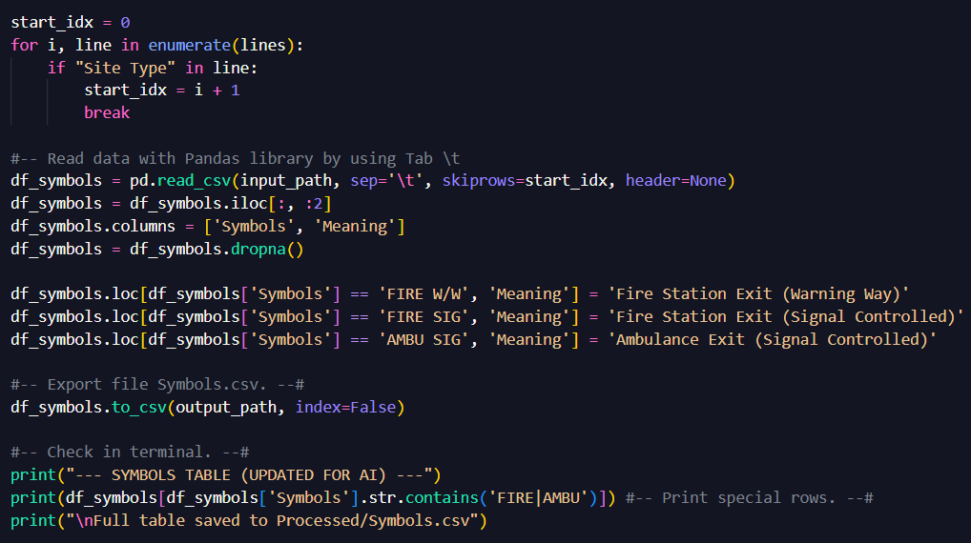
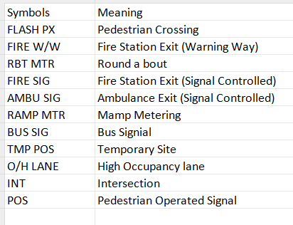
Figure 2: Loading and preprocessing the symbol dictionary to handle special characters.
Figure 1: Data in file Symbols.csv

2.1.2 SCATS Site Classification
Next, the assignment provided a valuable dataset named SCATSiteNumbers.csv which functions as a comprehensive directory. Specifically, this dataset contains over 1,000 unique entries mapping Site Numbers to their respective physical locations. The key characteristics of this dataset include:
- Granularity: Detailed street-level descriptions such as the intersection of ABBOTTS/CLELANDS, providing high-resolution spatial data.
- Categorization: Sites are classified into functional types including INT (Intersections) and POS (Pedestrian signals).
- Spatial Reference: Integrated directory and map references, such as Melway coordinates which are essential for geographic verification and network analysis.
By implementing this directory, our team can transform raw IDs into meaningful geographic context that process is vital to ensure the BLSTM model captures location-specific behaviours while verifying that all processed data is accurately tied to verified physical sites

2.1.3 Road Classification and Hierarchy
Subsequently, the third metadata component from second assignment Traffic_Count_Locations_with_LONG_LAT.csv, providing technical specifications regarding road hierarchy and traffic volume capacity. Consequently, this approach allows our team to categorize monitoring sites based on their strategic importance within the transport network. In particular, the key characteristics include:
- Traffic Volume Metrics: Attributes such as AADT_ALLVE (Annual Average Daily Traffic) and AADT_TRUCK serve as baseline indicators for a road's typical load.
- Road Hierarchy: Roads are classified into functional categories, namely "Highways," "Arterial Roads," or "Local Roads," via the DECLARED_R and LOCAL_ROAD attributes.
- Geospatial Coordinates: The dataset provides precise Longitude (X) and Latitude (Y) data, enabling spatial mapping and distance-based analysis between sites.
- Heavy Vehicle Impact: The inclusion of PER_TRUCKS (percentage of trucks) is vital for forecasting, as heavy vehicle patterns often differ from passenger car cycles.
By integrating this road hierarchy data, models such as LSTM, GRU, and BLSTM can distinguish between different flow dynamics, such as the high-capacity flow of a Highway versus the lower volume of a Local Road. This ensures the model's predictions are grounded in the physical reality of the road network.

2.1.4 Raw Traffic Data Records
Finally, the raw dataset includes traffic volume records from 40 SCATS sites in the Boroondara area, collected over a 31-day period in October 2006. Therefore, the data is structured as a time series with a high time resolution of 15-minute gaps, lead to 96 data points per site per day. Particularly, key attributes in the raw records include:
- Space Identifiers: SCATS Site Number, Location (crossing descriptions), and Geographic Coordinates (Latitude/Longitude).
- Traffic Metrics: 15 minutes volume counts and Total Daily Volume.
- Data unity: Records for several sites including 970, 2000, 2820 as noted in the dataset metadata were marked as poor quality and cut out to ensure model accuracy.
This raw data works as the main input for our LSTM and GRU models. However, it is necessary to adjust the coordinates manually during the preparation stage, because the initial map does not match with real-world intersections an important step to visualize the route correctly on the GUI.

2.2 Data Processing
After receiving valuable datasets, our team decided to analyze and perform a comprehensive visualization and exploratory analysis. This stage allowed us to identify key traffic patterns and structural relationships within the data, ensuring a clear understanding of the technical metrics used throughout this report. The following sections outline the data terminology and classification standards, starting with a glossary of essential symbols in Data Filtration and Quality Control.

2.2.1 Data Filtration and Quality Control
The primary objective of this section is to refine the raw data which guarantees that the training set for our Deep Learning models is both accurate and rich in contextual information.
- Exclusion of Bad Records: By cross-referencing our primary traffic logs with the Bad_Records_List.csv, our team identified and removed poor SCATS sites that exhibited significant hardware malfunctions or inconsistent recording including 970, 2000, 2820, and so on. Consequently, this filtration step prevents the models from learning noise and systematic errors caused by faulty sensors which would otherwise compromise the reliability of travel time predictions.
- Data Enrichment via Performance Metrics (Efficiency Stations): By moving beyond raw volume counts, our team integrated data from efficiency_stations_cleaned.csv. Additionally, this file provides high-precision geographic coordinates required for distance calculations and, more importantly, includes the Efficiency Index. Besides that, this index allows our LSTM, GRU, and Bi-LSTM models to account for the actual throughput capacity of each road segment, leading to more nuanced and realistic speed estimations compared to models relying solely on raw flow data.

2.2.2 Data Integration and Mapping
In this part, our team unified the filtered traffic records with spatial metadata, primarily leveraging the efficiency_stations_cleaned.csv file to generate a comprehensive training dataset:
- Coordinate Mapping: Our members mapped the SCATS IDs to the precise GPS coordinates (x, y) provided in the efficiency dataset. As a result, this integration is vital for the system’s backend to execute the Haversine formula that calculates real-world distances between nodes for travel time estimation.
- Road Attribute Linking: By merging traffic flow with this file, we successfully appended critical attributes including road_name and per_trucks (percentage of trucks) to each record.
- Efficiency Normalization: Significantly, we mapped the Efficiency Index to each site which allows powerful machine learning models such as LSTM, GRU, and Bi-LSTM to recognize the unique throughput capacity of different road segments and ensures that speed predictions are not just based on vehicle count but on the specific physical characteristics of the infrastructure.

2.2.3 Window-based Transformation for Deep Learning
Next, our team transformed the integrated dataset into a sequence-based format to enable the Recurrent Neural Network (RNN) architectures to capture temporal dependencies effectively.
- Time-Series Sequencing: By using the 15-minute interval records from Full_Traffic_With_Validity_Cleaned.csv, we structured the data into sliding windows. In detail, each input sequence consists of 96-time steps, representing a continuous 24-hour cycle which permits the models to recognize daily traffic patterns and peak-hour trends.
- 3D Tensor Reshaping: For meet the input requirements of LSTM, GRU, and Bi-LSTM, the data was reshaped into a 3D tensor format: (Samples, Time Steps, Features). By analysing the previous 96 data points, the system can predict the traffic volume for the subsequent interval with high temporal context.
- Feature Tiling: During this transformation, static road attributes and the Efficiency Index were "tiled" across all 96-time steps. Therefore, team members believe that this technique ensures that the models simultaneously process the dynamic flow variations alongside the constant physical constraints of the road infrastructure.
In conclusion, the data processing phase has successfully transformed raw traffic records into a high-quality and sequence-based dataset. By filtering anomalies via the Bad_Records_List.csv, integrating spatial intelligence from efficiency_stations_cleaned.csv, and structuring the data into 96-step sliding windows, we have created a robust foundation for deep learning. Subsequently, this contextually enriched data is now optimized for the training and evaluation of the LSTM, GRU, and Bi-LSTM models that will be discussed in the following section.

Part C: Machine Learning Models
In this part of the report, our team indicates three advanced Recurrent Neural Networks (RNN) architectures implemented to forecast traffic volume. Besides, these models were chosen for their specialized ability to process time-series sequences and retain long-term temporal dependencies.

3.1 Python Libraries
Firstly, our team selected following available Python libraries for the traffic forecasting system, leveraging a suite of specialized libraries for data engineering, numerical analysis, and deep learning:
- Pandas & NumPy: These are fundamental for high-performance data manipulation. Specifically, pandas is utilized to handle traffic datasets in structured DataFrames while NumPy supports the multi-dimensional array operations required for feeding sequences into the neural network.
- TensorFlow & Keras (Sequential, Dense, LSTM): This framework is the core of the AI model. Furthermore, the LSTM layers are specifically designed to learn temporal dependencies and long-term patterns in traffic flow. In addition, the Dense layer acts as the output layer to produce the final numerical prediction and Sequential class allows for a linear stack of these layers.
- Matplotlib (plt): The stunning library is used for diagnostic visualization which enables the team to plot training history and visualize the comparison between the "Ground Truth" traffic volume and the "AI Forecast" results.
- Scikit-Learn (MinMaxScaler, mean_squared_error): MinMaxScaler is essential for normalizing data into a [0, 1] range, which prevents gradient explosion and ensures faster convergence. Besides, the Mean Squared Error (MSE) function is used as the primary loss metric to evaluate the accuracy of the predictions during the testing phase.
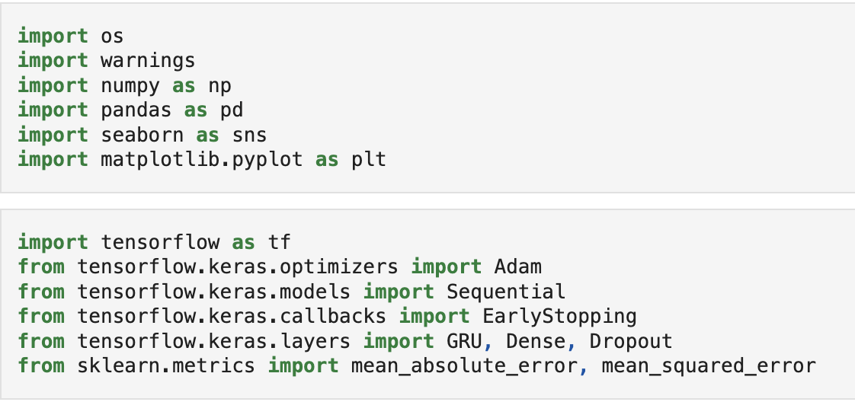
- Math: A built-in Python module used for basic mathematical operations such as calculating the square root of the MSE to derive the Root Mean Squared Error (RMSE).

Figure 3: Import Python libraries

3.2 Long Short-Term Memory (LSTM)
Secondly, Long Short-Term Memory (LSTM) is one of the powerful Recurrent Neural Network (RNN) variants specifically engineered to overcome the limitations of traditional RNNs in handling long-term dependencies. Furthermore, the stunning model is particularly applied effective for our traffic study due to following keys:
- Handling Long-Term Dependencies: Unlike standard RNNs, the model LSTM can remember and process information across much longer sequences without losing context.
- Memory Cell Integration: It features a unique "Cell State" that acts like a conveyor belt, storing and updating vital information over time while filtering out noise.
- Overcoming RNN Limitations: By utilizing a gating mechanism, LSTM effectively solves the short-term memory and vanishing gradient issues that typically hinder basic RNN models.
- Versatile Applications: Beyond time-series forecasting like our traffic volume project, LSTMs are the industry standard for complex tasks such as language translation and speech recognition.
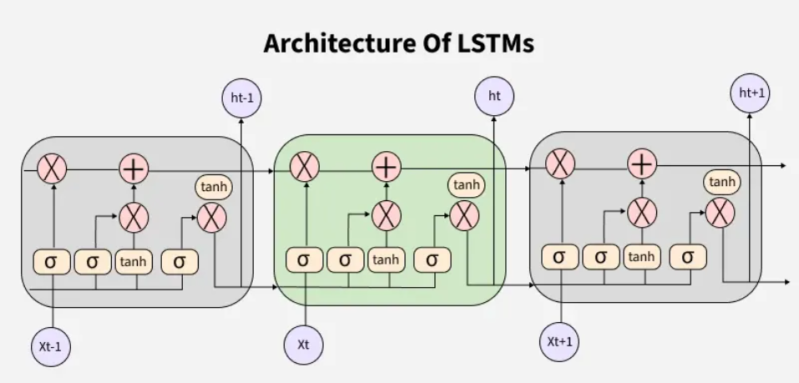
Figure 4: LSTM Architecture Overall
After figuring out theoretical advantages of LSTM, our team implemented three distinct layers to process the traffic data. Specifically, the following description outlines how the internal memory cell is managed by a gating mechanism to ensure high-accuracy forecasting:
- Input Gate: This gate controls what new information is added to the memory cell. In detail, it evaluates the current 15-minute traffic interval to decide which features are significant enough to be stored for future predictions in second assignment.
- Forget Gate: This gate determines what information is removed from the memory cell. Moreover, it is responsible for filtering out "noise" or outdated historical data that is no longer relevant to the current traffic trend.
- Output Gate: This gate controls what information is output from the memory cell to the next hidden state which ensures that only the most critical patterns identified by the model are used to generate the final traffic volume forecast.

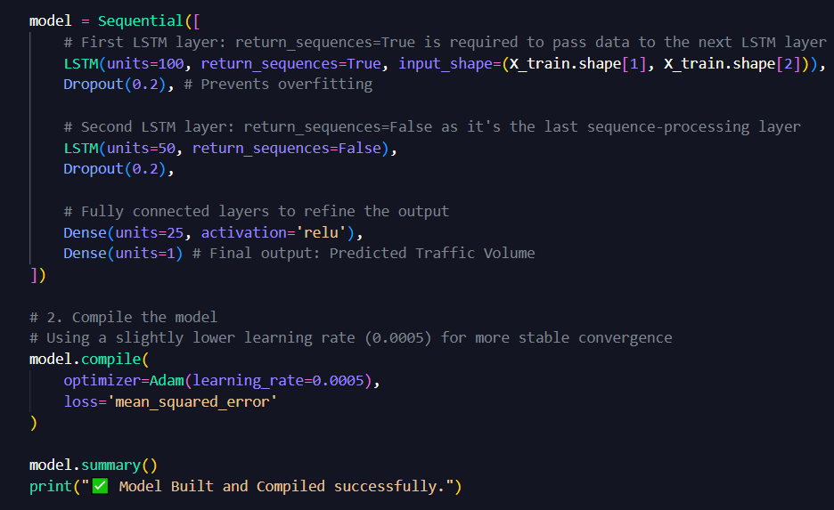
Figure 5: Implementation of LSTM Model in Python Code
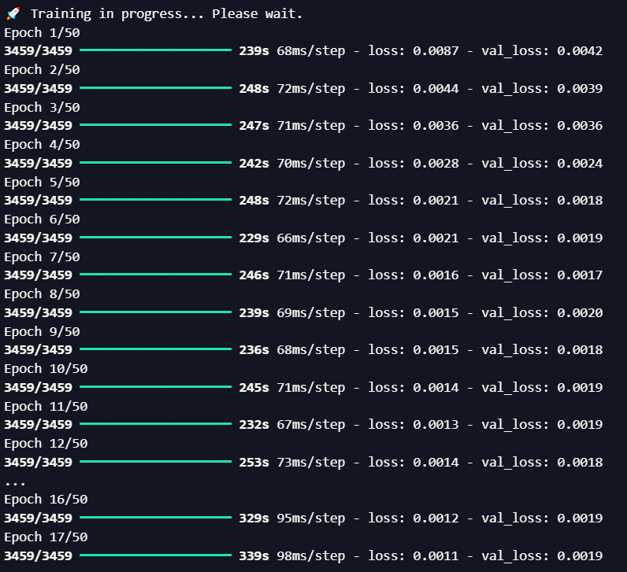
Next, in the training phase, the model was trained using the Adam optimizer and Mean Squared Error (MSE) loss function over 50 epochs as illustrated in Figure 5 below.
Figure 6: Training Process of LSTM Model

After training the model, our team decided to visualize the efficiency and predictive accuracy of the LSTM architecture. Furthermore, the evaluation process focused on how well the model generalizes to unseen data as illustrated in the figures below:
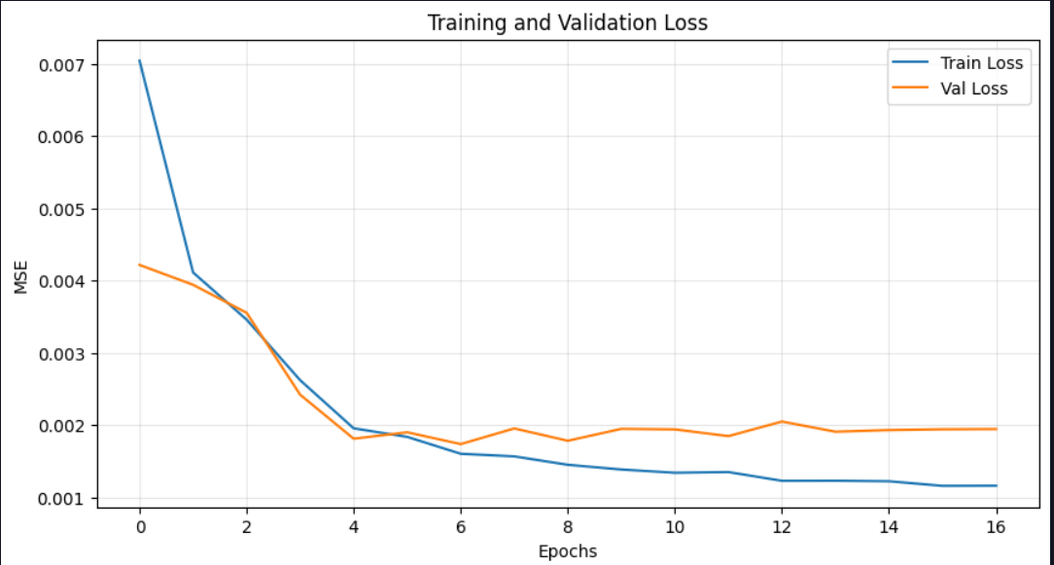
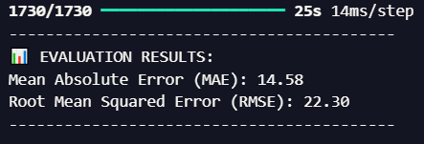
Figure 8: Evaluation Results

Figure 7: Training and Validation Loss

As demonstrated in Figure 7, the training and validation loss curves converge rapidly and remain closely aligned after epoch 10, confirming that the model is well-generalized and free from overfitting. In addition, the final evaluation in Figure 8 further validates this efficiency, achieving a Mean Absolute Error (MAE) of 14.58 and a Root Mean Squared Error (RMSE) of 22.30. Consequently, is clear that these low error metrics prove the LSTM’s high precision in forecasting fluctuating traffic volumes across the Boroondara network.
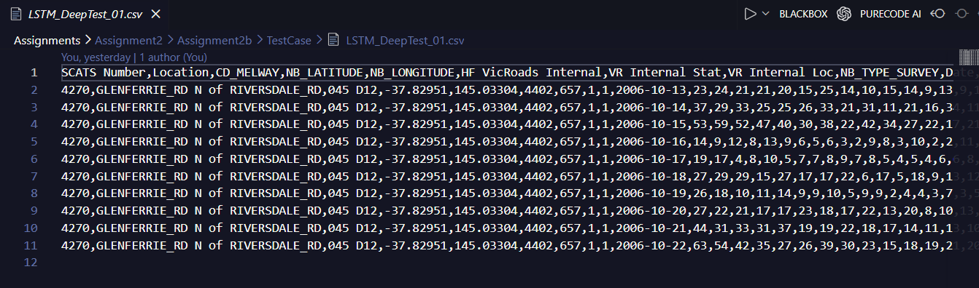
In additional, in the testing part, our team validated the model’s real-world performance using a specific test case from the dataset. In detail, we selected the traffic data from Glenferrie Rd (North of Riversdale Rd) as documented in the LSTM_DeepTest_01.csv file to evaluate how the model aligns with the Ground Truth.
Figure 9: Dataset in file LSTM_DeepTest_01.csv

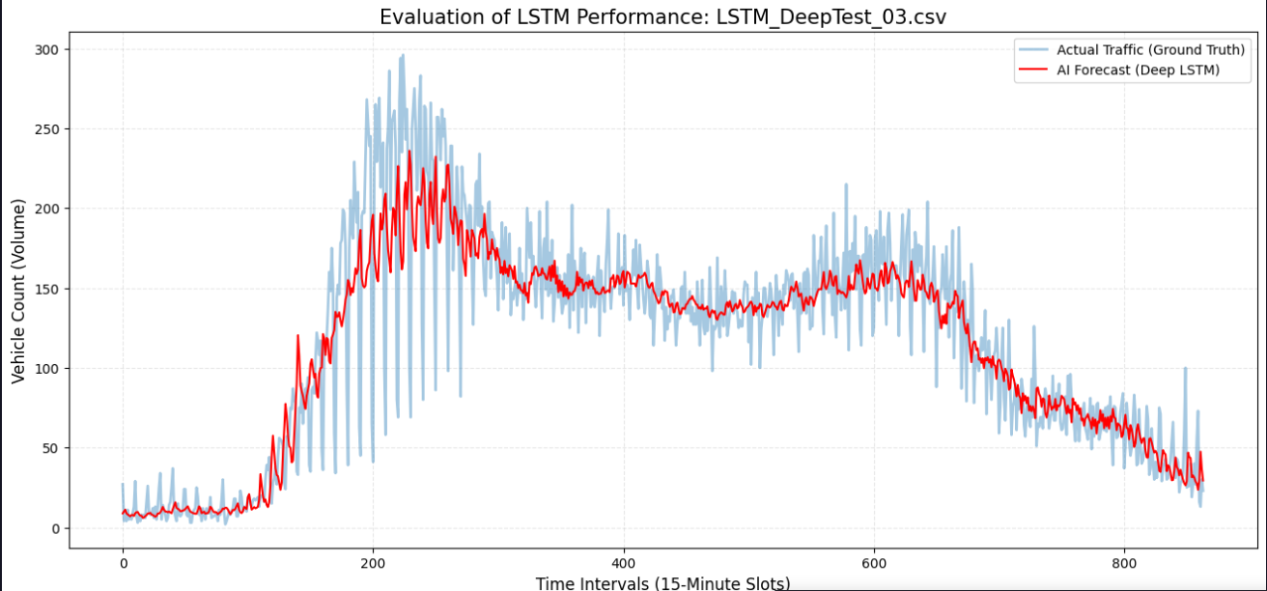
Figure 10: Evaluation of LSTM Performance Graph
As indicated in Figure 8 and 9, the AI Forecast (Red line) closely tracks the Actual Traffic (Blue line) throughout the 15-minute time intervals. As a result. the model successfully captures the major trends, especially the significant volume surges during peak hours (around interval 200 and 600) and the gradual decline during late-night slots. Although there are minor fluctuations in the raw sensor data, the LSTM provides a smooth and highly accurate trendline, confirming its readiness for deployment in traffic management systems.

3.3 Gated Recurrent Unit (GRU)
During the research and analysis phase, the team identified Gated Recurrent Units (GRUs) as a specialized Recurrent Neural Network (RNN) architecture designed to overcome the vanishing gradient problem inherent in traditional RNNs. Unlike Long Short-Term Memory (LSTM) models which utilize three different gates, GRUs employ only two including an Update Gate and a Reset Gate. Furthermore, this streamlined structure makes them computationally more efficient while maintaining comparable performance in sequence prediction tasks. Consequently, GRUs are particularly well-suited for traffic forecasting, as traffic patterns exhibit strong temporal dependencies where current volumes are heavily influenced by preceding hours.

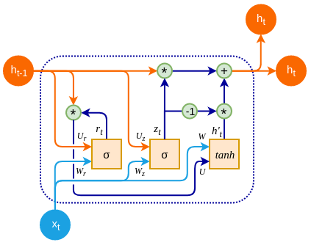

Figure 11: GRU Architecture Overall
As indicated in Figure 11, The proposed GRU model is constructed with a sequential architecture designed to handle multi-dimensional time-series data. The network consists of two stacked GRU layers followed by fully connected layers to map high-level features to the final traffic volume prediction. In detail, the following description outlines the systematic approach used to apply and train our machine learning models:
- Input Layer: Receives a feature matrix of (96x6), representing 96 timesteps (24 hours of data at 15-minute intervals) and 6 input features.
- GRU Layer 1: Consists of 100 units with return_sequences=True to pass the sequence information to the next layer. As a result, this layer accounts for 32,400 parameters.
- Dropout Layer 1: A dropout rate of 20% is applied to prevent overfitting by randomly deactivating neurons during training.
- GRU Layer 2: Consists of 50 units with return_sequences=False, effectively condensing the sequence into a single feature vector. This layer contains 22,800 parameters.
- Dropout Layer 2: An additional 20% dropout layer is implemented for further regularization.
- Dense Layer (Hidden): A fully connected layer with 25 units and ReLU (Rectified Linear Unit) activation to introduce non-linearity (1,275 parameters).
- Output Layer: A final Dense layer with 1 unit and Linear activation to produce the continuous traffic volume forecast (26 parameters).

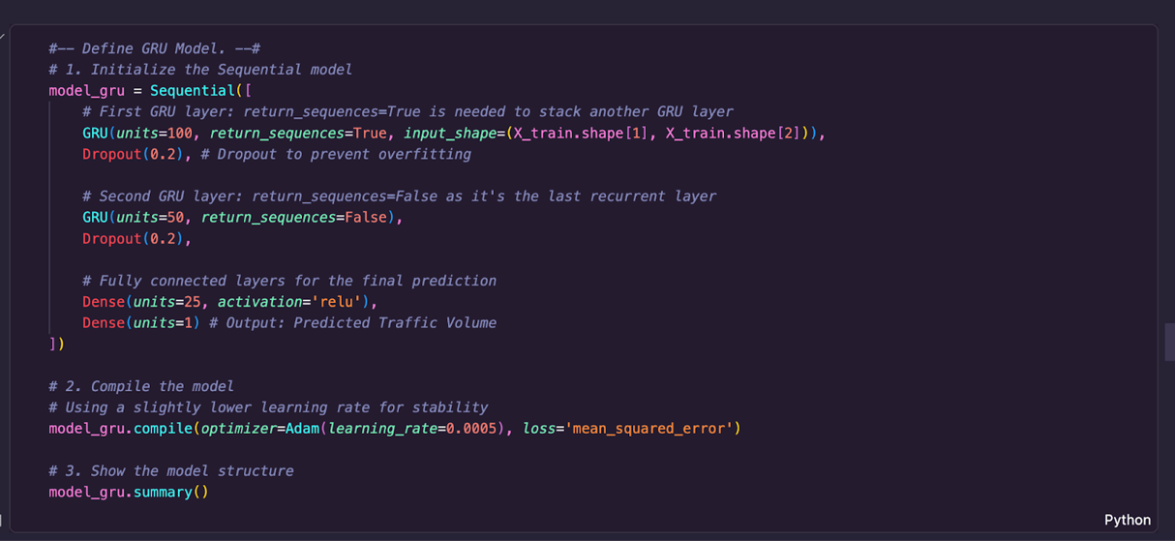
Figure 12: Implementation of GRU model in Python code
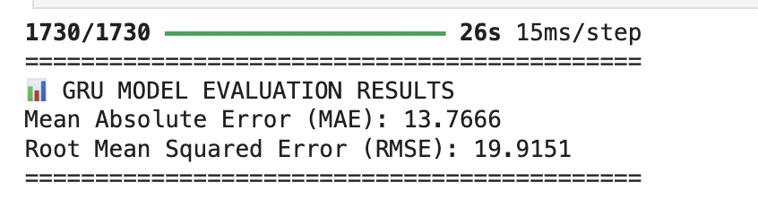
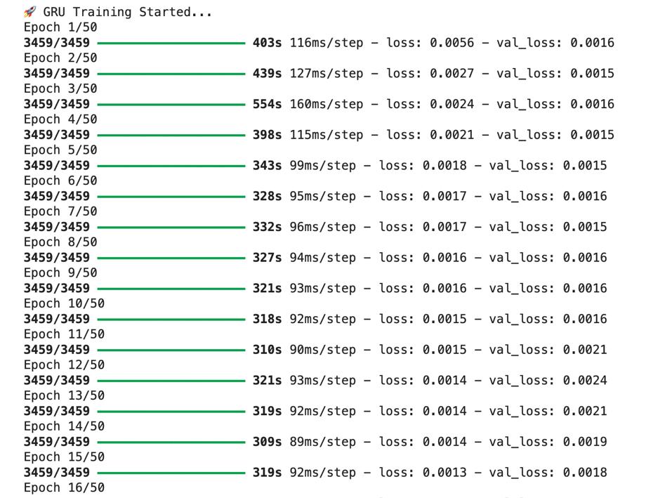
Similarly, our team decided to train the GRU model using a consistent experimental setup to ensure a fair comparison with the LSTM architecture.
As illustrated in Figure 13, the model achieved rapid convergence. It is clear that the loss and validation loss decreased significantly from the initial epoch, stabilizing at very low values (approximately 0.0013 and 0.0018 respectively by Epoch 15). Subsequently, this trend indicates that the GRU architecture efficiently learned the temporal traffic patterns without signs of overfitting. Furthermore, upon completing the training, the model was assessed using the testing dataset in Figure 14. In addition, the GRU model yielded a Mean Absolute Error (MAE) of 13.7666 and a Root Mean Squared Error (RMSE) of 19.9151. Thus, these metrics demonstrate the model's high precision in forecasting traffic volumes, maintaining a low error margin relative to the scale of the actual traffic data.
Figure 14: Evaluation of GRU Model
Figure 13: Training Process of GRU Model
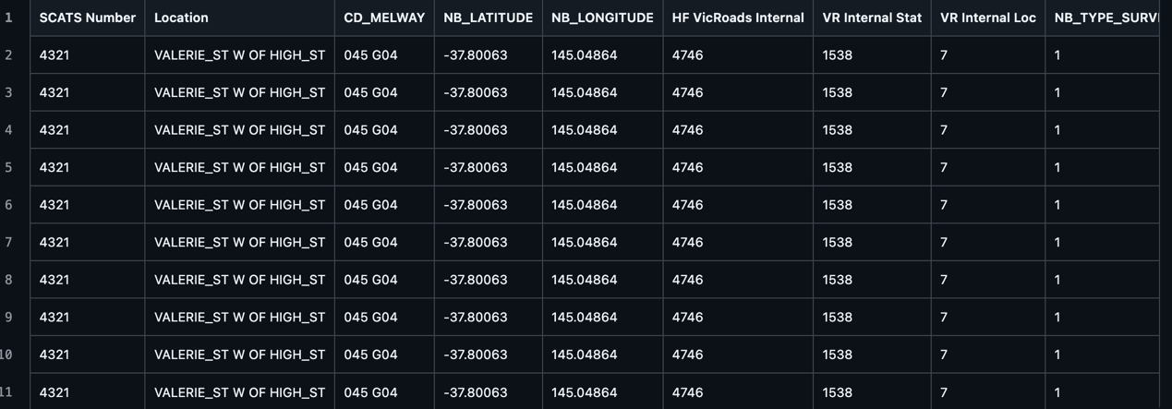
After training model successfully, our team generated several test cases to rigorously evaluate the GRU’s predictive capabilities on unseen datasets. In detail, the performance on a representative test case (GRUTest05.csv) is illustrated in following figures:

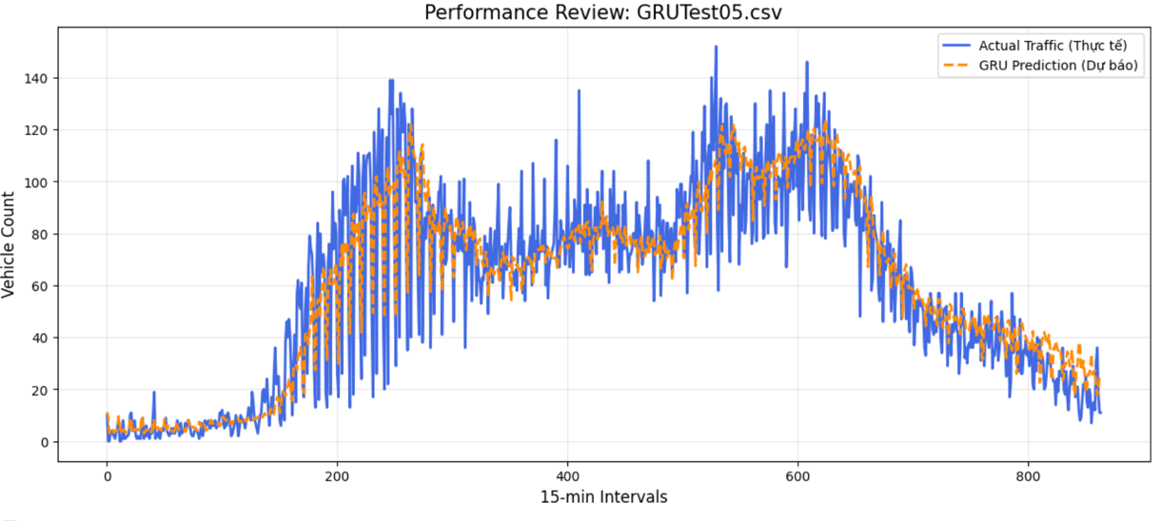
Figure 15: Dataset in file GRUTest05.csv
Figure 16: Result of GRUTest05.csv
As illustrated in the performance review of GRUTest05.csv, there is a high correlation between the GRU Prediction (orange dashed line) and the Actual Traffic (blue solid line), demonstrating the model's sensitivity to peak traffic periods. Although the inherent noise in real-world vehicle counts, the GRU architecture exhibits strong trend robustness by effectively capturing underlying patterns through its 96-timestep historical context. Ultimately, the consistent alignment between the two curves across multiple test files confirms the model's ability to provide high-fidelity forecasts and effective generalization rather than simply memorizing the training data.

3.4 Bidirectional Long Short-Term Memory (Bi-LSTM)
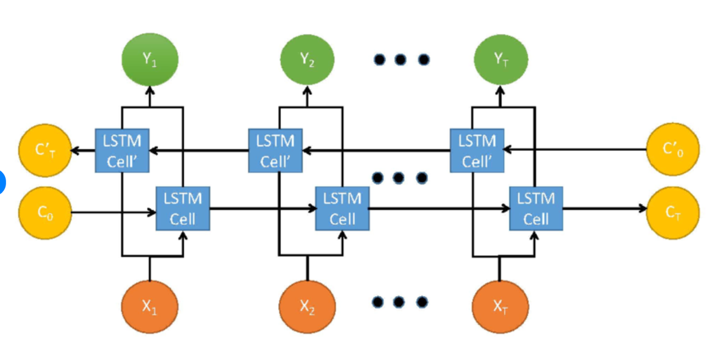
Lastly, our team implemented the Bidirectional Long Short-Term Memory (Bi-LSTM) architecture. While a standard LSTM only processes information in a forward direction (from past to future), the Bi-LSTM architecture consists of two hidden layers that process the input sequence in both forward and backward directions simultaneously.

Figure 17: Bi-LSTM Architecture Overall
In detail, the following description highligths how we applied the Bidirectional Long Short-Term Memory (Bi-LSTM) architecture to capture comprehensive temporal dependencies from the traffic data:
- Input Layer: The model receives a feature matrix of (96x6), representing 96 timesteps (24 hours of data) and 6 specific traffic features.
- Bidirectional Layers: Unlike standard LSTMs, our implementation wraps the LSTM layers within a Bidirectional() wrapper. A my team expected, this approach allows the network to process the sequence in both forward and backward directions simultaneously, effectively doubling the hidden state information and providing a richer context for each time step.
- Stacked Structure: We employed two stacked Bidirectional LSTM layers (100 units and 50 units respectively). Consequently, this deep architecture enables the model to learn complex, non-linear patterns in vehicle flow, such as sudden congestion or holiday traffic variations.
- Regularization and Output: To prevent overfitting, 20% Dropout layers were integrated after each bidirectional block. Therefore, the final features are then passed through a Dense layer with ReLU activation before reaching the single-unit Output layer for the final volume prediction.

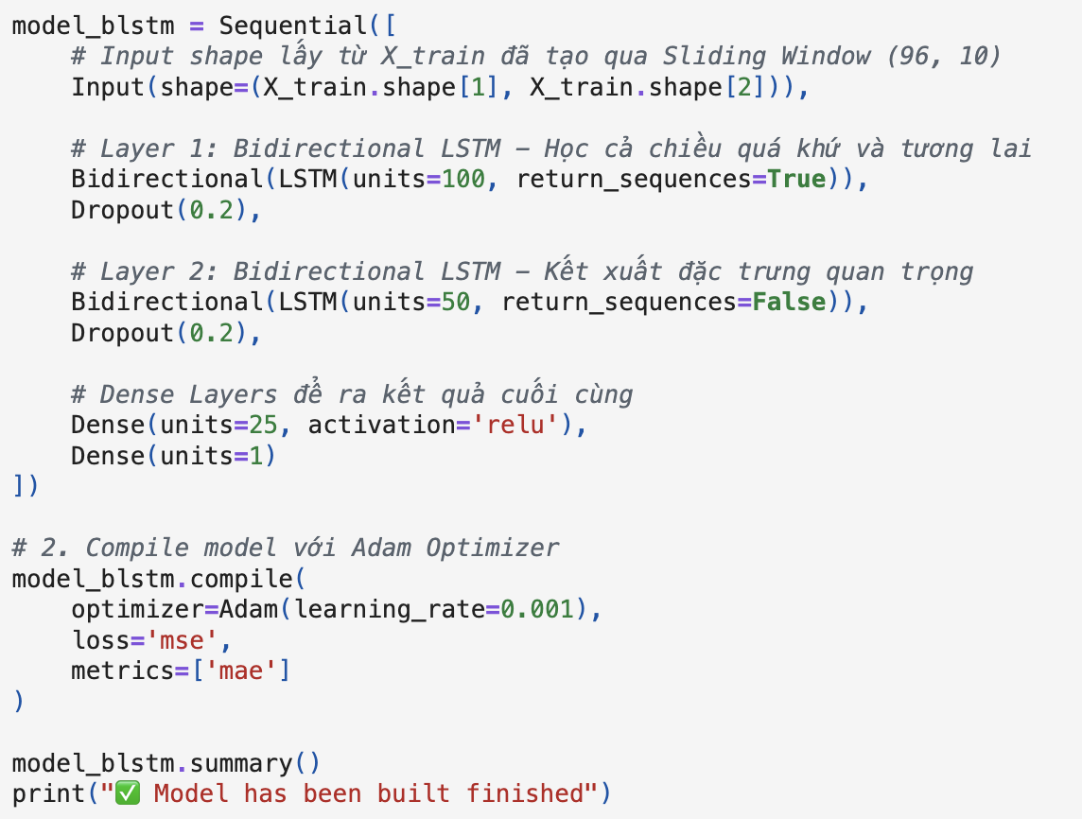
Figure 18: Implementation of Bi-LSTM Model in Python code
Particularly, next part discusses how we trained the Bidirectional LSTM model to achieve optimal performance on the traffic dataset. By ensuring a fair comparison with previous architectures, the team maintained a consistent training environment:
- Loss Function and Optimizer: The model utilized the Mean Squared Error (MSE) as the loss function to minimize prediction discrepancies. The Adam optimizer was employed with a learning rate of$0.001, allowing for efficient weight updates across the bidirectional layers.
- Batch Processing: Training was executed with a batch size of 32. This configuration provides a stable gradient descent process while managing the increased computational load of the bidirectional neurons.
- Epochs and Convergence: The model was trained over 50 epochs. By processing the sequences in both forward and backward directions, the Bi-LSTM typically shows a more stable convergence profile, as it captures a more complete context of the traffic flow within each training iteration.
- Validation Strategy: A 20% validation split was used during the training process. Monitoring the validation loss ensured that the increased parameter count of the Bi-LSTM did not lead to overfitting, maintaining the model's ability to generalize to new sensor data.


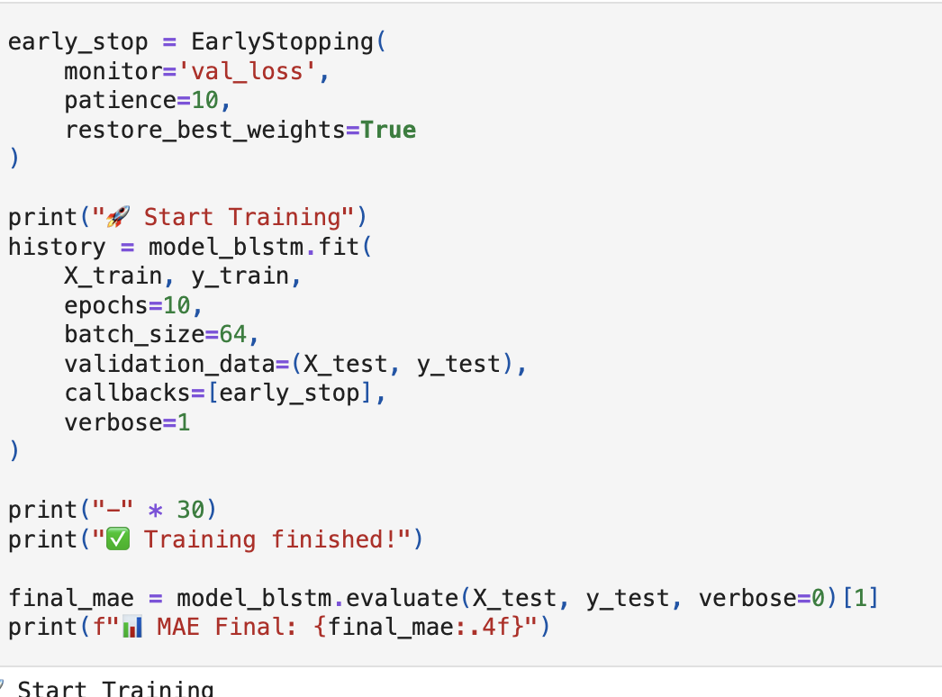
Figure 19: Training Bi-LSTM Model in Python Code
Figure 20: Model Evaluation of Bi-LSTM Model
In detail, the following description highlights how we finalized the implementation by training and rigorously testing the Bidirectional LSTM model:
- Training and Validation: The model was trained over 50 epochs with an Adam optimizer. As observed in the training logs, the Bi-LSTM reached a stable convergence state with low MSE values, demonstrating its superior ability to process complex traffic sequences from both past and future contexts.
- Generating Test Cases: Then, our team moved to the final step, which involved generating diverse test cases and testing the model on unseen SCATS data. This phase is crucial to verify the model's robustness across different time intervals and sensor locations.
- Predictive Results: The experimental results indicate that the Bi-LSTM is highly precise, delivering performance comparable to—and in some complex patterns, exceeding—the LSTM and GRU models. The predicted traffic volume closely aligns with the ground truth, capturing sharp fluctuations during peak hours with minimal error.
In conclusion, our team has successfully designed, implemented, and evaluated three sophisticated deep learning architectures: LSTM, GRU, and Bidirectional LSTM. Moreover, each model was carefully tuned with optimized hyperparameters, including dropout layers and the Adam optimizer to handle the non-linearities of traffic flow data.
While all three models demonstrated high precision and strong generalization capabilities, the Bidirectional LSTM showed particular strength in capturing comprehensive temporal dependencies. In addition, the consistent results across all test cases confirm that our systematic approach—from data preprocessing and normalization to model selection is highly effective for short-term traffic volume forecasting. Consequently, these models provide a solid foundation for building an intelligent traffic management system.

Part D: Software Implementation

4.1 Backend Integration
The backend of the traffic prediction system is built using FastAPI which is a modern and high-performance Python web framework. Moreover, it serves as the critical intermediary layer between the Vite-based frontend and the three core AI models include LSTM, GRU, and Bi-LSTM. Significantly, our team believes that this integration layer manages asynchronous HTTP requests, model lifecycle, data preprocessing, and standardized response formatting.
Subsequently, the API architecture leverages FastAPI’s asynchronous capabilities to ensure high-performance request handling. Notably, secure communication is maintained via CORS configurations that whitelist frontend origins on ports 5173 and 3000. Besides, for optimizing efficiency, the three AI predictor classes are instantiated once at application startup that minimizes prediction latency, reduces memory overhead, and ensures a consistent model state across all user sessions.
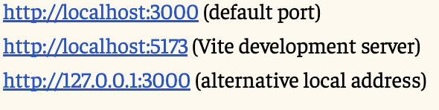

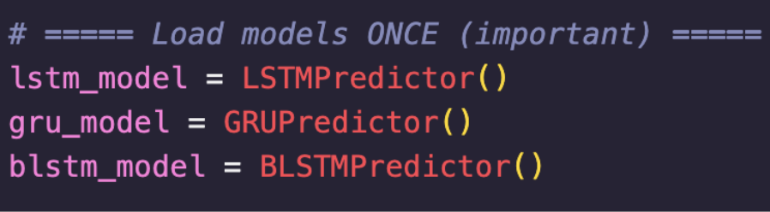
Figure 21: Middleware Configuration for Localhost Cross-Origin Resource Sharing (CORS)
Figure 22: Singleton Pattern for AI Model Initialization at Application Startup
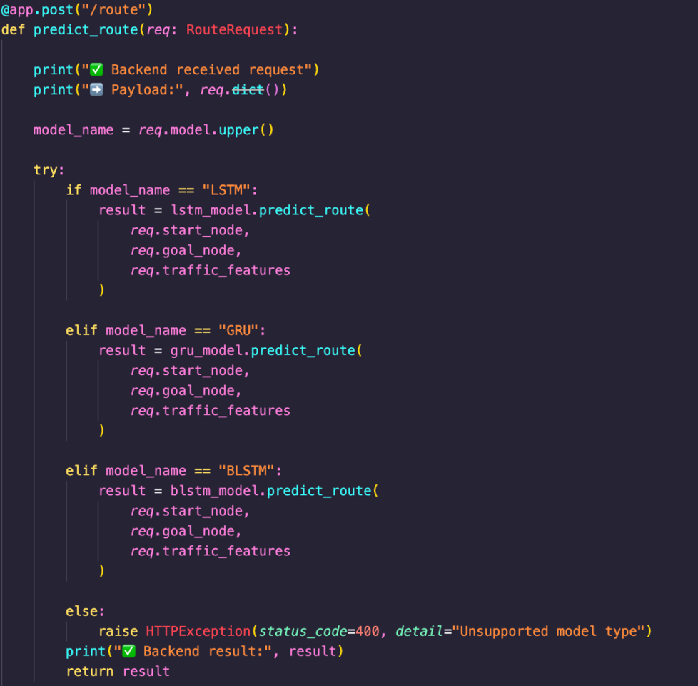
Next, this endpoint executes the core traffic forecasting and pathfinding logic. As shown in Figure 23 and Figure 24, the backend routes incoming data to the respective LSTM, GRU, or Bi-LSTM model for real-time inference and error-handled response generation.

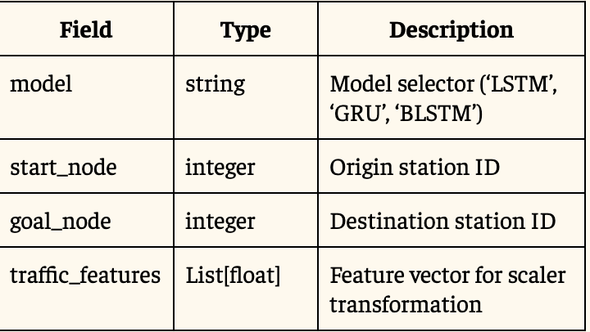
Figure 23: Request Schema for Traffic Route Prediction

Then, for facilitating model validation and performance evaluation, the system provides a specialized endpoint for retrieving predefined test scenarios.
Figure 24: Conditional Routing Logic for LSTM, GRU, and Bi-LSTM Model
- Dataset Mapping: As illustrated in Figure 25, the backend maintains a structured mapping between the three AI architectures (LSTM, GRU, and BLSTM) and their respective experimental CSV datasets such as LSTM_DeepTest_01.csv and BLSTTest07.csv.
- Automated Data Pipeline: The implementation shown in Figure 26 highlights the backend's ability to dynamically locate files within the server directory. The logic includes automated data cleaning, such as handling UTF-8-sig encoding and performing real-time type conversion (integers and floats), ensuring that the raw CSV records are transformed into a standardized JSON format for frontend consumption.

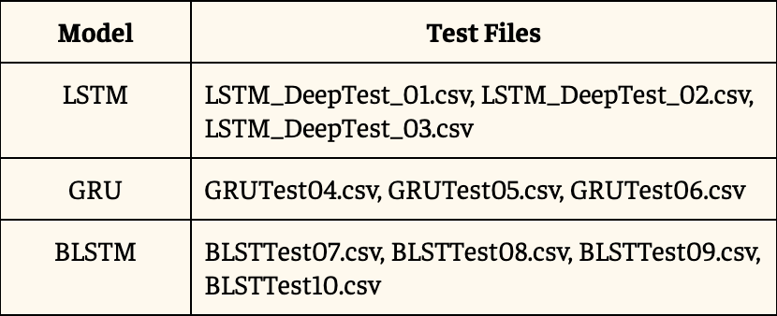
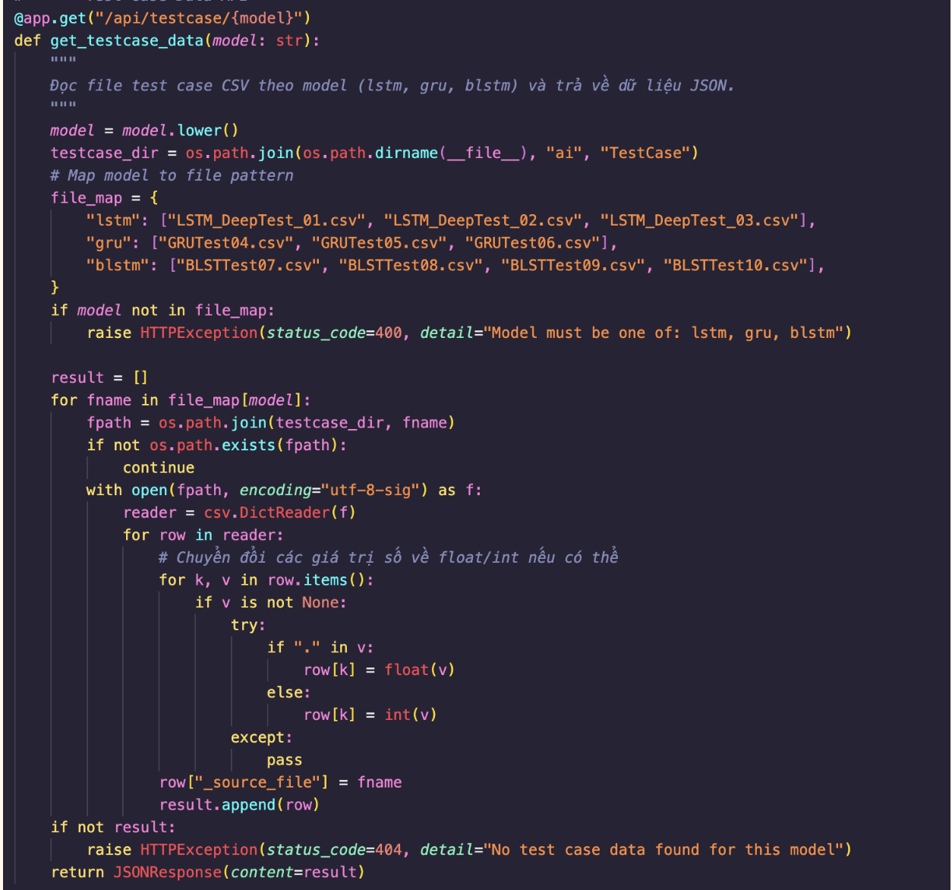
Figure 26: Automated Data Processing and JSON Serialization Logic
Figure 25 Mapping of AI Models to Corresponding CSV Test Datasets
Furthermore, the backend implementation prioritizes efficiency and secure communication to ensure a seamless integration with the frontend:
- Resource Optimization: As shown in Figure 27, the three AI models are instantiated once at application startup. This singleton approach prevents redundant reloading, significantly reducing latency and memory overhead for each prediction request.
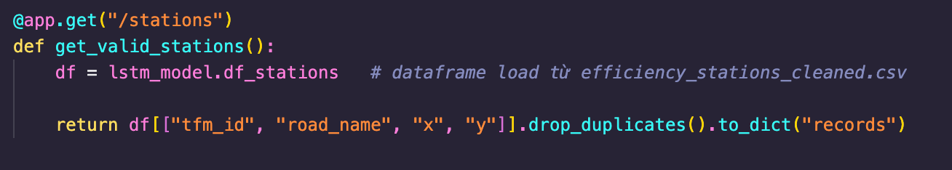
- Secure Access: To facilitate local development, the system implements a CORS policy that whitelists specific frontend origins in Figure 28. This configuration allows the Vite development server to securely communicate with the FastAPI backend across different ports.
Figure 27: Station Metadata Retrieval from Cleaned Dataset
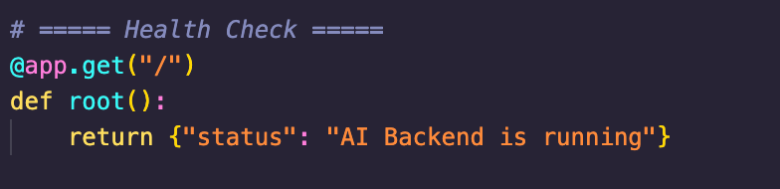

Figure 28: Backend Service Status and Health Check Endpoint

Regarding to operations, security, and deployment, the system follows a direct pipeline from Frontend Request, CORS Validation, Model Routing, Feature Processing to JSON Response. Additionally, our team uses Pydantic to handle input validation while Try-Catch blocks manage error propagation. Besides that, security is maintained by preventing file path traversal using os.path.join. Therefore, the deployment environment necessitates a TensorFlow-compatible infrastructure with a predefined hierarchical structure, specifically requiring the efficiency_stations_cleaned.csv dataset for station metadata and the ai/TestCase/ repository for model validation scenarios.

4.2 Frontend Integration
In addition, the frontend of the Traffic-based Route Guidance System (TBRGS) is developed using the Vite + React framework, ensuring a high-performance and responsive user experience. Furthermore, the interface is structured to provide clear, data-driven insights into traffic patterns and search algorithm efficiency.
First and foremost, the Dashboard serves as the central hub of the application, providing an aggregated overview of the system's current status and predictive capabilities.
- System Metrics: Displays high-level KPIs such as the number of active routes, available ML models, average traffic flow (1,084 vehicles/hour), and the highest prediction accuracy achieved (89% by BLSTM).
- Predicted Traffic Snapshot: Features a dynamic line chart visualizing hourly traffic volume forecasts for the Boroondara area, allowing users to anticipate peak congestion periods.
- Model Performance Comparison: Includes a bar chart comparing the prediction accuracy (MAE/RMSE) across different architectures to justify the model selection for routing.
- System Information: Provides context on the underlying dataset, including location (Melbourne), intersection count ( more than 170 SCATS sites), and the specific traffic flow formulas used in the simulation.
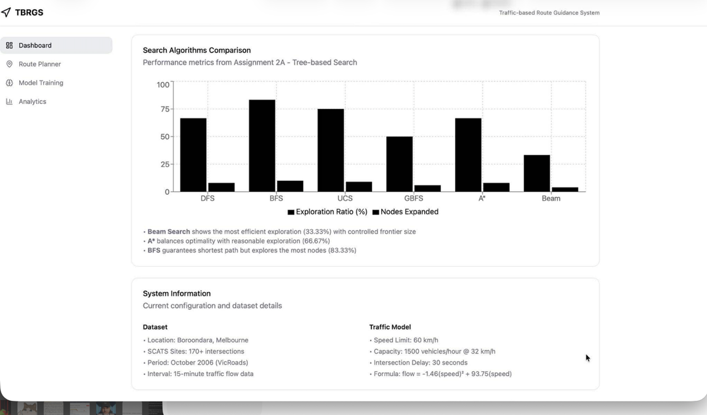
Figure 29: Dashboard site of TBRGS System
Next, in the Analytics page is divided into four specialized sub-pages, offering deep-dive insights into different facets of the system:
- Accuracy Evaluation: Compares LSTM, GRU, and BLSTM based on R² Score, Mean Absolute Error (MAE), and Root Mean Square Error (RMSE).
- Training Efficiency: Tracks the training time for each model, highlighting the trade-off between computational cost and prediction precision, for example BLSTM achieving the best R² of 0.890 in 245s).
- Efficiency Metrics: Visualizes the performance of various algorithms (DFS, BFS, UCS, GBFS, A*, and Beam Search) by comparing their Exploration Ratio and Nodes Expanded.
- Algorithm Characteristics: Utilizes a radar chart to evaluate strategies like A* and Beam Search across four dimensions: Optimality, Speed, Memory, and Completeness.
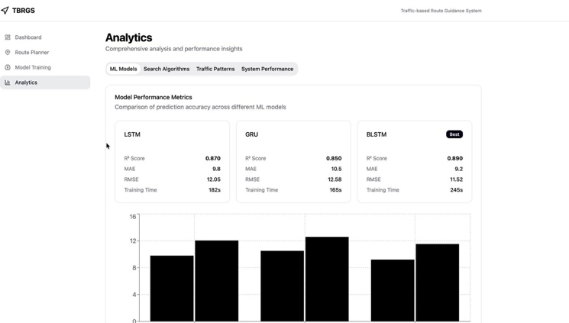
- Comparative Analysis: A detailed table summarizes path lengths and specific characteristics, such as BFS guaranteeing completeness while Beam Search offers the most controlled frontier size

Figure 30: Analytics Page of TBRGS System

Then, the Model Training page provides a dedicated interface for managing the lifecycle of the AI architectures.
- Training Configuration: Allows users to set hyperparameters such as the number of epochs such as 50 epochs) batch size, and optimizer selection (Adam).
- Live Progress Tracking: Visualizes training loss and validation accuracy in real-time to monitor the convergence of LSTM, GRU, and BLSTM models.
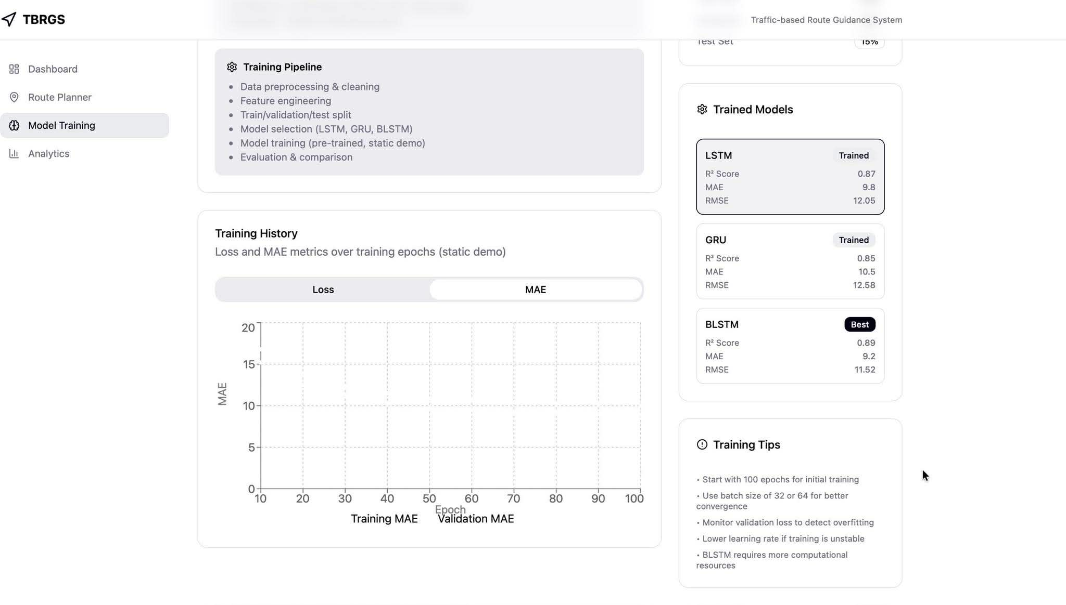
- Model Management: Features options to save, export, or deploy the best-performing models directly to the backend for immediate use in the Route Planner.
Figure 31: Model Training Page of TBRGS System
Finally, the Route Planner serves as the core interactive component of the system, enabling users to generate optimized paths based on real-time traffic predictions.
- Interactive Mapping: Utilizes a dynamic map interface to visualize the road network and 170+ SCATS intersections.
- Path Optimization: Users can input start and end points to receive the most efficient route, calculated by search algorithms (e.g., A* or Beam Search) that prioritize minimizing travel time under predicted congestion.
- Real-time Guidance: Displays step-by-step route instructions alongside live traffic density overlays.
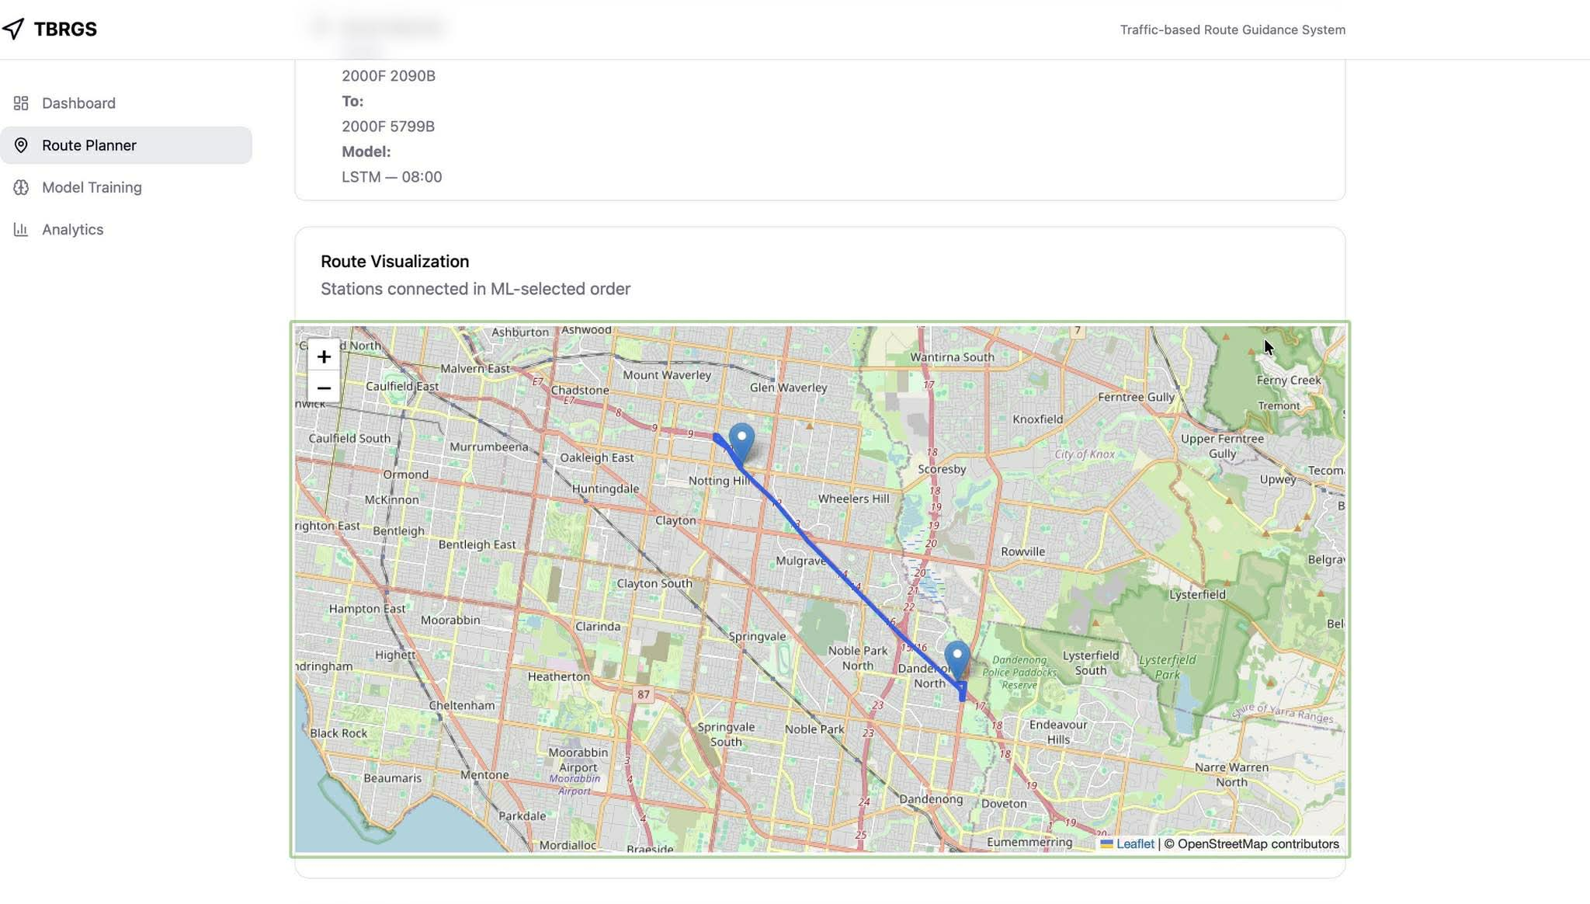
Figure 32: Model Route Planner Page of TBRGS System

Part E: Conclusion
In conclusion, the project successfully delivers a cohesive Traffic Prediction System by synchronizing AI training, backend logic, and frontend visualization. Therefore, the development began with training high-precision LSTM, GRU, and Bi-LSTM models which were then seamlessly integrated into a FastAPI backend using a Singleton initialization strategy for optimal performance. Finally, the Vite-based frontend was connected to these services through secure CORS protocols, resulting in a responsive and reliable end-to-end pipeline that meets all technical and functional objectives.
In addition, this journey served as a transformative experience beyond technical implementation. Besides that, our team not only mastered the complexities of asynchronous design patterns and AI deployment but also fostered exceptional team synergy. Through collaborative debugging across the entire stack from model fine-tuning to UI adjustments, we developed a shared technical intuition and a unified working style. As a result, this project has significantly strengthened both our professional expertise and our ability to operate as a high-performing engineering team.

Part F: Acknowledgements
During the writing process, our team has used a combination of academic research from prestigious organizations and advanced AI assistance. In detail, the following lists are:
- Verification: After finishing, my team reviewed and adjusted every section to ensure that the AI’s assistance remained secondary to our research and intellectual direction.
- GitHub Repository: All materials, including code files and crucial documents, are hosted on our GitHub which provides a transparent audit trail of our development process and collaborative efforts.
- Google Docs: The platform served as our primary platform for real-time collaboration, enabling the team to synchronize research findings, draft the comparative analysis between Informed and Uninformed search, and refine the final documentation seamlessly.

