COS20007

Object-Oriented Programming

Truong Ngoc Gia Hieu

105565520

Learning Summary Report

# Part A: Self-Assessment Details

This session aims to provide a stunning chance for personal reflection on previous tasks and growth during the couse. Notably, by enrolling in this fascinating course, I can evaluate my own performance, attitude, gain my strengths, and fields which I need to improve them. Consequently, this learning summary report not only allows me to foster self-awareness but also encourages accountability for strong actions and desired outcomes. In summary, the meaningful report offers me a great opportunity to look back what are my strengths and weaknesses to enhance for my academic performance in next courses and future career.

**Appendix I: Completed Tasks and Tutos’s Feedbacks**

* 1. 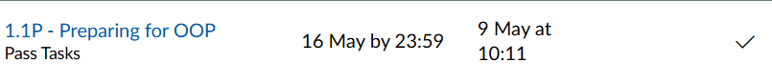**Week_01 (Task 1.1P and 1.2P)**

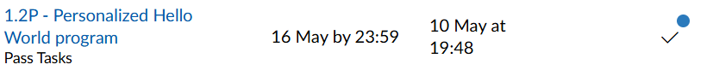

* 1. **Week_02 (Task 2.1P, 2.2P, 2.3P, and 2.4P)**

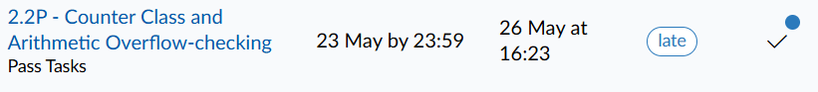

* 1. 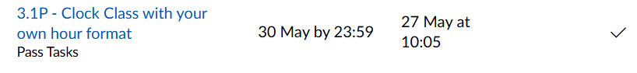**Week_03 (Task 3.1P, 3.2P, and 3.3P)**

* 1. A close-up of a sign

     AI-generated content may be incorrect.A black text on a white background

     AI-generated content may be incorrect.A white background with black text

     AI-generated content may be incorrect.A black and white text

     AI-generated content may be incorrect.**Week_04 (Task 4.1P and 4.2P)**
  2. 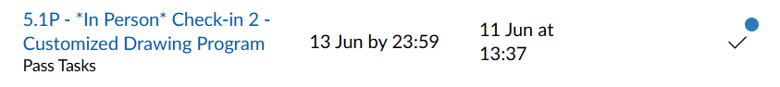**Week_05 (Task 5.1P, 5.2P, and 5.3C)**

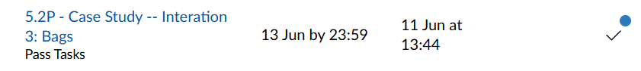

* 1. A close up of a number

     AI-generated content may be incorrect.A white background with black dots

     AI-generated content may be incorrect.A black and white text

     AI-generated content may be incorrect.**Week_06 (Task 6.1P, 6.2P, 6.3D, and 6.5HD)**

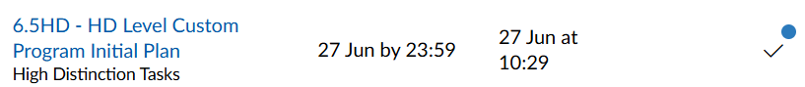

* 1. A close up of a number

     AI-generated content may be incorrect.**Week_07 (Task 7.1P and 7.2C)**

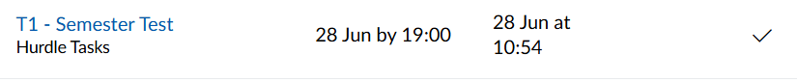  
  
  
  
  
  
**1.8 Week_08 (Test)**

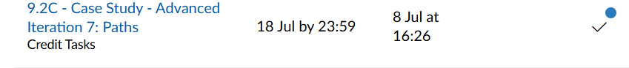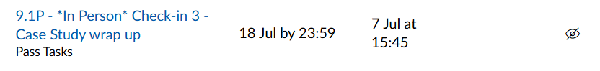**1.9 Week_09 (Task 9.1P and 9.2C)**

**Appendix II: Summary of Task Corrections**

Based on the tutor’s feedback on each specific tasks, I revise and update my code which adapt requirements. Therefore, during code revising phase, I frequent compare the previous code with updated code to figure out what funtions, methods, anad attributes that I had missed. However, due to busy learning schedule, I cannot submit the updated code while I have already upgraded them. Notably, tutor’s feedbacks allow me to not only know what requirements that I have missed but also greatc chances for me to learn new knowledge/ In summary, I ensure that task submissions from previous weeks up to Week 12 still remains unchanged, highlighting clarity and transparency regading the status of each task and commiment to continuous improvement.

**Appendix III: Uploaded Task Submission in PDF Format**

**Appendix IV: Source Code for Task Submissions in Compressed Zip format**

Based on the descriptions in the template. I decided to press on code files at the beginning of the course until right now into four .zip files including ***Drawing_Shape.zip, Preparation_Hello_Word_Clock.zip, SwinAdventure.zip, Custom_Program_Code.zip, Clock_own_project.zip,*** and ***SwinAdventureTest.zip***. Firstly, the ***‘Drawing_Shape.zip’*** file contains all code files for task submission related to Shape Drawing. Secondly, ***‘Preparation_Hello_World_Clock.zip’*** includes all source code for the Hello World program, The Counter, Clock projects, and Preparation at the beginning of the course. Thirdly, ***‘SwinAdventure.zip’*** holds code implementations in the SwinAdventure game. Then, the ‘***Custom_Program_Code.zip’*** provides code for custom program which aims for D (Distinct) level***.*** Next, the ***‘SwinAdventureTest.zip***’ include all the C# source code (.cs files) and test case implementations in my task submissions. Finally, the ***‘Clock_own_project.zip’*** uses another language (Python) to code.

Self-Assessment Statement

|  |  |  |  |  |
| --- | --- | --- | --- | --- |
|  | Pass (D) | Credit (C) | Distinction (B) | High Distinction (A) |
| Self-Assessment | 🗹 | 🗹 | 🗹 |  |

Minimum Pass Checklist

|  |  |
| --- | --- |
|  | Included |
| Learning Summary Report | 🗹 |
| Test is Complete | 🗹 |
| C# programs that demonstrate coverage of core concepts | 🗹 |
| Explanation of OO principles | 🗹 |
| All Pass Tasks are Complete | 🗹 |

Minimum Credit Checklist (in addition to Pass Checklist)

|  |  |
| --- | --- |
|  | Included |
| All Credit Tasks are Complete | 🗹 |

Minimum Distinction Checklist (in addition to Credit Checklist)

|  |  |
| --- | --- |
|  | Included |
| Custom program meets Distinction criteria & Interview booked | 🗹 |
| Design report has UML diagrams and screenshots of program | 🗹 |

# Declaration

I declare that this portfolio is my individual work. I have not copied from any other student’s work or from any other source except where due acknowledgment is made explicitly in the text, nor has any part of this submission been written for me by another person. Failure to meet this requirement will result in a failing grade for the unit.

Failure to provide the source code for any task submission will result in that task not being assessed, even if the task is included in PDF format.

Signature:

# Portfolio Overview

This portfolio includes work that demonstrates that I have achieve all Unit Learning Outcomes for COS20007 Unit Title to a **Distinction** level

In this comprehensive unit, I have immersed myself in each lectures to obtain valuable knowledges about the object-oriented programming field, specifically four distinct principles includin Encapsulation, Abstraction, Polymorphism, and Inheritance. Furthermore, throughout weekly exercises, I not only have a deep understanding of strong concepts but also the practical applications in the real world. Based on criterias on the Distinction (D) level, I decided to implement these Object-Oriented Programming (OOP) principles into my custom program named Tetris Game. Although the complexity of intergrating all four principles are challenging and require lots of efforts and contributions, I believe that this hands-on custom program is suitable for me as beginner to dive into the object-oriented field which allows me to apply my understanding of these principles to provide clear code, clear UML design, and well-structured.

In order to achieve the Distinction grade, I decide to focus on applying all Unit Learning Outcomes to complete required tasks and integrate all previous four principles in my custom program:

* **Modular Design**: A structured boardgame foundation 20 x 10 (20 rows and 10 columns) and clear UI elements for the game interface.
* **Hierarchical Block System (Inheritance)**: In the Tetris Game, there are seven different block types such as Z, J, L, O, S, T, and I which will be seven classes in the program respectively. Notably, these block classes derive from a comma base Block class (Block.cs).
* **Friendly UI Design and Core Mechanics**: In the game, there are some specific functions including “Hold”, “Next”, and a real-time ‘Score’ display during the game. Furthermore, the “Hold” block will be on the left side of the boardgame while   
  Next” is displayed on the right side. Finally, the ‘Score:” is shown on the top of the boardgame.
* **Game Flow and State Management**; The game starts with dropping blocks from top of the boardgame, then if a row is full, the score will increase precisely based on the updated gamestate. Then, player will play until the block reaches top. After that, the finish screen will dsiplay for asking that player want to play again or not.
* **Player Control**: Players control blocks intuitively using keyboard directional inputs for movement and space for rotation, demonstrating robust **Encapsulation** within the block and game state logic.

In conclusion, based on my previous explainations and descriptions, my custom program (project) strongly showcase my application of four principles of OOP and Unit Learning Outcomes to create a complex program, detailed UML Design, and well-structured program that adapt the requirements of Distinction (D) level.

# Task Summary

To demonstrate my learning in this unit, I would like the following tasks to be considered part of my portfolio:

* Week_1 (Task 1.1P and 1.2P)
* Week_2 (Task 2.1P, 2.2P, 2.3P and 2.4P)
* Week_3 (Task 3.1P, 3.2P, and 3.3P)
* Week_4 (Task 4.1P and 4.2P)
* Week_5 (Task 5.1P, 5.2P, and 5.3C)
* Week_6 (Task 6.1P, 6.2P, 6.3D, 6.4D, and 6.5HD)
* Week_7 (Task 7.1P and 7.2C)
* Week_8 (Semester Test – T1)
* Week_9 (Task 9.1P and 9.2C)
* Week_10 (Task 10.1C)
* Week-11 (Task 11.1P)
* Custom Program (D level)