
SWINBURNE UNIVERSITY OF TECHNOLOGY
DATA AND STRUCTURE

Unit Code: Computing Technology Project A (COS40005)
Project: Internal Assistant for Enterprise Knowledge (Slack chatbot with RAG)
Client: Katalon, Inc. (replacing the original VIB client)
Team: Group 7
Prepared by: Truong Ngoc Gia Hieu (Project Manager)
Version: v1.1 (Draft for discussion)
Date: 11TH Nov, 2026

Table of Contents

A. Purpose of the Document 3
B. Question 1: Real Data for the Knowledge Base 3
2.1 Why the suggested “test data” lists do not fit 3
2.2 Recommended real sources 3
2.3 Why Katalon is easier than the original VIB brief 4
2.4 Using real edit history to test freshness 4
C. Question 2: Slack Structure and Channels 5
3.1 What Katalon has published 5
3.2 What is not public 5
3.3 Industry reference (not Katalon-specific) 5
3.4 Impact on the design 5
D. Question 3: Confluence and S3 Structure 5
4.1 Public evidence that Katalon uses Confluence 5
4.2 What is still unknown 6
4.3 S3 structure (provided by the client) 6
4.4 Implications for the team’s pipeline 7
E. Consolidated Questions for the Client 8
F. Summary and Next Steps 9
References 10

A. Purpose of the Document
This document summarises the research Group 7 has completed so far for the Katalon internal-knowledge Slack assistant. It answers three questions the team needs settled before building the test environment:
- Data: which real (not mock or AI-generated) documents can fill the test Confluence site?
- Slack structure: how does Katalon organise Slack, and how many channels are there?
- Confluence (and S3) structure: how is Katalon’s knowledge organised, and what is still unknown?
For each question the document separates what is evidenced (with a citation), what is not public, and what must be asked of the client. Section E combines all open questions into one message for the client mentor, Mr. Phạm Tiến Thuận Phát. It complements the environment documents (Group 7, 2026a, 2026b).

B. Question 1: Real Data for the Knowledge Base

2.1 Why the suggested “test data” lists do not fit
Lists of public datasets for Katalon Studio (for example, the CURA demo site, weather and astronomy APIs, Kaggle and government CSV files) serve a different purpose: they are inputs for automated software testing with Katalon’s product. This project instead needs written internal-knowledge pages (policies, processes, product documentation) that employees ask questions about. Tabular or API data does not resemble Confluence content, so it cannot measure answer accuracy or freshness.

2.2 Recommended real sources
The sources below are real documents written by real companies and published openly. They are mapped to the Confluence spaces the client shared (Figure 1).
Target space | Real source | Why it fits | Licence / condition
Deal Desk | GitLab Handbook – Deal Desk | A real deal-desk team that streamlines opportunity management and is the first point of contact for sales support (GitLab, n.d.-a) | Creative Commons; free to copy and use with attribution (GitLab, 2016)
Partner Program | GitLab Channel Partner Program handbook | The primary handbook page for prospective and existing channel partners, with program guide and deal registration (GitLab, n.d.-b) | Creative Commons, attribution (GitLab, 2016)
Intranet / HR | GitLab Handbook (people policies) and 37signals Employee Handbook | Real policies and benefits; the GitLab handbook alone exceeds 2,000 printed pages (GitLab, n.d.-c) | 37signals policies are licensed under Creative Commons Attribution (Basecamp, n.d.)
True Platform | Katalon Docs (including legacy release notes) | Katalon’s own real, partly outdated product documentation (Katalon, n.d.-a) | Restricted: documentation use is limited to a reasonable number of copies (Katalon, n.d.-b); use a small excerpt and ask the client
(Reference only) | Apache Software Foundation Confluence (cwiki.apache.org) | A live Confluence instance showing real space and page hierarchies | Apache License 2.0 (Apache Software Foundation, 2025)

Table 1. Real data sources mapped to the Katalon spaces
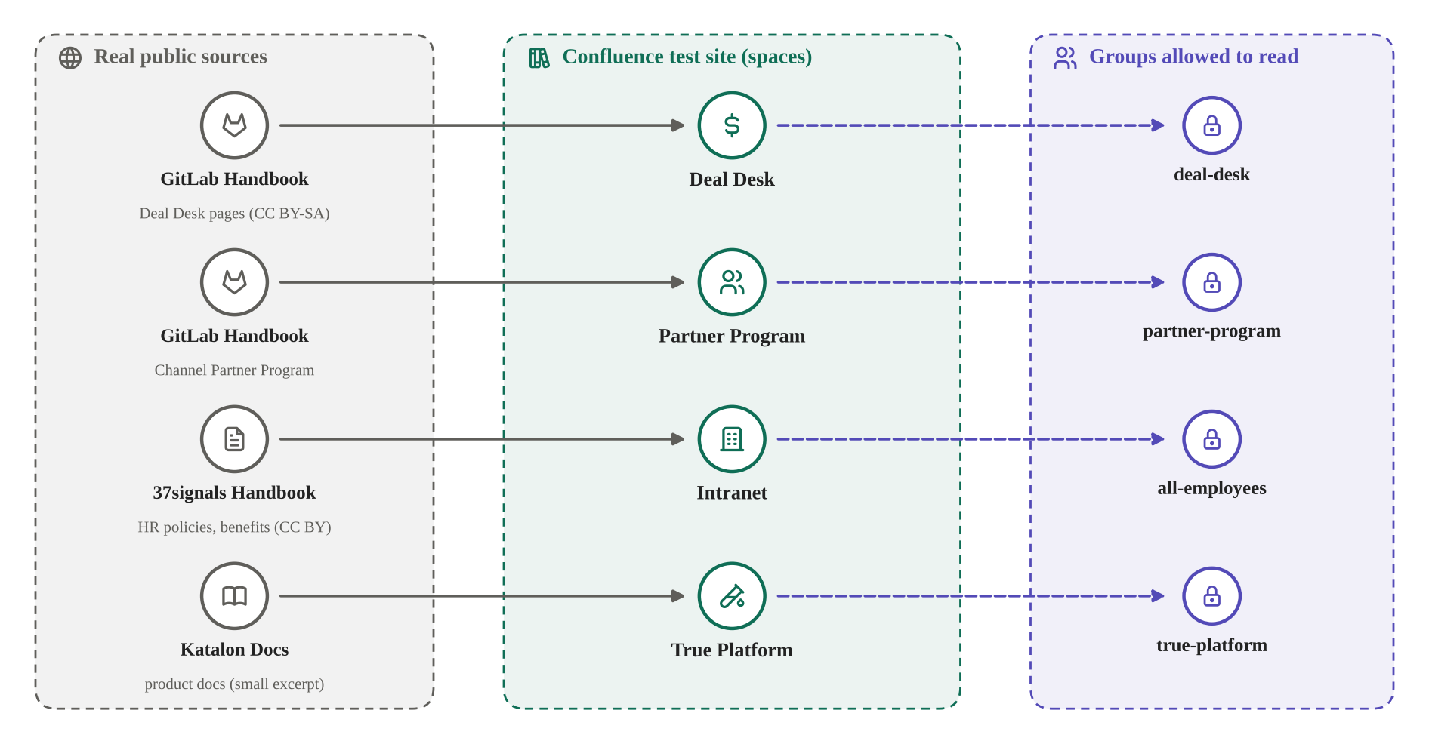
Figure 1. How real public sources fill the test Confluence spaces and which groups may read them

2.3 Why Katalon is easier than the original VIB brief
- Industry openness: software companies routinely publish documentation, and some (GitLab, 37signals) publish whole internal handbooks, so realistic material of the same kind exists.
- Banking confidentiality: a bank’s internal procedures and customer data are not released to external teams, and no bank publishes an internal handbook that could be borrowed.
- Known structure: the client has already shared Katalon’s real groups, page IDs and spaces, so the team knows exactly what to reproduce.

2.4 Using real edit history to test freshness
The GitLab Handbook is maintained as a Git repository, so it carries years of real edit history. The team can replay real commits (for example, a policy that changed) into the test Confluence site and measure how quickly the bot’s answer changes. This gives the freshness criterion (30%) evidence based on real changes instead of invented ones. All reused content must be attributed in the final report.

C. Question 2: Slack Structure and Channels

3.1 What Katalon has published
Katalon source | What it shows
Katalon Docs – Slack integration with Katalon True | Katalon’s product sends notifications about test results to a specified Slack channel (Katalon, n.d.-c)
Katalon Docs – Slack plugin for Katalon Studio | The plugin supports both public and private channels (Katalon, n.d.-d); this describes how customers use Slack, not Katalon’s internal workspace
Katalon careers pages | Staff collaborate in Jira and Confluence (Katalon, n.d.-e); Slack is not mentioned
Katalon Community forum | Katalon stated there was no Slack group for Katalon users (Katalon Community, n.d.)
BuiltIn company profile | About 501 employees, headquartered in Atlanta (BuiltIn, n.d.)

3.2 What is not public
No Katalon document describes its internal Slack workspace: the number of channels, naming conventions, or whether one workspace or Enterprise Grid is used. This is internal information that companies rarely disclose, so it must come from the client.

3.3 Industry reference (not Katalon-specific)
If the report needs an illustrative structure, it should be labelled as industry practice. Slack’s own internal communications team describes company-wide announcement channels, channels for each department (for example #sales-announcements) and many small teams, plus an open #slack-ama channel where anyone can ask leaders questions (Slack, n.d.).

3.4 Impact on the design
The number of channels does not change the architecture. The bot receives questions by direct message or @mention, and access rights come from Confluence, not from Slack channels. The only design rule that depends on channels is that answers given inside a channel must be ephemeral (visible only to the asker). Slack Connect users from outside the company must be refused, like guests.

D. Question 3: Confluence and S3 Structure

4.1 Public evidence that Katalon uses Confluence
Evidence | What it shows
Archived Katalon documentation URL `docs.katalon.com/display/KD/Test+Integrations` (Wikipedia contributors, n.d.) | /display/<space key>/ is Confluence’s URL format: Katalon’s public docs once ran on Confluence with space key KD
Short link `docs.katalon.com/x/KQHR` in the official `katalon-recorder-samples` repository (Katalon, n.d.-f) | /x/… is Confluence’s tiny-link format, a second confirmation
Katalon job posts | Writers record documentation tasks in Jira and Confluence (Katalon, n.d.-e)
Material shared by the client | The current spaces (Intranet, Deal Desk, Partner Program, True Platform), groups and page IDs

4.2 What is still unknown
The number of spaces, how permissions are set (space level versus page restrictions), how groups are managed, page volume and update frequency are not public and must be confirmed by the client.

4.3 S3 structure (provided by the client)
The team has no access to Katalon’s Amazon S3, which is the correct practice for an external team, and access is not needed: in both environment options the team uses its own AWS account and bucket (Group 7, 2026a, 2026b). On 11 November 2026 the client shared the reference structure used for ingested Confluence pages, and confirmed that each folder holds the current version of its page (T. T. P. Phạm, personal communication, November 11, 2026). Figure 2 reproduces it.
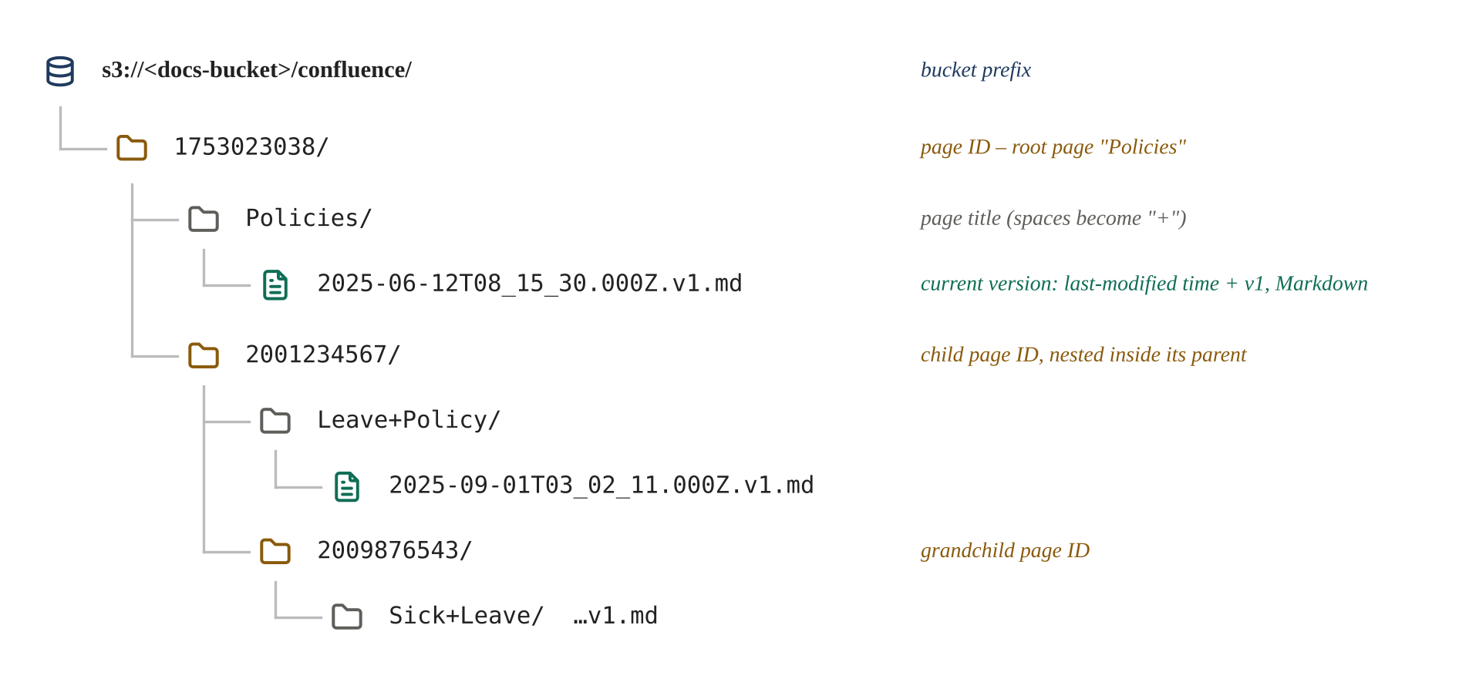
Figure 2. Reference S3 structure for ingested Confluence pages, as shared by the client
Element | Meaning | Use in the project
Page ID at the start of each folder | Identifies the Confluence page | Security: the permission filter works on page IDs
Child folders nested inside parent folders | The path encodes the page tree (ancestors) | Security: view restrictions on a parent page also apply to its child pages (Atlassian, n.d.), so ancestry matters
Title folder (spaces written as “+”) | Human-readable page title | Accuracy: readable source names in answers
File name = last-modified time + .v1.md | Only the current version is kept, in Markdown | Freshness: compare with the time in Confluence; Markdown keeps headings and lists for chunking

Table 2. How to read the S3 structure

4.4 Implications for the team’s pipeline
- Metadata sidecar files are needed. Bedrock reads filterable attributes from a file named after the document with .metadata.json appended, stored next to it (Amazon Web Services [AWS], n.d.-a). The shared structure shows no such file, so the team’s sync will write one per page, for example 2025-09-01T03_02_11.000Z.v1.md.metadata.json with page_id, ancestors, space_key, title, last_modified and allowed_groups.
- Renamed or moved pages change the path. Because the title and the parent chain are part of the key, a rename or move must delete the old folder before writing the new one; otherwise the bot may answer from duplicate or outdated content. This becomes a dedicated freshness test case.
- The space key is not in the path. It must be read from the Confluence API and stored in the metadata.
- Deep page trees create long keys. S3 object keys are limited to 1,024 bytes (AWS, n.d.-b), so the deepest page tree should be tested.

E. Consolidated Questions for the Client
The questions below can be sent to Mr. Phát as one message. Where a question is sensitive, an estimate or a yes/no answer is enough.
No | Question | Why the team needs it
S1 | One Slack workspace or Enterprise Grid (several workspaces)? | Shape of the Slack sandbox
S2 | About how many channels, and is there a naming convention (#team-, #proj-, #announce-)? | Realistic sandbox and channel tests
S3 | Do Slack user groups match Confluence groups (e.g. deal-desk in both)? | Extra cross-check of who the asker is
S4 | Is Slack Connect used with partners or customers? | External users must be refused like guests
C1 | Confluence Cloud or Data Center, and which plan? | Correct API; whether Atlassian Guard exists
C2 | Besides the four spaces shared, should any other space be included? Are personal spaces excluded? | Scope of the knowledge base
C3 | Are permissions mainly at space level, or are there many page restrictions? | Complexity of the permission layer
C4 | Are Confluence groups managed manually or synchronised from an identity provider through SCIM? | How users are matched across Slack and Confluence
C5 | Roughly how many pages per space, and how often are they updated? | Sync schedule and embedding cost (freshness)
C6 | Should attachments (PDF, Word, Excel) be answered from, or page text only? | Extraction work and cost
C7 | Should archived pages and drafts be excluded? | Scope of the knowledge base
B1 | Answered 11 Nov 2026 (Figure 2). Follow-up: what does “v1” mean – the Confluence version number or the export format version? | Correct freshness comparison
B2 | Format is Markdown (answered). Is there a .metadata.json file per page, and which fields? | Permission filter depends on metadata
B3 | What writes to the bucket, and how often? | Whether the team’s sync replaces or complements it
B4 | Is the bucket already a data source for a Bedrock knowledge base? | Alignment with Katalon’s current design
B5 | Could the team receive one or two redacted sample files or a sample metadata file? | Accurate test data format

Table 3. Open questions: S = Slack, C = Confluence, B = S3 bucket (B1 answered by the client)

F. Summary and Next Steps
Question | Answer so far | Next step
Data | Real, licensed sources are available for every space (Table 1) | Build a list of 30–50 pages with their space and group; confirm Katalon Docs use with the client
Slack structure | Not public; does not change the architecture | Send questions S1–S4
Confluence structure | Confluence use is evidenced; details are not public | Send questions C1–C7
S3 structure | Reference structure received from the client (Figure 2); metadata files still unknown | Send follow-up B1 and questions B2–B5

When the client answers, the team will update the Business Role Proposal (Section I) for its official version and the persona tables in both environment documents.

References
Amazon Web Services. (n.d.-a). Connect to Amazon S3 for your knowledge base. Amazon Bedrock User Guide. Retrieved November 11, 2026, from https://docs.aws.amazon.com/bedrock/latest/userguide/s3-data-source-connector.html
Amazon Web Services. (n.d.-b). Naming Amazon S3 objects. Amazon S3 User Guide. Retrieved November 11, 2026, from https://docs.aws.amazon.com/AmazonS3/latest/userguide/object-keys.html
Apache Software Foundation. (2025). Confluence wiki space for your project. https://infra.apache.org/cwiki.html
Atlassian. (n.d.). What are page restrictions? Confluence Cloud Support. Retrieved November 11, 2026, from https://support.atlassian.com/confluence-cloud/docs/what-are-page-restrictions/
Basecamp. (n.d.). All Basecamp policies are now on GitHub and licensed under Creative Commons. Signal v. Noise. Retrieved November 11, 2026, from https://m.signalvnoise.com/all-basecamp-policies-are-now-on-github-and-licensed-under-creative-commons/
BuiltIn. (n.d.). Katalon: Product designer [Company profile and job listing]. Retrieved November 11, 2026, from https://builtin.com/job/product-designer/7484540
GitLab. (2016, July 12). Our handbook is open source: Here’s why. GitLab Blog. https://about.gitlab.com/blog/our-handbook-is-open-source-heres-why/
GitLab. (n.d.-a). Deal Desk handbook. Retrieved November 11, 2026, from https://handbook.gitlab.com/handbook/sales/field-operations/sales-operations/deal-desk/
GitLab. (n.d.-b). GitLab channel partner program. Retrieved November 11, 2026, from https://handbook.gitlab.com/handbook/resellers/
GitLab. (n.d.-c). The handbook. Retrieved November 11, 2026, from https://handbook.gitlab.com/handbook/
Group 7. (2026a). Environment option 1: Zero-cost environment (Version 1.0, draft) [Unpublished project document]. COS40005 Computing Technology Project A, Swinburne University of Technology.
Group 7. (2026b). Environment option 2: Low-cost, closer-to-production environment (Version 1.0, draft) [Unpublished project document]. COS40005 Computing Technology Project A, Swinburne University of Technology.
Katalon. (n.d.-a). Release notes: Katalon TruePlatform legacy. Katalon Docs. Retrieved November 11, 2026, from https://docs.katalon.com/katalon-platform/release-notes/katalon-testops-release-notes-legacy
Katalon. (n.d.-b). TestOps agreement. Retrieved November 11, 2026, from https://web-api.katalon.com/terms/testops-agreement/
Katalon. (n.d.-c). Slack integration. Katalon Docs. Retrieved November 11, 2026, from https://docs.katalon.com/katalon-platform/integrations/slack-integration
Katalon. (n.d.-d). Manage test reports in Slack: Katalon Studio integration. Katalon Docs. Retrieved November 11, 2026, from https://docs.katalon.com/katalon-studio/integrations/test-analysis/manage-test-reports-in-slack---katalon-studio-integration
Katalon. (n.d.-e). Technical writer [Job listing]. Retrieved November 11, 2026, from https://katalon.com/careers/job/3B033B491B
Katalon. (n.d.-f). katalon-recorder-samples [GitHub repository]. Retrieved November 11, 2026, from https://www.github.com/katalon-studio/katalon-recorder-samples
Katalon Community. (n.d.). Is there a Slack group for Katalon Studio? [Online forum post]. Retrieved November 11, 2026, from https://forum.katalon.com/discussion/5444/is-there-a-slack-group-for-katalon-studio
Slack. (n.d.). Slack on Slack: How channels extend the reach of internal communications. Slack Blog. Retrieved November 11, 2026, from https://slack.com/blog/collaboration/slack-on-slack-how-channels-extend-the-reach-of-internal-communications
Wikipedia contributors. (n.d.). Katalon Studio. Wikipedia. Retrieved November 11, 2026, from https://en.wikipedia.org/wiki/Katalon_Studio

