
SWINBURNE UNIVERSITY OF TECHNOLOGY
ZERO-COST OPTION

Unit Code: Computing Technology Project A (COS40005)
Project: Internal Assistant for Enterprise Knowledge (Slack chatbot with RAG)
Client: Katalon, Inc. (replacing the original VIB client)
Team: Group 7
Prepared by: Truong Ngoc Gia Hieu (Project Manager)
Version: v1.0 (Draft for discussion)
Date: 11TH Nov, 2026

Table of Contents

A. Purpose and Scope 3
B. Environment at a Glance 3
C. Components in Detail 5
3.1 Okta Integrator Free Plan (identity provider) 5
3.2 Slack Developer Sandbox and the Slack app 5
3.3 Confluence Free plan and 14-day Standard trial 5
3.4 AWS Lambda with a function URL 6
3.5 Amazon DynamoDB with Time to Live 6
3.6 Amazon Bedrock Knowledge Bases with Titan Text Embeddings V2 6
3.7 Amazon S3 Vectors (vector store) 6
3.8 Amazon Nova Lite on Bedrock (answer generation) 7
3.9 AWS Systems Manager Parameter Store (standard tier) 7
3.10 EventBridge Scheduler, CloudWatch and AWS Budgets 7
D. Workflows and Sequence Diagrams 8
4.1 Provisioning test personas and signing in 8
4.2 Answering a question with two-layer access control 8
4.3 Keeping the knowledge base fresh 10
E. Testing in This Environment 11
5.1 Test personas 11
5.2 How access control is tested 11
F. Timeline 11
G. Cost Summary 12
H. Risks and Mitigations 12
I. Alignment with Evaluation Criteria 13
References 14

A. Purpose and Scope
This document describes in detail the Option 1: Zero-Cost Environment for the Katalon internal-knowledge Slack assistant built by Group 7. It explains every technology in the environment, why it was chosen, how it helps the project, and how the parts work together, using an architecture diagram and three sequence diagrams. It complements the Environment Options overview (Group 7, 2026a) and the matching project budget workbook (Group 7, 2026b).
The environment keeps the architecture requested by the client: Confluence is the only knowledge source, Slack is the only user interface, and Amazon Bedrock provides retrieval-augmented generation (RAG). It is a test (staging) environment. Katalon’s production Slack, Confluence and identity provider are not used, because an external student team is unlikely to be given access to them. All prices were checked on 11 November 2026, are in US dollars for the US East (N. Virginia) Region, and may change.

B. Environment at a Glance
Table 1 summarises the environment. Figure 1 shows how the components are connected.
Layer | Technology | Role in the project | Cost to the team
Identity provider | Okta Integrator Free Plan | Single sign-on (SAML) and SCIM provisioning for test personas | US$0
Chat interface | Slack Developer Sandbox + Slack app | Where employees ask questions and receive answers | US$0
Knowledge source | Confluence Free, then 14-day Standard trial | Sample spaces that copy Katalon’s structure, with real permissions | US$0
Compute | AWS Lambda (bot and sync functions) with a function URL | Runs all logic without servers | Always-free allowance
Caches and state | Amazon DynamoDB with Time to Live (TTL) | Identity map and permission cache | Always-free allowance
Retrieval | Amazon Bedrock Knowledge Bases + Titan Text Embeddings V2 | Chunking, embedding and filtered retrieval | Paid from AWS credits
Vector store | Amazon S3 Vectors | Stores embeddings with page-level metadata | Paid from AWS credits
Generation | Amazon Nova Lite on Bedrock (Nova 2 Lite if accuracy needs it) | Writes grounded answers from permitted chunks | Paid from AWS credits
Secrets | AWS Systems Manager Parameter Store (standard tier) | Holds the Slack and Confluence tokens | US$0
Scheduling and monitoring | Amazon EventBridge Scheduler, Amazon CloudWatch, AWS Budgets | Runs the sync, records logs and freshness, alerts on spending | Free allowances

Table 1. Components of the environment
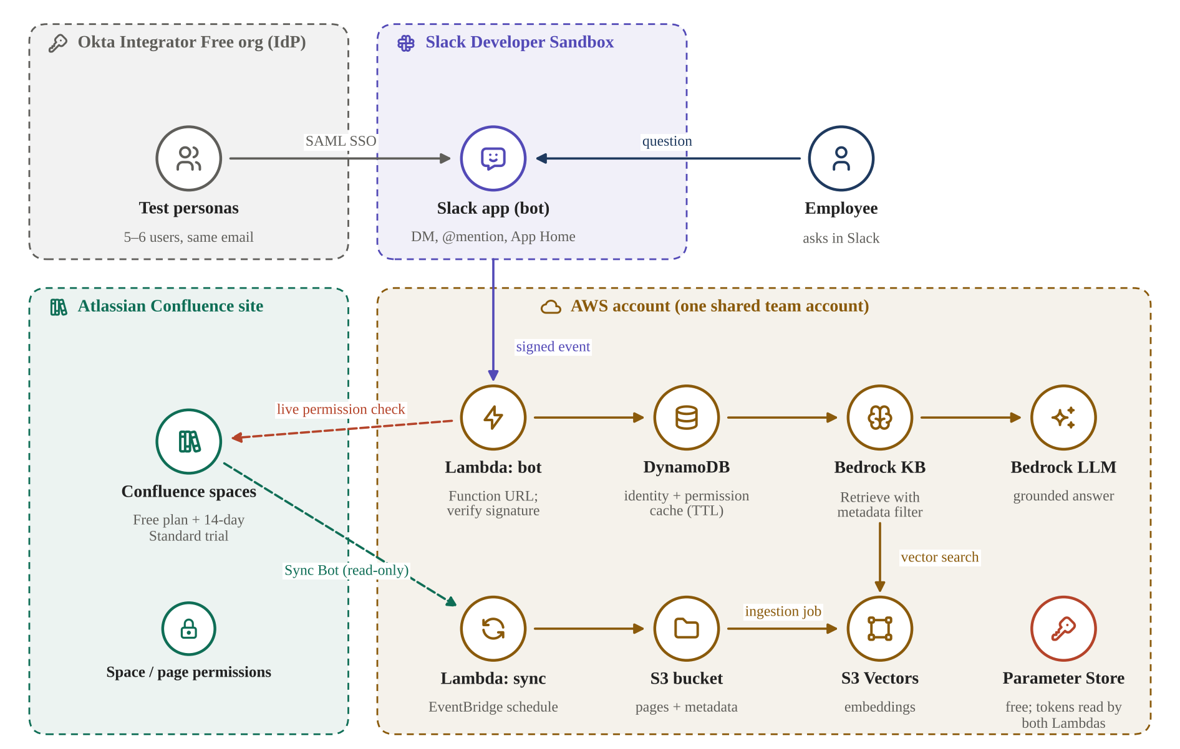
Figure 1. Architecture of Option 1: icons show each service; dashed arrows are permission traffic

C. Components in Detail
Each component below is described with three questions: what it is, why the team uses it, and how it helps the project. The evaluation weights referred to are the client’s: accuracy 40%, cost and maintainability 30%, security 20% and creativity 10%.

3.1 Okta Integrator Free Plan (identity provider)
Question | Answer
What it is | A free Okta organisation intended for building and testing integrations. It supports SAML and OIDC single sign-on and SCIM provisioning for custom app integrations (Okta, n.d.).
Why we use it | The Slack sandbox is an Enterprise Grid environment, and Grid requires all users to sign in with SSO, so an identity provider is mandatory (Slack, n.d.-h). Okta offers this at no cost.
How it helps the project | The sign-in path becomes the same as at Katalon: one company login, then Slack. SCIM creates the Slack test users with the same email addresses that the bot later uses to match people to Confluence accounts.

3.2 Slack Developer Sandbox and the Slack app
Question | Answer
What it is | A free, isolated Enterprise Grid sandbox from the Slack Developer Program, limited to eight users and two guests and active for six months by default (Slack, n.d.-a). The bot is a Slack app installed with a bot token (xoxb) and the scopes chat:write, app_mentions:read, im:history, users:read and users:read.email.
Why we use it | It gives the team a real enterprise Slack without touching Katalon’s workspace. Eight users are enough for the test personas, and the two guest seats let the team prove that guests are refused.
How it helps the project | Every event carries the sender’s Slack ID. The bot calls users.info to read the email address and the guest flags is_restricted and is_ultra_restricted (Slack, n.d.-c, n.d.-d, n.d.-e). Requests are authenticated with the signing secret: Slack signs each request with HMAC-SHA256, and the app compares the signature and rejects timestamps older than five minutes (Slack, n.d.-f).

3.3 Confluence Free plan and 14-day Standard trial
Question | Answer
What it is | A Confluence Cloud site on the Free plan (up to 10 users) for most of the project, upgraded to a 14-day Standard trial before integration testing and UAT. At the end of a trial without a card, the site returns to the Free plan automatically (Atlassian, n.d.-a).
Why we use it | The Free plan does not allow space or page permission settings (Atlassian, n.d.-c), so it is used only for work that does not need permissions. The trial supplies real permissions at the moment they are needed, at no cost.
How it helps the project | The site holds sample spaces that copy Katalon’s structure (Intranet, Deal Desk, Partner Program and True Platform) and the group names the client shared. A read-only Sync Bot account with an API token reads pages and checks permissions; it never edits content (Atlassian, n.d.-e).

3.4 AWS Lambda with a function URL
Question | Answer
What it is | Serverless functions: a bot function that handles Slack events and a sync function that keeps the knowledge base current. The bot function is reached through a Lambda function URL, a dedicated HTTPS endpoint (Amazon Web Services [AWS], n.d.-f).
Why we use it | There are no servers to patch, and Lambda’s free tier includes one million requests per month (AWS, n.d.-g). A function URL removes the need for Amazon API Gateway, whose free calls are not part of the AWS Free plan (AWS Builder Center, 2026).
How it helps the project | Slack expects an HTTP 2xx response within three seconds (Slack, n.d.-g). The bot function verifies the signature, acknowledges at once and continues the work asynchronously, which keeps the user experience responsive.

3.5 Amazon DynamoDB with Time to Live
Question | Answer
What it is | A serverless key-value database holding two caches: the identity map (Slack ID to email to Atlassian account ID) and the permission cache (allowed page IDs for each user).
Why we use it | Calling Slack and Confluence for every question would be slow and could hit rate limits. TTL deletes expired items automatically and without consuming write throughput (AWS, n.d.-h), and the free tier covers 25 GB of storage (AWS, n.d.-i).
How it helps the project | Answers are faster and cheaper (cost criterion). A 15-minute TTL means that permissions removed in Confluence stop being used quickly, and the live check in Section D removes even that delay for the pages actually used.

3.6 Amazon Bedrock Knowledge Bases with Titan Text Embeddings V2
Question | Answer
What it is | A managed RAG service that reads documents from an S3 bucket, splits them into chunks, embeds them and answers Retrieve calls. Titan Text Embeddings V2 produces 1,024-dimension vectors and accepts up to 8,192 tokens per input (AWS, n.d.-j).
Why we use it | It removes the need to write chunking and embedding code. Each page is stored with a .metadata.json file containing its page ID, space and groups, and Retrieve can filter on these attributes (AWS, 2024, n.d.-k).
How it helps the project | Retrieval only searches pages the asker may read (security), and only changed pages are re-processed during a sync (freshness and cost). Embedding costs about US$0.02 per million tokens (AWS, n.d.-a).

3.7 Amazon S3 Vectors (vector store)
Question | Answer
What it is | Vector storage built into Amazon S3, generally available since December 2025 and supported as a Bedrock knowledge-base vector store (AWS, 2025b).
Why we use it | The default quick-create store, Amazon OpenSearch Serverless, keeps a minimum of four capacity units running and costs roughly US$700 per month even with no queries (Mallesh, n.d.). S3 Vectors has no minimum charge and costs nothing while idle (amitrix, n.d.).
How it helps the project | For a corpus of a few hundred pages, storage and queries cost cents per month, which protects the AWS credits (AWS, n.d.-d). This is the single most important cost decision in the environment.

3.8 Amazon Nova Lite on Bedrock (answer generation)
Question | Answer
What it is | A low-cost foundation model on Bedrock, priced at about US$0.06 per million input tokens and US$0.24 per million output tokens; Nova 2 Lite costs about US$0.30 and US$2.50 (AWS, n.d.-a).
Why we use it | Answers are generated only from retrieved, permitted chunks, so a small model is usually enough. Starting with Nova Lite keeps evaluation runs cheap; the team can switch to Nova 2 Lite if accuracy tests show a need.
How it helps the project | Supports the 40% accuracy criterion through grounded answers with source links, while thousands of test questions still cost only a few dollars.

3.9 AWS Systems Manager Parameter Store (standard tier)
Question | Answer
What it is | A free store for configuration values and secrets. Standard parameters carry no additional charge (AWS, n.d.-c) and can be encrypted with AWS KMS.
Why we use it | Tokens must never be stored in code or in the repository. Parameter Store gives encrypted storage at zero cost.
How it helps the project | Holds the Slack bot token, the Slack signing secret and the Sync Bot API token. Both Lambda functions read them at start-up and keep them in memory, so the number of calls stays very low (security criterion).

3.10 EventBridge Scheduler, CloudWatch and AWS Budgets
Question | Answer
What it is | EventBridge Scheduler starts the sync function on a fixed schedule (AWS, n.d.-l). CloudWatch stores logs and custom metrics. AWS Budgets sends an alert when spending passes a threshold (AWS, n.d.-m).
Why we use it | Freshness depends on a reliable schedule, and the team needs evidence (logs, freshness metric) for the evaluation. A budget alert is the last line of defence against unexpected charges.
How it helps the project | Supports the freshness and cost criteria and provides the audit log of who asked what and which pages were used.

D. Workflows and Sequence Diagrams

4.1 Provisioning test personas and signing in
Figure 2 shows how the System Admin (Group 7) prepares a test persona and how the persona signs in. In production, Katalon IT performs the first four steps through its own identity provider; in this environment the team performs them in Okta and Confluence.
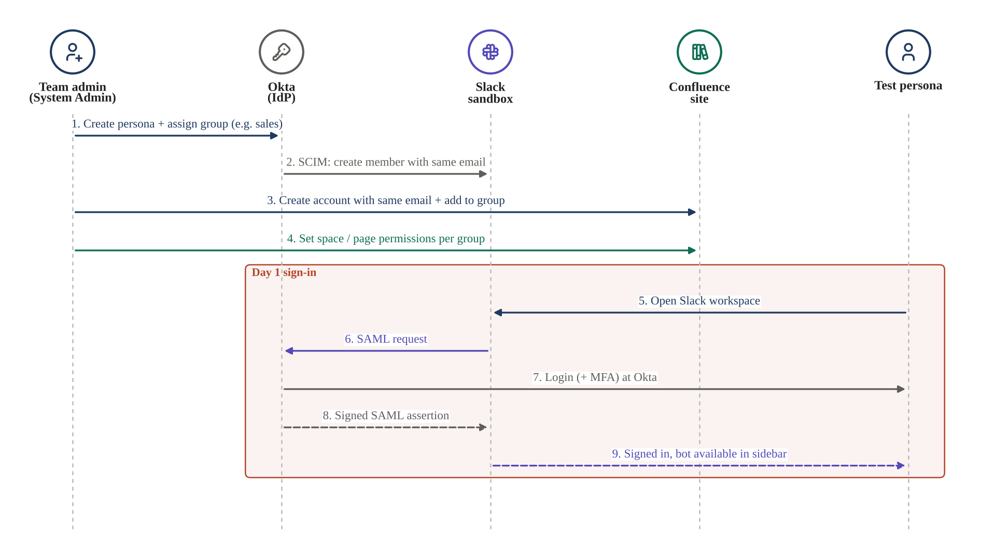
Figure 2. Sequence diagram: provisioning a persona and day-one sign-in
- Steps 1–2: the persona is created once in Okta, and SCIM creates the Slack member with the same email (Okta, n.d.).
- Steps 3–4: the Confluence account is created manually with the same email, because SCIM into Atlassian needs Atlassian Guard, which is not free for students. The account is added to a group, and the group decides which spaces and pages it can read.
- Steps 5–9: SAML single sign-on (Slack, n.d.-b). The bot never sees a password; it only receives the persona’s Slack ID with each event.

4.2 Answering a question with two-layer access control
Figure 3 is the core workflow. The asker never signs in to the bot separately; identity comes from Slack, and access comes from Confluence.
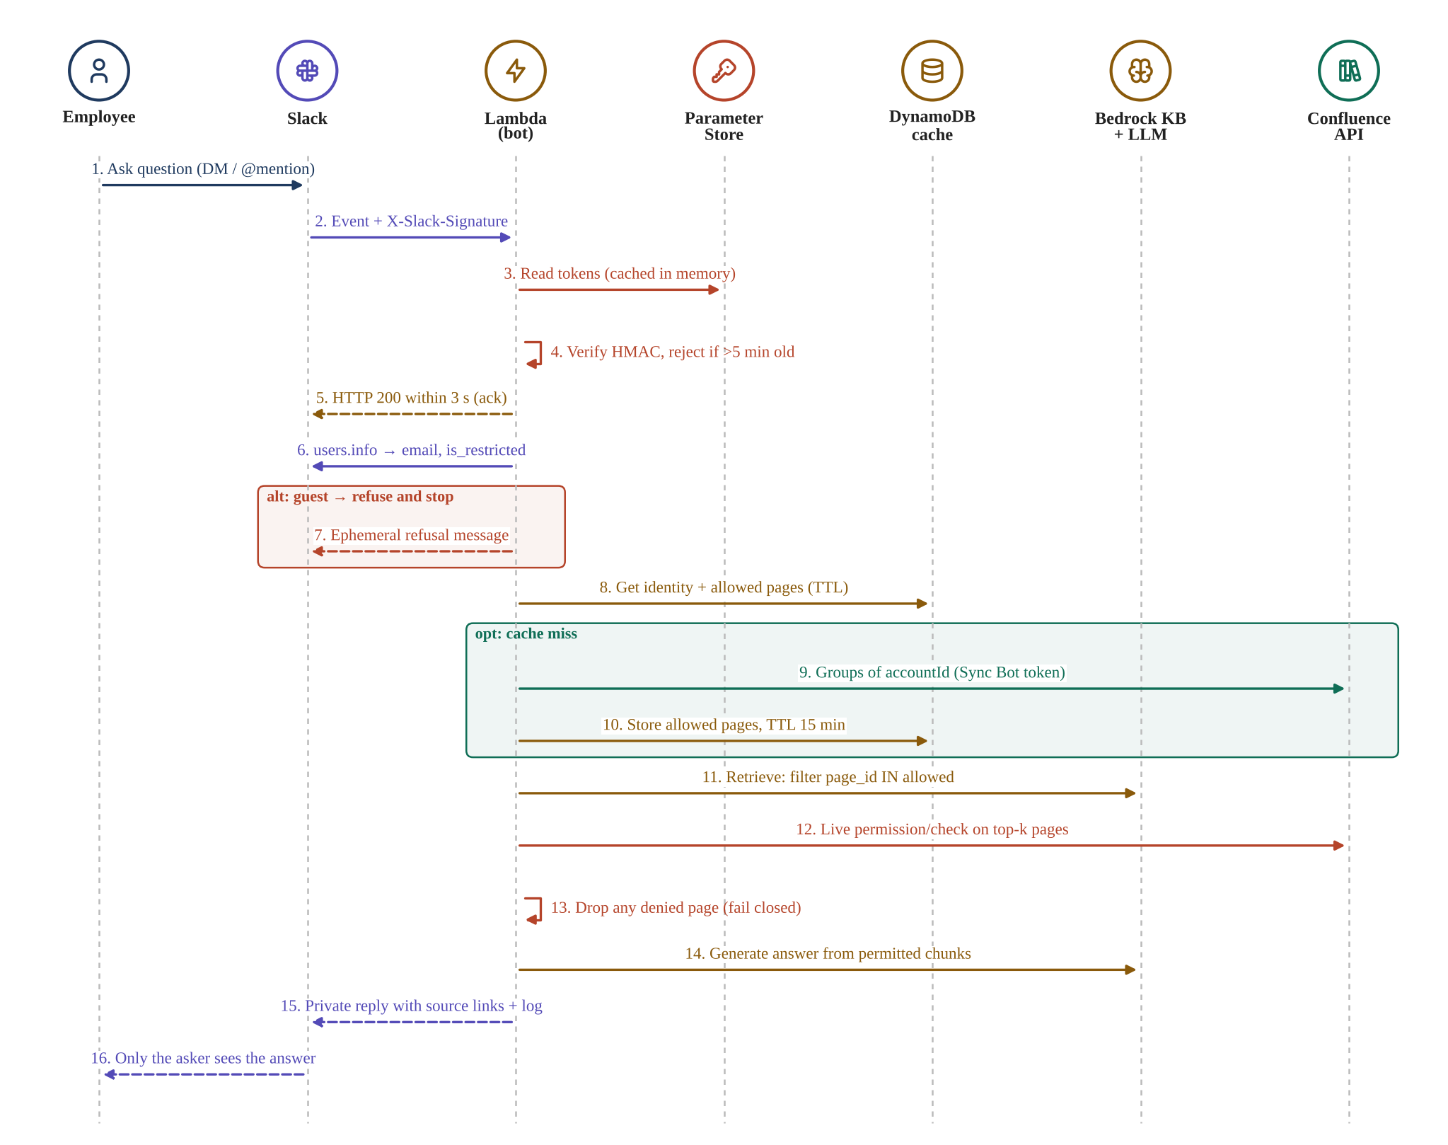
Figure 3. Sequence diagram: answering a question with a pre-filter and a live permission check
- Authenticate the request (steps 2–5). The bot reads its tokens from Parameter Store, verifies the Slack signature and acknowledges within three seconds (Slack, n.d.-f, n.d.-g).
- Identify the asker (steps 6–7). users.info returns the email and guest flags; guests receive a private refusal and processing stops (Slack, n.d.-c).
- Resolve permissions (steps 8–10). The allowed page IDs come from the DynamoDB cache, or from Confluence on a cache miss, and are cached with a 15-minute TTL.
- Layer 1, pre-filter (step 11). Bedrock Retrieve searches only chunks whose page_id is in the allowed list (AWS, n.d.-k).
- Layer 2, live check (steps 12–13). The top results are checked again with the Confluence permission-check API (Atlassian, n.d.-d). Any page that is denied, or cannot be checked, is dropped: the system fails closed (NHI Mgmt Group, n.d.).
- Answer privately (steps 14–16). The model writes the answer only from permitted chunks, and the reply is visible only to the asker, with source links. The question, user and page IDs are logged.
The second layer exists because a metadata filter is only as reliable as the identity and metadata passed to it. Recent RAG security research shows that checking identity only before retrieval is not sufficient, and recommends access decisions at both the retrieval and the generation stage (“Towards Secure Retrieval-Augmented Generation,” 2026; Yesil et al., 2026).

4.3 Keeping the knowledge base fresh
Figure 4 shows the incremental sync that serves the freshness criterion.
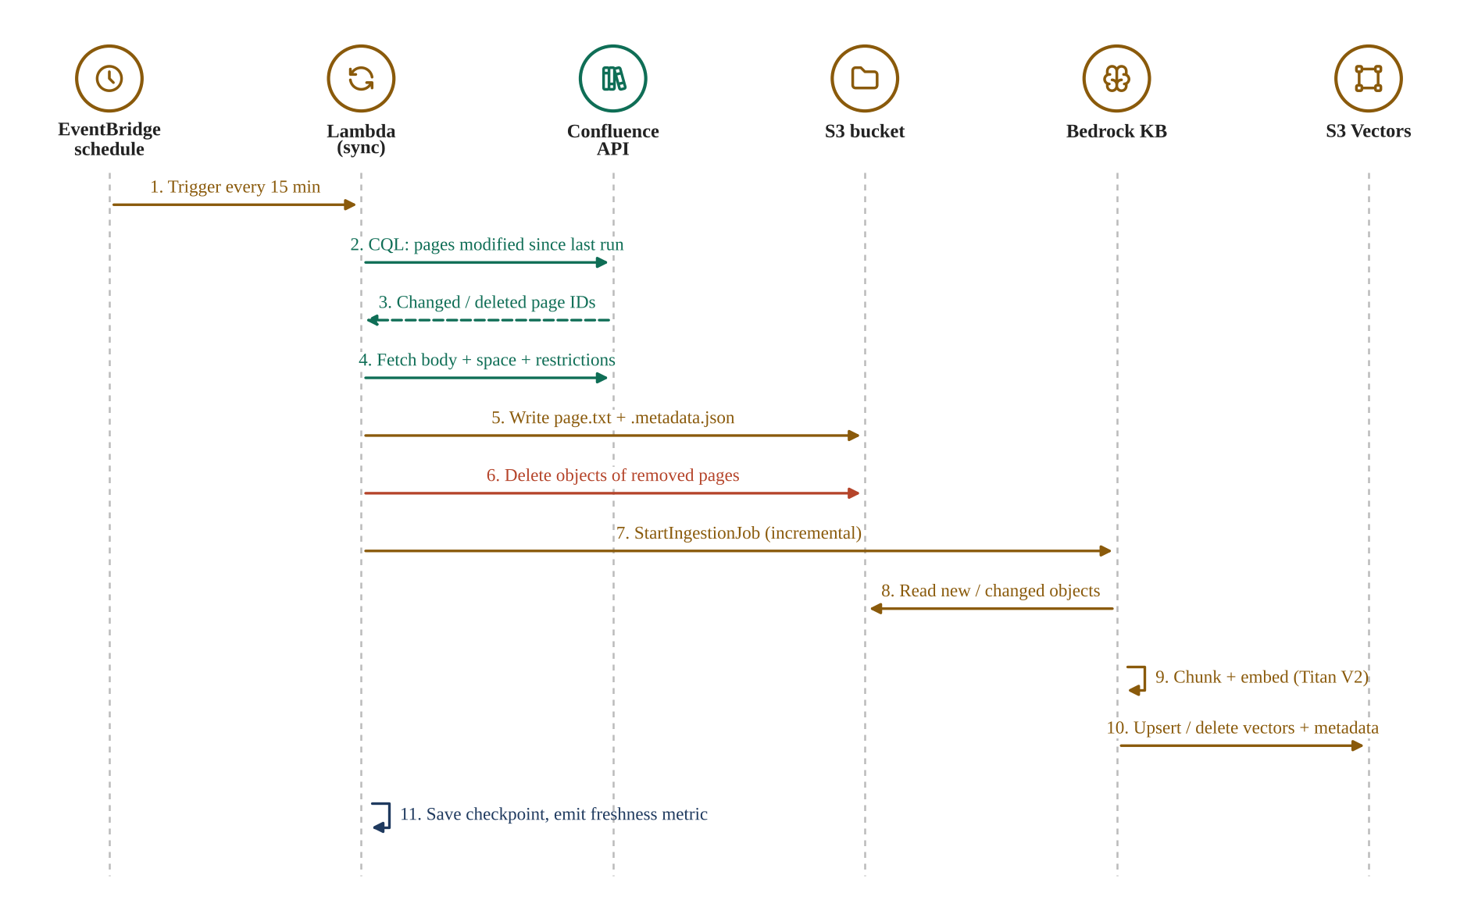
Figure 4. Sequence diagram: incremental synchronisation from Confluence to Bedrock
- Change detection: every 15 minutes the sync function asks Confluence, using CQL, for pages modified since the last checkpoint (Atlassian, n.d.-f).
- Metadata: each page is written to S3 with a .metadata.json file (page ID, space, groups), which is what makes the permission filter in Figure 3 possible (AWS, n.d.-k).
- Incremental ingestion: a Bedrock ingestion job processes only new, changed or deleted objects, so cost stays proportional to change (AWS, n.d.-n).
- Evidence: the function stores a checkpoint and publishes a freshness metric (minutes since the last successful sync) to CloudWatch for the evaluation.

E. Testing in This Environment

5.1 Test personas
Persona | Slack account | Confluence group | Expected result
Employee – Sales | Member | deal-desk | Answers only from Deal Desk and public Intranet pages
Employee – Partner | Member | partner-program | Answers only from Partner Program and public Intranet pages
Content Owner | Member | true-platform-admins (space admin) | Answers from True Platform; can force a re-sync
Client Reviewer | Member | reviewers | Same answers as an Employee; read-only dashboard
System Admin | Owner / Admin | none beyond own access | Manages the system but cannot read restricted pages
Guest | Single-channel guest | none | Refused with a private message

Table 2. Test personas (at most eight Slack users and two guests in the sandbox)

5.2 How access control is tested
- Build phase (Confluence Free): the permission layer is tested with mock permission data and unit tests, including fail-closed behaviour when the Confluence check times out. No real permissions exist yet.
- Integration phase (Standard trial, 14 days): permissions are configured in Confluence, the full persona matrix in Table 2 is run, and a page restriction is removed and re-added to measure how quickly the bot reacts.
- UAT: the Client Reviewer runs the scenarios inside the same trial window. The trial must start at least one week before the planned UAT session.

F. Timeline
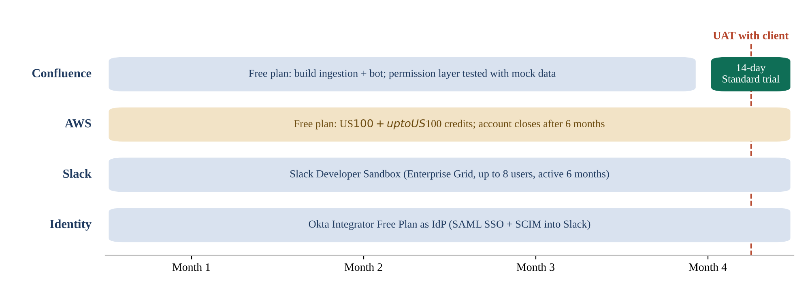
Figure 5. Four-month timeline of Option 1
The only time-critical element is the 14-day Standard trial. The AWS Free plan ends after six months or when the credits run out, whichever comes first (AWS, 2025a), so the AWS account should be opened when coding starts, not earlier.

G. Cost Summary
The detailed cost estimate, with labour hours and milestones, is in the matching budget workbook (Group 7, 2026b). The summary is:
Item | Estimate (4 months) | Paid by
Okta, Slack sandbox, Confluence Free + trial, Parameter Store | US$0 | Free plans
Lambda, DynamoDB, EventBridge, CloudWatch | US$0 | AWS always-free allowances
Bedrock (embeddings + Nova), S3 Vectors, S3 | About US$7–15 | AWS Free Tier credits (up to US$200)
Cash cost to the team | US$0

New AWS customers receive US$100 in credits at sign-up and can earn another US$100 by using services such as Amazon EC2 and Amazon Bedrock (AWS, 2025a). On the Free plan no charge is made unless the account is upgraded (AWS, n.d.-e).

H. Risks and Mitigations
Risk | Effect | Mitigation
The 14-day trial is too short or badly timed | Access control is not fully tested before UAT | Prepare all test scripts in advance; start the trial one week before UAT; fall back to Option 2 for one month
Some services are unavailable on the AWS Free plan | Architecture must change late | On day one, create a Bedrock knowledge base on S3 Vectors as a smoke test
The AWS Free plan closes after six months | Environment disappears before the end | Open the account when coding starts; never join AWS Organizations, which upgrades the plan (AWS Builder Center, 2026)
Someone selects OpenSearch Serverless by mistake | About US$700 per month, credits gone in about a week | Use S3 Vectors only; AWS Budgets alert at US$1
Tokens leak through code or logs | Security incident | Store tokens only in Parameter Store; never log tokens; rotate the Slack token if exposed
Sandbox data differs from Katalon’s real content | Accuracy results do not transfer | Build sample pages from the structure the client shared and ask the client to review them

I. Alignment with Evaluation Criteria
Criterion (weight) | How this environment supports it
Accuracy (40%) | Grounded answers from permitted chunks only, with source links; low model cost allows many evaluation runs.
Cost and maintainability (30%) | US$0 cash cost; S3 Vectors instead of OpenSearch Serverless; serverless services with no servers to maintain.
Security (20%) | Signature verification, guest refusal, two-layer permission check that fails closed, private replies, tokens in Parameter Store, audit log. Real permissions are tested during the trial window.
Creativity (10%) | A phased, zero-cost plan that still tests real access control, which is directly reusable by other student teams.

References
Amazon Web Services. (2024). Access control for vector stores using metadata filtering with Knowledge Bases for Amazon Bedrock. AWS Machine Learning Blog. https://aws.amazon.com/blogs/machine-learning/access-control-for-vector-stores-using-metadata-filtering-with-knowledge-bases-for-amazon-bedrock
Amazon Web Services. (2025a, July 16). AWS Free Tier now offers $200 in credits and 6-month free plan to explore AWS at no cost. What’s New with AWS. https://aws.amazon.com/about-aws/whats-new/2025/07/aws-free-tier-credits-month-free-plan
Amazon Web Services. (2025b). Amazon S3 Vectors now generally available with increased scale and performance. AWS News Blog. https://aws.amazon.com/blogs/aws/amazon-s3-vectors-now-generally-available-with-increased-scale-and-performance
Amazon Web Services. (n.d.-a). Amazon Bedrock pricing. Retrieved November 11, 2026, from https://aws.amazon.com/bedrock/pricing/
Amazon Web Services. (n.d.-b). AWS Secrets Manager pricing. Retrieved November 11, 2026, from https://aws.amazon.com/secrets-manager/pricing/
Amazon Web Services. (n.d.-c). AWS Systems Manager pricing. Retrieved November 11, 2026, from https://aws.amazon.com/systems-manager/pricing/
Amazon Web Services. (n.d.-d). Amazon S3 pricing. Retrieved November 11, 2026, from https://aws.amazon.com/s3/pricing/
Amazon Web Services. (n.d.-e). AWS Free Tier. Retrieved November 11, 2026, from https://aws.amazon.com/free/
Amazon Web Services. (n.d.-f). Creating and managing Lambda function URLs. AWS Lambda Developer Guide. Retrieved November 11, 2026, from https://docs.aws.amazon.com/lambda/latest/dg/urls-configuration.html
Amazon Web Services. (n.d.-g). AWS Lambda pricing. Retrieved November 11, 2026, from https://aws.amazon.com/lambda/pricing/
Amazon Web Services. (n.d.-h). Using time to live (TTL) in DynamoDB. Amazon DynamoDB Developer Guide. Retrieved November 11, 2026, from https://docs.aws.amazon.com/amazondynamodb/latest/developerguide/TTL.html
Amazon Web Services. (n.d.-i). Amazon DynamoDB pricing. Retrieved November 11, 2026, from https://aws.amazon.com/dynamodb/pricing/
Amazon Web Services. (n.d.-j). Amazon Titan Text Embeddings models. Amazon Bedrock User Guide. Retrieved November 11, 2026, from https://docs.aws.amazon.com/bedrock/latest/userguide/titan-embedding-models.html
Amazon Web Services. (n.d.-k). Connect to Amazon S3 for your knowledge base. Amazon Bedrock User Guide. Retrieved November 11, 2026, from https://docs.aws.amazon.com/bedrock/latest/userguide/s3-data-source-connector.html
Amazon Web Services. (n.d.-l). What is Amazon EventBridge Scheduler? Retrieved November 11, 2026, from https://docs.aws.amazon.com/scheduler/latest/UserGuide/what-is-scheduler.html
Amazon Web Services. (n.d.-m). AWS Budgets. Retrieved November 11, 2026, from https://aws.amazon.com/aws-cost-management/aws-budgets/
Amazon Web Services. (n.d.-n). Sync your data with your Amazon Bedrock knowledge base. Amazon Bedrock User Guide. Retrieved November 11, 2026, from https://docs.aws.amazon.com/bedrock/latest/userguide/kb-data-source-sync-ingest.html
amitrix. (n.d.). Which tier does your vector workload live on? DEV Community. Retrieved November 11, 2026, from https://dev.to/amitrix/which-tier-does-your-vector-workload-live-on-5f2a
Atlassian. (n.d.-a). Purchasing & licensing FAQ. Retrieved November 11, 2026, from https://www.atlassian.com/licensing
Atlassian. (n.d.-b). Atlassian Classroom license request. Retrieved November 11, 2026, from https://www.atlassian.com/solutions/survey/classroom-license-request
Atlassian. (n.d.-c). Confluence pricing. Retrieved November 11, 2026, from https://www.atlassian.com/software/confluence/pricing
Atlassian. (n.d.-d). The Confluence Cloud REST API: Content permissions. Atlassian Developer. Retrieved November 11, 2026, from https://developer.atlassian.com/cloud/confluence/rest/v1/api-group-content-permissions/
Atlassian. (n.d.-e). Manage API tokens for your Atlassian account. Atlassian Support. Retrieved November 11, 2026, from https://support.atlassian.com/atlassian-account/docs/manage-api-tokens-for-your-atlassian-account/
Atlassian. (n.d.-f). Advanced searching using CQL. Atlassian Developer. Retrieved November 11, 2026, from https://developer.atlassian.com/cloud/confluence/advanced-searching-using-cql/
AWS Builder Center. (2026). The $0 AWS account in 2026: Free plan, credits, guardrails. Retrieved November 11, 2026, from https://builder.aws.com/content/3Kkt4kNiDSUnO3n6db2weSNubzE/the-dollar0-aws-account-in-2026-free-plan-credits-guardrails
Group 7. (2026a). Environment options (Version 1.0, draft) [Unpublished project document]. COS40005 Computing Technology Project A, Swinburne University of Technology.
Group 7. (2026b). Project budget: Option 1, zero cost (Version 1.0, draft) [Unpublished spreadsheet]. COS40005 Computing Technology Project A, Swinburne University of Technology.
Mallesh, S. (n.d.). S3 Vectors for RAG: The cheapest vector store for Bedrock Knowledge Bases with Terraform. DEV Community. Retrieved November 11, 2026, from https://dev.to/suhas_mallesh/s3-vectors-for-rag-the-cheapest-vector-store-for-bedrock-knowledge-bases-with-terraform-487c
NHI Mgmt Group. (n.d.). Permission-aware RAG guide. Retrieved November 11, 2026, from https://nhimg.org/permission-aware-rag-guide
Okta. (n.d.). Create an app integration. Okta Developer. Retrieved November 11, 2026, from https://developer.okta.com/docs/guides/build-sso-integration/saml2/test-your-app/
Slack. (n.d.-a). Developer sandboxes. Slack Developer Docs. Retrieved November 11, 2026, from https://docs.slack.dev/tools/developer-sandboxes/
Slack. (n.d.-b). Set up SAML single sign-on for Slack. Slack Help Center. Retrieved November 11, 2026, from https://slack.com/help/articles/203772216
Slack. (n.d.-c). users.info method. Slack API. Retrieved November 11, 2026, from https://api.slack.com/methods/users.info
Slack. (n.d.-d). users:read.email scope. Slack API. Retrieved November 11, 2026, from https://api.slack.com/scopes/users:read.email
Slack. (n.d.-e). User object. Slack Developer Docs. Retrieved November 11, 2026, from https://docs.slack.dev/reference/objects/user-object
Slack. (n.d.-f). Verifying requests from Slack. Slack API. Retrieved November 11, 2026, from https://api.slack.com/authentication/verifying-requests-from-slack
Slack. (n.d.-g). Events API. Slack API. Retrieved November 11, 2026, from https://api.slack.com/apis/events-api
Slack. (n.d.-h). Testing Enterprise Grid apps. Slack API. Retrieved November 11, 2026, from https://api.slack.com/enterprise/testing
Towards secure retrieval-augmented generation: A comprehensive review of threats, defenses and benchmarks (arXiv:2603.21654). (2026). arXiv. https://arxiv.org/pdf/2603.21654
Yesil, H., Gultekin, S., Bozyigit, F., Tezel, B. T., & Challenger, M. (2026). A database-independent LLM framework for real-time authorization in retrieval-augmented generation [Workshop paper]. AAAI 2026 Workshop on Trustworthy Agentic AI. https://trustagenticai.github.io/AAAI2026/AAAI-Workshop/68.pdf

