
Smart Fleet Management (SmartFM)
School of Science, Computing and Engineering Technologies
Software Architecture and Application
Assignment 3
System Technical Report

Lecturer: Mr.Pham Thai Ky Trung
Course: Software Architecture and Application
CourseID: SWE30003
Dates: Mondays, 13:00 - 16:00 p.m
Team Members: Lu Nhat Hoang - 105234956
Duong Nguyen Dang - 1055084444
Truong Ngoc Gia Hieu - 105565520
Start Date: Jul 22th, 2026
End Date: Aug 5th, 2026
Submission Date: Aug 5th, 2026

Word Count: words

Abstraction

Table of Contents
Part A: Requirement Redesign Analysis X
1.1 Case Study Requirement Analysis X
1.2 Refined Overall Class Diagram X
1.2.1 Admin Subsystem Class Diagram X
1.2.2 Staff Subsystem Class Diagram X
1.2.3 Customer Subsystem Class Diagram X
1.2.4 Design Changes and Rationale X

Part A - Requirement Redesign Analysis

1.1 Case Study Requirement Analysis
First and foremost, the third assignment requires students to transition the architectural design from the second assignment into a fully functional software implementation. Consequently, the team members decided to re-evaluate the identified system roles, problem domain, functional requirements, and task descriptions to ensure that our proposed solutions effectively address the challenges ABC-Trans is facing. During the re-analysis phase, team members noticed that three specific roles were mentioned in the case study, including platform administrators (admin), company staff, and customers. By addressing these identified design flaws, the team refined and reconstructed the overall class diagram to ensure comprehensive system coverage and proper role-based architecture, guaranteeing that all roles are included.

1.2 Refined Overall Class Diagram
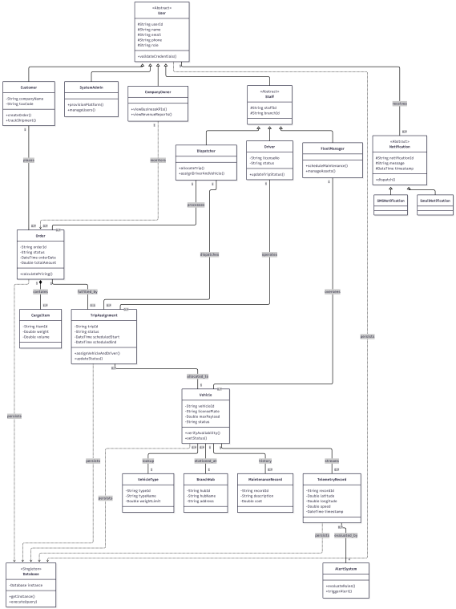

Figure 1: Updated Overall Class Diagram

The Refined Overall Class Diagram functions as the core architectural blueprint for the Smart Fleet Management (SmartFM) platform. It was refined over time to produce the optimal project outcome, incorporating object-oriented programming principles to build an optimized system. This design bridges core business entities with user identity management while maintaining scalability for future expansion. The updated structure addresses the weaknesses of previous models by enforcing well-defined subsystem boundaries, precise role hierarchies, and unified database communication channels.
System Architecture and Core Relationships
- Core User Inheritance Hierarchy:
- At the root of the user domain, the abstract User class encapsulates common identity attributes (userId, name, email, phone, role) and universal authentication behavior through validateCredentials().
- The User hierarchy is specialized into three functional domains:
  - Administrative and Executive Governance Domain: SystemAdmin and CompanyOwner handle platform setup, configuration, and top-level analytics.
  - Internal Operational Staff Domain: The abstract Staff class extends User to incorporate operational context (staffId, branchId, getProfile()). It further specializes into concrete operational roles: Dispatcher, Driver, and FleetManager.
  - External Client Domain: Customer extends User with corporate identity attributes (companyName, taxCode, billingAddress, creditLimit) to support client-side shipping requests and shipment tracking.
- Logistics and Order Fulfillment Core:
- Order and CargoItem: Customer shipping requests are captured by Order (orderId, customerId, orderDate, status, totalAmount, pickupAddress, deliveryAddress, calculatePricing(), cancelOrder(), getStatus()). An Order holds a composition relationship with CargoItem (itemId, description, weight, volume, isFragile, validatePhysicality()), representing individual packages packed within a single shipment.
- TripAssignment (Operational Reification Bridge): Orders are relegated and verified at the system level so that when physical transportation resources are deployed, everything is ready for execution. It regulates fulfillment schedules (scheduledStart, scheduledEnd), enabling human-operated processes to be carried out as efficiently as possible while binding an allocated Vehicle, Driver, and Dispatcher through assignVehicleAndDriver() and updateStatus().
- Vehicle Asset Domain: The system tracks everything from fleet assets down to the drivers themselves, ensuring all resources are assigned and operated in real time to maximize throughput and maintain operational efficiency (vehicleId, licensePlate, maxPayload, status, verifyAvailability(), setStatus()). Every Vehicle connects directly to its structural specification (VehicleType), operating hub (BranchHub), repair history (MaintenanceRecord), and real-time operational streams (TelemetryRecord).
- Real-Time Telemetry and Persistence Layer:
- Telemetry and Alerts: Vehicles stream real-time spatial and velocity metrics via TelemetryRecord (recordId, latitude, longitude, speed, timestamp). These telemetry streams are continuously evaluated by AlertSystem (evaluateRules(), triggerAlert()) to detect threshold violations and trigger automated messages via the abstract Notification hierarchy (SMSNotification, EmailNotification).
- Centralized Data Persistence: High-level business objects interact with data storage through a centralized Singleton Database component (Database instance, getInstance(), executeQuery()). This ensures consistent relational mapping across file-based JSON stores (database/data/.json) and relational SQL schemas (database/schema.sql, database/migrations/.sql).
1.2.1 Admin Subsystem Class Diagram
The Admin Subsystem governs technical platform setup, physical infrastructure provisioning, and executive-level business analytics. It enforces a strict separation of concerns between technical system management and high-level enterprise oversight while interacting directly with the global database accessor.
Key Components and Class Responsibilities
- SystemAdmin (Technical and Infrastructure Governance):
- Inherits directly from User and holds exclusive administrative authority for system setup (provisionPlatform()) and user identity governance (manageUsers()).
- Provisions physical logistics distribution infrastructure by managing BranchHub entities (hubId, hubName, address), which define physical hubs for fleet asset allocation and driver assignments.
- Manages fleet classification profiles by configuring VehicleType records (typeId, typeName, weightLimit, maxPayload, baseFuelRate). These profile parameters define structural payload constraints and baseline fuel cost rates used during automated pricing and trip allocation.
- Communicates directly with the Singleton Database interface to execute database queries, update system tables, and manage user security settings.
- CompanyOwner (Executive Oversight and Strategic Analytics):
- Inherits from User to provide executive monitoring capabilities without granting direct access to modify physical hardware parameters or low-level system settings.
- Evaluates corporate performance by inspecting BusinessKPI metrics (viewBusinessKPIs()), tracking key operational indicators such as completed order volume, fleet utilization rate, and on-time delivery percentages.
- Analyzes financial summaries via RevenueReport (viewRevenueReports(), generateReport(), exportPDF()) to review operational expenses, gross revenue, net profit margins, and payment transaction logs (PaymentTransaction) across active branches.
- Observes broad logistics activity by reviewing aggregated status summaries across active Order records and Vehicle deployment states.
- Infrastructure and Domain Metadata Entities:
- BranchHub and VehicleType: Store central metadata used across all operational subsystems to validate payload thresholds, map geographic origin/destination hubs, and compute automated tariffs.
- RevenueReport and BusinessKPI: Aggregate operational data from transaction logs, trip logs, and order histories into structured business intelligence reports.

1.2.2 Staff Subsystem Class Diagram
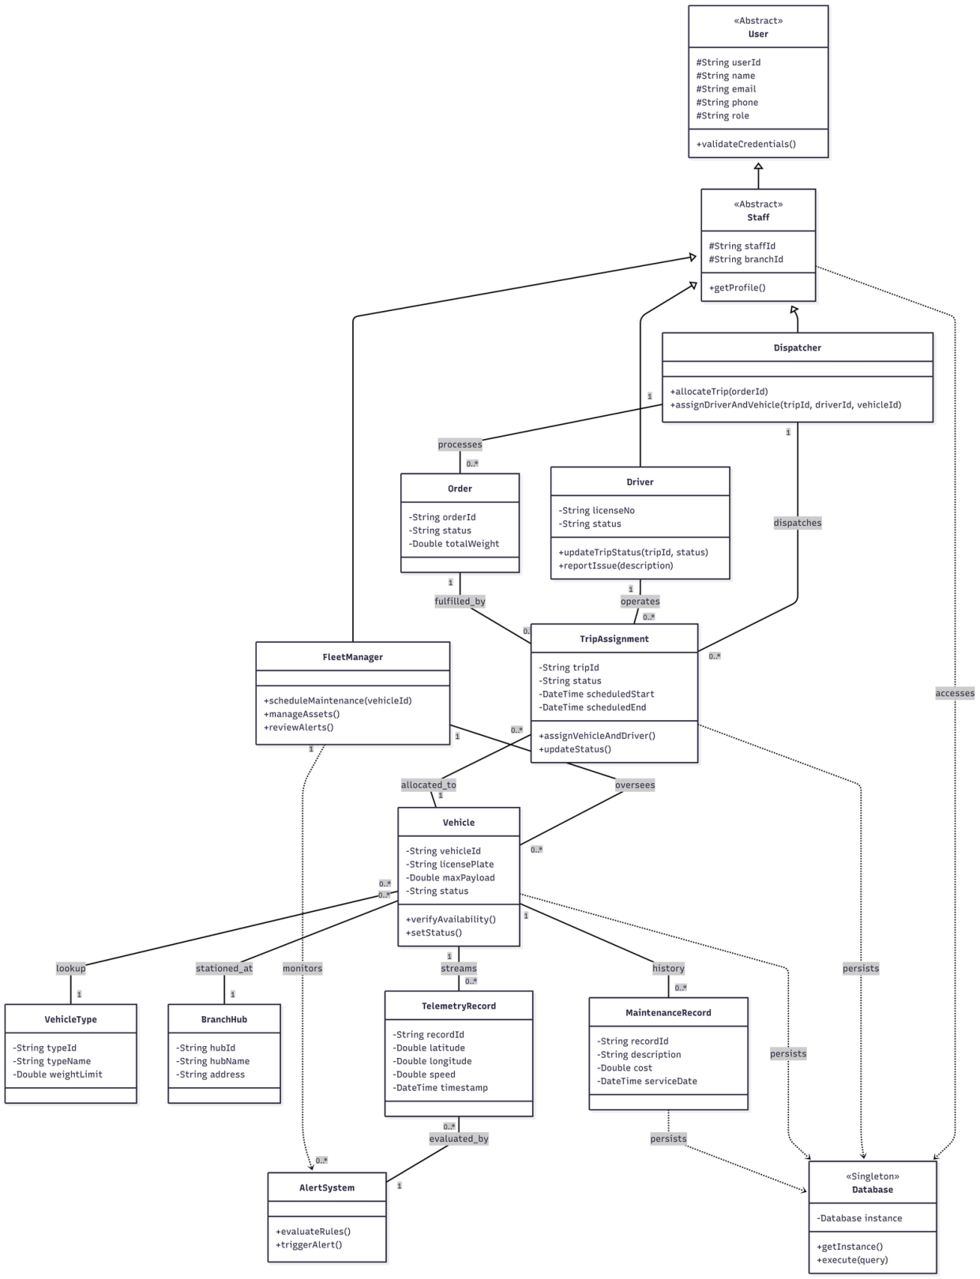

Figure 1.2.2: Staff Subsystem Class Diagram

System Description & Overview
The Staff Subsystem manages internal logistics operations, vehicle monitoring, trip scheduling, and operational alerts. This subsystem decouples internal staff functionalities from customer-facing operations, ensuring secure data handling and distinct role-based access control.

Key Components & Responsibilities:
User Hierarchy & Roles (User -> Staff):

- User: An abstract base class providing primary authentication features (userId, name, email, role, validateCredentials()).
- Staff: An abstract class extending User, representing company employees associated with a specific branch (branchId).
- Dispatcher: Handles order allocation and creates trip assignments. Contains methods like allocateTrip(orderId) and assignDriverAndVehicle(...).
- Driver: Operates assigned vehicles during transport trips. Stores driver licensing details (licenseNo), updates trip progress via updateTripStatus(), and submits operational issues through reportIssue().
- FleetManager: Responsible for fleet health, scheduling vehicle maintenance (scheduleMaintenance()), managing physical assets (manageAssets()), and reviewing system alerts (reviewAlerts()).

Fleet & Trip Management:

- TripAssignment: Connects an Order, Driver, and Vehicle. Tracks scheduling times (scheduledStart, scheduledEnd) and trip statuses.
- Vehicle: Represents fleet assets with payload limits and availability status (verifyAvailability(), setStatus()). Relates directly to VehicleType and BranchHub.
- TelemetryRecord & AlertSystem: Streams real-time GPS and speed telemetry (latitude, longitude, speed) from vehicles. The AlertSystem evaluates incoming telemetry against defined thresholds to trigger real-time warnings (evaluateRules(), triggerAlert()).
- MaintenanceRecord: Logs service history and costs (serviceDate, cost) linked to specific vehicles.

1.2.3 Customer Subsystem Class Diagram

System Description & Overview
The Customer Subsystem handles client-facing interactions, including order placement, shipment tracking, invoice generation, and automated notifications.

Key Components & Responsibilities
- Customer & Order Management:

  - Customer: Extends the abstract User class. Holds corporate/individual client attributes such as companyName, taxCode, billingAddress, and creditLimit. It enables users to initiate shipments (createOrder()), view tracking information (trackShipment()), and review historical transactions (viewOrderHistory()).

  - Order: Represents a logistics delivery request. Stores pickup and delivery addresses, weight parameters, and status flags. It contains core business methods like calculatePricing() and cancelOrder().
  - CargoItem: Represents individual physical packages bundled inside an Order (Composition relationship). Holds specifications such as weight, volume, and fragility flags (isFragile).

- Billing & Notifications:

  - Invoice: Automatically generated upon order finalization. Records billing details (amount, issueDate, paymentStatus) and manages payment updates via markAsPaid().

  - Notification Hierarchy: An abstract class defining message dispatching (dispatch()). Subclasses SMSNotification and EmailNotification implement specific delivery channels to notify customers about order progress and invoice updates.
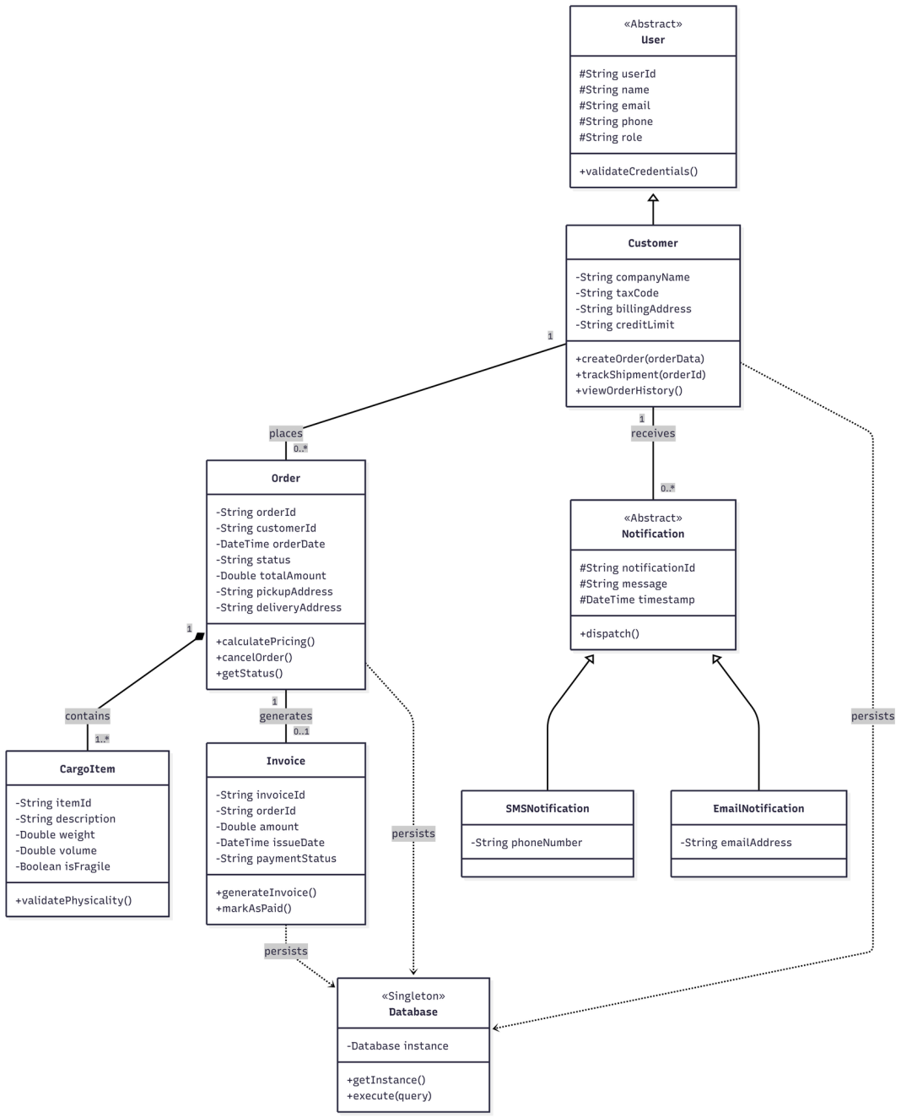

Figure 1.2.3: Staff Subsystem Class Diagram

1.2.4 Design Changes and Rationale
This section outlines the key architectural revisions introduced between the preliminary design (Assignment 2) and the current refined architecture (Assignment 3), along with the technical rationales behind these changes.
Structural Improvements & Refinement Rationale
Preliminary Design Issue (Assignment 2) | Refined Architectural Solution (Assignment 3) | Technical Rationale & Architectural Principle
Monolithic Class Aggregation (High Coupling)  Core entities like Order, Vehicle, and User were tightly coupled in a single centralized diagram. | Subsystem Decoupling (Separation of Concerns)  Divided the overall system into distinct operational domain models: Staff Subsystem and Customer Subsystem. | Single Responsibility Principle (SRP): Tightly coupled classes make maintenance difficult. Separating internal operation flows from customer interactions reduces system complexity, enhances scalability, and limits security vulnerability propagation across domain boundaries.
Lack of Real-time Operational Monitoring  Assignment 2 lacked dedicated entities for tracking vehicle telematics and automated alerting mechanisms. | Introduction of Telematics Domain  Added TelemetryRecord and AlertSystem classes dedicated to processing real-time telemetry updates (speed, coordinates). | Domain-Driven Design: Encapsulates IoT streaming and safety compliance logic out of general vehicle management, ensuring real-time event processing without polluting basic asset records.
Over-simplified User Roles  User management relied on generic attributes without structural distinction between operational staff and end clients. | Specialized Polymorphic Inheritance  Implemented explicit class structures (Driver, Dispatcher, FleetManager, Customer) deriving from abstract base classes (User, Staff). | Open/Closed Principle (OCP) & Polymorphism: Allows adding new operational roles (e.g., Third-party Logistics Auditor) in the future without modifying existing base User or Staff implementation logic.
Implicit Delivery Execution  Orders were directly mapped to drivers without representing the execution lifespan. | Explicit TripAssignment Entity  Introduced TripAssignment as an explicit reified entity coordinating Order, Driver, and Vehicle. | Indirection & Object-Oriented Design Pattern: Represents a many-to-many operational association smoothly. Allows tracking historical driver-vehicle assignments, rescheduled trips, and transit timestamps independently of raw orders.
Quality Attribute Impacts
- Maintainability: By structuring business entities into modular domain subsystems (Customer vs. Staff), developers can update customer notification channels or payment logic without risking regressions in internal fleet management or driver dispatching modules.

- Extensibility: Abstracting Notification into SMSNotification and EmailNotification allows seamless integration of new notification gateways (e.g., Push Notifications, Zalo Notification Service) with zero modification to core Order or Customer classes.

- Security & Data Isolation: Restricting access so that client-facing modules interact strictly with Customer and Order domains prevents unauthorized exposure of internal operational data (such as driver work hours, maintenance costs, or vehicle telemetry logs).

