**Exercise 1**

Theta=[0;pi/4;pi/2;3*pi/4;5*pi/4];

r = 2;

x = (r*cos(Theta))

x =

2.0000

1.4142

0.0000

-1.4142

-1.4142

y = (r*sin(Theta))

y =

0

1.4142

2.0000

1.4142

-1.4142

radius = sqrt(x.^2+y.^2)

radius =

2

2

2

2

2

**Exercise 2A**

T = linspace(1,10,91);

y = (exp((T./10)).*sin(T))./(T.^2+1);

plot(y,'k')

title('y=[(e^(T/10))(sin(T)]/(T^2+1)')

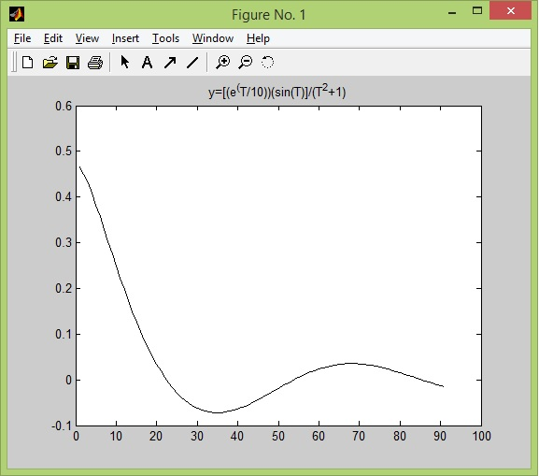

**Exercise 2B**

T = linspace(1,10,91);

y = (exp((T./10)).*sin(T))./(T.^2+1);

plot(T,y,'o-')

title('y=[(e^(T/10))(sin(T)]/(T^2+1)')

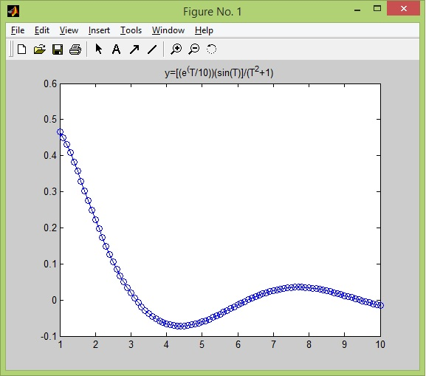

**Exercise 3**

T = 0:0.1:20;

x = sin(T);

y = cos(T);

z = T;

plot3(x,y,z)

title('Circular Helix')

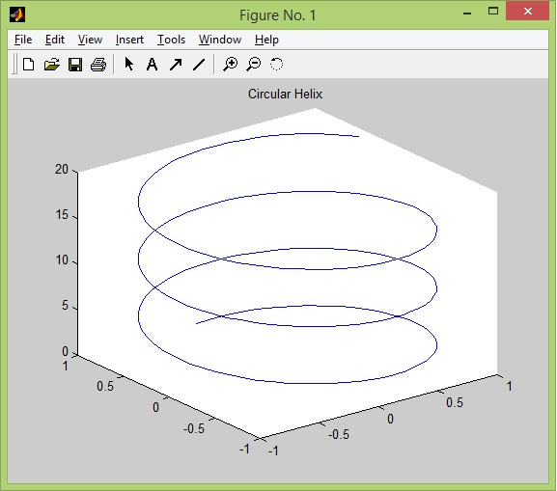

**Exercise 4**

x = 0:0.1:pi;

y = cos(x);

z = (1-((x.^2)/2)+((x.^4)/24));

plot(x,y,'r',x,z,'--')

grid on

title('Exercise 4')

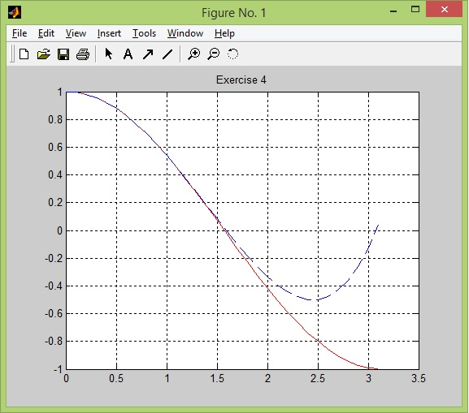

**Exercise 5**

function ex5

x=(0:0.1:4);

y1=f(x,-1);

y2=f(x,0);

y3=f(x,1);

plot(x,y1,'c',x,y2,'m',x,y3,'y');

title('Solutions to dy/dx=x+2');

legend('C=-1','C=0','C=1')

%-----------------------------------------

function [ y ] = f( x,C )

y=(x.^2)/2+2*x+C;

end

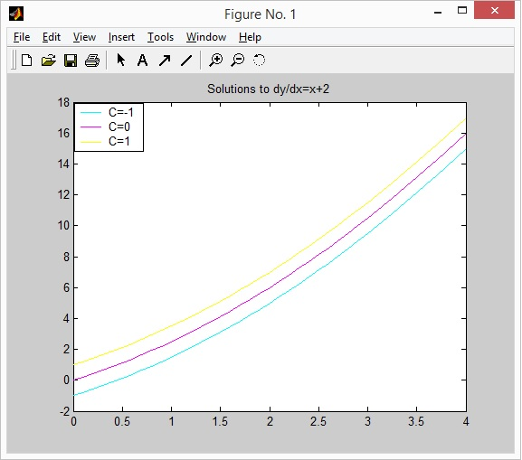

**Exercise 6A**

f=inline('x^3+(y*exp(x))/(x+1)','x','y')

f =

Inline function:

f(x,y) = x^3+(y*exp(x))/(x+1)

f(2,-1)

ans =

5.5370

**Exercise 6B**

f(2,-1)

ans =

5.5370

function [ dydx ] = f( x,y )

dydx=x.^3+(y*exp(x))/(x+1);