Exercise 1

function LAB06ex1

omega0 = 2; c = 1; omega = 1.4;

param = [omega0,c,omega];

t0 = 0; y0 = 0; v0 = 0; Y0 = [y0;v0]; tf = 50;

options = odeset('AbsTol',1e-10,'RelTol',1e-10);

[t,Y] = ode45(@f,[t0,tf],Y0,options,param);

y = Y(:,1); v = Y(:,2);

figure(1)

plot(t,y,'b-'); ylabel('y'); grid on;

t1 = 25; i = find(t>t1);

C = (max(Y(i,1))-min(Y(i,1)))/2;

disp(['computed amplitude of forced oscillation = ' num2str(C)]);

Ctheory = 1/sqrt((omega0^2-omega^2)^2+(c\*omega)^2);

disp(['theoretical amplitude = ' num2str(Ctheory)]);

%----------------------------------------------------------------

function dYdt = f(t,Y,param)

y = Y(1); v = Y(2);

omega0 = param(1); c = param(2); omega = param(3);

dYdt = [ v ; cos(omega\*t)-omega0^2\*y-c\*v ];

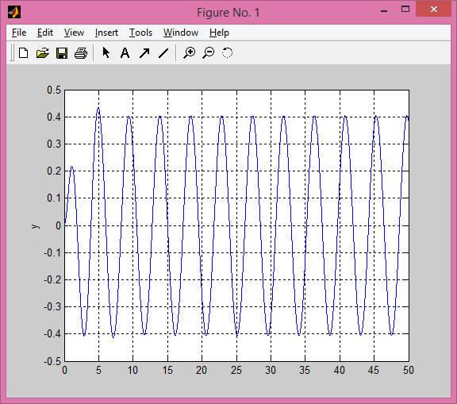

% Exercise 1

% part a, the amplitude of forced oscillations

>> alpha=((1\*1.4)/((2^2) - (1.4^2)))

alpha =

0.6863

>> amc=atan(alpha)

amc =

0.6015

The period of oscillation is about 4.49 seconds. Since ω0 is greater thanω, the first part of the piecewise equation is used. This equations returns: α = 0.6015 radians (I called it *amc*).

% part b

function LAB06ex1

omega0 = 2; c = 1; omega = 1.4;

alpha= atan((c\* omega)/((omega0^2) - (omega^2)));

param = [omega0,c,omega];

t0 = 0; y0 = 0; v0 = 0; Y0 = [y0;v0]; tf = 50;

options = odeset('AbsTol',1e-10,'relTol',1e-10);

[t,Y] = ode45(@f,[t0,tf],Y0,options,param);

y = Y(:,1); v = Y(:,2);

t1 = 25; i = find(t>t1);

C = (max(Y(i,1))-min(Y(i,1)))/2;

y=y-C\*(cos(omega\*t-alpha))

disp(['computed amplitude of forced oscillation = ' num2str(C)]);

Ctheory = 1/sqrt((omega0^2-omega^2)^2+(c\*omega)^2);

disp(['theoretical amplitude = ' num2str(Ctheory)]);

figure(1)

plot(t,y,'b-'); ylabel('y'); grid on;

disp(['alpha = ' num2str(alpha)]);

%----------------------------------------------------------------

function dYdt = f(t,Y,param)

y = Y(1); v = Y(2);

omega0 = param(1); c = param(2); omega = param(3);

dYdt = [ v ; cos(omega\*t)-omega0^2\*y-c\*v ];

0.0000

0.0000

computed amplitude of forced oscillation = 0.40417

theoretical amplitude = 0.40417

alpha = 0.60145

>>

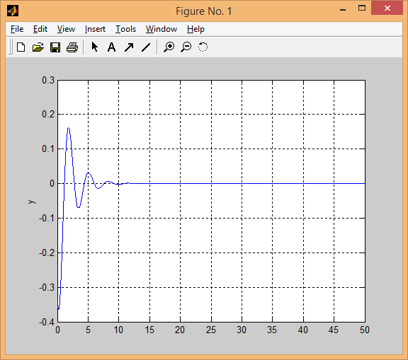

The oscillations decayed exponentially because the complementary solution describes the discrepancy between actual oscillations and forced oscillation. Since the oscillations were quickly forced to the specified oscillation equation, the discrepancy diminished quickly.

% Exercise 2

% part a

function LAB06ex2

omega0 = 2; c = 1;

OMEGA = 1:0.02:3;

C = zeros(size(OMEGA));

Ctheory = zeros(size(OMEGA));

t0 = 0; y0 = 0; v0 = 0; Y0 = [y0;v0]; tf = 50; t1 = 25;

for k = 1:length(OMEGA)

omega = OMEGA(k);

param = [omega0,c,omega];

[t,Y] = ode45(@f,[t0,tf],Y0,[],param);

i = find(t>t1);

C(k) = (max(Y(i,1))-min(Y(i,1)))/2;

Ctheory(k) = 1/sqrt((omega0^2-omega^2)^2+(c\*omega)^2);% FILL-IN

end

figure(2)

plot(OMEGA,Ctheory,'k-',OMEGA,Ctheory,'ro'); grid on;% FILL-IN

xlabel('\omega'); ylabel('C');

%---------------------------------------------------------

function dYdt = f(t,Y,param)

y = Y(1); v = Y(2);

omega0 = param(1); c = param(2); omega = param(3);

dYdt = [ v ; cos(omega\*t)-omega0^2\*y-c\*v ];

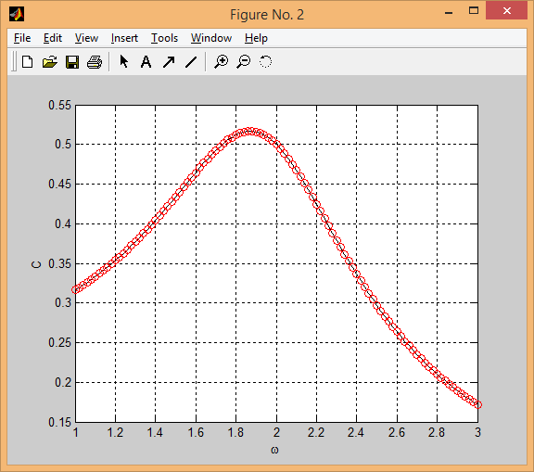

% part(b)

The approximate value of $ω$ that returns the maximum of the graph is $≈$ 1.8733. The corresponding value of *C* is 0.5167, in which 1.8733 is the practical resonance frequency.

% part(c)

omega0 = 2; c = 1;

OMEGA = 1:0.02:3;

syms W;

f(W)= 1/sqrt(((omega0^2) - (W^2))^2+(c\*W)^2);

y=diff(f);

z=solve(y)

f(z)

z =

0

-14^(1/2)/2

14^(1/2)/2

ans =

1/4

(2\*15^(1/2))/15

(2\*15^(1/2))/15

The zero of the function is at $ω$ = 14^(1/2)/2 or 1.871 which returns a value of *C* of (2\*15^(1/2))/15 or 0.5164. This analytical value of $ω$ is just a few ten-thousandths less than the approximation made in part b.

% part(d)

The graph from the beginning, with $ω$ = 14^(1/2)/2

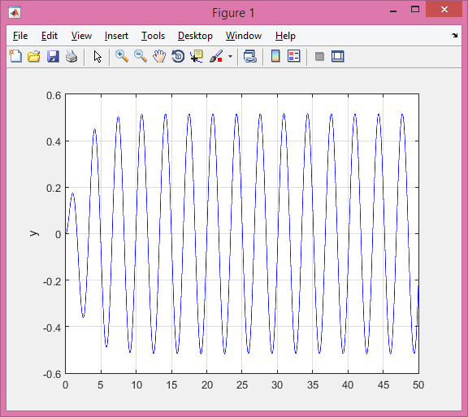

From this graph, the amplitude is about 0.5, which is more than it was in part 1. Theoretically, as $ω$ increases, the amplitude should decrease.

% part e

As the initial condition c was increased, the amplitude of the graph decreased. As the initial condition ω0 was increased, the initial amplitude was increased but the amplitude of the forced oscillation was the same.

From the equation, these changes make sense. Because c is in the denominator, it makes sense that a larger c value would decrease the amplitude. Since *ω*0 determines the initial oscillations, it makes sense that it would initially increase but eventually got damped to the forced oscillation.

%Exercise 3

% part(a)

c = 0

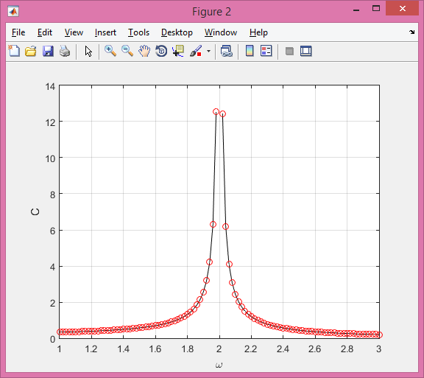

maximal amplitude= 12.5

pure resonant frequency= 2

ω= ω0=2

% part(b)

c=0; ω0= 14^(1/2)/2

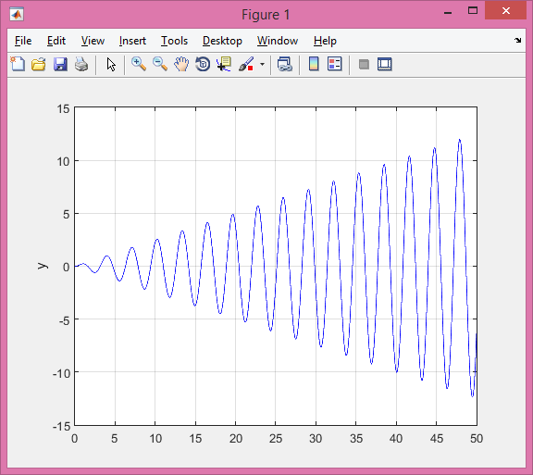

computed amplitude of forced oscillation = 12.1743

theoretical amplitude = Inf

%Exercise 4

%part(a)

function LAB06ex1

clc

omega0 = 2; c = 0; omega = 1.8;

param = [omega0,c,omega];

t0 = 0; y0 = 0; v0 = 0; Y0 = [y0;v0]; tf = 100;

options = odeset('AbsTol',1e-10,'relTol',1e-10);

[t,Y] = ode45(@f,[t0,tf],Y0,options,param);

y = Y(:,1); v = Y(:,2);

C = 1/(omega0^2-omega^2);

A=2\*C\*sin(.5\*(omega0-omega)\*t);

figure(1)

plot(t,y,'b-',t,A,'r',t,-A,'g'); grid on;

t1 = 25; i = find(t>t1);

disp(['computed amplitude of forced oscillation = ' num2str(C)]);

Ctheory = 1/sqrt((omega0^2-omega^2)^2+(c\*omega)^2);

disp(['theoretical amplitude = ' num2str(Ctheory)]);

%----------------------------------------------------------------

function dYdt = f(t,Y,param)

y = Y(1); v = Y(2);

omega0 = param(1); c = param(2); omega = param(3);

dYdt = [ v ; cos(omega\*t)-omega0^2\*y-c\*v ];

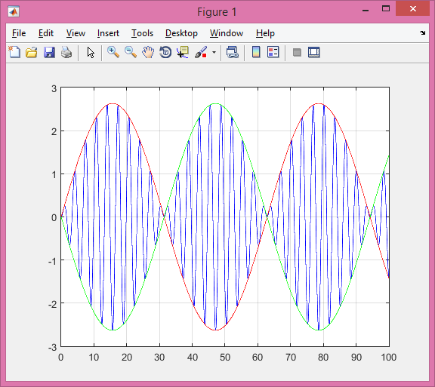

computed amplitude of forced oscillation = 1.3158

theoretical amplitude = 1.3158

%part(b)

The period of fast oscillation from the equation is 62.83s. This is confirmed by the graph:

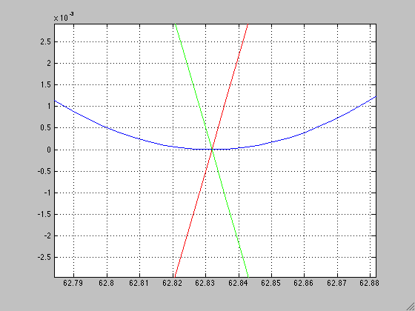

It can be observed that the lines pass the zero at the end of one period at about t=62.832s.

%part(c)

Analytical solution of the length of the graph using the equation 2π/( ω0- ω) = 31.42s. This value is confirmed by the graph:

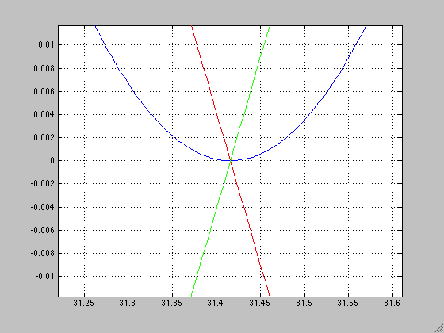

As seen from the graph the first intersection after t=0 is at t= 31.42s.

%part(d)

ω =1.9

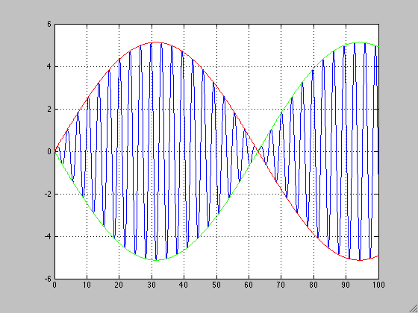

When omega is changed to 1.9, the period of fast oscillation increases to 125.664s and the length of the beats increases to 62.83s. These values are double the values from the last graph.

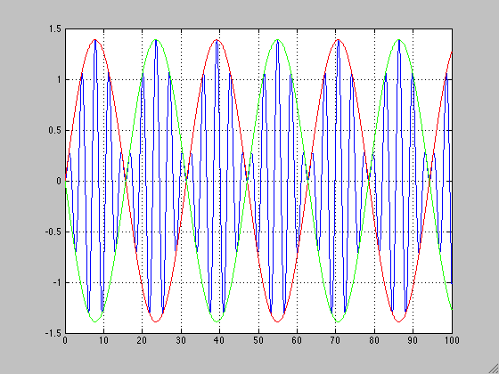 ω = 1.6

When omega is changed to 1.6, the period of fast oscillation decreases to 31.42s and the length of the beats decreases to 15.71s and these values are half of the original values from the graph where ω = 1.8

%part(e)

ω = 0.5

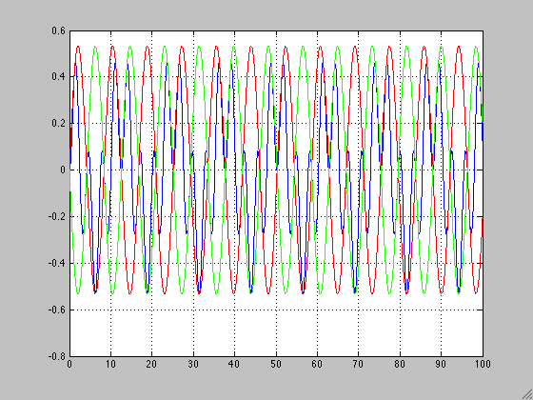

When ω is decreased to 0.5, the beats phenomenon no longer exists and the envelope functions no longer surround the oscillations of the graph. This happens because ω is decreased so much that it decreases the period as well.