# Lab 6

% Exercise 1, part a

function LAB04ex1

format long

t0 = 0;

tf = 40;

Y0 = [-1;0];

[t,Y] = ode45(@f,[t0,tf],Y0);

y = Y(:,1);

v = Y(:,2);

figure(1);

plot(t,y,'b-+',t,v,'ro-')

legend('y(t)','v(t)=y''(t)')

grid on;

ylim([-1.5,1.5]);

[t,Y(:,1)]

figure(2);

plot(y,v)

axis square;

xlabel('y'); ylabel('v=y''(t)');

grid on

ylim([-1.5,1.5]); xlim([-1,1]);

end

function dYdt=f(t,Y)

y = Y(1);

v = Y(2);

dYdt = [v;cos(t)-4*v-3*y];

end

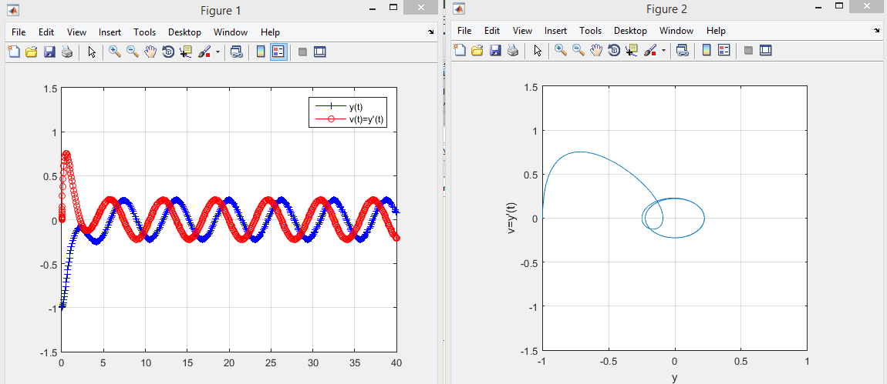

% Exercise 1, Part (b)

Table of approximate t values for which y has a local max or min

|  |  |  |
| --- | --- | --- |
| (t value) | Y(t) | Local min or max |
| 2.134 | -.0903 | max |
| 4.128 | -.2503 | min |
| 7.646 | .2155 | max |
| 10.552 | -.2233 | min |
| 13.663 | .2236 | max |
| 16.785 | -.2234 | min |
| 19.932 | .2235 | max |
| 23.073 | -.2235 | min |
| 26.215 | .2235 | max |
| 29.357 | -.2235 | min |
| 32.498 | .2235 | max |
| 35.639 | -.2235 | min |
| 38.781 | .2235 | max |

% Exercise 1, Part (c)

The long term behavior of y(t) seems to be the same sine wave graph with local maximum value of 0.2235 and local minimum value of -0.2235.

% Exercise 1, Part (d)

function LAB04ex1A

t0 = 0;

tf = 40;

Y0 = [1.5;5];

[t,Y] = ode45(@f,[t0,tf],Y0);

y = Y(:,1);

v = Y(:,2);

figure(1);

plot(t,y,'b-+',t,v,'ro-')

legend('y(t)','v(t)=y''(t)')

grid on;

ylim([-1.5,1.5]);

[t,Y(:,1)]

figure(2);

plot(y,v)

axis square;

xlabel('y'); ylabel('v');

grid on

ylim([-1.5,1.5]); xlim([-1,1]);

end

function dYdt=f(t,Y)

y=Y(1);

v=Y(2);

dYdt=[v; cos(t)-4*v-3*y];

end

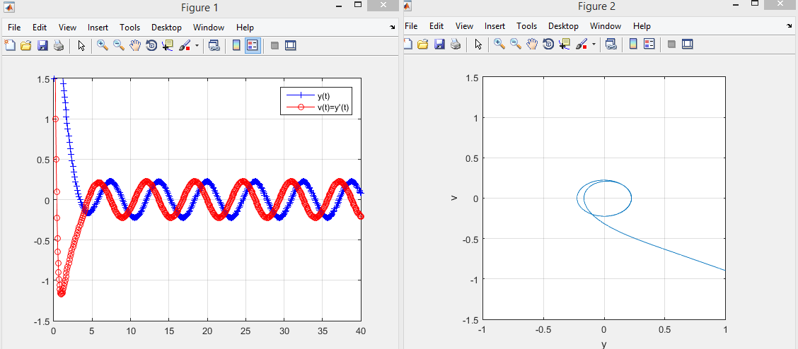

The graph of y(t) with modified initial conditions seems to have similar long term behavior as the previous graph of y(t). This is probably due to the initial conditions, which are the only differences between the two functions.

% Exercise 2, Part (a)

function LAB04ex2A

t0 = 0;

tf = 40;

Y0 = [-1;0];

[t,Y]=ode45(@f,[t0,tf],Y0);

y = Y(:,1);

v = Y(:,2);

[te,Ye]=euler(@f,[0,40],Y0,400);

figure(1);

plot(t,y,'b',t,v,'r')

legend('y(t)','v(t)=y''(t)')

grid on;

figure(2);

plot(y,v,'k')

axis square;

xlabel('y'); ylabel('v');

grid on

% Euler approximation

figure(3);

plot(te,Ye,'r',t,y,'k')

legend('Euler''s Approximation')

end

function dYdt = f(t,Y)

y = Y(1);

v = Y(2);

dYdt = [v;cos(t)-4*v*y^2-3*y];

end

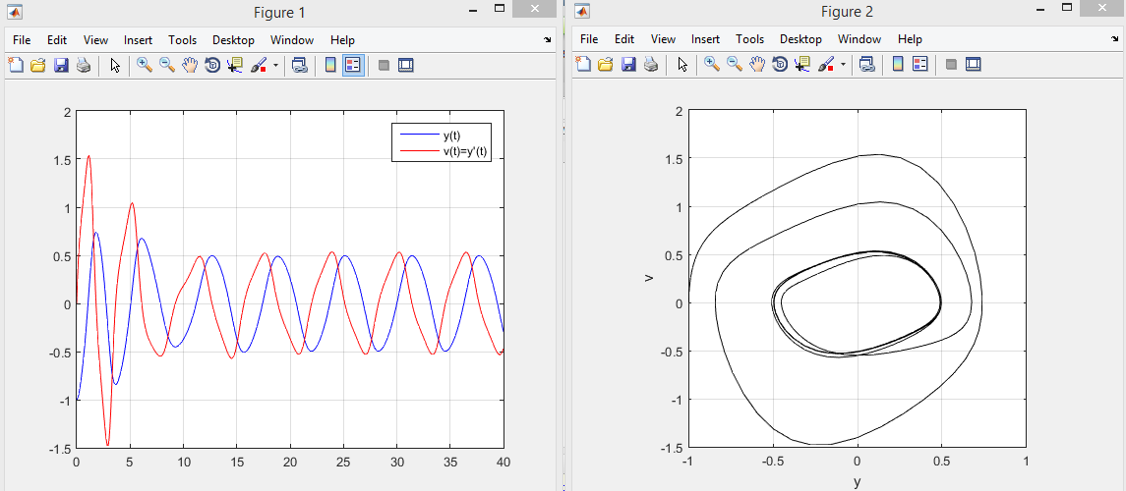

% Exercise 2, Part (b)

There is no correlation between the short-term behaviors between the output of this function and the previous function in exercise 1.

%Part c

When observing the long-term behavior, the t values for the local extrema are the same for both graphs. Additionally, the maximum and minimum values for both graphs have the same magnitude with opposite signs.

% Exercise 2, Part (d)

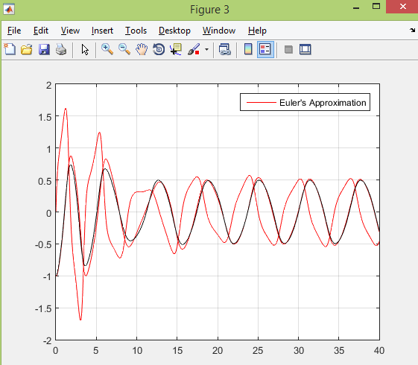

% Exercise 3

function LAB04ex3A

t0 = 0;

tf = 40;

Y0=[-1;0];

[t,Y] = ode45(@f,[t0,tf],Y0);

y = Y(:,1);

v = Y(:,2);

figure(1);

plot(t,y,'b-+',t,v,'ro-')

legend('y(t)','v(t)=y''(t)')

grid on;

ylim([-2,2]);xlim([0,40]);

figure(2);

plot(y,v)

axis square;

xlabel('y'); ylabel('v');

grid on

end

function dYdt=f(t,Y)

y = Y(1);

v = Y(2);

dYdt = [v;cos(t)-4*v*y-3*y];

end

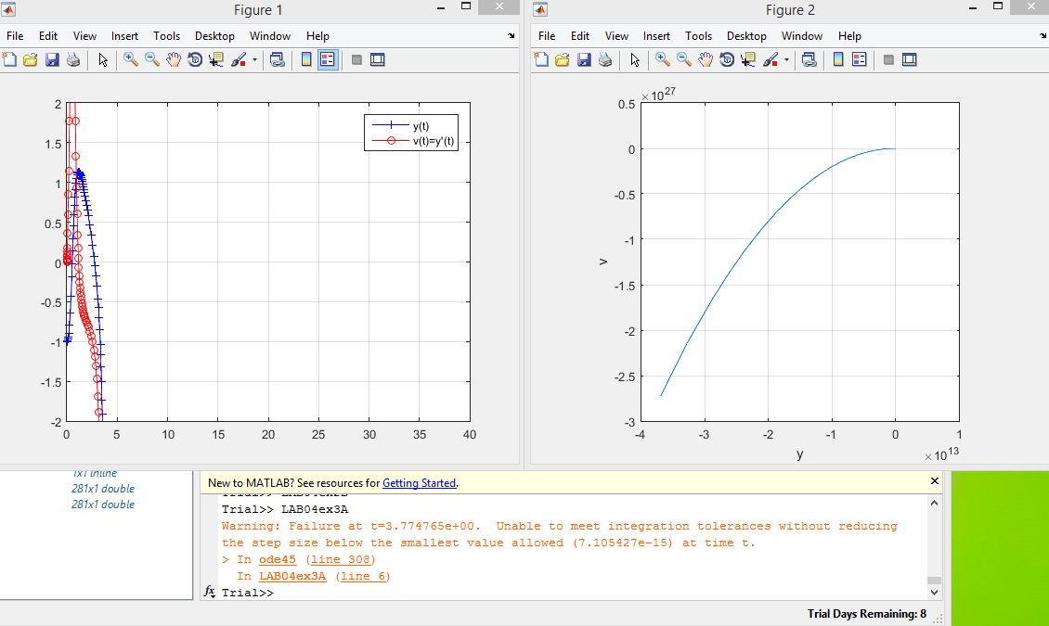

The solutions in Exercise 3 are significantly different than the solutions in Exercise 2. The graph outputs look completely different. Additionally, MATLAB gave a warning message as follows:

Warning: Failure at t=3.774765e+00. Unable to meet integration tolerances without reducing the step size below the smallest value allowed (7.105427e-15) at time t.

> In ode45 (line 308)

In LAB04ex3A (line 6)

This warning refers to the “stiffness” of the solution at that point because it is varying slowly while all the other solutions around it are varying more rapidly.

% Exercise 4, Part (a)

function LAB04ex4D

t0 = 0;

tf = 40;

Y0 = [-1;0;4]

[t,Y] = ode45(@f,[t0,tf],Y0);

y = Y(:,1);

v = Y(:,2);

w = Y(:,3);

figure(1);

plot(t,y,'b-+',t,v,'ro-',t,w,'k')

legend('y(t)','v(t)=y''(t)','w(t)=y''''(t)')

grid on;

ylim([-1.5,1.5]);

figure(2);

plot3(y,v,w,'k.-');

axis square;

xlabel('y'); ylabel('v=y'''); zlabel('w=y''''')

grid on

view([-40,60])

end

function dYdt = f(t,Y)

y = Y(1);

v = Y(2);

w = Y(3);

dYdt = [v;w;-sin(t)-4*y^2*w-8*y*v^2-3*v];

end

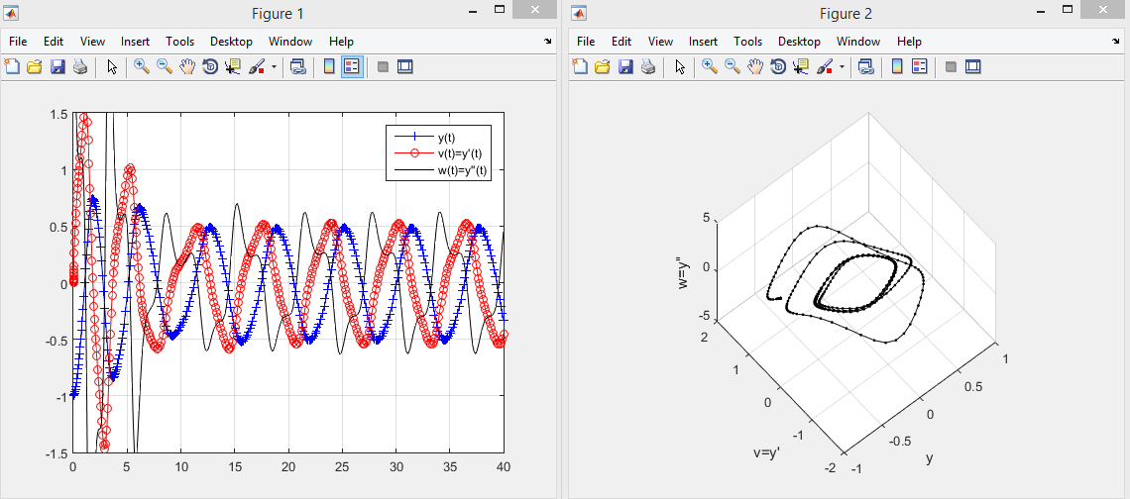

% Exercise 4, Part (b)

When comparing the wave graph from Part (a) with the wave graph from Exercise 2, Part(a), it seems that two of the time series graphs are the same. In this case, both red and blue graphs from each part correspond with each other quite closely.

% Exercise 4, Part (c)

The derivative of the ODE is $\frac{d^{3}y}{{dt}^{3}}+ \frac{4y^{2}d^{2}y}{dt^{2}}+8y(\frac{dy}{dt})^{2}+3y\frac{dy}{dt}$

% Exercise 4, Part (d)

The reason is that the derivative of the first ODE depends on the solution of the second ODE.