**MAT 343 MATLAB LAB 1 NAME: _Hieu Pham____**

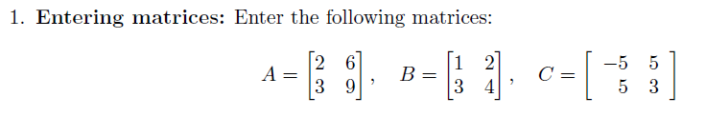

% Question 1

A=[2,6;3,9]; B=[1,2;3,4]; C=[-5,5;5,3];

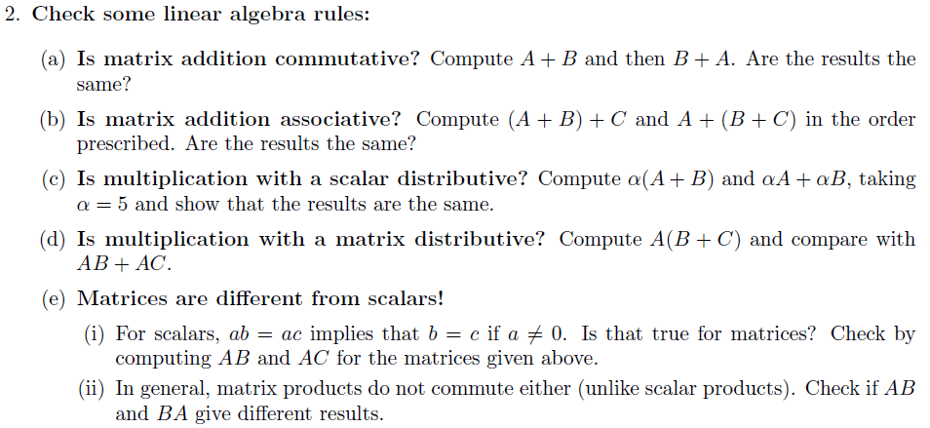

% Question 2(a)

A + B

ans =

3 8

6 13

B + A

ans =

3 8

6 13

% Yes, Matrix addition is commutative

**MAT 343 MATLAB LAB 1 NAME: _Hieu Pham____**

% Question 2(b)

(A+B)+C

ans =

-2 13

11 16

A+(B+C)

ans =

-2 13

11 16

% Yes, Matrix addition is associattive

% Question 2(c)

alpha = 5

alpha =

5

alpha*(A+B)

ans =

15 40

30 65

(alpha*A)+(alpha*B)

ans =

15 40

30 65

% Yes, multiplication with a scalar is distributive

% Question 2(d)

A*(B+C)

**MAT 343 MATLAB LAB 1 NAME: _Hieu Pham____**

ans =

40 56

60 84

(A*B)+(A*C)

ans =

40 56

60 84

% Yes, multiplication with matrix is distributive

% Question 2(e)

(A*B)

ans =

20 28

30 42

(A*C)

ans =

20 28

30 42

B

B =

1 2

3 4

C

C =

-5 5

5 3

**MAT 343 MATLAB LAB 1 NAME: _Hieu Pham____**

% AB = AC, but B != C . Matrix differs from scalar.

% (2e.2) Matrix product commutativeness

A*B

ans =

20 28

30 42

B*A

ans =

8 24

18 54

% Matrix products are not commutative

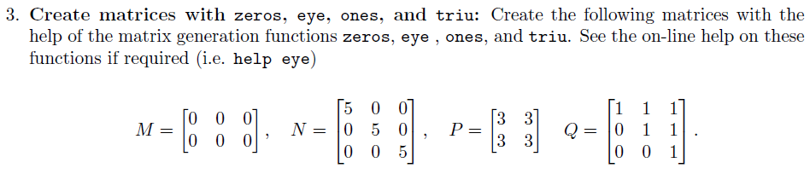

% Question 3

M=zeros(2,3)

M =

0 0 0

0 0 0

N=(5*eye(3))

**MAT 343 MATLAB LAB 1 NAME: _Hieu Pham____**

N =

5 0 0

0 5 0

0 0 5

P=(3*ones(2))

P =

3 3

3 3

Q=triu(ones(3),1)

Q =

0 1 1

0 0 1

0 0 0

% Not right, try again below...

Q=triu(ones(3),0)

Q =

1 1 1

0 1 1

0 0 1

% Question 3 complete

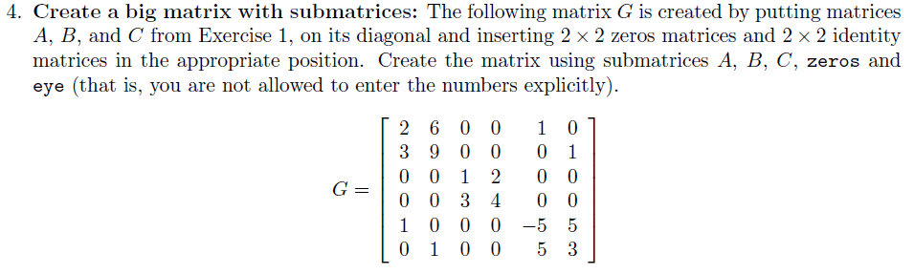

**MAT 343 MATLAB LAB 1 NAME: _Hieu Pham____**

% Question 4

% Create a big matrix by assembling submatrices

G=[A,zeros(2),eye(2);zeros(2),B,zeros(2);eye(2),zeros(2),C]

G =

2 6 0 0 1 0

3 9 0 0 0 1

0 0 1 2 0 0

0 0 3 4 0 0

1 0 0 0 -5 5

0 1 0 0 5 3

% Question 4 complete

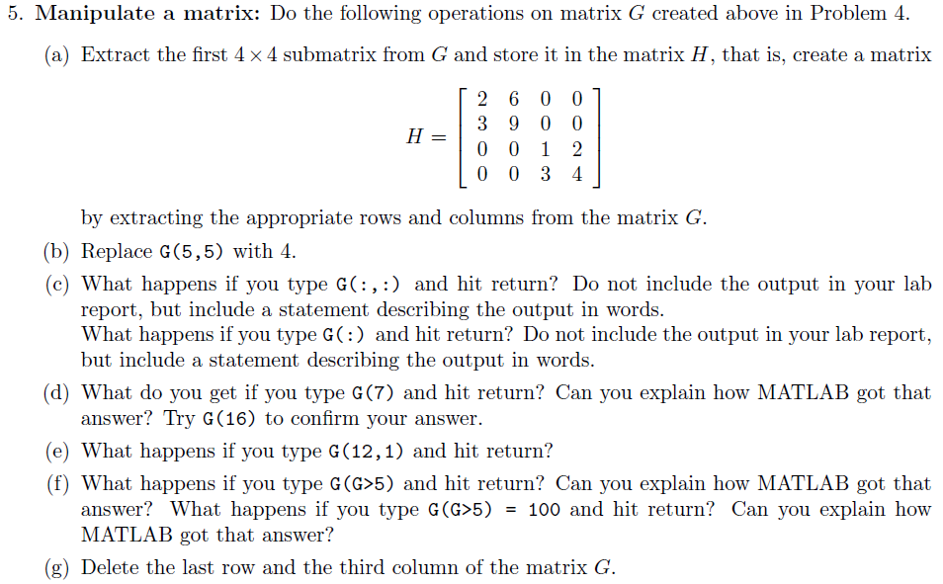

**MAT 343 MATLAB LAB 1 NAME: _Hieu Pham____**

% Question 5

% 5(a) Extract the first 4x4 submatrix grom G

H=G(1:4,1:4)

H =

2 6 0 0

3 9 0 0

0 0 1 2

0 0 3 4

% 5(b)

G(5,5)=4

G =

2 6 0 0 1 0

3 9 0 0 0 1

0 0 1 2 0 0

0 0 3 4 0 0

1 0 0 0 4 5

0 1 0 0 5 3

% 5(c)

G(:,:)

ans =

2 6 0 0 1 0

3 9 0 0 0 1

0 0 1 2 0 0

0 0 3 4 0 0

1 0 0 0 4 5

0 1 0 0 5 3

**MAT 343 MATLAB LAB 1 NAME: _Hieu Pham____**

% Another way to display matrix G entirely

G(:);

% This command connects matrix elements from first column

% to last column in a zigzag fashion in which the tail of

% one column connects to the head of another, resulting in

% a continuous vertical display of all elements.

% 5(c) complete

G(7)

ans =

6

% Element 7 is in column 2 of the first row. G(16) should return a 3

G(16)

ans =

3

% 5(d) complete

G(12,1)

??? Index exceeds matrix dimensions.

% We only have 6 rows here. Row 12-Column 1 does not exist.

% 5(e) complete

G(G>5)

ans =

6

9

% Matlab searches each element within matrix G for anything > 5

% If found, element location is marked. The process continued

**MAT 343 MATLAB LAB 1 NAME: _Hieu Pham____**

% until all elements have been searched and marked. Then Matlab

% displays the findings upon completion.

G(G>5)=100

G =

2 100 0 0 1 0

3 100 0 0 0 1

0 0 1 2 0 0

0 0 3 4 0 0

1 0 0 0 4 5

0 1 0 0 5 3

% Same search mechanism as in the step before, except

% the matrix is updated with values given in the search command.

% 5(f) complete

G(:,3)=[];G(6,:)=[];G

G =

2 100 0 1 0

3 100 0 0 1

0 0 2 0 0

0 0 4 0 0

1 0 0 4 5

% Delete the last row and the third column of matrix G

% 5(g) complete

**MAT 343 MATLAB LAB 1 NAME: _Hieu Pham____**

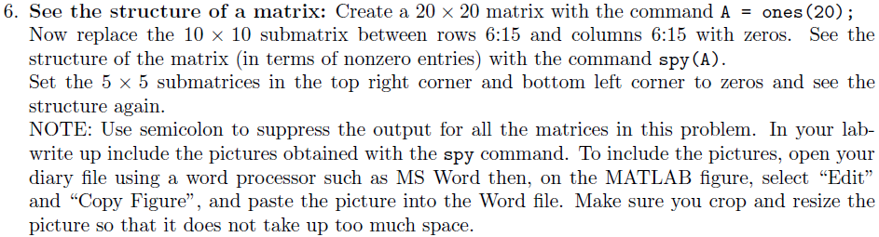

% Question 6

A=ones(20);

A(6:15,6:15) = zeros(10);

spy(A)

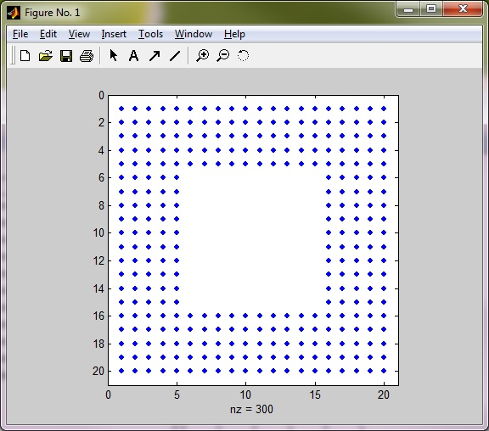

A(1:5,1:5) = zeros(5);

A(16:20,16:20) = zeros(5);

**MAT 343 MATLAB LAB 1 NAME: _Hieu Pham____**

spy(A)

% Question 6 complete

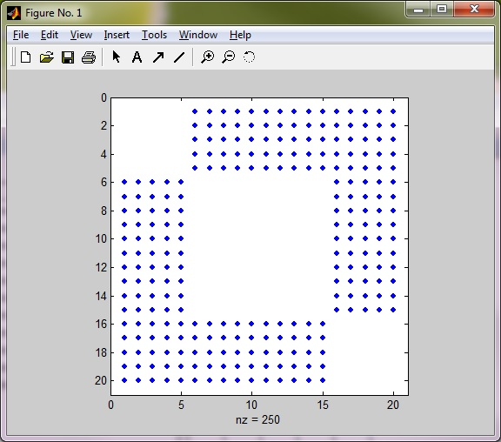

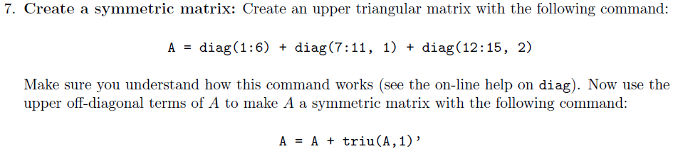

**MAT 343 MATLAB LAB 1 NAME: _Hieu Pham____**

% Question 7

A=(diag(1:6) + diag(7:11,1) + diag(12:15,2))

A =

1 7 12 0 0 0

0 2 8 13 0 0

0 0 3 9 14 0

0 0 0 4 10 15

0 0 0 0 5 11

0 0 0 0 0 6

A=A + triu(A,1)'

A =

1 7 12 0 0 0

7 2 8 13 0 0

12 8 3 9 14 0

0 13 9 4 10 15

0 0 14 10 5 11

0 0 0 15 11 6

% Commands produced expected results.

% Question 7 complete

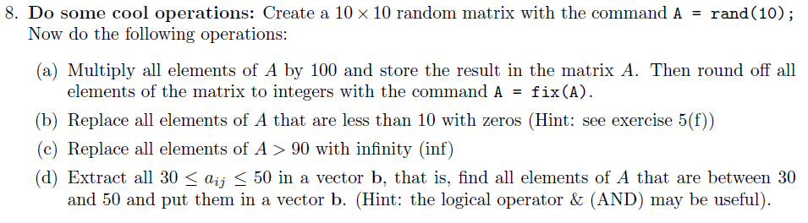

**MAT 343 MATLAB LAB 1 NAME: _Hieu Pham____**

% Question 8

A=rand(10);

A=100*A;

A=fix(A)

A =

58 20 41 21 68 45 60 8 12 23

42 37 30 64 21 4 1 45 45 23

51 78 87 32 83 2 1 44 71 4

33 68 1 96 62 31 19 35 89 7

43 46 76 72 13 1 58 15 27 64

22 56 97 41 20 38 5 67 25 19

57 79 99 74 60 68 36 69 86 84

76 5 78 26 62 9 63 72 23 17

52 60 43 43 37 3 71 47 80 17

64 5 49 93 57 61 69 55 90 99

A(A<10)=0

A =

58 20 41 21 68 45 60 0 12 23

42 37 30 64 21 0 0 45 45 23

51 78 87 32 83 0 0 44 71 0

33 68 0 96 62 31 19 35 89 0

43 46 76 72 13 0 58 15 27 64

22 56 97 41 20 38 0 67 25 19

57 79 99 74 60 68 36 69 86 84

76 0 78 26 62 0 63 72 23 17

52 60 43 43 37 0 71 47 80 17

**MAT 343 MATLAB LAB 1 NAME: _Hieu Pham____**

64 0 49 93 57 61 69 55 90 99

A(A>90)=inf

A =

58 20 41 21 68 45 60 0 12 23

42 37 30 64 21 0 0 45 45 23

51 78 87 32 83 0 0 44 71 0

33 68 0 Inf 62 31 19 35 89 0

43 46 76 72 13 0 58 15 27 64

22 56 Inf 41 20 38 0 67 25 19

57 79 Inf 74 60 68 36 69 86 84

76 0 78 26 62 0 63 72 23 17

52 60 43 43 37 0 71 47 80 17

64 0 49 Inf 57 61 69 55 90 Inf

b=A((A>=30) & (A<=50))

b =

42

33

43

37

46

41

30

43

49

32

41

**MAT 343 MATLAB LAB 1 NAME: _Hieu Pham____**

43

37

45

31

38

36

45

44

35

47

45

% Question 8 complete. The logical AND (&) is helpful indeed.