**MAT 343 MATLAB LAB 4 NAME: _Hieu Pham____**

%Lab 4 exercises

%Question1

clf

T = [-0.5, 0, 0.5, -0.5; -1, 1, -1, -1]

plot(T(1,:),T(2,:),'linewidth',2)

hold on

R = [0,1;1,0];

RT = R*T;

plot(RT(1,:),RT(2,:),'r','linewidth',2)

grid on

axis equal

legend('Original Triangle','Reflected Trinagle')

title('Reflection across 45 deg.')

hold off

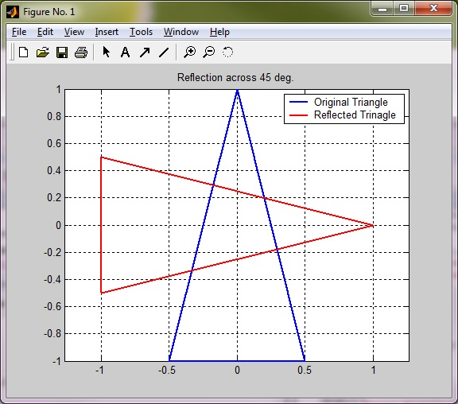

**MAT 343 MATLAB LAB 4 NAME: _Hieu Pham____**

%Lab 4 exercises

%Question2

clf

T = [-.5,0,.5,-.5;-1,1,-1,-1];

plot(T(1,:),T(2,:),'linewidth',2)

hold on

Q = [cos(pi/4),sin(pi/4);-sin(pi/4),cos(pi/4)];

R = [0,1;1,0];

RQT = R*Q*T;

plot(RQT(1,:),RQT(2,:),'r','linewidth',2)

grid on

axis equal

legend('Original Triangle','Reflected Trinagle')

title('Reflection across 45 deg. after 45 deg. rotation counterclockwise')

hold off

%Answer from question 2 and example 4 of the lab document are not the same.

%The order which matrices are multiplied matters. Triangle will be found

%in quadrant II instead of quadrant I if R multiplied first.

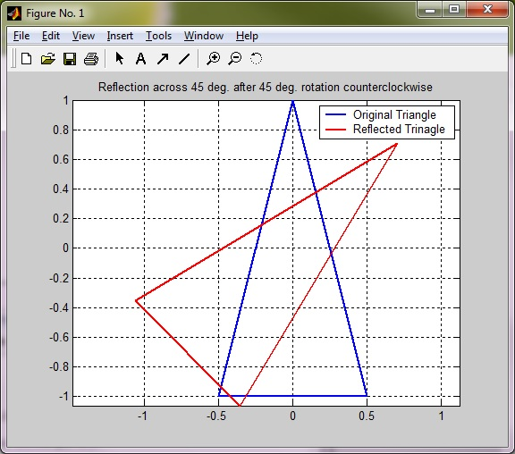

**MAT 343 MATLAB LAB 4 NAME: _Hieu Pham____**

%Lab 4 exercises

%Question3

clf

T = [-.5,0,.5,-.5;-1,1,-1,-1];

Q = [cos(pi/20),-sin(pi/20);sin(pi/20),cos(pi/20)];

p = plot(T(1,:),T(2,:));

axis([-2,2,-2,2])

axis square

figure(gcf)

hold on

for i = 1:40

T = Q*T;

set(p,'xdata',T(1,:),'ydata',T(2,:));

pause(0.1)

end

for i = 1:40

T = Q'*T;

set(p,'xdata',T(1,:),'ydata',T(2,:));

pause(0.1)

end

hold off

%The rotating triangle based on example 5

**MAT 343 MATLAB LAB 4 NAME: _Hieu Pham____**

%Lab 4 exercises

%Question4

%Triangle rotates counterclockwise,

%gets bigger and escapes the frame, and then shrinks back into the frame

%to original location.

clf

T = [-.5,0,.5,-.5;-1,1,-1,-1];

D = 1.25*eye(2);

Q = [cos(pi/20),-sin(pi/20);sin(pi/20),cos(pi/20)];

p = plot(T(1,:),T(2,:));

axis([-10,10,-10,10])

axis square

figure(gcf)

hold on

for i = 1:40

T = Q*D*T;

set(p,'xdata',T(1,:),'ydata',T(2,:));

pause(0.1)

end

D=.8

for i = 1:40

T = Q'*D*T;

set(p,'xdata',T(1,:),'ydata',T(2,:));

pause(0.1)

end

**MAT 343 MATLAB LAB 4 NAME: _Hieu Pham____**

%Lab 4 exercises

%Question5, part A

%The script is similar to example 6

%except for 20 iterations.

clf

T=[-0.5,0,0.5,-0.5;-1,1,-1,-1;1,1,1,1];

c1 = .1;

c2 = .1;

M1 = [1,0,c1;0,1,c2;0,0,1];

M2 = [1,0,-c1;0,1,0;0,0,1];

M3 = [1,0,c1;0,1,-c2;0,0,1];

p = plot(T(1,:),T(2,:));

axis([-7,9,-7,7])

axis square

figure(gcf)

grid on

for i = 1:20

T = M1*T;

set(p,'xdata',T(1,:),'ydata',T(2,:));

pause(0.1)

end

for i = 1:40

T=M2*T;

set(p,'xdata',T(1,:),'ydata',T(2,:));

pause(0.1)

end

for i = 1:20

T = M3*T;

set(p,'xdata',T(1,:),'ydata',T(2,:));

pause(0.1)

end

**MAT 343 MATLAB LAB 4 NAME: _Hieu Pham____**

%Lab 4 exercises

%Question5, part B

%Q has the following dimensions:

%Q =

%

% 0.9969 -0.0785 1.0000

% 0.0785 0.9969 1.0000

% 0 0 1.0000

clf

T=[-0.5,0,0.5,-0.5;-1,1,-1,-1;1,1,1,1];

c1 =.1;

c2 = .1;

M1 = [1,0,c1;0,1,c2;0,0,1];

M2 = [1,0,-c1;0,1,0;0,0,1];

M3 = [1,0,c1;0,1,-c2;0,0,1];

Q = [cos(pi/40), -sin(pi/40), 1; sin(pi/40), cos(pi/40), 1; 0,0,1]

p = plot(T(1,:),T(2,:));

axis([-40,10,-10,40])

axis square

figure(gcf)

grid on

for i = 1:20

T = Q*M1*T;

set(p,'xdata',T(1,:),'ydata',T(2,:));

pause(0.1)

end

for i = 1:40

T = Q*M2*T;

set(p,'xdata',T(1,:),'ydata',T(2,:));

pause(0.1)

end

for i = 1:40

T = Q*M3*T;

set(p,'xdata',T(1,:),'ydata',T(2,:));

pause(0.1)

end