**MAT 343 MATLAB LAB 5 NAME: _Hieu Pham____**

%Lab 5 - Question 1

x = [1:1:100]';

%Note the prime

y = randn(size(x));

% a column vector of 100 standard normal values.

X = [ones(size(x)),x];

% build the matrix X for linear model

z = X'*y;

% right hand side of the Normal Equations

S = X'*X;

% Left hand side of the Normal Equations

U = chol(S);

% Cholesky decomposition

w = U'\z;

% solve the normal equations using the Cholesky decomposition

c = U\w;

plot(x,y,'.','MarkerSize',7)

% plot the data points

q = 1:0.1:100;

% define a vector for plotting the linear fit

fit = c(1)+c(2)*q;

% define the linear fit

hold on

plot(q,fit,'r');

% plot the linear fit together with the data points

**MAT 343 MATLAB LAB 5 NAME: _Hieu Pham____**

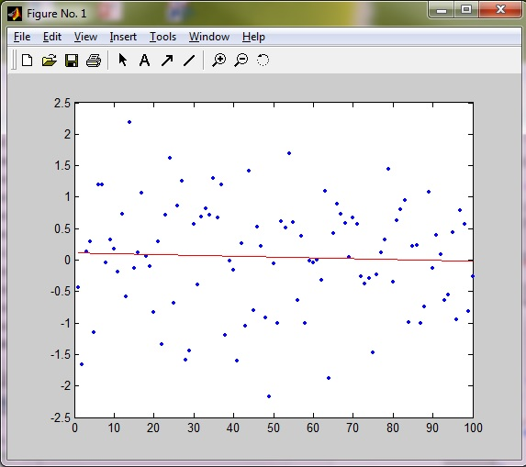

format short e

c

c =

1.1474e-001

-1.3229e-003

%The equation is y = (1.1474e-001)x - -1.3229e-003

%Question 1, Part B - Observation

%Strong correlations revealed in the composition above are expected due

%to uniform distribution of the points. y formed an nxn matrix consisting of

%P which is the size of x.

**MAT 343 MATLAB LAB 5 NAME: _Hieu Pham____**

%Lab 5 - Question 2

dat=load('co2.dat');

%Load raw data into the dat matrix

year=dat(:,1); %Year is first column

conc=dat(:,2); %Concentration level is second column

plot(year,conc,'o') %Plot out the data

%Lab 5 - QUestion 2 - Part A

%Following example 1 to compute best-fit line

X= [ones(size(year)),year];

z=X'*conc;

S=X'*X;

U=chol(S);

w=U'\z;

format short e

c=U\w

c =

-2.4718e+003

1.4204e+000

fit=c(1)+c(2)*year;

hold on

plot(year,fit,'k','linewidth',2)

axis tight

%Lab 5 - Question 2 - Part B

X=[ones(size(year)),year,year.^2];

z=X'*conc;

S=X'*X;

U=chol(S);

w=U'\z

w =

2.4137e+003

1.4061e+002

1.5018e+001

c2=U\w

c2 =

**MAT 343 MATLAB LAB 5 NAME: _Hieu Pham____**

4.4715e+004

-4.6174e+001

1.2000e-002

fit2=c2(1)+c2(2)*year+c2(3)*year.^2;

plot(year,fit2,'r','linewidth',2)

legend('data points','linear fit','quadratic fit',2)

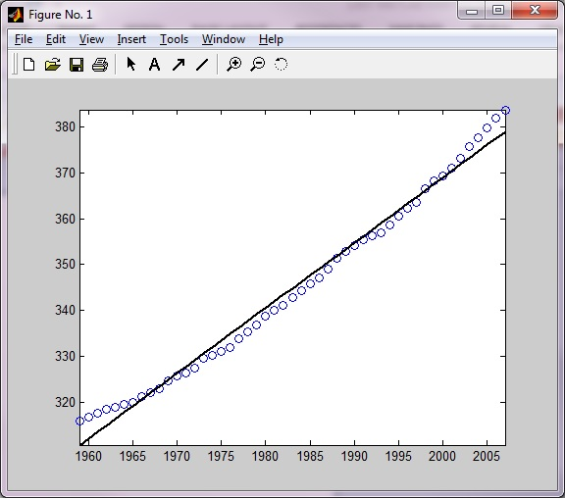

c (Part A) =

-2.4718e+003

1.4204e+000

**MAT 343 MATLAB LAB 5 NAME: _Hieu Pham____**

w =

2.4137e+003

1.4061e+002

1.5018e+001

c2 (Part B) =

4.4715e+004

-4.6174e+001

1.2000e-002

%Lab 5 - Question 3

format short e

dat = load('co2.dat');

x= [1;2;3;4;5;6;7;8;9;10];

y= [222;227;223;233;244;253;260;266;270;266];

hold on

X = [ones(size(x)),x,x.^2,x.^3];

z = X'*y;

S = X'*X;

U = chol(S);

w = U'\z;

c = U\w

c =

2.3023e+002

-1.0309e+001

3.7302e+000

-2.3388e-001

w

w =

7.7919e+002

5.5158e+001

-2.9593e+000

-1.2998e+001

plot(x,y,'.')

**MAT 343 MATLAB LAB 5 NAME: _Hieu Pham____**

axis tight

q = 1:.1:10;

fit = c(1)+c(2)*q+c(3)*q.^2+c(4)*q.^3;

plot(q,fit,'k','linewidth',2);

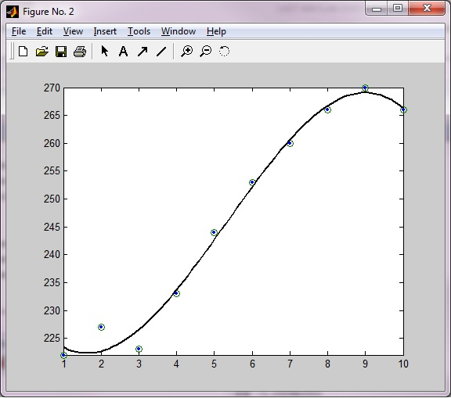

c (Part 2) =

2.3023e+002

-1.0309e+001

3.7302e+000

-2.3388e-001

**MAT 343 MATLAB LAB 5 NAME: _Hieu Pham____**

%Lab 5 - Question 3 - Part B

c2 = X\y

c2 =

2.3023e+002

-1.0309e+001

3.7302e+000

-2.3388e-001

c2 = c2([4:-1:1]);

q2 = 1:.1:10;

z2 = polyval(c2,q2);

figure

plot(q2,z2,x,y,'o');

hold off

%c values for part B

c2

c2 =

-2.3388e-001

3.7302e+000

-1.0309e+001

2.3023e+002

