**MAT 343 MATLAB LAB 6 NAME: _Hieu Pham____**

%Load picture file to MatLAB

A=imread('cauchybw.jpg');

B=double(A(:,:,1))+1;

B=B/256;

[U,S,V]=svd(B);

%Problem 1

sizeu=size(U)

sizeu =

**310 310**

sizes=size(S)

sizes =

**310 338**

sizev=size(V)

sizev =

**338 338**

%Problem 2

rank1=S(1,1)*U(:,1)*V(:,1)';

C=zeros(size(A));

C(:,:,1)=rank1;

C(:,:,2)=rank1;

C(:,:,3)=rank1;

C=max(0,min(1,C));

figure(1)

image(C)

**MAT 343 MATLAB LAB 6 NAME: _Hieu Pham____**

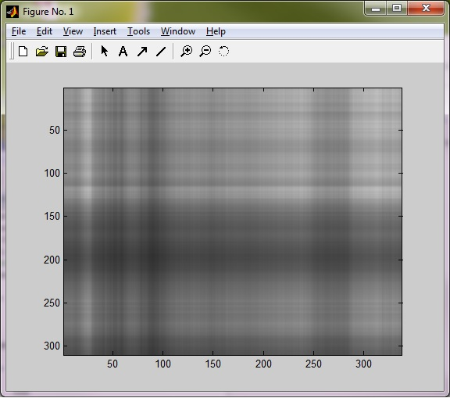

%Problem 3

for i=1:10

rank10=rank10+S(i,i)*U(:,i)*V(:,i)';

end

C=zeros(size(A));

C(:,:,1)=rank10;

C(:,:,2)=rank10;

C(:,:,3)=rank10;

C=max(0,min(1,C));

figure(2)

image(C)

**MAT 343 MATLAB LAB 6 NAME: _Hieu Pham____**

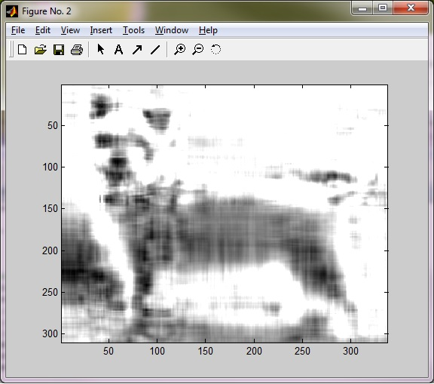

%Problem 4

rank50 = zeros(size(B));

for i = 1:50

rank50 = rank50+S(i,i)*U(:,i)*V(:,i)';

end

C = zeros(size(A));

C(:,:,1) = rank50;

C(:,:,2) = rank50;

C(:,:,3) = rank50;

C = max(0,min(1,C));

figure(3)

image(C)

**MAT 343 MATLAB LAB 6 NAME: _Hieu Pham____**

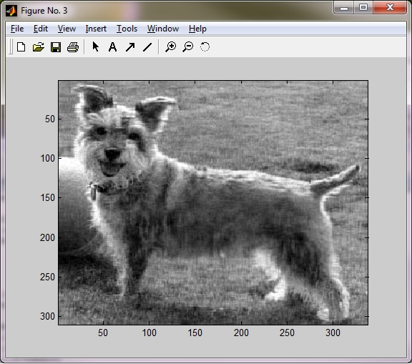

%I like the rank of 50 because it provided a good better approximation to the original %picture.

%Problem 5

rank310 = zeros(size(B));

for i = 1:310

rank310 = rank310+S(i,i)*U(:,i)*V(:,i)';

end

C = zeros(size(A));

C(:,:,1) = rank310;

C(:,:,2) = rank310;

C(:,:,3) = rank310;

C = max(0,min(1,C));

figure(3)

image(C)

**MAT 343 MATLAB LAB 6 NAME: _Hieu Pham____**

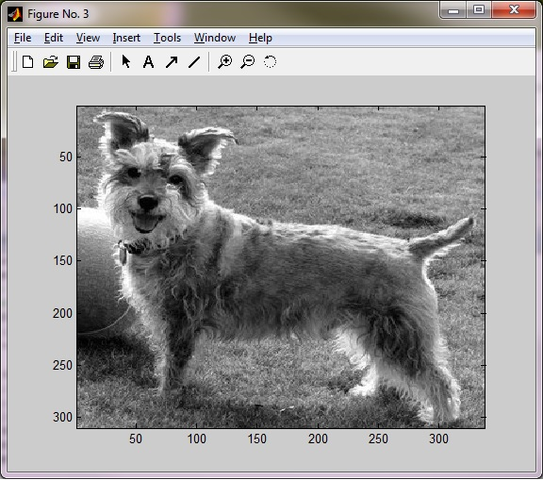

**rank(B)**

**ans =**

**310**

%Problem 6

a = 310;b = 338;c = 53;CR = (c*(a+b+1))/(a*b)

CR =

0.3283

% CR (Compression Rate) = 32.83%

% so 32.83% of the original picture was used

% as the approximation

a = 310;b = 338;CR = 1;c = ((CR*a*b)/(a+b+1))

**MAT 343 MATLAB LAB 6 NAME: _Hieu Pham____**

c =

161.4484

% c=161.4484 will give me the same amount of data as the original picture.

% Rounding up is better. Otherwise I will have less data than the original picture.

% I only need the amount of data that is the same as the original picture.