A **proposition** is a declarative sentence (that is, a sentence that declares a fact) that is either true

or false, but not both.

x + 1 = 3 is not a proposition because we don’t know what x is to determine true/false value of the proposition.

x + y = z is not a proposition because we don’t know what x, y, z values.

1 + 2 = 7 is (even though it’s false, but it is a proposition.)

Washington D.C is the capital of the US is (also a true proposition.)

We use letter to represent a proposition, example: p, q, r.

Example: let p be the proposition that “Toronto is the capital of Yemen”.

Negation of proposition: use the ~ or the $¬$ operators to denote negation.

Example: ~p or $¬$ p to negate p.

Negation is thought of, and expressed as “It is not the case that p”, whatever the proposition p happens to be.

Truth table: Table holding True (T) / False (F) values of the proposition.

Conjunction: it is equivalent to logical AND, denoted by $∧$ operator.

Disjunction: it is equivalent to logical OR, denoted by $∨$ operator.

2-Input Exclusive OR (XOR) takes the $⨁$ operator. XOR logic (2 similar inputs equal False. 2 different inputs equal True).

Conditional: Is denoted by the $→$ operator. Let’s say we have 2 propositions p and q. *p $→$* *q* holds False only when p is True AND q is False. Any other conditions result in True.

Normal condition: *p $→$* *q*

Converse condition: *q $→$* *p*

Inverse condition: $¬$*p $→$ $¬$* *q*

Contrapositive condition: $¬$*q $→$ $¬$* *p*

Biconditional: Is denoted by the $↔$ operator: It has the XNOR ($¬⨁$) Logic.

Logical Equivalence: 2 compound propositions having the same truth.

Logical Precedence:

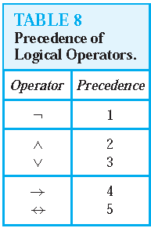

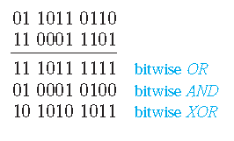

Propositional Equivalences:

A compound proposition that is always true, no matter what the truth values of the propositional variables that occur in it, is called a *tautology*.

A compound proposition that is always false is called a *contradiction*.

A compound proposition that is neither a tautology nor a contradiction is called a *contingency*.

The compound propositions *p* and *q* are called *logically equivalent* if *p* ↔ *q* is a tautology. The notation *p* ≡ *q* denotes that *p* and *q* are logically equivalent.

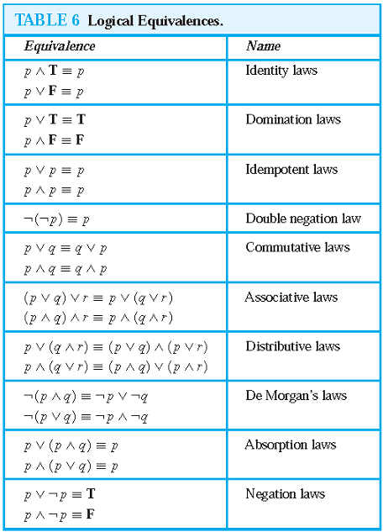

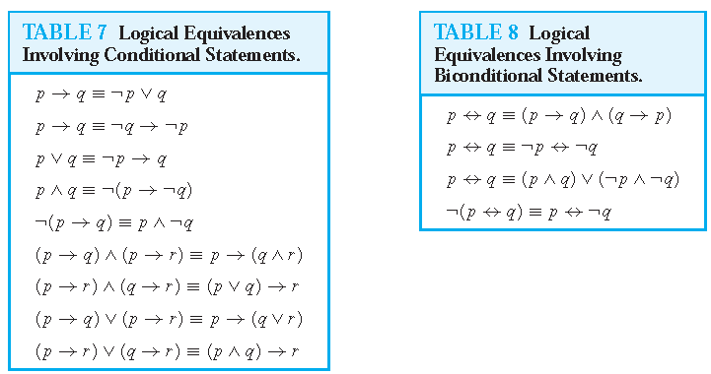

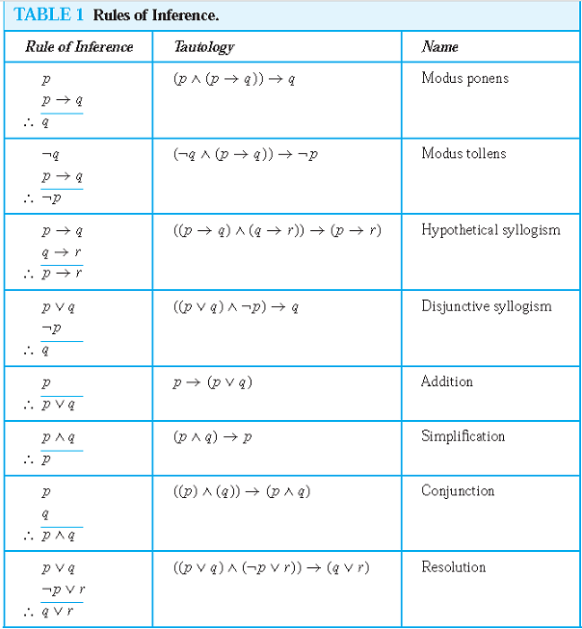

Rules of Inference for Quantified Propositions

