**Title of the Experiment: Constant velocity motion1D**

**Student’s name: Hieu Pham**

**Section SLN: 91007**

**TA’s Name: Wayne Christenson**

**Week of the experiment: 2**

**OBJECTIVE:**

This lab is concerned with one-dimensional motion along a line for which the experimenters can simply use real numbers instead of vectors. The quantities under study are: position, average speed, average velocity, and instantaneous velocity. The data are generated in KET Virtual Labs and analyzed with LoggerPro software.

**EXPERIMENTAL DATA:**

**PART 1: Object moving away from the motion sensor.**

Run 1:

**Complete the tables below and insert the graphs generated in this lab:**

**Table 1**

|  |  |  |  |  |  |
| --- | --- | --- | --- | --- | --- |
| **Time** (t)**, (s)** | **Position interval, (s)** | **Distance, (m)** | **Displacement,** | **Average/Instantaneous Speed, (m/s)** | **Average/Instantaneous Velocity, (m/s)** |
| 1.219 | 1.250 | 0.079 | 0.004 | 0.062 | 0.129 |
| 1.250 | 1.313 | 0.086 | 0.007 | 0.064 | 0.111 |
| 1.313 | 1.5 | 0.106 | 0.020 | 0.068 | 0.107 |
| 1.5 | 1.75 | 0.132 | 0.026 | 0.073 | 0.104 |
| 1.75 | 11.031 | 1.123 | 0.991 | 0.100 | 0.107 |
| 11.031 | 15.188 | 1.55 | 0.427 | 0.102 | 0.103 |

**Table 2**

|  |  |  |
| --- | --- | --- |
| Fit parameters – coefficients of thelinear fit **(position vs time) graph** | **Value, (units)** | **Name of Physics quantity** |
| Slope: | 0.105, m/s | Average Velocity |
| y-intercept: | -0.03929, m | Initial position |

**Velocity of the cart from (position vs time) graph is: v = __0.105 m/s____________**

**The equation (5) that describes the cart’s motion with the value of the slope as the true value of the average velocity is:**

**____________*x*(*t*) *= 0.105*(*t*-*t*0) – 0.0393__________________________________**

Use Logger Pro for statistical data to calculate average velocity and its uncertainty:

**Table 3**

|  |  |
| --- | --- |
| Average Velocity,(units) | 0.097, m/s |
| Standard deviation, (units) | 0.029, m/s |

Run 2: Car moving away with a different speed

**Table 4**

|  |  |  |
| --- | --- | --- |
| Fit parameters – coefficients of thelinear fit **(position vs time) graph** | **Value, (units)** | **Name of Physics quantity** |
| Slope: | 0.200, m/s | Average Velocity |
| y-intercept | -0.113, m | Initial Position |

**Velocity of the cart from (position vs time) graph is: v = ___0.200 m/s___________**

**The equation (5) that describes the cart’s motion with the value of the slope as the true value of the average velocity is:**

**_______ *x*(*t*) *= 0.200*(*t*-*t*0) – 0.113__________________________**

Use Logger Pro for statistical data to calculate average velocity and its uncertainty:

**Table 5**

|  |  |
| --- | --- |
| Average Velocity,(units) | 0.1825, m/s |
| Standard deviation, units, (units) | 0.0667, m/s |

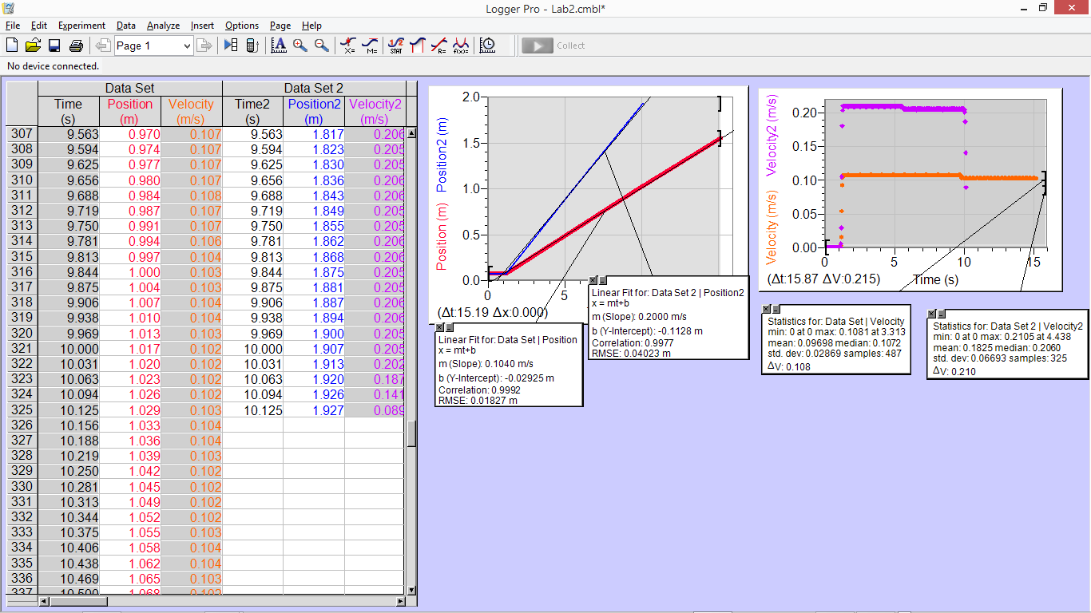

**PART 2: Object moving toward the motion sensor.**

Run 3:

**Table 6**

|  |  |  |  |  |  |
| --- | --- | --- | --- | --- | --- |
| **Time** (t)**, (s)** | **Position interval, (s)** | **Distance, (m)** | **Displacement, (m)** | **Average/Instantaneous Speed, (m/s)** | **Average/Instantaneous Velocity, (m/s)** |
| 1.156 | 1.188 | 1.899 | -0.026 | 1.631 | -0.813 |
| 1.188 | 1.438 | 1.692 | -0.207 | 1.367 | -0.828 |
| 1.438 | 2.094 | 1.149 | -0.543 | 0.804 | -0.828 |
| 2.094 | 2.563 | 0.763 | -0.386 | 0.411 | -0.823 |
| 2.563 | 2.938 | 0.455 | -0.308 | 0.221 | -0.821 |
| 2.938 | 3.406 | 0.073 | -0.382 | 0.083 | -0.816 |

**Table 7**

|  |  |  |
| --- | --- | --- |
| Fit parameters – coefficients of thelinear fit **(position vs time) graph** | **Value, (units)** | **Name of Physics quantity** |
| Slope: | -0.615, m/s | Average Velocity |
| y-intercept | 2.439, m | Initial position |

**Velocity of the cart from (position vs time) graph is: v = ___-0.827 m/s___**

**The equation (5) that describes the cart’s motion with the value of the slope as the true value of the average velocity is:**

**_________2.439 - *0.827*(*t*-*t*0)_____________________**

Use statistical data of velocity vs time graph for calculate the following:

**Table 8**

|  |  |
| --- | --- |
| Average Velocity,(units) | -0.827, m/s |
| Standard deviation, units, (units) | 0.399, m/s |

Run 4: Cart toward sensor with a different speed

**Table 9**

|  |  |
| --- | --- |
| Fit parameters – coefficients of thelinear fit **(position vs time) graph** | **Name of Physics quantity** |
| Slope: -0.7780, m/s | Average Velocity |
| y-intercept: 2.4000, m | Initial Position |

**Velocity of the cart from (position vs time) graph is: v = ____-0.780 m/s_____**

**The equation (5) that describes the cart’s motion with the value of the slope as the true value of the average velocity is:**

**__________2.400 - *0.780*(*t*-*t*0)______________________**

Use statistical data of velocity vs time graph for calculate the following:

**Table 10**

|  |  |
| --- | --- |
| Average Velocity, units | -0.587, m/s |
| Uncertainty, units | 0.2211, m |

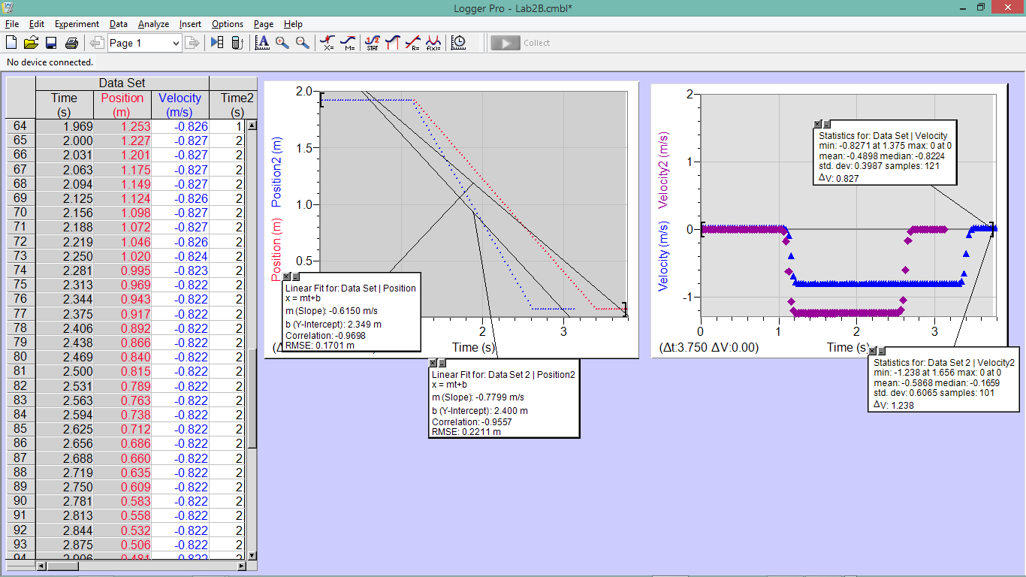

**PART 3. Matching position vs. time graphs**

Run 5: Method to reproduce graph:

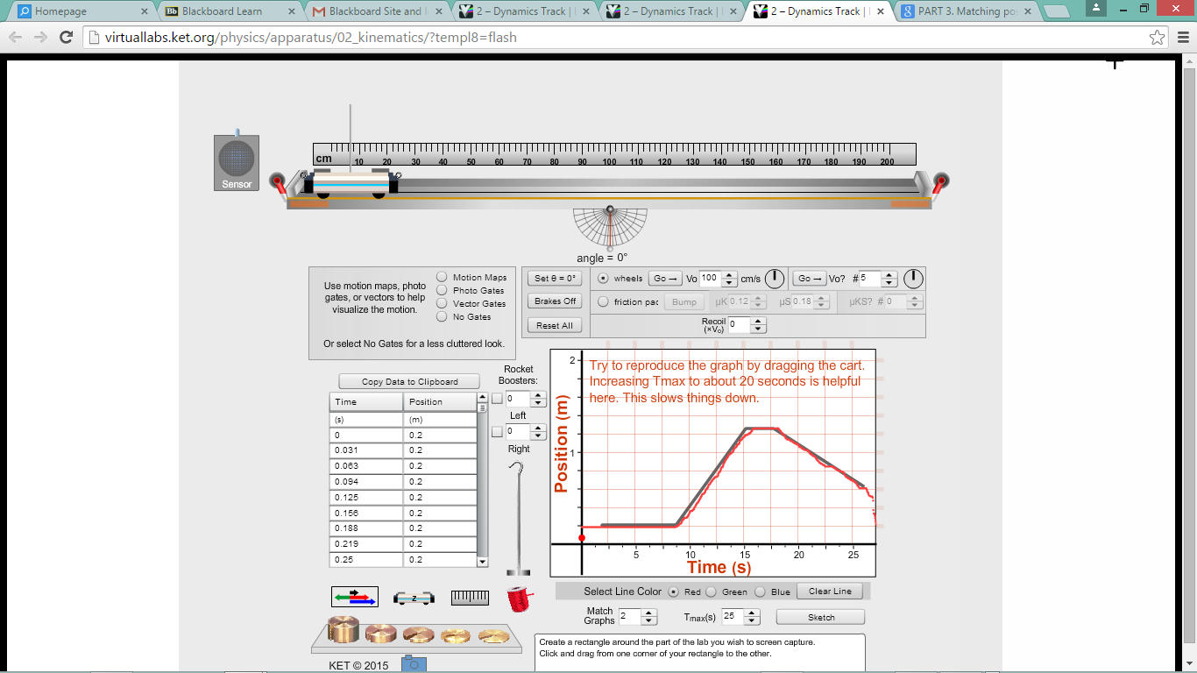

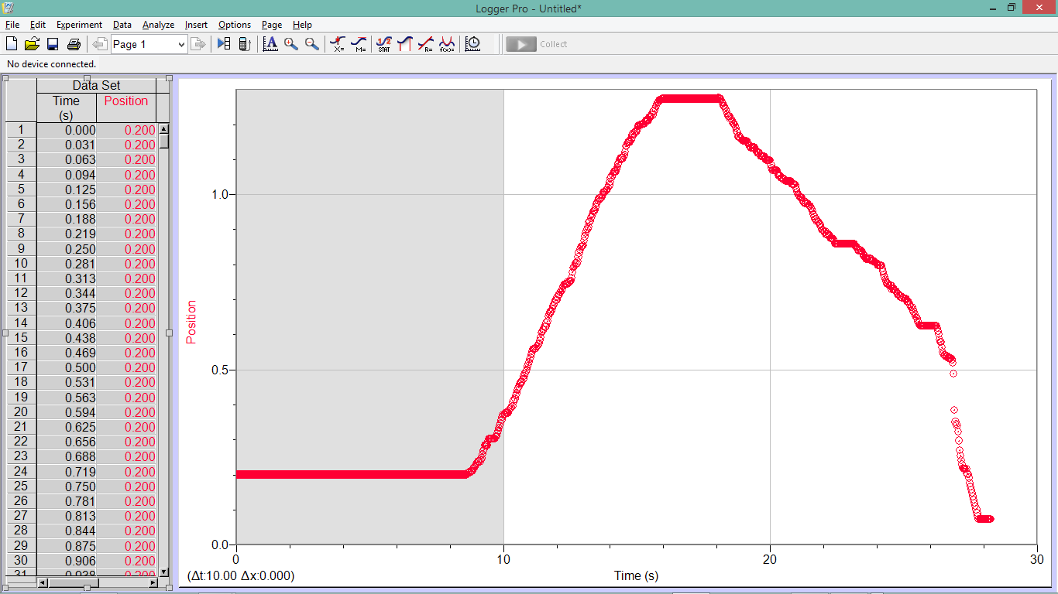

**DATA ANALYSIS :**

**Equations used:**

vavg,x = Δx / Δt

v = d / Δt

*vx* = lim(Δ*t*→0) Δ*x /* Δ*t* = *dx / dt*

Slope = velocity = tan(α)

*x*(*t*) *= x*0 *+ v*(*t*-*t*0)

**Part 1:**

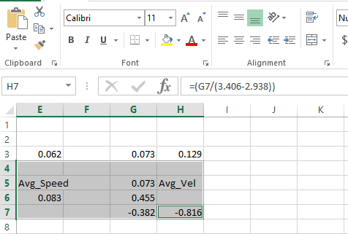

Cell G7 holds my Δ*x*

My Δ*t* is: (3.406s – 2.938s)

**PART 4. Motion with known velocity**

Run 6: Show calculation (use eqn. 1) used to make a predication for the final position of the cart after 2 s from the moment it crosses the 80 cm mark on the track.

**RESULTS (3 points) - summary of all major results of the lab. All results must be presented in the table.**

Table 11

**(Report results below with 4 significant figures)**

|  |  |  |  |
| --- | --- | --- | --- |
| Run #, average velocity, (units) | Position vs time graph | Velocity vs time graph | Percent difference, % |
| 1, average velocity, (units) |  |  |  |
| 2, average velocity, (units) |  |  |  |
| 3, average velocity, (units) |  |  |  |
| 4, average velocity, (units) |  |  |  |

**Equations of motion**

|  |  |
| --- | --- |
| Run | **Equation of motion (5)** |
| 1 |  |
| 2 |  |
| 3 |  |
| 4 |  |

Final position of the cart after 2 s from the moment it crosses the 80 cm mark on the track.

|  |  |
| --- | --- |
| **Predicted position:** | **Experimental position:** |
|  |  |

**DISCUSSION AND CONCLUSION (10 points):**

This is the most important part of the lab report. It is where you describe whether your results support the physics principal being investigated in the lab. Begin the discussion with the purpose of the experiment. Briefly explain the theory concept that was tested. Then explain how the experimental results support/or not the theoretical concept. Discuss the relationship between your raw measurements and your final results; the relationship between quantities in the graph; relationship between the independent and dependent variables. All questions from the lab manual should be answered in the narrative form.

For part 1 and 2, based on your experimental data distinguish the term distance/displacement/speed/velocity. How well do the two instantaneous velocities compare to the average velocity? Can you conclude that during time interval *t1 → t2* the cart was moving with constant velocity? After you compared the value of the average velocity of the first and second runs in part1 and 2. What graphical attribute signifies cart’s speed? How can you tell that the cart was moving with constant velocity based on the position vs time graph generated in this experiments? What attribute of position vs. time graph tells us the magnitude of velocity? What attribute of graphical representation of motion characterizes the direction of velocity? In run 2 how different is the shape of position vs. time graph in comparison to run 1?

Describe in details how did you need to move the cart along the track in order to reproduce the graph shown in the position vs. time display.

What caused any discrepancy in the predicted and experimental positions of the cart in part 4 of the lab?

Make a conclusion if the objective(s) of the lab has been achieved based on the final experimental results.

I would like to say that this lab does not reflect real physics of kinetics because so many different factors were omitted, namely friction. I do learn that instantaneous velocity approaches the average velocity as shown in run1. However, the amount of data collection for this lab, was way too much and therefore I will stop here due to commitment to other classes.

**APPENDIX**

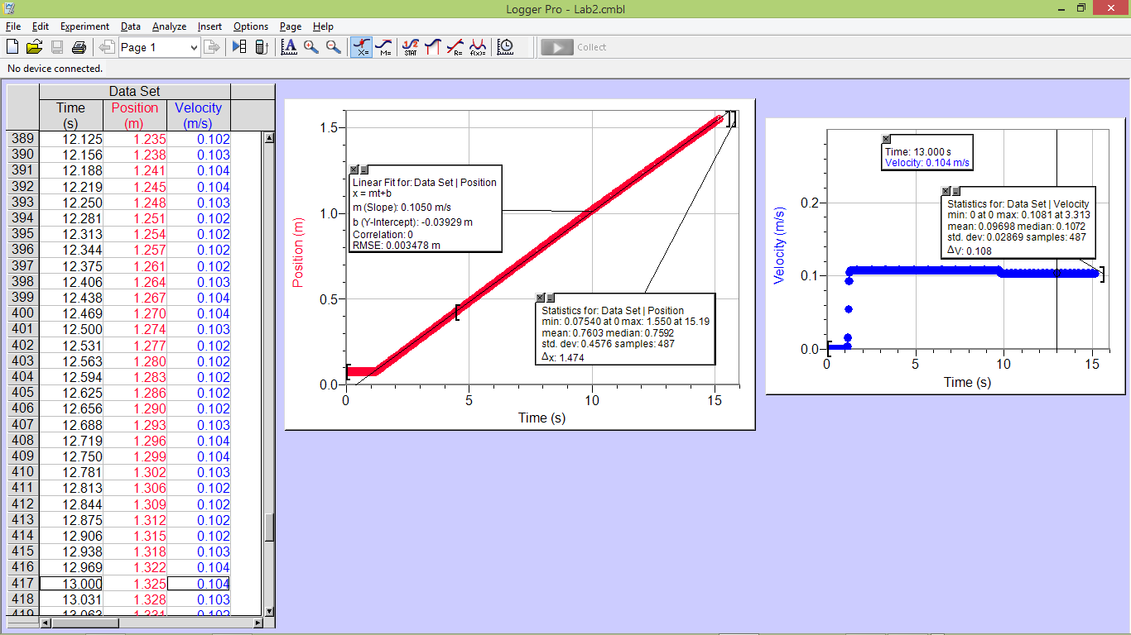

Run 1