Open the TI-Nspire document Sequences.tns.  Objective: To evaluate the limit of a sequence graphically.  Directions: For each of the sequences, find the limit by graphing the sequence on your TI-Nspire. | 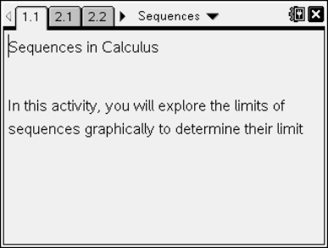

PART I
Follow the steps below to evaluate the limit for the example problem.
Example: Find the limit of 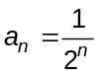.
Move to page 2.1. | Press / ¢ and / ¡ to navigate through the lesson.
Step 1: This first page is a spreadsheet with the values 1 to 10 filled in for the term index values of a sequence. | 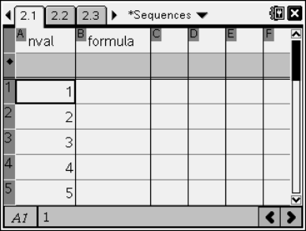
Step 2: Type the formula for the sequence in the box under the formula column.  Note: nval is the variable used for the values in column A. Use nval to represent the n-value in the sequence.  Step 3: Press · to fill in the formula column. | 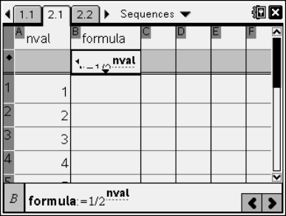
Step 4: Move to page 2.2 to graph the sequence.  Note: To graph the sequence, select Menu > Graph Type > Scatter Plot. Next, press the h key and select nval. Next, tab to the y box, press the h key, and select formula. The sequence will be graphed. | 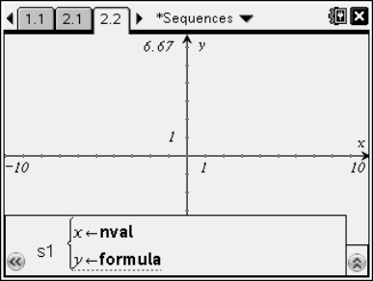
Step 5: Use / ¢ to move to page 2.3 to write your answer for this question.  Note: If your teacher wants to record your answers in the TI-Nspire document, then move to the answer field by pressing the e key and type your answer. Otherwise, record your answers below. | 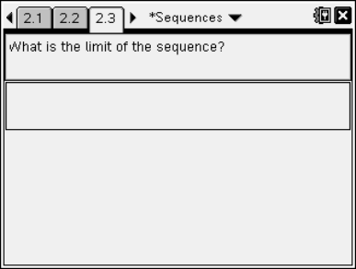

PART II
Directions: Find the limit of the following sequences graphically using your TI-Nspire handheld or software.

Note: The TI-NSpire document is set up for you to work on each question below in a different problem. If your teacher does not want you to record your answers in the TI-Nspire document, then you can record your answers below.

1. 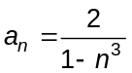

2. 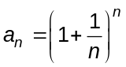

3. 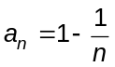

4. 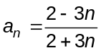

5. 