Open the TI-Nspire document Taylor_Polynomial_Examples.tns.  The nth degree Taylor polynomial associated with a function f at a point a, denoted T, is given by  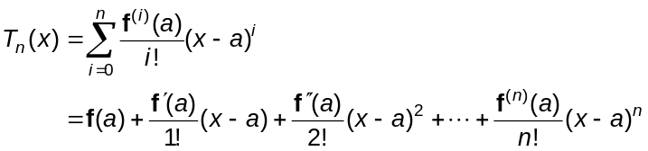  Taylor polynomials are often used to approximate the value of a function f close to, or in a neighborhood of, a. Some calculators may even use Taylor polynomials to evaluate functions such as 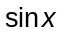 or 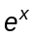. In this activity, taylorf represents the Taylor polynomial. | 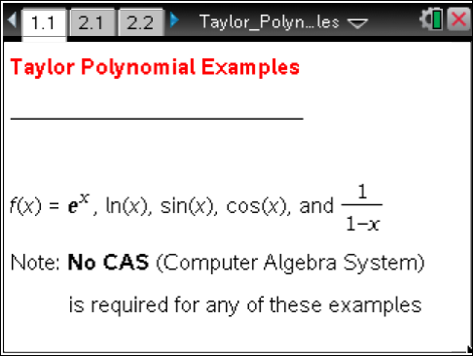

Move to page 2.2. | Press / ¢ and / ¡ to navigate through the lesson.
1. In the first example, the graph of 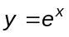 is dotted and the graph of the Taylor polynomial of degree n at a is solid. Use the slider arrows to change the degree, n, or the value of a.

a. With a = 0, set n = 1. Graph the first degree Taylor polynomial, , at 0. Describe the graph of 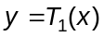.

b. Use the graph of and the Trace All feature to describe the accuracy of the Taylor polynomial approximation as x moves farther from a = 0.

c. Set n = 2. Describe the graph of 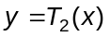, the second degree polynomial at 0.

d. Set n = 3. Describe the graph of 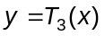, the third degree polynomial at 0.

e. Consider the graph of other Taylor polynomials for 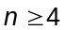. Describe the accuracy of the Taylor polynomial approximation as n increases.

Move to page 2.3.
On the Lists & Spreadsheets page, you may enter values for x in column A. The following values will be computed automatically: f (x), taylorf (x), and 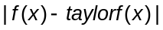, columns B, C, and D respectively. These resulting values are dependent upon the current values of n and a.

2. Adjust the values of n and a on page 2.2 as necessary and use the Lists & Spreadsheets page to answer the following questions.
a. For a fixed value of n, describe the accuracy of the Taylor polynomial approximation as the values of x are farther away from a.

b. For fixed values of a and x, describe the accuracy of the Taylor polynomial approximation as n increases.

Move to page 2.4.

The Lists & Spreadsheets page contains the derivative of the function f at a, the derivative of the Taylor polynomial at a, and the order of the derivative, in columns A, B, and C, respectively.

3. For different values of n, set on page 2.2, observe the value of the derivatives of f and taylorf at a. Describe the pattern.

Move to page 3.2.

4. In this example, the graph of 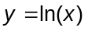 is dotted and the graph of the Taylor polynomial of degree n at a is solid. Use the slider arrows to change the degree, n, or the value of a. Adjust the values of n and a as necessary to answer the following questions.
a. For a = 2, describe the accuracy of the Taylor polynomial approximation as n increases.

b. Describe the behavior of each Taylor polynomial as and as . What happens to the graph of the Taylor polynomial, as , as n increases by 1, for example, from n = 6 to
n = 7? Explain why this behavior alternates as n increases.

c. For a = 0.3, consider various Taylor polynomials of degree n. Explain why the Taylor polynomial appears to be a very good approximation to the left of a = 0.3. but diverges rapidly to the right of a = 0.3.

Move to page 4.2.

5. In this example, the graph of y = sin x is dotted and the graph of the Taylor polynomial of degree n at a is solid. Use the slider arrows to change the degree, n, or the value of a.
a. For a = 0 and n = 1, describe the graph of the Taylor polynomial. Find the Taylor polynomial and describe the approximation for sin x for x close to 0.

b. For a = 0, consider the graph of the Taylor polynomials as n increases. Explain why the graph of the Taylor polynomials for n = 1 and for n = 2 are identical, and for n = 3 and n = 4, etc.

c. For each value of a and n, describe the accuracy of the Taylor approximation about the point
x = a.

Move to page 5.2.
6. In this example, the graph of 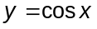 is dotted and the graph of the Taylor polynomial of degree n at a is solid. Use the slider arrows to change the degree, n, or the value of a.
a. For a = 0 and n = 1, describe the graph of the Taylor polynomial. Find the Taylor polynomial and explain why the slope of this linear approximation is 0.

b. For a = 0, consider the graph of the Taylor polynomials as n increases. Explain why the graph of the Taylor polynomials for n = 0 and for n = 1 are identical, and for n = 2 and n = 3, etc.

Move to page 6.2.

7. In this example, the graph of 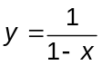 is dotted and the graph of the Taylor polynomial of degree n at a is solid. Use the slider arrows to change the degree, n, or the value of a.
a. For a = 0, consider various Taylor polynomials of degree n. Explain why there is no graph of the Taylor polynomial to the right of x = 1.

b. Consider the graph of the Taylor polynomial for a = 0 and n = 7. Explain the accuracy of this Taylor polynomial. Why does the Taylor polynomial appear to be a much better approximation to the right of a = 0 than to the left?

c. Explain how to obtain the graph of a Taylor polynomial that can be used to approximate the portion of the graph of 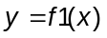 to the right of x = 1.

