

|  |
| --- |
|  |
| Coca-Cola Beverages Vietnam Limited  5Factor (Phase 2) Report Blueprint |
| |  |  |  | | --- | --- | --- | |  |  |  | |

Inter-K Joint Stock Company

NOV 2022

# Document control

## Change record

|  |  |  |  |
| --- | --- | --- | --- |
| Version | Name | Date | Change |
| 0.1 | Nguyen Van Huy | 25/10/2022 | Document creation |
| 0.2 | Nguyen Van Huy | 28/10/2022 | Update more detail information |
| 0.3 | Ngo Dinh Nhat Huy | 31/01/2023 | Update wording |
| 1.4 | Nguyen Quang Nhat | 01/02/2023 | Update wording |
| 1.5 | Nguyen Quang Nhat | 02/02/2023 | Update wording |
| 1.6 | Nguyen Quang Nhat | 07/03/2023 | Update Tien’s requirement on separate WS non-DSD out of Grocery |
| 1.7 | Dang Thi Cam Tien | 15/05/2023 | Update wording |
| 1.8 | Le Pham Ngoc Tram | 22/05/2023 | Update wording, update logic for index 1, 2, 3 |

## Inter-K Reviewers and Approvals

This document has been reviewed and approved by:

|  |  |  |  |
| --- | --- | --- | --- |
| **Name** | **Roles** | **Date Approved** | **Signature** |
| Ngoc, Vu Thai | Project Manager |  |  |

## Coca-Cola Reviewers and Approvals

This document has been reviewed and approved by:

|  |  |  |  |
| --- | --- | --- | --- |
| **Name** | **Roles** | **Date Approved** | **Signature** |
| Nguyen Le Phuoc Thinh | Business Intelligence Specialist |  |  |
| Le Thang Loi | Digital Solution Delivery Mgr - Distribution Management System (DMS) |  |  |
| Dinh Hoang Hai | SFA Specialist |  |  |
| Dang Thi Cam Tien | SFA Specialist |  |  |

Table of Contents

1. Document control 4

1.1 Change record 4

1.2 Inter-K Reviewers and Approvals 4

1.3 Coca-Cola Reviewers and Approvals 4

2. PACE Report Categories 6

2.1 Dimension 6

2.2 Service Outlet 6

2.3 5 Factor execution focuses 8

2.4 Core 13

3. Report template 14

3.1 Service outlet 14

3.2 5 Factor execution focuses 14

3.3 Core 15

4. Appendix: Changes tracking 16

4.1 5 Factor execution focuses 16

4.2 CORE 17

# PACE Report Categories

This document details target structure of proposed dashboards in second stage of iTenka-POC, detailed design of each report and analysis dimensions

## Dimension

|  |  |  |  |
| --- | --- | --- | --- |
| **Category** | **Item** | **Detail** | **Note** |
| Dimension | Time | Year, Quarter, Month, Week, Date by Coke Calendar  * Data must be filtered by week and MTD  **Week logic:   * In case week **has** been **completed**, report should show data until the last day of the week * In case a week has **not** been **completed**, report should show data as N-1 (N is current date) | * Time: * Prefer report update by real-time, at least require report update by daily and refresh before 7:15 AM. * Cut-off time of month end = the last date of KO-month plus 3 working days. * Working day = Calendar Day – Sunday – National Holiday * last day of the week: * is Friday (Coke calendar) * Data dim_date: Base on Coke calendar |
| Org Chart/ Hierarchy | RCD, SM (Sales Manager), ASM, TSM, SR (Sales Rep) | * SR (Sales Rep): Add in Sales Route info: * SFA update active sale route by weekly: apply immediately after uploading. * Result of month end: based on the latest uploading of each month. * Data Org Chart by week follow this rule: * For a month with 4 weeks: * W2 will get the data of W1. * W4 will get the data of W3. * For a month with 5 weeks: * W2 and W3 will get the data of W1. * W5 will get the data of W4. |
| Customer | Region, Distributor, Route, Classification, Channel, Sub-trade Channel | * Channels include Eating, Drinking, Grocery, WS non-DSD, … |
| Product | Category, Brand, Must Have SKU, Must Have SKU Segment, Consumer SKU, Product Code, Pack Type, Pack Size |  |

## Service Outlet

* + - 1. **Report Filter**

|  |  |  |
| --- | --- | --- |
| **Filter name** | **Type** | **Description** |
| Year | Single selection | Must follow Coke calendar |
| Month | Single selection | Must follow Coke calendar |
| Week | Single selection | Must follow Coke calendar |
| Channel | Multiple selection | Eating / Drinking / Grocery / WS non-DSD |

* + - 1. **Report Formula**

**The formula is for point forward data

** Regarding historical data, will be sent via csv file

|  |  |  |  |  |
| --- | --- | --- | --- | --- |
| **Index** | **Group** | **Metric** | **Formula** | **Note** |
| Index 0 | Service Outlet | Service Outlet | * Snapshot of Distinct Outlet with call plan (assigned to Route) within day. Closing distinct Service Outlet by 3rd week / 4th week of the period in 4 – 4 – 5 weeks accordingly. * Only count Outlet with Classification (Gold / Silver / Bronze), Channel (Eating / Drinking / Grocery / WS non-DSD) and with 25 Sub-trade Channels | * **Service Outlet:** * From at the beginning of month (based on Coke Calendar) to Cut-off time: Showing service outlet day by day as MM exported. * From Cut-off time to end of month: end of Friday of W3 (for month with 4 weeks) or W4 (for month with 5 weeks) based on Coke calendar. * Cut-off time of week: Showing service outlet of Friday of W1, W2, W3/W4 (Based on Coke_Calendar). * Example: The Cut-off time of Apr 2023 is 21 Apr. Data from 21 Apr to the end of the month is not change. * **Distinct Outlet:** * Service Outlet GT: Follow list of active sale route provided by SFA (Org Chart). * **Call Plan:** * Call Plan of period which was from Monday to Saturday. |
| Net Sales Revenue | * Total value of NSR based on transactions in secondary sales by KO_Month * Only count Outlet with Classification (Gold / Silver / Bronze), Channel (Eating/ Drinking/ Grocery/ WS non DSD) and with 25 Sub-trade Channels * Only count Outlet in Service Outlet * Only count Route ID in Orgchart |

## 5 Factor execution focuses

* + - 1. **Report Filter**

|  |  |  |
| --- | --- | --- |
| **Filter name** | **Type** | **Description** |
| Year | Single selection | Must follow Coke calendar |
| Month | Single selection | Must follow Coke calendar |
| Week | Single selection | Must follow Coke calendar |
| Channel | Multiple selection | Eating / Drinking / Grocery / WS non-DSD |
| Region | Multiple selection | Region name |
| ASM | Multiple selection | ASM name |
| TSM | Multiple selection | TSM name |

* + - 1. **Report Formula**

|  |  |  |  |  |
| --- | --- | --- | --- | --- |
| **Index** | **Group** | **Metric** | **Formula** | **Note** |
| Index 1 | Going for Gold/ Silver/ Bronze | Eating/ Drinking/ Grocery/ Wholesale non-DSD Outlet achieving MHS | * Mix purchase: Distinct Count Outlet purchasing **at least minimum quantity EA of any Consumer SKU within MHS**, and purchasing minimum quantity assigned to the MHS, and purchasing full list of MHS assigned to the Outlet Classification * Specific purchase: Distinct Count Outlet purchasing **1 specific Consumer SKU** with at least minimum quantity assigned to **MHS**, and purchasing full list of MHS assigned to the Outlet Classification | * MHS = Must Have SKU * Example:   *Condition: MHS Nutriboost includes 2 consumers:*  *1. Nutriboost Orange SS PET 297ml*  *2. Nutriboost Strawberry SS PET 297ml*   * ***Case 1: Mix Purchase:***   1 outlet (Gold – Drinking) has purchased 2 consumer SKU:   * Nutriboost Orange 2EA * Nutriboost Strawberry 10EA * Count achieved this MHS for Gold outlet * ***Case 2: Specific Purchase:***   1 outlet (Gold – Drinking) has purchased 1 consumer SKU:   * Nutriboost Orange 12EA * Count achieved this MHS for Gold outlet * At least minimum quantity EA of any Consumer SKU: * The condition of purchasing full MHS: bought at least minimum quantity of any Consumer SKU belong to every MHS allocated for each outlet in classification & channel group.   Note:  Before May2023: the minimum quantity of any Consumer SKU is 3EA  From May2023: the minimum quantity of any Consumer SKU is 1EA |
| % Going for Gold | Distinct Count Gold Outlet achieving **MHS (Must Have SKU)** / Distinct Count Gold Service Outlet | **%Going for Gold** = #Outlet reached G4G / Service outlet Gold.   * **Outlet reached G4G:** * Total quantity EA of **consumer SKU** (calculate Sales Register month-to-date) pass MHS condition (Gold). * Base on Service outlet: Outlet must be existing in service outlet * Channel & Classification: base on Outlet in Service outlet * Region: Mapping to Org Chart by Route Code to get Region * Route logic: Mapping the latest route ID base on Service Outlet * Need to show result of 2 metrics like: #G4G and %G4G. * Need to separate:   ***A. REAL DISTRIBUTION MAGIC (RDM)***   * %Going for Gold - Total * %Going for Gold - Eating * %Going for Gold - Drinking * %Going for Gold - Gro * %Going for Gold - WS non-DSD   ***B. CORE DISTRIBUTION MAGIC (CDM)***   * %Going for Gold - Total * %Going for Gold - Eating * %Going for Gold - Dinking * %Going for Gold - Gro * %Going for Gold - WS non-DSD |
| % Going for Silver | Distinct Count Silver Outlet achieving **MHS (Must Have SKU)** / Distinct Count Silver Service Outlet | **%Going for Silver** = #Outlet reached G4S / Service outlet Silver.  **Outlet reached G4S:**   * Total quantity EA of consumer SKU (calculate Sales Register month-to-date) pass MHS condition (Silver). * Base on Service outlet: Outlet must be existing in service outlet. * Channel & Classification: base on Outlet in Service outlet * Region: Mapping to Org Chart by Route Code to get Region * Route logic: Mapping the latest route ID base on Service Outlet * Need to show result of 2 metrics like: #G4S and %G4S. * Need to separate:   ***A. REAL DISTRIBUTION MAGIC (RDM)***   * %Going for Silver - Total * %Going for Silver - Eating * %Going for Silver - Drinking * %Going for Silver - Gro * %Going for Silver - WS non-DSD   ***B. CORE DISTRIBUTION MAGIC (CDM)***   * %Going for Silver - Total * %Going for Silver - Eating * %Going for Silver - Dinking * %Going for Silver - Gro * %Going for Silver - WS non-DSD |
| % Going for Bronze | Distinct Count Bronze Outlet achieving **MHS (Must Have Consumer SKU)** / Distinct Count Bronze Service Outlet | As above but count for Bronze classification. |
| Index 2 | Active Outlet by Product Group | Active Outlet | Distinct Count Outlet purchasing at least 3EA of any **Consumer SKU** of the group | **%Active Outlet** = #Active Outlet / #Service Outlet  **Active Outlet:**   * Total quantity EA of consumer SKU (calculate Sales Register month-to-date) at least 3EA. * Base on Service outlet: Outlet must be existing in service outlet * Channel & Classification: base on Outlet in Service outlet * Region: Mapping to Org Chart by Route Code to get Region * Route logic: Mapping the latest route ID base on Service Outlet * Need to show result of 2 metrics like: #Active Outlet and %Active Outlet |
| % Active Outlet by Coca-Cola | Distinct Count Active Outlet by Coca-Cola / Total Service Outlet | **%Active Outlet by Coke** = #Active Outlet by Coke / #Service Outlet   * Need to show result of 2 metrics like: #Active Outlet by Coke and %Active Outlet by Coke * Apply the same for all metrics of Index 2. |
| % Active Outlet by Sprite | Distinct Count Active Outlet by Sprite / Total Service Outlet |  |
| % Active Outlet by Nutriboost | Distinct Count Active Outlet by Nutriboost / Total Service Outlet |  |
| % Active Outlet by Tea | Distinct Count Active Outlet by Tea / Total Service Outlet |  |
| % Active Outlet by Energy | Distinct Count Active Outlet by Energy / Total Service Outlet |  |
| % Active Outlet by Thums up | Distinct Count Active Outlet by Thums up / Total Service Outlet |  |
| Index 3 | SKU/Outlet & SKU/Order | SKU/Outlet | (On Route **Consumer SKU** Count + Off Route **Consumer SKU** Count + eB2B **Consumer SKU Count**) / Distinct Count Outlet | **SKU/ Outlet** = Total of distinct count Consumer SKU of each outlet / Count active Outlet (base on Sales Register by month-to-date)  **Numerator:**   * Condition: Consumer SKU has total quantity EA (calculate Sales Register month-to-date) at least 3EA.   **Denominator:**   * Condition: Outlet base on Sales Register, has any consumer SKU has total quantity EA (calculate Sales Register month-to-date) at least 3EA. * Region: Mapping to Org Chart by Route Code to get Region * Route logic: Latest route has transaction on the same customer. |
| SKU/Order | (On Route **SKU** Count + eB2B SKU Count) / Sum of On Route Order | **SKU / Order** = Sum of SKU of each on route Order/ Sum of on route Order  **Numerator:**   * Condition: SKU has total quantity EA at least 3EA.   **Denominator:**   * On route outlet condition: outlet has visit plan. * On route order condition: bought at least 3EA of any SKU for on route outlet of the day (if an outlet bought many orders in the same day, consider them be one order) * Excluded Sunday & National holidays. * Not count for the day when SR was on leave: his Call Plan or (#Completion Call and Total Order = zero (no value)). * Region: Mapping to Org Chart by Route Code to get Region * Route logic: Record for the Route ID based on transaction and not change to latest Route in case it re-route throughout the month. |
| Index 4 | Net New Outlet | Target New Outlet | Base on Org Chart | * Currently, Target Values are maintained in the Org Chart files |
| Net New Outlet | New Outlet – Closed Outlet | * Data Closed Outlet only have for the last week of month (based on Coke Calendar) |
| Index 5 | Cooler Purity | Cooler Purity | Volume of Product / Value of Cooler | * Result of purity upload by weekly and monthly from external source |

## Core

* + - 1. **Report Filter**

|  |  |  |
| --- | --- | --- |
| **Filter name** | **Type** | **Description** |
| Year | Single selection | Must follow Coke calendar |
| Month | Single selection | Must follow Coke calendar |
| Week | Single selection | Must follow Coke calendar |
| Channel Group | Multiple selection | Eating / Drinking / Grocery / WS non-DSD |
| Region | Multiple selection | Region name |
| ASM | Multiple selection | ASM name |
| TSM | Multiple selection | TSM name |

* + - 1. **Report Formula**

|  |  |  |  |  |
| --- | --- | --- | --- | --- |
| **Index** | **Group** | **Metric** | **Formula** | **Note** |
| Index 1 | Going for Gold/ Silver/ Bronze | % Going for CORE Total | Distinct Count Outlet achieving **CORE MHS (Must Have SKU)** / Distinct Count Service Outlet | Look at Note for Part 2.3 – Index 1. |
| % Going for Gold CORE | Distinct Count Gold Outlet achieving **CORE MHS (Must Have SKU)** / Distinct Count Gold Service Outlet | Look at Note for Part 2.3 – Index 1. |
| % Going for Silver CORE | Distinct Count Silver Outlet achieving **CORE MHS (Must Have SKU)** / Distinct Count Silver Service Outlet | Look at Note for Part 2.3 – Index 1. |
| % Going for Bronze CORE | Distinct Count Bronze Outlet achieving **CORE MHS (Must Have SKU)** / Distinct Count Bronze Service Outlet | Look at Note for Part 2.3 – Index 1. |

## To-do List (New)

* + - 1. **Report Filter**

|  |  |  |
| --- | --- | --- |
| **Filter name** | **Type** | **Description** |
| Year | Single selection | Must follow Coke calendar |
| Month | Single selection | Must follow Coke calendar |
| Week | Single selection | Must follow Coke calendar |
| Channel Group | Multiple selection | Eating / Drinking / Grocery / WS non-DSD |
| Classification | Multiple selection | Gold / Silver / Bronze |
| Region | Multiple selection | Region name |
| ASM | Multiple selection | ASM name |
| TSM | Multiple selection | TSM name |
| MHS Group | Multiple selection | COR / STR / EDR / REG |

* + - 1. **Report Formula**

|  |  |  |  |  |
| --- | --- | --- | --- | --- |
| **Index** | **Group** | **Metric** | **Formula** | **Note** |
|  | MHS Invisible | Quantity check | * Sum of EA that has transaction:   + If no of EA >= Min quantity requirement => Count achieved (Completed #MHS) => Green color and value  + If no. of EA > 0 < Min quantity requirement => Count did not achieve (Incompleted #MHS) => Red Color and value  + If no. of EA = 0 => Count as outlet did not have any transations in month (Inactive) => Red Color and blank value  Min qty: MIX |  |
| Outlet missed MHS |  |  |
| Outlet did not purchase SKU |  |  |
|  |  |  |

# Report template

## Service outlet

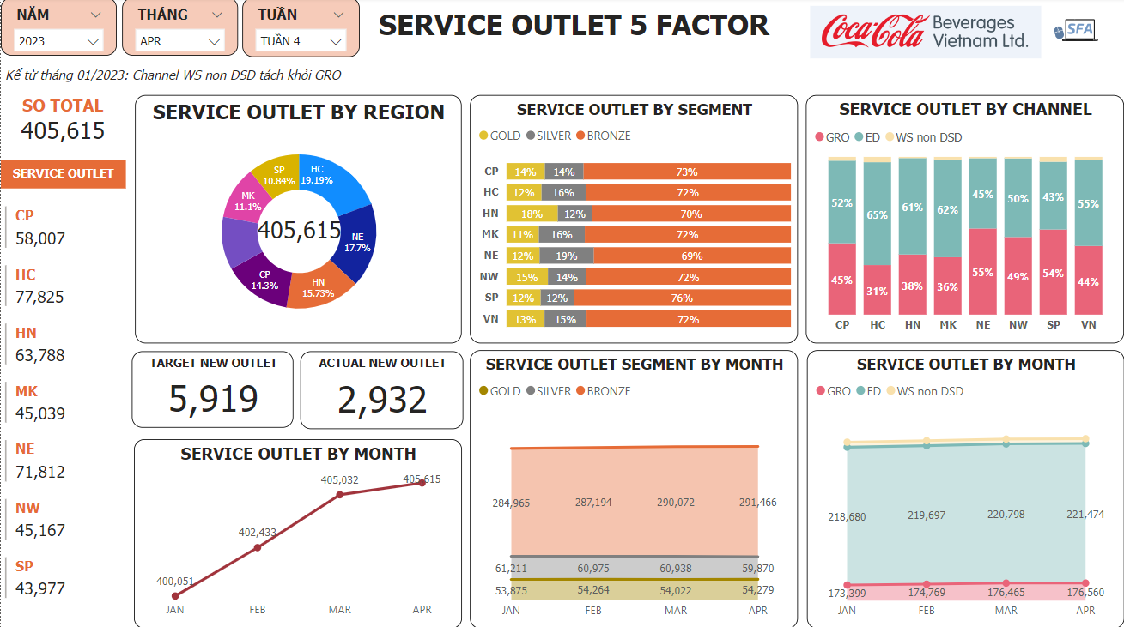

## 5 Factor execution focuses

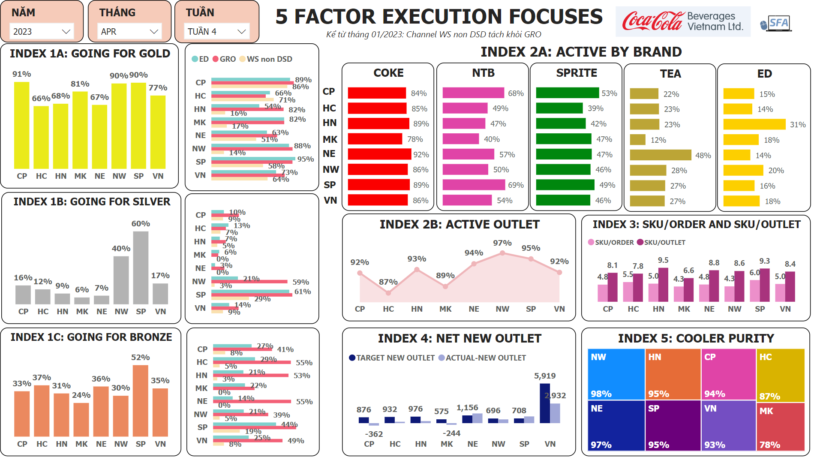

## Core

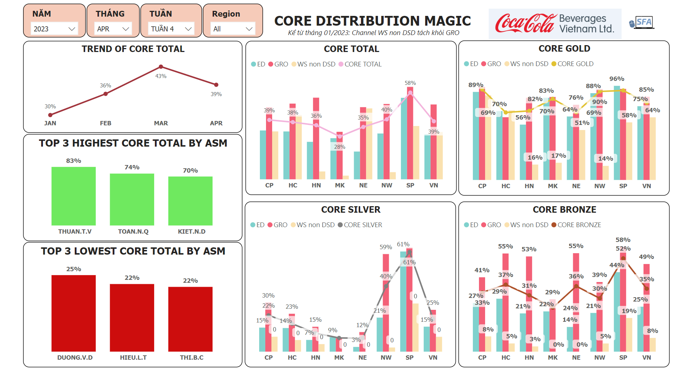

# Appendix: Changes tracking

## 5 Factor execution focuses

|  |  |  |  |  |
| --- | --- | --- | --- | --- |
| **Index** | **Formula** | **Previous logic** | **Updated logic** | **Change** |
| Index 1:  Going for | %Going for Gold = #Outlet reached G4G / Service outlet Gold.  %Going for Silver = #Outlet reached G4S / Service outlet Silver.  %Going for Bronze = #Outlet reached G4B / Service outlet Bronze.  #Outlet reached Going for: total quantity_EA of consumer SKU pass MHS condition | - Base on Service outlet: Outlet must be existing in service outlet - Channel & Classification: base on Outlet in Service outlet - Region: Mapping to Org Chart by Route Code to get Region - Route logic: Mapping the latest route ID base on SOL - "Outlet reached Going for" logic: Total quantity EA of consumer SKU by week to check pass MHS condition, then count passed outlet by month-to-date | - Base on Service outlet: Outlet must be existing in service outlet - Channel & Classification: base on Outlet in Service outlet - Region: Mapping to Org Chart by Route Code to get Region - Route logic: Mapping the latest route ID base on SOL - "Outlet reached Going for" logic: Total quantity EA of consumer SKU by month-to-date to check pass MHS condition | "Outlet reached Going for" logic: Total quantity EA of consumer SKU by month-to-date to check pass MHS condition |
| Index 2:  Active outlet | %Active Outlet = Count of Active Outlet / Count of Service Outlet  Condition of Active Outlet: total quantity_EA of any consumer SKU at least 3EA | '- Base on Service outlet: Outlet must be existing in service outlet - Channel & Classification: base on Outlet in Service outlet - Region: Mapping to Org Chart by Route Code to get Region - Route logic: Mapping the latest route ID base on SOL - "Active Outlet" logic: Total quantity EA of any consumer SKU within a day to check pass active outlet condition (>= 3EA) | - Base on Service outlet: Outlet must be existing in service outlet - Channel & Classification: base on Outlet in Service outlet - Region: Mapping to Org Chart by Route Code to get Region - Route logic: Mapping the latest route ID base on SOL - "Active Outlet" logic: Total quantity EA of any consumer SKU by month-to-date to check pass active outlet condition (>= 3EA) | "Active Outlet" logic: Total quantity EA of any consumer SKU by month-to-date to check pass active outlet condition (>= 3EA) |
| Index 3: SKU/Order | SKU/ Order = Total of distinct count SKU of each onroute order / Count Onroute Order  - Numerator: SKU has total quantity_EA at least 3EA  - Denominator: onroute order Onroute order condition: bought at least 3EA of any SKU for onroute outlet of the day (sum total all orders of a customer in one day) +A2:C5 | - Base on Sales Register - Region: Mapping to Org Chart by Route Code to get Region - Route logic: Seperate route has transaction - Calculate on Sales register: Total of distinct SKU & Count Onroute order by day | - Base on Sales Register - Region: Mapping to Org Chart by Route Code to get Region - Routle logic: Latest route has transaction on the same customer. - Calculate on Sales register: Total of distinct SKU & Count Onroute order by day | Routle logic: Latest route has transaction on the same customer.  New feedback from SFA on 18Apr: Update the logic SKU/Order: record for the Route ID based on transaction and not change to latest Route in case it re-route throughout the month. |
| Index 3:  SKU/Outlet | SKU/ Outlet = Total of distinct count Consumer SKU of each outlet / Count active Outlet  - Numerator: consumer SKU has total quantity_EA at least 3EA  - Denominator: outlet has any consumer SKU has total quantity_EA at least 3EA | - Base on Service outlet - Region: Mapping to Org Chart by Route Code to get Region - Routle logic: Latest route has transaction on the same customer. - Calculate on Sales register: Total of distinct Consumer SKU & Count active outlet by day, then count month-to-date | - Base on Sales Register - Region: Mapping to Org Chart by Route Code to get Region - Routle logic: Latest route has transaction on the same customer. - Calculate on Sales register: Total of distinct Consumer SKU & Count active outlet by month-to-date | - Base on Sales Register, not Service outlet - Calculate on Sales register: Total of distinct Consumer SKU & Count active outlet by month-to-date |

## CORE

|  |  |  |  |  |
| --- | --- | --- | --- | --- |
| **Index** | **Formula** | **Previous logic** | **Updated logic** | **Change** |
| Index 1:  Going for (CORE) | %Going for Gold CORE = #Outlet reached G4G CORE / Service outlet Gold.  %Going for Silver CORE = #Outlet reached G4S CORE / Service outlet Silver.  %Going for Bronze CORE = #Outlet reached G4B CORE / Service outlet Bronze.  #Outlet reached Going for (CORE): total quantity_EA of consumer SKU pass MHS condition | - Base on Service outlet: Outlet must be existing in service outlet - Channel & Classification: base on Outlet in Service outlet - Region: Mapping to Org Chart by Route Code to get Region - Route logic: Mapping the latest route ID base on SOL - "Outlet reached Going for" logic: Total quantity EA of consumer SKU by week to check pass MHS condition, then count passed outlet by month-to-date | - Base on Service outlet: Outlet must be existing in service outlet - Channel & Classification: base on Outlet in Service outlet - Region: Mapping to Org Chart by Route Code to get Region - Route logic: Mapping the latest route ID base on SOL - "Outlet reached Going for" logic: Total quantity EA of consumer SKU by month-to-date to check pass MHS condition | "Outlet reached Going for" logic: Total quantity EA of consumer SKU by month-to-date to check pass MHS condition (Same with Index 1 in 5-Factor execution focuses page) |

**Contact us**

Le Pham Ngoc Tram

Email: [tramle@inter-k.com](mailto:tramle@inter-k.com)

Vu Thai Ngoc

Email: [ngocvu@inter-k.com](mailto:ngocvu@inter-k.com)

Tran Thi Thanh Ly

Email: [lyttt@inter-k.com](mailto:lyttt@inter-k.com)