

**BookStore Online System**

**Software Requirement Specification**

**Author: Group 5 - SWR302**

Hà Việt Hiếu - HE176256

Nguyễn Hoàng Phi - HE172792

Nguyễn Thị Hà - HE173178

Lại Đình Cao Đức - HE176120

Trần Quốc Việt - HE170367

*Class: SE1745-NET*

- Hanoi, January 2024 -

1. Introduction

# 1. Purpose

We offer an e-commerce website for the convenience of our clients, as online purchasing continues to grow in accessibility and convenience within the e-commerce scene. The majority of consumers order books and other products online these days. As a result, we offer top-notch books together with a selection of styles that are constantly updated and closely monitored to guarantee complete user safety.

# 2. Project Scope

This project focuses on developing an e-commerce platform specifically for buying and selling books. The scope encompasses the following functionalities:

**Customer Features (In-Scope):**

* **User Accounts:** Customers can register, login, and logout of their accounts.
* **Book Search:** Customers can search for books by title, author, genre, or other relevant criteria.
* **Shopping Cart:** Customers can add, view, update, and cancel items in their shopping cart.
* **Checkout Process:** Customers can proceed to checkout, selecting their preferred shipping and payment methods.
* **Order Management:** Customers can view, update, and cancel orders they have placed.

**Staff/Manager Features (In-Scope):**

* **User Accounts:** Staff and managers can login and logout of their accounts with designated access levels.
* **Inventory Management:** Staff can add new book listings to the BooSon website, edit existing listings, and manage book stock levels.
* **Order Processing:** Staff can view, update, and cancel customer orders as needed.
* **Sales Reporting (Basic):** Managers can access basic reports on book sales, providing insights into popular titles and overall sales trends.

**Out-of-Scope:**

* **Advanced Inventory Management:** Features like low-stock alerts, automated reordering, and integration with supplier systems are excluded.
* **Advanced Sales Reporting:** Complex analytics features like customer segmentation or in-depth sales trend analysis are not included in this initial scope.
* **Community Features:** Integrations with social media platforms, book review sections, or user forums are outside the scope of this project.
* **Physical Bookstore Integration:** The system won't handle functionalities related to a physical bookstore (if applicable), such as managing in-store inventory or click-and-collect options.
* **Payment Gateway Integration:** While the checkout process will allow selecting a payment method, the actual integration with a specific payment gateway service is considered out-of-scope.

This project scope provides a clear understanding of the core functionalities to be developed for BooSon. Additional features can be considered for future iterations based on project success and business needs.

1. System Feature

# Actors list

### 

| **#** | **Actor** | **Description** |
| --- | --- | --- |
| 1 | Customer | Customers are book enthusiasts looking for a convenient way to purchase books. They can register for an account, browse and search for books, add items to their cart, checkout securely, choose shipping and payment methods, track their orders, and potentially manage past purchases (update addresses, reorder books, etc.). |
| 2 | Staff | Staff are employees responsible for managing the online bookstore inventory and order fulfillment. They can add new book listings, update existing book information, manage book stock levels, process customer orders (including viewing, updating, and cancelling them), and potentially handle basic customer inquiries. |
| 3 | Manager | Marketers are who oversee the overall operations of the Book Store system. Manager staff accounts and access levels, access comprehensive sales reports to analyze buying trends and make informed business decisions. |

### 

# Context diagram

Context diagram for Online Book Store System

# Feature Tree

# 4. Use-case Diagram

# 5. Use Case *Scenarios*

| **ID and Name:** | **UC-1: Customer Registration** | | |
| --- | --- | --- | --- |
| Created By: | … | Date Created: | January 10, 2024 |
| Primary Actor: | Customer | Secondary Actors: | Authentication service |
| Description: | A potential customer accesses the Online Bookstore System to register for an account, providing necessary personal information to create a unique account. | | |
| Trigger: | The customer indicates the desire to register for a new account. | | |
| Preconditions: | None | | |
| Postconditions: | POST-1. Customer registration information is requested to the system.  POST-2. System recognizes request information and validation.  POST-3. Created a new account if valid or response error to register. | | |
| Normal Flow: | **1.0 Order a Single Meal**  1. The customer navigates to the registration page.  2. The system displays a registration form requesting necessary details such as name, email, and password.  3. The customer fills in the required information.  4. The customer submits the registration form.  5. COS displays ordered menu items, individual prices, and total price, including taxes and delivery charge.  6. The system validates the information and, if successful, creates a new account for the customer.  7. The system sends a confirmation email to the customer.8. Patron selects a delivery time and specifies the delivery location.  8. The customer clicks on the confirmation link in the email to activate the account.  9. The system confirms the successful activation of the customer's account.  10. The customer is now registered and can proceed to log in. | | |
| Alternative Flows: | 1.Social Media Registration:  If the customer prefers to register using their social media account:  1.1 Patron selects the option to register via social media.  1.2 The system redirects the customer to the chosen social media platform for authentication.  1.3 After successful authentication, the system retrieves necessary customer information.  1.4 Continue with the normal flow from step 5, using the obtained information to pre-fill registration details. | | |
| Exceptions: | E1. Existing Email Address:  If the customer's email address provided during registration already exists in the system:  1.1 Display an error message indicating that the email address is already registered.  1.2 Prompt the customer to either log in using existing credentials or initiate a password reset.  1.3 The system terminates the registration use case.  E2. Email Confirmation Failure:  If the customer encounters issues with the email confirmation process:  2.1 The system fails to send the confirmation email.  2.2 Display an error message instructing the customer to check their email address for accuracy.  2.3 Provide an option to resend the confirmation email.  2.4 If the issue persists, offer an alternative method for account verification, such as through a phone number.  2.5 The system terminates the registration use case. | | |
| Priority: | High | | |
| Frequency of Use: | High | | |
| Business Rules: | BR-5, BR-6 | | |
| Other Information: | 1. The customer shall be able to reset their password in case of forgotten credentials.  2. Customer accounts must be activated through email confirmation to ensure validity. | | |
| Assumptions: | 1.Assume customers have a valid email address for account verification purposes.  2.Assume secure protocols are in place to protect customer registration information. | | |

| **ID and Name:** | **UC-2: Customer Login/Log out** | | |
| --- | --- | --- | --- |
| Created By: | … | Date Created: | January 10, 2024 |
| Primary Actor: | Customer | Secondary Actors: | Authentication service |
| Description: | An existing customer accesses the Online Bookstore System to log in or log out of their account. | | |
| Trigger: | The customer indicates the desire to log in or log out. | | |
| Preconditions: | The customer has a registered account in the system.  Postconditions: | | |
| Postconditions: | POST-1. The customer successfully logs in or out of the system.  POST-2. The system recognizes the login/logout request and performs the necessary actions.  POST-3. The system updates the customer's login status. | | |
| Normal Flow: | 1. The customer navigates to the search bar on the Online Bookstore System.  2. The system provides a search interface, allowing the customer to enter keywords, titles, authors, or genres.  3. The customer enters their search criteria.  4. The system performs a search using the provided criteria and displays a list of relevant books.  5. The customer browses through the search results, viewing book titles, authors, and brief descriptions.  6. The customer clicks on a specific book for more detailed information.  7. The system displays the detailed information page for the selected book.  8. The customer can add the book to their cart, proceed to checkout, or continue searching for more books. | | |
| Alternative Flows: | A1. Advanced Search Options:  If the customer wants to refine their search with advanced options:  1.1 The system provides advanced search filters such as publication year, price range, or language.  1.2 The customer specifies additional criteria to narrow down search results.  1.3 The system updates the search results based on the refined criteria.  A2. Voice Search:  If the customer prefers to use voice commands for searching:  2.1 The system supports voice search functionality.  2.2 The customer activates the voice search feature.  2.3 The system processes spoken commands and performs a search accordingly. | | |
| Exceptions: | E1. No Search Results:  If the search query returns no results:  1.1 The system displays a message indicating that no matching books were found.  1.2 The customer may revise the search criteria or explore other book categories.  E2. Technical Search Failure:  If there is a technical issue preventing the search functionality:  2.1 The system displays an error message indicating a temporary issue with the search feature.  2.2 The customer is prompted to try the search again later. | | |
| Priority: | High | | |
| Frequency of Use: | Very High | | |
| Business Rules: | BR-9, BR-10 | | |
| Other Information: | 1. The search results are sorted by relevance, considering factors like keyword match and popularity.  2. The search feature supports both simple and complex queries to cater to various customer preferences.  3. The system may provide suggestions or auto-complete options as the customer types of their search query. | | |
| Assumptions: | 1. Assume customers have valid login credentials (email/username and password) associated with their accounts.  2. Assume customers are aware of the security protocols and guidelines for creating and maintaining passwords.  3. Assume the system has secure protocols in place to protect customer login information during the authentication process.  4. Assume customers have access to the necessary devices and internet connectivity to complete the login/logout process.  5. Assume the system has implemented measures to prevent unauthorized access to customer accounts.  6. Assume customers are responsible for maintaining the confidentiality of their login credentials and taking necessary actions in case of unauthorized access. | | |

| **ID and Name:** | **UC-3: Search for Books** | | |
| --- | --- | --- | --- |
| Created By: | … | Date Created: | January 10, 2024 |
| Primary Actor: | Customer | Secondary Actors: | Search Engine |
| Description: | A customer utilizes the search functionality on the Online Bookstore System to find specific books based on their criteria. | | |
| Trigger: | The customer indicates the desire to search for books. | | |
| Preconditions: | None | | |
| Postconditions: | POST-1. The system displays search results based on the customer's query.  POST-2. The customer can view details of the search results and proceed with additional actions. | | |
| Normal Flow: | 1. The customer navigates to the login page.  2. The system displays a login form requesting the customer's credentials (email/username and password).  3. The customer enters their login credentials.  4. The customer submits the login form.  5. The system validates the information, and if successful, logs the customer into the system.  6. The customer interacts with the system (e.g., browse, shop).  7. The customer indicates the desire to log out.  8. The system logs the customer out and updates the login status. | | |
| Alternative Flows: | A1. Social Media Login:  If the customer prefers to log in using their social media account:  1.1 Customer selects the option to log in via social media.  1.2 The system redirects the customer to the chosen social media platform for authentication.  1.3 After successful authentication, the system retrieves necessary customer information.  1.4 The system logs the customer into the system using the obtained information. | | |
| Exceptions: | E1. Incorrect Login Credentials:  If the customer enters incorrect login credentials:  1.1 Display an error message indicating that the entered credentials are invalid.  1.2 Prompt the customer to re-enter the correct login credentials.  1.3 If the issue persists, offer the option to reset the password.  1.4 The system does not log in to the customer.  E2. Account Lockout:  If the system detects multiple unsuccessful login attempts:  2.1 Display a message informing the customer that their account is temporarily locked.  2.2 Provide information on how to unlock the account or reset the password.  2.3 The system does not log in to the customer. | | |
| Priority: | High | | |
| Frequency of Use: | High | | |
| Business Rules: | BR-7, BR-8 | | |
| Other Information: | 1. The customer can log out at any time to secure their account.  2. Secure protocols are in place to protect customer login information. | | |
| Assumptions: | 1. Assume that the Online Bookstore System has a comprehensive database of books, including titles, authors, genres, and relevant details.  2. Assume that the search engine within the system is efficient and capable of quickly processing search queries to provide accurate and relevant results. | | |

| **ID and Name:** | **UC-4: Manage Shopping Cart** | | |
| --- | --- | --- | --- |
| Created By: | … | Date Created: | January 10, 2024 |
| Primary Actor: | Customer | Secondary Actors: | Inventory System, Pricing System |
| Description: | A customer interacts with the Online Bookstore System to manage the items in their shopping cart, including adding, removing, and updating quantities of selected books. | | |
| Trigger: | The customer indicates the desire to manage items in their shopping cart. | | |
| Preconditions: | The customer is logged into the Online Bookstore System and has items in their shopping cart. | | |
| Postconditions: | POST-1. The customer's shopping cart is updated according to their actions.  POST-2. The system reflects changes in inventory availability and recalculates the total price. | | |
| Normal Flow: | 1. The customer navigates to the shopping cart page.  2. The system displays a list of items currently in the customer's shopping cart.  3. The customer has options to add more items  4. Remove existing items, or update the quantity of items in the cart.  5. The customer adds new books to the cart by browsing and selecting the desired items.  6. The customer updates the quantity of selected items or removes items they no longer wish to purchase.  7. The system recalculates the total price of the items in the shopping cart.  8. The customer proceeds to checkout or continues shopping. | | |
| Alternative Flows: | A1. Save for Later:  If the customer wants to temporarily remove an item but save it for future consideration:  1.1 The system provides an option for the customer to "Save for Later."  1.2 The item is moved to a separate section, allowing the customer to revisit it later.  A2. Apply Coupon or Discount Code:  If the customer has a coupon or discount code:  2.1 The system provides a field for the customer to enter the coupon or discount code.  2.2 The system validates and applies the discount to the total price. | | |
| Exceptions: | E1. Payment Failure:  If the Payment Gateway indicates a payment failure:  1.1 The system displays an error message indicating the issue.  1.2 The customer is prompted to review payment details or choose an alternative payment method.  1.3 The system does not complete the transaction until payment is successfully processed.  E2. Address Validation Error:  If there is an issue with the customer's entered shipping address:  2.1 The system displays an error message indicating the address validation issue.  2.2 The customer corrects the address or chooses a different one before proceeding. | | |
| Priority: | High | | |
| Frequency of Use: | High | | |
| Business Rules: | BR-7, BR-8 | | |
| Other Information: | The system retains shopping cart information even if the customer logs out and logs back in.  Cart information is stored for a reasonable duration to facilitate continuity for the customer across sessions.  The system sends notifications or reminders if items in the cart are in limited stock or if there are pending discounts that can be applied | | |
| Assumptions: | Assume that the Inventory System is up-to-date and accurately reflects the current stock of books available in the Online Bookstore. | | |

| **ID and Name:** | **UC-5: Checkout Process** | | |
| --- | --- | --- | --- |
| Created By: | … | Date Created: | January 10, 2024 |
| Primary Actor: | Customer | Secondary Actors: | Payment Provider, Order Processing System |
| Description: | A customer finalizes their book selections and proceeds through the checkout process to complete the purchase on the Online Bookstore System. | | |
| Trigger: | The customer indicates the desire to proceed to checkout after managing their shopping cart. | | |
| Preconditions: | The customer is logged into the Online Bookstore System and has items in their shopping cart. | | |
| Postconditions: | POST-1. The system generates an order and processes the customer's payment.  POST-2. The customer receives an order confirmation with details and an order number.  POST-3. The system updates inventory levels and order history. | | |
| Normal Flow: | 1. The customer navigates to the checkout page after managing their shopping cart.  2. The system displays a summary of the items in the cart, including titles, quantities, and total price.  3. The customer reviews and confirms their shipping address or selects a saved address.  4. The customer selects a preferred shipping method (e.g., standard, expedited).  5.. The system calculates shipping costs and updates the total price.  6. The customer chooses a payment method (e.g., credit card, PayPal).  7. The system redirects the customer to the Payment Gateway for secure payment processing.  8. The customer enters payment details and completes the transaction.  9. The system receives payment confirmation from the Payment Gateway.  10. The system generates an order with the selected items, shipping details, and payment information.  11. The customer receives an order confirmation with a summary, order number, and delivery estimate.  12. The system updates inventory levels to reflect the purchased items.  The system adds the order to the customer's order history. | | |
| Alternative Flows: | A1. Apply Discount Code:  If the customer has a discount code to apply:  1.1 The customer enters the discount code during checkout.  1.2 The system validates and applies the discount to the total price before proceeding.  A2. Multiple Shipping Addresses:  If the customer wants to ship items to multiple addresses:  2.1 The system provides an option for the customer to add multiple shipping addresses.  2.2 The customer assigns specific items to each shipping address during checkout. | | |
| Exceptions: | E1. Payment Failure:  If the Payment Gateway indicates a payment failure:  1.1 The system displays an error message indicating the issue.  1.2 The customer is prompted to review payment details or choose an alternative payment method.  1.3 The system does not complete the transaction until payment is successfully processed.  E2. Address Validation Error:  If there is an issue with the customer's entered shipping address:  2.1 The system displays an error message indicating the address validation issue.  2.2 The customer corrects the address or chooses a different one before proceeding. | | |
| Priority: | High | | |
| Frequency of Use: | High | | |
| Business Rules: | BR-7, BR-8 | | |
| Other Information: | 1. The system provides order tracking information once the items are shipped.  2. Secure protocols are in place to protect customer payment information during the checkout process.  3. The checkout process is designed to be user-friendly, guiding customers through each step with clear instructions. | | |
| Assumptions: | Assume that the Inventory System maintains accurate and real-time information about the availability of books in the Online Bookstore, ensuring that items in the customer's order are in stock. | | |

| **ID and Name:** | **UC-6: Select Shipment** | | |
| --- | --- | --- | --- |
| Created By: | … | Date Created: | January 10, 2024 |
| Primary Actor: | Customer | Secondary Actors: | Shipping Service, Inventory System |
| Description: | A customer chooses a preferred shipment method and provides the necessary details for the delivery of purchased books. | | |
| Trigger: | The customer initiates the checkout process and reaches the shipment selection step. | | |
| Preconditions: | The customer has completed the shopping cart and checkout process up to the shipment selection step. | | |
| Postconditions: | POST-1. The system records the selected shipment method and details for order processing.  POST-2. Inventory levels are updated to account for the shipment. | | |
| Normal Flow: | 1. The system prompts the customer to select a shipment method during the checkout process.  2. The customer chooses a preferred shipment method (e.g., standard, expedited).  3. The customer provides the necessary shipping details, including the delivery address.  4. The system calculates shipping costs and updates the total price.  5. The customer proceeds to the next step in the checkout process. | | |
| Alternative Flows: | None | | |
| Exceptions: | E1. No Shipment Method Selected:  If the customer proceeds without selecting a shipment method:  1.1 The system displays an error message prompting the customer to choose a shipment method.  1.2 The customer returns to the shipment selection step. | | |
| Priority: | High | | |
| Frequency of Use: | High | | |
| Business Rules: | BR-7, BR-8 | | |
| Other Information: | 1. The system may provide estimated delivery dates based on the selected shipment method.  2. Shipping costs may vary based on the chosen method and delivery location. | | |
| Assumptions: | 1. Assume that the Shipping Service is integrated seamlessly to provide real-time shipment details.  2. Assume that the customer enters accurate shipping information for successful delivery.  3. Assume that the system updates inventory levels based on the chosen shipment method. | | |

| **ID and Name:** | **UC-8: Manage Orders** | | |
| --- | --- | --- | --- |
| Created By: | … | Date Created: | January 10, 2024 |
| Primary Actor: | Customer | Secondary Actors: | Order Processing System |
| Description: | A customer views and manages their order history, including tracking shipments and reviewing past purchases. | | |
| Trigger: | The customer navigates to the "Order History" section within their account. | | |
| Preconditions: | The customer is logged into the Online Bookstore System. | | |
| Postconditions: | POST-1. The system displays the customer's order history with relevant details.  POST-2. The customer can track the status of ongoing orders and review past orders. | | |
| Normal Flow: | 1. The customer navigates to the "Order History" section within their account.  2. The system displays a list of the customer's orders, including order numbers, items purchased, and status.  3. The customer selects a specific order to view more details.  4. The system provides additional information such as shipment tracking details, order summary, and payment information. | | |
| Alternative Flows: | None | | |
| Exceptions: | None | | |
| Priority: | Medium | | |
| Frequency of Use: | Moderate | | |
| Business Rules: | BR-7, BR-8 | | |
| Other Information: | 1. The system may provide links to shipment tracking services for convenience.  2. Customers may have the option to initiate returns or report issues with orders. | | |
| Assumptions: | 1. Assume that customers could access order details for a reasonable duration.  2. Assume that the system updates order statuses in real-time based on processing and shipping updates. | | |

| **ID and Name:** | **UC-9: Staff/Manager Login/Log out** | | |
| --- | --- | --- | --- |
| Created By: | … | Date Created: | January 10, 2024 |
| Primary Actor: | Staff/Manager | Secondary Actors: | Authentication Service, System Logs |
| Description: | Staff or Managers access the Online Bookstore System by logging in with valid credentials, allowing them to perform administrative tasks. They can also securely log out to end their session. | | |
| Trigger: | Staff or Managers initiate the login or logout process. | | |
| Preconditions: | Access to the login URL of staff and manager | | |
| Postconditions: | POST-1. Staff or Managers are successfully logged into the system with appropriate access privileges.  POST-2. The system logs the login/logout activity for security purposes. | | |
| Normal Flow: | 1. A Staff or Manager navigates to the login page of the Online Bookstore System.  2. The system prompts the user to enter their username and password.  3. The Staff or Manager enters valid login credentials.  4. The system verifies the credentials with the Authentication Service.  5. If the credentials are valid, the system grants access with appropriate privileges.  6. The Staff or Manager can perform administrative tasks within the system. | | |
| Alternative Flows: | None | | |
| Exceptions: | E1. Invalid Credentials:  If the entered credentials are invalid:  1.1 The system displays an error message indicating the login failure.  1.2 The Staff or Manager is prompted to re-enter valid credentials. | | |
| Priority: | Medium | | |
| Frequency of Use: | Moderate | | |
| Business Rules: | BR-7, BR-8 | | |
| Other Information: | 1. The system may enforce password complexity rules for enhanced security.  2. Failed login attempts may result in temporary account lockouts for security reasons. | | |
| Assumptions: | 1. Assume that the Authentication Service effectively verifies user credentials.  2. Assume that Staff or Managers have been provided with secure and confidential login credentials.  3. Assume that the system logs login/logout activities for auditing and security monitoring. | | |

| **ID and Name:** | **UC-10: Store Item Management** | | |
| --- | --- | --- | --- |
| Created By: | … | Date Created: | January 10, 2024 |
| Primary Actor: | Staff/Manager | Secondary Actors: | Inventory System |
| Description: | Staff or Managers manage the items available in the Online Bookstore, including adding new items, updating existing items, and removing items from the inventory. | | |
| Trigger: | Staff or Managers initiate the store item management process. | | |
| Preconditions: | Staff or Managers are logged into the Online Bookstore System with appropriate access privileges. | | |
| Postconditions: | POST-1. The Inventory System is updated with changes to the item catalog.  POST-2. Customers can view and purchase the updated items. | | |
| Normal Flow: | 1. A Staff or Manager accesses the "Store Item Management" section within the Online Bookstore System.  2. The system displays a dashboard or interface for managing items, including options to add, update, or remove items.  3. The Staff or Manager selects an option:  3.1 Add New Item:  3.1.1 The Staff or Manager provides details for the new item, including title, author, genre, price, and quantity.  3.1.2 The system validates the information and adds the new item to the inventory.  3.2 Update Existing Item:  3.2.1 The Staff or Manager selects an existing item from the catalog.  3.2.2 The Staff or Manager modifies details such as price, quantity, or other relevant information.  3.2.3 The system validates the changes and updates the item in the inventory.  3.3 Remove Item:  3.3.1 The Staff or Manager selects an existing item to be removed from the catalog.  3.3.2 The system prompts for confirmation.  3.3.3 If confirmed, the item is removed from the inventory.  The system provides a confirmation message and updates the Inventory System accordingly. | | |
| Alternative Flows: | None | | |
| Exceptions: | E1. Invalid Item Details:  If the Staff or Manager provides invalid details when adding or updating an item:  1.1 The system displays an error message indicating the issue.  1.2 The Staff or Manager is prompted to correct the information. | | |
| Priority: | High | | |
| Frequency of Use: | Moderate | | |
| Business Rules: | BR-7, BR-8 | | |
| Other Information: | 1. The system may support batch updates for multiple items simultaneously.  2. Staff or Managers may have the ability to view sales performance and customer reviews for each item. | | |
| Assumptions: | 1. Assume that the Inventory System is seamlessly integrated for real-time updates.  2. Assume that Staff or Managers have received appropriate training for effective store item management.  3. Assume that the system logs changes made during item management for auditing purposes. | | |

# 6. User Stories & Acceptance Criteria

## 6.1. Client Registration

* ***User Story*:** As a prospective client, I desire to sign up on the online bookshop system to access personalized features.
* ***Acceptance Criteria:***
  + Provided that I am a new user when I navigate to the registration page,
  + Then I should be able to input my personal information, including name, email, and password.
  + Upon submitting the registration form,
  + Then the system should generate a unique account for me.

## 6.2. Customer Login/Logout

* ***User Story:*** As an enrolled client, I wish to log into the system to access my account and log out when I'm finished.
* ***Acceptance Criteria:***
  + Given that I am an enrolled client when I input my credentials and click the login button,
  + Then the system should provide me access to my account.
  + Once I am done using the system,
  + Then I should be able to log out, ensuring the security of my account.

## 6.3. Search for Books

* ***User Story***: As a patron, I wish to explore books based on different criteria to find those of interest.
* ***Acceptance Criteria:***
  + Given that I am on the bookshop website when I use the search functionality,
  + The system should exhibit relevant results based on my search criteria, such as title, author, genre, or keywords.

## 6.4. Manage Shopping Cart

* **User Story**: As a customer, I want to handle my shopping cart by adding, viewing, updating, and canceling items before proceeding to checkout.
* **Acceptance Criteria:**
  + Given that I have items in my shopping cart when I navigate to the cart,
  + Then I should see a list of items with options to update or remove them.
  + When I make changes to the cart,
  + Then the system should reflect those changes accordingly.

## 6.5. Checkout Process

* ***User Story***: As a customer, I want to complete the checkout process by selecting items, choosing shipment options, and making payment.
* ***Acceptance Criteria***:
  + Given that I am prepared to checkout when I proceed to checkout,
  + Then I should be guided through selecting items, choosing shipment options, and providing the necessary details for payment.

## 6.6. Select Shipment:

* ***User Story***: As a customer, I wish to select my preferred shipment method and provide delivery details during the checkout process.
* ***Acceptance Criteria***:
  + Given that I am in the checkout process when I reach the shipment section,
  + Then I can choose from available shipping methods and provide the necessary delivery details.

## 6.7. Select Payment:

* ***User Story***: As a customer, I wish to select a payment method and provide the necessary details for a successful transaction.
* ***Acceptance Criteria:***
  + Given that I am in the payment section of the checkout process when I select a payment method,
  + Then I should be able to provide the necessary details for a successful transaction.

## 6.8. Manage Orders

* **User Story:** As a customer, I want to manage my orders by creating, viewing, updating, and canceling them.
* **Acceptance Criteria:**
  + Given that I am logged into my account when I navigate to the orders section,
  + Then I should see a list of my orders with options to view, update, or cancel them.

## 6.9. Personnel/Administrator Login/Log out

* ***User Story:*** As a staff or manager, I want to log into the system with my credentials and log out when I'm done.
* ***Acceptance Criteria:***
  + Given that I am a staff or manager, when I enter my credentials and click the login button,
  + Then the system should grant me access to the staff or manager functionalities.
  + When I'm finished using the system,
  + Then I should be able to log out, ensuring the security of my account.

## 6.10. Manage Item Inventory

* ***User Story***: As a staff or manager, I want to manage bookstore inventory by adding new items, updating details, and managing availability.
* ***Acceptance Criteria:***
  + Given that I am logged into the system as staff or manager when I navigate to the item management section,
  + Then I should be able to add new items, update existing item details, and manage their availability in the bookstore inventory.

# 

# 7. Class Diagram for the bookstore system

# 8. Data model for the Book Store Online

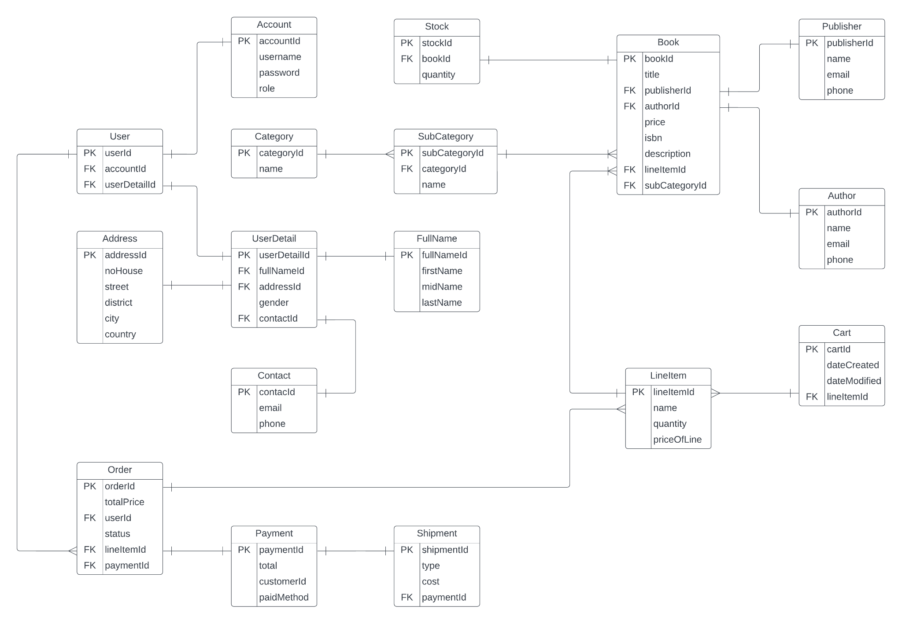

# 9. The Activity Diagram for A Book Store Online

3.1 *Access Process (User/Staff/Manager)*

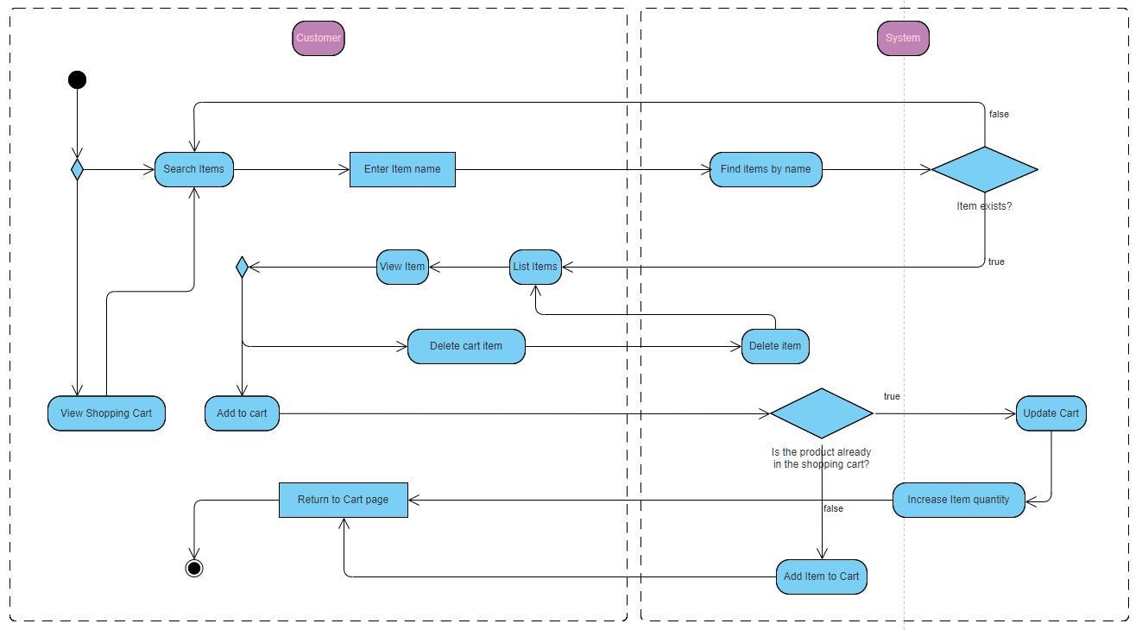

*3.2 Create Cart Process*

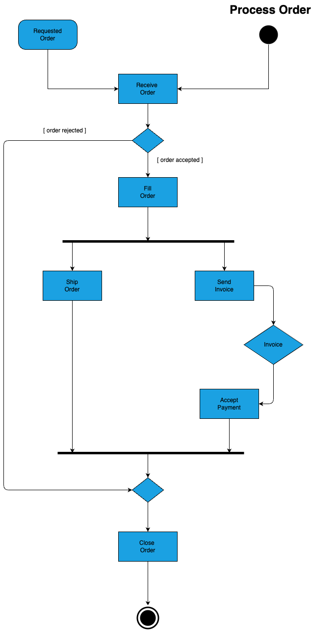

*3.3 Order Process (User)*

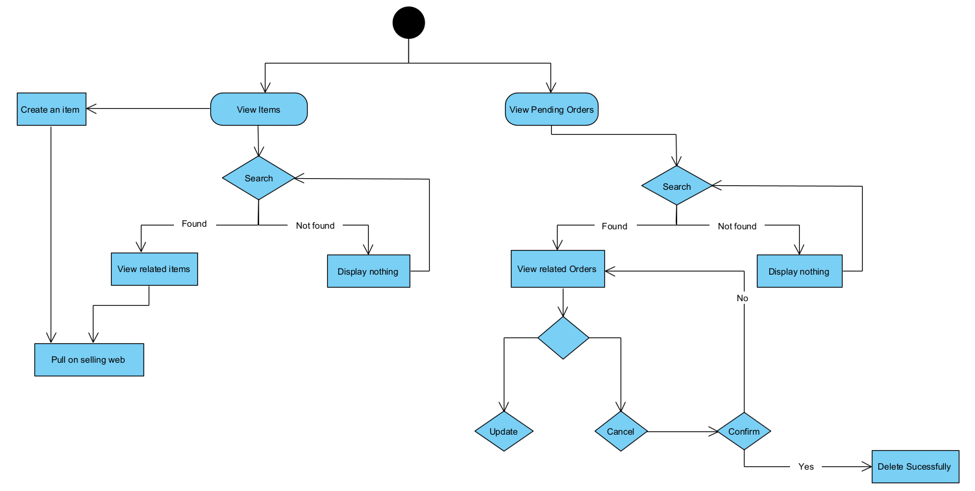

* 1. *Staff/Admin manager*

# 

# 10*.* Generate Database

CREATE TABLE Account (

accountId INT PRIMARY KEY,

username VARCHAR(50),

password VARCHAR(50),

role VARCHAR(50)

);

CREATE TABLE FullName (

fullNameId INT PRIMARY KEY,

firstName VARCHAR(50),

midName VARCHAR(50),

lastName VARCHAR(50)

);

CREATE TABLE Contact (

contacId INT PRIMARY KEY,

email VARCHAR(50),

phone VARCHAR(50)

);

CREATE TABLE Address (

addressId INT PRIMARY KEY,

noHouse VARCHAR(50),

street VARCHAR(50),

district VARCHAR(50),

city VARCHAR(50),

country VARCHAR(50)

);

CREATE TABLE UserDetail (

userDetailId INT PRIMARY KEY,

fullNameId INT,

addressId INT,

gender VARCHAR(50),

contactId INT,

FOREIGN KEY (fullNameId) REFERENCES FullName(fullNameId),

FOREIGN KEY (addressId) REFERENCES Address(addressId),

FOREIGN KEY (contactId) REFERENCES Contact(contacId)

);

CREATE TABLE [User] (

userId INT PRIMARY KEY,

accountId INT,

userDetailId INT,

FOREIGN KEY (accountId) REFERENCES Account(accountId),

FOREIGN KEY (userDetailId) REFERENCES UserDetail(userDetailId)

);

CREATE TABLE Payment (

paymentId INT PRIMARY KEY,

total DECIMAL(10,2),

customerId INT,

paid_Method VARCHAR(50)

);

CREATE TABLE Publisher (

publisherId INT PRIMARY KEY,

name VARCHAR(50),

email VARCHAR(50),

phone VARCHAR(50)

);

CREATE TABLE Author (

authorId INT PRIMARY KEY,

name VARCHAR(50),

email VARCHAR(50),

phone VARCHAR(50)

);

CREATE TABLE Category (

categoryId INT PRIMARY KEY,

name VARCHAR(50)

);

CREATE TABLE SubCategory (

subCategoryId INT PRIMARY KEY,

categoryId INT,

name VARCHAR(50),

FOREIGN KEY (categoryId) REFERENCES Category(categoryId)

);

CREATE TABLE Book (

bookId INT PRIMARY KEY,

title VARCHAR(50),

authorId INT,

publisherId INT,

price DECIMAL(10,2),

isbn VARCHAR(50),

description TEXT,

subCategoryId INT,

FOREIGN KEY (authorId) REFERENCES Author(authorId),

FOREIGN KEY (publisherId) REFERENCES Publisher(publisherId),

FOREIGN KEY (subCategoryId) REFERENCES SubCategory(subCategoryId)

);

CREATE TABLE LineItem (

lineItemId INT PRIMARY KEY,

name VARCHAR(50),

quantity INT,

priceOfLine DECIMAL(10,2),

bookId INT,

subCategoryId INT,

FOREIGN KEY (bookId) REFERENCES Book(bookId),

FOREIGN KEY (subCategoryId) REFERENCES SubCategory(subCategoryId)

);

CREATE TABLE Stock (

stockId INT PRIMARY KEY,

bookId INT,

quantity INT,

FOREIGN KEY (bookId) REFERENCES Book(bookId)

);

CREATE TABLE [Order] (

orderId INT PRIMARY KEY,

userId INT,

totalPrice DECIMAL(10,2),

status VARCHAR(50),

lineItemId INT,

paymentId INT,

FOREIGN KEY (userId) REFERENCES [User](userId),

FOREIGN KEY (lineItemId) REFERENCES LineItem(lineItemId),

FOREIGN KEY (paymentId) REFERENCES Payment(paymentId)

);

CREATE TABLE Shipment (

shipmentId INT PRIMARY KEY,

type VARCHAR(50),

cost DECIMAL(10,2),

paymentId INT,

FOREIGN KEY (paymentId) REFERENCES Payment(paymentId)

);

CREATE TABLE Cart (

cartId INT PRIMARY KEY,

dateCreated DATETIME,

dateModified DATETIME,

lineItemId INT,

userId INT,

accountId INT,

userDetailId INT,

addressId INT,

FOREIGN KEY (lineItemId) REFERENCES LineItem(lineItemId),

FOREIGN KEY (userId) REFERENCES User(userId),

FOREIGN KEY (accountId) REFERENCES Account(accountId),

FOREIGN KEY (userDetailId) REFERENCES UserDetail(userDetailId),

FOREIGN KEY (addressId) REFERENCES Address(addressId)

);

-- Sample data for Account table

INSERT INTO Account (accountId, username, password, role)

VALUES (1, 'user1', 'password1', 'admin'),

(2, 'user2', 'password2', 'user'),

(3, 'user3', 'password3', 'user');

-- Sample data for FullName table

INSERT INTO FullName (fullNameId, firstName, midName, lastName)

VALUES (1, 'John', 'Doe', 'Smith'),

(2, 'Alice', 'Jane', 'Doe');

-- Sample data for Contact table

INSERT INTO Contact (contacId, email, phone)

VALUES (1, 'john@example.com', '1234567890'),

(2, 'alice@example.com', '9876543210');

-- Sample data for Address table

INSERT INTO Address (addressId, noHouse, street, district, city, country)

VALUES (1, '123', 'Main Street', 'Downtown', 'New York', 'USA'),

(2, '456', 'Park Avenue', 'Uptown', 'Los Angeles', 'USA');

-- Sample data for UserDetail table

INSERT INTO UserDetail (userDetailId, fullNameId, addressId, gender, contactId)

VALUES (1, 1, 1, 'Male', 1),

(2, 2, 2, 'Female', 2);

-- Sample data for User table

INSERT INTO User (userId, accountId, userDetailId)

VALUES (1, 1, 1),

(2, 2, 2);

-- Sample data for Payment table

INSERT INTO Payment (paymentId, total, customerId, paid_Method)

VALUES (1, 100.00, 1, 'Credit Card'),

(2, 50.00, 2, 'PayPal');

-- Sample data for Publisher table

INSERT INTO Publisher (publisherId, name, email, phone)

VALUES (1, 'Publisher1', 'publisher1@example.com', '111-111-1111'),

(2, 'Publisher2', 'publisher2@example.com', '222-222-2222');

-- Sample data for Author table

INSERT INTO Author (authorId, name, email, phone)

VALUES (1, 'Author1', 'author1@example.com', '111-111-1111'),

(2, 'Author2', 'author2@example.com', '222-222-2222');

-- Sample data for Category table

INSERT INTO Category (categoryId, name)

VALUES (1, 'Fiction'),

(2, 'Non-Fiction');

-- Sample data for SubCategory table

INSERT INTO SubCategory (subCategoryId, categoryId, name)

VALUES (1, 1, 'Fantasy'),

(2, 1, 'Mystery'),

(3, 2, 'Biography');

-- Sample data for Book table

INSERT INTO Book (bookId, title, authorId, publisherId, price, isbn, description, subCategoryId)

VALUES (1, 'Book1', 1, 1, 20.00, 'ISBN123456', 'Description for Book1', 1),

(2, 'Book2', 2, 2, 15.00, 'ISBN789012', 'Description for Book2', 2);

-- Sample data for LineItem table

INSERT INTO LineItem (lineItemId, name, quantity, priceOfLine, bookId, subCategoryId)

VALUES (1, 'Item1', 2, 40.00, 1, 1),

(2, 'Item2', 1, 15.00, 2, 2);

-- Sample data for Stock table

INSERT INTO Stock (stockId, bookId, quantity)

VALUES (1, 1, 50),

(2, 2, 30);

-- Sample data for Order table

INSERT INTO Order (orderId, userId, totalPrice, status, lineItemId, paymentId)

VALUES (1, 1, 100.00, 'Completed', 1, 1),

(2, 2, 50.00, 'Pending', 2, 2);

-- Sample data for Shipment table

INSERT INTO Shipment (shipmentId, type, cost, paymentId)

VALUES (1, 'Express', 10.00, 1),

(2, 'Standard', 5.00, 2);

-- Sample data for Cart table

INSERT INTO Cart (cartId, dateCreated, dateModified, lineItemId, userId, accountId, userDetailId, addressId)

VALUES (1, '2024-02-28 10:00:00', '2024-02-28 10:30:00', 1, 1, 1, 1, 1),

(2, '2024-02-28 11:00:00', '2024-02-28 11:30:00', 2, 2, 2, 2, 2);

3. Quality Attributes

3.1. Usability

* **Simple and intuitive interface:** The website should be easy for customers of all technical backgrounds to navigate and use.
* **Search functionality:** Customers should be able to easily find the books they are looking for using various search criteria.
* **Clear checkout process:** The checkout process should be straightforward and transparent, with clear instructions and minimal steps.

# 3.2. Reliability

* **High system uptime:** The Book Store Online website should be available to customers 24/7 with minimal downtime for maintenance.
* **Accurate product information:** Book listings should be accurate and up-to-date, reflecting current stock levels and pricing.
* **Secure transactions:** The Book Store Online must ensure secure customer information and financial transactions.

# 3.3. Performance

* **Fast loading times:** The website should load quickly and efficiently, even when dealing with high volumes of traffic.
* **Responsive search results:** Search queries should return results promptly, minimizing waiting times.
* **Efficient order processing:** Orders should be processed quickly and accurately to ensure timely delivery to customers.

# 3.4. Security

* **Data protection:** Customer information, including account details and payment information, must be protected with robust security measures.
* **Payment gateway security:** Integration with a secure payment gateway is crucial to prevent financial fraud.
* **User authentication:** Strong authentication methods should be implemented to prevent unauthorized access to user accounts.

# 3.5. Maintainability:

* **Modular design:** The system should be designed with modular components for easy maintenance and future upgrades.
* **Clear documentation:** Well-documented code and system functionalities are essential for efficient maintenance and troubleshooting.
* **Scalability:** The system should be scalable to accommodate future growth in user base and transaction volume.