Journal-Ready and Production-Scale Blueprint
for Robust Reward Design on Attack-Graph MDPs
notation table, architecture figure, dataset/case design, and scalable experiment framework
Topic | Robust Reward Design for MDPs in Cybersecurity
Package focus | Exact small-case studies + scalable large-graph approximation path
Main use | Write the paper and run reproducible benchmarks

1. Executive summary
Keep the exact theoretical core unchanged: model the attack graph as an MDP, choose D and budget C, solve the standard Stackelberg reward-design problem to obtain v1*, then replace an arbitrary optimal allocation with an optimal interior-point allocation x_IP that maximizes a robustness margin c*. For larger graphs, add a second path that approximates robust behavior by top-k intervention screening, slack-aware allocation, and empirical robustness evaluation.

2. Refined problem statement
Let M=(S,A,T,gamma,rho) be the attacker MDP induced by a probabilistic attack graph. The defender modifies the attacker reward r2 over D with a nonnegative vector x satisfying sum x_i <= C. The standard exact problem yields v1* under optimistic best-response selection. The robust objective is to find x_IP inside an optimal allocation region so that tie-breaking, reward-perception errors, and bounded rationality do not destroy defender value.

3. Notation table
Symbol | Meaning
M=(S,A,T,gamma,rho) | Attacker MDP
r1 | Defender reward
r2 | Attacker reward
D | Intervention set
C | Budget
m | Occupancy measure
BR(x) | Best-response set
P_m | Allocation region
x_MILP | Standard exact allocation
x_IP | Interior-point allocation
c* | Robustness margin
delta, tau | Perception noise and bounded-rationality parameters

4. Architecture figure
The system below separates the exact path used for theory-faithful small cases from the scalable path used for larger graphs.
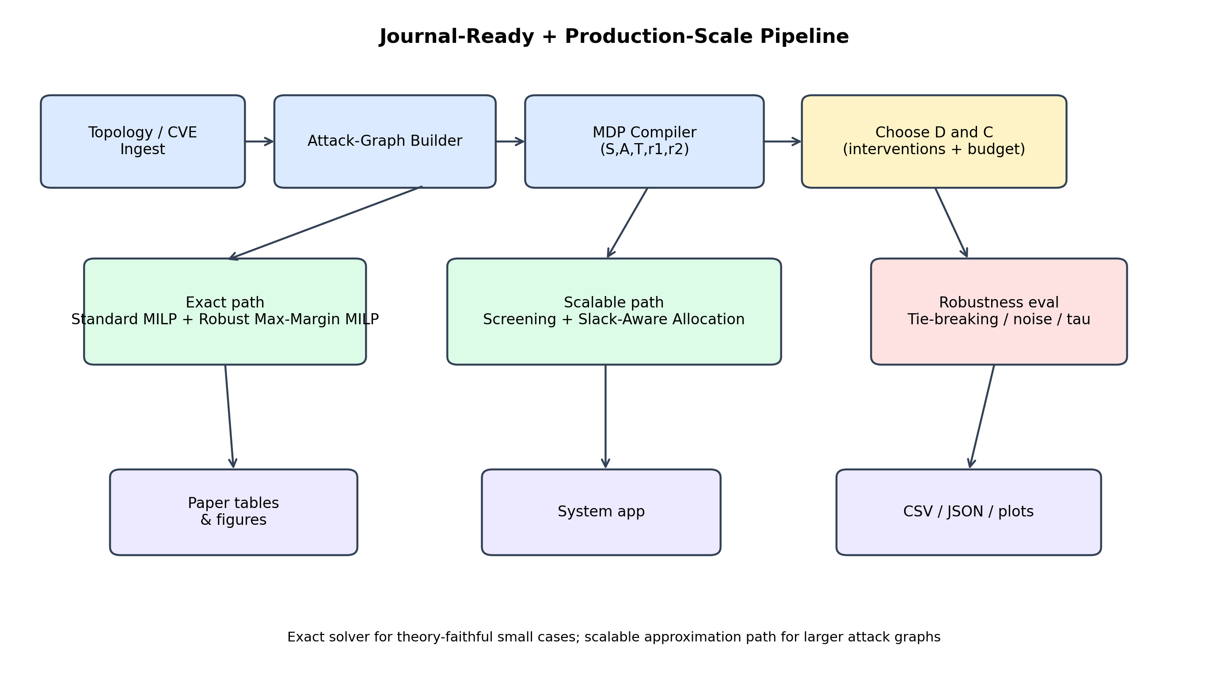
Figure 1. Exact path for theory-faithful small cases; scalable path for larger attack graphs.

5. Dataset / case-design matrix
case_name | scale | num_states | target_use | method | primary_question
paper_style_attack_graph | small | 13 | Exact replication/exposition | exact | Does robust allocation close the optimistic-pessimistic gap?
branching_enterprise_graph | small | 14 | Budget stress/existence failure | exact | When does the robust margin collapse to zero?
lateral_movement_graph | small | 16 | Enterprise lateral movement | exact | How much does robustness reduce true-goal reachability?
large_enterprise_64 | large | 65 | Scalable benchmark | scalable | How well does top-k intervention screening preserve defender value?
large_enterprise_120 | large | 121 | Production-scale benchmark | scalable | How does the scalable pipeline behave when the graph nearly doubles in size?

6. Experimental protocol
- Bucket A: exact validation of x_MILP versus x_IP.
- Bucket B: intervention-set design study for D.
- Bucket C: budget sweep for C.
- Bucket D: scalable large-graph benchmark.

7. Benchmark snapshot
case_name | mode | num_states | optimistic_value | pessimistic_value | margin | tau05_true_goal_prob | tau05_decoy_prob
paper_style_attack_graph | exact_standard | 13 | 0.6765 | 0.3292 | 0.0 | 0.3555 | 0.6367
paper_style_attack_graph | exact_robust | 13 | 0.6765 | 0.6765 | 0.4 | 0.2729 | 0.7182
branching_enterprise_graph | exact_standard | 14 | 0.713 | 0.3429 | 0.0 | 0.3622 | 0.6292
branching_enterprise_graph | exact_robust | 14 | 0.713 | 0.3429 | 0.0 | 0.3622 | 0.6292
lateral_movement_graph | exact_standard | 16 | 0.7085 | 0.6291 | 0.0 | 0.3752 | 0.6144
lateral_movement_graph | exact_robust | 16 | 0.7085 | 0.7085 | 0.4 | 0.2383 | 0.7507
large_enterprise_64 | scalable_heuristic | 65 | 0.7993 | 0.7993 | 0.5 | 0.0016 | 0.9953
large_enterprise_120 | scalable_heuristic | 121 | 0.7993 | 0.7993 | 0.5 | 0.0 | 1.0
Interpretation: the paper-style and lateral-movement cases show exact robust allocations closing a large optimistic–pessimistic gap, while the larger enterprise graphs show that the scalable path can still drive the attacker toward decoys with a high empirical margin.

8. Claim discipline for publication
- Use the exact MILP only for small/medium tabular instances.
- Report the large-graph path as an approximation pipeline, not as a theorem-preserving replacement.
- Separate exact and scalable results in different tables.
- State clearly where the theory ends and where empirical robustness begins.

9. Recommended paper skeleton

Introduction
Motivate why standard reward design is too fragile in cybersecurity.

Problem Formulation
Define M, r1, r2, D, C, occupancy measures, and the exact problem.

Exact Robust Reward Design
Present x_MILP, x_IP, and c*.

Scalable Production Path
Present intervention screening, slack-aware allocation, and empirical robustness.

Experiments
Report exact, D-design, budget sweep, and scalable benchmarks.

Limitations
Separate fundamental framework limits from technical scaling limits.

