Coupling and cohesion in cart

1. **CartScreen**

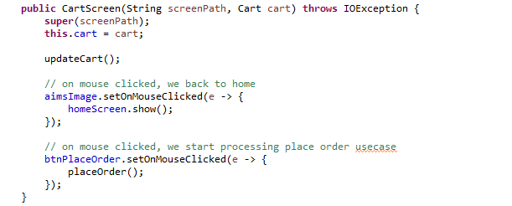

Constructor accepts a parameter of data structure type with all attributes being used -> Data coupling

Call method “placeOrder” with argument of data structure type with all attributes being used -> Data coupling

“updateCart” has no parameters -> Uncoupled coupling

Call method “setCartMedia” with argument of data structure type with all attributes being used -> Data coupling

“updateCartCost” has no parameters -> Uncoupled coupling

Call method “updateCost” with no arguments -> Uncoupled coupling

All methods are performed on same data “cart” -> Communication cohesion

1. **CartItemScreen**

Data coupling

Data coupling

All methods are performed sequentially -> Sequential cohesion

1. **Cart**

Data coupling

Uncoupled coupling

All methods are performed on same data “cartMediaList”, “costVAT”, “costNoVAT” -> Communication cohesion

1. **CartMedia**

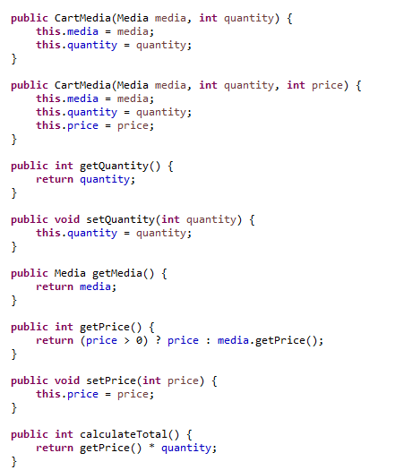

Data and uncoupled coupling

All methods has independent code and are performed on same data “media”, “quantity”, “price” -> Informational cohesion