1. **Given the provided data, what are three conclusions that we can draw about crowdfunding campaigns?**

Finding 1: There are three Parent Categories (theater, film & video, music) which account for mostly the total projects joined in the campaign. Specifically, the theater category reaches 344 projects, the film & video category is calculated as 178 projects, while the amount of music category is 175 projects [Graph 1].

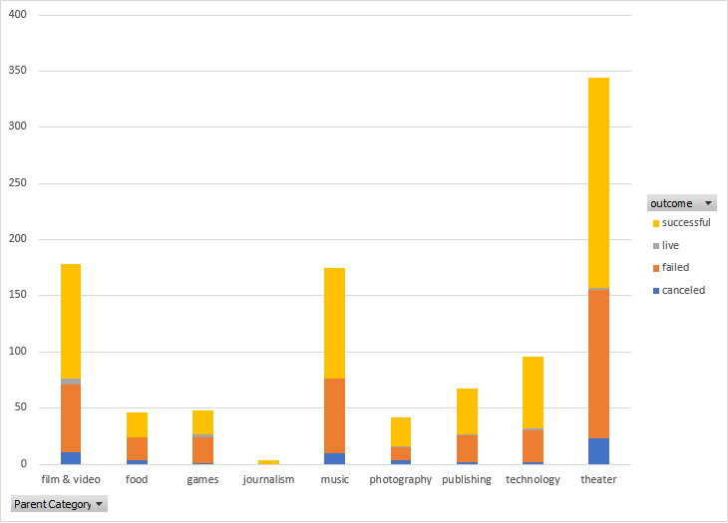

Graph 1: Parent Category illustration

Finding 2: Meanwhile, the sub-category of plays is dominant in the sub-categories with 344 projects, accounting for over one-third of the total sub-categories [Graph 2].

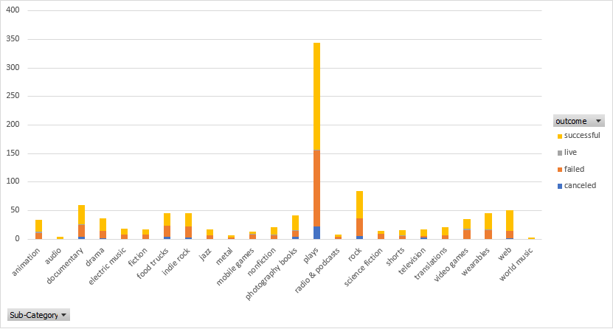

Graph 2: Sub-category illustrations

Finding 3: Mostly, the month which companies open their account balances will be in July [Graph 3]. Therefore, part of it can be contributed to conclude that most of these projects can be funded in July every year.

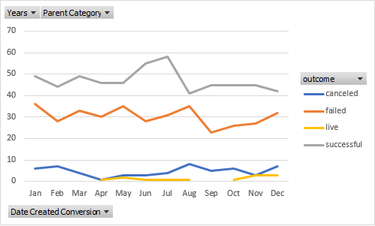

Graph 3: Date Created Conversion illustration

1. **What are some limitations of this dataset?**

The timestamp value of the platform was recorded in an unusual way, which is difficult to determine exactly the time.

The amount of funds is recorded in many currencies (USD, CAD, AUD, …), which means it is not easy to calculate how much money the project was funded, because we need to convert the money to a common currency (like USD) before calculating or doing any analysis with the funds.

The categories of goal, backers_count, average donation do not include the unit, which could not be helpful for measurement.

The platform does not split the name of individual and the name of corporation separately, which cannot determine whether the owner of projects is in person or in a group.

1. **What are some other possible tables and/ or graphs that we could create, and what additional value would they provide?**

With the above things being said, we should create an additional graph to illustrate the currencies recorded on the platform.

