Stage 1 Lab - Human vs AI: Building Your First SmartCare Prototype

Learning objectives
- Create and run a simple Python file with basic input,output and processing statements
- Use lists, dictionaries and functions to enhance the Python file
- Build a small SmartCare appointment prototype.
- Use AI as a tutor rather than a replacement.
- Compare human-written and AI-generated code.
- Verify AI-generated code through execution and test inputs.
- Document a short AI-use reflection.

Files to create and commit in GitHub
stage01/
smartcare_v01.py
comparison.md
reflection.md
ai_usage.md

Part A - Understand the Problem: AI OFF
SmartCare needs a small prototype that allows a receptionist to record patient appointments. Each appointment records patient name, practitioner name and appointment time.
What data must be stored?
- Patient name; Practitioner name; Appointment time.
What functions might be useful?
- book_appointment() - to add a new appointment
- display_appointments() - to view all recorded appointments
- validate_input() - to ensure required fields are not empty
- check_duplicate() - to prevent overbooking the same practitioner at the same time

What could go wrong?
- Duplicate appointments (same practitioner, identical time)
- Patient or practitioner names are missing or empty.
- Invalid time format or past dates.
- No option to cancel or modify appointments.
- No persistence (data is lost when the program finishes).
- There is no error handling for unexpected inputs.
What requirements are unclear?
- How long should appointments be (in duration)?
- Should patients be able to schedule appointments with any practitioner or a specific one?
- Is it necessary to set a maximum number of appointments?
- Should the system prevent a practitioner from being double booked?

Part B - Build a Human-Written Prototype: AI OFF

#task 1
# Create and run a simple Python file with basic input,output statements

print("Welcome to SmartCare: Community Clinic Appointment Booking System!")

# First Appointment
patient1_name = 'Alice Smith'
practitioner1_name = 'Dr. John Doe'
appointment1_time = '2024-07-20 10:00 AM'
print(f"Patient: {patient1_name} | Practitioner: {practitioner1_name} | Time: {appointment1_time}")

# Second Appointment
patient2_name = 'Bob Johnson'
practitioner2_name = 'Dr. Jane Roe'
appointment2_time = '2024-07-20 11:30 AM'
print(f"Patient: {patient2_name} | Practitioner: {practitioner2_name} | Time: {appointment2_time}")

#task1enhanced
# Use lists, dictionaries and functions to enhance the Python file

appointments = []

def book_appointment(patient_name, practitioner_name, appointment_time):
if not patient_name:
raise ValueError("Patient name cannot be empty")
appointment = {
"patient": patient_name,
"practitioner": practitioner_name,
"time": appointment_time
}
appointments.append(appointment)

def display_appointments():
if not appointments:
print("No appointments recorded.")
return
for appointment in appointments:
print(f"Patient: {appointment['patient']} | Practitioner: {appointment['practitioner']} | Time: {appointment['time']}")

print("Welcome to SmartCare: The Clinical Appointment Booking System!")
book_appointment('Alice Smith', 'Dr. John Doe', '2024-07-20 10:00 AM')
book_appointment('Bob Johnson', 'Dr. Jane Roe', '2024-07-20 11:30 AM')
display_appointments()

^ Now, run both programs , and identify at least five limitations.
No patient verification - Multiple appointments can be created with identical patient/practitioner/time combinations (no unique constraints).
No appointment ID - Cannot reference specific appointments for updates or cancellations.
No cancellation/modification - Appointments cannot be updated or cancelled once booked.
No duplication prevention - The system allows the same practitioner to be booked at overlapping times.
No time validation - Past dates and improper time formats are accepted without error checking.
No appointment duration - The system does not track how long appointments last, therefore overbooking cannot be detected.

Part C - Use AI as Tutor: AI ON (Use only UC approved GenAI Tool such as Microsoft CoPilot)
Suggested prompt structure:
Act as a Python tutor.
I am learning introductory software technology.
Here is a small appointment-booking function.
1. Explain what the code does.
- Your script prints a welcome message and then prints two hard-coded appointment records. It does not store them, validate them, or process them — it simply defines variables and prints formatted text.
2. Identify three limitations.
- No data storage — appointments are printed but not saved anywhere
- No reuse of logic — the code repeats itself instead of using a function
- No validation or rules — the program cannot detect empty names, invalid times, or double bookings
3. Suggest improvements.
- These are small, incremental improvements:
- Use a function to avoid repeating the print logic
- Store appointments in a list so the system can grow later
- Add basic checks (e.g., empty names, missing times) to make the program safer
These changes keep your program simple but make it more like a real appointment system.
4. Do not rewrite the whole application. ///
5. Ask me two questions to test my understanding.
- Why is using a function better than repeating the same print code twice?
Avoid repeating the print logic.
- What advantage do you get by storing appointments in a list instead of only printing them?
The system can grow later when there are more patients.

Part D - Generate an Alternative: AI ON
Ask AI to create a simple beginner-friendly Python function that stores patient name, practitioner name and appointment time. Explicitly prohibit a database or GUI.
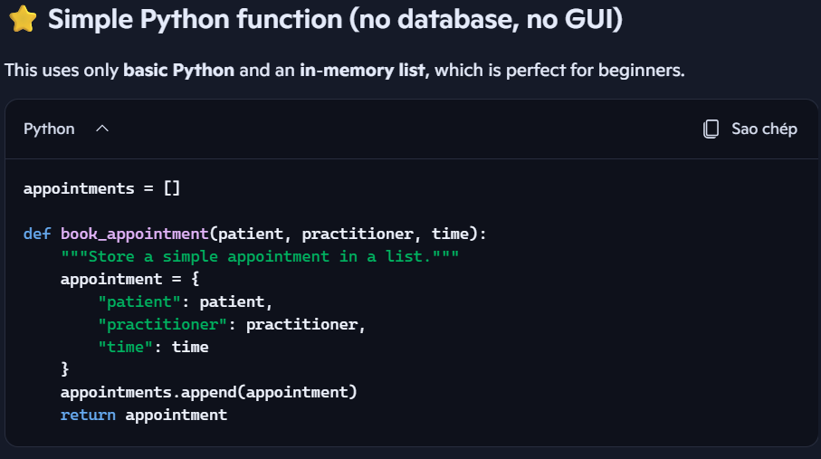

Part E - Compare Human and AI Versions
Question | Human version | AI version
Easy to understand? | Yes - clear variable names and structured logic | Yes - very simple and concise with docstring
Runs successfully? | Yes - executes without errors | Yes - executes without errors
Uses only required features? | Yes - stores three required fields plus validation | Yes - stores ONLY the three required fields, nothing extra
Adds assumptions? | Minimal - adds validation for empty patient name | No assumptions - completely minimal approach
Handles errors? | Yes - validates empty patient names, raises ValueError | No error handling - accepts any input including None
Could I explain it? | Yes - I wrote it; logic is clear and detailed | Yes - extremely minimal; 3-line core logic

Part F - Verify Behaviour

Normal appointment - Book Alice Smith with Dr. John Doe at 2024-07-20 10:00 AM → Should display successfully

Blank patient name - Try booking with empty patient name → Should raise ValueError

2 appointments same practitioner/time - Book Dr. John Doe twice at 2024-07-20 10:00 AM → Should allow (limitation identified)

Strange input - Try patient_name=None or appointment_time=None → Should accept or fail depending on implementation

Display when empty - Call display_appointments() with no bookings → Should print "No appointments recorded."

Part G - Improve One Thing
Improvement: Add duplicate detection to prevent the same practitioner being booked at the same time.
def book_appointment(patient_name, practitioner_name, appointment_time):
if not patient_name:
raise ValueError("Patient name cannot be empty")
for appointment in appointments: # Check for duplicate booking
if appointment["practitioner"] == practitioner_name and appointment["time"] == appointment_time:
raise ValueError(f"Dr. {practitioner_name} is already booked at {appointment_time}")

appointment = {
"patient": patient_name,
"practitioner": practitioner_name,
"time": appointment_time
}
appointments.append(appointment)

Part H - Reflection (150-250 words)
I created a simple Python prototype that supported basic input/output and string formatting. The first version had unique variables for each visit, which didn't scale. The improved version adds lists and dictionaries for storing numerous appointments, as well as basic validation for empty patient names. This taught me how important data structures are for organizing collections.
AI as a tutor can assist me understand code logic by asking guided questions rather than delivering entire solutions. This necessitates a greater knowledge of why specific tactics operate. For example, AI can assist me in reasoning about edge scenarios (double bookings, invalid times) that I may otherwise overlook. It also displays industry-standard methods such as error handling and validation, which a newbie may not naturally adopt.
Yes, AI may presume that appointment timings must be validated as genuine future dates, or that practitioners have a maximum appointment time. This emphasizes the significance of clearly defining requirements and closely analyzing AI output.
I tested both the human and AI versions using test cases that included regular input, blank names, duplicate bookings, and unexpected values. I compared behavior to the original criteria, determining the restrictions each version addressed or added.
Implementing permanent storage (database or file I/O), adding time validation and appointment duration tracking, creating a user interface, and including cancellation/modification options. The prototype demonstrated that the main concept works; production-grade work requires security, scalability, and user experience.

Submission checklist [GitHub Commit]
- Python file runs.
- Comparison table completed.
- Normal and unusual inputs tested.
- AI assistance documented.
- Reflection completed.
- I can explain my code.

