**Hàm logarith, hàm mũ**

import cv2  
import imutils  
import numpy as np  
  
# logarithmic, ham mu  
img = cv2.imread('logimg.jpg')  
img_log = (np.log(img+1)/(np.log(1+np.max(img))))*255  
img_log = np.array(img_log, dtype=np.uint8)  
cv2.imshow('log_image', img_log)  
cv2.imshow('original_img', img)

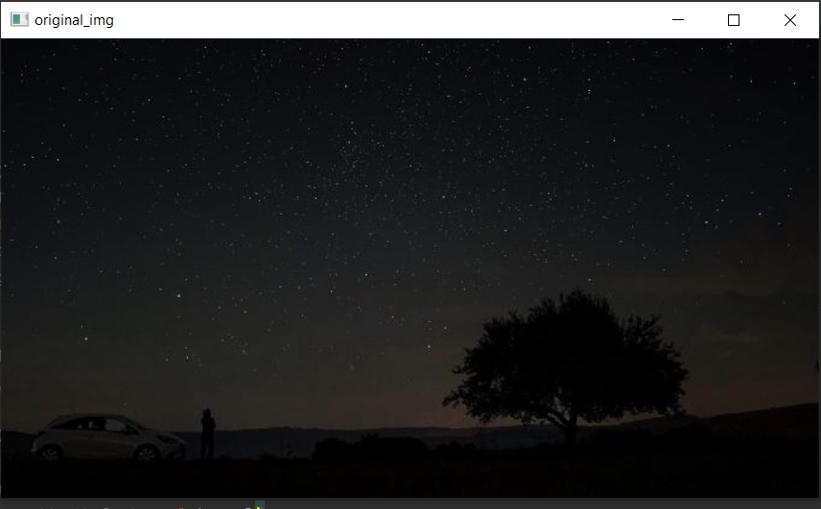

*Ảnh gốc*

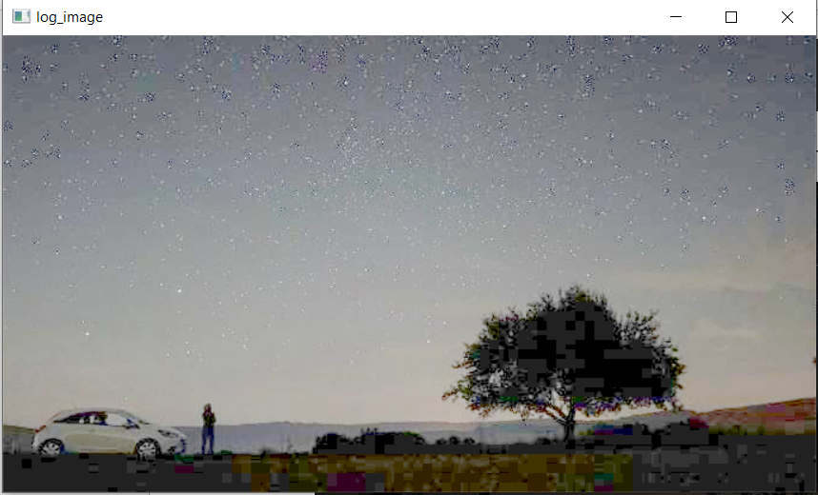

*Ảnh sau khi logarithmic transformation*

**Mean filter, median filter, weighted filter**

kernel = np.ones((5, 5), np.float32)/25  
kernel1 = np.array([[1, 2, 1],  
 [2, 4, 2],  
 [1, 2, 1]])/16  
img = cv2.imread('noiseimg.png')  
img_median = cv2.medianBlur(img, 9)  
img_mean = cv2.filter2D(src=img, ddepth=0, kernel=kernel)  
img_weighted = cv2.filter2D(src=img, ddepth=0, kernel=kernel1)  
cv2.imshow('orig_img', img)  
cv2.imshow('median_image', img_median)  
cv2.imshow('mean_img', img_mean)  
cv2.imshow('weighted_img', img_weighted)

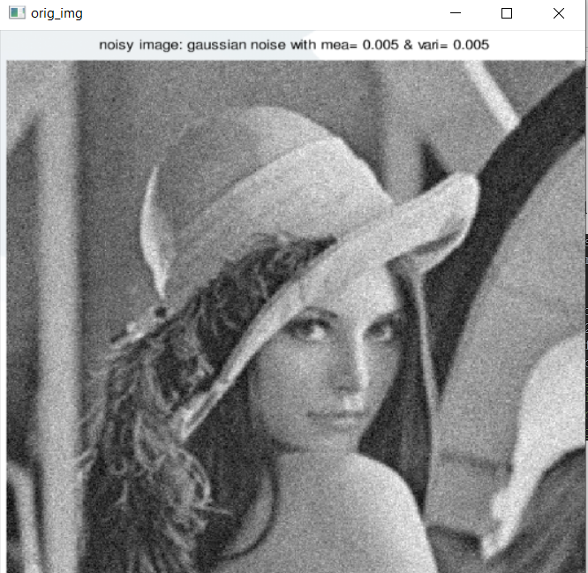

*Ảnh gốc*

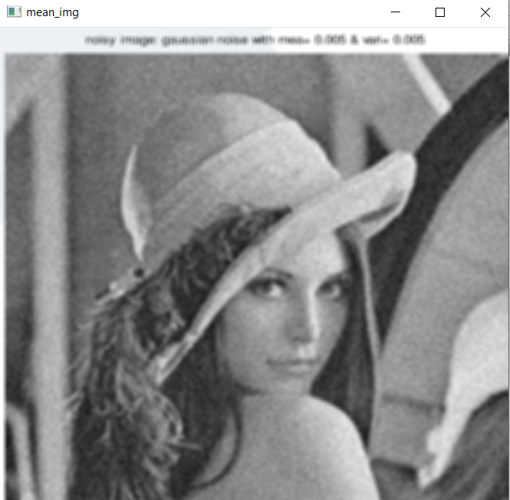

*Ảnh lọc trung bình*

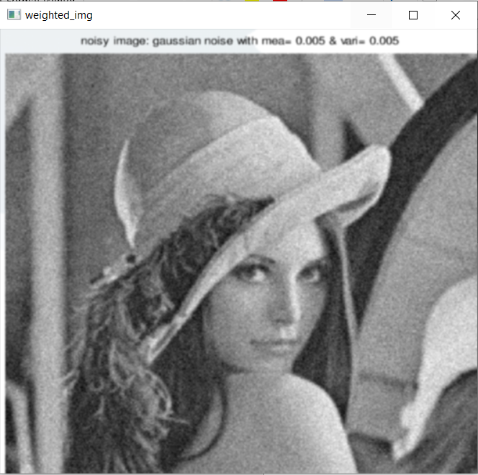

*Ảnh lọc trung bình có trọng số*

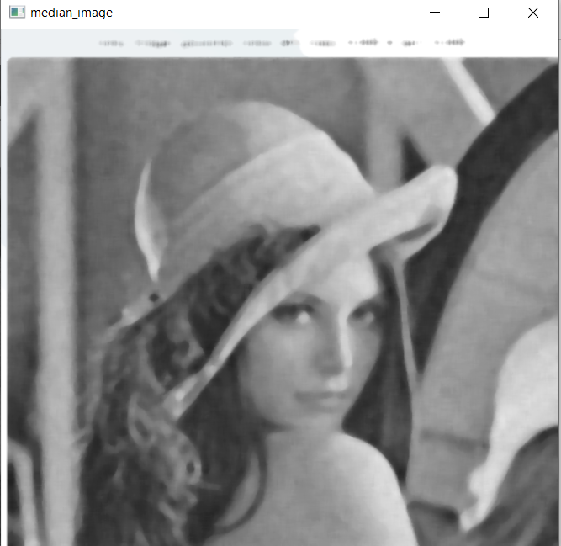

*Ảnh lọc trung vị*

**Sharpening, segmentation**

kernel2 = np.array([[0, 1, 0],  
 [1, -4, 1],  
 [0, 1, 0]])  
img = cv2.imread('dep1.jpg')  
img = imutils.resize(img, width=443, height=591)  
img = cv2.cvtColor(img, cv2.COLOR_BGR2GRAY)  
cv2.imshow('origi_img', img)  
img = cv2.medianBlur(img, 7)  
image_sharp = cv2.filter2D(src=img, ddepth=0, kernel=kernel2)  
s, thresh_sharp = cv2.threshold(image_sharp, 20, 255, cv2.THRESH_BINARY)  
cv2.imshow('sharp_img', image_sharp)  
cv2.imshow('segmentation_img', thresh_sharp)

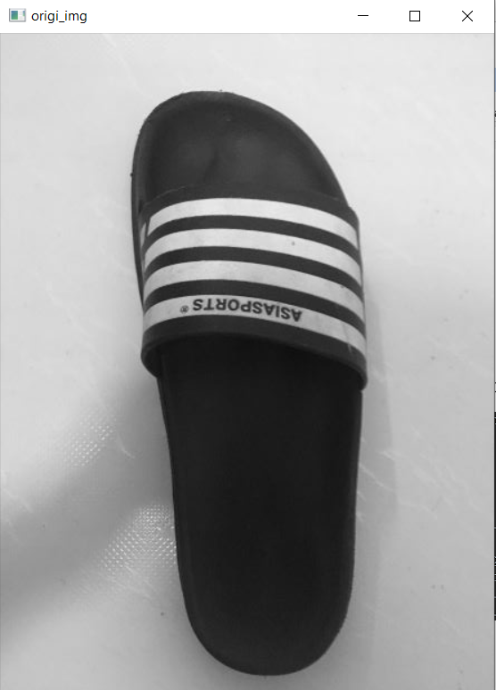

*Ảnh gốc*

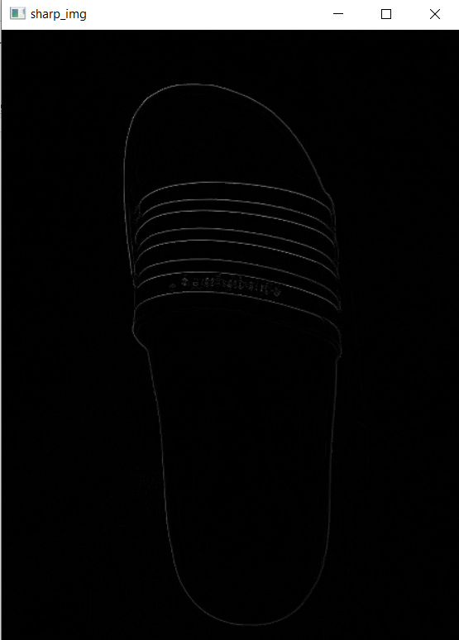

*Ảnh sau khi sharpening*

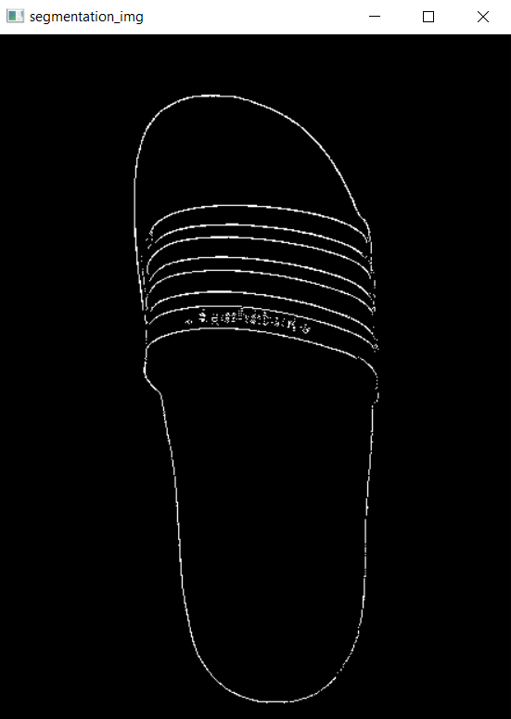

*Ảnh sau khi thersholding từ ảnh sharpening*