COSC 30603
Lab Assignment 2: ER Model and Relational DB
Name: Hieu Nguyen

Due: Sep 16.

- ER Diagram
Draw an ER diagram for the following entity types and add at least 10 relationship types of your own for these entity types in the ER diagram. You should focus on defining correct relationship types as well as their cardinality ratios and participation constraints. Please also write a sentence to describe each relation, cardinality ratios and participation constraints.

• Student (SId, SSNo, StuName, CurAddress, LocalTel, PermAddress, PermTel, Sex, BDate, Gpa), PK: SId.
• Department (DId, DeptName, DeptAddress, Tel), PK: DId.
• DegreeProgram (PId, ProgName, ProgType, UnivReq, CollReq, DeptReq), PK: PId.
• CourseDescription (CNo, Title, Credits, Description), PK: CNo.
• CourseOffering (SeqId, Semester, Year), PK: SeqId.
• TextBook (ISBN, TextName, Publisher), PK: ISBN.
• Faculty (FacSSNo, FacName, OfficeAddress, Tel), PK: FacSSNo.

Paste you ER diagram here:

- Student has a relationship with Degree Program, as student enrolls in Degree Program. The cardinality ratios is M:N, participation constraints is total.
- Degree Program has a relationship with Course Offered as for each Degree Program, it requires specific courses to complete the program. The cardinality ratios is M:N, participation constraints is total.
- CourseOffered has a relationship with CourseDescription as the course will contain its own description. The cardinality ratios is 1:1, participation constraints is partial.
- CourseDescription has a relationship with TextBook as textbook is required for courses. The cardinality ratios is 1:M, participation constraints is total.
- CourseOffered has a relationship with Faculties as faculties will teach the courses. The cardinality ratios is 1:1, participation constraints is partial.
- Faculties has two relationships with Departments. One is supervise as department will supervise faculties. The cardinality ratios is 1:M, participation constraints is total. Second relationship is awards as department may recognize faculties. The cardinality ratios is M:N, participation constraints is total
- Faculties has a relationship Association as faculties may join into other associations on and off campus. The cardinality ratios is M:N, participation constraints is total.
- Departments has a relationship with DegreeProgram as Departments offer the programs. The cardinality ratios is M:N, participation constraints is total.
- Student has a relationship Internship as students may or may not have internship. The cardinality ratios is 1:M, participation constraints is partial.
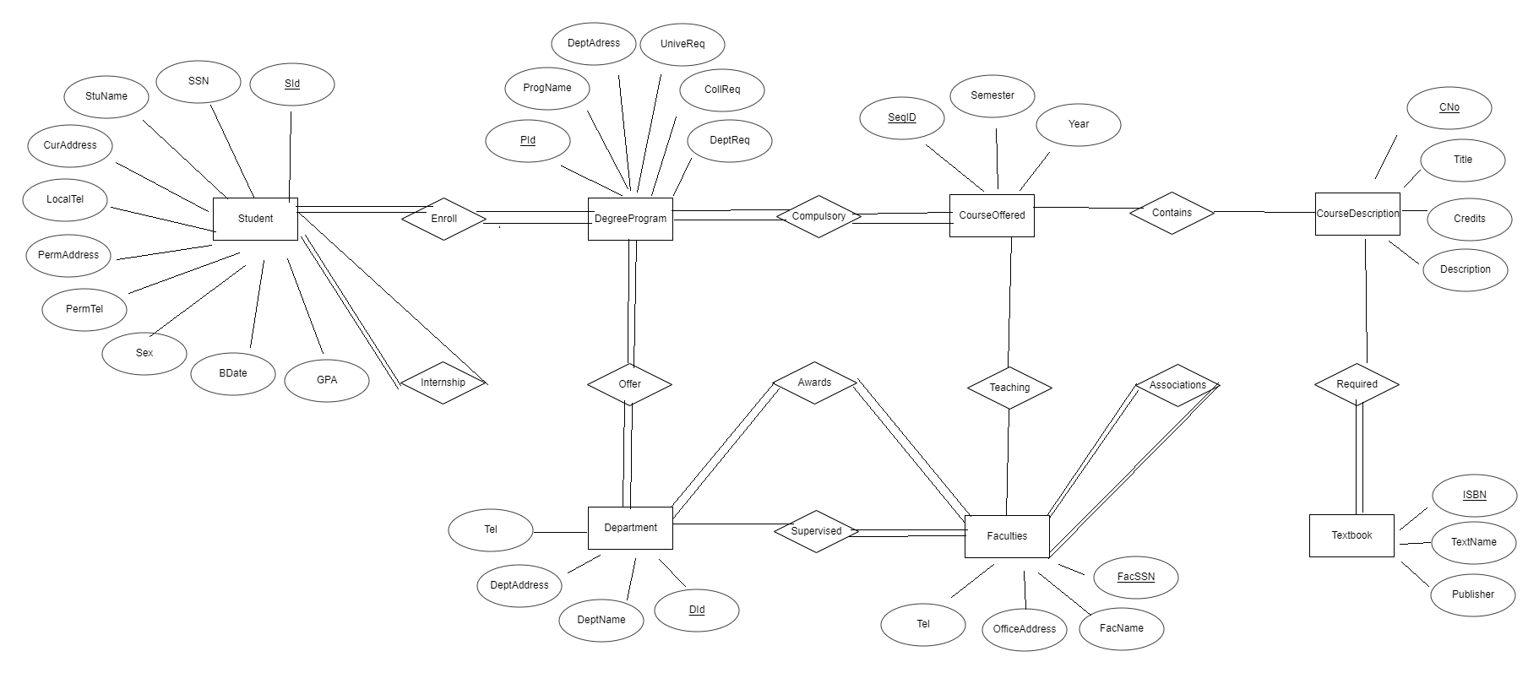

- Try primary key and foreign key constraints

(a) Put the following commands into the terminal.
//first, create a DB called TCU in MySQL
create table student(
sid INT(10) primary key,
stuname VARCHAR(30),
localtel INT(10)
);

insert into student values (12, 'Harry', 817888);
insert into student values (12, 'Ron', 817458);
Screenshot: 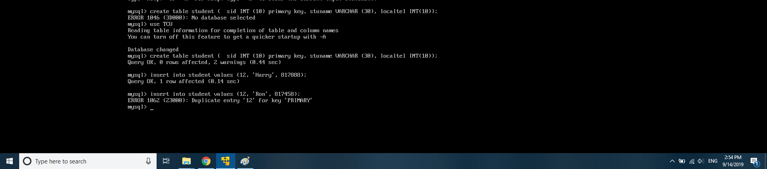

Why do you see the error message in the output?
Answer:
- Because we have duplicate ID which is also a primary key

Give the name of the constraints that was violated.
Answer: Key Constraint

(b) Correct the problem and run the two inserts again.
Screenshot

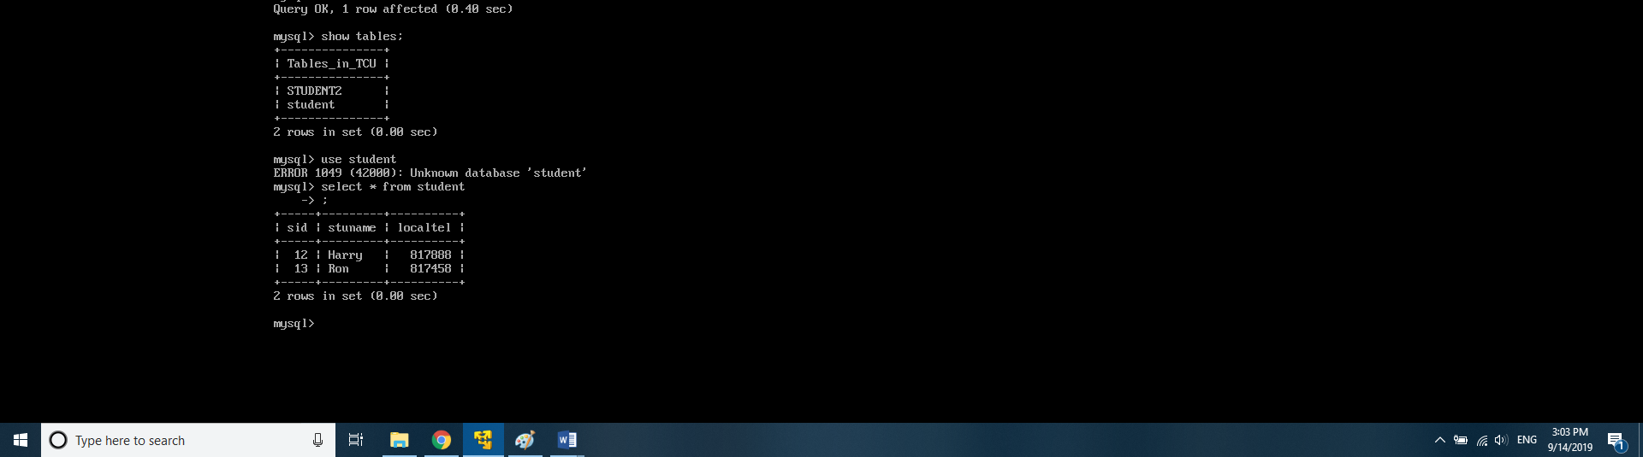

(c) Add the following commands.
create table studentcourse(
sid INT(10),
cid INT (8),
grade DOUBLE (3,1),
//make sid and cid be the PK
//make sid FK, which refers to sid of the student table
[Your answer here]
);

insert into studentcourse values(12, 54,3.5);
insert into studentcourse values(412, 54,3.5);

Screenshot: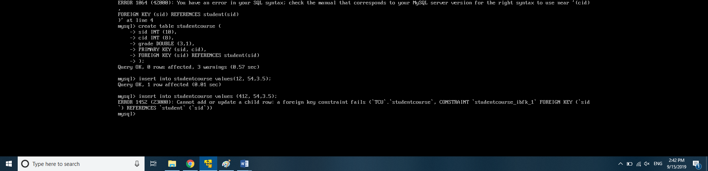

Why do you see the error message in the output?
Answer:
- Cannot add or update a child row: a foreign key constraint fails. Since there is no record for sid 412 in the parent table – student table.

Give the name of the constraints that was violated.
Answer: Referential Integrity Constraint

(d) Correct the problem and run again.
Screenshot:

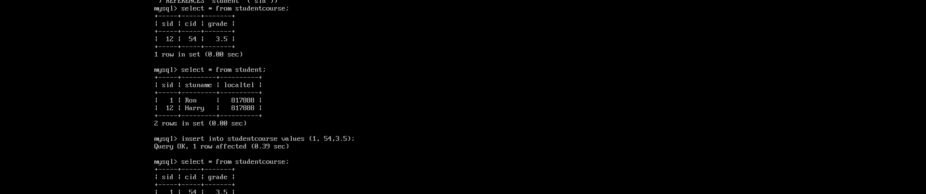

- Now consider the ER diagram that you created in part 1 of the lab. Create a file lab2_er.sql that contains SQL commands to create tables for ONLY the entity types (NOT the relationship types) in the ER diagram. Decide the data types of each attribute by yourself. Make sure that the tables can be created in MySQL before you turn in.
The first statement in your lab2_er.sql should be
create database TCU_YourFullName
Print out the file lab2_er.sql and submit it along with this lab assignment.

