COSC 30603
Homework 2
Hieu Nguyen
Due: Sep 16, 2019.
Requirement: Your answers must be printed or typed. You may attach hand-drawn figures if needed.

- Consider the following data requirements. (50 pts)
A real estate agent has a license number, a name (first name and last name) and several phone numbers. Every agent must belong to a real estate company. A real estate agent can be a supervisor of several other agents, while an agent can only have one supervisor.
A real estate company has a company name and the number of real estate agents who work for the company.
A real estate company may have a number of real estate agents, while a real estate agent can only work for one real estate company.
A real estate company can have at most one parent real estate company. A real estate company can be the parent of several other real estate companies.
A house can be listed by only one real estate company. A house has a list id assigned by the real estate company. The list id is unique only within the same real estate company. A house also has the number of bed rooms and the square footage. A real estate company may list many houses at the same time.
A house buyer has an SSN and a birth date. The buyer may look at several houses, while a house may be seen by many buyers.
A buyer buys a house from a real estate agent on a closing date.
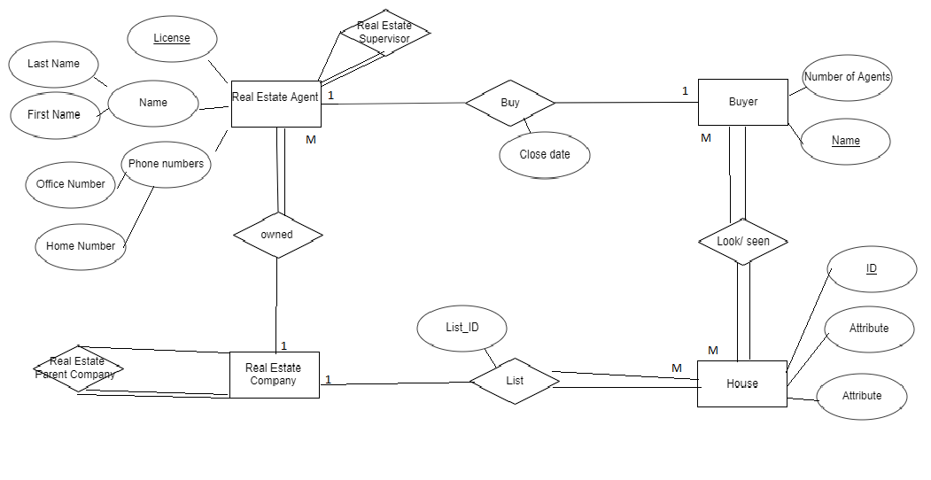
Draw an ER diagram based on the requirements
- Consider the following ER diagram. Map it into a relational database schema. Hint: Do not forget to add UNIQUE and NOT NULL in the schema where they needed. (50 pts)
Note: For simplicity, the domain for each attribute can be omitted in the schema. The database schema should use the following format for each table:
Relation_name (attribute name list), PK: ..., FK (if any): ... references ..., UNIQUE, NOT NULL
For example:
Project (ProjectNo, ProjectName), PK: ProjectNo.
Employee (EmployeeNo, Name, WorksOn), PK: ProjectNo, FK: WorksOn references Project, Workson: UNIQUE, NOT NULL.
* Assume that workson is a 1:1 total relationship for Employee between Employee and Project.

Book
previous edition
1
1
ISBN
Title
Publisher
PName
Number of published books
publish
N
1
Author
Locations
write
N
M
SSN
AName
First
Last
Contract
sign
Sign date
Id
Start date
Lawyer
review
Fee
N
M
End
date
Lic#
Years

- Author (SSN, First, Last), PK: SSN
- Book (ISBN, Title), PK: ISBN.
- Publisher (PName, Number of published books, Locations). PK: PName. FK: Pname references Publisher
- Contract (Id, Start Date, End Date). PK: Id
- Lawyer (Lic#, Years,). PK: Lic#.
- Write(SSN, ISBN) ,PK: (SSN,ISBN), FK: SSN references Author , ISBN references books
- Review(Id,Lic#,Fee), Pk:(Id,Lic#) , FK: Id references Contract, Lic# references Lawyer
- Publisher_Name, SSN, Lic#, ISBN: UNIQUE, NOT NULL

