COSC 30603
Lab Assignment 3: EER Model
You need to turn in: a hardcopy of your answers (use bold face style), a hardcopy of lab3.sql and an e-copy of your lab3.sql.
You need to work in a SQL client software, e.g. MySQL Workbench, Navicat (not free), SQLYog Community Version (Windows), Sequel Pro (Mac).
Don’t use terminal.

Name: Hieu Nguyen

Due: Sep 27, 2019.

- Requirement Specification
Consider the following set of requirements for a student database that is used to keep track of student information in a university.
(a) The database should keep track of a student’s name, id, social security number, current address and phone number, permanent address and phone number, birth date, sex, class, major department, minor department (if any), and degree program (B.A., B.S., etc.).
(b) Course description has course title, course number, short description, number of credit hours, offering department, prerequisite courses, set of text books and semester offered.
(c) Course offering contains sequence number, year, semester, time, place, instructor and TAs.
(d) The department has the following information: department name, department location, phone, chairperson, faculty members and degree programs.
(e) Other information such as course grades, grade point average, student advisors, probation status and graduate/undergraduate level should be captured in the schema design.
- EER Diagram
An EER diagram based on the above requirement specification is provided (see next page).
- Add the following additional requirements to the EER diagram. Add new entity types and attributes as needed. Modifications can be made directly on the original EER diagram (please use a different color (e.g. purple) to make your additions explicit, also you MUST annotate your additions with the corresponding question numbers so it will be easier for me to grade, NO POINTS will be given if you fail to annotate your EER).
(a) Departments have joint degree programs, that is, a degree program can be administered by more than one department.
gpa
Degree Program
major
minor
N
N
1
1
Undergraduate
Probational Student
Graduate
Course Offering
taken
grade
M
N
Course Description
TA
N
M
type
name
requirements
college
university
offers
N
Dept requirement
Faculty
coordinator
1
1
offers
N
M
prerequisite
N
M
chair
1
1
works for
1
N
has
1
N
Textbook
has
N
M
instructor
N
1
advisor
counselor
1
N
1
N
1
Student
Department
mentor
teach
supervise
Research Proj
Use
Labotary
(b) Graduate students can teach courses.
(c) Student can mentor other students (e.g., a senior student mentors some junior students). Assume that a student mentor can have several mentees. But a student mentee can only have at most one mentor.
(d) Each laboratory has a faculty as its director.
(e) A faculty can supervise multiple research projects.
(f) Students using certain labs for certain research projects.
(g) Every graduate student MUST have an advisor.

- An instructor may have office hours which
(a) corresponds to each course, or
(b) corresponds to each instructor (i.e., same office hours for all the courses that the instructor teaches)
How can each one of the above two cases be incorporated, independently, in the EER diagram?
Answer: You only need to show the relevant part of the above EER here.

Course Offering
Office hours

Instructor

Office Hours
Faculty

- Not all faculty members are teaching. Consider creating a new entity Instructor and making it a subclass of Faculty. Make necessary modifications to the EER diagram.
Answer: You only need to show the relevant part of the above EER here.

Course Offering
teach
Instructor
Faculty
In this part of the lab assignment, you will learn to implement 1:1, 1:N and N:M relationships in MySQL.

(a) We implement the 1:1 relationship chair between Department and Faculty in the EER diagram. Since Department totally participates in the relationship, we implement the foreign key for the relationship in the Department table. Why?
Answer:
Because there is only one department chair for each department, and not every faculty is a department chair. In order to save spaces, we use foreign key for the relationship in Department; by doing so, a null value won’t be put on those faculties who are not department chair.

Open your MySQL Workbench and connect to MySQL in VMWare, then write the following (Replace YourName with your real name):
CREATE DATABASE IF NOT EXISTS UNIVERSITY_YourName;
USE UNIVERSITY_YourName;

Since the foreign key in the Department table is referencing the Faculty table, we need to create the Faculty table first. Create a file called lab3.sql. Add the following SQL commands into lab3.sql.

/*drop all tables if they exist ignoring the foreign key constraints*/
SET FOREIGN_KEY_CHECKS=0;
DROP TABLE IF EXISTS faculty;
DROP TABLE IF EXISTS department;
DROP TABLE IF EXISTS courseoffering;
DROP TABLE IF EXISTS coursedescription;
DROP TABLE IF EXISTS dept_offers_coursedesc;
DROP TABLE IF EXISTS textbook;
SET FOREIGN_KEY_CHECKS=1; 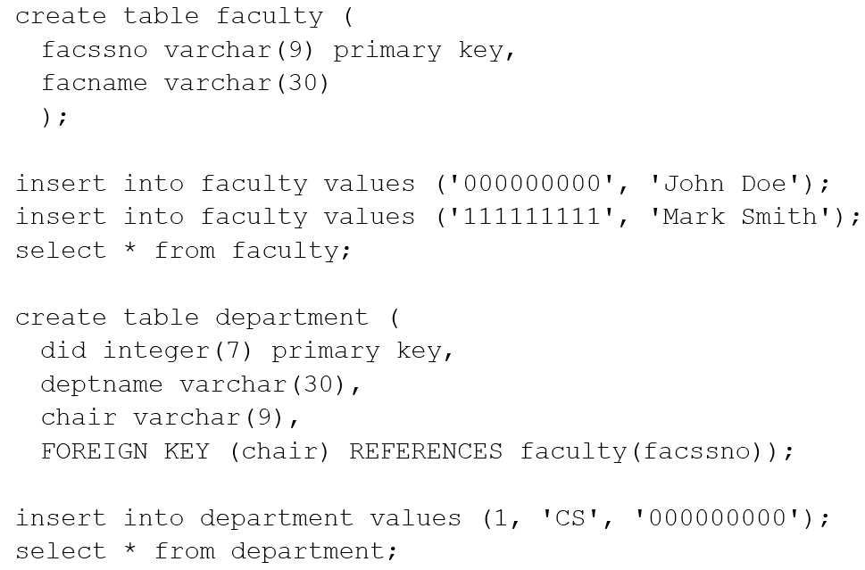
Run the SQL statements in lab3.sql in MySQL workbench. Based on the statements in lab3.sql, who is the chair of CS department?
Answer:
John Doe

Append the following statements in lab3.sql:

Who is the chair of MS department?
Answer:
John Doe

The insertion of the second tuple is semantically wrong. Why?
Answer:
John Doe is a department chair for two departments. Since its relation is 1:1 which means a faculty can only be a chair for one Department.

The MySQL system does not detect the problem! To prevent inserting the second tuple, you need to make the foreign key attribute (chair) in Department UNIQUE.
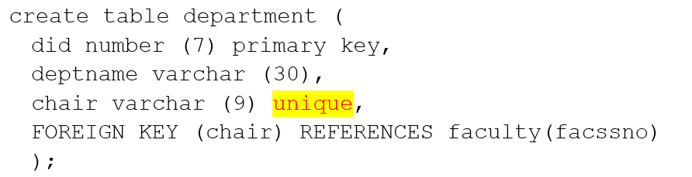
Go back to MySQL Workbench and rerun the SQL statements in lab3.sql. Observe that the second tuple cannot be inserted now.
Screenshot:

Comment out the second insert using /**/
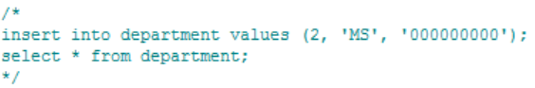
(b) 1:N relationship is implemented almost the same as 1:1 relationship except that UNIQUE is not needed. Foreign key should be defined in the table on the N side.
Append the following SQL commands in lab3.sql.

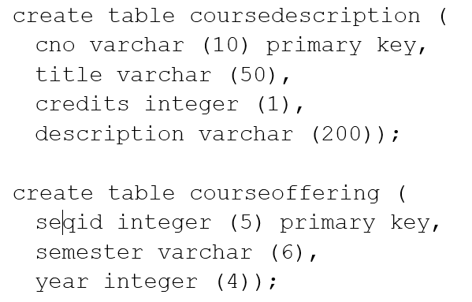
Now implement in lab3.sql the 1:N relationships has between CourseDescription and CourseOffering and instructor between Faculty and CourseOffering. Make sure that your implementation in lab3.sql works in MySQL workbench.

Answer (copy your SQL implementation of the above description here):

descriptionno varchar (10),
instructor varchar(9),
foreign key (descriptionno) references coursedescription (cno),
FOREIGN KEY (instructor) REFERENCES faculty (facssno));

(c) For an N:M relationship, a new table should be created. For example, the N:M relationship offers between Department and CourseDescription can be implemented in lab3.sql as follows:

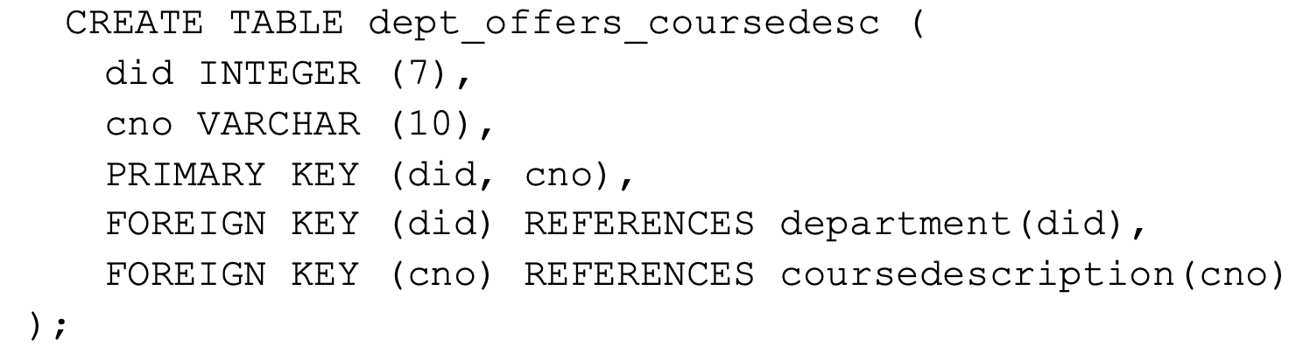
Go back to MySQL workbench and rerun lab3.sql.

Add the following statement in lab3.sql.

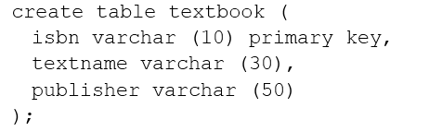
Now implement in lab3.sql the N:M relationship has between CourseOffering and TextBook.
Answer (copy your SQL implementation of the above description here):

create table has (
seqid integer (5),
bookno varchar(10),
primary key (seqid, bookno),
foreign key (seqid) references courseoffering(seqid),
foreign key (bookno) references textbook(isbn));

Print out the file lab3.sql in a separate paper and also submit it along with this lab assignment.

