COSC 30603
Lab Assignment 5: Data Loading and SQL
You need to turn in: a hardcopy of your answers (type your answer in a different font or color, e.g. bold face style), a hardcopy of lab5.sql.
You can work directly in terminal in for this lab.
Name: Hieu Nguyen

Due: Nov 1, 2019.

- Data Loading Documentation
In this assignment, we will first complete data loading. A row-by-row insertion into tables is not efficient for large databases. As an alternative method, data loading allows us to directly load data from files into tables.

MySQL provides a “LOAD” command that can load data stored in a text file into a table. The following illustrates the loading of the data located in dat file into the tables. In the following example, the LOAD command is directly entered at the MySQL prompt. It may be a good idea to create a script file (.sql file) with the load command and use the “SOURCE” command to execute the “LOAD” command. This way, if there are any syntax errors, these can be corrected in the script file and the load command can be re-executed.

MySQL Documentation:
https://dev.mysql.com/doc/refman/8.0/en/load-data.html

- Create a sql file, lab5.sql in Workbench.
We first create the relation schemas.
The schema is based on the EER diagram given on the next page.
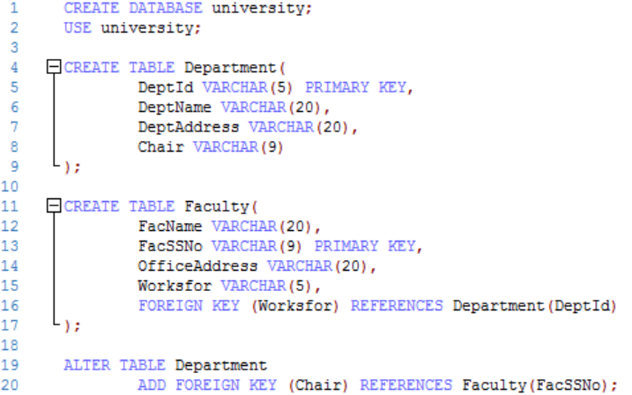
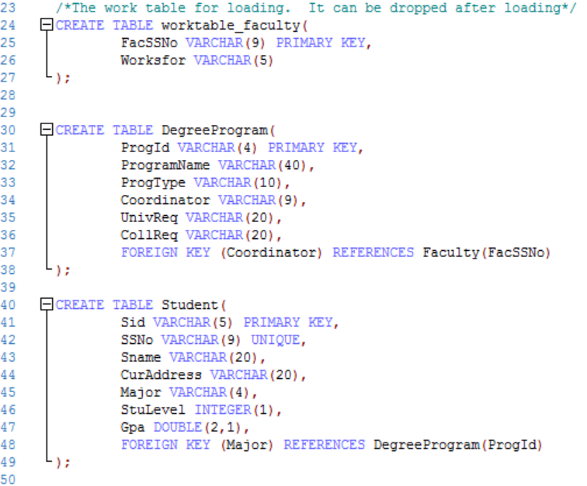
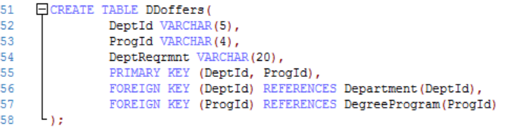
What are the entity types and relationship types of the EER diagram that have been implemented in this schema?
Answer:
- Entity: Faculty and Department involves in relationship types chair and works
- Entity: Faculty and Degree Program involves in relationship types coordinator
- Entity: Student and Degree Program involves in relationship types major
- Entity: Department and Degree Program involves in relationship types offers

- Download lab5_data.zip and unzip it on your computer. E.g. I copied the folder to D:\
- Enable MySQL LOAD
To enable MySQL’s load data capability, you need to start your MySQL from terminal using:
See this StackOverflow post for more info.
https://stackoverflow.com/questions/10762239/mysql-enable-load-data-local-infile
In this lab, if you need to execute load, you have to do that through terminal, NOT Workbench.
- Open faculty.dat files. Review faculty data in faculty.dat. This is call CSV (Comma-separated values)
- Execute the following command in terminal to load faculty data into faculty table:
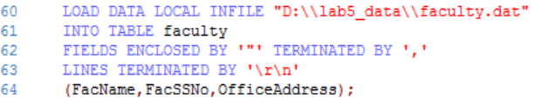
You may check the content of the faculty table now.
select * from faculty;

Is the table properly loaded? Copy the screenshot here:
- Yes
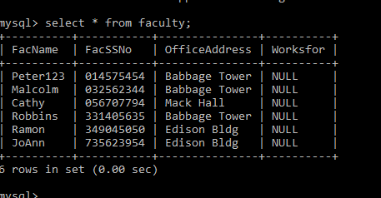

- Explain the meaning of
  - Fields enclosed by
From .dat files, scans thru strings that have “ “ then treats as values into tuples.

  - Terminated by
Let us know when to the data is terminated, in other words, we know when the values are inserted into tuples and tuples into tables

N
d
mentor
gpa
Degree Program
major
minor
N
N
1
M
Undergraduate
Probational Student
Course Offering
taken
grade
M
N
Course Description
TA
N
M
type
name
requirements
college
university
offers
N
Dept requirement
coordinator
1
1
offers
N
M
prerequisite
N
M
chair
1
1
works for
1
N
has
1
N
Textbook
has
N
M
offering
1
advisor
counselor
1
N
N
1
teach
1
N
1
N
supervise
1
N
director
1
N
Project
Lab
use
N
P
M
Office hour
Start date
Faculty
1
Office hour
Instructor
Faculty
Instructor
d
Non Univ.
Instructor
Company Name
address
Graduate
Instructor
English
Test Score
Student
Department
Graduate

- Execute the following command in terminal to load department data:
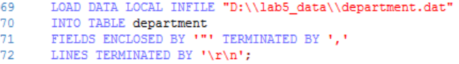
You may check the content of the department table now.
select * from department;
Is the table properly loaded? Copy the screenshot here:
- Yes

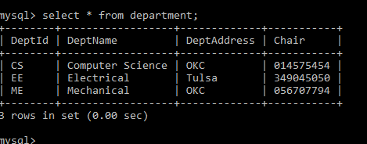

- We are ready to load the foreign key column, worksfor, of the faculty table now (now, they are NULL). We need to use SQL UPDATE to do this.

- The foreign key data is first loaded into the temporary table worktable_faculty. Note that we do not have a corresponding worktable_faculty.dat file. So we need to extract some columns from faculty.data using the following command:
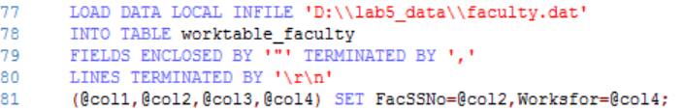
Explain the meaning of
  - (@col1, @col2, …@col4)
They are temporary columns as faculty has 4-tuples but worktable_faculty only has 2-tuples

  - SET FacSSNo=@col2
We update the values of FacSSNo to the values at column 2

You may check the content of the worktable_faculty table now.
select * from worktable_faculty;
Is the table properly loaded? Copy the screenshot here:
- Yes

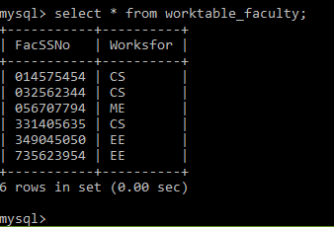

- Now update the worksfor column of the Faculty table using the following SQL command:
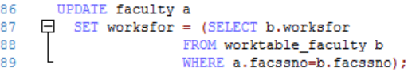
Note the syntax of the update statement, which is a correlated nested SQL statement. Also note that, to assign the query result into a column, the statement must guarantee that the result set contains only one record value. Otherwise, the statement will not work.
Now check the content of the faculty table in Workbench and copy your answer here.
select * from faculty;

- Load data for tables DegreeProgram, Student and DDoffers.
Can we load DDoffers before DegreeProgram? Why?
Answer:
We can’t load DDoffers before DegreeProgram. It’s because of key integrity constraint.

Copy your SQL code for loading the three tables here:
DegreeProgram.dat
load data local infile "D:\\HieuNguyen-Work\\TCU-Fall2019\\Database\\lab5_data\\degreeprogram.dat" INTO table degreeprogram fields enclosed by '"'terminated by ',' lines terminated by '\r\n';

Student.dat
load data local infile
"D:\\HieuNguyen-Work\\TCU-Fall2019\\Database\\lab5_data\\student.dat" INTO table student fields enclosed by '"'terminated by ',' lines terminated by '\r\n';

DDoffers.dat
load data local infile "D:\\HieuNguyen-Work\\TCU-Fall2019\\Database\\lab5_data\\ddoffers.dat" INTO table ddoffers fields enclosed by '"'terminated by ',' lines terminated by '\r\n';

- Now we will review some algebraic expressions and the corresponding SQL statements.
(a) σ_{major='P000'} Student
Give the meaning of the expression in English.
Answer:
Return all student who are majoring with its program id = P000

Run the following equivalent SQL statement and check your answer.
select * from student where major='P000';

Screenshot:

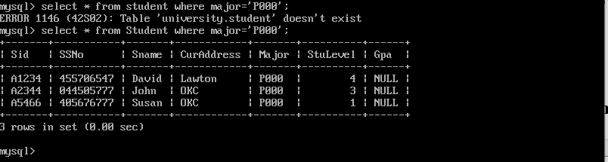

(b) π_{sid, sname} σ_{major='P000'} Student
Give the meaning of the expression in English.
Answer:
Same as above but return students’ names and ids

Run the following equivalent SQL statement and check your answer.
select sid, sname from student where major='P000';
Screenshot:
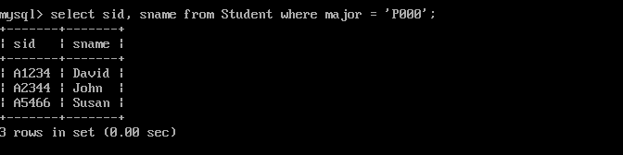

(c) π_{facssno, facname} σ_{worksfor='CS'} Faculty
Give the meaning of the expression in English.
Answer:
Return SSN and name for all faculties who work in CS Department

Write an equivalent SQL statement and run it to check your answer.
Answer:
Select FACSSNo, FacName
From Faculty
Where worksfor =’CS’;

Run the equivalent SQL statement and check your answer.
Screenshot:

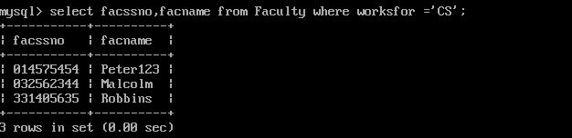

- Consider the following query in English:
Get program id and program name of all programs that offer BS degree.
(a) Give an algebraic expression for the query.
Answer:
π_{ProgId, ProgramName} σ_{ProgType='BS'}

(b) Write an equivalent SQL statement.
Answer:
Select ProgId, ProgramName
From DegreeProgram
Where ProgType = ‘BS’;

Run the equivalent SQL statement and check your answer.
Screenshot:

- Run the following SQL statement
select * from faculty, department;
(a) What is the meaning of the SQL statement?
Answer:
Return cross product of faculty and department

(b) Give an equivalent relational algebraic expression.
Answer:
π (Faculty x Department)

Run the equivalent SQL statement and check your answer.
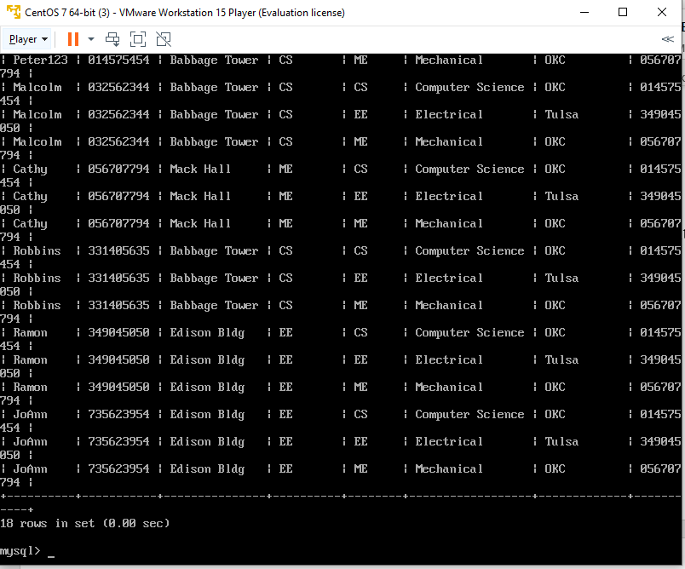
- π_{facssno, facname, deptname} σ_{worksfor=deptid} (Faculty × Department)
(a) Give the meaning of the expression in English.
Answer:
Return the SSN, name of faculties and department name that they work for

(b) Run the following equivalent SQL statement and check your answer.
select facssno, facname, deptname
from faculty, department
where worksfor=deptid;

Screenshot:
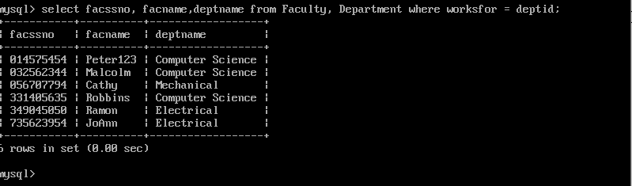

- π_{facssno, facname, deptname}
σworksfor=deptid and (officeaddress='Babbage Tower' or officeaddress='Edition Bldg') (Faculty × Department)

(a) Give the meaning of the expression in English.
Answer:
Return the SSN, name of faculties and the department name they work for which their office in either Babbage Tower or Edison Building

(b) Run the following equivalent SQL statement and check your answer.
select facssno, facname, deptname
from faculty, department
where worksfor=deptid and
(officeaddress='Babbage Tower'
or officeaddress='Edition Bldg');

Screenshot:
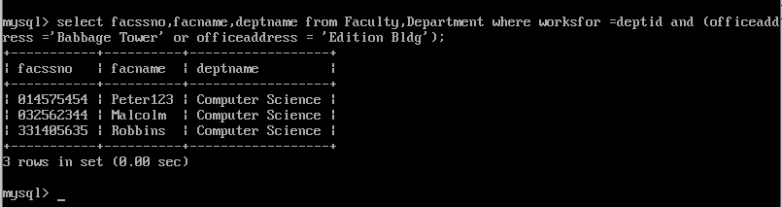

- Consider the following query in English:
Get student id, student name, program name and program type of all students from OKC and at levels less than or equal to 4.

(a) Give an algebraic expression for the query.
Answer:
π_{Sid, Sname, ProgramName}
σMajor=ProgID and CurAddress = ‘OKC’ and StuLevel<=4) (Student× DegreeProgram)

(b) Write an equivalent SQL statement.
Answer
select Sid, Sname, ProgramName
from Student, DegreeProgram
where Major=ProgId and CurAddress='OKC' and StuLevel<=4;

(c) Run the statement in SQL to verify the answer.

