COSC 30603
Lab Assignment 6: More on SQL
Name: Hieu Nguyen
Due: Nov 13, 2019

- In this assignment, we will first complete data loading.
  - Download lab6_data.zip and unzip it on your computer. E.g. I copied the folder to D:\ (Assume I installed MySQL on my local PC, if you are using vmware, you need to make some adjustments)
  - Create the relation schemas.
Run lab6_schema.sql in Workbench. The schema is based on the EER diagram on the next page. In addition to the tables used in Lab 5, three new tables are added, namely CourseDescription, CourseOffering and taken. Note that the only difference between this EER diagram and the one used in Lab 5 is that 1:N instead of N:M cardinality constraints have been assumed for the offer relationship type between CourseDescription and Department.
  - Enable MySQL LOAD
To enable MySQL’s load data capability, you need to start your MySQL from terminal using:
See this StackOverflow post for more info.
https://stackoverflow.com/questions/10762239/mysql-enable-load-data-local-infile
In this lab, if you need to execute load, you have to do that through terminal, NOT Workbench.
  - Modify source.sql

MySQL source command:
https://dev.mysql.com/doc/refman/8.0/en/mysql-batch-commands.html
  - Execute the following command in terminal.
source D:/lab6_data/source.sql;
You need to change the file directory first.
Copy your results (prompts from terminal) here:

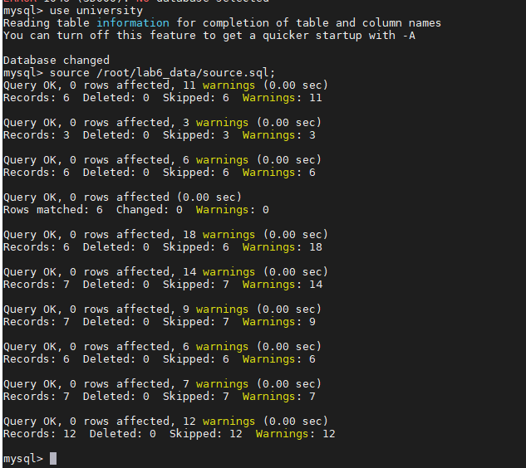

N
d
mentor
gpa
Degree Program
major
minor
N
N
1
M
Undergraduate
Probational Student
Course Offering
taken
grade
M
N
Course Description
TA
N
M
type
name
requirements
college
university
offers
N
Dept requirement
coordinator
1
1
offers
1
M
prerequisite
N
M
chair
1
1
works for
1
N
has
1
N
Textbook
has
N
M
offering
1
advisor
counselor
1
N
N
1
teach
1
N
1
N
supervise
1
N
director
1
N
Project
Lab
use
N
P
M
Office hour
Start date
Faculty
1
Office hour
Instructor
Faculty
Instructor
d
Non Univ.
Instructor
Company Name
address
Graduate
Instructor
English
Test Score
Student
Department
Graduate

- Create a Foreign Key Reference Graph.
(a) A foreign key reference graph is a directed graph where nodes represent the referencing and referenced tables and a directed edge represents the foreign key reference from the referencing table to the referenced table. An edge is labeled with the foreign key.

A foreign key reference graph provides a good reference for designing queries that requires join operations of several tables. It is more helpful when the database consists of a large number of tables.

(b) A foreign key reference graph based on the lab schema is presented as follows.
offer
instructor
sid
cno
SeqId
Department
DeptId
Faculty
FacSSNo
DegreeProgram
ProgId
Student
Sid
DDoffers
DeptId, ProgId ProgId
CourseDescription
Cno
SeqId
taken
Sid, SeqId
Chair
worksFor
Coordinator
Major
ProgId
DeptId
CourseOffering
(c) In the above graph, add the foreign references for the three additional tables of this lab, namely CourseDescription, CourseOffering and taken.
- Nested queries. Note that you can use the foreign key reference graph on the previous page to design the queries.
(a) Consider the following nested query:
select deptname
from department
where deptid in (select deptid
from ddoffers x, degreeprogram y
where x.progid=y.progid and progtype='BS');

Give the meaning of the SQL statement in English.
Answer:
- Return department’s whether they offer BS programs

Run the SQL statement and check your answer.

(b) Give an SQL statement for the following plain English query. You are required to use a nested query.
Give the name of those departments that offers BS or PhD programs.
Answer:
select deptname
from department
where deptid in (select deptid
from ddoffers x, degreeprogram y
where x.progid=y.progid and (progtype='BS' or progtype=’PhD’));

Run the SQL statement and check your answer.

(c) Give an SQL statement for the following plain English query. You are required to use a nested query.
Give the name of those departments that offers both BS and PhD programs.
Answer:
- Same as above answer from b)

Run the SQL statement and check your answer.

- Correlated nested queries
(a) Consider the following correlated nested query:

select sid as StudentId, sname StudentName
from student x
where 3.5<(select max(Grade)
from taken a, courseoffering b
where x.sid=a.sid and a.seqid=b.seqid and b.cno='CS480');

Give the meaning of the SQL statement in English.
Answer:
- Return Student Id and Student’s name from those who took CS480 having grade greater than 3.5

Run the SQL statement and check your answer.

(b) Give an SQL statement for the following plain English query. You are required to use a correlated nested query.
Give id and name of those students who take CS480 and have an average grade greater than 3.5.
Answer:
- select sid as StudentId, sname StudentName
from student x
where 3.5 < (select max(Grade)
from taken a, courseoffering b
where x.sid=a.sid and a.seqid=b.seqid and b.cno='CS480');

Run the SQL statement and check your answer.

- Like operator
(a) Consider the following correlated nested query:

select deptid as DepartmentId, deptname as DepartmentName
from Department x
where deptid in (select DeptId
from ddoffers y, degreeprogram z
where x.deptId=y.deptid and y.progid=z.progid and
z.programname like '%Computer%' and
z.progtype='BS');

Give the meaning of the SQL statement in English.
Answer:
- Return Department Id and Department Name from those departments offer BS program and program name contains “Computer”

Run the SQL statement and check your answer.

(b) Give an SQL statement for the following plain English query. You are required to use the like operator.
Get department name and name of department chair for those departments that offer BS degree program and program name containing “Computer”.
Answer:

select deptid as DepartmentId, deptname as DepartmentName
from Department x
where deptid in (select DeptId
from ddoffers y, degreeprogram z
where x.deptId=y.deptid and y.progid=z.progid and
z.programname like '%Computer%' and
z.progtype='BS');

Run the SQL statement and check your answer.

- Exists and not exists
(a) Consider the following correlated nested query:

select sname
from student x
where not exists (select sid
from taken y, courseoffering z
where x.sid = y.sid and y.seqid = z.seqid
and z.cno = 'CS480');

Give the meaning of the SQL statement in English.

Answer:
- Return name of student who did not take course CS480

Run the SQL statement and check your answer.

(b) Give an SQL statement for the following plain English query. You are required to use exists.
Get id and name of those students who major in CS Department and take CS480.
Answer:

select sname
from student x
where not exists (select sid
from taken y, courseoffering z
where x.sid = y.sid and y.seqid = z.seqid
and z.cno = 'CS480');
join (select sid
from student x2, ddoffers ddo
where x2.major = ddo.progid and ddo.deptid = d.deptid and d.deptname = ‘Computer Science’) t2 on t1.sid = t2.sid)

Run the SQL statement and check your answer.

- Group by and having
(a) Consider the following query:

select x.seqid, y.cno, count(*) as StudentCount,
avg(grade) as AverageGrade
from taken x, courseoffering y
where x.seqid=y.seqid
group by x.seqid, y.cno
having count(*) >= 2
order by cno asc;

Give the meaning of the SQL statement in English.
Answer:
- Return the course sequence id, course number, number from students who took the course and have average of each course that has more than 2

Run the SQL statement and check your answer.

(b) Give an SQL statement for the following plain English query. You are required to use group by and having
Get instructor id, course sequence id and course number for all course offerings having an average grade of 4.0.
Answer:
- select y.instructor, y.cno
from taken x, courseoffering y
where x.seqid=y.seqid and avg(grade) = 4.0

Run the SQL statement and check your answer.
(c) Give an SQL statement for the following plain English query. You are required to use group by and having
Get instructor id and course number for all courses having an average grade of 4.0.
Answer:
- select y.instructor, y.cno
from taken x, courseoffering y
where x.seqid=y.seqid and avg(grade) = 4.0

Run the SQL statement and check your answer.

- Outer join
Even though we didn’t formally introduce outer join and inner join. We are using inner join all the time. We have never used outer join.
Here is a tutorial:
https://stackoverflow.com/questions/38549/what-is-the-difference-between-inner-join-and-outer-join
Read the Stackoverflow thread before you proceed, the example given in the best answer really helps understand difference between inner and outer join.

(a) Insert two tuples first
insert into faculty (facname, facssno)
values ('John Doe', '000559999');
insert into department (deptid, deptname)
values ('MATH', 'Mathematics');
select * from faculty;
select * from department;

(b) Try the following two outer join queries and observe the results.
Left join:
SELECT facname, facssno, deptname
FROM faculty X LEFT JOIN department Y ON x.worksfor=y.deptid;

Right join:
SELECT facname, facssno, deptname
FROM faculty X RIGHT JOIN department Y ON x.worksfor=y.deptid;

- Queries involving long join paths (in the foreign key reference graph)
(a) Consider the following query:

select deptname, facname
from department d, faculty f, courseoffering co,
coursedescription cd
where d.deptid=f.worksfor and f.facssno=co.instructor and
co.cno=cd.cno and cd.offers=d.deptid;

Give the meaning of the SQL statement in English.
Answer:

- Return department name and instructor’s name from each deparments

Run the SQL statement and check your answer.

(b) Give SQL statements for the following three English language queries. These queries involve only equi-joins just like the above SQL statement. For each of these queries, you first identify the correct join path in the foreign key reference graph. After you have identified the join path for a query, you design the SQL statements by using a sequence of equijoins.

- Get the name of each student and the student’s department name.
Answer:
- Select sname, deptname
from student s, degreeprogram dp, department d, ddoffers ddo
where s.major = dp.progid and dp.progid = ddo.progid and ddo.deptid = d.deptid;

- Get the name of each student and the names of those department that the student takes at least one course from.
select sname, deptname
from student s, taken t, department d, courseoffering co, coursedescription cd
where s.sid = t.sid and t.seqid = co.seqid and co.cno = cd.cno and cd.offers = d.deptid;

- Get student name and the student’s department name if the student takes at least one course offered by the student’s department.
Select sname, deptname
from (select sname, deptname, student s, degreeprogram dp, department d, ddoffers ddo
where s.major = dp.progid and dp.progid = ddo.progid and ddo.deptid = d.deptid as t1
join
(select sname, deptname
from student s, taken t, department d, courseoffering co, coursedescription cd
where s.sid = t.sid and t.seqid = co.seqid and co.cno = cd.cno and cd.offers = d.deptid) as t2
on t1.deptname = t2.deptname and t1.sname = t2.sname

