COSC 30603
Homework 6
Due: Dec 11, 2019.

You need to write your answers in the sql file (hw6_FirstNameLastName.sql) I provided. No credit will be given if a SQL statement won’t compile in Workbench. No credit will be given if wrong answer is returned.

How to submit this homework?
- Submit the sql file online (e.g hw6_BingyangWei.sql, no need to print out this sql file).
- Copy your answer from sql file to this word doc as well. Also get a screenshot of the result of each question and paste in this word doc. Print out this doc, staple and turn in on due day, but no need to submit this word doc online.

- Write a query in SQL to display those employees who contain a letter z to their first name and also display their last name, department, city, and state province.

Select e.first_name,e.last_name,
d.department_name, l.city, l.state_province
from employees e
join departments d
on e.department_id = d.department_id
join locations l
on d.location_id = l.location_id
where e.first_name like'%z%';

Screenshot of result of executing the sql above:

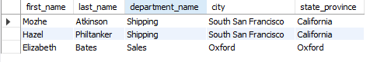

- Write a query in SQL to display all departments that don’t have any employees.

select distinct d1.department_name
from departments d1
where not exists (select distinct e1.department_id
from emp_details_view e1
where d1.department_id = e1.department_id);

Screenshot of result of executing the sql above:

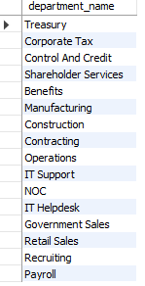

- Write a query in SQL to display the first and last name and salary for those employees who earn less than the employee earn whose number is 182. You are required to use Theta join for this question.

select e1.first_name, e1.last_name, e1.salary
from emp_details_view e1 join emp_details_view e2 on e1.salary < e2.salary
where e2.employee_id = 182;

Screenshot of result of executing the sql above:

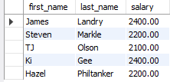

- Write a query in SQL to display the first name and last name of every employee and the first name and last name of his/her manager’s manager.

select e1.first_name, e1.last_name, e2.first_name, e2.last_name
from employees e1 join employees e2
where e1.manager_id = e2.employee_id;

Screenshot of result of executing the sql above:
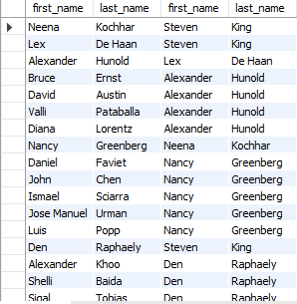

- Write a query in SQL to display the first name, last name, and department number for those employees who works in the same department as the employee who holds the last name as Taylor.

select e1.first_name, e1.last_name, e1.department_id
from emp_details_view e1
where exists (select * from emp_details_view e2
where e2.last_name = 'Taylor' and e1.department_id = e2.department_id);

Screenshot of result of executing the sql above:
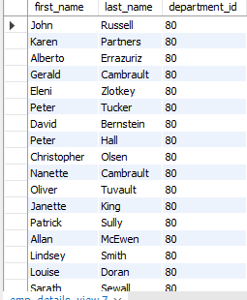
- Write a query in SQL to display the job title, department name, first and last name of employee, and starting date for all the jobs which started on or after 1st January, 1993 and ending with on or before 31 August, 1997.

select e1.job_title, e1.department_name, e1.first_name, e1.last_name
from emp_details_view e1 join job_history j1 on e1.employee_id = j1.employee_id
where j1.start_date >= '19930101' and j1.end_date <= '19970831';

Screenshot of result of executing the sql above:

- Write a query in SQL to display every manager’s first and last name, and the lowest salary of his/her subordinates.

create view manager
as
select e2.employee_id, e2.first_name, e2.last_name, e1.salary from employees e1 join employees e2 where e1.manager_id = e2.employee_id;

select * from manager m1 where not exists ( select * from manager m2 where m2.salary < m1.salary and m1.employee_id = m2.employee_id);

Screenshot of result of executing the sql above:
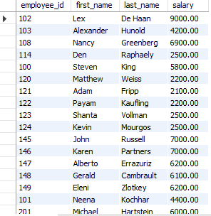

- Write a query in SQL to display the country name, city, and number of those departments where at least 2 employees are working.

select country_name,city, count (department_id)
from countries
join locations using (country_id)
join departments using (location_id)
where department_id IN
(select department_id
from employees
group by department_id
having count (department_id)>=2)
group by country_name,city;
Screenshot of result of executing the sql above:

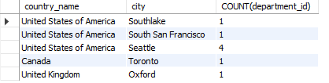

- Write a query to display the employee number, first name and last name and job title for all employees whose salary is more than ANY average salary of any department.

select e1.employee_id, e1.first_name, e1.last_name, e1.job_title
from emp_details_view e1
where e1.salary > (select avg(e2.salary) from emp_details_view e2);

Screenshot of result of executing the sql above:
