****Nova**** is a project in the [OpenStack](https://openmetal.io/learn/glossary/what-is-openstack/) platform that was developed to provide quick access to compute resources and allow the provisioning and managing of instances, or virtual machines.

**NOVA - OPENSTACK**

**Github: hieunguyeu810**

***Queue:*** RabbitMQ (usually), amqp, fake, kafka, kombu

***SQL Server:*** stores nost run-time and build-time states

***nova-api:*** accepts and responds to end user compute api call

***nova-api-metadata:*** accepts metadata requests from instances

***nova-compute:*** a worker daemon that creates and terminates VM instances through hypervisor APIs (libvirt for KVM or QEMU, VMwareAPI for VMware)

***nova-scheduler:*** takes request from the queue and determines on which compose server host its runs

***nova-conductor:*** Mediates interactions between the nova-compute service and the database

***nova-novncproxy:*** Provides a proxy for accessing running instances through a VNC connection

***nova-spicehtml5proxy:*** Provides a proxy for accessing running instances through a SPICE connection

OPENSTACK CLIENT

NOVA CLIENT



DASHBOARD

HORIZON



NEUTRON



PLACEMENT

NOVA

QUEUE

nova-api

nova-compute

nova-scheduler

nova-conductor

nova-novncproxy

daemon

nova-spicehtml5proxy

daemon

nova-api-metadata

service

SQL Server



KEYSTONE

GLANCE



**Server:** list, create, show, update, delete

- Status

- Password

- Metadata

- Action

- Networks

...

**Response (local request ID)**

X-Compute-Request-Id

X-Openstack-Request-Id

**Request (global request ID)**

X-Openstack-Request-Id

Compute API

**Architecture**

Network

1. Provider Network:
2. Self-service Network:

(Option 2)



**CONTROLLER NODE**

2 NIC

**COMPUTE NODE**

2 NIC

**BLOCK STORAGE**

1 NIC

**OBJECT STORAGE**

1 NIC

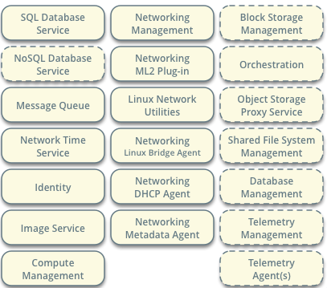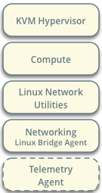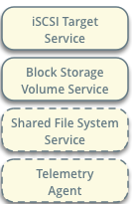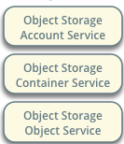

nova-scheduler

- - AllHostsFilter

- ComputeCapabilitiesFilter

- ComputeFilter

- DifferentHostFilter

- ImagePropertiesFilter

- IsolatedHostsFilter

- IoOpsFilter

- JsonFilter

- MetricsFilter

- SameHostFilter

...

filter

- RAMWeigher

- CPUWeigher

- DiskWeigher

- MetricsWeigher

- IoOpsWeigher

- PCIWeigher

- ServerGroupSoftAffinityWeigher

- BuildFailureWeigher

- BuildFailureWeigher

- HypervisorVersionWeigher

...

weight

**Compute Service**