LDAP: Lightweight Directory Access Protocols

An open, vendor-neutral, industry standard application protocol for accessing and maintaining distributed directory information services over an Internet Protocol network.

RFC-4511

**How LDAP works**

**Github: hieunguyeu810**

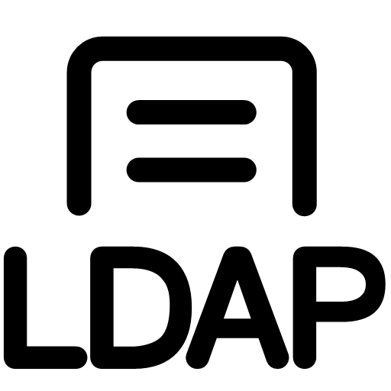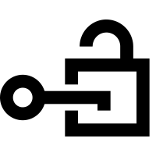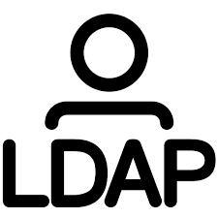

MODIFY

LDIF

DELETE

host: IP or FQDN of LDAP server

port: network port (default port 389)

DN: distinguished name (use as search base)

attributes: comma-separated list of atributes to retrives

scope: search scope (base, one, sub)

filter: search filter (ex: (objectClass=*)

extensions: extensions of LDAP URL format

ldap://host:port/DN?attributes?scope?filter?extensions

**URI SCHEMA**

SEARCH & COMPARE

dn:CN=John Smith,OU=Legal,DC=example,DC=com

changetype: modify

replace: employeeID

employeeID: 1234

**LDIF: LDAP Data Interchange Format**

ROOT

dc=net

dc=com

dc=org

c=us

c=uk

o=XOrg

o=myOrg

ou=people

ou=groups

uid=101

uid=102

cn=dev

cn=sys

COUNTRIES

ORGANIZATIONS

ORGANIZATIONAL UNITS

PEOPLE

import/export

BIND

AUTHENTICATE

ADD

**LDAP OPERATIONS**

**LDAP DIRECTORY TREE**

LDAP CLIENT



LDAP SERVER

ESTABLISH A TCP CONNECTION

BIND REQUEST

BIND RESPONSE

SEARCH REQUEST

SEARCH RESPONSE

UNBIND REQUEST

VERIFY

CREDENTIALS

CLOSED CONNECTION

LOGIN

LOGIN

SUCCESSFULLY



API GATEWAY

Credentials



Credentials

Authenticated &

Authorized Request



Authenticated &

Authorized Request

BUSINESS APPLICATION



SEARCH

DOMAIN