**Octavia** is an open source, operator-scale load balancing solution designed to work with OpenStack.

**OCTAVIO - OPENSTACK**

**Github: hieunguyeu810**

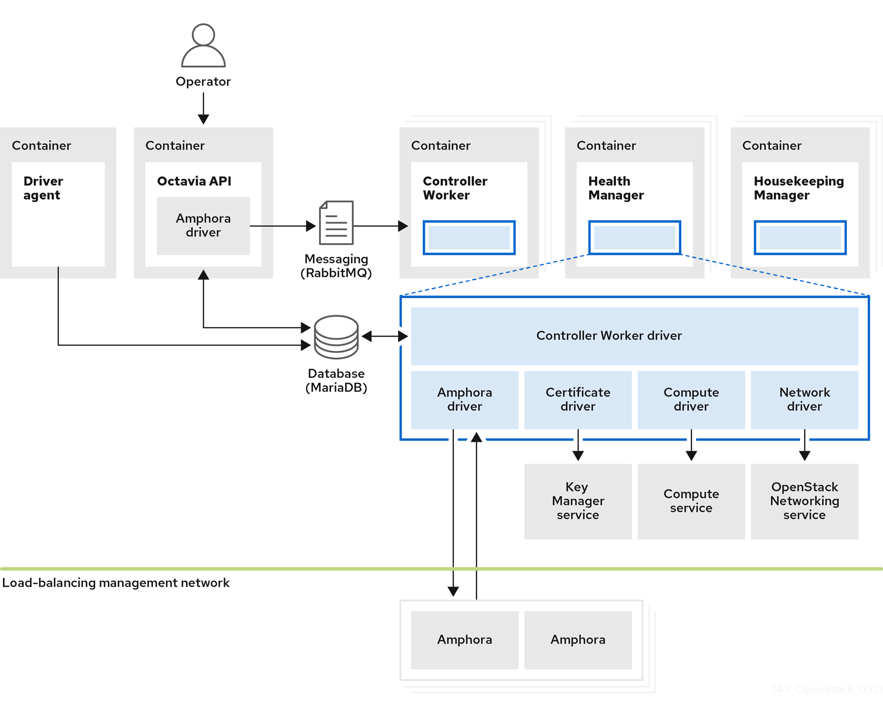

Members

Health Monitor

Pool

Members

Health Monitor

Pool

Listener

Port 443/HTTPS

Listener

Port 80/HTTP

Load balancer

VIP

Pool

Health Monitor

Member 1

Member 2

Member n

**LBaaSv2**

* L7 Content switching [IMP feature]
* Multiple TCP ports per load balancer
* TLS Termination at load balancer to avoid the load on instances.
* Load balancer running inside instances.

**LBaaSv1**

* L4 Load balancing
* Session persistence including cookies based
* Cookie insertion
* Driver interface for 3rd parties.

**Load Balancer as a service (LBaaS)**