# ModelSim timing diagram colour scheme

1. Install ModelSim following indications in [Unit 1.13B](http://digsys.upc.es/ed/CSD/units/Ch1/U1_13B/Unit1_13B.html)
2. Edit preferences:

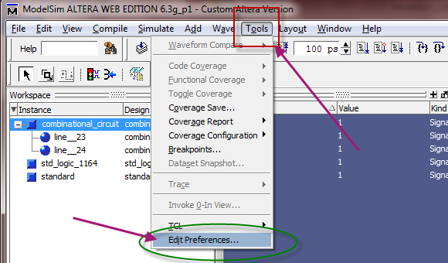

Fig. 1 Click on the Tools tab, and then on Edit preferences

1. Go down to “Wave Windows” and take a look the colour applied to every item which conforms the wave windows where the timing diagrams will be sketched. Change the colour of the logic values.

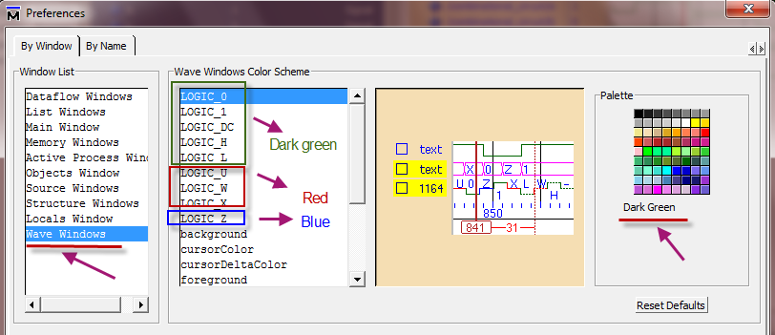

Fig. 2 Change the colour of the waveform logic values

1. Change the colour of the other items:

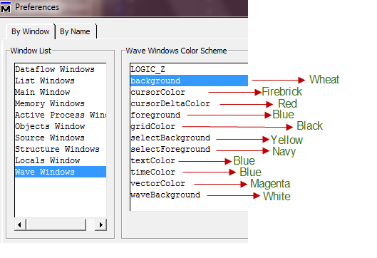

Fig. 3 Colours for the remaining graphical items

1. Run a simulation and check how a timing diagram looks like.

So that a given timing diagram will look like the one represented in Fig. 4. Use comments, so that it becomes clear to the reader that you comprehend what exactly in going on in the circuit.

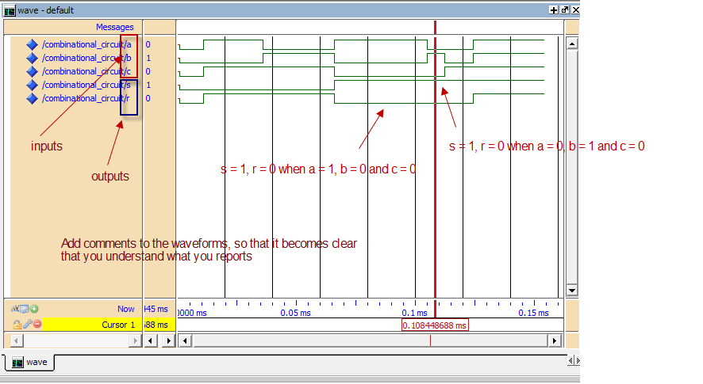

Fig. 4 A typical simulation screen ready for reporting on the solution file

Use this scheme or a similar one with the white background always in any of your simulations.