|  |
| --- |
| **TRƯỜNG ĐẠI HỌC BÁCH KHOA HÀ NỘI**  Description: Description: Description: logo_128**VIỆN ĐIỆN TỬ-VIỄN THÔNG**  **BÁO CÁO THÍ NGHIỆM**  **KIẾN TRÚC MÁY TÍNH**  **Họ tên sinh viên: Nguyễn Minh Hiếu**  **Mã lớp TN: 688522**  **MSSV: 20151336**  **Lớp: Điện tử 3 k60**  **Hà Nội, 2019** |

**Example 1:**

# A demonstration of some simple MIPS instructions

# used to test QtSPIM

# Declare main as a global function

.globl main

# All program code is placed after the

# .text assembler directive

.text

# The label 'main' represents the starting point

main:

li $t2, 25 # Load immediate value (25)

lw $t3, value # Load the word stored in value (see bottom)

add $t4, $t2, $t3 # Add

sub $t5, $t2, $t3 # Subtract

sw $t5, Z #Store the answer in Z (declared at the bottom)

# Exit the program by means of a syscall.

# There are many syscalls - pick the desired one

# by placing its code in $v0. The code for exit is "10"

li $v0, 10 # Sets $v0 to "10" to select exit syscall

syscall # Exit

# All memory structures are placed after the

# .data assembler directive

.data

# The .word assembler directive reserves space

# in memory for a single 4-byte word (or multiple 4-byte words)

# and assigns that memory location an initial value

# (or a comma separated list of initial values)

value: .word 12

Z: .word 0

**Result:**

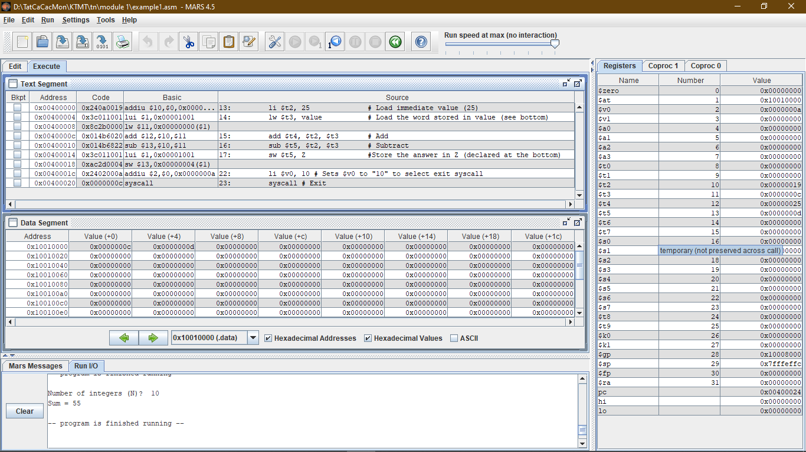

**Example 2:**

# "Hello World" in MIPS assembly

# From: http://labs.cs.upt.ro/labs/so2/html/resources/nachos-doc/mipsf.html

# All program code is placed after the

# .text assembler directive

.text

# Declare main as a global function

.globl main

# The label 'main' represents the starting point

main:

# Run the print\_string syscall which has code 4

li $v0,4 # Code for syscall: print\_string

la $a0, msg # Pointer to string (load the address of msg)

syscall

li $v0,10 # Code for syscall: exit

syscall

# All memory structures are placed after the

# .data assembler directive

.data

# The .asciiz assembler directive creates

# an ASCII string in memory terminated by

# the null character. Note that strings are

# surrounded by double-quotes

msg: .asciiz "Hello World!\n"

**Output:**

Hello World!

**Example 3:**

# Simple input/output in MIIPS assembly

# From: http://labs.cs.upt.ro/labs/so2/html/resources/nachos-doc/mipsf.html

# Start .text segment (program code)

.text

.globl main

main:

# Print string msg1

li $v0,4 # print\_string syscall code = 4

la $a0, msg1 # load the address of msg

syscall

# Get input A from user and save

li $v0,5 # read\_int syscall code = 5

syscall

move $t0,$v0 # syscall results returned in $v0

# Print string msg2

li $v0,4 # print\_string syscall code = 4

la $a0, msg2 # load the address of msg2

syscall

# Get input B from user and save

li $v0,5 # read\_int syscall code = 5

syscall

move $t1,$v0 # syscall results returned in $v0

# Math!

add $t0, $t0, $t1 # A = A + B

# Print string msg3

li $v0, 4

la $a0, msg3

syscall

# Print sum

li $v0,1 # print\_int syscall code = 1

move $a0, $t0 # int to print must be loaded into $a0

syscall

# Print \n

li $v0,4 # print\_string syscall code = 4

la $a0, newline

syscall

li $v0,10 # exit

syscall

# Start .data segment (data!)

.data

msg1: .asciiz "Enter A: "

msg2: .asciiz "Enter B: "

msg3: .asciiz "A + B = "

newline: .asciiz "\n"

**Output:**

Enter A: 2

Enter B: 3

A + B = 5

**Example 4:**

# Simple routine to demo a loop

# Compute the sum of N integers: 1 + 2 + 3 + ... + N

# From: http://labs.cs.upt.ro/labs/so2/html/resources/nachos-doc/mipsf.html

.text

.globl main

main:

# Print msg1

li $v0,4 # print\_string syscall code = 4

la $a0, msg1

syscall

# Get N from user and save

li $v0,5 # read\_int syscall code = 5

syscall

move $t0,$v0 # syscall results returned in $v0

# Initialize registers

li $t1, 0 # initialize counter (i)

li $t2, 0 # initialize sum

# Main loop body

loop: addi $t1, $t1, 1 # i = i + 1

add $t2, $t2, $t1 # sum = sum + i

beq $t0, $t1, exit # if i = N, continue

j loop

# Exit routine - print msg2

exit: li $v0, 4 # print\_string syscall code = 4

la $a0, msg2

syscall

# Print sum

li $v0,1 # print\_string syscall code = 4

move $a0, $t2

syscall

# Print newline

li $v0,4 # print\_string syscall code = 4

la $a0, lf

syscall

li $v0,10 # exit

syscall

# Start .data segment (data!)

.data

msg1: .asciiz "Number of integers (N)? "

msg2: .asciiz "Sum = "

lf: .asciiz "\n"

**Output:**

Number of integers (N)? 5

Sum = 15

**Example 5 with stack**

# Simple routine to demo functions

# USING a stack in this example to preserve

# values of calling function

# ------------------------------------------------------------------

.text

.globl main

main:

# Register assignments

# $s0 = x

# $s1 = y

# Initialize registers

lw $s0, x # Reg $s0 = x

lw $s1, y # Reg $s1 = y

# Call function

move $a0, $s0 # Argument 1: x ($s0)

jal fun # Save current PC in $ra, and jump to fun

move $s1,$v0 # Return value saved in $v0. This is y ($s1)

# Print msg1

li $v0, 4 # print\_string syscall code = 4

la $a0, msg1

syscall

# Print result (y)

li $v0,1 # print\_int syscall code = 1

move $a0, $s1 # Load integer to print in $a0

syscall

# Print newline

li $v0,4 # print\_string syscall code = 4

la $a0, lf

syscall

# Exit

li $v0,10 # exit

syscall

# ------------------------------------------------------------------

# FUNCTION: int fun(int a)

# Arguments are stored in $a0

# Return value is stored in $v0

# Return address is stored in $ra (put there by jal instruction)

# Typical function operation is:

fun: # This function overwrites $s0 and $s1

# We should save those on the stack

# This is PUSH'ing onto the stack

addi $sp,$sp,-4 # Adjust stack pointer

sw $s0,0($sp) # Save $s0

addi $sp,$sp,-4 # Adjust stack pointer

sw $s1,0($sp) # Save $s1

# Do the function math

li $s0, 3

mul $s1,$s0,$a0 # s1 = 3\*$a0 (i.e. 3\*a)

addi $s1,$s1,5 # 3\*a+5

# Save the return value in $v0

move $v0,$s1

# Restore saved register values from stack in opposite order

# This is POP'ing from the stack

lw $s1,0($sp) # Restore $s1

addi $sp,$sp,4 # Adjust stack pointer

lw $s0,0($sp) # Restore $s0

addi $sp,$sp,4 # Adjust stack pointer

# Return from function

jr $ra # Jump to addr stored in $ra

# ------------------------------------------------------------------

# Start .data segment (data!)

.data

x: .word 5

y: .word 0

msg1: .asciiz "y="

lf: .asciiz "\n"

**Output:**

y=20

**Example 5 without stack**

# Simple routine to demo functions

# NOT using a stack in this example.

# Thus, the function does not preserve values

# of calling function!

# ------------------------------------------------------------------

.text

.globl main

main:

# Register assignments

# $s0 = x

# $s1 = y

# Initialize registers

lw $s0, x # Reg $s0 = x

lw $s1, y # Reg $s1 = y

# Call function

move $a0, $s0 # Argument 1: x ($s0)

jal fun # Save current PC in $ra, and jump to fun

move $s1,$v0 # Return value saved in $v0. This is y ($s1)

# Print msg1

li $v0, 4 # print\_string syscall code = 4

la $a0, msg1

syscall

# Print result (y)

li $v0,1 # print\_int syscall code = 1

move $a0, $s1 # Load integer to print in $a0

syscall

# Print newline

li $v0,4 # print\_string syscall code = 4

la $a0, lf

syscall

# Exit

li $v0,10 # exit

syscall

# ------------------------------------------------------------------

# FUNCTION: int fun(int a)

# Arguments are stored in $a0

# Return value is stored in $v0

# Return address is stored in $ra (put there by jal instruction)

# Typical function operation is:

fun: # Do the function math

li $s0, 3

mul $s1,$s0,$a0 # s1 = 3\*$a0 (i.e. 3\*a)

addi $s1,$s1,5 # 3\*a+5

# Save the return value in $v0

move $v0,$s1

# Return from function

jr $ra # Jump to addr stored in $ra

# ------------------------------------------------------------------

# Start .data segment (data!)

.data

x: .word 5

y: .word 0

msg1: .asciiz "y="

lf: .asciiz "\n"

**Output:**

y=20

**Example 6:**

# Simple routine to demo a loop

# Compute the sum of N integers: 1 + 2 + 3 + ... + N

# Same result as example4, but here a function performs the

# addition operation: int add(int num1, int num2)

# ------------------------------------------------------------------

.text

.globl main

main:

# Register assignments

# $s0 = N

# $s1 = counter (i)

# $s2 = sum

# Print msg1

li $v0,4 # print\_string syscall code = 4

la $a0, msg1

syscall

# Get N from user and save

li $v0,5 # read\_int syscall code = 5

syscall

move $s0,$v0 # syscall results returned in $v0

# Initialize registers

li $s1, 0 # Reg $s1 = counter (i)

li $s2, 0 # Reg $s2 = sum

# Main loop body

loop: addi $s1, $s1, 1 # i = i + 1

# Call add function

move $a0, $s2 # Argument 1: sum ($s2)

move $a1, $s1 # Argument 2: i ($s1)

jal add2 # Save current PC in $ra, and jump to add2

move $s2,$v0 # Return value saved in $v0. This is sum ($s2)

beq $s0, $s1, exit # if i = N, continue

j loop

# Exit routine - print msg2

exit: li $v0, 4 # print\_string syscall code = 4

la $a0, msg2

syscall

# Print sum

li $v0,1 # print\_string syscall code = 4

move $a0, $s2

syscall

# Print newline

li $v0,4 # print\_string syscall code = 4

la $a0, lf

syscall

li $v0,10 # exit

syscall

# ------------------------------------------------------------------

# FUNCTION: int add(int num1, int num2)

# Arguments are stored in $a0 and $a1

# Return value is stored in $v0

# Return address is stored in $ra (put there by jal instruction)

# Typical function operation is:

# 1.) Store registers on the stack that we will overwrite

# 2.) Run the function

# 3.) Save the return value

# 4.) Restore registers from the stack

# 5.) Return (jump) to previous location

# Note: This function is longer than it needs to be,

# in order to demonstrate the usual 5 step function process...

add2: # Store registers on the stack that we will overwrite (just $s0)

addi $sp,$sp, -4 # Adjust stack pointer

sw $s0,0($sp) # Save $s0 on the stack

# Run the function

add $s0,$a0,$a1 # Sum = sum + i

# Save the return value in $v0

move $v0,$s0

# Restore overwritten registers from the stack

lw $s0,0($sp)

addi $sp,$sp,4 # Adjust stack pointer

# Return from function

jr $ra # Jump to addr stored in $ra

# ------------------------------------------------------------------

# Start .data segment (data!)

.data

msg1: .asciiz "Number of integers (N)? "

msg2: .asciiz "Sum = "

lf: .asciiz "\n"

**Output:**

Number of integers (N)? 10

Sum = 55