**TRƯỜNG ĐẠI HỌC BÁCH KHOA HÀ NỘI**

**VIỆN ĐIỆN TỬ - VIỄN THÔNG**



**BÁO CÁO THÍ NGHIỆM NGÔN NGỮ LẬP TRÌNH**

**Họ tên sinh viên: Nguyễn Minh Hiếu**

**MSSV: 20151336**

**Lớp: Điện tử 03 K60**

**Mã lớp TN: 683614**

**MODULE 1**

**Program 1.1**

#include<iostream>

using namespace std;

int main(){

char ch;

cout<<"Nhap 1 ki tu: ";

cin>>ch;

cout<<"Ki tu vua nhap la: "<<ch<<endl;

cout<<"Ma ASCII cua ki tu do la: "<<(int)(ch)<<endl;

cout<<"Ma co so 8 cua ki tu do la: "<<oct<<(int)(ch)<<endl;

cout<<"Ma co so 16 cua ki tu do la: "<<hex<<(int)(ch)<<endl;

system("pause");

return 0;

}

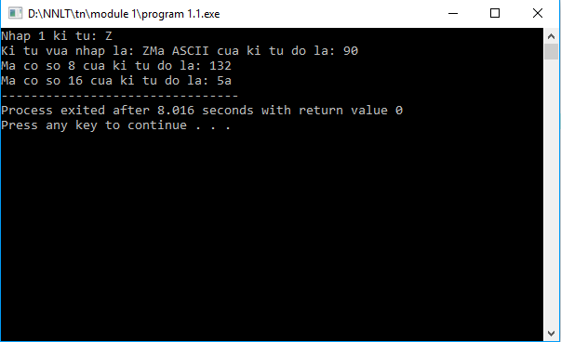

**Program 1.2**

#include<iostream>

#define PI 3.14

using namespace std;

int main(){

double f,C,X;

cout<<"Nhap tan so f: ";

cin>>f;

cout<<"\nNhap dien dung C: ";

cin>>C;

X=1/(2*PI*f*C);

cout<<"Dien khang cua tu dien X="<<X<<endl;

system("pause");

return 0;

}

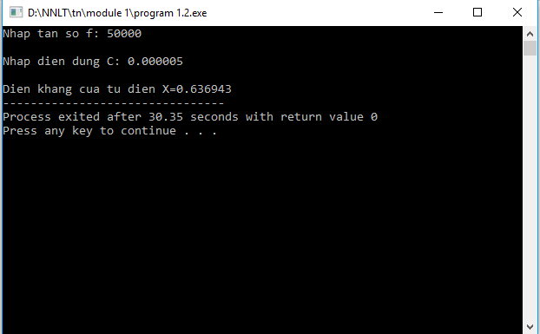

**Program 1.3**

#include<iostream>

using namespace std;

int main(){

double R1,R2,R3,Rtd;

int a;

cout<<"Nhap gia tri R1: ";

cin>>R1;

cout<<"Nhap gia tri cua R2: ";

cin>>R2;

cout<<"Nhap gia tri cua R3: ";

cin>>R3;

cout<<"Nhap cach mac dien tro\nNoi tiep: 1\nSong song: 2 ";

cin>>a;

if (a==1) Rtd=R1+R2+R3;

if (a==2) Rtd=1/(1/R1+1/R2+1/R3);

cout<<"Gia tri dien tro tuong duong la Rtd= "<<Rtd<<endl;

system("pause");

return 0;

}

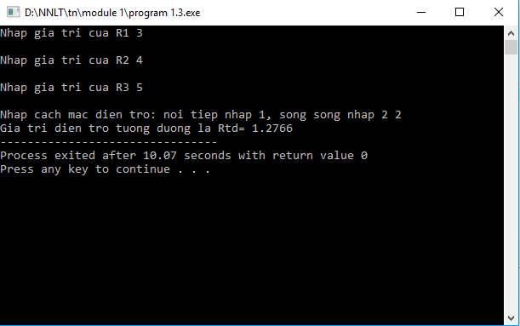

**Program 2.1**

#include<iostream>

using namespace std;

int main(){

double A[19];

int N;

do{

cout<<"\nNhap so dien tro (0<N<20) ";

cin>>N;

if(N>0&&N<20) continue;

cout<<"\nNhap lai, chi nhap 0<N<20 ";

}while(N<=0||N>=20);

for(int i=0;i<N;i++){

do{

cout<<"\nNhap gia tri cua R"<<i+1<<" ";

cin>>A[i];

if(A[i]>0) continue;

cout<<"\nNhap lai gia tri R>0 ";

}while(A[i]<=0);

}

int a;

do{

cout<<"Nhap cach mac dien tro\nNoi tiep: 1\nSong song: 2 ";

cin>>a;

if(a==1||a==2) continue;

cout<<"\nNhap lai, chi nhap 1 hoac 2 ";

}while(a!=1&&a!=2);

double Rtd=0, m=0;

if(a==1){

for(int i=0;i<N;i++)

Rtd+=A[i];

}

else {

for(int i=0;i<N;i++){

m+=(1/A[i]);

Rtd=1/m;

}

}

cout<<"\nGia tri dien tro tuong duong la Rtd="<<Rtd<<endl;

system("pause");

return 0;

}

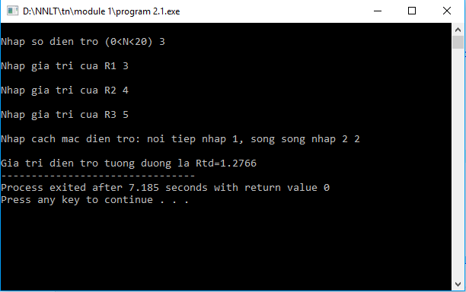

**Program 2.2**

#include<iostream>

#include<string.h>

using namespace std;

int sotu(char s[]){

int dem=0;

if(s[0]!=' ') dem++;

for(int i=0;i<strlen(s);i++)

if(s[i]==' '&&s[i+1]!=' '&&s[i+1]!='\0')

dem++;

return dem;

}

int main(){

char s[200];

cout<<"Nhap xau ki tu: ";

cin.ignore();

cin.getline(s,200);

cout<<"So tu la "<<sotu(s)<<" tu"<<endl;

system("pause");

return 0;

}

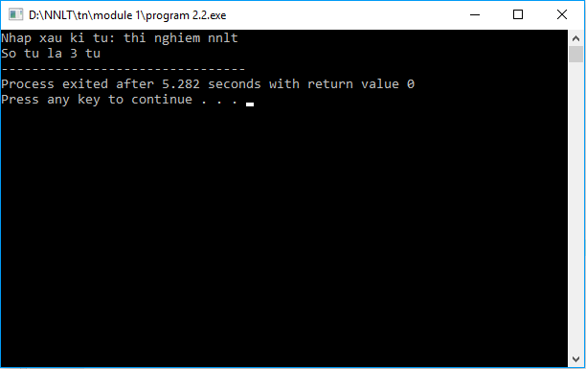

**Program 2.3**

#include<iostream>

using namespace std;

void nhapmatran(double A[][10], int m, int n){

for(int i=0;i<m;i++)

for(int j=0;j<n;j++){

cout<<"Nhap gia tri cua A["<<i+1<<"]["<<j+1<<"] ";

cin>>A[i][j];

}

}

void inmatran(double A[][10],int m, int n){

cout<<"\nMa tran vua nhap la ";

for(int i=0;i<m;i++){

cout<<"\n";

for(int j=0;j<n;j++)

cout<<A[i][j]<<"\t";

}

}

double tongmatran(double A[][10], int m, int n){

double tong=0;

for(int i=0;i<m;i++)

for(int j=0;j<n;j++)

tong+=A[i][j];

return tong;

}

void tonghang(double A[][10],int m, int n){

for(int i=0;i<m;i++){

double tonghang=0;

for(int j=0;j<n;j++)

tonghang+=A[i][j];

cout<<"\nTong cua hang thu "<<i+1<<" bang "<<tonghang;

}

}

void tongcot(double A[][10],int m, int n){

for(int j=0;j<n;j++){

double tongcot=0;

for(int i=0;i<m;i++)

tongcot+=A[i][j];

cout<<"\nTong cua cot thu "<<j+1<<" bang "<<tongcot;

}

}

int main(){

double A[10][10];

int m,n;

cout<<"Nhap so hang m=";cin>>m;

cout<<"Nhap so cot n=";cin>>n;

nhapmatran(A,m,n);

inmatran(A,m,n);

cout<<"\nTong cua cac phan tu trong ma tran la "<<tongmatran(A,m,n);

tonghang(A,m,n);

tongcot(A,m,n);

system("pause");

return 0;

}

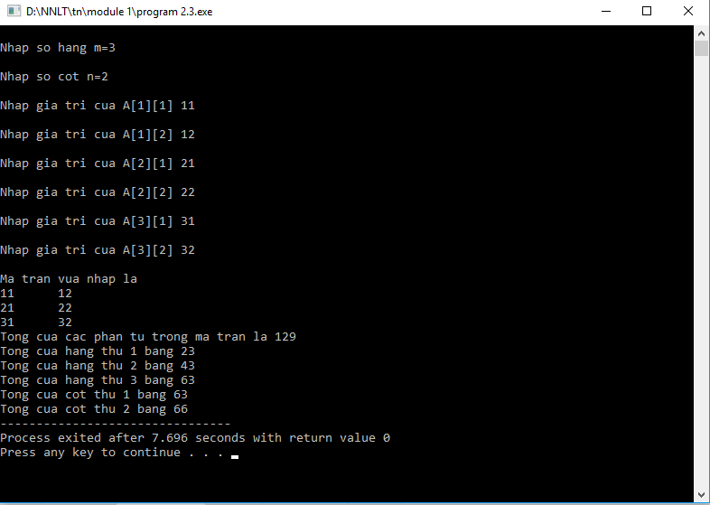

**BÀI VỀ NHÀ**

**Bài 1**

#include<iostream>

using namespace std;

int Factorial(int N){

if(N==0) return 1;

int gt=1;

for(int i=0;i<N;i++)

gt*=(i+1);

return gt;

}

int main(){

int N;

cout<<"Nhap so nguyen duong N: ";

cin>>N;

cout<<"N!="<<Factorial(N)<<endl;

system("pause");

return 0;

}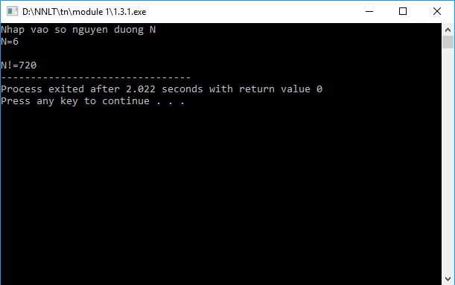

**Bài 2**

#include <iostream>

using namespace std;

double Pow(double x,int n){

if(n==0) return 1;

if (n<0) return 1.0/pow(x, -n);

else return pow(x,n-1)*x;

}

int main (){

double x;

int n;

cout<<"Nhap x: ";

cin>>x;

cout<<"Nhap n: ";

cin>>n;

cout<<x<<"^"<<n<<"="<<Pow(x,n)<<endl;

system("pause");

return 0;

}

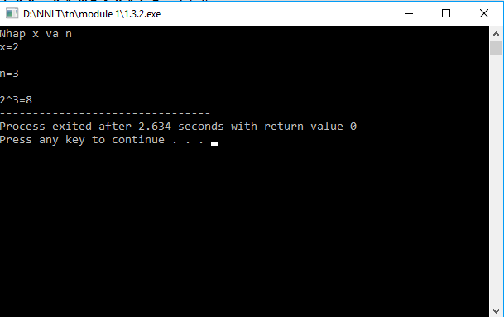

**Bài 3**

#include <iostream>

using namespace std;

int uscln(int a, int b){

if(a<b) swap(a,b);

int u;

do{

u=a%b;

a=b;

b=u;

}while(u!=0);

return a;

}

int main(){

int a,b;

cout<<"Nhap a: ";

cin>>a;

cout<<"Nhap b: ";

cin>>b;

cout<<"UCLN cua 2 so la "<<uscln(a,b)<<endl;

system("pause");

return 0;

}

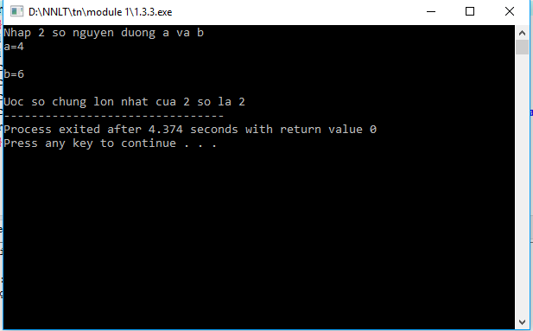

**Bài 4**

#include<iostream>

using namespace std;

double Value(double a[], int n, double x0){

double f=0;

for(int i=0;i<=n;i++)

f+=a[i]*pow(x0,i);

return f;

}

int main(){

double a[100];

int n;

double x0;

cout<<"x0=";cin>>x0;

if(x0==0){

cout<<"Gia tri cua f(x) la f=0";

exit(0);

}

cout<<"n=";cin>>n;

for(int i=0;i<=n;i++){

cout<<"a["<<i<<"]=";cin>>a[i];

}

cout<<"Gia tri cua f(x) la f="<<Value(a,n,x0)<<endl;

system("pause");

return 0;

}

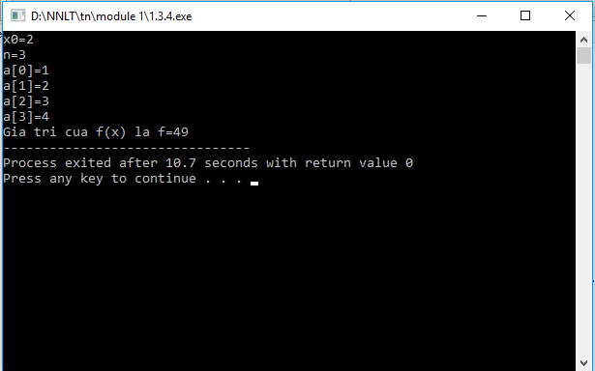

**MODULE 2**

**Program 1.1**

#include <iostream>

using namespace std;

class Complex{

private:

double re,im;

public:

Complex(double r=0,double i=0):re(r),im(i){}

Complex(const Complex &c):re(c.re),im(c.im){}

public:

Complex operator +(Complex c);

Complex operator -(Complex c);

Complex operator *(Complex c);

Complex operator /(Complex c);

public:

friend ostream& operator<<(ostream &out,Complex c){

return(out<<'('<<c.re<<","<<c.im<<"i)");

}

};

Complex Complex::operator+(Complex c){

return Complex(this->re+c.re,this->im+c.im);

}

Complex Complex::operator -(Complex c){

return Complex(this->re-c.re,this->im-c.im);

}

Complex Complex ::operator*(Complex c){

return Complex((this->re*c.re)-(this->im*c.im),(this->re*c.im)+(c.re*this->im));

}

Complex Complex::operator / (Complex c){

double m=c.re*c.re+c.im*c.im;

return Complex((this->re*c.re+this->im*c.im)/m,(-this->re*c.im+this->im*c.re)/m);

}

int main(){

Complex y(8,9),z(3,4);

double a=0.5;

cout<<y<<"+"<<z<<"+"<<a<<"="<<y+z+a<<endl;

cout<<y<<"-"<<z<<"="<<y-z<<endl;

cout<<y<<"*"<<z<<"="<<y*z<<endl;

cout<<y<<"/"<<z<<"="<<y/z<<endl;

system("pause");

return 0;

}

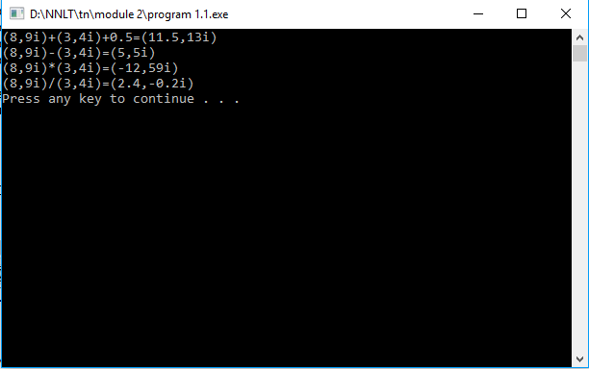

**Program 1.2**

#include <iostream>

#include <string.h>

using namespace std;

class String{

private:

int length;

char *data;

private:

String(int length, char *data):length(length),data(data){}

public:

String():length(0),data(new char[1]){data[0];}

String(const char* s){

length= strlen(s);

data=new char[length +1];

strcpy(data,s);

}

String (const String&s):length(s.length),data(s.data){}

~String(){delete[] data;}

public:

int Compare(String s){

int r=strcmp(data,s.data);

if(r>0)return 1;

if (r<0) return -1;

return 0;

}

public:

char &operator[](int index){return data[index];}

String&operator=(String&s);

public:

String operator + (char c);

String operator + (String s);

public:

int operator == (String s);

int operator != (String s);

friend ostream&operator<<(ostream&out,const String&s){

return(out<<s.data);

}

};

String&String::operator=(String&s){

delete[] data;

length=s.length;

data=new char[length+1];

strcpy(data,s.data);

return(*this);

}

String String::operator +(char c){

int length =this->length +1;

char *data =new char[length+1];

strcpy(data,this->data);

data[this->length]=c;

data[length]=0;

return String(length,data);

}

String String::operator +(String s){

int length=this->length+s.length;

char *data=new char[length+1];

strcpy(data,this->data);

strcat(data,s.data);

return String(length,data);

}

int String::operator ==(String s){

return strcmp (data,s.data);

}

int String::operator!=(String s){

return(!strcmp(data,s.data));

}

int main(){

String s("Thi nghiem nnlt");

char ch='a';

cout<<s<<"+"<<ch<<"="<<s+ch<<endl;

String ss("module 2");

cout<<s<<"+"<<ch<<"+"<<ss<<"="<<s+ch+ss<<endl;

system("pause");

return 0;

}

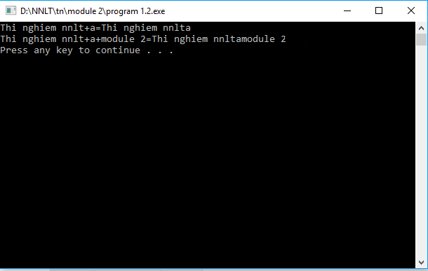

**MODULE 3**

int main(){

int year, day, month;

nhapTen();

nhapNam(year);

namNhuan(year);

canChi(year);

xemThuBatKi(year,month,day);

system("pause");

return 0;

}

