Index

- Introduction
- Objectives of the project
- Problem Statement
- Deliverables
- Hardware/ Software Requirements

Introduction

The thirst for learning, upgrading technical skills and applying the concepts in real life environment at a fast pace is what the industry demands from IT professionals today. However busy work schedules, far-flung locations, and unavailability of convenient time-slots pose as major barriers when it comes to applying the concepts into realism. And hence the need to look out for alternative means of implementation in the form of laddered approach.

The above truly pose as constraints especially for our students too! With their busy schedules, it is indeed difficult for our students to keep up with the genuine and constant need for integrated application which can be seen live especially so in the field of IT education where technology can change on the spur of a moment. Well, technology does come to our rescue at such times!!

Keeping the above in mind and in tune with our constant endeavour to use Technology in our training model, we at Aptech have thought of revolutionizing the way our students learn and implement the concepts using tools themselves by providing a live and synchronous eProject learning environment!

So what is this eProject?

eProject is a step by step learning environment that closely simulates the classroom and Lab based learning environment into actual implementation. It is a project implementation at your fingertips!! An electronic, live juncture on the machine that allows you to

- Practice step by step i.e. laddered approach.
- Build a larger more robust application.
- Usage of certain utilities in applications designed by user.
- Single program to unified code leading to a complete application.
- Learn implementation of concepts in a phased manner.
- Enhance skills and add value.
- Work on real life projects.
- Give a real life scenario and help to create applications more complicated and useful.
- Mentoring through email support.

How do we start accessing the Sample eProject?

The students at the centre are expected to complete this eProject and send complete documentation with source code within the time allotted to eprojects@aptech.ac.in

Looking forward to a positive response from your end!!

Objectives of the project

The Objective of this program is to give a sample project to work on real life projects. These applications help you build a larger more robust application.

The objective is not to teach you the software’s but to provide you with a real life scenario and help you create basic applications using the tools.

You can revise the topics before you start with the project.

This project is meant for students who have completed the module of HTML5. These programs should be done in the Lab sessions with assistance of the faculty if required.

It is very essential that a student has a clear understanding of the subject.

Kindly get back @ eprojects@aptech.ac.in in case of any doubts regarding the application or its objectives.

Problem Statement

Introduction

About the Company.
OceanGate Limited is a company established 3 years back which deals in various data storage products right from floppy disk to optical storage devices. It has state of the Art machinery for production of the storage devices/disks which are becoming popular as days pass by due to the excellent quality, fast delivery on purchases and efficient after sales Services.

Oceangate products have become so popular that the demand for the products is not only coming from local market but also international market.

The website is to be developed for the Windows Platform using HTML5, JavaScript and Geolocation. The site should work well in all leading browsers including Chrome, IE, Firefox etc.

Problem statement:

1) The products even after being very popular in the market and the sales increasing there are some probable customers who want to view the product, learn about the features and product specifications in terms of storage technique, overall looks etc.

2) Some probable customers would also like to compare the various products within the same category. For e.g. there are 2 different types of CD ROM Drives one with max speed 24X and the other with 52X.

3) The product range is not known to quite a few customers they just order on the basis of the feedback or recommendations given by their friends or colleagues and after delivery of the product it does not match either the requirements or expectations leading to wastage of time, resources and delivery costs.

4) Existing customers needing some help and support on the product after installation would have to call the oceangate office (difficult with phone lines continuously Busy) who would take their call and send the Service centre people to the place where the product is installed.

Solution:

The management team was very concerned with the kind of problems arising like some of the mentioned above and formed a Group within the company which would discuss the same and come out with a solution.
The group so formed came out with a solution that the company should have a web site of its own which will host information on the products of the company with the entire categorization.

The solution was accepted by the management and some story boarders were hired to take consultation on the development of web site they had lots of discussions with the management a prototype was developed and the screen dumps of the same are given below based on which the site needs to be developed.

Home page
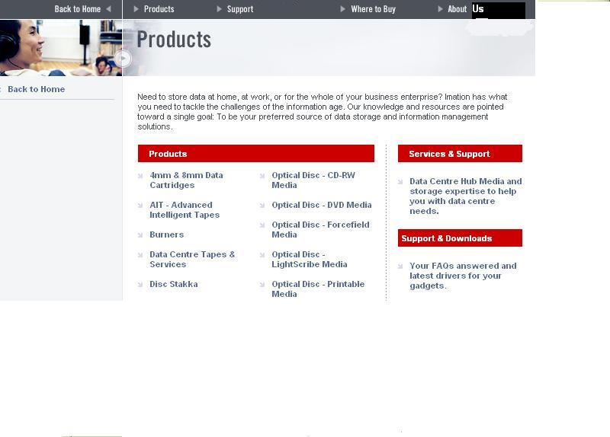
if you observe the above screen dump you can see they have advised that there should be a menu comprising of the following:

- Products: displays products page with the links to various products category wise like for e.g. Compact disks link on the product page will lead to another page with the various types of Compact disks available like CD, CDR, CDRW etc which further on has the thumbnail images and product specifications and features mentioned as shown in screen dump below
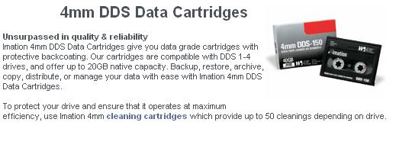
- Support: Would have the support centre address and contact details by which the consumers can directly approach / call up the service centres rather than following the indirect channel in use earlier.
- Where to buy: will have the contact details of the distributors the consumers can choose which one is nearest to their residence or office and purchase the product directly rather than approaching the company all the time.
- About us: is the link which will provide the information of the company and it success factors and client base etc.
- Testimonials / review of the products could also be available along with the product so that the probable customer could go through the same before selecting the product.

The site needs to built for the above requirements according to your imagination and development skills the only thing to be kept in mind is that the above suggested points are to be incorporated in the site. Since it’s a sample site that is being made by you can take dummy data from various sites on storage devices and use it.

Based on the site’s presentation, appearance, flow of information and innovativeness will lead the company to choose you to develop the full fledged site for their company.

Requirement Specification:
The Web site is to be created based on the following requirements.

- The Home Page should be created making use of Frames with a suitable logo
- The site should display a menu which will contain the options for brief introduction about the various products available, location of the shop and any other information if required.
- The information should be categorized according to the brand names of the products like if a User wants to see only Samsung products then he click on a Link/button/menu etc and he will see only That Brand products.
- When a user selects any particular brand, a list of products for that brand will be displayed
- A brief summary of features of individual products should be displayed on the Web Page along with the product but detailed Features should be stored in Individual Word documents which can be downloaded or viewed by the User who wishes to see the same.
- The user should also be able to compare the various products of different as well as similar brands.
- There should be a “Contact Us” page which will have the Address of the Company which is as follows and the mail address which when clicked will invoke the local mail client from where they can send an email. Address of the Company should be displayed using GeoLocation API (eg. GoogleMaps).

Standards plan:

USE OF DATABASE IS NOT MANDATORY. YOU CAN DEVELOP STATIC WEB PAGES.

Every code block must have comments.
The logic of the program needs to be explained. Proper documentation should be maintained.
Complete Project Report along with synopsis, code and documentation should be prepared.

Documentation:

No project is complete without documentation. In fact, it is one of the most important activities during the development of a project. The documentation of an ideal project will be in the form of a project report comprising of the following documents:

- Certificate of Completion.
- Table of Contents.
- Problem Definition.
- Customer Requirement Specification.
- Project Plan.
- E-R Diagrams.
- Algorithms.
- GUI Standards Document.
- Interface Design Document.
- Task Sheet.
- Project Review and Monitoring Report.
- Unit Testing Check List.
- Final Check List.

Deliverables

You need to submit the following Deliverables:

- Hardbound Documentation of the project.

- You need to follow all the following points as a part of your
eprojects execution process and will carry 10 marks in the final eProject Result.

a) Send us 2 (two) eprojects status mail, each should be after 10
days interval from your eprojects start date. Incase if your project
is less than 30 days then also you need to send 2 (two) status
mails (first status mail between 7-10 days and second 3 days
before the end date of project).

b) The status mail should consist of description with review document (what's going on the project). Also you can send your doubts / clarification or any additional inputs required to complete your eproject any time during the project planning and execution.

c) At the time of project submission also send us the feedback along with your documentation (soft and hard bound copy). The Feedback form is attached with this mail.

Remember that the subject of your email should start either with the word STATUS: or DOUBT: accordingly..

Hardware/ Software Requirements

Hardware

- A minimum computer system that will help you access all the tools in the courses is a Pentium 166 or better

- 64 Megabytes of RAM or better

Software

- Notepad/HTML editor
- Dreamweaver / Javascript
- IE 5.0/ Netscape 6.0

