

Hotel Management System
Software Requirement Specification
Project Code: HMS
Document Code: HMS-SRS– v1.2

– Hanoi, October 2026 –
Table of Contents
I. Record of Changes 3
II. Software Requirement Specification 4
1. Product Overview 4
1.1 Organizational Context & Target Operational Profile 4
1.2 Core Business Process: The Complete Guest Stay Cycle 4
2. User Requirements 7
2.1 Actors 7
2.2 Use Cases 8
3. Software Features 33
3.1 Functional Overview 33
3.2 Booking Process 53
3.3 Booking Confirmation & Check-in 63
3.4 Active Guest Stay Management 78
3.5 Checkout & Payment 89
3.6 Housekeeping & Maintenance 105
4. Business process 118
4.1 Check-in 118
4.2 Check out 119
4.3 Transfer room 120
4.4 Booking online 121
4.5 Booking on site 122
4.6 Order service 123
5. Non-Functional Requirements 123
5.1 External Interfaces 123
5.2 Quality Attributes 126
6. Requirement Appendix 131
6.1 Business Rules 131
6.2 Common Requirements 133
6.3 Application Messages List 133
6.4 Other Requirements… 134

I. Record of Changes
Date | A*  M, D | In charge | Change Description
25/09/2026 | A | KhangND | Add an overall description about the product with some introduction and the context diagram.
25/09/2026 | A | KhangND | Add Actors và Use Cases Diagram, Use Case Description
28/09/2026 | A | HieuVQ | Define Comprehensive Requirement Appendix (BR-01 to BR-42, Common Requirements, Messages List MSG01-MSG40, and Other Requirements).
28/09/2026 | A | GiapND | Add the Screen Flow section
28/09/2026 | A | GiapND | Add the screen description
28/09/2026 | A | LinhNH | Add Non-Functional Requirement
29/09/2026 | M | KhangND | Modify over description about the product and context diagram after revision.
29/09/2026 | M | KhangND | Modify Use Cases diagram and Use Case Description
30/09/2026 | M | GiapND | Revise the Screen Flow based on the updated use cases
30/09/2026 | M | LinhNH | Modify Non-Functional Requirement based on SRS that already updated
30/09/2026 | A | GiapND | Add Booking screen definitions, mockups, and use case descriptions.
1/10/2026 | M | TungPV | Modify ERD
01/10/2026 | A | HieuVQ | Add Housekeeping mockup, screen definitions, use case descriptions, business rule, common requirement, application message and other requirements.
2/10 | M | KhangND | Update product overview and context diagram, modify some use cases in Use case description table and use case diagram
3/10 | M | GiapND | Update the Screen Flow based on the revised use cases and user roles
4/10 | A | TungPV | Add business process
24/10 | M, A | HieuVQ | Separate Administrator role into Administrator (IT & Security) and Manager (Operations & Business); Add UC-51 Assign Room Cleaning Task under Subsystem 2; Update screen authorization matrix (Table 4) with Manager column; Update Use Case Table 2, overview and Business Rules (BR-06, BR-43).
*A - Added M - Modified D - Deleted

II. Software Requirement Specification

1. Product Overview
The Hotel Management System (HMS) is a centralized web-based operational platform engineered to coordinate daily lodging activities across independent hospitality establishments. The system automates room inventory allocation, online reservation handling, guest reception logistics, room cleanliness tracking, ancillary service consumption, folio billing, financial reporting, and guest satisfaction reviews.

1.1 Organizational Context & Target Operational Profile
The software is designed for independent mid-scale boutique and commercial hotels (3-star to 4-star standard) operating with an inventory of 60 to 150 rooms and a staff base of 25 to 50 employees operating across flexible shifts. The enterprise structure consists of four functional divisions and departments:
- Rooms & Commercial Division: Comprising Front Office, Sales & Marketing, and Housekeeping departments. Front desk staff handle reservations, verify identification, allocate clean rooms, issue physical keys, transfer rooms, and complete departures. Sales & Marketing staff configure room tariffs, promotional vouchers, and analyze occupancy trends. Housekeeping floor staff track vacated rooms, clean rooms, update sanitation states (Dirty -> Clean), and report equipment malfunctions for maintenance.
- Services & Ancillary Division: Comprising Food & Beverage (F&B) and Supplemental Services (Spa & Amenities) departments. Restaurant, room service, minibar, and spa staff deliver guest requests and post service charges directly onto active room stay folios.
- Accounting Department: An independent finance department where accountants review revenue ledgers, reconcile payment settlements, track outstanding balances, and audit cash flows.
- IT & Technical Department: An independent operational department where IT specialists manage employee user accounts, access permissions, security parameters, system audit logs, and maintain network infrastructure.

1.2 Core Business Process: The Complete Guest Stay Cycle
The system coordinates the guest journey through four stages:
- Stage 1: Pre-Arrival & Reservation: Prospective guests search available rooms by dates and guest count. Creating an online booking requires advance payment via an external payment gateway, which automatically transitions the booking to Confirmed. Direct or phone reservations are recorded and confirmed by front desk staff.
- Stage 2: Arrival & Check-In: The guest arrives at the hotel. Receptionists verify legal identification, match the booking, assign a vacant room certified as Clean, hand over physical keys, and transition the booking to Checked-In and the assigned room to Occupied.
- Stage 3: In-House Stay & Service Consumption: During the stay, guests order room service, dining, minibar items, or spa amenities either through the guest portal or via service staff. Staff record consumption charges directly into the active guest folio. Room transfers or stay extensions are processed based on downstream room vacancy. Housekeeping conducts routine cleaning and maintains room hygiene states.
- Stage 4: Departure, Folio Settlement & Turnover: At checkout, housekeeping inspects the room for minibar usage or property damage and reports them to the front desk. Staff compile an itemized folio including room nights, ancillary services, surcharges, and voucher deductions. Once the balance is settled, staff complete the checkout, print an itemized invoice receipt, and the system sets the room to Dirty for housekeeping turnover. Guests may then submit an accommodation review.

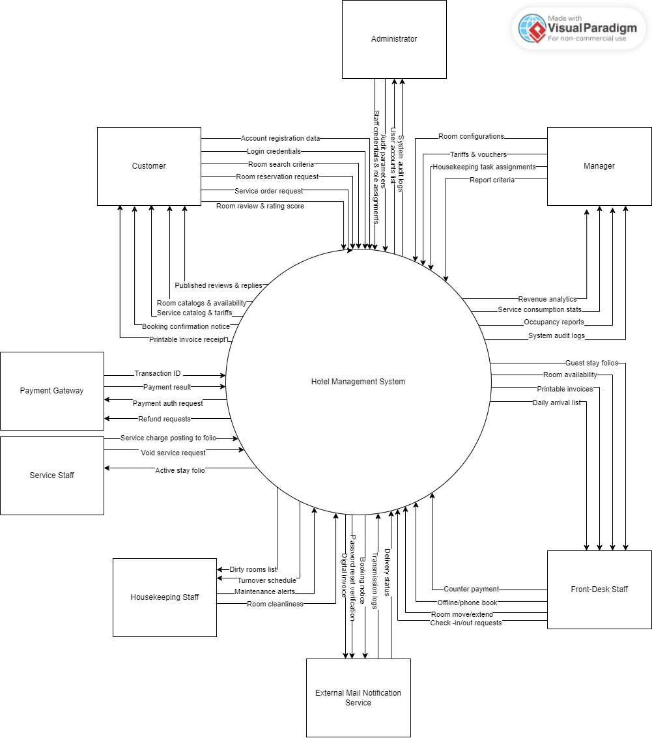
Figure 1-1: Hotel Management System overview
As described in Figure 1-1, the system will have the following components:
- Hotel Management System (HMS): The central software application boundary providing core business logic processing, database transactions, operational rule enforcement, access control validation, and state coordination across all operational departments.
- Customer: An external end-user who accesses public services to register an account, search real-time room availability, initiate bookings, submit advance deposits, order ancillary services during an active stay, review stay history, and post verified feedback upon departure.
- Front-Desk Staff: An internal operational actor executing front-office desk duties: processing guest arrivals and check-ins, allocating clean rooms, issuing key cards, handling mid-stay transfers and extensions, compiling stay folios, recording direct payments, and completing departure checkouts.
- Housekeeping Staff: An internal operational actor managing floor hygiene: viewing assigned rooms requiring sanitation, toggling cleanliness statuses between Dirty, Clean, and Inspected, and placing defective rooms under maintenance.
- Service Staff: An internal operational actor representing ancillary service departments (F&B, room service, minibar, spa, laundry) who delivers ordered items to rooms and posts consumption charges directly to the active guest folio.
- Manager: An internal managerial and supervisory authority (representing General Manager, Sales & Marketing, Accounting, and Operations Supervisors) responsible for configuring master property data (room types, physical rooms, base tariffs, service items, promotional vouchers), assigning dirty rooms to housekeeping staff for cleaning, moderating customer reviews, inspecting operational audit logs, and analyzing occupancy and revenue analytics.
- Administrator: An internal IT and technical authority responsible solely for managing user accounts, toggling account statuses, assigning user roles, configuring audit tracking parameters, and inspecting system security audit logs.
- Payment Gateway: An external third-party financial service (e.g., VNPay) that receives electronic deposit authorization requests from the HMS, securely processes customer payments, and returns authenticated transaction confirmation tokens and payment statuses.
- Mail Notification Service: An external automated mail transfer service (SMTP) that receives outbound email payloads from the HMS to dispatch transactional booking confirmations, password recovery verification tokens, and digital itemized folio receipts to recipients.

2. User Requirements

2.1 Actors

# | Actor | Description
1 | Customer | An external guest who accesses public booking features: browsing room categories, registering an account, booking rooms, submitting online deposits, ordering in-stay services, viewing personal stay histories, and authoring room reviews after departure.
2 | Front-Desk Staff | A receptionist responsible for front-office operations: confirming pending bookings, conducting guest check-ins, allocating physical rooms, managing room transfers and extensions, compiling itemized folios, processing counter payments, and executing checkout departures.
3 | Housekeeping Staff | A floor staff member responsible for room hygiene: receiving assigned cleaning rooms, updating cleanliness progression (Dirty → Clean → Inspected), and reporting equipment malfunctions for maintenance lockouts.
4 | Service Staff | An operational staff member representing ancillary amenities (F&B, minibar, spa, laundry): delivering services to in-house guests, posting auxiliary charges directly to active guest stay folios, and requesting cancellations for unrendered items.
5 | Manager | A hotel manager, sales/marketing specialist, or accountant who configures room categories, physical room inventory, service tariffs, and discount vouchers; assigns room cleaning tasks to housekeeping staff; moderates customer reviews; inspects system audit logs; and generates business analytical reports.
6 | Administrator | An IT system administrator responsible for governing user accounts, activating/deactivating user access, assigning staff roles, configuring system audit parameters, and inspecting security audit logs.
7 | Payment Gateway | An external electronic payment processing entity (VNPay) that validates credit card or digital wallet transactions, processes online room reservation deposits, and returns transaction authorization codes.
8 | Mail Notification Service | An external automated mail delivery system (Google SMTP) that receives system requests to dispatch transactional booking confirmations, password recovery verification codes, and digital itemized receipts.

2.2 Use Cases
The system provides 51 use cases partitioned into five functional subsystems:
- Subsystem 1: Account & Authentication Management (UC01 – UC10): Covers account registration, authentication, profile self-management, administrative user control, and password recovery.
- Subsystem 2: Room & Facility Management (UC11 – UC20, UC-51): Covers room category configuration, inventory setup, room browsing, housekeeping workflow, cleaning task assignment, and maintenance tracking.
- Subsystem 3: Reservation & Front-Desk Operations (UC21 – UC30): Covers room availability searches, booking lifecycles (creation, cancellation, confirmation), and front-desk execution (check-in, room move, extension, checkout).
- Subsystem 4: Ancillary Services & Billing Management (UC31 – UC40): Covers the auxiliary service catalog, folio charge postings, voucher applications, payment collection, and invoice generation.
- Subsystem 5: Reviews, Audit & Reporting Management (UC41 – UC50): Covers customer reviews, moderation, audit trail viewing, and managerial business reporting.

2.2.1 Diagram(s)
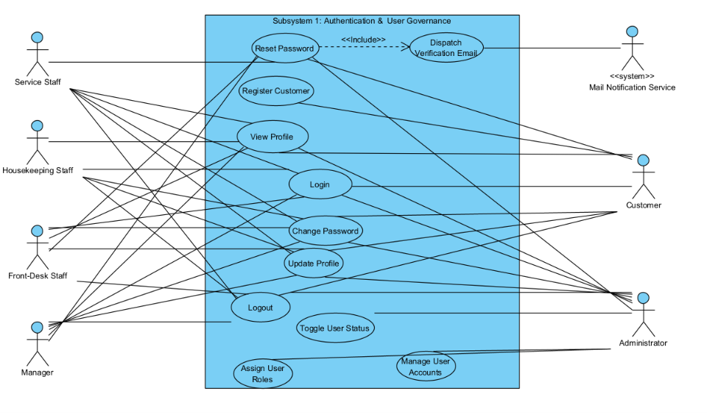
Figure 2-1: Subsystem 1 Use Case Diagram
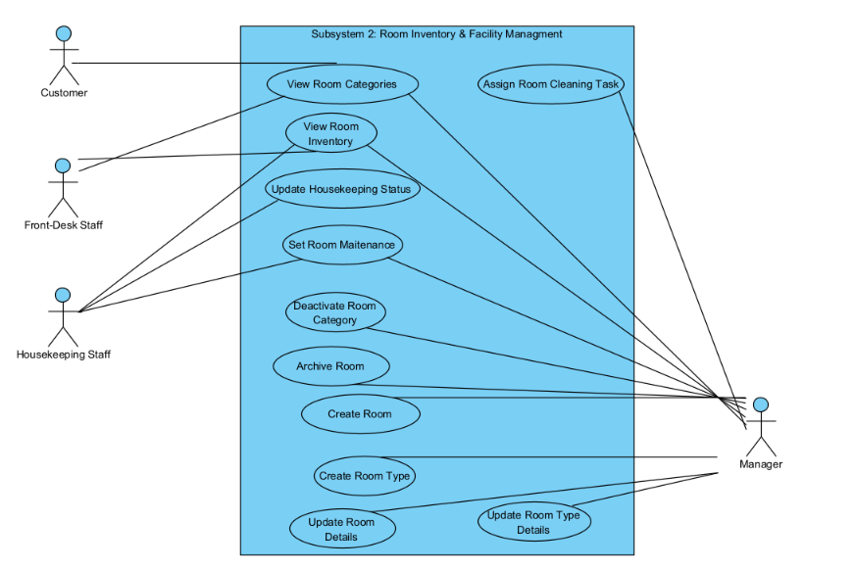
Figure 2-2: Subsystem 2 Use Case Diagram
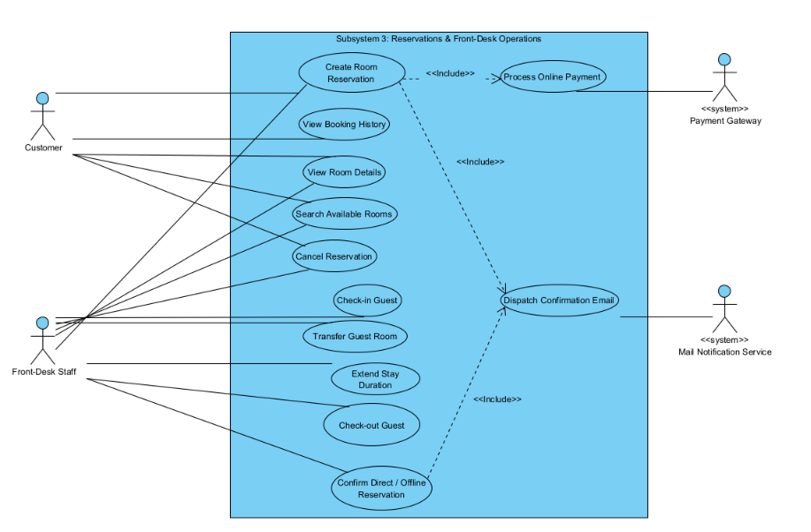
Figure 2-3: Subsystem 3 Use Case Diagram
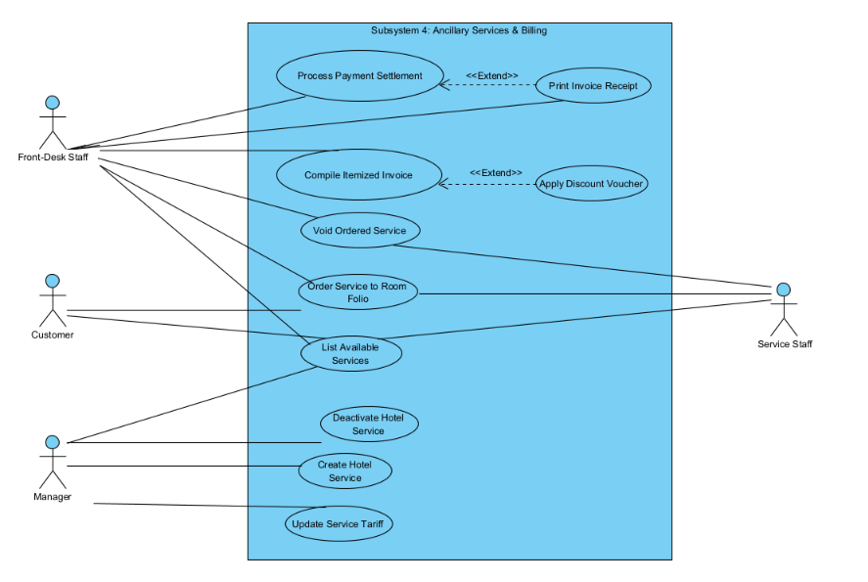
Figure 2-4: Subsystem 4 Use Case Diagram
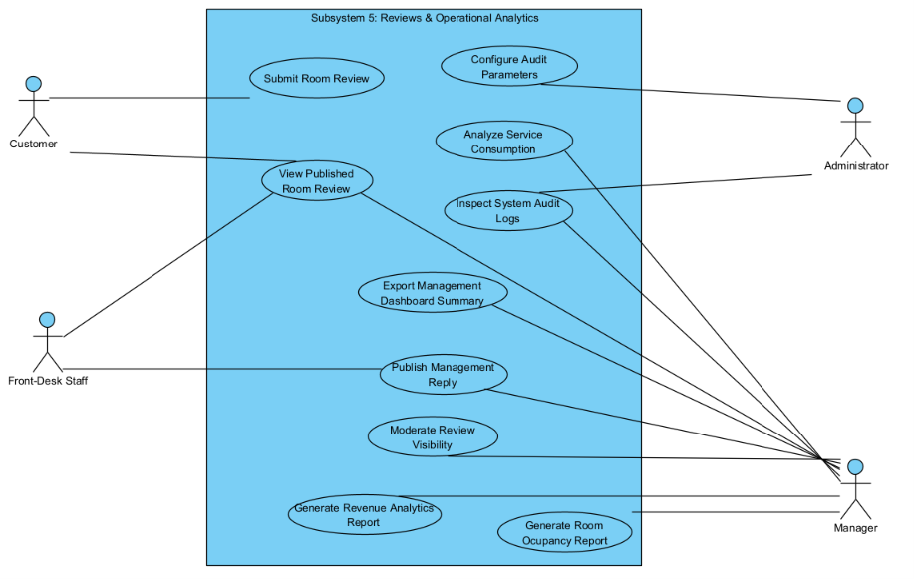
Figure 2-5: Subsystem 5 Use Case Diagram

2.2.2 Descriptions

ID | Group Function | Use Case | Actors | Use Case Description & Main Flow
UC-01 | Account & Authentication | Register Customer | Customer | Description: Allows an unauthenticated guest to create a personal customer account.  Main Flow:  1. Customer accesses registration view.  2. Customer inputs legal name, email, phone number, and password.  3. System validates format and verifies email uniqueness.  4. System creates customer account and displays confirmation.  Alternative Flow:  • Email Exists: System prompts error and suggests login.
UC-02 | Account & Authentication | Log In | All Users | Description: Authenticates credentials to grant system access to authorized modules.  Main Flow:  1. User inputs registered email and password.  2. System validates credentials and confirms account is Active.  3. System establishes authenticated user session and redirects to role dashboard.  Alternative Flow:  • Invalid Credentials: System rejects login and displays error notification.
UC-03 | Account & Authentication | View Profile | All Users | Description: Displays the personal account profile of the currently logged-in user.  Main Flow:  1. User accesses personal profile view.  2. System retrieves profile attributes of the current session.  3. System displays full name, email, phone number, and assigned role.
UC-04 | Account & Authentication | Update Profile | All Users | Description: Modifies personal user contact information.  Main Flow:  1. User updates name or phone number on profile view.  2. User confirms updates.  3. System validates telephone format and commits changes.  4. System acknowledges update success.  Alternative Flow:  • Invalid Format: System alerts invalid phone syntax and requires re-entry.
UC-05 | Account & Authentication | Change Password | All Users | Description: Updates account password for security maintenance.  Main Flow:  1. User inputs current password, new password, and confirmation password.  2. System validates current password correctness.  3. System validates new password complexity rules.  4. System saves updated credentials and confirms success.  Alternative Flow:  • Mismatch: System flags non-matching confirmation password.
UC-06 | Account & Authentication | Log Out | All Users | Description: Terminates the current authenticated user session.  Main Flow:  1. User triggers logout command.  2. System clears the active session context.  3. System redirects user to the public landing page.
UC-07 | Account & Authentication | Manage User Accounts | Administrator | Description: Provides administrative retrieval, search, and filtering of all user accounts.  Main Flow:  1. Administrator accesses user governance view.  2. System loads account records with filters.  3. Administrator filters users by name, role, or active status.  4. System refreshes display table with matching records.
UC-08 | Account & Authentication | Toggle User Account Status | Administrator | Description: Activates or deactivates user accounts to govern access.  Main Flow:  1. Administrator selects target user account.  2. Administrator changes status (Active/Inactive).  3. System verifies administrator is not deactivating self.  4. System commits status and immediately revokes active tokens for inactive accounts.
UC-09 | Account & Authentication | Assign User Roles | Administrator | Description: Updates employee access permissions across staff roles.  Main Flow:  1. Administrator selects employee account.  2. Administrator selects new role (Front-Desk Staff, Housekeeping Staff, Service Staff, Manager, Administrator).  3. System validates authority, commits new role, and logs administrative action.  4. System displays confirmation message.
UC-10 | Account & Authentication | Reset Password | All Users, Mail Notification Service | Description: Recovers account access via time-limited verification email.  Main Flow:  1. User inputs registered email on recovery screen.  2. System validates email existence and creates time-limited token.  3. System requests Mail Notification Service to dispatch reset email.  4. User accesses link, provides new password, and system updates credentials.  Alternative Flow:  • Expired Token: System informs user link expired and prompts new request.
UC-11 | Room & Facility Management | Create Room Type | Manager | Description: Configures a new accommodation category (e.g., Deluxe, Suite).  Main Flow:  1. Administrator opens category creation form.  2. Administrator inputs category title, standard base rate, guest capacity, and amenities list.  3. System validates uniqueness and confirms positive rate.  4. System adds category to active catalog.
UC-12 | Room & Facility Management | Update Room Type Details | Manager | Description: Adjusts rates, capacities, or descriptions of an existing room tier.  Main Flow:  1. Administrator selects an existing room category.  2. Administrator edits base nightly price, guest capacity, or amenity tags.  3. System validates inputs and updates the category record.  4. System acknowledges modification.
UC-13 | Room & Facility Management | Deactivate Room Category | Manager | Description: Decommissions a room category from the active catalog.  Main Flow:  1. Administrator selects room category to decommission.  2. System verifies no active physical rooms are assigned to this category.  3. System sets category to inactive, preventing future bookings while retaining historical data.
UC-14 | Room & Facility Management | View Room Categories | Customer, Front-Desk Staff, Manager | Description: Displays public catalog of accommodation categories and descriptions.  Main Flow:  1. User navigates to accommodations view.  2. System retrieves all active room categories.  3. System displays category cards detailing photos, descriptions, capacities, and base rates.
UC-15 | Room & Facility Management | Create Room | Manager | Description: Registers an individual physical room unit into inventory.  Main Flow:  1. Administrator inputs room door number, floor index, and selects room category.  2. System validates room number uniqueness across the property.  3. System saves room with occupancy status Vacant and cleanliness Clean.
UC-16 | Room & Facility Management | Update Room Details | Manager | Description: Modifies physical room attributes, floor location, or notes.  Main Flow:  1. Administrator selects target room record.  2. Administrator updates floor index, category association, or notes.  3. System commits updates and refreshes inventory display.
UC-17 | Room & Facility Management | Archive Room | Manager | Description: Retires an unusable room unit from active operational inventory.  Main Flow:  1. Administrator selects room to archive.  2. System verifies room is vacant with no active or future bookings.  3. System flags room as archived, removing it from scheduling.  Alternative Flow:  • Room Occupied: System rejects archival and displays error message.
UC-18 | Room & Facility Management | View Room Inventory | Front-Desk Staff, Housekeeping Staff, Manager | Description: Displays operational table of all hotel rooms with multi-status filters.  Main Flow:  1. Staff opens room inventory dashboard.  2. Staff applies filters by floor, category, occupancy status, or cleanliness status.  3. System retrieves and displays matching room records.
UC-19 | Room & Facility Management | Update Housekeeping Status | Housekeeping Staff | Description: Updates room hygiene progression between Dirty and Clean.  Main Flow:  1. Housekeeping staff accesses housekeeping board.  2. Staff selects a dirty room that has been thoroughly sanitized.  3. Staff sets status to Clean.  4. System updates room hygiene state, signaling readiness to the front desk.
UC-20 | Room & Facility Management | Set Room Maintenance | Housekeeping Staff, Manager | Description: Locks an out-of-order room for physical repairs, preventing reservations.  Main Flow:  1. Staff identifies an equipment fault and selects target room.  2. Staff inputs defect description and estimated repair completion date.  3. System sets room status to Under Maintenance and locks room availability.
UC-51 | Room & Facility Management | Assign Room Cleaning Task | Manager | Description: Assigns dirty or vacated rooms to specific Housekeeping Staff members for cleaning turnover.  Main Flow:  1. Manager accesses housekeeping assignment view and filters rooms with Dirty status.  2. Manager selects target dirty room(s) and selects an active Housekeeping Staff member.  3. Manager inputs cleaning priority or instructions and confirms assignment.  4. System records the assignment and updates the selected staff member's Housekeeping Board.  Alternative Flow:  • Staff Inactive/Unavailable: System blocks assignment and prompts selecting another active staff member.
UC-21 | Reservation & Front-Desk | Search Available Rooms | Customer, Front-Desk Staff | Description: Discovers unoccupied rooms meeting specified dates and guest counts.  Main Flow:  1. User inputs check-in date, check-out date, and guest counts.  2. System validates date logic (departure after arrival; arrival not in past).  3. System scans inventory, excluding booked, occupied, and maintenance units.  4. System displays eligible vacant room types and estimated totals.  Alternative Flow:  • No Vacancy: System notifies user that no rooms match and suggests alternative dates.
UC-22 | Reservation & Front-Desk | View Room Details | Customer, Front-Desk Staff | Description: Displays specifications, photos, amenities, and reviews for a selected room type.  Main Flow:  1. User selects a room type card.  2. System retrieves photo galleries, bed layouts, amenity checklists, rates, and verified reviews.  3. System renders detailed view.
UC-23 | Reservation & Front-Desk | Create Room Reservation | Customer, Front-Desk Staff, Payment Gateway, Mail Notification Service | Description: Reserves advance accommodations online with mandatory pre-payment.  Main Flow:  1. User selects stay dates, room type, guest count, and inputs contact info.  2. System computes total stay price and reserves room quota.  3. Customer authorizes full stay payment/deposit via Payment Gateway.  4. Gateway confirms successful payment; system records transaction and marks booking as Confirmed.  5. System requests Mail Notification Service to dispatch booking confirmation email with reference code.  Alternative Flow:  • Payment Failed: System releases reserved quota and alerts customer of payment rejection.
UC-24 | Reservation & Front-Desk | View Booking History | Customer | Description: Allows authenticated customer to inspect past, active, and pending bookings.  Main Flow:  1. Customer navigates to "My Bookings".  2. System loads reservations linked to customer account.  3. System displays booking cards detailing stay dates, room types, status badges, and folios.
UC-25 | Reservation & Front-Desk | Cancel Reservation | Customer, Front-Desk Staff | Description: Cancels an unfulfilled booking and calculates applicable penalty fees.  Main Flow:  1. User selects active reservation and initiates cancellation.  2. System evaluates remaining hours before check-in against cancellation rules.  3. System displays applicable penalty terms.  4. User confirms cancellation; system sets status to Cancelled and releases inventory.  Alternative Flow:  • In-House Stay: System blocks online cancellation if booking is already checked in.
UC-26 | Reservation & Front-Desk | Confirm Direct / Offline Reservation | Front-Desk Staff, Mail Notification Service | Description: Records and confirms direct bookings created via telephone, corporate contracts, or front desk walk-ins.  Main Flow:  1. Staff inputs customer contact details, dates, and selected room category.  2. Staff verifies direct guarantee deposit (cash, bank transfer, or corporate billing).  3. Staff confirms reservation; system sets booking status to Confirmed and deducts category inventory quota.  4. System requests Mail Notification Service to send booking confirmation email to the guest.  Alternative Flow:  • No Inventory: System alerts staff that category is fully committed for requested dates.
UC-27 | Reservation & Front-Desk | Check In Guest | Front-Desk Staff | Description: Processes guest arrival, records legal identity, assigns a physical clean room unit, and delivers keys.  Main Flow:  1. Staff retrieves confirmed booking by code, phone number, or guest name.  2. Staff inspects and records guest national identification (ID/Passport).  3. System displays available vacant physical rooms of booked tier having Clean status.  4. Staff selects and assigns a specific physical room number (e.g., Room 302).  5. Staff applies early arrival surcharge if check-in is before standard 14:00 time.  6. Staff confirms check-in; system updates booking status to Checked-In, marks assigned room as Occupied, and staff issues physical key card.  Alternative Flow:  • No Clean Room Available: System prevents check-in and alerts staff to contact housekeeping for expedited cleaning.
UC-28 | Reservation & Front-Desk | Transfer Guest Room | Front-Desk Staff | Description: Reallocates an in-house guest to an alternative physical room during stay.  Main Flow:  1. Staff opens active guest stay folio and initiates room move.  2. Staff selects a new vacant Clean room and records transfer reason.  3. System recalculates folio rate adjustments: upgrades append charges; downgrades due to hotel facility faults post credit balance.  4. System assigns new room, frees previous room (marking it Dirty), and updates folio.
UC-29 | Reservation & Front-Desk | Extend Stay Duration | Front-Desk Staff | Description: Postpones the scheduled departure date for a resident guest.  Main Flow:  1. Staff inputs requested new departure date.  2. System verifies assigned room is vacant for all extended nights.  3. System calculates additional room charges and appends them to folio.  4. System updates departure date.  Alternative Flow:  • Room Conflict: System alerts staff of conflict and suggests room transfer.
UC-30 | Reservation & Front-Desk | Check Out Guest | Front-Desk Staff | Description: Finalizes guest departure, closes billing folios, and releases physical room.  Main Flow:  1. Staff opens departure folio and confirms key return.  2. System verifies outstanding folio balance is zero.  3. Staff confirms checkout.  4. System updates booking to Completed and marks room as Dirty for turnover.  Alternative Flow:  • Unsettled Balance: System blocks checkout completion until balance is paid in full.
UC-31 | Services & Billing | Create Hotel Service | Manager | Description: Defines an ancillary hospitality service (e.g., Laundry, Buffet, Spa).  Main Flow:  1. Administrator enters service title, unit price, category, and billing unit.  2. System verifies title uniqueness within category.  3. System registers service item into active catalog.
UC-32 | Services & Billing | Update Service Tariff | Manager | Description: Updates the pricing structure of an existing ancillary service.  Main Flow:  1. Administrator selects target service item.  2. Administrator updates unit rate.  3. System validates positive pricing and saves changes, applying solely to future orders.
UC-33 | Services & Billing | Deactivate Hotel Service | Manager | Description: Deprecates an auxiliary service from the active ordering menu.  Main Flow:  1. Administrator selects service item to discontinue.  2. System flags service as inactive, preventing new orders while preserving past order records.
UC-34 | Services & Billing | List Available Services | Customer, Front-Desk Staff, Service Staff | Description: Displays active ancillary hotel services and current price schedules.  Main Flow:  1. User navigates to services menu.  2. System retrieves active service items grouped by category.  3. System displays services, descriptions, and unit prices.
UC-35 | Services & Billing | Order Service to Room Folio | Customer, Front-Desk Staff, Service Staff | Description: Appends consumed auxiliary items directly onto active guest stay folio.  Main Flow:  1. Actor (Customer via portal or Service/Front-Desk Staff) selects active room, items, and quantities.  2. System verifies booking status is Checked-In.  3. System computes item subtotals and posts charges directly to guest folio.  Alternative Flow:  • Not Checked In: System rejects posting if room is vacant or checked out.
UC-36 | Services & Billing | Void Ordered Service | Front-Desk Staff, Service Staff | Description: Voids mistakenly posted service charges before delivery.  Main Flow:  1. Staff opens active stay folio.  2. Staff selects unrendered service line item and enters void reason.  3. System removes charge, recalculates folio balance, and logs void action.
UC-37 | Services & Billing | Compile Itemized Invoice | Front-Desk Staff | Description: Compiles room charges, services, surcharges, and discounts into an invoice.  Main Flow:  1. Staff initiates invoice compilation for departure booking.  2. System aggregates: (Room Nights $×$ Rate) + Service Charges + Surcharges.  3. System generates an itemized invoice record under status Unpaid.
UC-38 | Services & Billing | Apply Discount Voucher | Front-Desk Staff | Description: Applies a promotional code or corporate discount to an invoice.  Main Flow:  1. Staff inputs voucher code into invoice form.  2. System verifies voucher active dates, usage quota, and minimum spend criteria.  3. System recalculates invoice total, deducting promotional discount.  Alternative Flow:  • Invalid/Expired Code: System alerts staff of invalid voucher and maintains original balance.
UC-39 | Services & Billing | Process Payment Settlement | Front-Desk Staff | Description: Records monetary collection across supported tender methods (Cash, Card, Transfer).  Main Flow:  1. Staff selects payment tender method and inputs received amount.  2. System checks that received amount matches balance due.  3. System marks invoice as Paid and generates payment confirmation.  Alternative Flow:  • Partial Payment: System records partial payment and updates remaining balance due.
UC-40 | Services & Billing | Print Invoice Receipt | Front-Desk Staff | Description: Formats and prints an official itemized payment receipt for the guest.  Main Flow:  1. Front-desk staff triggers print receipt action.  2. System formats document with hotel corporate header, booking code, itemized breakdown, and payment stamp.  3. System renders printable invoice view.
UC-41 | Reviews, Audit & Reporting | Submit Room Review | Customer | Description: Allows verified guests to submit star ratings and written feedback after departure.  Main Flow:  1. Customer selects a completed reservation.  2. System verifies booking status is Completed and review has not been submitted previously.  3. Customer inputs star rating (1–5) and comments.  4. System saves review and updates average room category rating.  Alternative Flow:  • Duplicate Review: System blocks submission if review was already submitted for this stay.
UC-42 | Reviews, Audit & Reporting | View Published Room Reviews | All Users | Description: Displays historical verified guest feedback and management responses.  Main Flow:  1. User navigates to reviews section of a room category.  2. System retrieves verified, non-hidden reviews for that category.  3. System renders average rating, guest comments, and management replies.
UC-43 | Reviews, Audit & Reporting | Publish Management Reply | Front-Desk Staff, Manager | Description: Allows hotel management or front office supervisor to post an official public response to a review.  Main Flow:  1. Staff selects a customer review.  2. Staff writes an official management reply.  3. System publishes reply underneath customer review.  Alternative Flow:  • Duplicate Reply: System prompts editing existing reply instead of duplicate posting.
UC-44 | Reviews, Audit & Reporting | Moderate Review Visibility | Manager | Description: Hides inappropriate or defamatory customer reviews from public display.  Main Flow:  1. Administrator identifies a review violating content standards.  2. Administrator executes hide review action.  3. System flags review as hidden, excluding it from public view and rating calculations.
UC-45 | Reviews, Audit & Reporting | Generate Room Occupancy Report | Manager | Description: Calculates and visualizes hotel room occupancy percentages over a selected period.  Main Flow:  1. Administrator specifies start and end dates.  2. System computes: $(\text{Occupied Room Nights} / \text{Available Room Nights}) \times 100\%$.  3. System displays occupancy distribution chart and statistics.  Alternative Flow:  • Invalid Range: System alerts administrator if start date is after end date.
UC-46 | Reviews, Audit & Reporting | Generate Revenue Analytics Report | Manager | Description: Compiles financial revenue segmented by room tariffs and ancillary services.  Main Flow:  1. Administrator selects reporting interval (daily, monthly, quarterly).  2. System aggregates settled payments from paid invoices.  3. System displays revenue trend charts and breakdown figures.
UC-47 | Reviews, Audit & Reporting | Analyze Service Consumption | Manager | Description: Ranks auxiliary hotel services by usage volume and total sales.  Main Flow:  1. Administrator accesses service analytics view.  2. System aggregates historical service orders within the selected date range.  3. System displays ranked table of consumed services sorted by sales volume.
UC-48 | Reviews, Audit & Reporting | Configure Audit Parameters | Administrator | Description: Configures retention periods and tracking rules for sensitive operations.  Main Flow:  1. Administrator accesses audit governance console.  2. Administrator defines critical operations subject to audit tracking and retention policy.  3. System saves audit parameters and applies logging rules to transactions.
UC-49 | Reviews, Audit & Reporting | Inspect System Audit Logs | Manager, Administrator | Description: Enables administrative review of operational audit records for accountability.  Main Flow:  1. Administrator accesses audit log viewer.  2. Administrator filters records by actor, action category, or date range.  3. System displays chronological audit entries with operator identity and activity details.
UC-50 | Reviews, Audit & Reporting | Export Management Dashboard Summary | Manager | Description: Exports operational and financial performance summaries to spreadsheet files.  Main Flow:  1. Administrator initiates report export action.  2. System aggregates occupancy metrics, revenue figures, net bookings, and service sales.  3. System generates and downloads formatted summary spreadsheet.

3. Software Features

3.1 Functional Overview
The Hotel Management System is described through its screen flow, screen descriptions, user roles, screen authorization, non-screen functions, and entity relationships. These components define how users interact with the system, which functions each role can access, background system functions, and the main data entities used by HMS.

3.1.1 Screens Flow

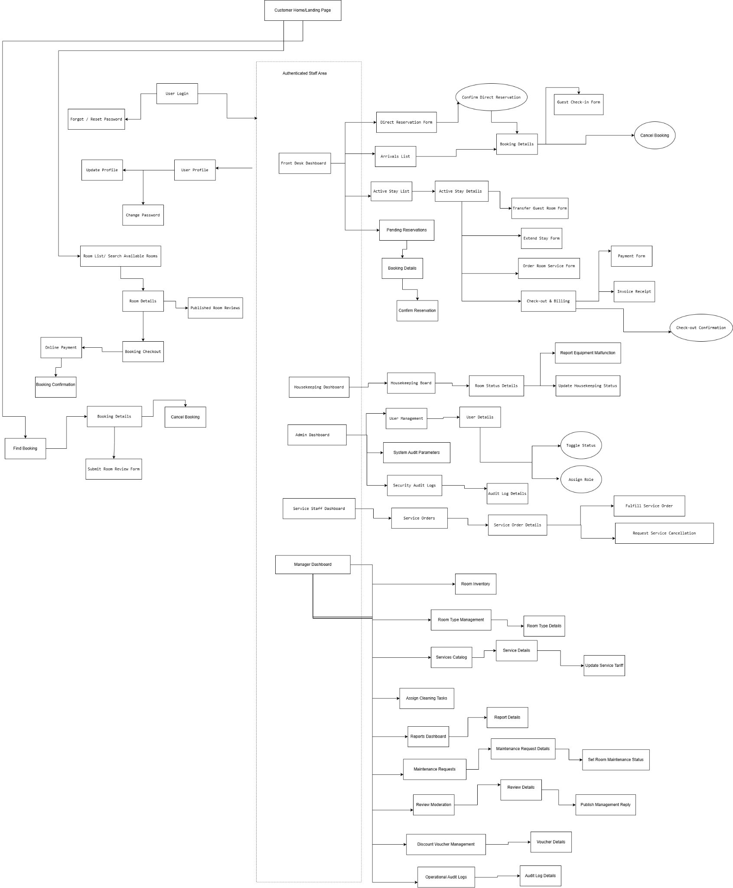

Screen Flow Notation
- Rectangle: Represents a system screen, form, or view.
- Oval: Represents a system action or confirmation step.
- Arrow: Represents the navigation or transition between screens.
- Post-Login Area: Represents functions that are available only to authenticated users.

3.1.2 Screen Descriptions

# | Feature | Screen | Description
1 | Customer Access | Customer Home/Landing Page | Provides public access to room categories, room availability search, room details, and published reviews without requiring customer login.
2 | Authentication | User Login | Authenticates user credentials and grants access to authorized system modules according to the user's role and account status.
3 | Authentication | Forgot / Reset Password | Allows users to recover account access through a time-limited password reset link sent to their registered email address.
4 | User Profile | User Profile | Displays the current user's full name, email address, phone number, and assigned role.
5 | User Profile | Update Profile | Allows users to update their name and phone number, subject to input validation.
6 | User Profile | Change Password | Allows users to change their password after validating the current password and the new password requirements.
7 | Room Search | Room List / Search Available Rooms | Displays active room categories and allows users to search for available accommodation based on check-in date, check-out date, and guest count.
8 | Room Search | Room Details | Displays the selected room category's photos, bed configuration, amenities, rates, capacity, and verified reviews.
9 | Reviews | Published Room Reviews | Displays verified guest reviews, average ratings, and published management replies for a room category.
10 | Booking | Booking Checkout | Allows customers to enter stay dates, room category, guest count, contact information, and special notes before submitting a reservation.
11 | Payment | Online Payment | Allows customers to complete the required reservation deposit through the integrated payment gateway.
12 | Booking | Booking Confirmation | Displays the reservation result and the unique Booking Reference Code after the reservation process.
13 | Booking | Find Booking | Allows customers to locate an existing reservation using its Booking Reference Code.
14 | Booking | Booking Details | Displays the selected reservation's stay dates, room category, booking status, and related booking information.
15 | Booking | Cancel Booking | Allows customers to cancel an eligible reservation, review applicable cancellation penalties, and release the reserved inventory after cancellation.
16 | Reviews | Submit Room Review Form | Allows verified guests to submit a star rating and written feedback after completing their stay.
17 | Front Desk | Front Desk Dashboard | Provides access to reservation handling, guest check-in, active stay management, billing, payment, and check-out functions.
18 | Booking | Direct Reservation Form | Allows front-desk staff to enter guest information, stay dates, room category, guest count, and special notes to create a direct reservation.
19 | Booking | Confirm Direct Reservation | Allows front-desk staff to review and confirm a direct reservation according to the reservation confirmation process.
20 | Check-in | Arrivals List | Displays confirmed reservations scheduled for guest arrival.
21 | Booking | Booking Details | Displays reservation information selected from the arrivals or direct reservation workflow.
22 | Check-in | Guest Check-in Form | Allows front-desk staff to verify guest identification, assign a vacant room with Clean status, and complete check-in.
23 | Booking | Cancel Booking | Allows front-desk staff to cancel an eligible reservation in accordance with the hotel's cancellation rules.
24 | Booking | Pending Reservations | Displays reservations with Pending status awaiting front-desk confirmation.
25 | Booking | Booking Details | Displays the selected pending reservation's details and deposit or booking guarantee information for verification.
26 | Booking | Confirm Reservation | Allows front-desk staff to verify a pending reservation, change its status to Confirmed, and initiate a confirmation email to the guest.
27 | Stay Management | Active Stay List | Displays current guest stays that have been checked in.
28 | Stay Management | Active Stay Details | Displays detailed information about an active guest stay, including the assigned room and associated folio.
29 | Stay Management | Transfer Guest Room Form | Allows front-desk staff to reallocate an in-house guest to another available, clean room and update the guest folio for any rate difference.
30 | Stay Management | Extend Stay Form | Allows front-desk staff to extend a guest's departure date after checking room availability and calculating additional room charges.
31 | Room Service | Order Room Service Form | Allows staff to select auxiliary hotel services and quantities for an active guest stay and post the charges to the guest folio.
32 | Billing | Check-out & Billing | Compiles room charges, service charges, surcharges, and discounts into an itemized invoice and supports the guest check-out process.
33 | Payment | Payment Form | Allows front-desk staff to record payments using supported methods and update the invoice payment status.
34 | Billing | Invoice Receipt | Displays a printable itemized invoice receipt containing the booking reference, charge breakdown, and payment information.
35 | Billing | Check-out Confirmation | Displays the result of check-out after the outstanding folio balance has been settled and the booking has been completed.
36 | Housekeeping | Housekeeping Dashboard | Provides access to housekeeping tasks, room cleanliness information, and equipment malfunction reporting.
37 | Housekeeping | Housekeeping Board | Displays room cleanliness statuses and assigned room-cleaning tasks.
38 | Housekeeping | Room Status Details | Displays the selected physical room's cleanliness status and related housekeeping information.
39 | Maintenance | Report Equipment Malfunction | Allows housekeeping staff to report an equipment fault by providing the defect description and estimated repair completion date.
40 | Housekeeping | Update Housekeeping Status | Allows housekeeping staff to update a room's cleanliness status from Dirty to Clean after cleaning is completed.
41 | Administration | Admin Dashboard | Provides access to user account administration, role assignment, system audit parameters, and security audit logs.
42 | User Management | User Management | Allows administrators to retrieve, search, and filter user accounts by name, role, or account status.
43 | User Management | User Details | Displays detailed information about a selected user account.
44 | User Management | Toggle Status | Allows administrators to activate or deactivate a user account and restrict access for inactive accounts.
45 | User Management | Assign Role | Allows administrators to assign an authorized system role to an employee account.
46 | Audit Management | System Audit Parameters | Allows administrators to configure audit tracking rules and retention periods for sensitive operations.
47 | Audit Management | Security Audit Logs | Displays recorded security-related system audit events for review.
48 | Audit Management | Audit Log Details | Displays detailed information about a selected audit log entry.
49 | Service Operations | Service Staff Dashboard | Provides access to service order processing and service fulfillment functions.
50 | Service Operations | Service Orders | Displays service orders associated with active guest stays.
51 | Service Operations | Service Order Details | Displays the details of a selected service order, including its service items and quantities.
52 | Service Operations | Fulfill Service Order | Allows service staff to record the fulfillment of a service order and post consumed service charges to the active guest folio.
53 | Service Operations | Request Service Cancellation | Allows staff to request the cancellation of an unrendered service charge, provide a reason, and update the folio after the cancellation is processed.
54 | Management | Manager Dashboard | Provides access to room inventory, room category management, service tariffs, cleaning task assignment, maintenance requests, review moderation, reports, vouchers, and operational audit logs.
55 | Room Management | Room Inventory | Displays physical room records with occupancy and cleanliness statuses and supports filtering by room attributes and status.
56 | Room Type Management | Room Type Management | Displays room categories and provides access to create, update, and deactivate room categories.
57 | Room Type Management | Room Type Details | Displays a selected room category's title, base nightly rate, guest capacity, and amenities.
58 | Service Management | Services Catalog | Displays active auxiliary hotel services grouped by category, including service descriptions and unit prices.
59 | Service Management | Service Details | Displays the details of a selected hotel service, including its category, billing unit, and unit price.
60 | Service Management | Update Service Tariff | Allows the manager to update an existing service's unit price. The updated tariff applies to future orders.
61 | Housekeeping Management | Assign Cleaning Tasks | Allows the manager to assign dirty or vacated rooms to active housekeeping staff and provide cleaning instructions or priorities.
62 | Reporting | Reports Dashboard | Provides access to room occupancy, revenue, service consumption, and management summary reports.
63 | Reporting | Report Details | Displays the selected report's results and statistics for the specified reporting period.
64 | Maintenance Management | Maintenance Requests | Displays equipment malfunction and room maintenance requests submitted by staff.
65 | Maintenance Management | Maintenance Request Details | Displays the details of a selected maintenance request, including the reported defect and estimated repair completion date.
66 | Maintenance Management | Set Room Maintenance Status | Allows the manager to place a room Under Maintenance to prevent further reservations while repairs are required.
67 | Review Management | Review Moderation | Displays customer reviews and allows the manager to hide inappropriate reviews from public display and rating calculations.
68 | Review Management | Review Details | Displays the rating, written feedback, and moderation information for a selected customer review.
69 | Review Management | Publish Management Reply | Allows the manager to publish an official response beneath a customer review.
70 | Discount Voucher Management | Discount Voucher Management | Displays discount voucher records and provides access to voucher information and management functions.
71 | Discount Voucher Management | Voucher Details | Displays voucher information, including its code, validity period, usage quota, minimum spend criteria, and discount details.
72 | Audit Management | Operational Audit Logs | Displays recorded operational and administrative audit events for management review.
73 | Audit Management | Audit Log Details | Displays detailed information about a selected operational audit log entry.

3.1.3 Screen Authorization

# | Screen / Function | Guest / Public | Customer | Front-Desk Staff | Housekeeping Staff | Service Staff | Manager | Administrator
1 | User Login | X | X | X | X | X | X | X
1.1 | Forgot / Reset Password | X | X | X | X | X | X | X
1.2 | Register Customer | X
2 | User Profile |  | X | X | X | X | X | X
2.1 | Update Profile |  | X | X | X | X | X | X
2.2 | Change Password |  | X | X | X | X | X | X
3 | Room List / Search Available Rooms | X | X | X |  |  | X | X
4 | Room Details | X | X | X |  |  | X
4.1 | Published Room Reviews | X | X | X | X | X | X | X
5 | Customer Home |  | X
6 | Booking Checkout |  | X | X
6.1 | Online Payment |  | X
7 | My Bookings |  | X
8 | Booking Details (Customer) |  | X
8.1 | Cancel Booking |  | X
8.2 | Submit Room Review Form |  | X
8.3 | Order Room Service |  | X
9 | Front Desk Dashboard |  |  | X
10 | Direct Reservation Form |  |  | X
10.1 | Confirm Direct Reservation |  |  | X
11 | Arrivals List |  |  | X
12 | Booking Details (Front Desk) |  |  | X
12.1 | Cancel Booking |  |  | X
12.2 | Guest Check-in Form |  |  | X
13 | Active Stay List |  |  | X
14 | Active Stay Details |  |  | X
14.1 | Transfer Guest Room Form |  |  | X
14.2 | Extend Stay Form |  |  | X
14.3 | Order Room Service Form |  |  | X
14.4 | Check-out & Billing |  |  | X
14.5 | Payment Form |  |  | X
14.6 | Invoice Receipt |  |  | X
14.7 | Check-out Confirmation |  |  | X
15 | Staff Reviews Desk |  |  | X
15.1 | Review Details |  |  | X
15.2 | Publish Management Reply |  |  | X |  |  | X
16 | Housekeeping Dashboard |  |  |  | X
17 | Housekeeping Board |  |  |  | X |  | X
17.1 | Room Status Details |  |  |  | X |  | X
17.2 | Update Housekeeping Status |  |  |  | X
17.3 | Assign Cleaning Tasks (UC-51) |  |  |  |  |  | X
18 | Maintenance Room List |  |  |  | X |  | X
18.1 | Room Maintenance Details |  |  |  | X |  | X
18.2 | Set Room Maintenance |  |  |  | X |  | X
19 | Admin Dashboard |  |  |  |  |  |  | X
20 | User Management |  |  |  |  |  |  | X
20.1 | User Details |  |  |  |  |  |  | X
20.2 | Toggle Status |  |  |  |  |  |  | X
20.3 | Assign Role |  |  |  |  |  |  | X
21 | Manager Dashboard |  |  |  |  |  | X
21.1 | Room Type Management |  |  |  |  |  | X
21.2 | Room Type Details |  |  |  |  |  | X
22 | Room Inventory |  |  | X | X |  | X
23 | Services Catalog |  |  |  |  |  | X
23.1 | Service Details |  |  |  |  |  | X
24 | Review Moderation |  |  |  |  |  | X
24.1 | Review Details |  |  |  |  |  | X
24.2 | Publish Management Reply |  |  | X |  |  | X
25 | Audit Logs |  |  |  |  |  | X | X
25.1 | Audit Log Details |  |  |  |  |  | X | X
25.2 | Audit Configuration |  |  |  |  |  |  | X
26 | Reports Dashboard |  |  |  |  |  | X
26.1 | Report Details |  |  |  |  |  | X
26.2 | Export Management Summary |  |  |  |  |  | X
27 | Service Staff Dashboard |  |  |  |  | X
27.1 | Service Orders |  |  |  |  | X
27.2 | Service Order Details |  |  |  |  | X
27.3 | Order Service |  |  |  |  | X
27.4 | Void Ordered Service |  |  |  |  | X

3.1.4 Non-Screen Functions

# | Feature | System Function | Description
1 | Account & Authentication | Authentication Service | Validates user credentials and account status before granting access.
2 | Account & Authentication | Password Reset Service | Generates a password reset token and requests the mail service to send the reset email.
3 | Reservation & Front-Desk | Room Availability Service | Checks room availability for the requested stay period and booking criteria.
4 | Reservation & Front-Desk | Booking Reference Generation | Generates a unique reference code for a confirmed reservation.
5 | Reservation & Front-Desk | Booking Notification Service | Send a confirmation email after a reservation is confirmed.
6 | Reservation & Front-Desk | Payment Gateway Integration | Processes online reservation payments and receives payment results from the external payment gateway.
7 | Services & Billing | Invoice Calculation Service | Calculates room charges, service charges, surcharges, discounts, and invoice totals.
8 | Reviews, Audit & Reporting | Audit Logging Service | Records system activities that are subject to audit tracking.
9 | Reviews, Audit & Reporting | Report Processing Service | Calculates data for occupancy, revenue, and service consumption reports.

3.1.5 Entity Relationship Diagram

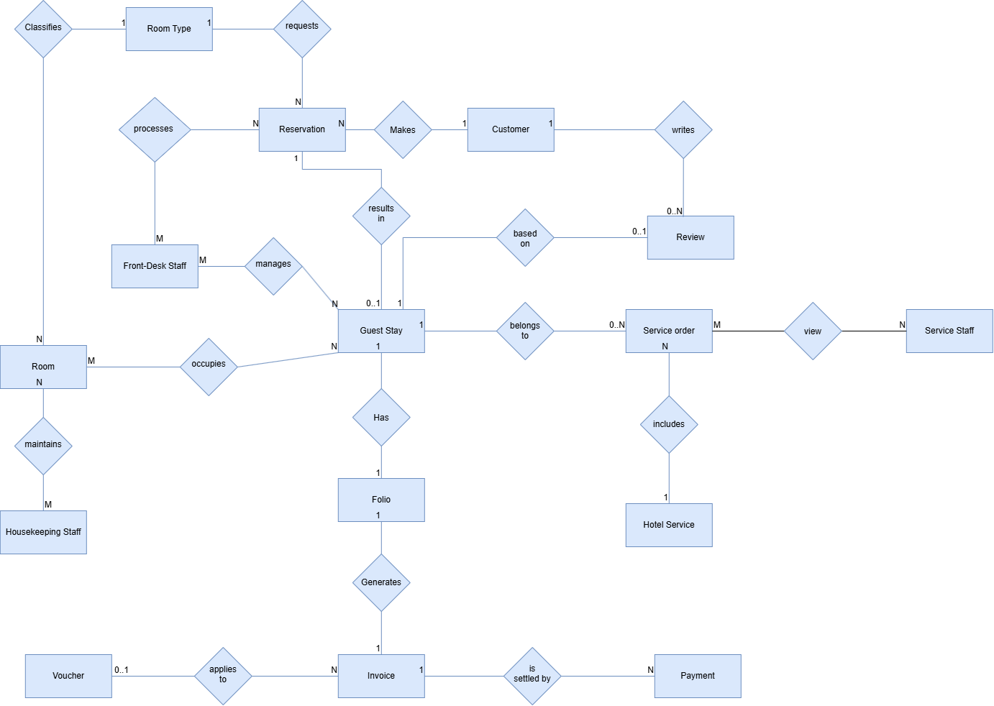
Entities Description
# | Entity | Description
1 | Customer | Represents a hotel guest who can make room reservations, place service orders, and submit reviews after completing a stay.
2 | Front-Desk Staff | Represents hotel reception staff responsible for processing reservations and managing guest stays, including confirmation, check-in, room transfer, stay extension, billing, and check-out activities.
3 | Housekeeping Staff | Represents hotel staff responsible for maintaining guest rooms and updating their housekeeping or maintenance status.
4 | Room Type | Represents a category of accommodation offered by the hotel, defining the type of room requested during reservation, such as Deluxe or Suite.
5 | Room | Represents an individual physical room in the hotel that belongs to a room type and can be assigned to guests during their stays.
6 | Reservation | Represents an advance booking made for a customer, containing the requested room type and planned stay information before guest check-in.
7 | Guest Stay | Represents the actual period of accommodation that results from an eligible reservation after the guest checks in, including the physical room or rooms occupied during the stay.
8 | Hotel Service | Represents an ancillary service offered by the hotel, such as laundry, breakfast, spa, or airport transportation, that can be ordered during a guest stay.
9 | Service Order | Represents a record of hotel services ordered for an active guest stay, including the selected service items to be charged to the guest.
10 | Folio | Represents the financial record of an active guest stay, accumulating room charges, service charges, surcharges, discounts, and other amounts incurred before final billing.
11 | Invoice | Represents the itemized bill generated from a guest folio, summarizing the charges, applicable discounts, taxes, and final amount payable by the guest.
12 | Voucher | Represents a valid promotional or corporate discount that may be applied to an eligible invoice to reduce its payable amount according to defined conditions.
13 | Payment | Represents a monetary settlement recorded against an invoice using a supported payment method, such as cash, card, or bank transfer.
14 | Review | Represents a rating and written feedback submitted by a customer based on a completed guest stay.
15 | Service staff | Represents hotel staff responsible for receiving and fulfilling service orders during guest stays, including updating order progress and recording service completion.

3.1.6 Entity Details
- Customer
# | Attribute name | PK | Type | Mandatory | Description
1 | Customer ID | x | Integer | Yes | Uniquely identifies a customer.
2 | Full Name |  | String | Yes | Stores the customer's full legal name.
3 | Email |  | String | Yes | Stores the customer's registered email address.
4 | Phone Number |  | String | Yes | Stores the customer's contact telephone number.
5 | Password |  | String | Yes | Stores the customer's account authentication credential.
6 | Account Status |  | String | Yes | Indicates whether the customer account is active or inactive.

- Front-Desk Staff
# | Attribute name | PK | Type | Mandatory | Description
1 | Staff ID | x | Integer | Yes | Uniquely identifies a front-desk staff member.
2 | Full Name |  | String | Yes | Stores the staff member's full name.
3 | Email |  | String | Yes | Stores the staff member's registered email address.
4 | Phone Number |  | String | No | Stores the staff member's contact telephone number.
5 | Account Status |  | String | Yes | Indicates whether the staff account is active or inactive.
- Housekeeping Staff
# | Attribute name | PK | Type | Mandatory | Description
1 | Staff ID | x | Integer | Yes | Uniquely identifies a housekeeping staff member.
2 | Full Name |  | String | Yes | Stores the staff member's full name.
3 | Email |  | String | Yes | Stores the staff member's registered email address.
4 | Phone Number |  | String | No | Stores the staff member's contact telephone number.
5 | Account Status |  | String | Yes | Indicates whether the staff account is active or inactive.
- Room Type
# | Attribute name | PK | Type | Mandatory | Description
1 | Room Type ID | x | Integer | Yes | Uniquely identifies a room type.
2 | Type Name |  | String | Yes | Stores the room category name, such as Deluxe or Suite.
3 | Nightly Price |  | Decimal | Yes | Stores the standard nightly rate.
4 | Guest Capacity |  | Integer | Yes | Specifies the maximum number of guests.
5 | Description |  | String | No | Describes the room type.
6 | Amenities |  | String | No | Describes amenities provided by the room type.
7 | Status |  | String | Yes | Indicates whether the room type is active.
- Room
# | Attribute name | PK | Type | Mandatory | Description
1 | Room ID | x | Integer | Yes | Uniquely identifies a physical hotel room.
2 | Room Number |  | String | Yes | Stores the unique room door number.
3 | Floor |  | Integer | Yes | Specifies the floor on which the room is located.
4 | Operational Status |  | String | Yes | Indicates whether the room is Available, Occupied, or under Maintenance.
5 | Housekeeping Status |  | String | Yes | Indicates the room sanitation state, such as Dirty, Clean, or Inspected.
6 | Room Notes |  | String | No | Stores additional operational notes about the room.
- Reservation
# | Attribute name | PK | Type | Mandatory | Description
1 | Reservation ID | x | Integer | Yes | Uniquely identifies a reservation.
2 | Reservation Code |  | String | Yes | Stores the confirmation/reference code of the reservation.
3 | Check-in Date |  | Date | Yes | Specifies the planned arrival date.
4 | Check-out Date |  | Date | Yes | Specifies the planned departure date.
5 | Guest Count |  | Integer | Yes | Specifies the number of guests included in the reservation.
6 | Special Notes |  | String | No | Stores special requests or notes from the guest.
7 | Booking Total |  | Decimal | Yes | Stores the calculated temporary reservation total.
8 | Status |  | String | Yes | Indicates the reservation state, such as Pending, Confirmed, Checked-In, Cancelled, or Completed.
- Guest Stay
# | Attribute name | PK | Type | Mandatory | Description
1 | Stay ID | x | Integer | Yes | Uniquely identifies an actual guest stay.
2 | Actual Check-in Time |  | DateTime | Yes | Records the actual guest check-in time.
3 | Actual Check-out Time |  | DateTime | No | Records the actual checkout time when the stay is completed.
4 | Stay Status |  | String | Yes | Indicates whether the stay is active or completed.
- Hotel Service
# | Attribute name | PK | Type | Mandatory | Description
1 | Service ID | x | Integer | Yes | Uniquely identifies a hotel service.
2 | Service Name |  | String | Yes | Stores the service title.
3 | Category |  | String | Yes | Specifies the service category.
4 | Unit Price |  | Decimal | Yes | Stores the current unit price of the service.
5 | Billing Unit |  | String | Yes | Defines how the service is charged.
6 | Description |  | String | No | Provides additional information about the service.
7 | Status |  | String | Yes | Indicates whether the service is currently available for ordering.
- Service Order
# | Attribute name | PK | Type | Mandatory | Description
1 | Service Order ID | x | Integer | Yes | Uniquely identifies a service order.
2 | Order Date Time |  | DateTime | Yes | Records when the service order was created.
3 | Quantity |  | Integer | Yes | Specifies the quantity ordered.
4 | Subtotal |  | Decimal | Yes | Stores the calculated charge for the ordered service.
5 | Status |  | String | Yes | Indicates the current state of the service order.
6 | Void Reason |  | String | No | Records the reason when an ordered service is voided.
- Folio
# | Attribute name | PK | Type | Mandatory | Description
1 | Folio ID | x | Integer | Yes | Uniquely identifies a guest stay folio.
2 | Room Charges |  | Decimal | Yes | Stores accumulated accommodation charges.
3 | Service Charges |  | Decimal | Yes | Stores accumulated ancillary service charges.
4 | Surcharges |  | Decimal | Yes | Stores additional charges such as early check-in fees.
5 | Total Balance |  | Decimal | Yes | Stores the current outstanding balance of the folio.
6 | Status |  | String | Yes | Indicates whether the folio is open or closed.
- Invoice
# | Attribute name | PK | Type | Mandatory | Description
1 | Invoice ID | x | Integer | Yes | Uniquely identifies an invoice.
2 | Issue Date Time |  | DateTime | Yes | Records when the invoice was generated.
3 | Subtotal |  | Decimal | Yes | Stores total charges before discounts and taxes.
4 | Discount Amount |  | Decimal | Yes | Stores the discount deducted from the bill.
5 | Tax Amount |  | Decimal | Yes | Stores applicable tax charges.
6 | Total Amount |  | Decimal | Yes | Stores the final amount payable.
7 | Status |  | String | Yes | Indicates the invoice payment state, such as Unpaid or Paid.
- Voucher
# | Attribute name | PK | Type | Mandatory | Description
1 | Voucher ID | x | Integer | Yes | Uniquely identifies a voucher.
2 | Voucher Code |  | String | Yes | Stores the promotional code entered during billing.
3 | Start Date |  | Date | Yes | Specifies when the voucher becomes valid.
4 | End Date |  | Date | Yes | Specifies when the voucher expires.
5 | Usage Quota |  | Integer | Yes | Specifies the permitted usage limit.
6 | Minimum Stay Value |  | Decimal | No | Specifies the minimum eligible bill/stay value.
7 | Discount Value |  | Decimal | Yes | Specifies the discount provided by the voucher.
8 | Status |  | String | Yes | Indicates whether the voucher is active.
- Payment

# | Attribute name | PK | Type | Mandatory | Description
1 | Payment ID | x | Integer | Yes | Uniquely identifies a payment transaction.
2 | Payment Date Time |  | DateTime | Yes | Records when payment was processed.
3 | Amount |  | Decimal | Yes | Stores the monetary amount received.
4 | Payment Method |  | String | Yes | Specifies the tender method, such as Cash, Card, or Transfer.
5 | Status |  | String | Yes | Indicates the result/status of the payment transaction.
- Review
# | Attribute name | PK | Type | Mandatory | Description
1 | Review ID | x | Integer | Yes | Uniquely identifies a guest review.
2 | Rating |  | Integer | Yes | Stores the customer's star rating from 1 to 5.
3 | Comment |  | String | Yes | Stores written feedback submitted by the customer.
4 | Submitted Date Time |  | DateTime | Yes | Records when the review was submitted.
5 | Visibility Status |  | String | Yes | Indicates whether the review is publicly visible or hidden.
6 | Management Reply |  | String | No | Stores an official hotel response to the customer review.

3.2 Booking Process

3.2.1 UC-14-View Room List
3.2.1.1 Mock-up
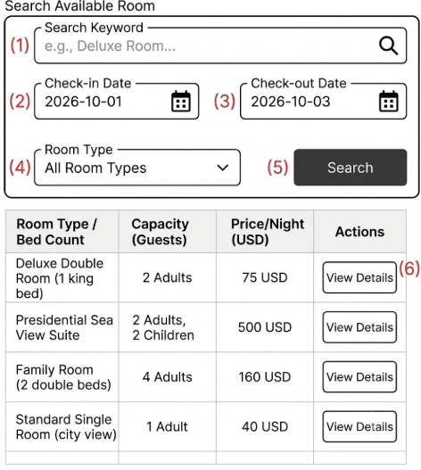
Figure 3-1: Screen Design of Room List

Table 3-1: Screen Definition
# | Field Name | Type | Mandatory | Max Length | Description
1 | Search Keyword | Text | No | 100 | Enter a room name to search.
2 | Check-in Date | Date | Yes | 10 | Select the check-in date.
3 | Check-out Date | Date | Yes | 10 | Select the check-out date.
4 | Room Type | Selection | No | - | Select a room type.
5 | Search | Button | - | - | Search for available rooms.
6 | View Details | Button | - | - | View details of the selected room.

3.2.1.2 Use Case Description
Use Case ID |  | UC-14 | Use Case Name |  | View Room Categories
Author |  | GiapND | Version | 1.2 | Date | 30/09/2026
Actor |  | Customer, Front-Desk Staff, Administrator
Description |  | Allows users to view active room categories and basic room information.
Precondition |  | PRE-01: The system is available.
Trigger |  | TRG-01: The user opens the Room List screen.
Post-Condition |  | POS-01: Active room categories are displayed.
Main flows
Step | Actor | Action
1 | User | Open the Room List screen.
2 | System | Get all active room categories.
3 | System | Display room categories with photos, descriptions, capacity, and base price.

Alternative flows
AT1 | At step 2 in the Main Flow, if the system cannot retrieve room category data because of an internal error.
Sub step | Actor | Action
2.1 | HMS | Display an error message: "Cannot load room categories."

Business Rules
# | Rule Description
BR-01 | Only active room categories can be displayed.
BR-02 | The base price of a room category must be greater than 0.

3.2.2 UC21-Search Available Rooms
3.2.2.1 Mock-up
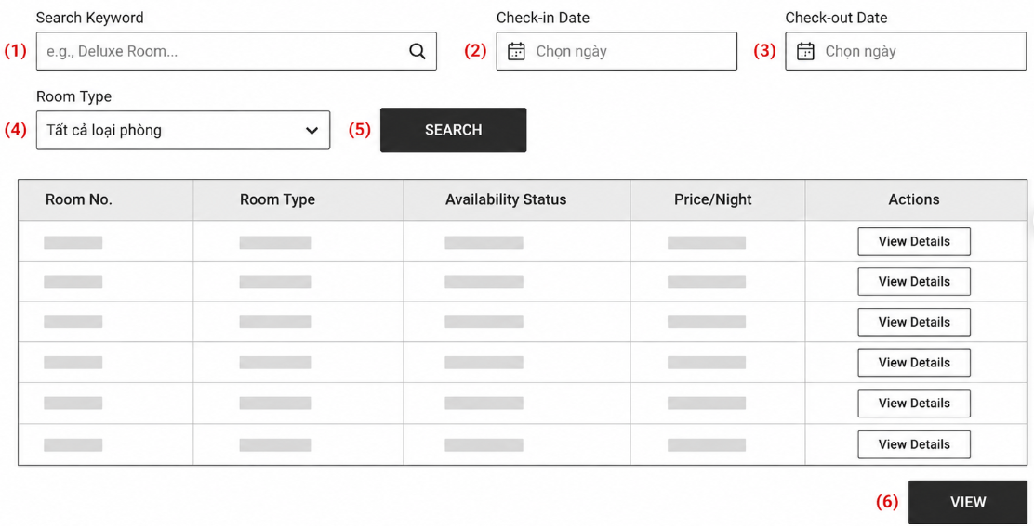
Figure 3-2: Screen Design of Room List
Table 3-2: Screen Definition
# | Field Name | Type | Mandatory | Max Length | Description
1 | Search Keyword | Text | No | 100 | Enter a room name to search.
2 | Check-in Date | Date | Yes | 10 | Select the check-in date.
3 | Check-out Date | Date | Yes | 10 | Select the check-out date.
4 | Room Type | Selection | No | - | Select a room type.
5 | Search | Button | - | - | Search for available rooms.
6 | View | Button | - | - | View details of the selected room.

3.2.2.2 Use Case Description

Use Case ID |  | UC-21 | Use Case Name |  | Search Available Rooms
Author |  | GiapND | Version | 1.2 | Date | 30/09/2026
Actor |  | Customer, Front-Desk Staff
Description |  | Allows users to search for available rooms based on stay dates and number of guests.
Precondition |  | PRE-01: The system is available.
Trigger |  | TRG-01: The user starts a room availability search.
Post-Condition |  | POS-01: Available room options are displayed.
Main flows
Step | Actor | Action
1 | User | Enter the check-in date, check-out date, and number of guests.
2 | HMS | Validate the entered dates.
3 | HMS | Search for rooms that are not booked, occupied, or under maintenance.
4 | HMS | Display available room options and estimated prices.

Alternative flows
AT1 | At step 4 in the Main Flow, if no available room matches the search criteria.
Sub step | Actor | Action
4.1 | HMS | Display a message: "No available rooms found."
4.2 | User | Change the search criteria and search again.

AT2 | At step 2 in the Main Flow, if the check-in date or check-out date is invalid.
Sub step | Actor | Action
2.1 | HMS | Display a message: "Invalid check-in or check-out date."
2.2 | User | Enter valid dates and search again.

Business Rules
# | Rule Description
BR-01 | The check-in date must not be in the past.
BR-02 | The check-out date must be after the check-in date.
BR-03 | Booked, occupied, or maintenance rooms cannot be shown as available.
BR-04 | Only rooms that match the search criteria can be displayed.

3.2.3 UC22-Room Detail
3.2.1.1 Mock-up
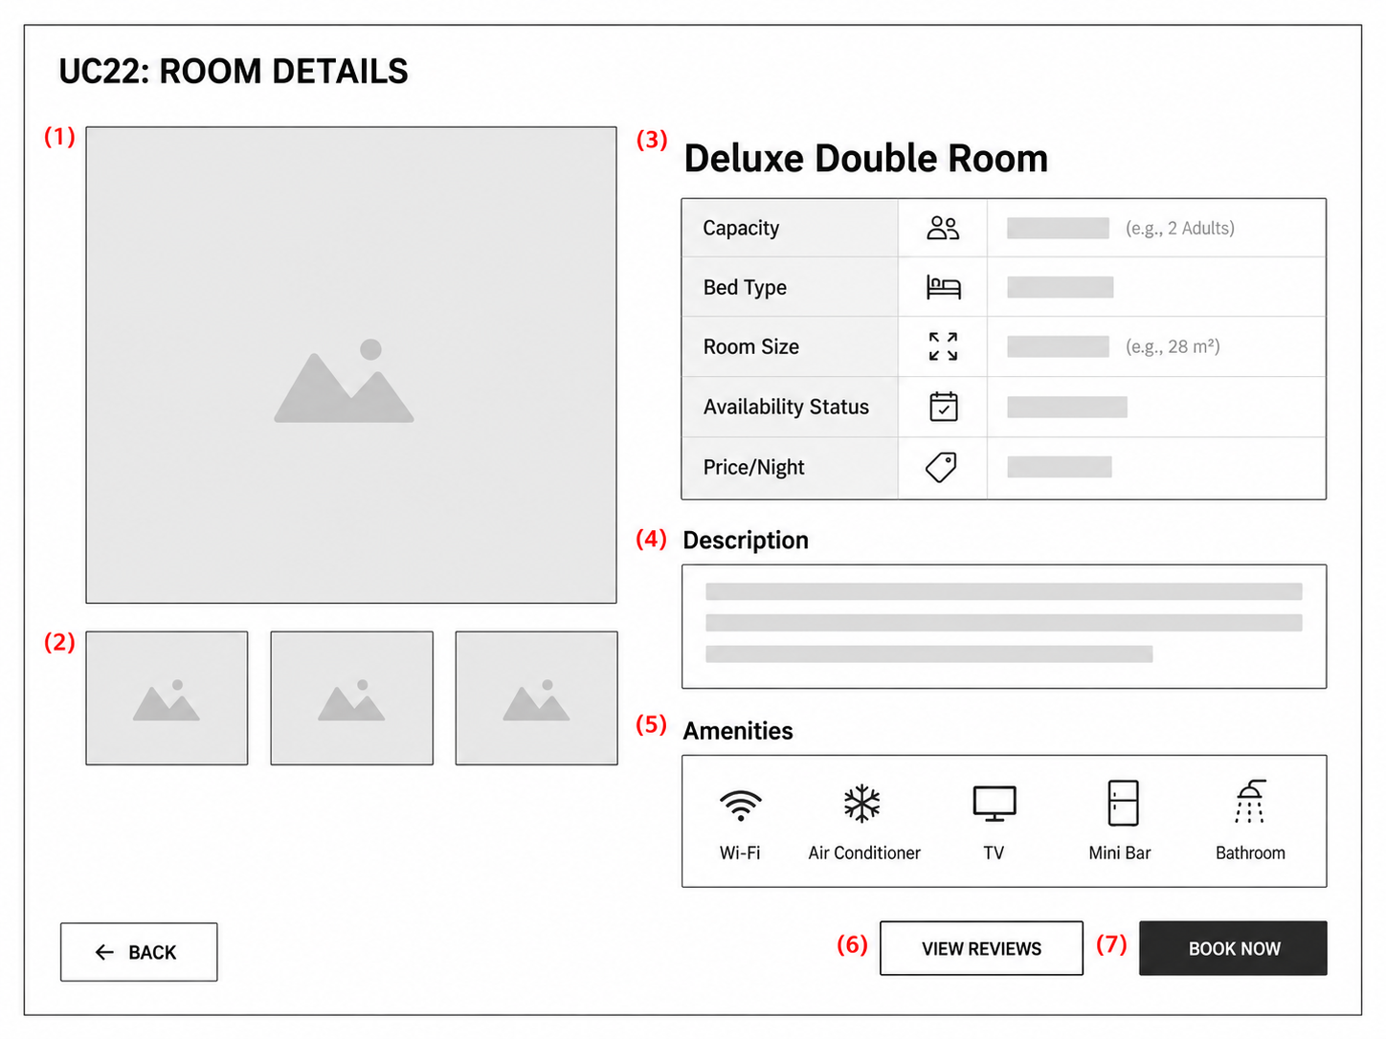
Figure 3-3: Screen Design of Room Detail

Table 3-3: Screen Definition
# | Field Name | Type | Mandatory | Max Length | Description
1 | Main Room Image | Image | - | - | Display the main room image.
2 | Other Images | Image List | - | - | Display other room images.
3 | Room Information | Display | - | - | Display room type, capacity, bed, and price.
4 | Description | Text | - | - | Display the room description.
5 | Amenities | List | - | - | Display room amenities.
6 | View Reviews | Button | - | - | View published room reviews.
3.2.3.2 Use Case Description

Use Case ID |  | UC-22 | Use Case Name |  | View Room Detail
Author |  | GiapND | Version | 1.2 | Date | 30/09/2026
Actor |  | Customer, Front-Desk Staff
Description |  | Allows users to view detailed information about a selected room type.
Precondition |  | PRE-01: The selected room type exists and is available in the system.
Trigger |  | TRG-01: The user selects a room type to view its details.
Post-Condition |  | POS-01: The selected room type information is displayed.
Main flows
Step | Actor | Action
1 | User | Select a room type to view details.
2 | HMS | Get detailed information of the selected room type.
3 | HMS | Display room images, capacity, bed information, amenities, price, and description.

Alternative flows
AT1 | At step 2 in the Main Flow, if the selected room type cannot be found or loaded.
Sub step | Actor | Action
2.1 | HMS | Display a message: "Room information is not available."
2.2 | User | End the current use case.

Business Rules
# | Rule Description
BR-01 | The selected room type must exist in the system.
BR-02 | Only active room types can be viewed.
BR-03 | Room information must belong to the selected room type.
BR-04 | The displayed room price must be the current room rate.

3.2.4 UC23-Booking Checkout
3.2.1.1 Mock-up
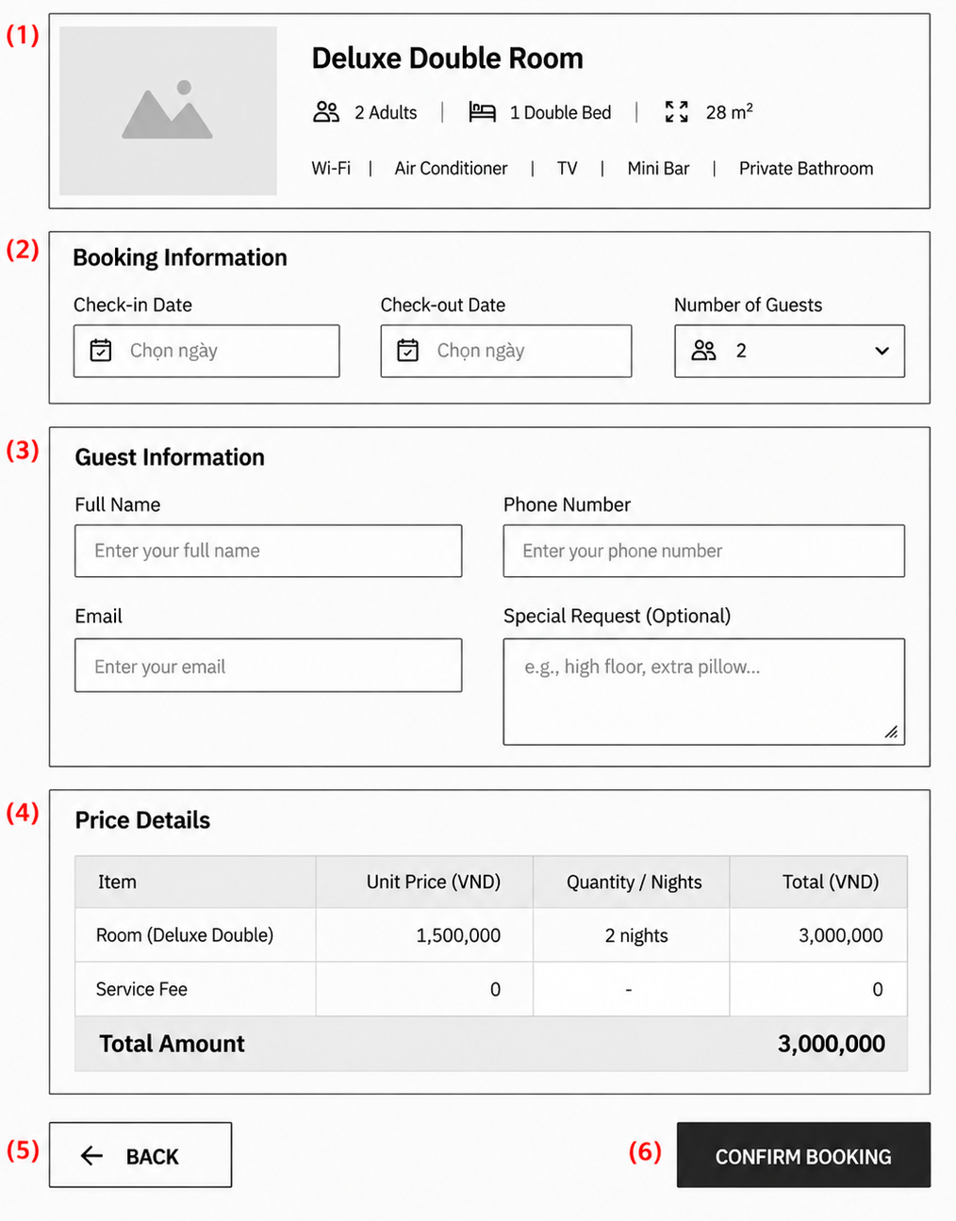
Figure 3-4: Screen Design of Booking Checkout

Table 3-4: Screen Definition
# | Field Name | Type | Mandatory | Max Length | Description
1 | Room Information | Display | - | - | Show information about the selected room type.
2 | Booking Information | Form | Yes | - | Enter or confirm stay dates and number of guests.
3 | Guest Information | Form | Yes | - | Enter guest contact information and special requests.
4 | Price Details | Display | - | - | Show booking charges and total amount.
5 | Back | Button | - | - | Return to the previous screen.
6 | Confirm Booking | Button | - | - | Confirm and create the reservation.
3.2.3.2 Use Case Description

Use Case ID |  | UC-23 | Use Case Name |  | View Booking checkout
Author |  | GiapND | Version | 1.2 | Date | 30/09/2026
Actor |  | Customer, Front-Desk Staff
Description |  | Allows users to create a reservation for a selected room type and stay period.
Precondition |  | PRE-01: The selected room type is available for the requested stay period.
Trigger |  | TRG-01: The user starts the booking process for a selected room type.
Post-Condition |  | POS-01: A new reservation is created with Pending status and a booking reference code.
Main flows
Step | Actor | Action
1 | User | Select a room type to view details.
2 | User | Enter guest contact information and special requests.
3 | HMS | Calculate the total booking price.
4 | HMS | Check room availability for the selected stay period.
5 | User | Confirm the booking information.
6 | HMS | Create the reservation with Pending status.
7 | HMS | Generate a unique booking reference code.

Alternative flows
AT1 | At step 4 in the Main Flow, if the selected room type is no longer available.
Sub step | Actor | Action
4.1 | HMS | Notify the user that the selected room type is no longer available.
4.2 | User | Select another available room type or stay period.

3.2.5 UC24-My Booking
3.2.1.1 Mock-up
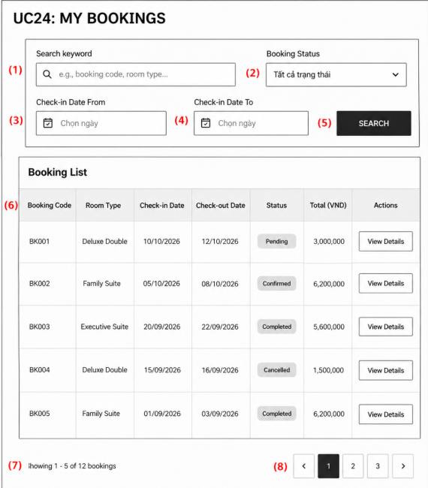

Figure 3-5: Screen Design of My Booking

Table 3-5: Screen Definition
# | Field Name | Type | Mandatory | Max Length | Description
1 | Search Keyword | Text | No | 100 | Enter a booking code or room type to search.
2 | Booking Status | Selection | No | - | Select a booking status.
3 | Check-in Date From | Date | No | 10 | Select the start check-in date.
4 | Check-in Date To | Date | No | 10 | Select the end check-in date.
5 | Search | Button | - | - | Search for matching bookings.
6 | Booking List | Display | - | - | Show the customer's booking information.
3.2.3.2 Use Case Description

Use Case ID |  | UC-24 | Use Case Name |  | View Booking History
Author |  | GiapND | Version | 1.2 | Date | 30/09/2026
Actor |  | Customer
Description |  | Allows an authenticated customer to view past, active, and pending bookings.
Precondition |  | PRE-01: The customer is logged in to the system.
Trigger |  | TRG-01: The customer opens the My Bookings screen.
Post-Condition |  | POS-01: The customer's booking history is displayed.
Main flows
Step | Actor | Action
1 | Customer | Open the My Bookings screen.
2 | Customer | Get bookings linked to the current customer account.
3 | HMS | Display booking information, including stay dates, room type, status, and total amount.
4 | Customer | Select a booking to view its details.
5 | HMS | Display the selected booking details.

Alternative flows
AT1 | At step 4 in the Main Flow, if the selected room type is no longer available.
Sub step | Actor | Action
2.1 | HMS | Notify the customer that no bookings are available.
2.2 | HMS | End the current use case.

Business Rules
# | Rule Description
BR-01 | A customer can view only bookings linked to their own account.
BR-02 | Only authenticated customers can view booking history.
BR-03 | Booking information must show the current booking status.
BR-04 | Past, active, and pending bookings can be included in the booking history.

3.3 Booking Confirmation & Check-in

3.3.1 UC-26 – Confirm Direct / Offline Reservation
3.3.1.1 Mock-up
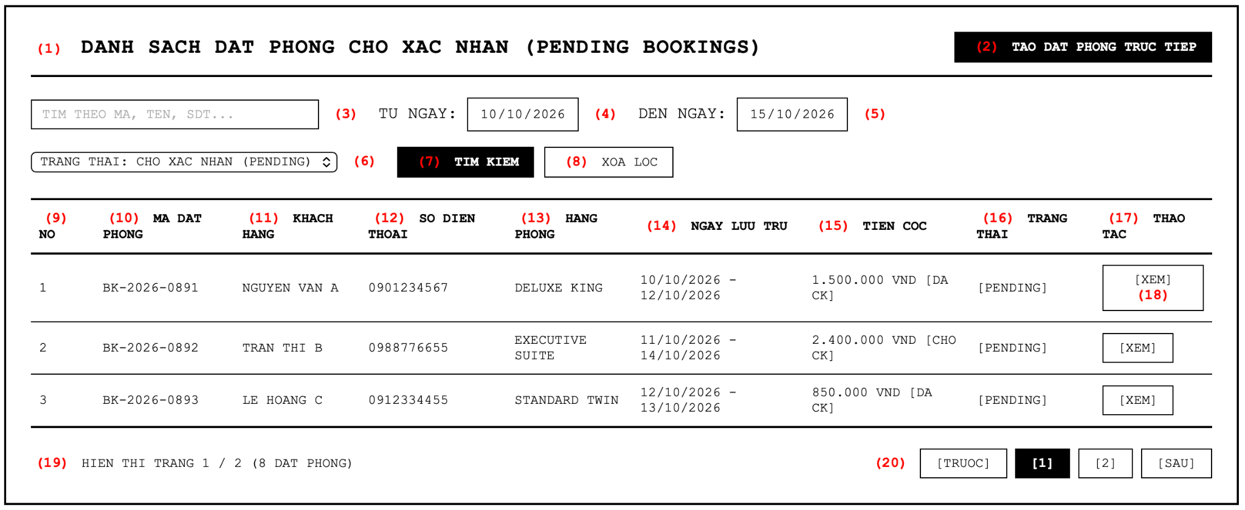Figure 3-6: Screen Design of Pending-booking

Table 3-6: Screen Definition
# | Field Name | Type | Mandatory | Max Length | Description
1 | (1) Screen Title | Label | - | - | Displays the screen title: "DANH SACH DAT PHONG CHO XAC NHAN (PENDING BOOKINGS)".
2 | (2) Direct Booking Button | Button | - | - | Navigates staff to create direct reservation for walk-in or telephone guests.
3 | (3) Search Keyword | Text | No | 100 | Enter keyword to filter by booking code, guest name, or phone number.
4 | (4) Check-in From Date | Date | No | 10 | Specifies the start date of the arrival period for filtering.
5 | (5) Check-in To Date | Date | No | 10 | Specifies the end date of the arrival period for filtering.
6 | (6) Status Dropdown | Selection | Yes | - | Select reservation status to filter (Pending by default, All, Confirmed, Cancelled).
7 | (7) Search Button | Button | - | - | Executes the search and refreshes the pending reservations table.
8 | (8) Reset Filter Button | Button | - | - | Clears all search keyword inputs and resets filters to default.
9 | (9) Row Index (No) | Integer | - | - | Sequential order number of the reservation record.
10 | (10) Booking Code | Text | - | 20 | Displays unique identification code of the reservation (e.g. BK-2026-0891).
11 | (11) Guest Name | Text | - | 100 | Displays customer full legal name.
12 | (12) Phone Number | Text | - | 15 | Displays contact telephone number of the customer.
13 | (13) Room Type | Text | - | 50 | Displays reserved room category (e.g. Deluxe King, Executive Suite).
14 | (14) Stay Period | Text | - | 30 | Displays check-in and check-out dates and total nights.
15 | (15) Deposit Amount | Numeric | - | - | Displays required deposit amount and settlement status (e.g. 1.500.000 VND [DA CK]).
16 | (16) Status Label | Text | - | 20 | Displays current reservation operational status [Pending].
17 | (17) Actions Header | Label | - | - | Column header for row operational links.
18 | (18) View Action Button | Button | - | - | Navigates Front-Desk Staff to the Booking Details screen (3.3.2) for the selected record.
19 | (19) Record Summary | Text | - | - | Displays current page number and total count of reservations found.
20 | (20) Pagination | Navigation | - | - | Allows staff to switch between pages of the pending reservations list.

3.3.1.2 Use Case Description

Use Case ID |  | UC26 | Use Case Name |  | Confirm Direct
Author |  | TungPV | Version | 1.2 | Date | 04/10/2026
Actor |  | Front-Desk Staff, Customer, Mail Notification Service
Description |  | Processes direct confirmation of pending reservation by validating deposit payment and deducting category quota.
Precondition |  | PRE-01: The system is available.  PRE-02: Front-Desk Staff is logged in with valid reception authorization.  PRE-03: The reservation exists in Pending status within its 24-hour hold duration (BR-19).  PRE-04: The requested room category has available inventory quota for all stay dates.
Trigger |  | TRG-01: Front-Desk Staff reviews reservation details and clicks the CONFIRM button.
Post-Condition |  | POS-01: The reservation status is updated from Pending to Confirmed.  POS-02: Inventory quota for the reserved room category is deducted across the stay duration.  POS-03: Mail Notification Service dispatches confirmation email to customer with booking reference and deposit confirmation.  POS-04: The reservation becomes eligible for guest check-in upon arrival (UC-27).
Main flows
Step | Actor | Action
1 | Front-Desk Staff | Select a pending reservation from Pending Bookings (3.3.1) and click VIEW (18).
2 | HMS | Retrieve and display reservation details: Guest Information (2), Room Type (3), Check-in Date (4), Check-out Date (5), and Deposit / Contact Info (6).
3 | Front-Desk Staff | Inspect guest details and verify deposit payment receipt (cash receipt or bank transfer reference code).
4 | Front-Desk Staff | Click the "CONFIRM" button (9).
5 | HMS | Validate that reservation status is currently Pending and room category quota is available for the entire stay period.
6 | HMS | Update reservation status to Confirmed, deduct one quota unit per night for the room category, request Mail Notification Service to send confirmation email to guest, and display confirmation success alert.

Business Rules
ID | Rule
BR-22 | Only Pending reservations can be confirmed; confirmation requests a notification email to the guest.

3.3.2 UC-26 – Confirm Reservation
3.3.2.1 Mock-up
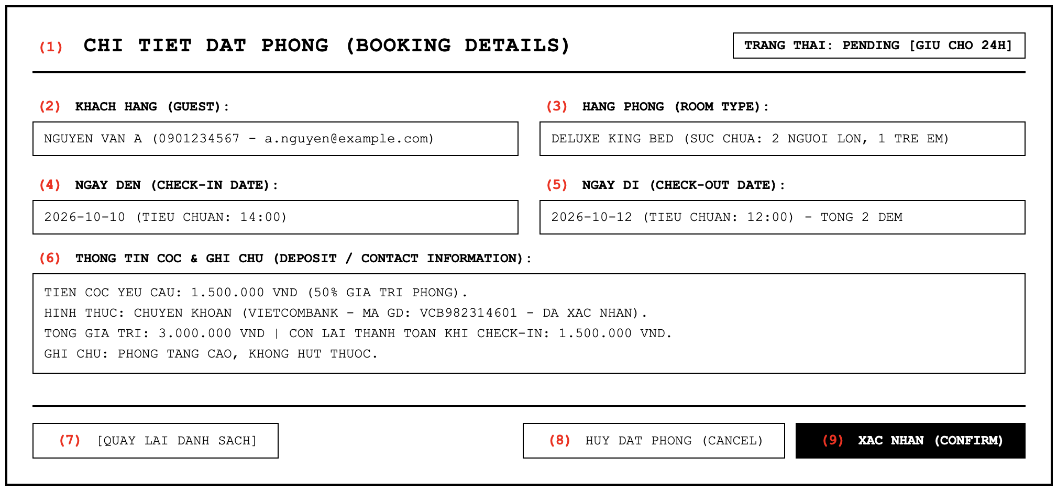
Figure 3.7: Screen Design of Booking Details

Table 3.3.2: Screen Definition

# | Field Name | Type | Mandatory | Max Length | Description
1 | (1) Screen Title | Label | - | - | Displays the screen title: "CHI TIET DAT PHONG (BOOKING DETAILS)" and status tag [PENDING].
2 | (2) Guest Information | Text | Yes | 255 | Displays customer legal full name, telephone contact number, and registered email address.
3 | (3) Room Type | Text | Yes | 100 | Displays reserved room category (e.g. Deluxe King Bed) and maximum guest capacity.
4 | (4) Check-in Date | Date | Yes | 10 | Displays planned arrival date and standard check-in hour (14:00).
5 | (5) Check-out Date | Date | Yes | 10 | Displays planned departure date, standard departure hour (12:00), and total reserved nights.
6 | (6) Deposit / Contact Info | Textarea | Yes | 500 | Displays verified guarantee deposit details (amount, tender method, bank transfer ref), and special requests.
7 | (7) Back Button | Button | - | - | Returns Front-Desk Staff to the Pending Bookings list screen (3.3.1).
8 | (8) Cancel Booking Button | Button | - | - | Cancels reservation if deposit cannot be verified or hold duration has expired.
9 | (9) CONFIRM Button | Button | - | - | Confirms pending reservation: sets status to Confirmed, deducts room category quota, logs operator ID, and triggers confirmation email.
3.3.2.2 Use Case Description
Use Case ID | UC-26 | Use Case Name | Confirm Direct / Offline Reservation
Author | HieuVQ | Version | 1.2 | Date | 04/10/2026
Actor | Front-Desk Staff, Customer, Mail Notification Service
Description | Processes direct confirmation of pending reservation by validating deposit payment and deducting category quota.
Precondition | PRE-01: The system is available.  PRE-02: Front-Desk Staff is logged in with valid reception authorization.  PRE-03: The reservation exists in Pending status within its 24-hour hold duration (BR-19).  PRE-04: The requested room category has available inventory quota for all stay dates.
Trigger | TRG-01: Front-Desk Staff reviews reservation details and clicks the CONFIRM button.
Post-Condition | POS-01: The reservation status is updated from Pending to Confirmed.  POS-02: Inventory quota for the reserved room category is deducted across the stay duration.  POS-03: Mail Notification Service dispatches confirmation email to customer with booking reference and deposit confirmation.  POS-04: The reservation becomes eligible for guest check-in upon arrival (UC-27).
Main flows
Step | Actor | Action
1 | Front-Desk Staff | Select a pending reservation from Pending Bookings (3.3.1) and click VIEW (18).
2 | HMS | Retrieve and display reservation details: Guest Information (2), Room Type (3), Check-in Date (4), Check-out Date (5), and Deposit / Contact Info (6).
3 | Front-Desk Staff | Inspect guest details and verify deposit payment receipt (cash receipt or bank transfer reference code).
4 | Front-Desk Staff | Click the "CONFIRM" button (9).
5 | HMS | Validate that reservation status is currently Pending and room category quota is available for the entire stay period.
6 | HMS | Update reservation status to Confirmed, deduct one quota unit per night for the room category, request Mail Notification Service to send confirmation email to guest, and display confirmation success alert.
Alternative flows
AT1 | At step 5 in the Main Flow, if the room category quota is fully exhausted.
Sub step | Actor | Action
5.1 | HMS | Display error message: "Room category quota is fully committed for the selected dates."
5.2 | Front-Desk Staff | Contact customer to advise room unavailability and offer alternative room category.
AT2 | At step 3 in the Main Flow, if the deposit payment cannot be verified.
Sub step | Actor | Action
3.1 | Front-Desk Staff | Hold reservation confirmation and contact customer for deposit settlement.
3.2 | Front-Desk Staff | Click Cancel Booking (8) if customer declines or hold window expires.
AT3 | At step 6 in the Main Flow, if automated mail dispatch encounters network error.
Sub step | Actor | Action
6.1 | HMS | Commit confirmation in database, log warning, and prompt staff to resend confirmation email manually.
Business Rules
# | Rule Description
BR-19 | New reservations start as Pending with a unique reference code, hold category quota for 24 hours, and are auto-cancelled if not confirmed or deposited in time.
BR-22 | Only Pending reservations can be confirmed; confirmation requests a notification email to the guest.

3.3.3 UC-27 – Check-in Guest
3.3.3.1 Mock-up
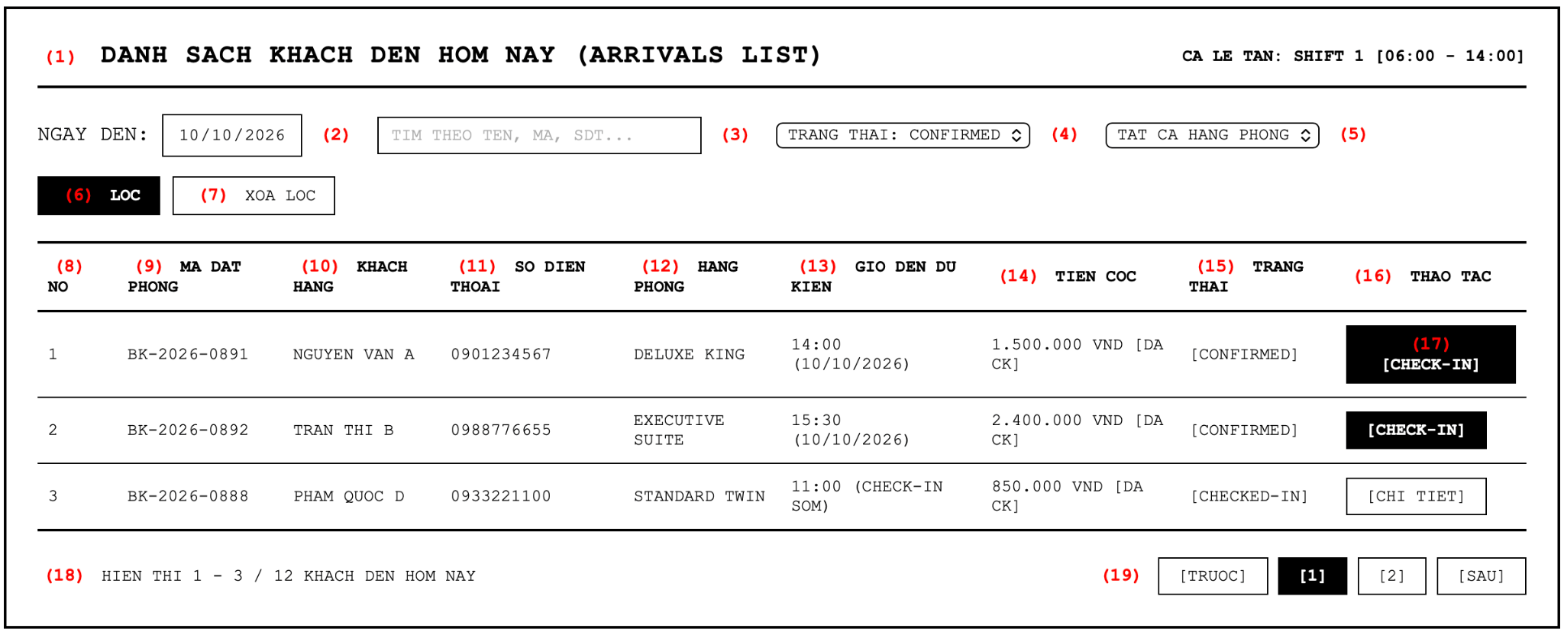
Figure 3-8: Screen Design of Arrivals List

Table 3-8: Screen Definition

# | Field Name | Type | Mandatory | Max Length | Description
1 | (1) Screen Title | Label | - | - | Displays screen title: "DANH SACH KHACH DEN HOM NAY (ARRIVALS LIST)".
2 | (2) Arrival Date Filter | Date | Yes | 10 | Specifies the target arrival date to query expected guests (defaults to today).
3 | (3) Search Keyword | Text | No | 100 | Allows filtering by customer name, booking reference code, or telephone number.
4 | (4) Status Filter | Selection | Yes | - | Filters arrivals by status (Confirmed by default, All, Checked-In).
5 | (5) Room Type Filter | Selection | No | - | Filters arrivals by booked room category (All, Deluxe King, Executive Suite, etc.).
6 | (6) Filter Button | Button | - | - | Queries database and refreshes the arrivals list based on entered criteria.
7 | (7) Reset Filter Button | Button | - | - | Resets all search keywords and filter criteria to default today values.
8 | (8) Row Index (No) | Integer | - | - | Sequential display order of arriving guest records.
9 | (9) Booking Code | Text | - | 20 | Displays unique reference code of the confirmed reservation.
10 | (10) Guest Name | Text | - | 100 | Displays legal name of the arriving guest.
11 | (11) Phone Number | Text | - | 15 | Displays telephone contact number of the guest.
12 | (12) Booked Room Type | Text | - | 50 | Displays reserved accommodation tier.
13 | (13) Expected Arrival Time | Time / Text | - | 20 | Displays guest estimated arrival time (or standard check-in hour 14:00).
14 | (14) Deposit Status | Numeric | - | - | Displays verified deposit amount and payment confirmation.
15 | (15) Status Label | Text | - | 20 | Displays reservation lifecycle state [Confirmed] eligible for check-in.
16 | (16) Actions Header | Label | - | - | Column header for receptionist operational actions.
17 | (17) Check-in Action Button | Button | - | - | Navigates Front-Desk Staff to Guest Check-in Form (3.3.4) to process arrival.
18 | (18) Record Summary | Text | - | - | Displays current page and total count of arrivals scheduled for the queried date.
19 | (19) Pagination | Navigation | - | - | Navigates through multi-page results of the arrivals list.
3.3.3.2 Use Case Description
Use Case ID | UC-27 | Use Case Name | Check In Guest - Arrivals List
Author | HieuVQ | Version | 1.2 | Date | 04/10/2026
Actor | Front-Desk Staff
Description | Allows Front-Desk Staff to track daily guest arrivals and initiate the physical check-in procedure.
Precondition | PRE-01: The system is available.  PRE-02: Front-Desk Staff is authenticated with front-office operational privileges.  PRE-03: Reservations exist with Confirmed status matching the arrival date.
Trigger | TRG-01: Front-Desk Staff opens Arrivals List to prepare daily guest reception.
Post-Condition | POS-01: Scheduled arrivals are displayed with booking code, guest name, booked tier, and deposit.  POS-02: Staff selects an arriving guest and proceeds to Guest Check-in Form (3.3.4).
Main flows
Step | Actor | Action
1 | Front-Desk Staff | Access the Arrivals List screen (3.3.3) on front-office workstation.
2 | HMS | Retrieve and display confirmed reservations scheduled for arrival on the selected date.
3 | Front-Desk Staff | Filter by guest name, phone, or arrival date to locate the arriving customer.
4 | Front-Desk Staff | Click the [CHECK-IN] button (17) on the customer record to initiate arrival processing.
Alternative flows
AT1 | At step 2 in the Main Flow, if no arrivals are scheduled for the queried date.
Sub step | Actor | Action
2.1 | HMS | Display informational message: "No arrivals scheduled for this date."
Business Rules
# | Rule Description
BR-23 | Check-in requires a Confirmed reservation and a valid ID or Passport.

3.3.4 UC-27 – Check-in Guest

3.3.4.1 Mock-up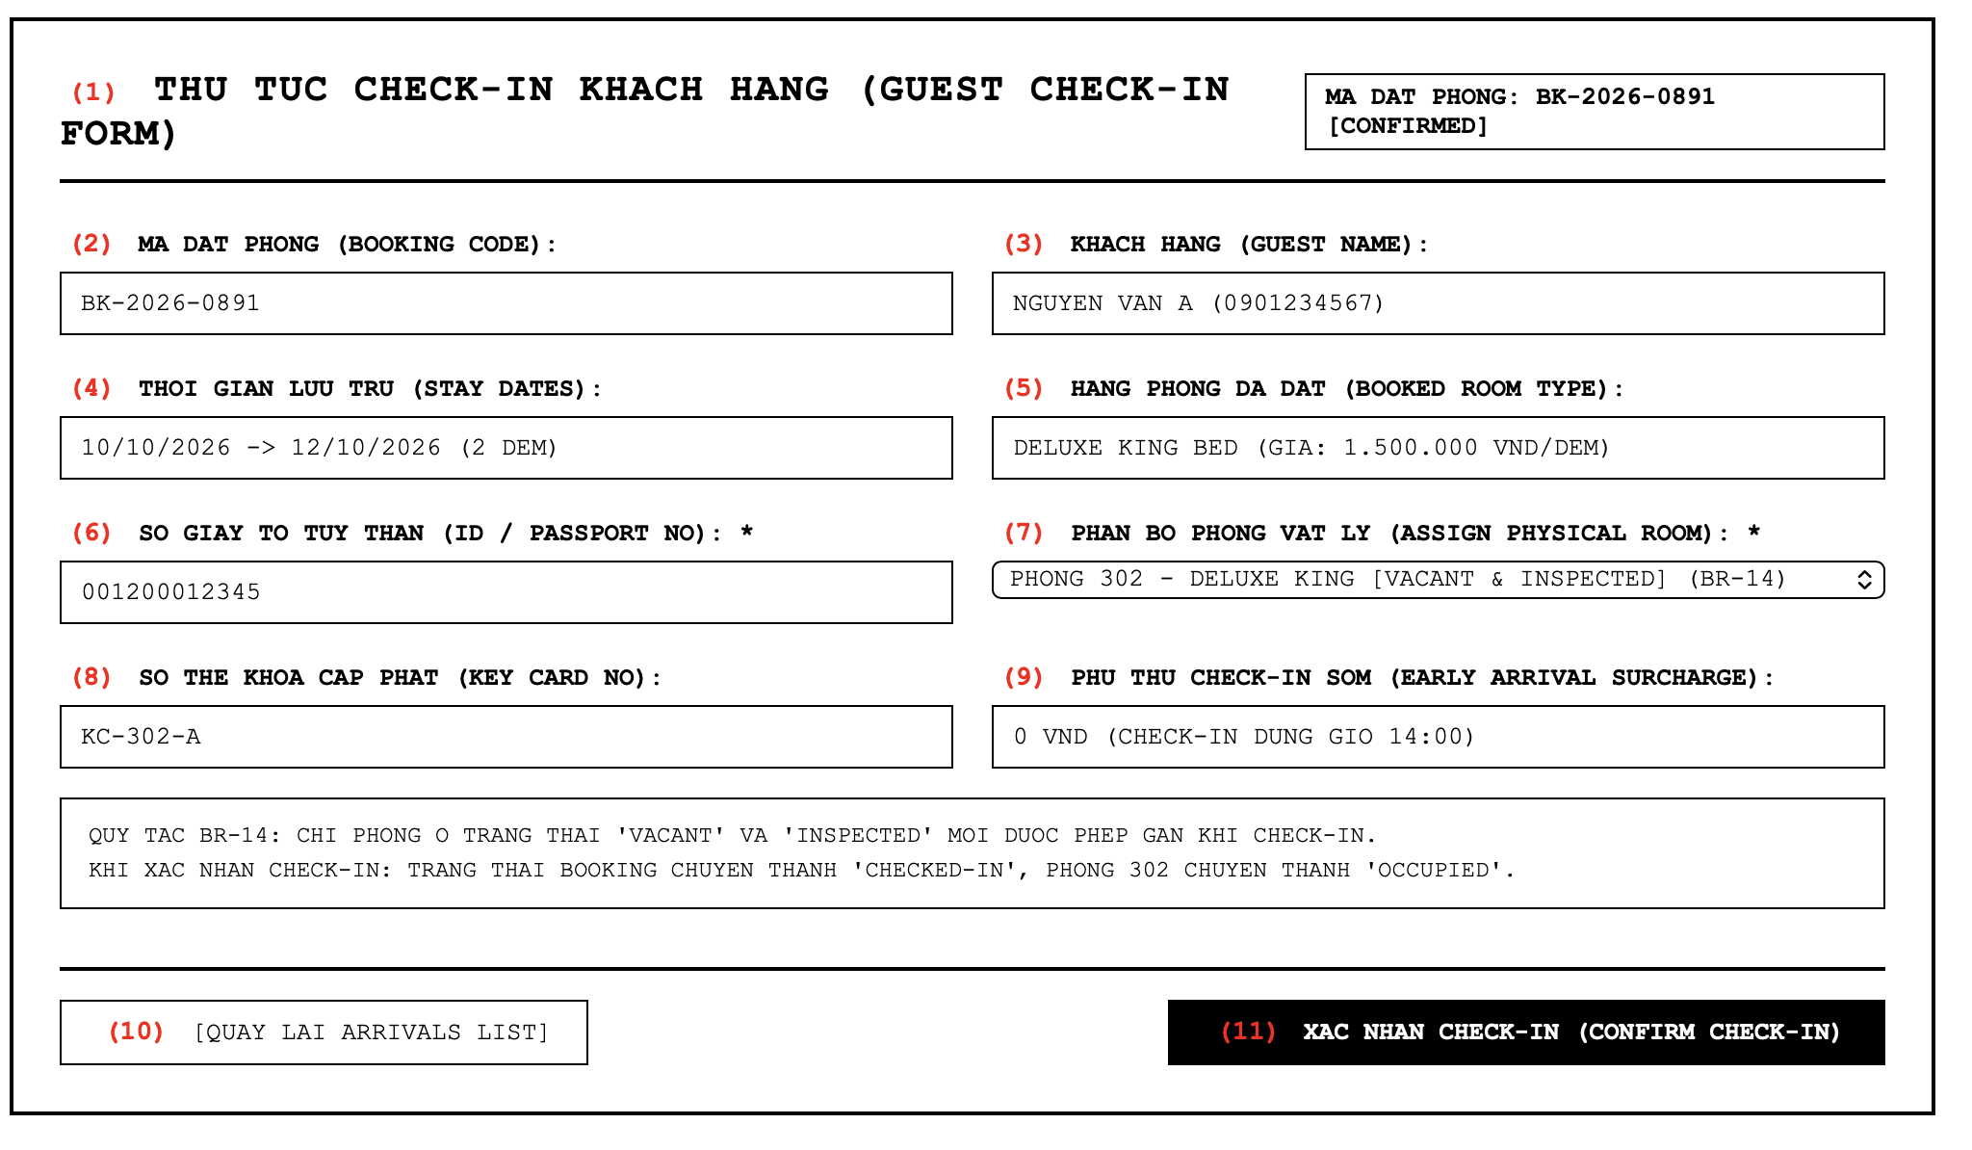Figure 3-9: Screen Design of Guest Check-in Form

Table 3-9: Screen Definition

# | Field Name | Type | Mandatory | Max Length | Description
1 | (1) Screen Title | Label | - | - | Displays screen title: "THU TUC CHECK-IN KHACH HANG (GUEST CHECK-IN FORM)".
2 | (2) Booking Code | Text | Yes | 20 | Displays reference code of the confirmed booking being processed (Read-only).
3 | (3) Guest Name | Text | Yes | 100 | Displays customer full legal name and contact phone (Read-only).
4 | (4) Stay Dates | Text | Yes | 30 | Displays scheduled check-in and check-out dates and total nights (Read-only).
5 | (5) Booked Room Type | Text | Yes | 50 | Displays booked room category and contracted nightly tariff (Read-only).
6 | (6) ID / Passport Number | Text | Yes | 20 | Allows staff to input and record guest National ID or Passport number (BR-23).
7 | (7) Assign Physical Room | Selection | Yes | - | Dropdown listing vacant physical rooms of booked tier having Inspected status (BR-14).
8 | (8) Key Card Number | Text | Yes | 20 | Records physical RFID key card serial issued to the guest.
9 | (9) Early Arrival Surcharge | Numeric | No | - | Allows input of surcharge fee if guest checks in prior to standard 14:00 time (BR-35).
10 | (10) Back Button | Button | - | - | Returns to Arrivals List (3.3.3) without committing check-in.
11 | (11) Confirm Check-in Button | Button | - | - | Finalizes check-in: creates Guest Stay, sets booking to Checked-In, and marks room as Occupied.
3.3.4.2 Use Case Description
Use Case ID | UC-27 | Use Case Name | Check In Guest - Check-in Form
Author | HieuVQ | Version | 1.2 | Date | 04/10/2026
Actor | Front-Desk Staff
Description | Processes guest arrival, verifies legal identity, allocates an inspected physical room, issues keys, and opens stay folio.
Precondition | PRE-01: The system is available.  PRE-02: Front-Desk Staff is authenticated with front-office operational privileges.  PRE-03: The reservation status is Confirmed (BR-23).  PRE-04: At least one physical room of the booked category has Vacant and Inspected status (BR-14).
Trigger | TRG-01: Front-Desk Staff initiates check-in from the Arrivals List.
Post-Condition | POS-01: Booking status is updated from Confirmed to Checked-In.  POS-02: Selected physical room occupancy status is updated from Vacant to Occupied.  POS-03: Active Guest Stay record is established and linked to an initialized Folio.  POS-04: Front desk issues room key card to guest.
Main flows
Step | Actor | Action
1 | Front-Desk Staff | Open Guest Check-in Form (3.3.4) from Arrivals List (3.3.3).
2 | HMS | Retrieve and display confirmed reservation details: booking code, guest name, stay dates, and booked room type.
3 | Front-Desk Staff | Inspect guest national identification and enter ID/Passport number (6).
4 | HMS | Query and populate dropdown (7) with physical rooms of the booked category having Vacant occupancy and Inspected housekeeping status (BR-14).
5 | Front-Desk Staff | Select a physical room unit (e.g. Room 302), enter key card code (8), and specify early check-in surcharge if arriving before 14:00 (9).
6 | Front-Desk Staff | Click Confirm Check-in button (11).
7 | HMS | Validate mandatory ID entry and verify selected physical room remains Vacant and Inspected.
8 | HMS | Create active Guest Stay record, transition booking status to Checked-In, update physical room occupancy to Occupied, initialize guest billing folio, and display check-in success message.
Alternative flows
AT1 | At step 4 in the Main Flow, if no clean inspected physical room is available in the booked category.
Sub step | Actor | Action
4.1 | HMS | Display alert: "No Inspected rooms currently available for this category."
4.2 | Front-Desk Staff | Contact Housekeeping Department to request expedited cleaning and inspection.
AT2 | At step 7 in the Main Flow, if guest ID/Passport number is missing or invalid.
Sub step | Actor | Action
7.1 | HMS | Halt submission and highlight required ID field: "Valid ID or Passport number is mandatory."
AT3 | At step 5 in the Main Flow, if guest arrives prior to standard check-in hour 14:00.
Sub step | Actor | Action
5.1 | Front-Desk Staff | Inform guest of early check-in surcharge policy and record surcharge amount (BR-35).
Business Rules
# | Rule Description
BR-10 | New rooms start with Vacant occupancy status and Inspected housekeeping status.
BR-14 | Only Vacant and Inspected rooms can be assigned at check-in or transfer.
BR-23 | Check-in requires a Confirmed reservation and a valid ID or Passport.
BR-35 | Early check-in before standard 14:00 time may incur a surcharge.

3.4 Active Guest Stay Management

3.4.1 UC-28 – Transfer Guest Room
3.4.1.1 Mock-up
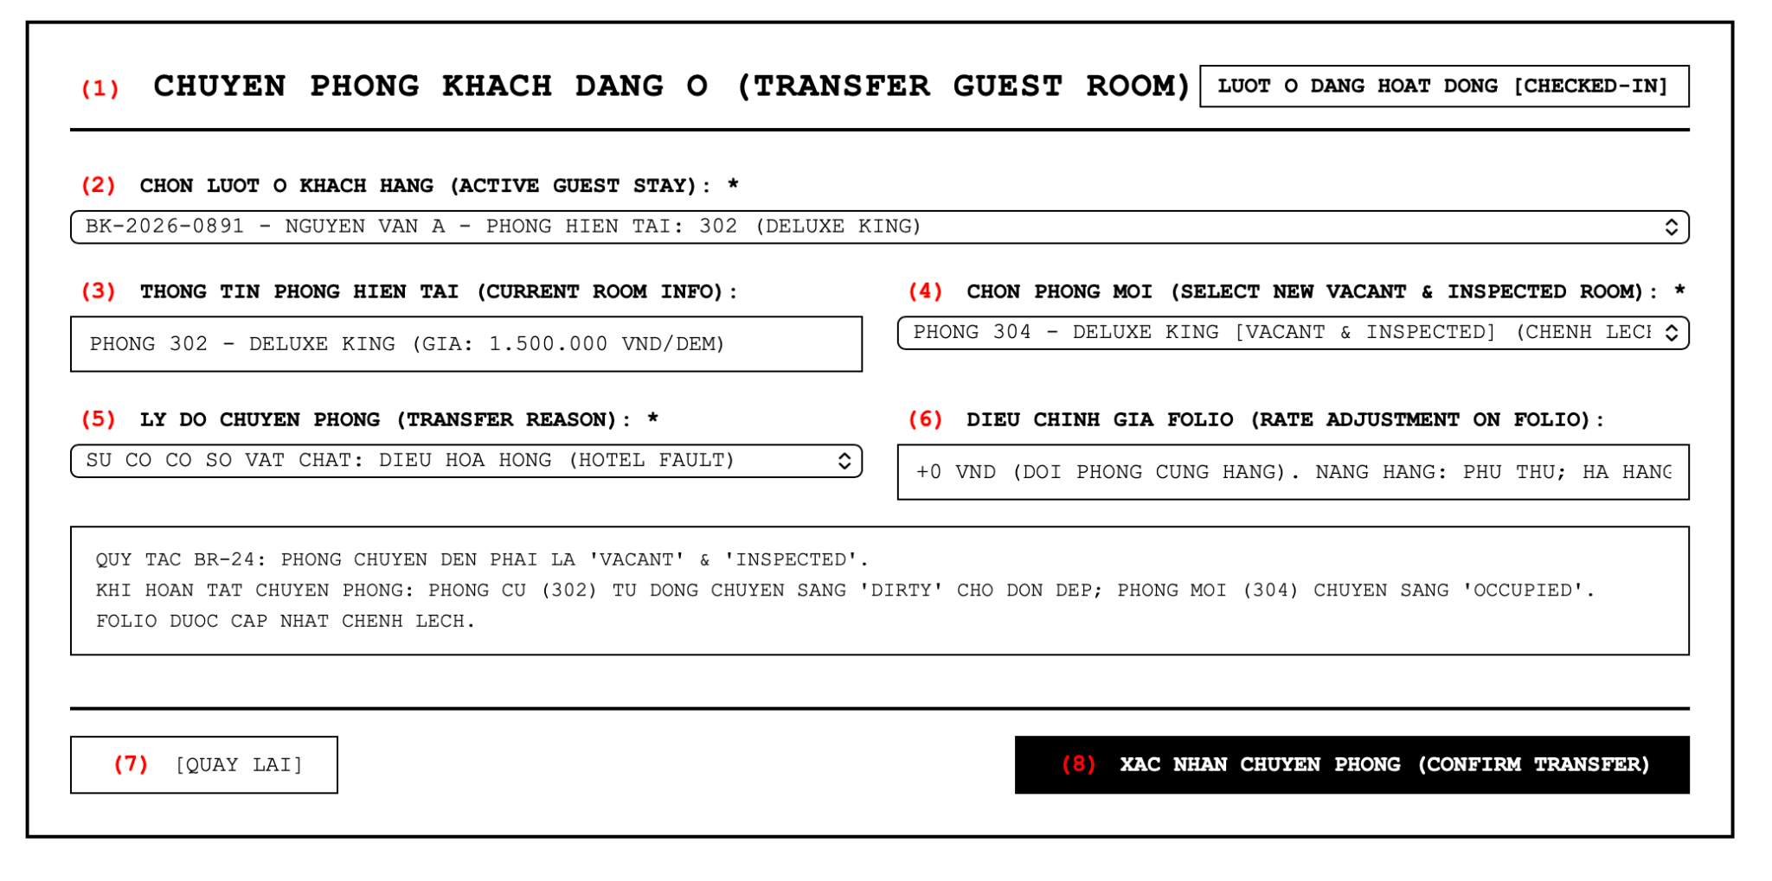Figure 3-10: Screen Design of Transfer Guest Room

Table 3-10: Screen Definition

# | Field Name | Type | Mandatory | Max Length | Description
1 | (1) Screen Title | Label | - | - | Displays screen title: "CHUYEN PHONG KHACH DANG O (TRANSFER GUEST ROOM)".
2 | (2) Active Stay Selector | Selection | Yes | - | Dropdown to choose the in-house guest stay currently in Checked-In status.
3 | (3) Current Room Info | Text | Yes | 100 | Displays current physical room number, room tier, and nightly tariff (Read-only).
4 | (4) Select New Room | Selection | Yes | - | Dropdown listing vacant physical rooms possessing Inspected housekeeping status (BR-14, BR-24).
5 | (5) Transfer Reason | Selection | Yes | 255 | Dropdown/text to record rationale (Facility fault, guest upgrade, quiet area request).
6 | (6) Rate Adjustment | Text | - | 100 | Displays calculated nightly rate differential appended to stay folio (Upgrades charge; hotel-fault downgrades credit).
7 | (7) Back Button | Button | - | - | Cancels room move and navigates back to active stay dashboard.
8 | (8) Confirm Transfer Button | Button | - | - | Executes room transfer: moves guest to new room, marks old room Dirty, and updates folio balance.
3.4.1.2 Use Case Description
Use Case ID | UC-28 | Use Case Name | Transfer Guest Room
Author | HieuVQ | Version | 1.2 | Date | 04/10/2026
Actor | Front-Desk Staff
Description | Reallocates an active resident guest to an alternative physical room during stay due to facility issues or upgrade requests.
Precondition | PRE-01: The system is available.  PRE-02: Front-Desk Staff is logged in with front-office operational privileges.  PRE-03: The guest stay has Checked-In status.  PRE-04: At least one alternative physical room is Vacant and Inspected for remaining nights.
Trigger | TRG-01: Front-Desk Staff initiates a room transfer request upon guest notification.
Post-Condition | POS-01: The guest stay record is updated with the new physical room assignment.  POS-02: Destination room occupancy is updated from Vacant to Occupied.  POS-03: Previous room occupancy is set to Vacant and housekeeping status is updated to Dirty (BR-24).  POS-04: The active stay folio is updated with calculated tariff adjustments.
Main flows
Step | Actor | Action
1 | Front-Desk Staff | Open Transfer Guest Room screen (3.4.1) and select target in-house guest stay (2).
2 | HMS | Retrieve and display current room number, room tier, and remaining stay nights (3).
3 | HMS | Query and populate dropdown (4) with available vacant rooms holding Inspected status across remaining nights.
4 | Front-Desk Staff | Select new destination room (4) and choose/input transfer reason (5).
5 | HMS | Calculate rate differential between current room and destination room for remaining nights (6).
6 | Front-Desk Staff | Review rate adjustments and click Confirm Transfer button (8).
7 | HMS | Reallocate guest stay to new physical room (mark new room Occupied), release vacated previous room (mark previous room Dirty per BR-24), append rate difference to active folio, and display transfer success notification.
Alternative flows
AT1 | At step 3 in the Main Flow, if no vacant inspected room is available in the desired category.
Sub step | Actor | Action
3.1 | HMS | Display warning: "No inspected rooms available in same tier."
3.2 | Front-Desk Staff | Select an alternative category (upgrade or downgrade) with appropriate rate adjustment.
AT2 | At step 4 in the Main Flow, if transfer reason is omitted.
Sub step | Actor | Action
4.1 | HMS | Halt transfer and prompt staff: "Transfer reason is mandatory (BR-13/BR-24)."
Business Rules
# | Rule Description
BR-13 | Housekeeping status follows Dirty to Clean to Inspected; direct Inspected to Dirty requires a recorded reason.
BR-14 | Only Vacant and Inspected rooms can be assigned at check-in or transfer.
BR-24 | Transfer requires a Vacant and Inspected new room; the old room becomes Dirty and the folio is updated with the rate difference.

3.4.2 UC-29 – Extend Stay Form
3.4.2.1 Mock-up
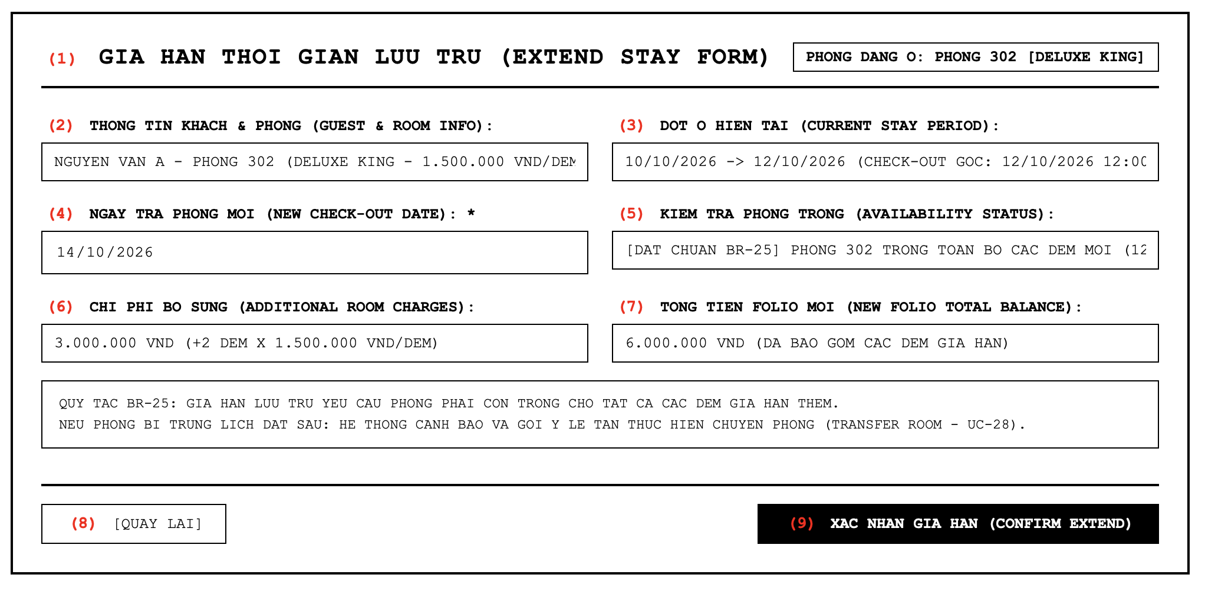Figure 3-11: Screen Design of Extend Stay Form

Table 3-11: Screen Definition

# | Field Name | Type | Mandatory | Max Length | Description
1 | (1) Screen Title | Label | - | - | Displays screen title: "GIA HAN THOI GIAN LUU TRU (EXTEND STAY FORM)".
2 | (2) Guest & Room Info | Text | Yes | 100 | Displays guest legal name, assigned physical room number, and current category rate (Read-only).
3 | (3) Current Stay Period | Text | Yes | 30 | Displays current check-in date and contracted check-out date (Read-only).
4 | (4) New Check-out Date | Date | Yes | 10 | Allows staff to input requested extended departure date (must be after current check-out date).
5 | (5) Availability Status | Text | - | 100 | Real-time check verifying currently assigned room is unreserved for all extended nights (BR-25).
6 | (6) Additional Charges | Numeric | - | - | Calculates additional room tariff for extended nights appended to folio.
7 | (7) New Folio Balance | Numeric | - | - | Displays updated total accumulated stay folio balance including extensions.
8 | (8) Back Button | Button | - | - | Returns to active guest dashboard without committing date changes.
9 | (9) Confirm Extend Button | Button | - | - | Commits extension: postpones departure date, reserves room nights, and posts charges to folio.
3.4.2.2 Use Case Description
Use Case ID | UC-29 | Use Case Name | Extend Stay Duration
Author | HieuVQ | Version | 1.2 | Date | 04/10/2026
Actor | Front-Desk Staff
Description | Postpones scheduled departure date for a resident guest after verifying room availability and recalculating folio charges.
Precondition | PRE-01: The system is available.  PRE-02: Front-Desk Staff is authenticated with front-office operational privileges.  PRE-03: The guest stay has Checked-In status.  PRE-04: The new departure date is strictly after current departure date (BR-17).
Trigger | TRG-01: Guest requests late departure or additional nights at front desk.
Post-Condition | POS-01: The scheduled departure date of the guest stay is updated.  POS-02: The room calendar holds assigned room across extended duration.  POS-03: Additional room charges are appended to the active stay folio.
Main flows
Step | Actor | Action
1 | Front-Desk Staff | Open Extend Stay Form (3.4.2) for a resident guest.
2 | HMS | Retrieve and display resident guest details, current physical room, and scheduled departure date (2, 3).
3 | Front-Desk Staff | Input requested new departure date (4).
4 | HMS | Verify that assigned physical room is vacant and has no conflicting upcoming reservations for all extra nights (BR-25).
5 | HMS | Calculate additional room charges and project new folio balance (6, 7).
6 | Front-Desk Staff | Confirm extension request with guest and click Confirm Extend button (9).
7 | HMS | Update stay departure date, block physical room calendar across extra nights, post extra room charges to folio, and display extension success notification.
Alternative flows
AT1 | At step 4 in the Main Flow, if the assigned physical room has an upcoming reservation conflict.
Sub step | Actor | Action
4.1 | HMS | Alert staff of reservation conflict: "Room is reserved by another booking for requested extension dates (BR-25)."
4.2 | Front-Desk Staff | Suggest room transfer (UC-28) to another room category having vacancy for extended period.
AT2 | At step 4 in the Main Flow, if new departure date is not after current departure date.
Sub step | Actor | Action
4.1 | HMS | Display validation error: "New check-out date must be after current check-out date (BR-17)."
Business Rules
# | Rule Description
BR-17 | Check-in date must not be in the past; check-out date must be after the check-in date.
BR-25 | Stay extension requires availability for all extra nights; otherwise a room transfer is suggested.

3.4.3 UC-34 – List Available Services
3.4.3.1 Mock-up
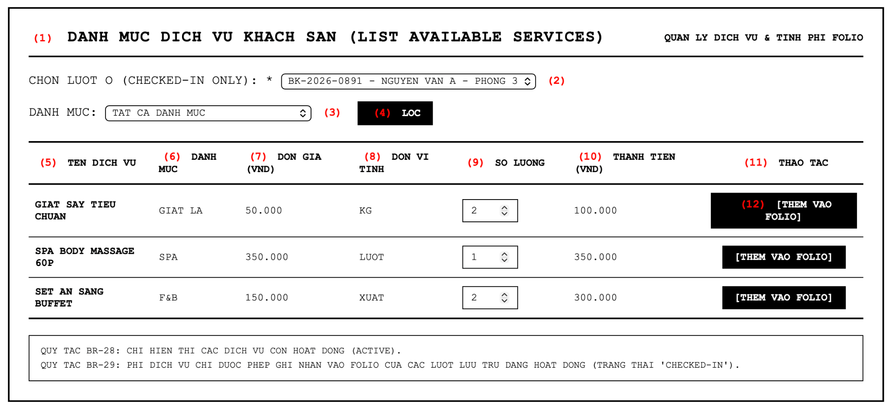Figure 3-12: Screen Design of List Available Services

Table 3-12: Screen Definition
# | Field Name | Type | Mandatory | Max Length | Description
1 | (1) Screen Title | Label | - | - | Displays screen title: "DANH MUC DICH VU KHACH SAN (LIST AVAILABLE SERVICES)".
2 | (2) Active Stay Selector | Selection | Yes | - | Dropdown to select target active resident guest stay in Checked-In status (BR-29).
3 | (3) Category Filter | Selection | No | - | Filters service items by catalog department (All, F&B, Laundry, Spa, Minibar).
4 | (4) Filter Button | Button | - | - | Queries and updates service items table according to selected department.
5 | (5) Service Title | Text | - | 100 | Displays official name of hotel amenity/service (Only active items shown per BR-28).
6 | (6) Service Category | Text | - | 50 | Displays department grouping of service (Laundry, F&B, Spa).
7 | (7) Unit Price | Numeric | - | - | Displays current standard unit tariff in VND (Must be greater than 0 per BR-27).
8 | (8) Unit of Measure | Text | - | 20 | Displays unit calculation standard (e.g. Kg, Session, Set, Item).
9 | (9) Quantity Input | Integer | Yes | - | Allows input of quantity units consumed by guests (Minimum 1).
10 | (10) Subtotal | Numeric | - | - | Displays calculated line subtotal (Unit price * Quantity).
11 | (11) Actions Header | Label | - | - | Column header for service posting action.
12 | (12) Add to Folio Button | Button | - | - | Posts service order line item directly onto active stay folio (BR-29).
3.4.3.2 Use Case Description
Use Case ID | UC-34 | Use Case Name | List Available Services
Author | HieuVQ | Version | 1.2 | Date | 04/10/2026
Actor | Customer, Front-Desk Staff, Service Staff
Description | Displays active ancillary hotel services and schedules, allowing staff to post consumed service charges to active stay folios.
Precondition | PRE-01: The system is available.  PRE-02: Staff user is logged in with reception or service operational authorization.  PRE-03: The target guest stay is currently in Checked-In status (BR-29).  PRE-04: The requested hotel service is set to Active status in service catalog (BR-28).
Trigger | TRG-01: Guest requests an ancillary hotel service (F&B, laundry, spa) during residency.
Post-Condition | POS-01: Service order line item is recorded with service ID, quantity, unit price, and timestamp.  POS-02: Charge amount is appended to resident guest stay folio.  POS-03: Folio total payable balance is automatically recalculated.
Main flows
Step | Actor | Action
1 | Front-Desk Staff / Service Staff | Access List Available Services screen (3.4.3).
2 | HMS | Retrieve and display active service catalog grouped by department (5, 6, 7).
3 | User | Select target active resident stay holding Checked-In status (2).
4 | User | Locate requested service item, specify consumed quantity (9), and review subtotal (10).
5 | User | Click Add to Folio button (12).
6 | HMS | Validate stay status is Checked-In (BR-29) and service item is Active (BR-28).
7 | HMS | Create Service Order record, post ancillary charge directly to guest stay folio, recalculate folio balance, and display charge confirmation notification.
Alternative flows
AT1 | At step 6 in the Main Flow, if the target stay has already been checked out.
Sub step | Actor | Action
6.1 | HMS | Reject charge posting: "Charges can only be posted to active Checked-In stays (BR-29)."
AT2 | At step 5 in the Main Flow, if quantity entered is less than 1 or non-numeric.
Sub step | Actor | Action
5.1 | HMS | Display error alert: "Quantity must be a positive integer."
Business Rules
# | Rule Description
BR-27 | Service title must be unique within its category and unit price greater than 0; price changes apply to future orders only.
BR-28 | Only active services are displayed for ordering.
BR-29 | Service charges can be posted only to Checked-In stays.
BR-30 | Ordered service can be voided only before delivery with a reason; the folio is recalculated.

3.5 Checkout & Payment

3.5.1 UC-37,38 – Check-out & Billing
3.5.1.1 Mock-up
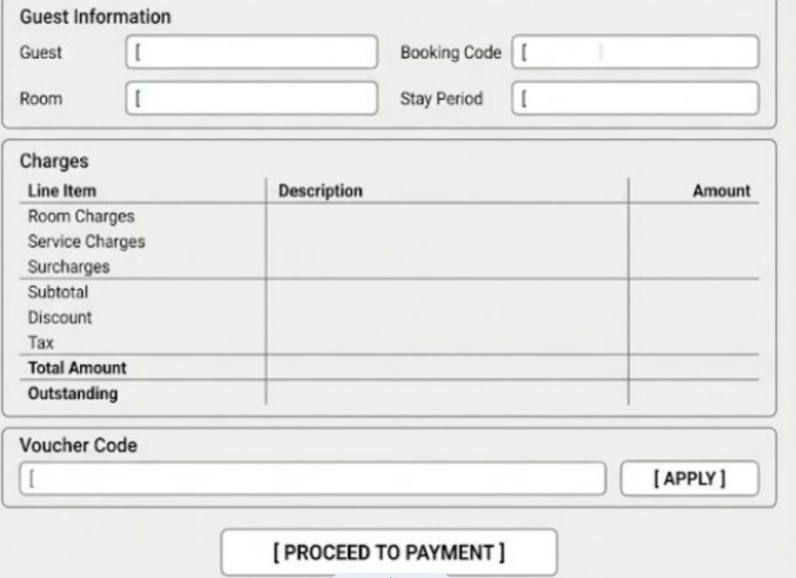

Figure 3-13: Screen Design of Check-out & Billing

Table 3-13: Screen Definition
# | Field Name | Type | Mandatory | Max Length | Description
1 | Guest | Display | N/A | N/A | Displays the guest associated with the departure booking.
2 | Booking Code | Display | N/A | N/A | Displays the booking reference associated with the guest stay.
3 | Room | Display | N/A | N/A | Displays the physical room assigned to the booking.
4 | Stay Period | Display | N/A | N/A | Displays the guest's check-in and check-out dates.
5 | Room Charges | Decimal | N/A | N/A | Displays the accumulated room charges for the stay.
6 | Service Charges | Decimal | N/A | N/A | Displays charges for hotel services consumed during the stay.
7 | Surcharges | Decimal | N/A | N/A | Displays applicable additional charges associated with the stay.
8 | Subtotal | Decimal | N/A | N/A | Displays the total amount before discount and applicable tax.
9 | Voucher Code | Text | No | N/A | Allows staff to enter a promotional voucher code.
10 | Apply Button | Button | N/A | N/A | Validates and applies the entered voucher code.
11 | Discount | Decimal | N/A | N/A | Displays the discount amount applied to the invoice.
12 | Applicable Tax | Decimal | N/A | N/A | Displays the applicable tax amount.
13 | Total Amount | Decimal | N/A | N/A | Displays the final amount payable after applicable deductions and charges.
14 | Outstanding Balance | Decimal | N/A | N/A | Displays the amount remaining to be paid.
15 | Proceed to Payment Button | Button | N/A | N/A | Opens the Payment Form for settlement of the outstanding balance.

3.5.1.2 Use Case Description

Use Case ID |  | UC37 | Use Case Name |  | Compile Itemized Invoice
Author |  | LinhNH | Version | 1.2 | Date | 28/09/2026
Actor |  | Front-Desk Staff
Description |  | Compiles room charges, service charges, surcharges, and other applicable billing information into an itemized invoice for a departure booking.
Precondition |  | PRE-01: A departure booking/stay is available for billing.
Trigger |  | TRG-01: Front-Desk Staff initiates invoice compilation for the departure booking.
Post-Condition |  | POS-01: An itemized invoice is generated with status Unpaid and the outstanding balance is displayed.
Main flows
Step | Actor | Action
1 | Front-Desk Staff | Initiates invoice compilation for the departure booking.
2 | System | Retrieves the room charges, service charges, and applicable surcharges associated with the guest stay.
3 | System | Aggregates the applicable charges to calculate the invoice subtotal.
4 | System | Generates an itemized invoice record with status Unpaid.
5 | System | Calculates and displays the invoice amount and outstanding balance.
6 | System | Displays the itemized billing information on the Check-out & Billing screen.

Alternative flows
ALT-01 | Billing information cannot be retrieved  At Step 2, if the system cannot retrieve the required billing information:
Sub step | Actor | Action
2.1 | System | Detects that required booking or charge information cannot be retrieved.
2.2 | System | Does not generate the invoice.
2.3 | System | Displays an error message and keeps the staff on the billing screen.

Business Rules
# | Rule Description
BR-31 | Invoice is generated as Unpaid from room charges plus service charges plus surcharges

3.5.1.3 Use Case Description
Use Case ID |  | UC38 | Use Case Name |  | Apply Discount Voucher
Author |  | LinhNH | Version | 1.2 | Date | 28/09/2026
Actor |  | Front-Desk Staff
Description |  | Applies a valid promotional voucher or discount code to the invoice and recalculates the invoice total and outstanding balance.
Precondition |  | PRE-01: An invoice has been generated and is eligible for discount application.
Trigger |  | TRG-01: Front-Desk Staff enters a voucher code and selects Apply.
Post-Condition |  | POS-01: The invoice total and outstanding balance are recalculated according to the valid discount.
Main flows
Step | Actor | Action
1 | Front-Desk Staff | Enters a voucher code into the Voucher Code field.
2 | Front-Desk Staff | Selects Apply.
3 | System | Validates the voucher code.
4 | System | Verifies the voucher active dates, usage quota, and minimum spend criteria.
5 | System | Applies the eligible promotional discount.
6 | System | Recalculates the invoice total and outstanding balance.
7 | System | Displays the updated discount, total amount, and outstanding balance.

Alternative flows
ALT-01 | Invalid or Expired Voucher  At Step 4, if the voucher is invalid, expired, exceeds its usage quota, or does not satisfy the required minimum spend:
Sub step | Actor | Action
4.1 | System | Detects that required booking or charge information cannot be retrieved.
4.2 | System | Does not generate the invoice.
4.3 | System | Displays an error message and keeps the staff on the billing screen.
4.4 | System | Maintains the original invoice balance.

Business Rules
# | Rule Description
BR-32 | Vouchers must be within valid dates, quota, and minimum spend; an invalid voucher keeps the original balance

3.5.2 UC-39 – Payment Form
3.5.2.1 Mock-up
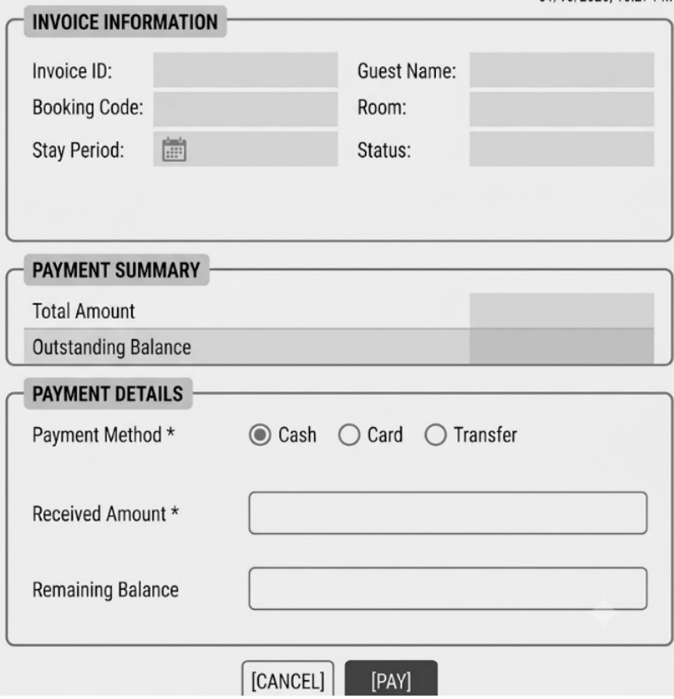

Figure 3-14: Screen Design of Payment Form

Table 3-14: Screen Definition
# | Field Name | Type | Mandatory | Max Length | Description
1 | Invoice ID | Display | N/A | N/A | Displays the unique identifier of the invoice.
2 | Guest Name | Display | N/A | N/A | Displays the guest associated with the invoice.
3 | Booking Code | Display | N/A | N/A | Displays the booking reference associated with the invoice.
4 | Room | Display | N/A | N/A | Displays the physical room associated with the booking.
5 | Stay Period | Display | N/A | N/A | Displays the guest's stay period.
6 | Status | Display | N/A | N/A | Displays the current payment status of the invoice.
7 | Total Amount | Decimal | N/A | N/A | Displays the total invoice amount.
8 | Outstanding Balance | Decimal | N/A | N/A | Displays the amount currently due for payment.
9 | Payment Method | Dropdown | Yes | N/A | Allows staff to select the payment method, such as Cash, Card, or Transfer.
10 | Received Amount | Decimal | Yes | N/A | Records the amount received from the customer.
11 | Remaining Balance | Decimal | N/A | N/A | Displays the balance remaining after the recorded payment.
12 | Cancel Button | Button | N/A | N/A | Cancels the current payment operation and returns to the previous screen.
13 | Pay Button | Button | N/A | N/A | Submits the payment information for processing.

3.5.2.2 Use Case Description

Use Case ID |  | UC39 | Use Case Name |  | Process Payment Settlement
Author |  | LinhNH | Version | 1.2 | Date | 28/09/2026
Actor |  | Front-Desk Staff
Description |  | Records monetary collection for an invoice using a supported payment method such as Cash, Card, or Transfer.
Precondition |  | PRE-01: An unpaid invoice with an outstanding balance exists.
Trigger |  | TRG-01: Front-Desk Staff selects a payment method, enters the received amount, and selects Pay.
Post-Condition |  | POS-01: The payment transaction is recorded. POS-02: If the invoice is fully settled, the invoice status becomes Paid and payment confirmation is generated.
Main flows
Step | Actor | Action
1 | Front-Desk Staff | Opens the Payment Form for the selected invoice.
2 | System | Displays the invoice information, total amount, and outstanding balance.
3 | Front-Desk Staff | Selects the payment method.
4 | Front-Desk Staff | Enters the received amount.
5 | Front-Desk Staff | Selects Pay.
6 | System | Validates the payment information and checks the received amount against the outstanding balance.
7 | System | Records the payment transaction.
8 | System | Updates the remaining balance.
9 | System | If the outstanding balance is fully settled, change the invoice status to Paid.
10 | System | Generates payment confirmation and displays the updated payment information.

Alternative flows
ALT-01 | Partial Payment  At Step 6, if the received amount is less than the outstanding balance:
Sub step | Actor | Action
6.1 | System | Detects that the payment does not fully settle the outstanding balance.
6.2 | System | Records the received payment amount.
6.3 | System | Calculates the remaining balance.
6.4 | System | Keeps the invoice unsettled and displays the updated remaining balance.

ALT-02 | Invalid Payment Information  At Step 6, if required payment information is missing or invalid:
Sub step | Actor | Action
6.1 | System | Rejects the payment submission.
6.2 | System | Displays a validation message.
6.3 | System | Does not create the payment transaction.

ALT-03 | Received Amount Exceeds Outstanding Balance
Sub step | Actor | Action
6.1 | System | Detects that the received amount exceeds the outstanding balance.
6.2 | System | Rejects the payment submission.
6.3 | System | Displays a validation message indicating that the received amount cannot exceed the outstanding balance.
6.4 | System | Keeps the payment form available for correction.

Business Rules
# | Rule Description
BR-33 | Supported payment methods are Cash, Card, and Transfer; partial payment updates the remaining balance
BR-34 | A fully paid invoice becomes Paid with confirmation; the receipt can be printed .

3.5.3 UC-40 –Invoice Receipt
3.5.3.1 Mock-up
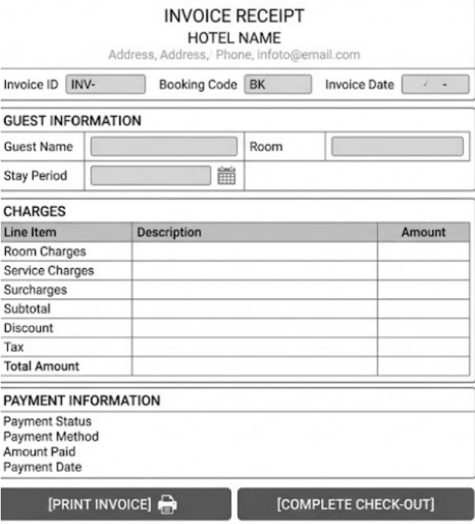

Figure 3-15: Screen Design of Invoice Receipt

Table 3-15: Screen Definition
# | Field Name | Type | Mandatory | Max Length | Description
1 | Hotel Name | Display | N/A | N/A | Displays the hotel name in the invoice header.
2 | Hotel Contact Information | Display | N/A | N/A | Displays the hotel's address, phone number, and email information.
3 | Invoice ID | Display | N/A | N/A | Displays the unique invoice identifier.
4 | Booking Code | Display | N/A | N/A | Displays the booking reference associated with the invoice.
5 | Invoice Date | Display | N/A | N/A | Displays the date on which the invoice was generated.
6 | Guest Name | Display | N/A | N/A | Displays the guest's name.
7 | Room | Display | N/A | N/A | Displays the physical room associated with the stay.
8 | Stay Period | Display | N/A | N/A | Displays the guest's check-in and check-out dates.
9 | Room Charges | Decimal | N/A | N/A | Displays the room charges included in the invoice.
10 | Service Charges | Decimal | N/A | N/A | Displays the charges for consumed hotel services.
11 | Surcharges | Decimal | N/A | N/A | Displays applicable additional charges.
12 | Subtotal | Decimal | N/A | N/A | Displays the subtotal before discount and applicable tax.
13 | Discount | Decimal | N/A | N/A | Displays the discount amount applied to the invoice.
14 | Applicable Tax | Decimal | N/A | N/A | Displays the applicable tax amount.
15 | Total Amount | Decimal | N/A | N/A | Displays the final invoice amount.
16 | Payment Status | Display | N/A | N/A | Displays the current payment status of the invoice.
17 | Payment Method | Display | N/A | N/A | Displays the method used for payment.
18 | Amount Paid | Decimal | N/A | N/A | Displays the amount recorded as paid.
19 | Payment Date | Date/Time | N/A | N/A | Displays the date and time of the payment.
20 | Print Invoice Button | Button | N/A | N/A | Renders the invoice in a printable format.
21 | Complete Check-out Button | Button | N/A | N/A | Continues to the guest check-out completion process.

3.5.3.2 Use Case Description

Use Case ID |  | UC40 | Use Case Name |  | Print Invoice Receipt
Author |  | LinhNH | Version | 1.2 | Date | 28/09/2026
Actor |  | Front-Desk Staff
Description |  | Formats and prints an official itemized payment receipt for the guest.
Precondition |  | PRE-01: An invoice exists with the required billing and payment information.
Trigger |  | TRG-01: The user selects the Print Invoice action.
Post-Condition |  | POS-01: The system renders the invoice in a printable format.
Main flows
Step | Actor | Action
1 | Front-Desk Staff | Open the invoice receipt.
2 | System | Retrieves the invoice, booking, guest, charge, discount, tax, and payment information.
3 | System | Displays the invoice information including Invoice ID, Booking Code, Guest Name, Room, and Stay Period.
4 | System | Displays the itemized room charges, service charges, surcharges, discount, applicable tax, and total amount.
5 | System | Displays the payment status, payment method, amount paid, and payment date.
6 | Front-Desk Staff | Selects Print Invoice.
7 | System | Formats the invoice with the hotel header and billing information.
8 | System | Renders the formatted invoice in a printable view.

Alternative flows
ALT-01 | Invoice information cannot be retrieved  At Step 2, if the system cannot retrieve the required invoice information:
Sub step | Actor | Action
2.1 | System | Detects that the required invoice or billing information cannot be retrieved.
2.2 | System | Does not generate the printable invoice.
2.3 | System | Displays an error message and keeps the staff on the Invoice Receipt screen.

ALT-02 | Invoice is not available  At Step 1, if the selected invoice does not exist or is unavailable:
Sub step | Actor | Action
1.1 | System | Detects that the requested invoice is unavailable.
1.2 | System | Does not display the invoice receipt.
1.3 | System | Displays an error message and returns the staff to the previous screen.

Business Rules
# | Rule Description
BR-34 | A fully paid invoice becomes Paid with confirmation; the receipt can be printed

3.5.4 UC-30 – Check-out Confirmation
3.5.4.1 Mock-up
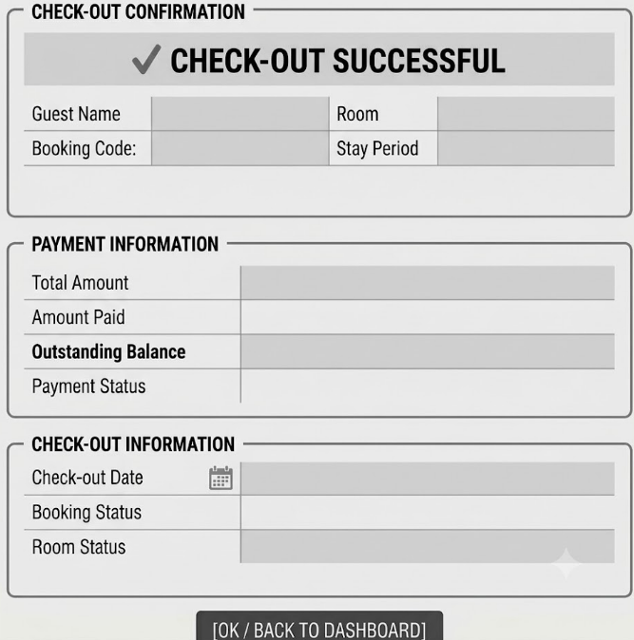

Figure 3-16: Screen Design of Check-out Confirmation

Table 3-16: Screen Definition
# | Field Name | Type | Mandatory | Max Length | Description
1 | Check-out Confirmation Message | Display | N/A | N/A | Displays the confirmation message indicating that the guest check-out has been completed successfully.
2 | Guest Name | Display | N/A | N/A | Displays the name of the guest associated with the completed booking.
3 | Booking Code | Display | N/A | N/A | Displays the booking reference associated with the completed check-out.
4 | Room | Display | N/A | N/A | Displays the physical room associated with the completed stay.
5 | Stay Period | Display | N/A | N/A | Displays the guest's check-in and check-out dates.
6 | Total Amount | Decimal | N/A | N/A | Displays the final total amount of the invoice.
7 | Amount Paid | Decimal | N/A | N/A | Displays the total amount that has been paid for the booking.
8 | Outstanding Balance | Decimal | N/A | N/A | Displays the remaining unpaid balance of the booking.
9 | Payment Status | Display | N/A | N/A | Displays the current payment status of the invoice.
10 | Check-out Date | Date/Time | N/A | N/A | Displays the date and time when the guest check-out was completed.
11 | Booking Status | Display | N/A | N/A | Displays the updated booking status after successful check-out.
12 | Room Status | Display | N/A | N/A | Displays the updated room status as Vacant / Dirty after successful check-out.
13 | OK / Back to Dashboard Button | Button | N/A | N/A | Returns the staff to the dashboard or previous main screen after check-out completion.

3.5.4.3 Use Case Description

Use Case ID |  | UC30 | Use Case Name |  | Check Out Guest
Author |  | LinhNH | Version | 1.2 | Date | 28/09/2026
Actor |  | Front-Desk Staff
Description |  | Finalizes the guest departure after the invoice has been fully settled, completes the booking, updates the room status for turnover, and displays the check-out confirmation.
Precondition |  | PRE-01: The guest has a valid departure booking.  PRE-02: The invoice exists and contains the required billing and payment information.  PRE-03: The outstanding balance is fully settled.
Trigger |  | TRG-01: The Front-Desk Staff selects the Complete Check-out action from the Invoice Receipt screen.
Post-Condition |  | POS-01: The booking status is updated to Completed.  The room status is updated to Vacant / Dirty for housekeeping turnover.  POS-03: The check-out date and time are recorded.  POS-04: The system displays the Check-out Confirmation screen.
Main flows
Step | Actor | Action
1 | Front-Desk Staff | Selects Complete Check-out from the Invoice Receipt screen.
2 | System | Retrieves the booking, guest, room, invoice, and payment information.
3 | System | Verifies that the booking is eligible for check-out.
4 | System | Verifies that the Outstanding Balance is fully settled.
5 | System | Updates the booking status to Completed.
6 | System | Updates the room status to Vacant / Dirty for housekeeping turnover.
7 | System | Records the check-out date and time.
8 | System | Displays the Check-out Confirmation screen with guest, booking, payment, and check-out information.
9 | Front-Desk Staff | Reviews the displayed check-out confirmation information.
10 | Front-Desk Staff | Selects OK / Back to Dashboard.
11 | System | Returns the staff to the dashboard or main screen.

Alternative flows
ALT-01 | Outstanding Balance is not fully settled  At Step 4, if the booking has an outstanding balance:
Sub step | Actor | Action
4.1 | System | Detects that the Outstanding Balance is greater than zero.
4.2 | System | Does not complete the guest check-out.
4.3 | System | Displays an error message indicating that the outstanding balance must be fully paid before check-out.
4.4 | System | Returns or keeps the staff on the payment/invoice screen to complete the remaining payment.

ALT-02 | Booking information cannot be retrieved  At Step 2, if the system cannot retrieve the required booking information:
Sub step | Actor | Action
2.1 | System | Detects that the required booking, guest, room, or invoice information cannot be retrieved.
2.2 | System | Does not complete the check-out.
2.3 | System | Displays an error message indicating that the check-out information cannot be retrieved.
2.4 | System | Keeps the staff on the previous screen.

Business Rules
# | Rule Description
BR-26 | Check-out requires zero outstanding balance; the room becomes Dirty after departure.

3.6 Housekeeping & Maintenance

3.6.1 UC19-Update Housekeeping Board
3.6.1.1 Mock-up

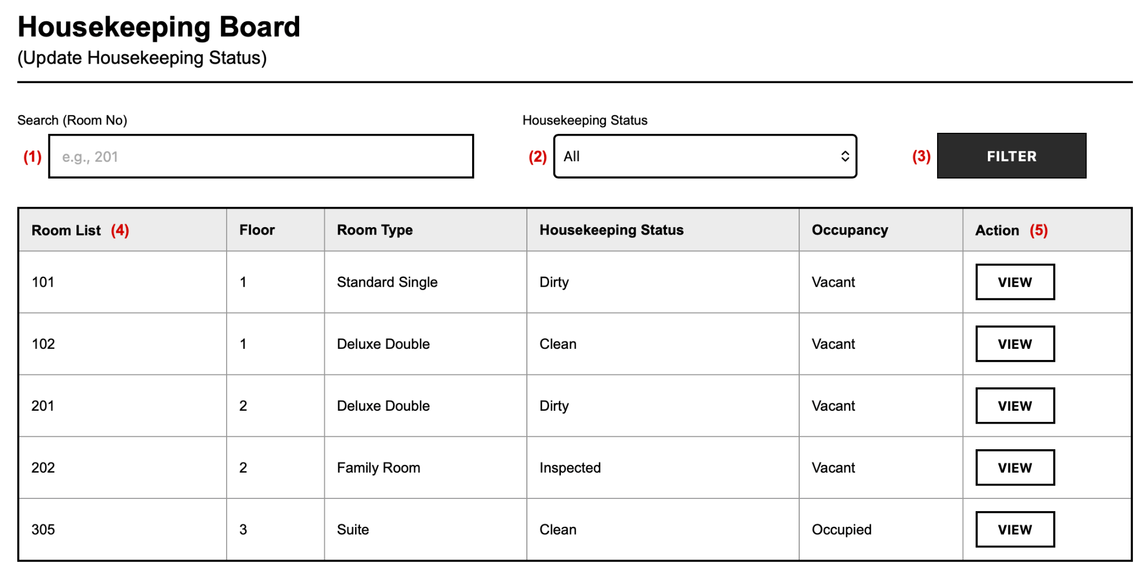Figure 3-17: Screen Design of Housekeeping Board
Table 3-17: Screen Definition
# | Field Name | Type | Mandatory | Max Length | Description
1 | Search Keyword | Text | No | 50 | Enter a room number to search.
2 | Housekeeping Status | Selection | No | N/A | Select All, Dirty, Clean, or Inspected to filter the board.
3 | Filter | Button | N/A | N/A | Applies the search keyword and status filter to the room list.
4 | Room List | Display | N/A | N/A | Displays Room No, Floor, Room Type, Housekeeping Status, and Occupancy.
5 | View | Button | N/A | N/A | Opens Room Status Details for the selected room.

3.6.1.2 Use Case Description
Use Case ID |  | UC19 | Use Case Name |  | Update Housekeeping Status – Board
Author |  | HieuVQ | Version | 1.0 | Date | 02/10/2026
Actor |  | Housekeeping Staff
Description |  | Allows housekeeping staff to view rooms with Dirty, Clean, and Inspected status.
Precondition |  | PRE-01: Staff is logged in.  PRE-02: Room inventory exists.
Trigger |  | TRG-01: Staff opens the Housekeeping Board.
Post-Condition |  | POS-01: Filtered rooms with housekeeping status are displayed.
Main flows
Step | Actor | Action
1 | Housekeeping Staff | Open the Housekeeping Board.
2 | System | Retrieve rooms with housekeeping status and occupancy.
3 | System | Display the room list with Room No, Floor, Room Type, status, and occupancy.
4 | Housekeeping Staff | Enter a room number and/or select a status filter to narrow the list.

Alternative flows
ALT-01 | At Step 3, if no room matches the filter criteria.
Sub step | Actor | Action
3.1 | System | Display a message: "No rooms found."
3.2 | Housekeeping Staff | Change the filter criteria and search again.

Business Rules

# | Rule Description
BR-01 | Housekeeping status must be one of Dirty, Clean, or Inspected.
BR-02 | The board displays both housekeeping status and occupancy for each room.

3.6.2 UC19-Room Status Details
3.6.2.1 Mock-up
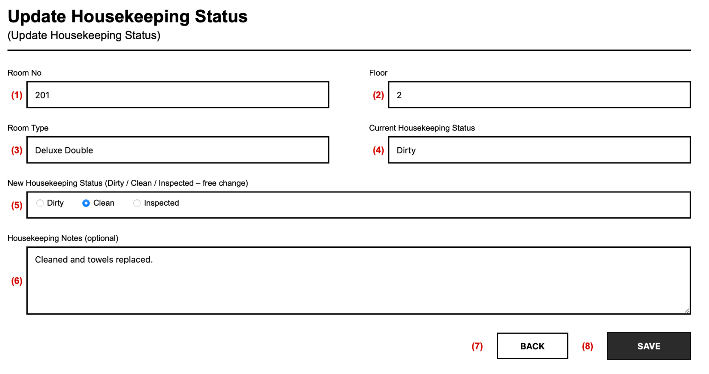Figure 3-18: Screen Design of Room Status Details

Table 3-18: Screen Definition
# | Field Name | Type | Mandatory | Max Length | Description
1 | Room No | Display | N/A | N/A | Displays the selected room number.
2 | Floor | Display | N/A | N/A | Displays the floor of the room.
3 | Room Type | Display | N/A | N/A | Displays the room category.
4 | Current Housekeeping Status | Display | N/A | N/A | Displays Dirty, Clean, or Inspected before update.
5 | New Housekeeping Status | Selection | Yes | N/A | Select Dirty, Clean, or Inspected. Any status can be changed to any other status.
6 | Housekeeping Notes | Text | No | 500 | Enter optional cleaning notes.
7 | Back | Button | N/A | N/A | Return to the Housekeeping Board without saving.
8 | Save | Button | N/A | N/A | Validate and save the new housekeeping status.

3.6.2.2 Use Case Description
Use Case ID |  | UC19 | Use Case Name |  | Update Housekeeping Status
Author |  | HieuVQ | Version | 1.0 | Date | 02/10/2026
Actor |  | Housekeeping Staff
Description |  | Allows housekeeping staff to view room details and update the hygiene status.
Precondition |  | PRE-01: The room exists. PRE-02: The Housekeeping Board is displayed.
Trigger |  | TRG-01: Staff selects a room and saves a new status.
Post-Condition |  | POS-01: The room hygiene status is updated and shown on the board.
Main flows
Step | Actor | Action
1 | Housekeeping Staff | Select a room from the Housekeeping Board.
2 | System | Display room information and the current housekeeping status.
3 | Housekeeping Staff | Select a new status among Dirty, Clean, Inspected and enter notes.
4 | System | Validate that a new status is selected.
5 | System | Update the room status and confirm. Front-Desk can see the updated readiness.

Alternative flows
ALT-01 | At Step 4, if no new status is selected.
Sub step | Actor | Action
4.1 | System | Display a message: "Please select a new housekeeping status."
4.2 | Housekeeping Staff | Select a status and save again.
ALT-02 | At Step 3, if the room is Under Maintenance.
Sub step | Actor | Action
3.1 | System | Display a message: "Room under maintenance. Housekeeping update is not allowed."
3.2 | Housekeeping Staff | Return to the board.

Business Rules
# | Rule Description
BR-01 | The new housekeeping status is mandatory.
BR-02 | Any status can be changed to any other status (Dirty, Clean, Inspected).
BR-03 | Only Vacant and Inspected rooms can be assigned to guests at check-in.

3.6.3 UC20-Maintenance Room List
3.6.3.1 Mock-up
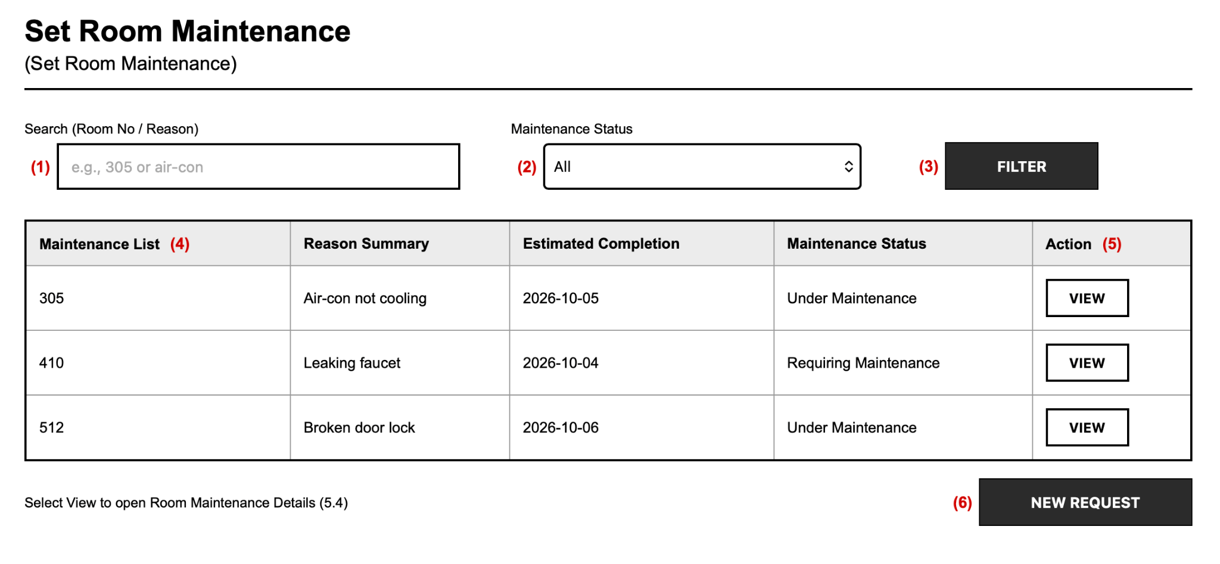Figure 3-19: Screen Design of Maintenance Room List

Table 3-19: Screen Definition
# | Field Name | Type | Mandatory | Max Length | Description
1 | Search Keyword | Text | No | 50 | Enter a room number or reason keyword to search.
2 | Maintenance Status | Selection | No | N/A | Select All, Requiring Maintenance, or Under Maintenance.
3 | Filter | Button | N/A | N/A | Apply the search and status filter to the list.
4 | Maintenance List | Display | N/A | N/A | Display Room No, Reason Summary, Estimated Completion, and Maintenance Status.
5 | View | Button | N/A | N/A | Open Room Maintenance Details for the selected room.
6 | New Request | Button | N/A | N/A | Open the Set Room Maintenance Form for a new request.

3.6.3.2 Use Case Description
Use Case ID |  | UC20 | Use Case Name |  | Set Room Maintenance – List
Author |  | HieuVQ | Version | 1.0 | Date | 02/10/2026
Actor |  | Housekeeping Staff, Administrator
Description |  | Allows staff to view rooms requiring maintenance or under maintenance.
Precondition |  | PRE-01: Staff is logged in. PRE-02: Maintenance records exist or can be created.
Trigger |  | TRG-01: Staff opens the Maintenance Room List.
Post-Condition |  | POS-01: Filtered maintenance rooms are displayed.
Main flows
Step | Actor | Action
1 | Housekeeping Staff, Administrator | Open the Maintenance Room List.
2 | HMS | Retrieve rooms with maintenance reason, estimated completion, and status.
3 | HMS | Display the maintenance list.
4 | Housekeeping Staff, Administrator | Search by keyword and/or filter by maintenance status.

Alternative flows
ALT-01 | At Step 3, if no room matches the filter.
Sub step | Actor | Action
3.1 | System | Display a message: "No maintenance rooms found."
3.2 | Housekeeping Staff, Administrator | Change the filter and search again.

Business Rules
# | Rule Description
BR-01 | Maintenance status is either Requiring Maintenance or Under Maintenance.
BR-02 | Rooms Under Maintenance are unavailable for reservation and check-in.

3.6.4 UC20-Room Maintenance Details
3.6.4.1 Mock-up
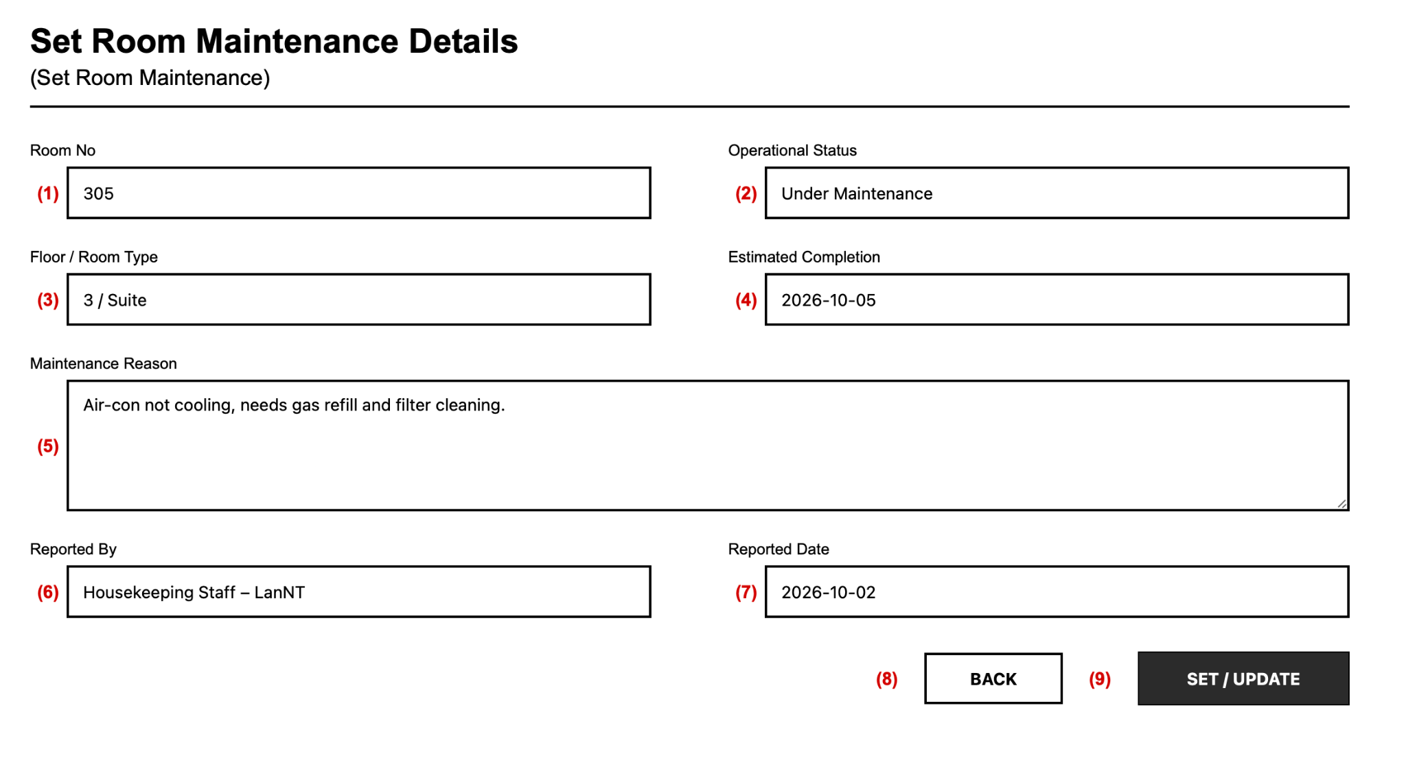Figure 3-20: Screen Design of Room Maintenance Details

Table 3-20: Screen Definition
# | Field Name | Type | Mandatory | Max Length | Description
1 | Room No | Display | N/A | N/A | Display the room number.
2 | Operational Status | Display | N/A | N/A | Display Available, Occupied, or Under Maintenance.
3 | Floor / Room Type | Display | N/A | N/A | Display the floor and room category.
4 | Estimated Completion | Display | N/A | N/A | Display the expected repair completion date.
5 | Maintenance Reason | Display | N/A | N/A | Display the reported defect reason.
6 | Reported By | Display | N/A | N/A | Display the staff who reported the issue.
7 | Reported Date | Display | N/A | N/A | Display the report date.
8 | Back | Button | N/A | N/A | Return to the Maintenance Room List.
9 | Set / Update | Button | N/A | N/A | Open the Set Room Maintenance Form to edit.

3.6.4.2 Use Case Description
Use Case ID |  | UC20 | Use Case Name |  | Set Room Maintenance – Details
Author |  | HieuVQ | Version | 1.0 | Date | 02/10/2026
Actor |  | Housekeeping Staff, Administrator
Description |  | Allows staff to view maintenance information for a selected room.
Precondition |  | PRE-01: The room has a maintenance record. PRE-02: The maintenance list is displayed.
Trigger |  | TRG-01: Staff selects a room to view maintenance details.
Post-Condition |  | POS-01: Maintenance reason and estimated completion are displayed.
Main flows
Step | Actor | Action
1 | Housekeeping Staff, Administrator | Select a room from the Maintenance Room List.
2 | HMS | Display room, maintenance reason, estimated completion, and reporter info.
3 | Housekeeping Staff, Administrator | Review the details and choose Set / Update when changes are needed.

Alternative flows
ALT-01 | At Step 2, if the maintenance record cannot be shown.
Sub step | Actor | Action
2.1 | System | Display a message: "Maintenance information is not available."
2.2 | Housekeeping Staff, Administrator | Return to the list.

Business Rules
# | Rule Description
BR-01 | Details show the current reason and estimated completion for the room.
BR-02 | Rooms Under Maintenance remain locked for new reservations.

3.6.5 UC20-Set Room Maintenance Form
3.6.5.1 Mock-up
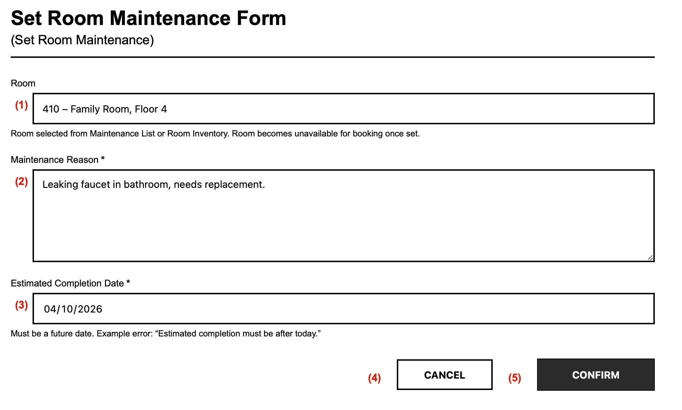Figure 3-21: Screen Design of Set Room Maintenance Form

Table 3-21: Screen Definition
# | Field Name | Type | Mandatory | Max Length | Description
1 | Room | Display | N/A | N/A | Display the selected room. The room becomes unavailable for booking once set to Under Maintenance.
2 | Maintenance Reason | Text | Yes | 500 | Enter the defect reason.
3 | Estimated Completion Date | Date | Yes | N/A | Select the expected completion date. Must be after the current date.
4 | Cancel | Button | N/A | N/A | Discard input and return to the previous screen.
5 | Confirm | Button | N/A | N/A | Validate and set the room to Under Maintenance.

3.6.5.2 Use Case Description
Use Case ID |  | UC20 | Use Case Name |  | Set Room Maintenance
Author |  | HieuVQ | Version | 1.0 | Date | 02/10/2026
Actor |  | Housekeeping Staff, Administrator
Description |  | Locks an out-of-order room for repairs, preventing reservations.
Precondition |  | PRE-01: The target room exists.  PRE-02: The room is not already Under Maintenance with the same reason.
Trigger |  | TRG-01: Staff confirms maintenance with reason and estimated completion.
Post-Condition |  | POS-01: Room operational status becomes Under Maintenance and availability is locked.
Main flows
Step | Actor | Action
1 | Housekeeping Staff, Administrator | Open the Set Room Maintenance Form for the target room.
2 | HMS | Display the selected room.
3 | Housekeeping Staff, Administrator | Enter the maintenance reason and estimated completion date.
4 | HMS | Validate that the reason is provided and the date is after the current date.
5 | HMS | Set room status to Under Maintenance, lock availability, and confirm.

Alternative flows
ALT-01 | At Step 4, if the reason is empty.
Sub step | Actor | Action
4.1 | System | Display a message: "Maintenance reason is required."
4.2 | Housekeeping Staff, Administrator | Enter the reason and confirm again.
ALT-02 | At Step 4, if the estimated date is not after the current date.
Sub step | Actor | Action
4.1 | System | Display a message: "Estimated completion must be after today."
4.2 | Housekeeping Staff, Administrator | Select a valid date and confirm again.
ALT-03 | At Step 3, if the room is Occupied.
Sub step | Actor | Action
3.1 | System | Display a message: "Room is occupied. Maintenance can start after check-out."
3.2 | Housekeeping Staff, Administrator | Cancel or select another room.

Business Rules
# | Rule Description
BR-01 | Maintenance reason is mandatory with a maximum of 500 characters.
BR-02 | Estimated completion must be after the current date.
BR-03 | A room Under Maintenance cannot be booked or assigned at check-in.
BR-04 | Only Housekeeping Staff and Administrator can set room maintenance.

3.6.6 UC-51 – Assign Room Cleaning Task
3.6.6.1 Mock-up
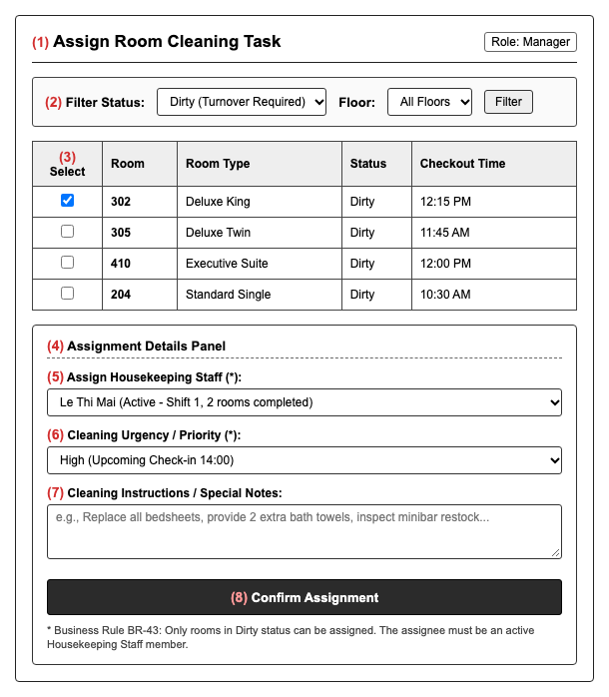
Figure 3-22: Screen Design of Assign Room Cleaning Task
Table 3-22: Screen Definition
# | Field Name | Type | Mandatory | Max Length | Description
1 | (1) Screen Title | Label | - | - | Displays the screen title: "Phân Công Dọn Buồng Phòng (Assign Room Cleaning Task)".
2 | (2) Status Filter | Selection | Yes | - | Filters rooms by cleanliness status (defaults to Dirty per BR-43, All).
3 | (3) Select Target Room | Checkbox | Yes | - | Allows manager to select one or multiple dirty rooms for cleaning turnover.
4 | (4) Assignment Form Panel | Container | - | - | Container holding assignment input controls and staff selection.
5 | (5) Housekeeping Staff | Selection | Yes | - | Dropdown listing active housekeeping staff members on duty (BR-43).
6 | (6) Cleaning Priority | Selection | Yes | - | Specifies turnaround urgency: Normal, High (check-in 14:00), or Urgent (early arrival).
7 | (7) Cleaning Instructions | Textarea | No | 500 | Allows manager to enter specific room sanitation notes, linen changes, or defect checks.
8 | (8) Confirm Assignment Button | Button | - | - | Commits cleaning task assignment, updates Housekeeping Board, and notifies assigned staff member.
3.6.6.2 Use Case Description
Use Case ID | UC-51 | Use Case Name | Assign Room Cleaning Task
Author | HieuVQ | Version | 1.2 | Date | 24/10/2026
Actor | Manager, Housekeeping Staff
Description | Assigns dirty or vacated rooms to specific Housekeeping Staff members for cleaning turnover.
Precondition | PRE-01: The system is available.  PRE-02: Manager is authenticated with managerial privileges.  PRE-03: At least one room has Dirty status (BR-43).  PRE-04: At least one Housekeeping Staff member is active.
Trigger | TRG-01: Manager accesses the housekeeping assignment console to allocate cleaning tasks.
Post-Condition | POS-01: Target rooms are linked to assigned staff member.  POS-02: Assigned staff member's Housekeeping Board is refreshed with new tasks.  POS-03: Cleaning priority and special instructions are logged.
Main flows
Step | Actor | Action
1 | Manager | Navigate to Housekeeping Assignment view (3.6.6) and filter rooms with Dirty status.
2 | HMS | Retrieve and display unassigned dirty rooms with room number, tier, and vacancy timestamp.
3 | Manager | Select target dirty room(s) (3) and choose an active Housekeeping Staff member from dropdown (5).
4 | Manager | Select cleaning priority (6), input specific instructions if needed (7), and click Confirm Assignment (8).
5 | HMS | Validate that selected room is in Dirty status and selected staff member is active (BR-43).
6 | HMS | Record task assignment, update room record with assigned staff identity, update staff member's Housekeeping Board (UC-19), and display assignment success confirmation.
Alternative flows
AT1 | At step 3 in the Main Flow, if no active housekeeping staff members are available on duty.
Sub step | Actor | Action
3.1 | HMS | Display alert message: "No active housekeeping staff members currently available."
3.2 | Manager | Wait for shift change or activate available staff before re-attempting assignment.
AT2 | At step 5 in the Main Flow, if the selected room status has already changed or has been assigned.
Sub step | Actor | Action
5.1 | HMS | Alert manager: "Room status has changed or is already assigned. Refreshing room list."
Business Rules
# | Rule Description
BR-43 | Only rooms with Dirty status can be assigned for housekeeping turnover; cleaning tasks must be assigned to an active Housekeeping Staff member.

4. Business process

4.1 Check-in
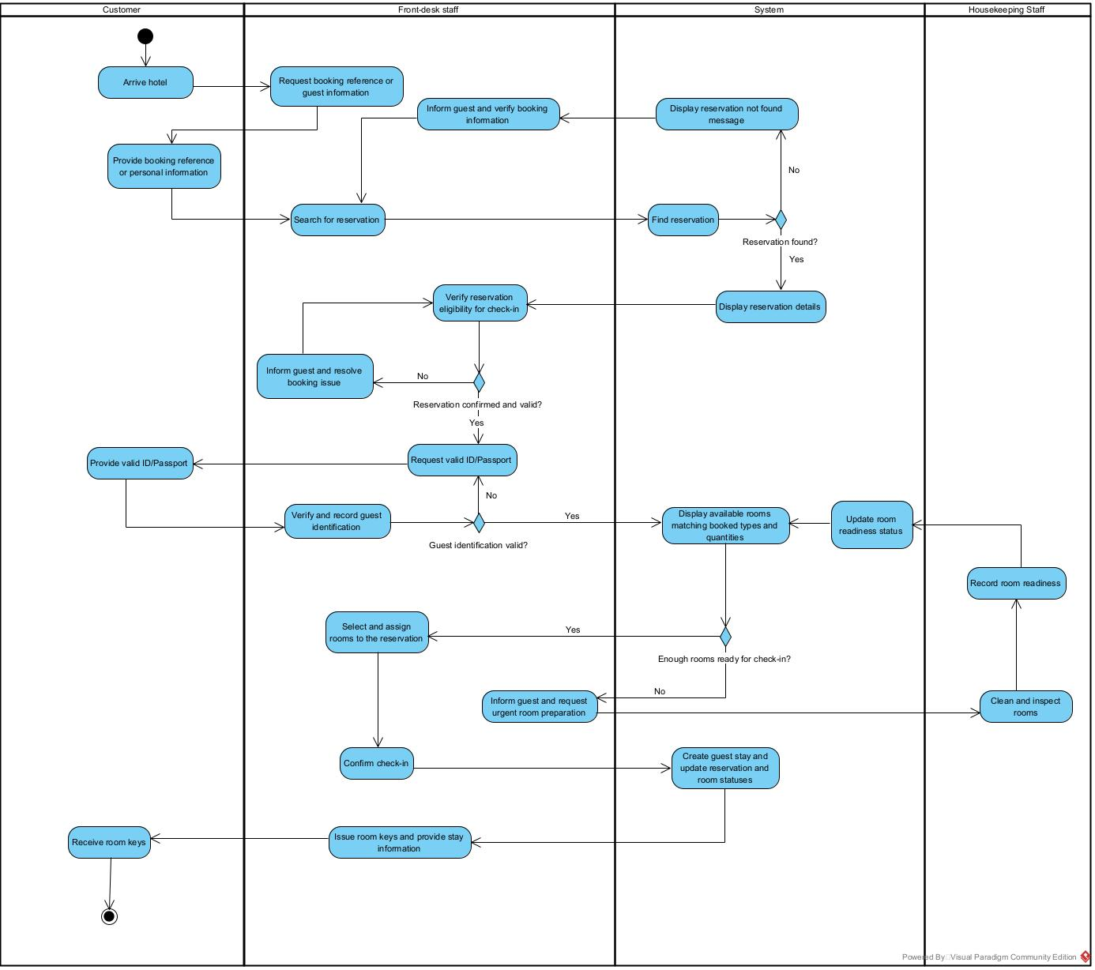

4.2 Check out
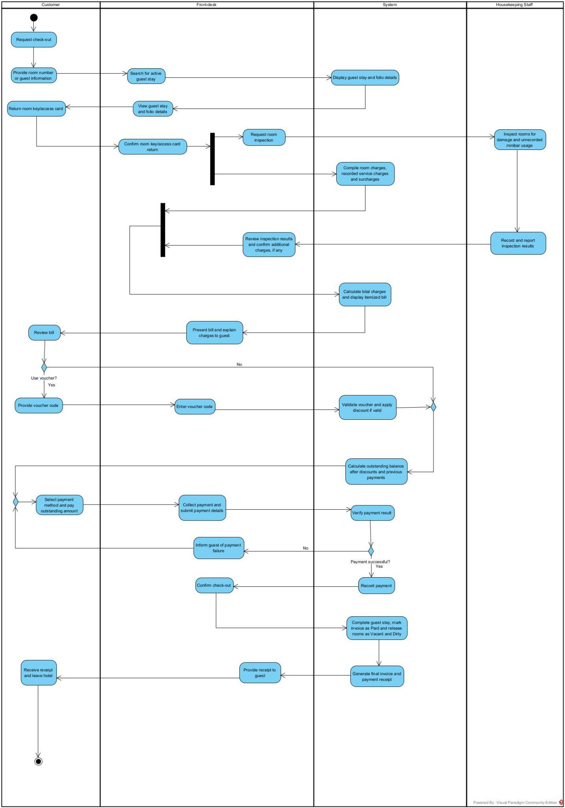

4.3 Transfer room
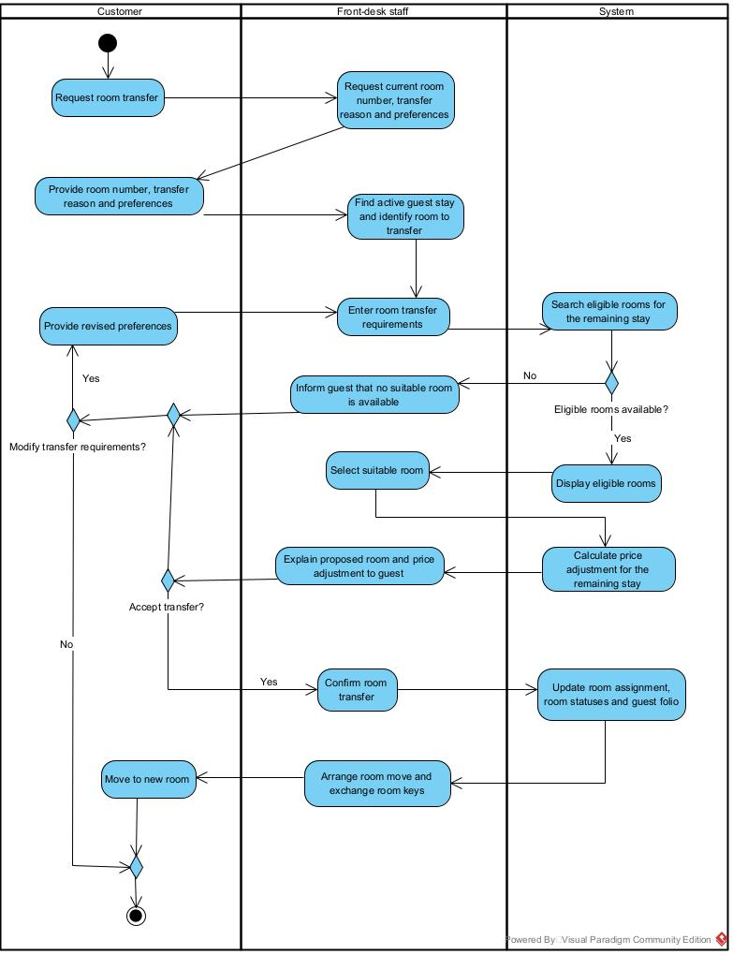

4.4 Booking online
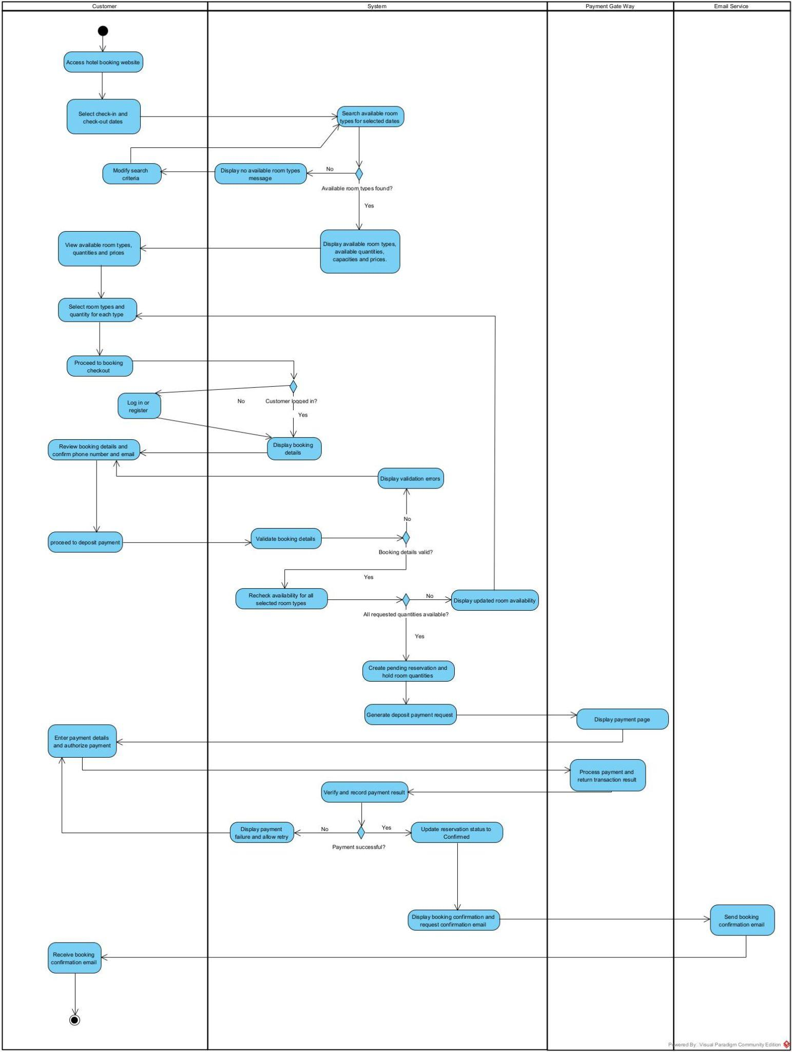

4.5 Booking on site
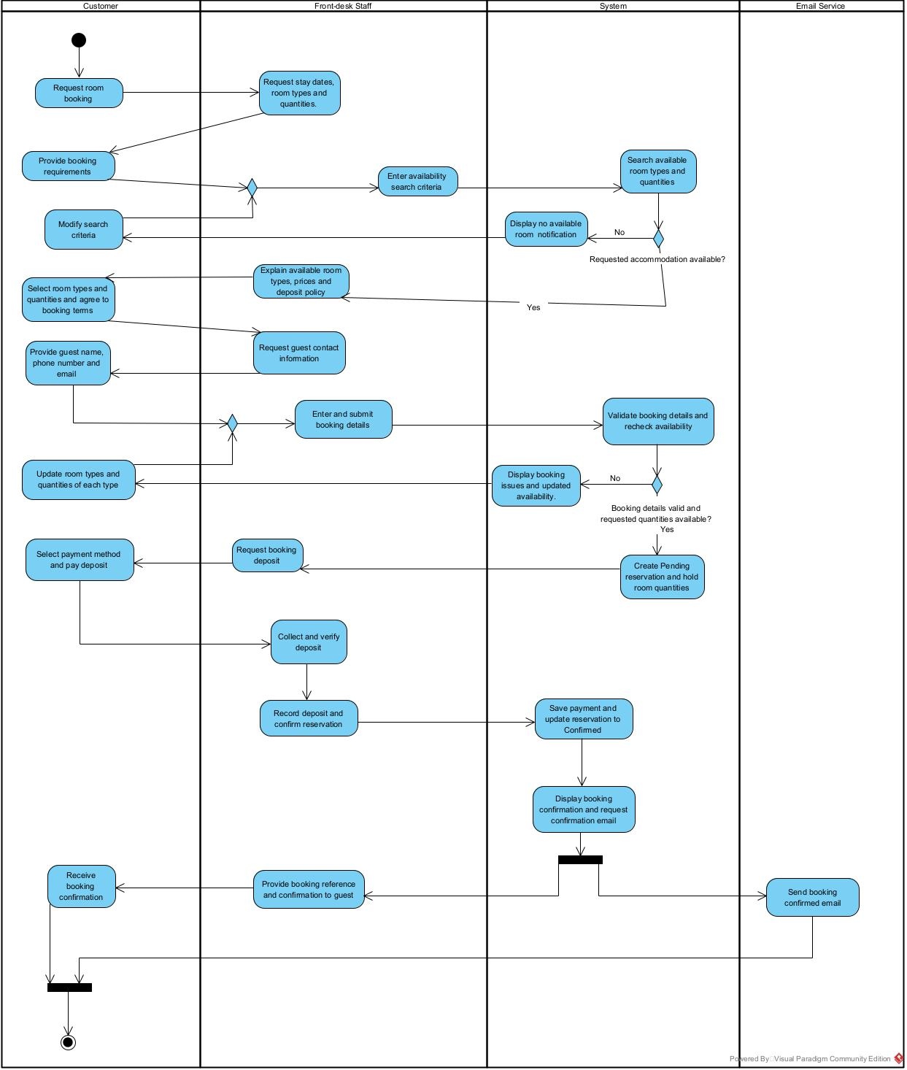

4.6 Order service
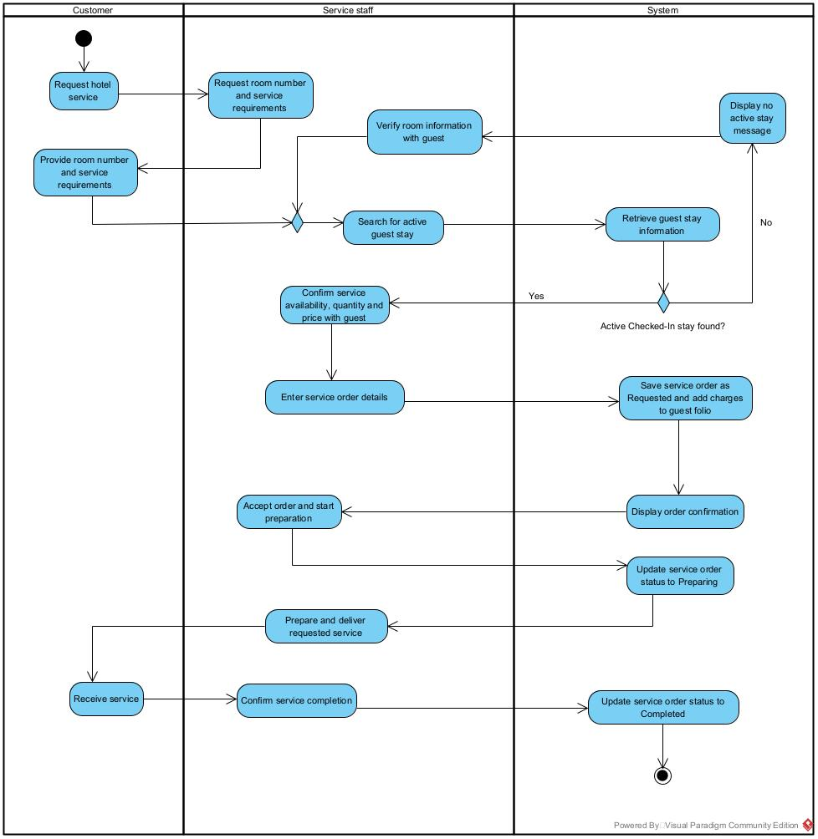

5. Non-Functional Requirements

5.1 External Interfaces
This section provides information to ensure that the system will communicate properly with users and with external hardware or software/system elements.

5.1.1 User Interfaces
The system shall provide user interfaces for authorized users to access and perform the functions defined in this SRS.
The user interfaces shall provide appropriate functions according to the user's role and permissions.

Interface | Requirement
Login Interface | The system shall provide a Login interface for users to enter their registered credentials before accessing protected functions.
User Profile Interface | The system shall provide a User Profile interface for users to view their profile information and access the profile functions available to their role.
Room Search Interface | The system shall provide a Search Available Room interface for users to enter the criteria required to search for available rooms and view the corresponding results.
Booking Interface | The system shall provide a Booking Checkout interface for customers to review the selected room and reservation information before confirming a booking.
Guest Check-in Interface | The system shall provide a Guest Check-in Form for Front-Desk Staff to enter and review the information required to check in a guest.
Active Stay Interface | The system shall provide an Active Stay interface for Front-Desk Staff to view information for guests currently staying at the hotel.
Room Service Interface | The system shall provide a Room Service interface for Customer and Front-Desk Staff to record services requested during an active guest stay.
Check-out & Billing Interface | The system shall provide a Check-out & Billing interface for Front-Desk Staff to review guest charges and payment information required for checkout.
Payment Interface | The system shall provide a Payment interface for Front-Desk Staff to enter and review payment information before recording a payment.
Invoice Receipt Interface | The system shall provide an Invoice Receipt interface for users to review and print the guest invoice receipt.
Housekeeping Interface | The system shall provide Housekeeping interfaces for Housekeeping Staff to view room housekeeping status and update the status of assigned rooms.
Maintenance Interface | The system shall provide Maintenance Room interfaces for Housekeeping Staff and Administrator to view and report room maintenance issues.
Administration Interface | The system shall provide administration interfaces for the Administrator to manage the functions assigned to the Administrator role, including users, rooms, services, reviews, audit logs, and reports.

5.1.2 Hardware Interfaces
The system shall support the hardware required for users to interact with the system and to produce printed documents.
Interface | Requirement
User Input Devices | The system shall accept input through the input devices available on the device used to access the system.
Display Device | The system shall display system interfaces and information on the display device used to access the system.
Printing Device | The system shall support printing the Invoice Receipt through a printing device available to the user.

5.1.3 Software Interfaces
The system shall exchange the information required by the external services defined in this SRS.
Interface | Requirement
Mail Notification Service | The system shall provide a software interface to the Mail Notification Service for booking confirmations, password recovery codes, and digital receipts.
Payment Gateway Integration | The system shall provide secure API integration with external payment gateways (e.g., VNPay, OnePay) for online reservation deposit processing.

5.1.4 Communication Interfaces
The system shall provide communication interfaces required to exchange information with external services.

Interface | Requirement
External Service Communication | The system shall exchange the notification information required for booking confirmations, password recovery codes, and digital receipts with the Mail Notification Service.

5.2 Quality Attributes
This section specifies measurable quality requirements for the Hotel Management System, including usability, reliability, performance, security, maintainability, availability, and compatibility.

5.2.1 Usability
The system shall provide consistent and understandable interfaces that allow users to complete their assigned tasks and identify invalid input or unsuccessful operations.

Interface / Task | Requirement
Login | The system shall provide separate input fields for the user credentials required by the Login function.
Room Search | The system shall present the room search criteria and corresponding search results within the same Room Search workflow.
Booking | The system shall present the selected room and reservation information on the Booking Checkout interface before the customer confirms the booking.
Check-in | The system shall present the guest information and room information required for check-in on the Guest Check-in Form.
Check-out | The system shall present the guest charges and payment information required for checkout on the Check-out & Billing interface.
Payment | The system shall present the payment amount and payment information before Front-Desk Staff confirms the payment.
Invoice | The system shall present the invoice information required for the user to review and print the Invoice Receipt.
Housekeeping | The system shall display the current housekeeping status of a room before Housekeeping Staff updates the status.

5.2.2 Reliability
Reliability Attribute | Requirement
Reservation Data | The system shall retain confirmed reservation information, including the booking reference, customer, requested room type, and planned stay information, after successful confirmation.
Booking Reference | The system shall retain the unique booking reference associated with each confirmed reservation.
Guest Stay | The system shall retain guest stay information created from an eligible reservation after successful check-in.
Service Order | The system shall retain each recorded service order against the corresponding active guest stay.
Folio Charges | The system shall retain recorded room charges, service charges, surcharges, discounts, and other amounts in the guest folio until the invoice is finalized.
Invoice Calculation | The system shall use the recorded folio charges, applicable discount, and tax information consistently when producing the invoice total displayed before payment.
Payment Recording | The system shall retain the payment method and received amount against the corresponding invoice after a payment operation is successfully completed.
Payment Settlement | The system shall maintain the invoice payment status consistently with the recorded payments and outstanding balance.
Check-out Completion | The system shall retain the checkout date and time and the completed booking status after a successful check-out.
Room Status after Check-out | The system shall retain the checked-out room as operational status Available and housekeeping status Dirty after successful check-out.
Housekeeping Status | The system shall retain the latest valid housekeeping status recorded for a room.
Audit Trail | The system shall retain auditable administrative operations in the audit log so that authorized users can review the recorded operation.

5.2.3 Performance
Function | Requirement
Room Search | The system shall display the available room search results within 3 seconds after the user submits the search criteria under normal operating conditions.
Booking | The system shall display the booking confirmation result within 3 seconds after the customer confirms the booking under normal operating conditions.
Check-in | The system shall display the check-in result within 3 seconds after Front-Desk Staff submits the Guest Check-in Form under normal operating conditions.
Payment | The system shall display the payment result within 3 seconds after Front-Desk Staff confirms the payment under normal operating conditions.
Invoice | The system shall generate the Invoice within 3 seconds after Front-Desk Staff initiates invoice compilation under normal operating conditions.
Reports | The system shall display the requested report within 3 seconds after the Administrator submits the report criteria under normal operating conditions.

5.2.4 Security

Security Attribute | Requirement
Authentication | The system shall require users to log in before accessing protected functions.
Role Authorization | The system shall restrict each protected function to the user roles authorized to access that function.
Unauthorized Access | The system shall prevent a user from accessing a function that is not authorized for the user's assigned role.
Password Change | The system shall require an authenticated user to provide the information required by the Change Password function before changing the account password.
Password Storage | The system shall not store user passwords in a form that allows the original password to be directly read from stored account data.
Session Termination | The system shall terminate the authenticated user session when the user logs out.
Inactive Account Access | The system shall prevent accounts that are not Active from accessing the system.

5.2.5 Maintainability
The system shall support maintenance and configuration changes without unnecessarily affecting completed reservation, guest stay, payment, invoice, or other historical transaction records.

Maintainability Attribute | Requirement
User Management | The system shall allow the Administrator to update user information and user roles without modifying existing reservation or guest stay records.
Room Configuration | The system shall allow the Administrator to update room types and room inventory through the Room Type Management and Room Inventory functions without modifying completed reservation records.
Service Configuration | The system shall allow the Administrator to update hotel service information through the Services Catalog function without modifying historical service orders already recorded for guest stays.
Review Management | The system shall allow the Administrator to manage customer reviews through the Review Moderation function without modifying the associated completed guest stay.
Configuration Isolation | The system shall keep configurable room and service information separate from completed transaction records so that later configuration changes do not alter completed records.
Change Impact | The system shall allow changes to one configurable function to be made without requiring changes to unrelated completed reservation, guest stay, payment, or invoice records.

5.2.6 Availability
The system shall remain available for normal hotel operations during the operating periods defined for the HMS

Availability Requirement | Requirement
Normal Operation | The system shall be available for users to perform the functions defined in this SRS during the hotel's defined operating periods.
Data Preservation | The system shall not lose booking, payment, invoice, or check-out data that has been successfully committed because of a temporary service interruption.

5.2.7 Compatibility
The system shall operate consistently within the supported software environment defined for the HMS.

Compatibility Requirement | Requirement
Supported Environment | The system shall operate correctly in the supported software environment specified for the HMS.
Browser Compatibility | The system shall provide the functions defined in this SRS consistently across the supported web browsers specified for the HMS.

6. Requirement Appendix
This appendix consolidates business rules, common requirements, application messages, and other requirements for the Hotel Management System.

6.1 Business Rules
Table 6.1: Business Rules

ID | Rule Definition
BR-01 | Registered email must be unique across all user accounts.
BR-02 | Only accounts with Active status can access the system.
BR-03 | Password change requires the correct current password and matching new password confirmation.
BR-04 | Password recovery link is time-limited; an expired link requires a new request.
BR-05 | Administrators cannot deactivate their own account.
BR-06 | Staff roles are Front-Desk Staff, Housekeeping Staff, Service Staff, Manager, and Administrator.
BR-07 | Room category titles must be unique and nightly price must be greater than 0.
BR-08 | Only active room categories are displayed to guests.
BR-09 | Room numbers must be unique across the property.
BR-10 | New rooms start with Vacant occupancy status and Inspected housekeeping status.
BR-11 | Room category with assigned physical rooms cannot be deactivated.
BR-12 | Occupied rooms or rooms with active or upcoming reservations cannot be archived.
BR-13 | Housekeeping status follows Dirty to Clean to Inspected; direct Inspected to Dirty requires a recorded reason.
BR-14 | Only Vacant and Inspected rooms can be assigned at check-in or transfer.
BR-15 | Maintenance reason is mandatory with a maximum of 500 characters; estimated completion must be after the current date.
BR-16 | Rooms Under Maintenance are unavailable for search, reservation, and check-in.
BR-17 | Check-in date must not be in the past; check-out date must be after the check-in date.
BR-18 | Availability search excludes Booked, Occupied, and Under Maintenance rooms.
BR-19 | New reservations start as Pending with a unique reference code, hold category quota for 24 hours, and are auto-cancelled if not confirmed or deposited in time.
BR-20 | Customers can view only bookings linked to their own account.
BR-21 | Cancellation is allowed only before check-in and may incur a penalty.
BR-22 | Only Pending reservations can be confirmed; confirmation requests a notification email to the guest.
BR-23 | Check-in requires a Confirmed reservation and a valid ID or Passport.
BR-24 | Transfer requires a Vacant and Inspected new room; the old room becomes Dirty and the folio is updated with the rate difference.
BR-25 | Stay extension requires availability for all extra nights; otherwise a room transfer is suggested.
BR-26 | Check-out requires zero outstanding balance; the room becomes Dirty after departure.
BR-27 | Service title must be unique within its category and unit price greater than 0; price changes apply to future orders only.
BR-28 | Only active services are displayed for ordering.
BR-29 | Service charges can be posted only to Checked-In stays.
BR-30 | Ordered service can be voided only before delivery with a reason; the folio is recalculated.
BR-31 | Invoice is generated as Unpaid from room charges plus service charges plus surcharges.
BR-32 | Vouchers must be within valid dates, quota, and minimum spend; an invalid voucher keeps the original balance. Each invoice accepts at most one voucher; applying a new voucher replaces the existing discount.
BR-33 | Supported payment methods are Cash, Card, and Transfer; partial payment is allowed and updates the remaining balance.
BR-34 | A fully paid invoice becomes Paid with confirmation; the receipt can be printed.
BR-35 | Early check-in before the standard time may incur a surcharge.
BR-36 | Only Completed stays can be reviewed once with a rating from 1 to 5.
BR-37 | Only verified, non-hidden reviews with replies are publicly displayed.
BR-38 | Hidden reviews are excluded from public view and rating calculation.
BR-39 | Each review accepts one management reply; further edits update the existing reply.
BR-40 | Report date range must satisfy start date on or before end date.
BR-41 | Revenue reports aggregate only Paid invoices.
BR-42 | Audit records cannot be edited or deleted by operational staff and follow a minimum 12-month retention policy.
BR-43 | Only rooms with Dirty status can be assigned for housekeeping turnover; cleaning tasks must be assigned to an active Housekeeping Staff member.

6.2 Common Requirements
Common requirements are numbered CR-01 to CR-12 and apply to all screens.
Table 6.2: Common Requirements
# | Requirement Description
CR-01 | Fields marked * are mandatory and must be provided before Confirm or Save.
CR-02 | Text fields respect maximum lengths (search keyword 50, names 100, reason and notes 500).
CR-03 | Dates use YYYY-MM-DD; estimated completion must be a future date.
CR-04 | Failed validation keeps the user on the same screen with an inline message.
CR-05 | Cancelling, voiding, hiding, or archiving requires confirmation.
CR-06 | Menus and screens are visible only to authorized roles.
CR-07 | Search or filter with no match displays a No ... message and keeps the criteria.
CR-08 | Monetary amounts are non-negative; totals are recalculated after each change.
CR-09 | Booking and invoice reference codes are unique and shown after creation.
CR-10 | List screens support search and filter by code, dates, and status.
CR-11 | All monetary operations (deposit, payment, refund) shall be recorded in the audit log.
CR-12 | Monetary amounts are displayed in VND and rounded to the nearest thousand.

6.3 Application Messages List
Table 6.3: Application Messages
# | Message code | Message Type | Context | Content
1 | MSG01A | Inline | No rooms result | No rooms found.
2 | MSG01B | Inline | No maintenance result | No maintenance rooms found.
3 | MSG01C | Inline | No available rooms result | No available rooms found.
4 | MSG01D | Inline | No bookings result | No bookings found.
5 | MSG02A | Inline error under field | Required field is empty | The {field} field is required.
6 | MSG02B | Inline error under field | Maintenance reason is empty | Maintenance reasons are required.
7 | MSG02C | Inline error under field | Housekeeping status not selected | Please select a new housekeeping status.
8 | MSG03 | Inline | Maximum length exceeded | Exceed max length of {max_length}.
9 | MSG04A | Inline | Invalid stay dates | Invalid check-in or check-out date.
10 | MSG04B | Inline | Invalid completion date | Estimated completion must be after today.
11 | MSG05 | Inline | Email already registered | Email is already registered. Please log in.
12 | MSG06 | Inline | Authentication failed | Incorrect email or password. Only Active accounts can access the system.
13 | MSG07 | Inline | Recovery link expired | The recovery link has expired. Please request a new one.
14 | MSG08A | Inline | Room occupied | The room is occupied.
15 | MSG08B | Inline | Room under maintenance | Room is under maintenance.
16 | MSG08C | Inline | Suggest alternative | Please select another room or dates.
17 | MSG09 | Inline | Voucher invalid | Invalid or expired voucher. The original balance is kept.
18 | MSG10 | Inline | Balance blocks check-out | Outstanding balance must be settled before check-out.
19 | MSG11A | Inline | Reservation created | Reservation created with code {code}.
20 | MSG11B | Inline | Housekeeping updated | Housekeeping status updated.
21 | MSG11C | Inline | Maintenance set | Maintenance set.
22 | MSG11D | Inline | Payment recorded | Payment recorded.
23 | MSG11E | Inline | Invoice paid | Invoice is Paid.
24 | MSG12A | Inline | Duplicate review | Review already submitted for this stay.
25 | MSG12B | Inline | Maintenance unavailable | Maintenance information is not available.

6.4 Other Requirements…
# | Requirement
OR-01 | Audit logs are retained for a minimum of 12 months, viewable only by the Administrator, and cannot be edited or deleted.
OR-02 | Invoice receipt is printable in A4/A5 with hotel header, booking code, itemized charges, and payment stamp.
OR-03 | Management summary export covers occupancy, revenue, bookings, and service sales for the selected period.
OR-04 | Full backup runs nightly, retained for 30 days, with RPO less than 24 hours for in-scope booking, folio, invoice, and payment data.
OR-05 | User interface supports Vietnamese and English; default is Vietnamese for staff and English for guests.

