

Hotel Management System
Software Design Document
Project Code: HMS
Document Code: HMS_SDD– v1.0

– Ha Noi, October, 2026 –

Table of Contents
1 Introduction 4
1.1 Purpose 4
1.2 Definitions, Acronyms and Abbreviations 4
1.3 References 7
2 System Architecture 8
2.1 System Overview 8
2.2 Assumptions 10
2.3 Design Constraints 11
3 Software Architecture Design 13
3.1 Architectural Representation 13
3.2 Software Architecture 13
3.2.1 Process View 15
3.2.2 Logical View 15
3.2.3 Development View 19
3.2.4 Deployment View 22
4 Detailed Component Design 22
4.1 Common Design 22
4.1.1 Exception Handling 22
4.1.2 Logging (Audit Logging) 23
4.1.3 Messages Processing 23
4.1.4 UI Structures 23
4.1.5 Utility Classes/Components 23
4.1.6 Transaction Management 24
4.2 Account & Authentication Management 24
4.2.1 Screen Design 24
4.2.2 Class/Component Design 26
4.2.3 Object Interactions (Sequence Diagram) 30
4.3 Room & Facility Management 31
4.3.1 Screen Design 31
4.3.2 Class/Component Design 34
4.3.3 Object Interactions (Sequence Diagram) 37
4.4 Reservation & Front-Desk Operations 40
4.4.1 Screen Design 40
4.4.2 Class/Component Design 44
4.4.3 Object Interactions (Sequence Diagram) 47
4.5 Ancillary Services & Billing Management 49
4.5.1 Screen Design 50
4.5.2 Class/Component Design 51
4.5.3 Object Interactions (Sequence Diagram) 54
4.6 Reviews, Audit & Reporting Management 56
4.6.1 Screen Design 56
4.6.2 Class/Component Design 57
4.6.3 Object Interactions (Sequence Diagram) 60
5. Database Design 61
5.1 Database Design 61
a. Role 62
b. User 62
c. Room_Type 63
d. Room 63
e. Reservation 63
f. Reservation_Detail 64
g. Guest_Stay 64
h. Stay_Room_Assignment 65
i. Room_Maintenance 65
j. Review 65
k. Hotel_Service 66
l. Service_Order 66
m. Folio 66
n. Folio_Item 67
o. Voucher 67
p. Invoice 68
q. Payment 68
r. Customer 69
5.2 Data File Design 69

1 Introduction

1.1 Purpose
This Software Design Document (SDD) provides a comprehensive architectural and detailed technical design for the Hotel Management System (HMS). It translates the functional and non-functional requirements specified in the HMS Software Requirement Specification (HMS-SRS-v1.2) into an executable software architecture, component structure, and relational database schema.
Specifically, this document contains the following information:
- System Architecture (Section 2): Defines the high-level Client-Server architecture, the interaction between user groups, the frontend Single Page Application (SPA), the backend application server, the relational database server (Microsoft SQL Server), and external integrated services (Payment Gateway and Mail Notification Service), along with system assumptions and design constraints.
- Software Architecture Design (Section 3): Presents the architectural views of the system, including the Process View, Logical View, Development View, and Deployment View, following the 3-Layer Architecture pattern.
- Detailed Component Design (Section 4): Specifies the common design mechanisms (error handling, logging, security filters, transaction management) and the detailed class diagrams, class specifications, screen definitions, and sequence diagrams for the system's features and use cases.
- Database Design (Section 5): Details the physical relational database tables in Microsoft SQL Server and the mapped JPA Entity and Data Transfer Object (DTO) classes.
This document is intended for the following readers:
- SBA301 Instructors: To review and evaluate the architectural soundness, adherence to software engineering standards, and compliance with the SBA301 technical stack.
- Software Developers (Frontend & Backend Engineers): To serve as the authoritative technical specification for implementing ReactJS components, Spring Boot REST controllers, business services, and Spring Data JPA repositories.
- Quality Assurance (QA) / Testing Engineers: To understand component interfaces, API contracts, and transaction boundaries when designing unit and integration test cases.

1.2 Definitions, Acronyms and Abbreviations
The table below lists all common business and technical definitions, acronyms, and abbreviations used throughout this Software Design Document:

Term / Acronym | Full Form / Definition | Description
HMS | Hotel Management System | The centralized web-based software platform designed to coordinate daily lodging operations across independent 3-star to 4-star hotels.
SRS | Software Requirement Specification | The baseline requirements document (HMS-SRS-v1.2) specifying the functional and non-functional requirements of the HMS.
SDD | Software Design Document | This document, which describes the system architecture, component design, and database design of the HMS.
SPA | Single Page Application | A web application implemented in ReactJS that dynamically updates the current page via JavaScript without requiring full page reloads from the server.
CSR | Client-Side Rendering | A rendering model in which the client web browser renders the user interface using JavaScript and exchanges JSON data with backend APIs.
REST | Representational State Transfer | An architectural style for networked applications using standard stateless HTTP methods (GET, POST, PUT, DELETE) to manipulate resources.
API | Application Programming Interface | A set of defined endpoints exposed by the backend server to enable communication with the frontend client and external services.
JWT | JSON Web Token | An open standard (RFC 7519) used for stateless user authentication and authorization between the client browser and the backend server.
RBAC | Role-Based Access Control | A security approach that restricts system access to authorized user roles (Customer, Front-Desk Staff, Housekeeping Staff, Service Staff, Administrator).
ORM | Object-Relational Mapping | A programming technique (using Hibernate) that maps object-oriented domain entities in Java to relational database tables.
JPA | Java Persistence API | The Jakarta EE specification used via Spring Data JPA for managing relational data in Java applications.
DTO | Data Transfer Object | An object used to encapsulate and transfer data between the presentation layer and the service layer, decoupling database entities from API payloads.
DAO / Repository | Data Access Object / Repository | The persistence layer abstraction responsible for executing database CRUD queries and encapsulating data access logic.
RDBMS | Relational Database Management System | The relational database engine (Microsoft SQL Server) used to store structured, transactional hotel data.
Folio | Guest Stay Folio | The financial ledger of an active guest stay that accumulates room charges, service orders, and surcharges prior to invoice generation.
SMTP | Simple Mail Transfer Protocol | The standard communication protocol used to send outbound transactional emails via an external mail server.

1.3 References
The following table lists the documents, standards, and technical specifications referenced by this Software Design Document:

No. | Document Title / Standard | Version | Date | Author / Source / Location
1 | Hotel Management System – Software Requirement Specification (HMS-SRS) | v1.2 | Oct 2026 | HMS Project Team (KhangND, HieuVQ, GiapND, LinhNH, TungPV) – FPT University
2 | Software Design Document (SDD) Template | v1.0 | 2026 | Department of Software Engineering, FPT University
3 | SBA301 Courseware & Lecture Materials | 2026 | 2026 | FPT University Academic Curriculum (ReactJS SPA, RESTful APIs, Spring Boot 3, JPA/Hibernate, MongoDB, JWT Security)
4 | Spring Boot & Spring Security Reference Documentation | 3.2+ | 2024 | VMware / Spring.io (https://docs.spring.io/spring-boot/)
5 | React Official Documentation | 18.2+ | 2024 | Meta Open Source (https://react.dev/)
6 | OpenAPI Specification (Springdoc-OpenAPI / Swagger 3) | 3.0.3 | 2024 | OpenAPI Initiative (https://swagger.io/specification/)
7 | RFC 7519 – JSON Web Token (JWT) | Standard | May 2015 | Internet Engineering Task Force (https://datatracker.ietf.org/doc/html/rfc7519)

2 System Architecture

2.1 System Overview
The Hotel Management System (HMS) is designed using a decoupled Client-Server Architecture. All end-user groups interact with the system through a modern web browser running a Single Page Application (SPA), which communicates with the backend application server over HTTP/HTTPS using RESTful JSON APIs. The backend server processes business logic, enforces security and transaction rules, persists data across relational and document databases, and integrates with external payment and email services.
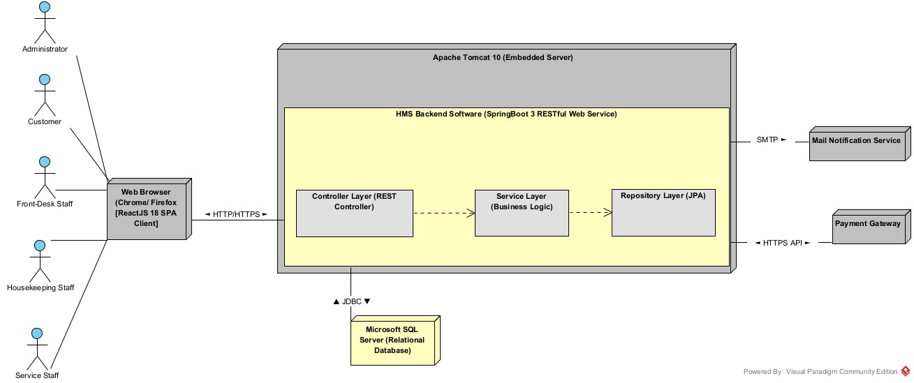
Figure 2-1: System Architectural Overview
As described in Figure 2-1, the system will have the following components:
- User Groups (Actors):
  - Customer: An external guest who accesses public and customer-specific features via a web browser to browse room categories, search real-time room availability, create online reservations with advance deposit payments, order room services during an active stay, view booking histories, and submit room reviews after departure.
  - Front-Desk Staff: A receptionist responsible for front-office operations, including confirming pending offline/direct reservations, verifying guest identification and allocating clean physical rooms at check-in, handling mid-stay room transfers and stay extensions, compiling itemized invoices, applying discount vouchers, recording counter payments, and completing guest check-outs.
  - Housekeeping Staff: A floor staff member or housekeeping supervisor who monitors room inventory, updates room cleanliness states (Dirty $→$ Clean $→$ Inspected), and places out-of-order rooms under maintenance.
  - Service Staff: An operational staff member from ancillary service departments (F&B, room service, minibar, spa, laundry) who views active service orders, posts consumed service charges onto active guest stay folios, and voids unrendered service items.
  - Administrator: A hotel manager, accountant, or IT administrator who configures master data (room types, physical rooms, hotel services, promotional vouchers), manages user accounts and role assignments, moderates customer reviews, inspects system audit logs, and generates occupancy and revenue analytical reports.
- Web Browser & HMS ReactJS SPA Client: This is the client-side presentation component accessed by all five user groups on desktop or mobile web browsers (Google Chrome, Mozilla Firefox, Microsoft Edge). It is developed as a Single Page Application (SPA) using ReactJS 18, React Router DOM for client-side navigation across the 54 screens defined in the SRS, React-Bootstrap for responsive UI layouts, and Axios for sending asynchronous HTTP/HTTPS requests with JSON payloads and JWT Bearer tokens to the backend server.
- HMS Backend Software: This is the core developing server software built on Java 21 and the Spring Boot 3 framework, deployed on an embedded Apache Tomcat 10 application server. Internally, it is organized into a strict 3-Layer Architecture (Controller $→$ Service $→$ Repository), secured by Spring Security 6 with stateless JWT (JSON Web Token) authentication, and documented using Springdoc-OpenAPI (Swagger 3).
- Microsoft SQL Server 2022: This is the primary Relational Database Management System (RDBMS) connected to the HMS Backend Software via JDBC and managed through Spring Data JPA / Hibernate ORM. It stores all structured, relational, and ACID-compliant operational entities, including user accounts, room types, physical rooms, reservations, guest stays, hotel services, service orders, folios, invoices, vouchers, payments, and customer reviews.
- Payment Gateway (VNPay / OnePay): This is an external third-party electronic payment processing system that the HMS Backend Software integrates with over HTTPS REST APIs to authorize online reservation deposit payments (UC-23) and receive authenticated transaction confirmation results.
- Mail Notification Service: This is an external mail server (e.g., Google SMTP Service) that the HMS Backend Software integrates with via the SMTP protocol (JavaMailSender) in order to send password recovery verification links (UC-10), booking confirmation notices (UC-23, UC-26), and digital itemized invoice receipts to users.

2.2 Assumptions
This system is designed based on the following assumptions regarding hardware, software, operating systems, end-user characteristics, and operational environment:
- Server Operating System & Runtime Environment:
  - Windows Server 2019/2022 or Ubuntu Linux 22.04 LTS (64-bit).
  - Java Development Kit (JDK) 21 LTS installed on the application server with a minimum of 8 GB RAM.
  - Node.js v18.x LTS or higher and npm v9.x+ available in the build environment for compiling the ReactJS frontend bundle.
- Database Management Systems:
  - Microsoft SQL Server 2019 or 2022 installed and accessible via TCP port 1433.
  - Automated nightly database backups are configured at the infrastructure level to retain backups for 30 days and maintain a Recovery Point Objective (RPO) of less than 24 hours (OR-04).
- Client Hardware, Operating Systems & Software:
  - End-user devices (desktop PCs at the front desk, laptops, tablets, or smartphones) running Windows 10/11, macOS, Android, or iOS.
  - Modern ECMAScript 6+ compliant web browsers: Google Chrome (v110+), Mozilla Firefox (v110+), Microsoft Edge (v110+), or Apple Safari (v16+) with JavaScript and localStorage enabled.
  - Standard A4/A5 laser or thermal receipt printers connected to front-desk workstations and PDF viewer software (e.g., Adobe Acrobat Reader or built-in browser print engine) to print itemized invoice receipts (Section 5.1.2 & OR-02 of SRS).
- Network & External Services Availability:
  - The hotel property (60 to 150 rooms) has stable local area network (LAN) and continuous broadband internet connectivity.
  - External third-party services—specifically the Payment Gateway (VNPay/OnePay) and the SMTP Mail Notification Service—are operational, reachable over the internet, and respond within standard network timeout limits.
- End-User Characteristics & Operational Scope:
  - Hotel staff (Front-Desk, Housekeeping, Service Staff, and Administrators) possess basic computer literacy and web browser navigation skills.
  - Physical room key cards are handed over manually by front-desk receptionists and recorded by serial number in the Guest Check-in Form (UC-27); direct hardware integration with physical RFID door lock encoders is outside the scope of this software

2.3 Design Constraints
This system must comply with the following global limitations, architectural standards, and business rules imposed by the HMS-SRS-v1.2 and the SBA301 technical framework:
- Architectural & Technology Stack Constraints:
  - 3-Layer Backend Architecture: The Spring Boot backend must strictly separate responsibilities into three layers: controllers (REST API handling), services (business logic and transaction management), and repositories (data persistence). Controllers must not access Repositories directly, and database Entity objects must not be exposed directly to the client without Data Transfer Object (DTO) mapping.
  - Single Page Application (SPA) Frontend: The user interface must be implemented as a ReactJS SPA using Functional Components and React Hooks (useState, useEffect, useContext). Legacy React Class Components and server-side HTML rendering (e.g., JSP) are prohibited.
  - Client-Server Communication Protocol: All data transfers between the web browser and the backend server must be executed asynchronously via Axios over HTTP/HTTPS using RESTful conventions and application/json; charset=UTF-8 payloads.
- Performance & Scalability Constraints:
  - 3-Second Response Time SLA: In compliance with Section 5.2.3 of the SRS, every core operation—including Room Availability Search (UC-21), Booking Creation (UC-23), Guest Check-in (UC-27), Invoice Compilation (UC-37), Payment Settlement (UC-39), and Report Generation (UC-45..47)—must complete and display results within 3 seconds under normal operating conditions.
  - Server-Side Pagination: All list and search endpoints (room inventory, customer bookings, user accounts, service catalog, and audit logs) must implement server-side pagination and filtering using Spring Data's Pageable and Page<T> interfaces to prevent memory bottlenecks (CR-10).
- Security & Access Control Constraints:
  - Stateless JWT Authentication & Account Status Enforcement: Protected API endpoints must require a valid JWT Bearer token in the Authorization HTTP header. Only accounts with Active status are permitted to access the system (BR-02), and deactivating a user account (UC-08) must immediately revoke access for any active tokens belonging to that account.
  - Role-Based Authorization: Both frontend route guards and backend Spring Security filters must strictly enforce the role permissions defined in the Screen Authorization Matrix (Section 3.1.3 of SRS and CR-06).
  - Password Cryptography: User passwords must never be stored or transmitted in plaintext (Section 5.2.4 of SRS); all passwords must be hashed using the one-way BCrypt hashing algorithm before being persisted in the database.
- Data Repository, Transaction & Business Rule Constraints:
  - ACID Transaction Management: Multi-step state changes—such as Guest Check-in (updating Reservation status to Checked-In, creating a Guest Stay, initializing a Folio, and setting Room status to Occupied), Room Transfer (UC-28), Stay Extension (UC-29), and Guest Check-out (UC-30)—must be executed within atomic database transactions (@Transactional) so that any failure rolls back all partial changes (Section 5.2.2 & 5.2.6 of SRS).
  - Configuration Isolation for Historical Records: In accordance with Section 5.2.5 of the SRS and BR-27, updates to room category base tariffs (UC-12) or hotel service unit prices (UC-32) must not alter completed reservations, historical service orders, or finalized invoices. Transactional tables must snapshot the applicable unit price at the time of creation.
  - 24-Hour Pending Reservation Hold: New reservations created in Pending status must hold room category quota for 24 hours and be automatically cancelled by a scheduled background task (@Scheduled) if deposit or confirmation is not completed within 24 hours (BR-19).
  - Immutable Audit Trail & Retention Policy: All monetary operations (deposit, payment, refund – CR-11) and auditable administrative actions must be logged in an append-only audit store, retained for a minimum of 12 months, and restricted from editing or deletion by operational staff (BR-42, OR-01).
  - Currency & Rounding Standard: All monetary amounts must be non-negative, stored using exact decimal types (BigDecimal / DECIMAL), displayed in VND, and rounded to the nearest thousand (CR-08, CR-12).
- User Interface, Localization & API Documentation Constraints:
  - Bilingual Support: The user interface must support both Vietnamese (default for staff roles) and English (default for guests/customers) as specified in OR-05.
  - Standardized Validation & Application Messages: Failed input validations must keep the user on the same screen and return standardized inline message codes (MSG01A to MSG12B) matching Section 6.2 (CR-01 to CR-12) and Section 6.3 of the SRS.
  - OpenAPI / Swagger Compliance: All RESTful API endpoints must be documented using Springdoc-OpenAPI (Swagger 3) annotations to facilitate verification, validation, and API testing.

3 Software Architecture Design

3.1 Architectural Representation
The Hotel Management System (HMS) architecture is represented through four architectural views: Logical View, Process View, Development View, and Deployment View. These views describe the system structure, runtime behavior, source code organization, and physical deployment.

View | Purpose | UML Diagrams Used
Logical View | Describes the internal structure of the HMS, including major classes, responsibilities, and relationships. | Class Diagram
Process View | Describes runtime behavior and interactions among system components during major hotel operations. | Activity Diagram
Development View | Describes the organization of the system into frontend modules, backend layers, and package dependencies. | Package Diagram
Deployment View | Describes how the ReactJS client, Spring Boot backend, SQL Server, MongoDB, and external services are deployed and connected. | Deployment Diagram

3.2 Software Architecture

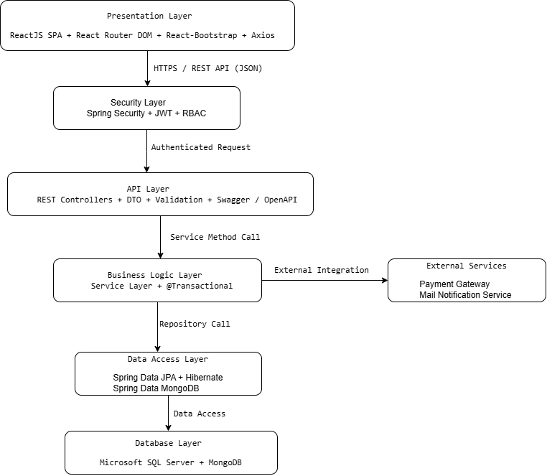
Figure 3-1: HMS Layered Architecture Pattern

Layer | Responsibility
Presentation | Renders the user interface, handles user interactions, manages client-side navigation, and sends HTTP/HTTPS requests via Axios.
Security | Intercepts protected requests, validates JWT tokens, verifies account status, and enforces role-based access control.
API | Receives REST requests, validates input data, delegates processing to the Business Logic Layer, and returns DTO responses.
Business Logic | Implements business rules, manages transactions, coordinates repositories, and integrates with external services.
Data Access | Abstracts persistence operations using Spring Data JPA, Hibernate ORM, and Spring Data MongoDB.
Database | Persists structured transactional data in Microsoft SQL Server and audit log documents in MongoDB.

3.2.1 Process View
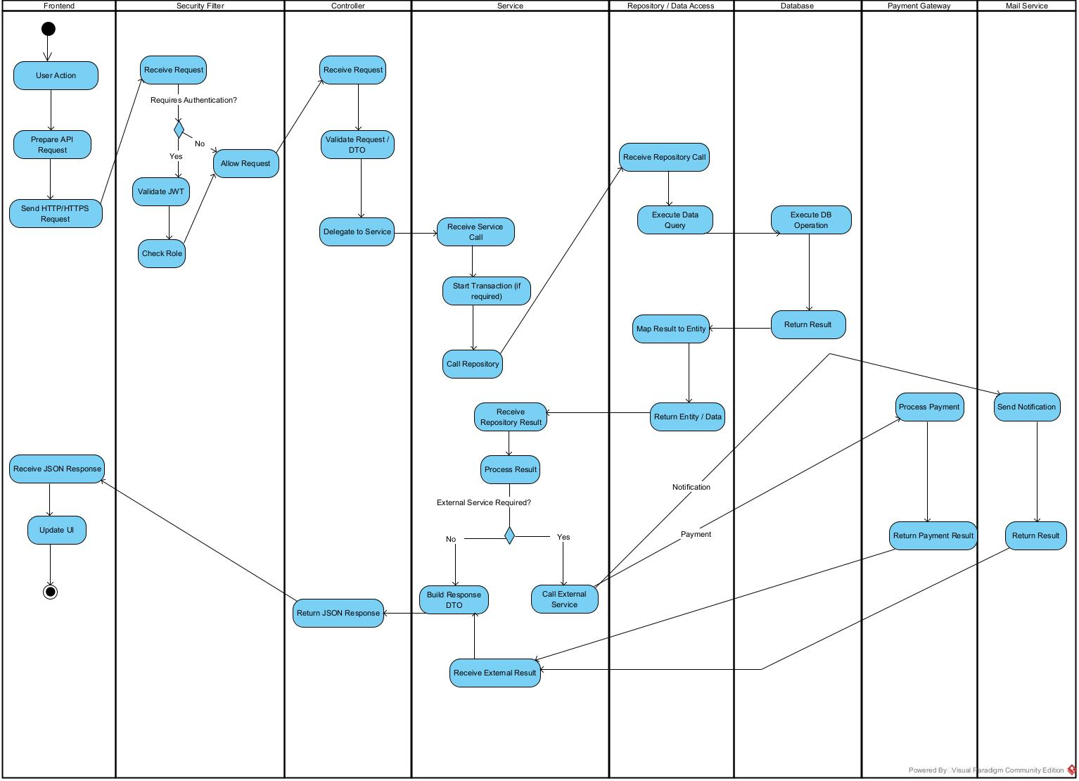
Figure 3-2: HMS Process Overview

3.2.2 Logical View
3.2.2.1 Frontend Logical View
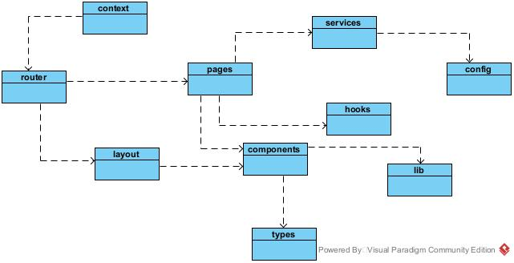

Figure 3-3: HMS FrontEnd Logical Overview

Package | Responsibility
contexts | Provides shared application state such as authentication status, current user information, and role data.
config | Stores application configuration such as API base URLs, constants, and environment settings.
router | Manages application routes, navigation, protected routes, and role-based access using React Router DOM.
layouts | Provides common page layouts such as headers, navigation bars, sidebars, and page containers.
pages | Contains page-level modules for major HMS functions such as booking, check-in, active stay, housekeeping, services, reviews, and administration.
components | Contains reusable UI components shared across multiple pages.
services | Handles communication with backend REST APIs using Axios and organizes API calls by functional module.
hooks | Contains reusable React Hooks for state handling, data loading, and shared frontend logic.
lib | Provides common utility functions and helper logic used by frontend modules.
types | Defines shared data structures and frontend data models used across components and services.

3.2.2.1 Backend Logical View
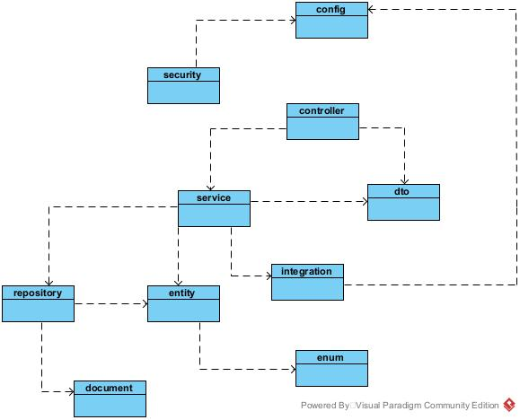
Figure 3-4: HMS Back-End Logical Overview

Package | Responsibility
config | Contains application-level configuration for CORS, Swagger/OpenAPI, database access, security, payment gateway, and mail integration.
security | Handles JWT authentication, password encoding, account validation, and role-based authorization.
controller | Receives REST API requests, validates request data, delegates processing to the Service layer, and returns response DTOs.
service | Implements business rules, manages transactions, coordinates repositories, and invokes external integrations when required.
repository | Provides data access operations for SQL Server and MongoDB using Spring Data repositories.
entity | Contains JPA entity models mapped to relational tables in Microsoft SQL Server through Hibernate ORM.
dto | Defines request and response data transfer objects used between API and service layers.
integration | Handles communication with external systems such as the Payment Gateway and Mail Notification Service.
document | Contains MongoDB document models used for document-based data such as system audit logs.
enum | Defines shared constant value types such as user roles, reservation status, room status, payment status, and other domain states.

3.2.3 Development View

3.2.3.1 Package Diagram

3.2.3.1.1 Back end package diagram
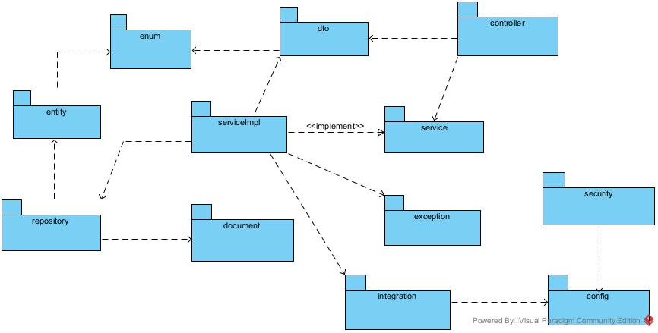
Figure 3-1: HMS Back-End Package Diagram

No | Package | Description
01 | Config | Contains application configuration for CORS, OpenAPI, security, database access, payment, and mail services.
02 | Security | Handles JWT authentication, password encoding, and role-based access control.
03 | Controller | Contains REST controllers that receive HTTP requests and delegate processing to services.
04 | DTO | Contains request and response objects used for data exchange between layers.
05 | Entity | Contains JPA entity classes mapped to relational tables in Microsoft SQL Server.
06 | Document | Contains MongoDB document models used for document-based data such as audit logs.
07 | Enums | Defines shared constant values such as user roles, reservation status, room status, and payment status.
08 | Exception | Contains custom exceptions and global exception handling components.
09 | Repository | Contains Spring Data repositories for accessing SQL Server and MongoDB data.
10 | Service | Defines service interfaces for business operations.
11 | ServiceImpl | Implements service interfaces, business rules, and transaction processing.
12 | Integration | Handles communication with external systems such as the Payment Gateway and Mail Notification Service.

3.2.3.1.2 Front-end package diagram
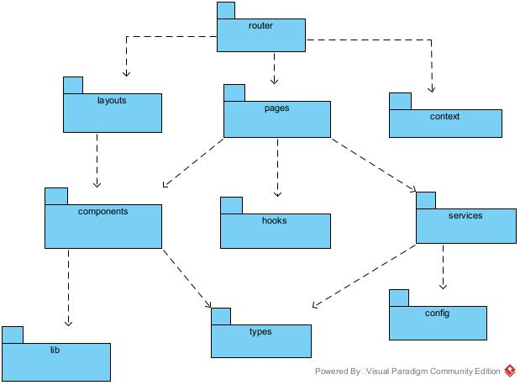
Figure 3-2: HMS Front-End Package Diagram

No | Package | Description
01 | router | Manages application routing, navigation, protected routes, and role-based route access.
02 | layouts | Defines shared page layouts such as headers, sidebars, navigation areas, and page containers.
03 | pages | Contains page-level components corresponding to major HMS screens and application routes.
04 | context | Manages shared application state such as authentication status, current user, and role information using React Context API.
05 | components | Contains reusable UI components shared across multiple pages.
06 | hooks | Contains reusable React Hooks for shared state handling, data loading, and frontend logic.
07 | services | Handles communication with backend REST APIs and organizes API calls by functional module.
08 | config | Contains frontend configuration such as API base URLs, environment settings, and shared constants.
09 | lib | Contains reusable utility functions and helper logic used across frontend modules.
10 | types | Defines shared data types and interfaces used by pages, components, and services.

3.2.4 Deployment View

Configuration Description
No | Component/Node | Description
01 | < name> | <Description of the component>
02

4 Detailed Component Design

4.1 Common Design
This section defines the standardized architectural mechanisms, shared components, and cross-cutting concerns applied across all five subsystems (50 use cases and 54 screens) of the Hotel Management System (HMS). It covers centralized exception handling, audit logging, application message processing, frontend UI structures, shared utility components, and declarative transaction management.

4.1.1 Exception Handling
The HMS backend implements a centralized exception handling mechanism using Spring Boot’s @RestControllerAdvice (GlobalExceptionHandler). This ensures that all runtime, validation, security, and business rule exceptions thrown from any Controller or Service are intercepted and transformed into a uniform JSON payload (ApiErrorResponse).
Response Payload Attributes:
- Timestamp (LocalDateTime): The exact UTC timestamp of the error.
- status (int): HTTP status code (e.g., 400 Bad Request, 401 Unauthorized, 403 Forbidden, 404 Not Found, 409 Conflict).
- ErrorCode (String): Standardized business rule code matching the SRS error catalogue (e.g., MSG01C, MSG04A, MSG08A, MSG09, MSG10).
- Message (String): Descriptive client-facing message.
- ValidationErrors (Map<String, String>): Key-value map detailing invalid field names and rejection reasons.
Core Custom Exceptions:
- ResourceNotFoundException: Thrown when an entity (Room, Reservation, Stay, Invoice) does not exist.
- BusinessException: Thrown when a business constraint is violated (e.g., uninspected room assignment, non-zero balance checkout).
- InvalidReservationStateException: Thrown during illegal lifecycle state transitions.
- UnauthorizedOperationException: Thrown when access is forbidden by RBAC.

4.1.2 Logging (Audit Logging)
- All monetary operations (deposit, payment, refund) and auditable administrative actions must be logged.
- The system persists these records as immutable AuditLog documents within a MongoDB (NoSQL) document database.
- These audit records follow a minimum 12-month retention policy, cannot be edited or deleted by operational staff, and are viewable only by the Administrator.

4.1.3 Messages Processing
- The system utilizes a standardized application message catalogue with predefined codes (MSG01A to MSG12B)
- Failed input validations keep the user on the same screen and return standardized inline messages.
- The user interface supports bilingual messaging: Vietnamese is the default for staff roles, and English is the default for guests/customers.

4.1.4 UI Structures
- The frontend is built as a Single Page Application (SPA) using ReactJS 18 with Functional Components, React Router DOM for client-side navigation, and React-Bootstrap for responsive UI layouts.
- The UI relies on common page layouts such as headers, navigation bars, sidebars, and page containers.
- To prevent memory bottlenecks, all list and search endpoints (e.g., room inventory, customer bookings, user accounts) must implement server-side pagination and filtering using Spring Data's Pageable and Page<T> interfaces.
- On forms, fields marked with * are mandatory and must be provided before actions like Confirm or Save can be executed.

4.1.5 Utility Classes/Components
- Frontend: Reusable React Hooks are provided for shared state handling and data loading, while common utility functions and helper logic are organized within the hooks and lib packages. Axios is utilized for sending asynchronous HTTP/HTTPS requests with JSON payloads.
- Backend: Data Transfer Objects (DTO) are used to encapsulate and transfer data between the presentation layer and the service layer. This ensures that database Entity objects are not exposed directly to the client via API payloads.

4.1.6 Transaction Management
- The backend enforces strict ACID Transaction Management using Spring Boot's @Transactional annotation.
- Multi-step state changes—such as Guest Check-in (which involves updating the Reservation status to Checked-In, creating a Guest Stay, initializing a Folio, and setting the Room status to Occupied), Room Transfers, Stay Extensions, and Check-outs—must be executed within atomic database transactions. If any failure occurs, all partial changes are rolled back.
- The design enforces "Configuration Isolation" for historical records: updates to room category base tariffs or hotel service unit prices must not alter completed reservations, historical service orders, or finalized invoices.

4.2 Account & Authentication Management
The Account & Authentication subsystem coordinates identity access management, user registration, role governance, credential recovery, and secure JWT-based stateless session management across all user personas (Customer, Front-Desk Staff, Housekeeping Staff, Administrator). This section details the detailed component design covering UC-01 through UC-10.

4.2.1 Screen Design
Figure 4-1 illustrates the user authentication screen. Table 4-1 provides the control specifications for the login interface.
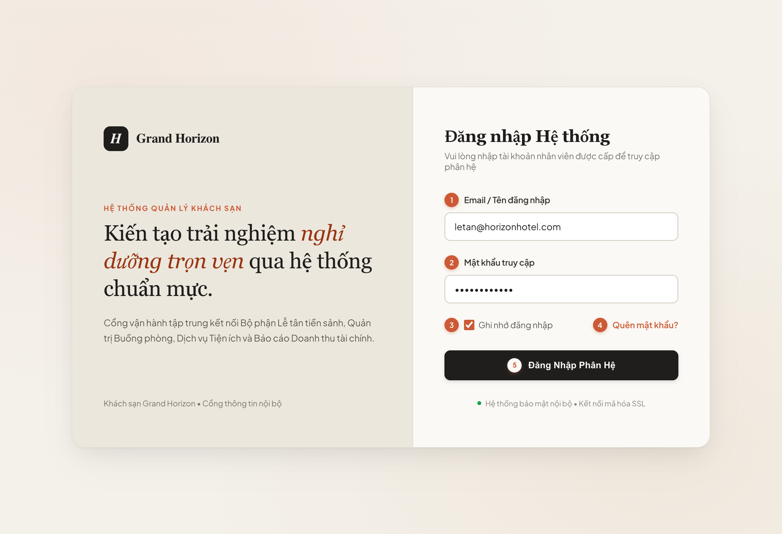
Figure 4-1: Screen Design of User Login (UC-02)
Table 4-1: Screen Definition for User Login (UC-02)
No | Object/Control Name | Type | Required | Length | Description
(1) | txtUsername | TextField | Yes | 4-100 chars | Input field for registered staff user email [DB Mapping: tbl_user.email]. Validates RFC 5322 syntax.
(2) | txtPassword | PasswordField | Yes | 6-50 chars | Secure masked password input. Compared against BCrypt hash [DB Mapping: tbl_user.password_hash].
(3) | chkRememberMe | Checkbox | No | Default: false | Controls refresh token cookie expiration (7 days persistent vs session-only).
(4) | lnkForgotPassword | Hyperlink | No | Redirect | Navigates to secure staff password recovery workflow (UC-10).
(5) | btnLogin | Button | Yes | Trigger API | Initiates Step 1 in Sequence Diagram UC-02; dispatches HTTP POST /api/v1/auth/login [Auth Filter Validation].

4.2.2 Class/Component Design

4.2.2.1 Backend Class Diagram
The backend architecture strictly adheres to standard Java Spring Boot 3-Tier Enterprise patterns. The diagram uses flat layout and strictly applies standard UML relationship arrows: Realization (..|>) between ServiceImpl and Interface, Dependency (..>) from Controller to Service and Repository to Entity, and Aggregation (o--) for Spring bean dependency injection and domain entity associations.
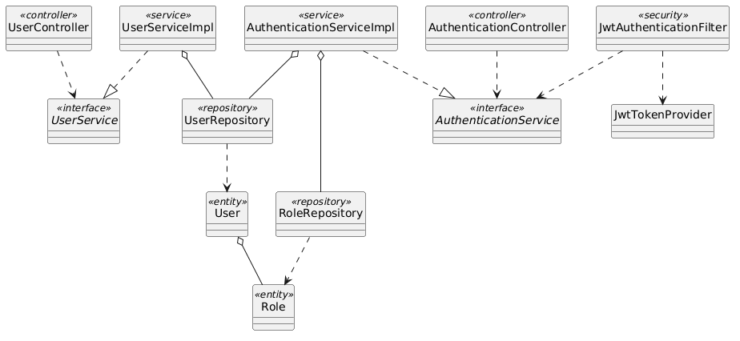
Figure 4-2: Backend Class/Component Structure Diagram for Account & Authentication

4.2.2.2 Classes/Component Description
4.2.2.2.1 AuthenticationController Class
Class | AuthenticationController
Description | Exposes REST endpoints for user authentication, token issuance, and password recovery.
Base Class | None
Constructor | + AuthenticationController(authService: AuthenticationService)
Prototype | @RestController @RequestMapping("/api/v1/auth") public class AuthenticationController
Source File | com/hotel/hms/controller/AuthenticationController.java
Namespace | com.hotel.hms.controller
Attributes | Name | Type | Description
 | authService | AuthenticationService | Business logic interface for credential authentication.
Methods | Name | Input | Output | Description
 | login | LoginRequestDTO request | ResponseEntity<AuthResponseDTO> | Authenticates credentials and returns JWT bearer token.
 | resetPassword | ResetPasswordDTO request | ResponseEntity<Void> | Validates token and commits updated credential.

4.2.2.2.2 AuthenticationServiceImpl Class
Class | AuthenticationServiceImpl
Description | Implements core authentication flows, BCrypt credential matching, and JWT token generation.
Base Class | AuthenticationService
Constructor | + AuthenticationServiceImpl(userRepo: UserRepository, roleRepo: RoleRepository, tokenProvider: JwtTokenProvider)
Prototype | @Service @Transactional public class AuthenticationServiceImpl implements AuthenticationService
Source File | com/hotel/hms/service/impl/AuthenticationServiceImpl.java
Namespace | com.hotel.hms.service.impl
Attributes | Name | Type | Description
 | userRepository | UserRepository | Data access for user identity retrieval.
 | roleRepository | RoleRepository | Data access for user authorization roles.
 | jwtTokenProvider | JwtTokenProvider | Component generating HMAC-SHA signed JWT tokens.
Methods | Name | Input | Output | Description
 | authenticate | LoginRequestDTO dto | AuthResponseDTO | Verifies password hash and produces JWT accessToken with role claims.
 | requestPasswordReset | String email | void | Generates reset token and invokes MailNotificationService.

4.2.2.2.3 UserRepository Class
Class | UserRepository
Description | Spring Data JPA repository providing database queries for User entity records.
Base Class | JpaRepository<User, Long>
Constructor | None (Spring Data JPA Interface)
Prototype | @Repository public interface UserRepository extends JpaRepository<User, Long>
Source File | com/hotel/hms/repository/UserRepository.java
Namespace | com.hotel.hms.repository
Attributes | Name | Type | Description
 | None | - | Inherits standard Spring Data JPA persistence context.
Methods | Name | Input | Output | Description
 | findByEmail | String email | Optional<User> | Retrieves active user account by unique email address.
 | existsByEmail | String email | boolean | Checks uniqueness of email during account registration.

4.2.2.2.4 User Class
Class | User
Description | JPA entity mapped to table 'User'. Represents staff and customer account credentials and operational status.
Base Class | None
Constructor | + User()
Prototype | @Entity @Table(name = "User") public class User
Source File | com/hotel/hms/entity/User.java
Namespace | com.hotel.hms.entity
Attributes | Name | Type | Description
 | userId | Long | Primary key identifier of user.
 | email | String | Unique email address used for system login.
 | passwordHash | String | BCrypt hashed secret key; never stored in plaintext.
 | fullName | String | Full legal name of the user.
 | role | Role | Many-to-One reference to Role entity.
 | phone | String | Contact telephone number (mapped to User.phone in Section 5).
 | status | String | Operational account status: ACTIVE, SUSPENDED, DELETED (mapped to User.status in Section 5).
Methods | Name | Input | Output | Description
 | getUserId | void | Long | Returns user primary key.
 | getPasswordHash | void | String | Returns hashed credential.

4.2.3 Object Interactions (Sequence Diagram)
Figure 4-3 illustrates the runtime sequence flow for UC-02 User Login. Table 4-2 details each interaction step.
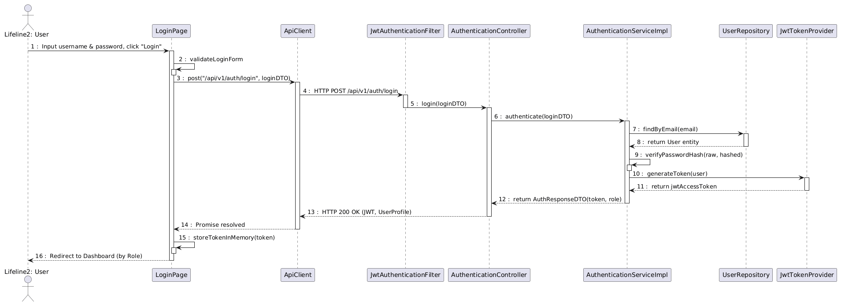
Figure 4-3: Sequence Diagram for UC-02 User Login Flow
Table 4-2: Interaction Steps for UC-02 User Login Flow
Step | Caller (From) | Callee (To) | Action / Method | Description
1 | User | LoginPage | Input credentials & click 'Login' | Submits email and password on login form.
2-3 | LoginPage | LoginPage | validateLoginForm() | Client validation for mandatory email and password length.
4 | LoginPage | ApiClient | post('/api/v1/auth/login', dto) | Axios HTTP POST request to authentication API.
5 | ApiClient | JwtAuthenticationFilter | doFilterInternal() | Security filter intercepts request; passes unauthenticated endpoint.
6 | JwtAuthenticationFilter | AuthenticationController | login(loginDTO) | Transfers request to REST controller.
7 | AuthenticationController | AuthenticationServiceImpl | authenticate(loginDTO) | Delegates credential verification to business service.
8-9 | AuthenticationServiceImpl | UserRepository | findByEmail(email) | Queries User entity from database by email.
10 | AuthenticationServiceImpl | AuthenticationServiceImpl | verifyPasswordHash() | Validates password against BCrypt hash.
11-12 | AuthenticationServiceImpl | JwtTokenProvider | generateToken(user) | Generates HMAC-SHA signed JWT token containing user ID and Role claims.
13 | AuthenticationServiceImpl | AuthenticationController | return AuthResponseDTO | Returns JWT token and user profile data.
14 | AuthenticationController | ApiClient | HTTP 200 OK (JSON) | REST API responds with JWT bearer token.
15 | ApiClient | LoginPage | Promise resolved | Frontend receives authenticated token.
16 | LoginPage | User | Redirect to Dashboard | Stores token in memory and navigates user based on role.

4.3 Room & Facility Management
The Room & Facility Management subsystem governs physical accommodation categories, room units, floor indexing, real-time cleanliness states, and maintenance lockouts (UC-11 through UC-20). This section details the complete technical design focusing on UC-19 (Update Housekeeping Status) and UC-20 (Set Room Maintenance).

4.3.1 Screen Design
Figures 4-4 and 4-5 show the screen designs for the Housekeeping Board and Set Room Maintenance Form. Tables 4-3 and 4-4 define their controls.
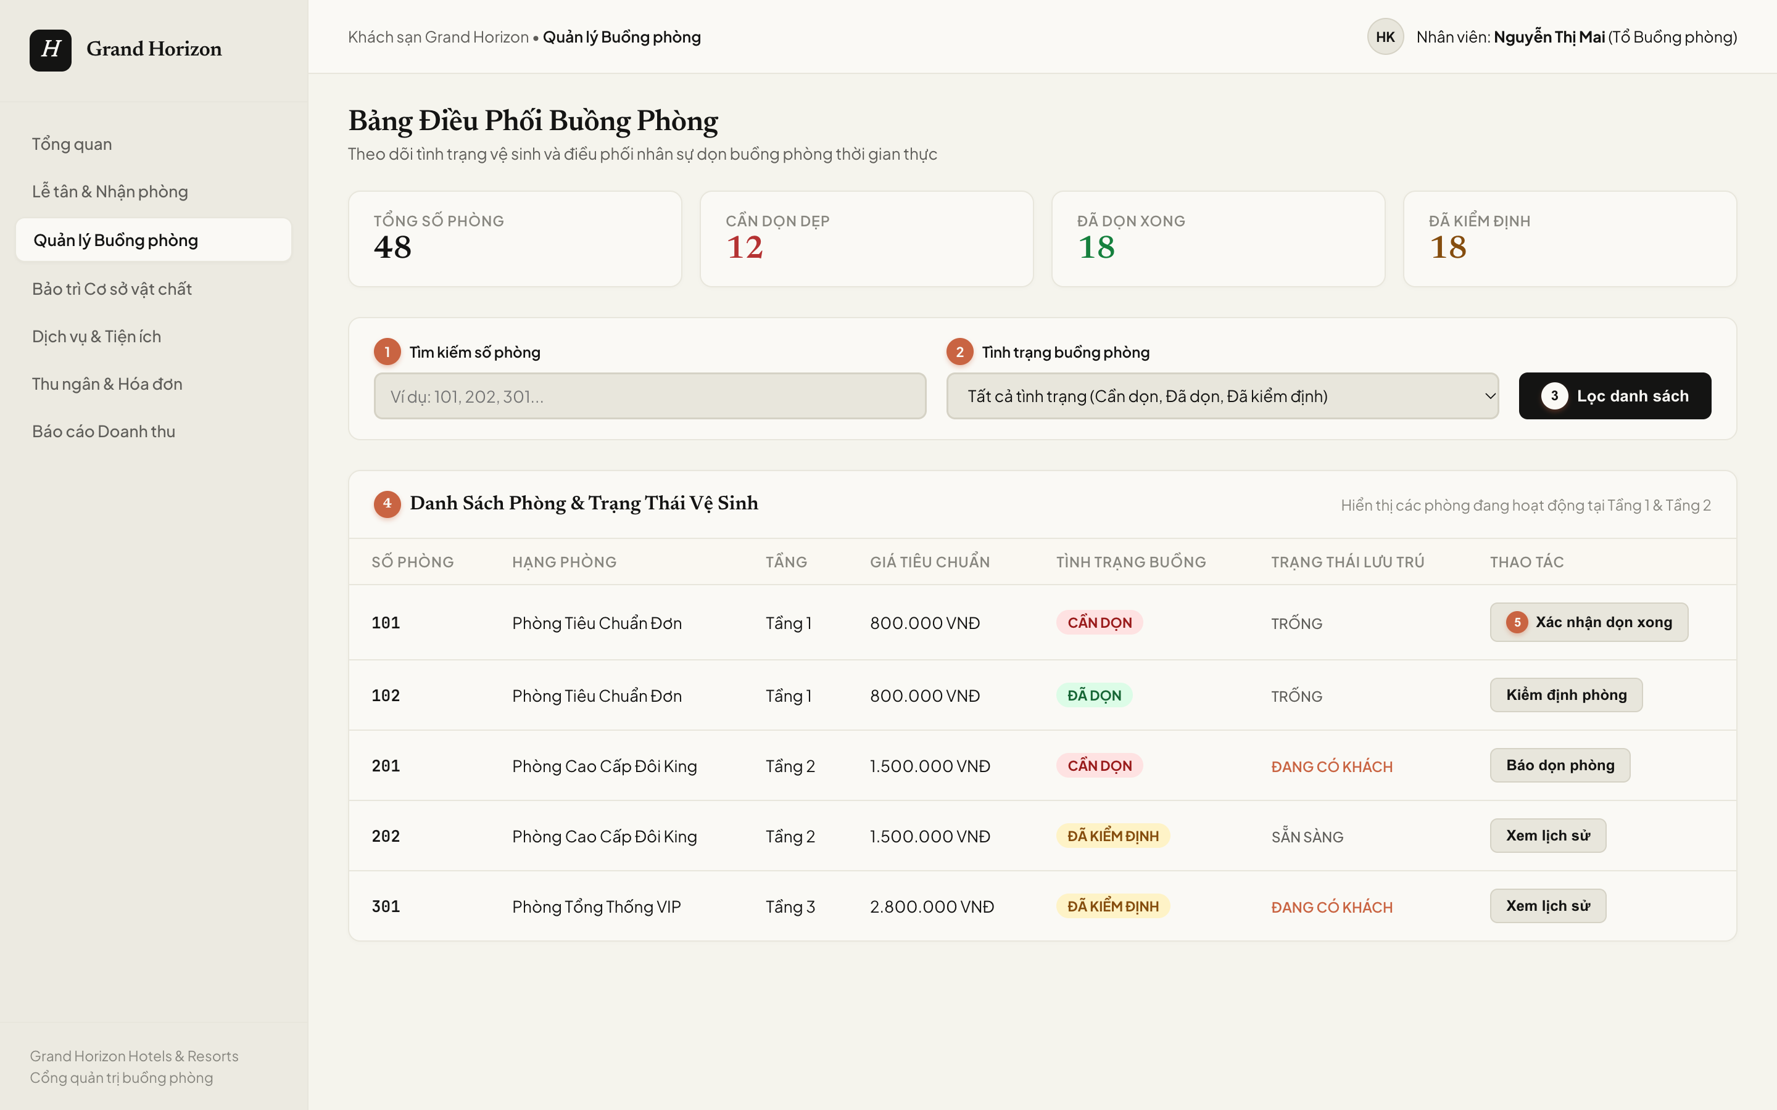
Figure 4-4: Screen Design of Housekeeping Board (UC-19)
Table 4-3: Screen Definition for Housekeeping Board (UC-19)
No | Object/Control Name | Type | Required | Length | Description
(1) | txtSearchRoomNo | TextBox | No | 50 chars | Keyword search filtering physical rooms by door number [DB Mapping: tbl_room.room_number].
(2) | cboHousekeepingStatus | Dropdown | No | N/A | Filter dropdown for sanitation criteria [DB Mapping: tbl_room.status in (DIRTY, CLEAN, INSPECTED)].
(3) | btnFilter | Button | Yes | Trigger API | Applies search criteria and executes GET /api/v1/housekeeping/rooms to re-render grid.
(4) | gridRoomList | Grid / Table | Yes | N/A | Dynamic room sanitation dataset [DB Mapping: tbl_room INNER JOIN tbl_room_type ON room_type_id].
(5) | btnConfirmClean | Button | Yes | Trigger API | Row action initiating Step 1 in Sequence Diagram UC-19; transitions room state [DB Action: UPDATE tbl_room.status = 'CLEAN'].

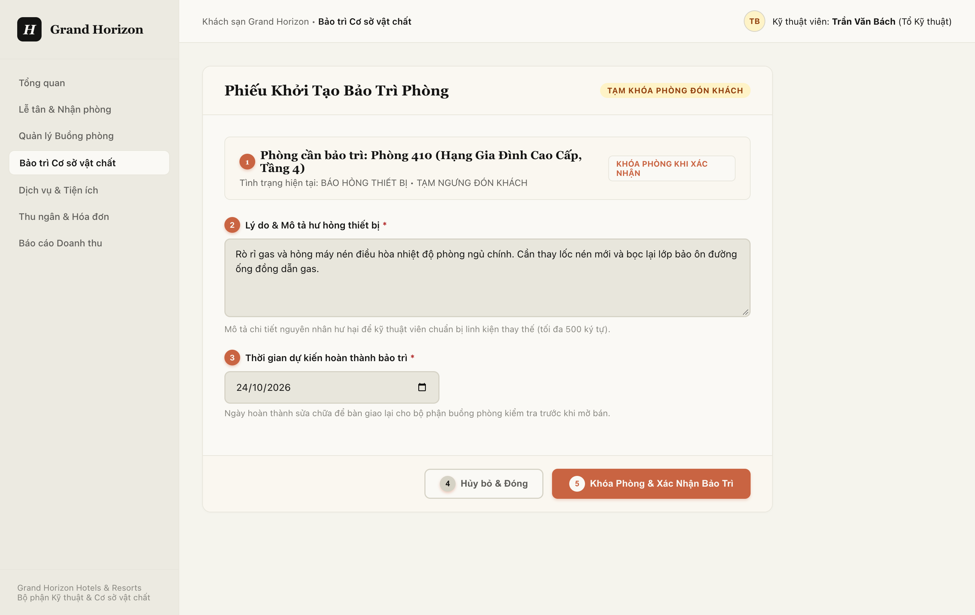
Figure 4-5: Screen Design of Set Room Maintenance Form (UC-20)
Table 4-4: Screen Definition for Set Room Maintenance Form (UC-20)
No | Object/Control Name | Type | Required | Length | Description
(1) | lblRoomSelected | Label / Display | Yes | N/A | Displays target physical room number and category [DB Mapping: tbl_room.room_number, tbl_room_type.type_name].
(2) | txtMaintenanceReason | TextArea | Yes | 500 chars | Mandatory technical explanation of defect [DB Mapping: tbl_room_maintenance.note] (*). Enforces Rule BR-16.
(3) | dtMaintainedAt | DatePicker | Yes | YYYY-MM-DD | Target completion date [DB Mapping: tbl_room_maintenance.maintained_at] (*).
(4) | btnCancel | Button | No | Redirect | Cancels maintenance order creation and returns to room overview.
(5) | btnConfirmMaintenance | Button | Yes | Trigger API | Dispatches POST /api/v1/rooms/maintenance [DB Action: INSERT tbl_room_maintenance, UPDATE tbl_room.status = 'UNDER_MAINTENANCE'].

4.3.2 Class/Component Design

4.3.2.1 Backend Class Diagram
Figure 4-6 presents the backend class diagram for Room & Facility Management using flat layout and rigorous UML relationships: Realization (..|>) for services, Dependency (..>) for controller and repository interactions, and Aggregation (o--) for repository injection and entity associations.
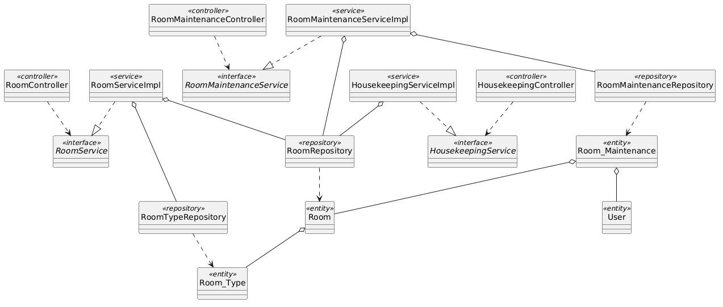
Figure 4-6: Backend Class/Component Structure Diagram for Room & Facility Management

4.3.2.2 Classes/Component Description
4.3.2.2.1 HousekeepingController Class
Class | HousekeepingController
Description | REST controller exposing endpoints for housekeeping board retrieval and room hygiene updates.
Base Class | None
Constructor | + HousekeepingController(housekeepingService: HousekeepingService)
Prototype | @RestController @RequestMapping("/api/v1/housekeeping") public class HousekeepingController
Source File | com/hotel/hms/controller/HousekeepingController.java
Namespace | com.hotel.hms.controller
Attributes | Name | Type | Description
 | housekeepingService | HousekeepingService | Service handling cleanliness transitions.
Methods | Name | Input | Output | Description
 | updateCleanliness | Long roomId, CleanlinessDTO dto | ResponseEntity<RoomDTO> | Updates room status to CLEAN.
 | getBoard | Integer floor, String status | ResponseEntity<List<RoomDTO>> | Retrieves rooms filtered by floor and status.

4.3.2.2.2 RoomMaintenanceServiceImpl Class
Class | RoomMaintenanceServiceImpl
Description | Service executing room maintenance scheduling, guest occupancy conflict verification, and inventory locking.
Base Class | RoomMaintenanceService
Constructor | + RoomMaintenanceServiceImpl(maintenanceRepo: RoomMaintenanceRepository, roomRepo: RoomRepository)
Prototype | @Service @Transactional public class RoomMaintenanceServiceImpl implements RoomMaintenanceService
Source File | com/hotel/hms/service/impl/RoomMaintenanceServiceImpl.java
Namespace | com.hotel.hms.service.impl
Attributes | Name | Type | Description
 | roomMaintenanceRepository | RoomMaintenanceRepository | Persistence repository for maintenance records.
 | roomRepository | RoomRepository | Persistence repository for room operational status.
Methods | Name | Input | Output | Description
 | scheduleMaintenance | Long roomId, MaintenanceDTO dto | MaintenanceResponseDTO | Checks occupancy, creates RoomMaintenance record, and sets room status to UNDER_MAINTENANCE.
 | checkOccupancyStatus | Room room | void | Throws RoomOccupiedException if room currently has active guest stay.

4.3.2.2.3 RoomRepository Class
Class | RoomRepository
Description | Spring Data JPA repository managing physical room records and operational states.
Base Class | JpaRepository<Room, Long>
Constructor | None (Spring Data JPA Interface)
Prototype | @Repository public interface RoomRepository extends JpaRepository<Room, Long>
Source File | com/hotel/hms/repository/RoomRepository.java
Namespace | com.hotel.hms.repository
Attributes | Name | Type | Description
 | None | - | Inherits Spring Data JPA persistence context.
Methods | Name | Input | Output | Description
 | findByRoomNumber | String roomNumber | Optional<Room> | Finds room record by unique door number.
 | updateRoomStatus | Long roomId, String status | int | Modifies room operational status in SQL Server.

4.3.2.2.4 Room Class
Class | Room
Description | JPA entity mapped to table 'Room'. Stores physical room number, room type reference, and status.
Base Class | None
Constructor | + Room()
Prototype | @Entity @Table(name = "Room") public class Room
Source File | com/hotel/hms/entity/Room.java
Namespace | com.hotel.hms.entity
Attributes | Name | Type | Description
 | roomId | Long | Primary key identifier of room.
 | roomNumber | String | Unique door number (e.g., '301').
 | status | String | Current state: VACANT, OCCUPIED, DIRTY, CLEAN, UNDER_MAINTENANCE.
 | roomType | Room_Type | Many-to-One reference to Room_Type entity.
Methods | Name | Input | Output | Description
 | isAvailable | void | boolean | Returns true if room is VACANT and CLEAN.
 | setStatus | String status | void | Sets new operational status.

4.3.3 Object Interactions (Sequence Diagram)
Figures 4-7 and 4-8 depict runtime sequence interactions for UC-19 and UC-20. Tables 4-5 and 4-6 list each interaction step.
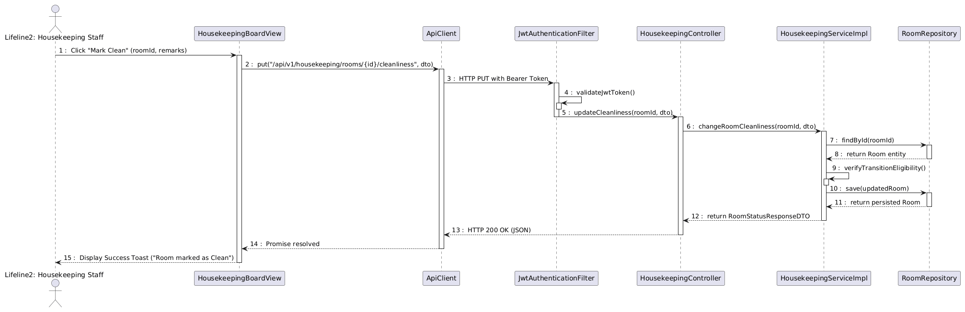
Figure 4-7: Sequence Diagram for UC-19 Update Housekeeping Status
Table 4-5: Interaction Steps for UC-19 Update Housekeeping Status
Step | Caller (From) | Callee (To) | Action / Method | Description
1 | HKStaff | HousekeepingBoardView | Click 'Mark Clean' | Housekeeping staff confirms room cleaning completion.
2 | HousekeepingBoardView | ApiClient | put('/api/v1/housekeeping/...') | Dispatches HTTP PUT request with Bearer JWT.
3-4 | ApiClient | JwtAuthenticationFilter | validateJwtToken() | Validates JWT signature and role claims.
5 | JwtAuthenticationFilter | HousekeepingController | updateCleanliness() | Invokes controller endpoint.
6 | HousekeepingController | HousekeepingServiceImpl | changeRoomCleanliness() | Transfers request to transactional service.
7-8 | HousekeepingServiceImpl | RoomRepository | findById(roomId) | Loads Room entity from database.
9 | HousekeepingServiceImpl | HousekeepingServiceImpl | verifyTransitionEligibility() | Validates state transition rule (DIRTY -> CLEAN).
10-11 | HousekeepingServiceImpl | RoomRepository | save(updatedRoom) | Commits updated Room entity with status 'CLEAN'.
12 | HousekeepingServiceImpl | HousekeepingController | return RoomStatusResponseDTO | Returns updated DTO payload.
13 | HousekeepingController | ApiClient | HTTP 200 OK (JSON) | REST API responds with HTTP 200.
14 | ApiClient | HousekeepingBoardView | Display Success Toast | Board refreshes room card to CLEAN.

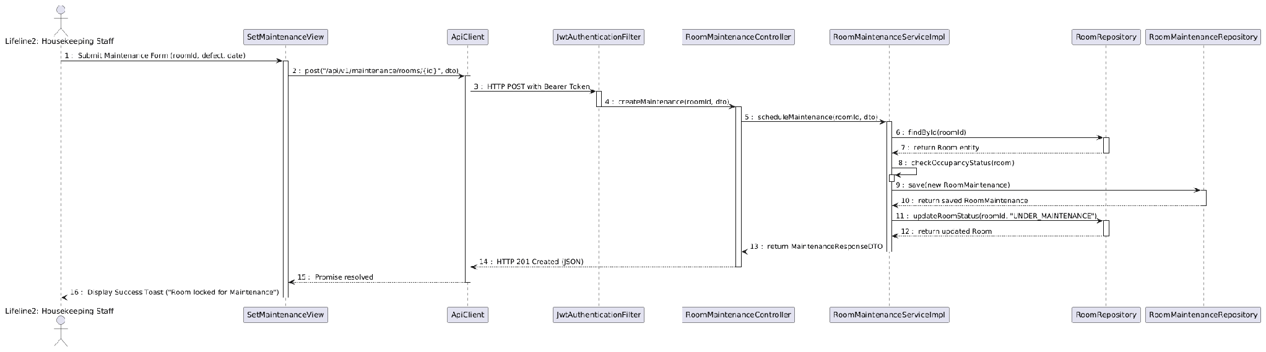
Figure 4-8: Sequence Diagram for UC-20 Set Room Maintenance
Table 4-6: Interaction Steps for UC-20 Set Room Maintenance
Step | Caller (From) | Callee (To) | Action / Method | Description
1 | HKStaff | SetMaintenanceView | Submit Maintenance Form | Submits defect note and estimated completion date.
2 | SetMaintenanceView | ApiClient | post('/api/v1/maintenance/...') | Dispatches HTTP POST request with Bearer JWT.
3 | ApiClient | JwtAuthenticationFilter | validateJwtToken() | Validates token credentials.
4 | JwtAuthenticationFilter | RoomMaintenanceController | createMaintenance() | Invokes Controller endpoint.
5 | RoomMaintenanceController | RoomMaintenanceServiceImpl | scheduleMaintenance() | Delegates to maintenance service.
6-7 | RoomMaintenanceServiceImpl | RoomRepository | findById(roomId) | Loads Room entity from database.
8 | RoomMaintenanceServiceImpl | RoomMaintenanceServiceImpl | checkOccupancyStatus() | Verifies room is not currently OCCUPIED.
9-10 | RoomMaintenanceServiceImpl | RoomMaintenanceRepository | save(new RoomMaintenance) | Persists maintenance order record.
11-12 | RoomMaintenanceServiceImpl | RoomRepository | updateRoomStatus('MAINTENANCE') | Updates status to UNDER_MAINTENANCE.
13 | RoomMaintenanceServiceImpl | RoomMaintenanceController | return MaintenanceResponseDTO | Returns maintenance ticket DTO.
14 | RoomMaintenanceController | ApiClient | HTTP 201 Created | REST API confirms room locked.
15 | ApiClient | SetMaintenanceView | Display Success Toast | Closes dialog and refreshes inventory.

4.4 Reservation & Front-Desk Operations
The Reservation & Front-Desk subsystem manages guest accommodation discovery, online reservation checkout, front-desk arrival check-in, physical room key allocation, and active guest stay tracking (UC-21 through UC-30). This section details UC-21/23 (Room Reservation) and UC-27 (Guest Check-in).

4.4.1 Screen Design
Figures 4-9 and 4-10 illustrate the user interfaces for Booking Checkout and Guest Check-in. Tables 4-7 and 4-8 define their controls.
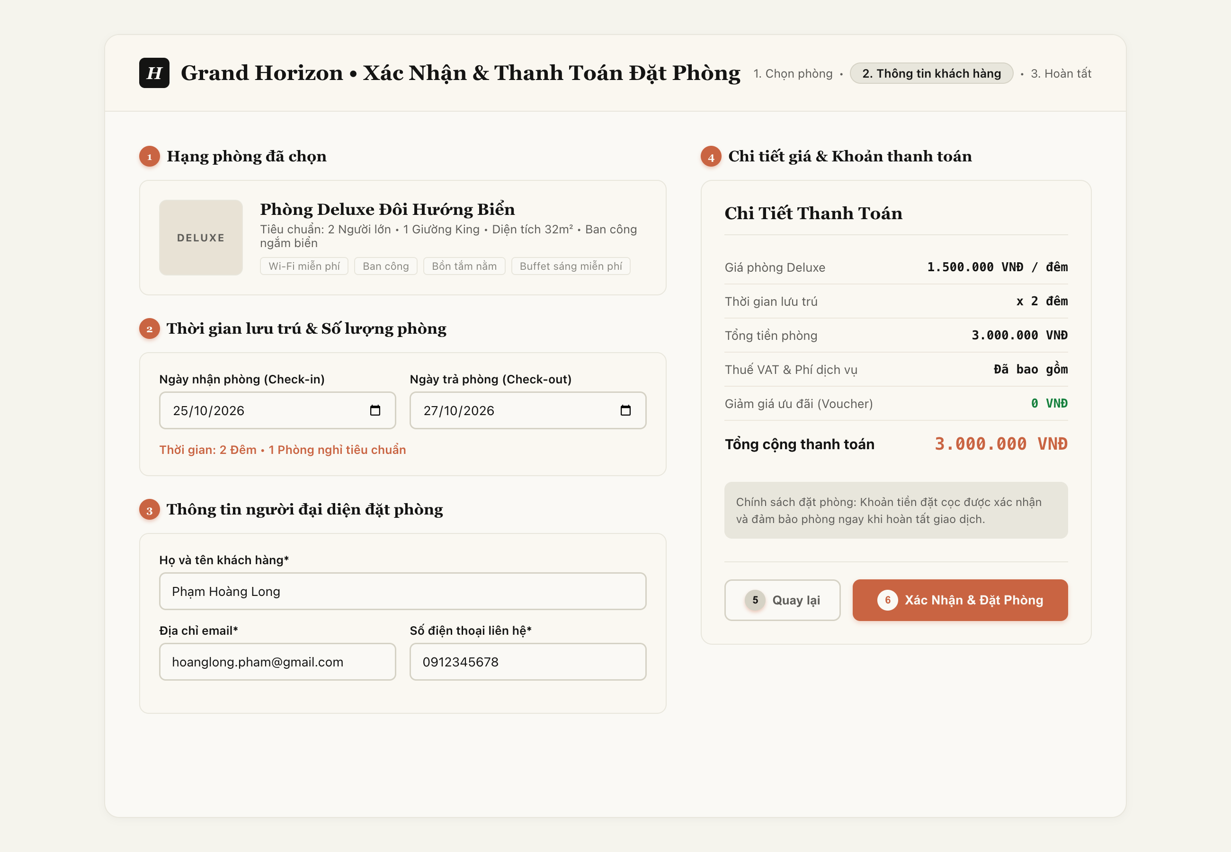
Figure 4-9: Screen Design of Booking Checkout (UC-23)
Table 4-7: Screen Definition for Booking Checkout (UC-23)
No | Object/Control Name | Type | Required | Length | Description
(1) | pnlRoomOverview | Display / Panel | Yes | N/A | Displays reserved room category, capacity, and base price [DB Mapping: tbl_room_type.type_name, capacity, base_price].
(2) | pnlBookingDates | Input / Panel | Yes | N/A | Selects scheduled stay interval and room count [DB Mapping: tbl_reservation.check_in_date, check_out_date, tbl_reservation_detail.quantity].
(3) | pnlGuestContact | Input / Panel | Yes | N/A | Primary guest contact information fields [DB Mapping: tbl_reservation.contact_name, contact_email, contact_phone].
(4) | tblPriceDetails | Display / Table | Yes | Currency | Itemized tariff calculation [DB Mapping: tbl_reservation_detail.agreed_rate * duration; tbl_payment.amount deposit].
(5) | btnBack | Button | No | Redirect | Navigates back to room search and category selection catalog.
(6) | btnConfirmBooking | Button | Yes | Trigger API | Initiates Step 1 in Sequence Diagram UC-23 [DB Action: INSERT tbl_reservation (status='CONFIRMED'), INSERT tbl_reservation_detail, INSERT tbl_payment].

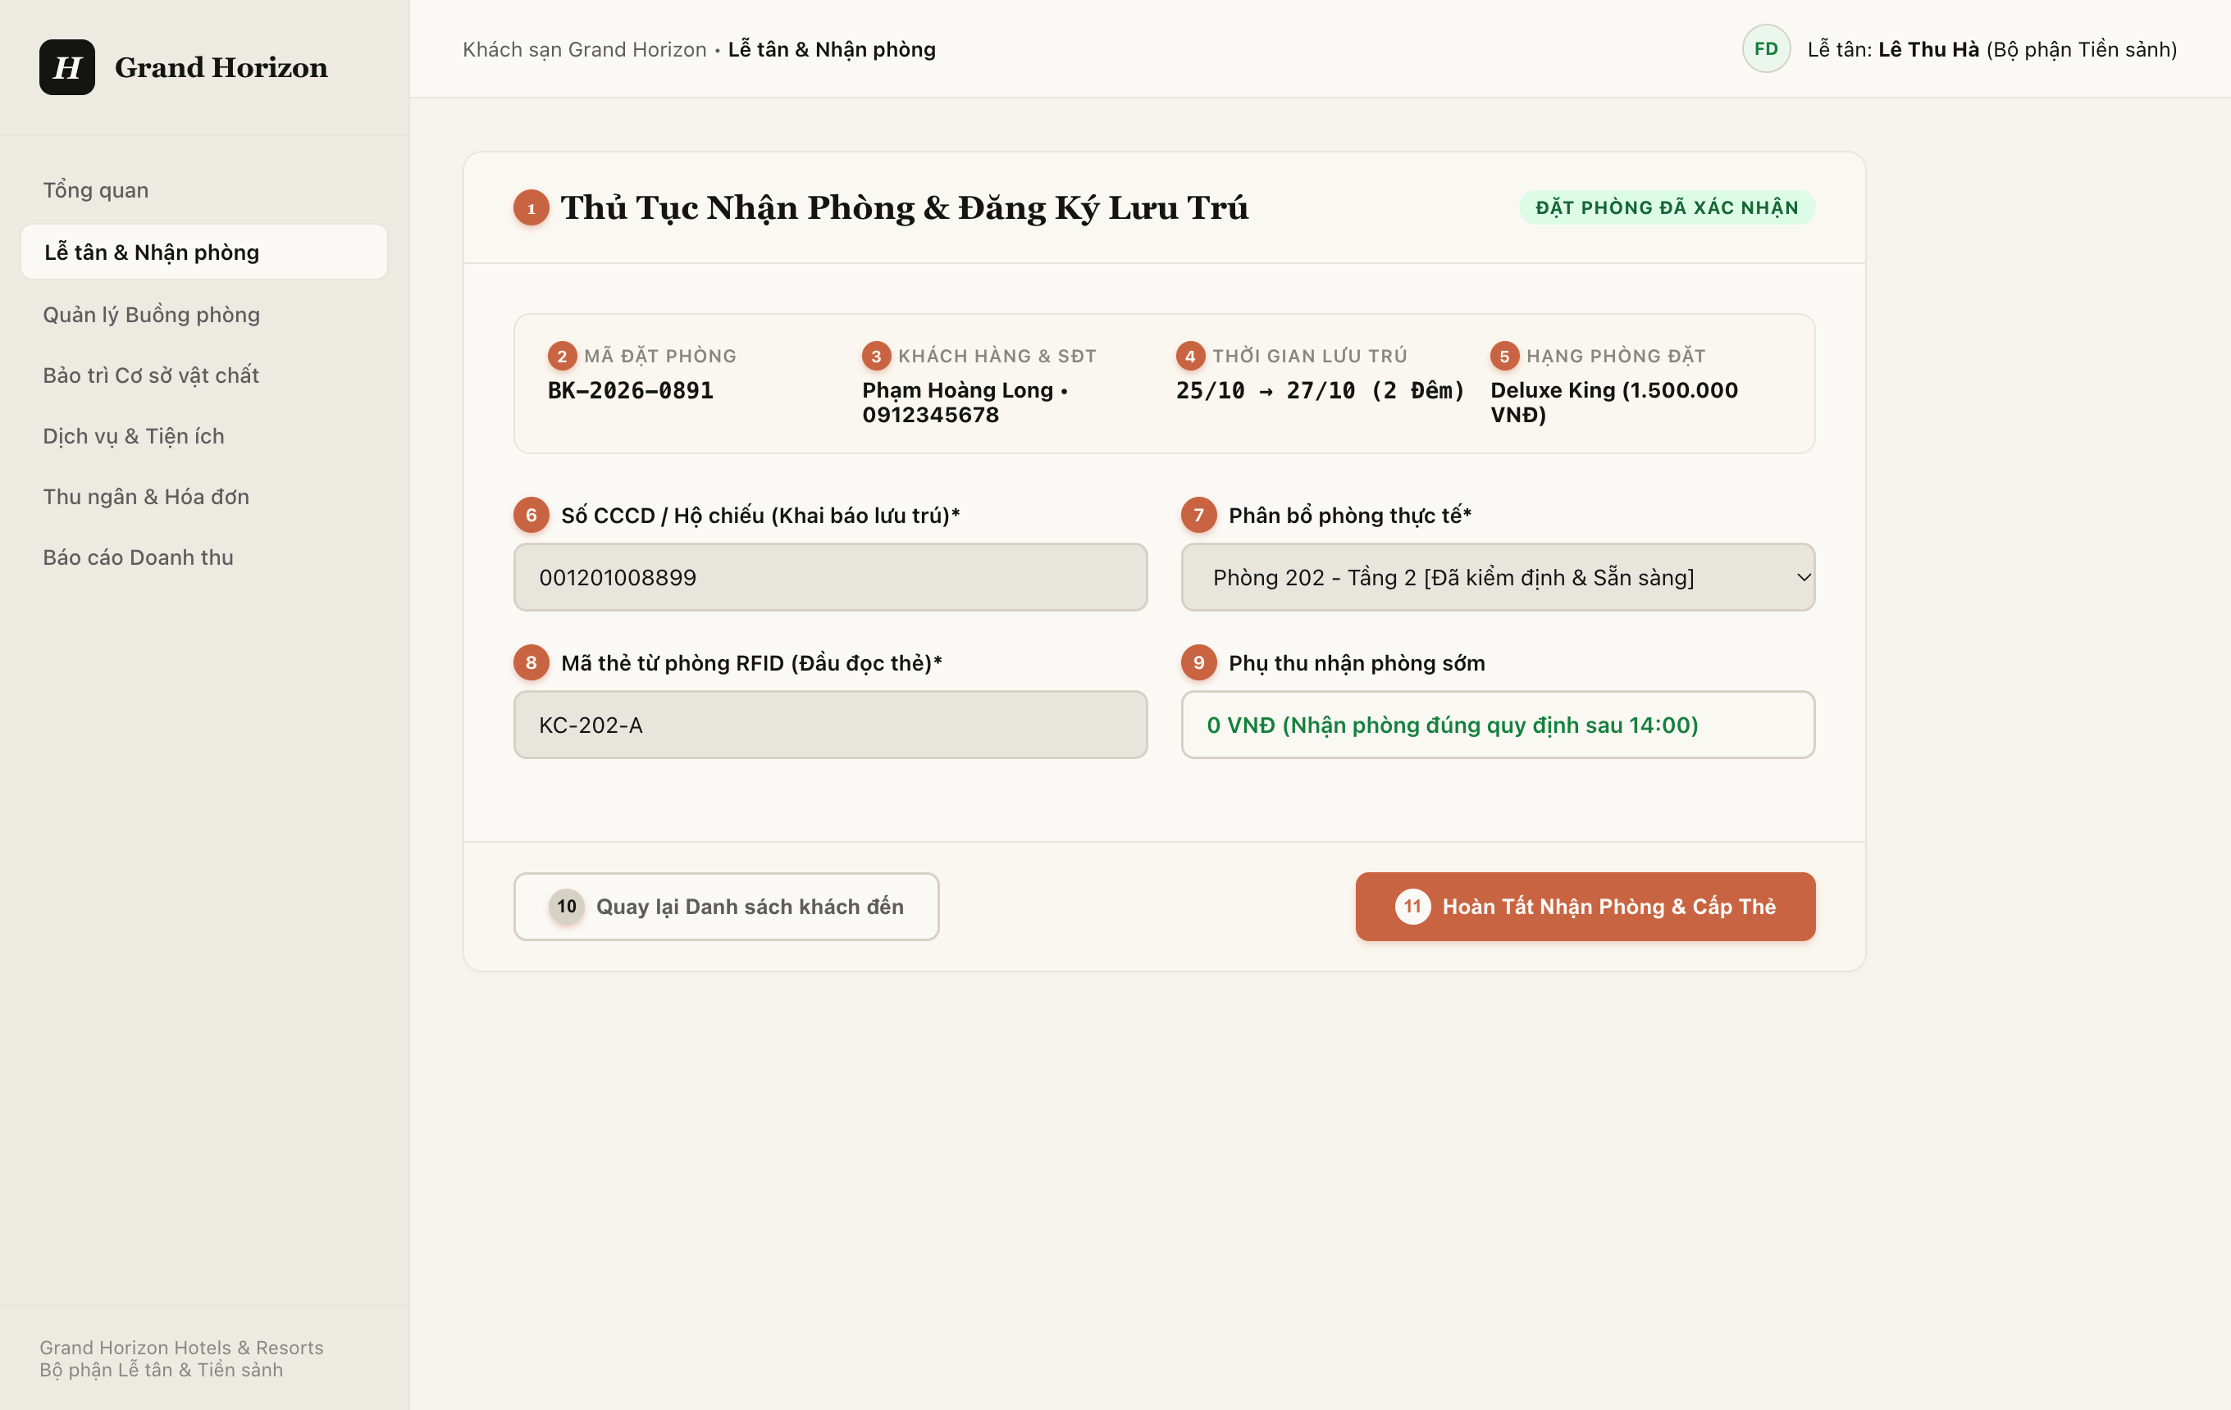
Figure 4-10: Screen Design of Guest Check-in Form (UC-27)
Table 4-8: Screen Definition for Guest Check-in Form (UC-27)
No | Object/Control Name | Type | Required | Length | Description
(1) | lblCheckinTitle | Label / Header | Yes | N/A | Header identifying the active check-in registration workflow.
(2) | txtBookingCode | Display / Text | Yes | 20 chars | Displays verified reservation code [DB Mapping: tbl_reservation.reservation_code].
(3) | txtGuestProfile | Display / Text | Yes | 100 chars | Displays registered guest full name and phone number [DB Mapping: tbl_customer.full_name, phone_number].
(4) | txtStayInterval | Display / Date | Yes | N/A | Displays check-in / check-out dates and night duration [DB Mapping: tbl_guest_stay.actual_check_in, expected_check_out].
(5) | txtRoomCategory | Display / Text | Yes | 50 chars | Displays reserved room category name and standard rate [DB Mapping: tbl_room_type.type_name].
(6) | txtIdentityCard | TextBox | Yes | 9-20 chars | Mandatory Citizen ID / Passport number for legal lodging registry [DB Mapping: tbl_customer.identity_card_number] (*).
(7) | cboAssignRoom | Dropdown | Yes | N/A | Selects clean, inspected room for assignment [DB Mapping: tbl_room.room_id; DB Action: INSERT tbl_stay_room_assignment] (*).
(8) | txtKeyCardNumber | TextBox | Yes | 20 chars | Physical RFID card number encoded for door access [DB Action: RFID Card Encoder Sync] (*).
(9) | txtEarlySurcharge | Display / Currency | No | N/A | Calculated early check-in surcharge if arriving before 14:00 [DB Mapping: tbl_additional_charge.amount].
(10) | btnBackToArrivals | Button | No | Redirect | Returns to front-desk pending arrivals queue without saving.
(11) | btnCompleteCheckin | Button | Yes | Trigger API | Initiates Step 1 in Sequence Diagram UC-27 [DB Action: INSERT tbl_guest_stay, INSERT tbl_stay_room_assignment, UPDATE tbl_room.status='OCCUPIED', INSERT tbl_folio].

4.4.2 Class/Component Design

4.4.2.1 Backend Class Diagram
Figure 4-11 illustrates the backend class structure for Reservation and Front-Desk operations. Crucially, it utilizes UML Composition (*--) for lifecycle-dependent parent-child entities: Reservation *-- Reservation_Detail and Guest_Stay *-- Stay_Room_Assignment, alongside Realization (..|>) for services and Aggregation (o--) for repository links.
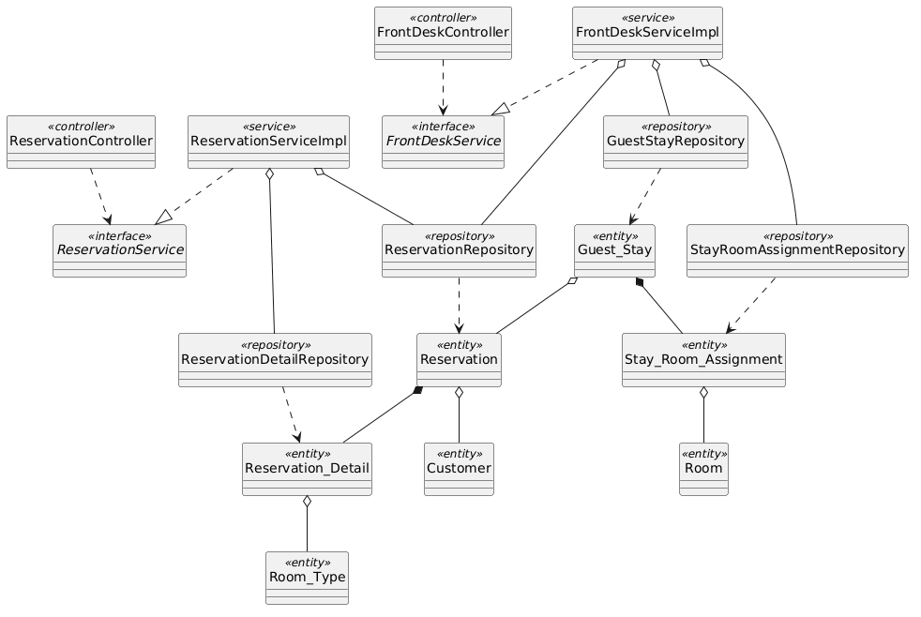
Figure 4-11: Backend Class/Component Structure Diagram for Reservation & Front-Desk

4.4.2.2 Classes/Component Description
4.4.2.2.1 ReservationController Class
Class | ReservationController
Description | REST controller exposing endpoints for booking creation, cancellation, and guest booking inquiries.
Base Class | None
Constructor | + ReservationController(reservationService: ReservationService)
Prototype | @RestController @RequestMapping("/api/v1/reservations") public class ReservationController
Source File | com/hotel/hms/controller/ReservationController.java
Namespace | com.hotel.hms.controller
Attributes | Name | Type | Description
 | reservationService | ReservationService | Business logic interface for room reservations.
Methods | Name | Input | Output | Description
 | createReservation | ReservationRequestDTO dto | ResponseEntity<ReservationResponseDTO> | Validates quota and creates room reservation.
 | getReservation | Long id | ResponseEntity<ReservationResponseDTO> | Retrieves reservation itinerary details.

4.4.2.2.2 FrontDeskServiceImpl Class
Class | FrontDeskServiceImpl
Description | Service executing front-desk arrival check-in, physical room assignment, and Guest_Stay creation.
Base Class | FrontDeskService
Constructor | + FrontDeskServiceImpl(resRepo: ReservationRepository, stayRepo: GuestStayRepository, roomRepo: RoomRepository, assignRepo: StayRoomAssignmentRepository)
Prototype | @Service @Transactional public class FrontDeskServiceImpl implements FrontDeskService
Source File | com/hotel/hms/service/impl/FrontDeskServiceImpl.java
Namespace | com.hotel.hms.service.impl
Attributes | Name | Type | Description
 | reservationRepository | ReservationRepository | Access to reservation records.
 | guestStayRepository | GuestStayRepository | Persistence for active guest stay records.
 | roomRepository | RoomRepository | Persistence for updating room operational status.
 | stayRoomAssignmentRepository | StayRoomAssignmentRepository | Persistence for room door allocations.
Methods | Name | Input | Output | Description
 | performCheckIn | CheckInRequestDTO dto | CheckInResponseDTO | Allocates room, creates GuestStay, updates room status to OCCUPIED, opens folio.
 | transferRoom | Long stayId, Long newRoomId | void | Transfers guest stay to new room and marks old room DIRTY.

4.4.2.2.3 ReservationRepository Class
Class | ReservationRepository
Description | Spring Data JPA repository managing Reservation entity records and booking status queries.
Base Class | JpaRepository<Reservation, Long>
Constructor | None (Spring Data JPA Interface)
Prototype | @Repository public interface ReservationRepository extends JpaRepository<Reservation, Long>
Source File | com/hotel/hms/repository/ReservationRepository.java
Namespace | com.hotel.hms.repository
Attributes | Name | Type | Description
 | None | - | Inherits Spring Data JPA persistence context.
Methods | Name | Input | Output | Description
 | findByReservationId | Long id | Optional<Reservation> | Queries reservation by ID.
 | findActiveBookingsByDate | LocalDate date | List<Reservation> | Queries active bookings for arrival dispatch.

4.4.2.2.4 Guest_Stay Class
Class | Guest_Stay
Description | JPA entity mapped to table 'Guest_Stay'. Records actual check-in and check-out timestamps of an active stay.
Base Class | None
Constructor | + Guest_Stay()
Prototype | @Entity @Table(name = "Guest_Stay") public class Guest_Stay
Source File | com/hotel/hms/entity/Guest_Stay.java
Namespace | com.hotel.hms.entity
Attributes | Name | Type | Description
 | stayId | Long | Primary key identifier of guest stay.
 | actualCheckIn | LocalDateTime | Recorded check-in arrival timestamp.
 | actualCheckOut | LocalDateTime | Recorded departure timestamp.
 | status | String | Stay status: CHECKED_IN, CHECKED_OUT.
 | reservation | Reservation | Many-to-One reference to Reservation entity.
Methods | Name | Input | Output | Description
 | getStayId | void | Long | Returns stay primary key.
 | setStatus | String status | void | Sets stay status.

4.4.3 Object Interactions (Sequence Diagram)
Figures 4-12 and 4-13 depict the runtime interactions for Room Reservation and Guest Check-in. Tables 4-9 and 4-10 list each step.
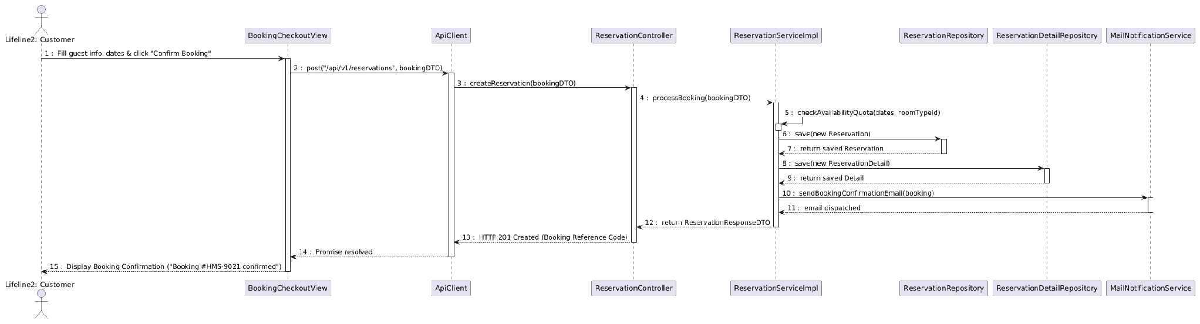
Figure 4-12: Sequence Diagram for UC-23 Room Reservation
Table 4-9: Interaction Steps for UC-23 Room Reservation
Step | Caller (From) | Callee (To) | Action / Method | Description
1 | Customer | BookingCheckoutView | Fill dates & click 'Confirm Booking' | Submits accommodation booking form.
2 | BookingCheckoutView | ApiClient | post('/api/v1/reservations', dto) | Dispatches HTTP POST request to backend.
3 | ApiClient | ReservationController | createReservation(dto) | Invokes reservation controller.
4 | ReservationController | ReservationServiceImpl | processBooking(dto) | Delegates booking creation to business service.
5 | ReservationServiceImpl | ReservationServiceImpl | checkAvailabilityQuota() | Verifies room inventory availability for requested dates.
6-7 | ReservationServiceImpl | ReservationRepository | save(new Reservation) | Persists Reservation entity in SQL Server.
8-9 | ReservationServiceImpl | ReservationDetailRepository | save(new Detail) | Persists room type and agreed price detail.
10-11 | ReservationServiceImpl | MailNotificationService | sendConfirmationEmail() | Triggers automated email notification with reference code.
12 | ReservationServiceImpl | ReservationController | return ReservationDTO | Returns reservation confirmation payload.
13 | ReservationController | ApiClient | HTTP 201 Created | Responds with HTTP 201 status code.
14 | ApiClient | BookingCheckoutView | Display Confirmation | Renders booking reference code to customer.

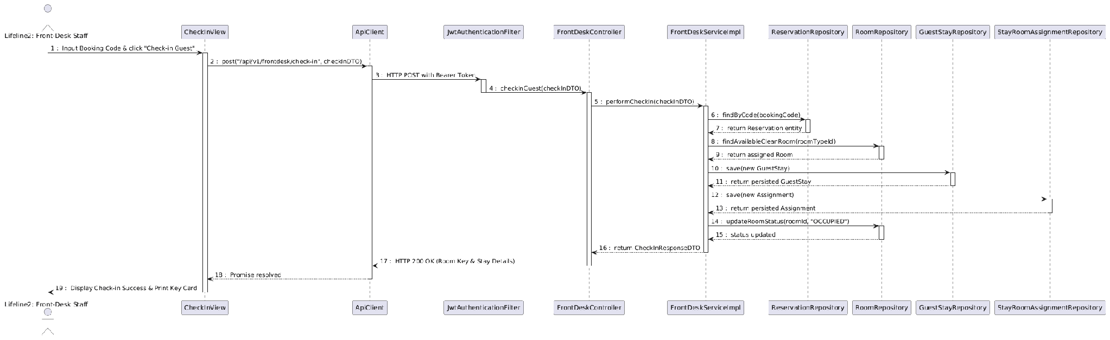
Figure 4-13: Sequence Diagram for UC-27 Guest Check-in
Table 4-10: Interaction Steps for UC-27 Guest Check-in
Step | Caller (From) | Callee (To) | Action / Method | Description
1 | Staff | CheckInView | Input Booking Code & click 'Check-in' | Staff enters booking code on front-desk check-in screen.
2 | CheckInView | ApiClient | post('/api/v1/frontdesk/check-in', dto) | Dispatches HTTP POST request with Bearer JWT.
3 | ApiClient | JwtAuthenticationFilter | validateJwtToken() | Validates front-desk staff credentials.
4 | JwtAuthenticationFilter | FrontDeskController | checkInGuest() | Invokes front-desk controller endpoint.
5 | FrontDeskController | FrontDeskServiceImpl | performCheckIn() | Transfers check-in logic to service layer.
6-7 | FrontDeskServiceImpl | ReservationRepository | findByCode() | Retrieves reservation and verifies booking status.
8-9 | FrontDeskServiceImpl | RoomRepository | findAvailableCleanRoom() | Queries and locks eligible vacant clean physical room.
10-11 | FrontDeskServiceImpl | GuestStayRepository | save(new GuestStay) | Persists Guest_Stay record with arrival timestamp.
12-13 | FrontDeskServiceImpl | StayRoomAssignmentRepository | save(new Assignment) | Persists physical room door assignment.
14-15 | FrontDeskServiceImpl | RoomRepository | updateRoomStatus('OCCUPIED') | Updates room status to OCCUPIED in database.
16 | FrontDeskServiceImpl | FrontDeskController | return CheckInResponseDTO | Returns stay details and room assignment.
17 | FrontDeskController | ApiClient | HTTP 200 OK | REST API confirms check-in completion.
18 | ApiClient | CheckInView | Display Check-in Success | Renders success dialog and prints key card.

4.5 Ancillary Services & Billing Management
The Ancillary Services & Billing subsystem coordinates on-premise hotel service catalogs (dining, laundry, spa), room folio charge posting, voucher discount applications, multi-currency invoicing, and payment settlements (UC-31 through UC-40). This section details UC-35 (Order Hotel Service) and UC-37/39 (Folio Invoicing & Payment Settlement).

4.5.1 Screen Design
Figure 4-14 illustrates the hotel service catalog interface used for posting service orders to guest folios. Table 4-11 lists its controls.
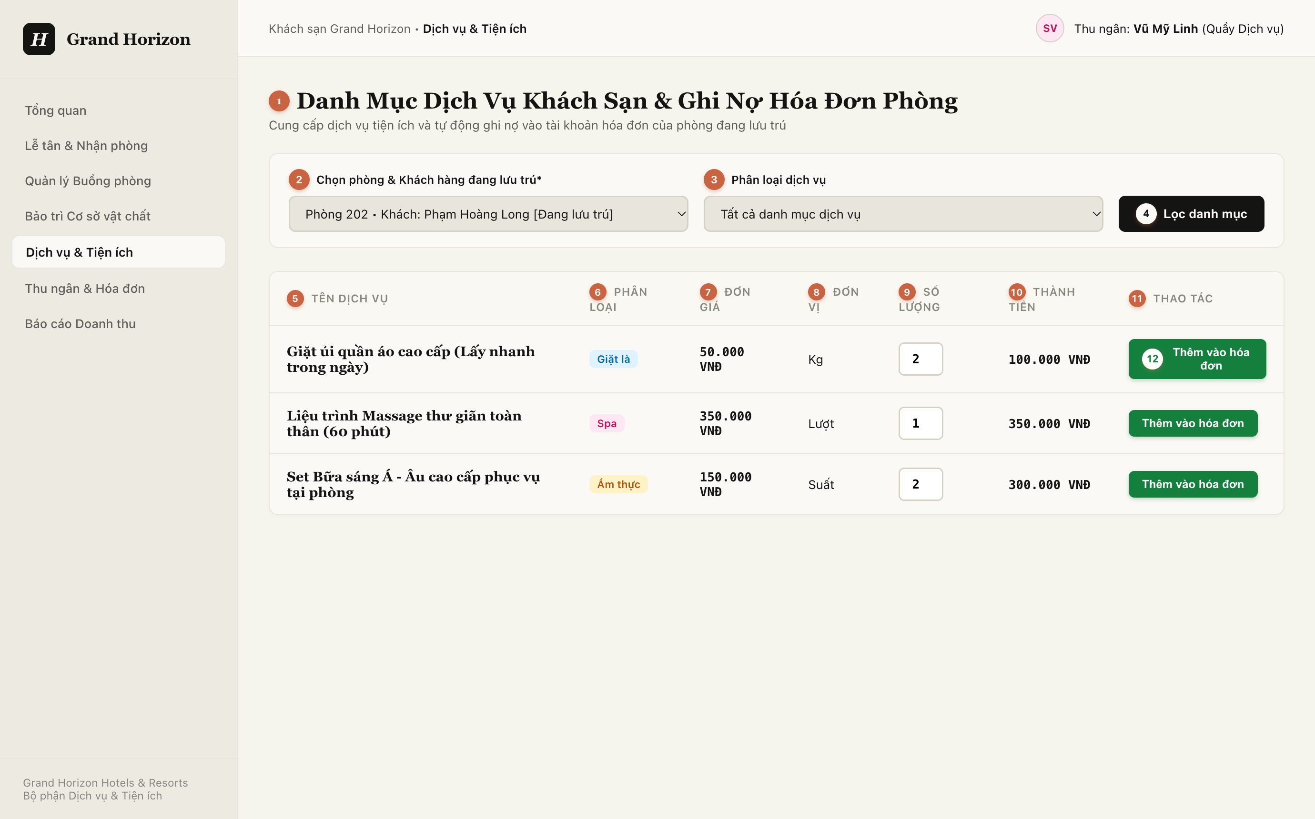
Figure 4-14: Screen Design of Available Hotel Services (UC-34 & UC-35)
Table 4-11: Screen Definition for Hotel Service Ordering (UC-35)
No | Object/Control Name | Type | Required | Length | Description
(1) | lblCatalogTitle | Label / Header | Yes | N/A | Header identifying the ancillary service catalog and folio debit workflow.
(2) | cboActiveGuestStay | Dropdown | Yes | N/A | Selects active occupied guest stay to receive service charges [DB Mapping: tbl_guest_stay.stay_id, tbl_room.room_number] (*).
(3) | cboCategoryFilter | Dropdown | No | N/A | Department categorization filter (All, Laundry, Spa & Wellness, Food & Beverage).
(4) | btnFilterCatalog | Button | No | Trigger API | Filters displayed service catalog list according to selected department.
(5) | colServiceName | Display / Text | Yes | 100 chars | Commercial name of service item [DB Mapping: tbl_service.service_name].
(6) | colCategory | Display / Badge | Yes | 50 chars | Department categorization badge (Laundry, Spa, Dining).
(7) | colUnitPrice | Display / Currency | Yes | N/A | Official standard unit price [DB Mapping: tbl_service.unit_price].
(8) | colUnit | Display / Text | Yes | 20 chars | Service measurement unit (Kg, Session, Set).
(9) | txtQuantity | NumberInput | Yes | Min: 1, Max: 99 | Order quantity selected by staff or guest [DB Mapping: tbl_service_order.quantity].
(10) | colTotalAmount | Display / Currency | Yes | N/A | Item charge subtotal dynamically computed as unit_price * quantity.
(11) | colActionHeader | Label / Header | Yes | N/A | Column header for row operational action buttons.
(12) | btnAddToFolio | Button | Yes | Trigger API | Direct order button [DB Action: INSERT into tbl_service_order (status='POSTED'); UPDATE tbl_folio.total_amount].

4.5.2 Class/Component Design

4.5.2.1 Backend Class Diagram
Figure 4-15 illustrates the backend class structure for Ancillary Services and Billing Management. It enforces Composition (*--) for Folio *-- Additional_Charge, Realization (..|>) for all billing and order services, Dependency (..>) for controller endpoints and JPA queries, and Aggregation (o--) for repository injection and billing entity references.
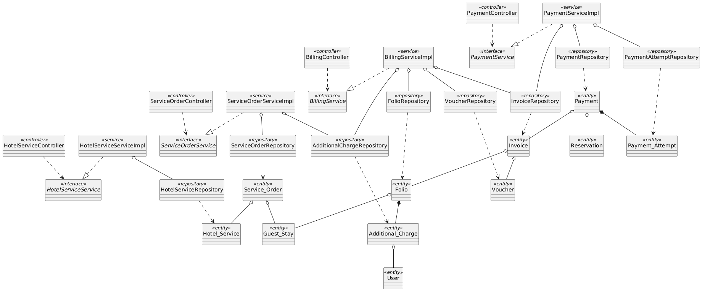
Figure 4-15: Backend Class/Component Structure Diagram for Ancillary Services & Billing

4.5.2.2 Classes/Component Description
4.5.2.2.1 BillingController Class
Class | BillingController
Description | REST controller exposing endpoints for folio compilation, voucher discounts, checkout invoicing, and payment processing.
Base Class | None
Constructor | + BillingController(billingService: BillingService)
Prototype | @RestController @RequestMapping("/api/v1/billing") public class BillingController
Source File | com/hotel/hms/controller/BillingController.java
Namespace | com.hotel.hms.controller
Attributes | Name | Type | Description
 | billingService | BillingService | Business logic interface for folio billing and payment settlements.
Methods | Name | Input | Output | Description
 | getFolioDetails | Long stayId | ResponseEntity<FolioDTO> | Retrieves itemized room and service charges for an active stay.
 | processCheckOutPayment | PaymentSettlementDTO dto | ResponseEntity<InvoiceReceiptDTO> | Finalizes folio, records payment, and creates fiscal Invoice.

4.5.2.2.2 BillingServiceImpl Class
Class | BillingServiceImpl
Description | Service executing folio item consolidation, tax/discount computations, payment gateway settlement, and invoice generation.
Base Class | BillingService
Constructor | + BillingServiceImpl(folioRepo: FolioRepository, invoiceRepo: InvoiceRepository, paymentRepo: PaymentRepository, gateway: PaymentGateway)
Prototype | @Service @Transactional public class BillingServiceImpl implements BillingService
Source File | com/hotel/hms/service/impl/BillingServiceImpl.java
Namespace | com.hotel.hms.service.impl
Attributes | Name | Type | Description
 | folioRepository | FolioRepository | Access to guest folio records and items.
 | invoiceRepository | InvoiceRepository | Persistence for generated Invoice entities.
 | paymentRepository | PaymentRepository | Persistence for completed transaction payments.
 | paymentGateway | PaymentGateway | Integration client for electronic payment transactions.
Methods | Name | Input | Output | Description
 | settleFolioAndCheckout | PaymentSettlementDTO dto | InvoiceReceiptDTO | Validates balance, executes transaction, issues Invoice, and closes Folio.
 | applyVoucher | Long folioId, String voucherCode | FolioDTO | Applies discount voucher to folio grand total.

4.5.2.2.3 Folio Class
Class | Folio
Description | JPA entity mapped to table 'Folio'. Tracks aggregate financial charges and balance incurred during a guest stay.
Base Class | None
Constructor | + Folio()
Prototype | @Entity @Table(name = "Folio") public class Folio
Source File | com/hotel/hms/entity/Folio.java
Namespace | com.hotel.hms.entity
Attributes | Name | Type | Description
 | folioId | Long | Primary key identifier of folio.
 | createdAt | LocalDateTime | Timestamp when folio account was created upon check-in (mapped to Folio.created_at in Section 5).
 | totalAmount | BigDecimal | Current cumulative financial balance.
 | status | String | Folio status: OPEN, SETTLED, CLOSED.
 | guestStay | Guest_Stay | One-to-One reference to Guest_Stay entity.
Methods | Name | Input | Output | Description
 | getFolioId | void | Long | Returns folio primary key.
 | getTotalAmount | void | BigDecimal | Returns current balance.

4.5.2.2.4 Invoice Class
Class | Invoice
Description | JPA entity mapped to table 'Invoice'. Represents legally binding fiscal receipt issued upon stay settlement.
Base Class | None
Constructor | + Invoice()
Prototype | @Entity @Table(name = "Invoice") public class Invoice
Source File | com/hotel/hms/entity/Invoice.java
Namespace | com.hotel.hms.entity
Attributes | Name | Type | Description
 | invoiceId | Long | Primary key identifier of invoice.
 | issueDate | LocalDateTime | Timestamp when invoice was generated upon checkout (mapped to Invoice.issue_date in Section 5).
 | totalAmount | BigDecimal | Final billed total including taxes and discounts.
 | finalAmount | BigDecimal | Payable total amount after voucher discount deduction (mapped to Invoice.final_amount in Section 5).
 | voucher | Voucher | Optional promotional discount voucher applied (Many-to-One, mapped to Invoice.voucher_id in Section 5).
 | status | String | Invoice settlement status: PAID, UNPAID, CANCELLED (mapped to Invoice.status in Section 5).
 | folio | Folio | Many-to-One reference to settled Folio.
Methods | Name | Input | Output | Description
 | getInvoiceId | void | Long | Returns invoice ID.
 | getTotalAmount | void | BigDecimal | Returns grand total.

4.5.3 Object Interactions (Sequence Diagram)
Figure 4-16 illustrates the runtime interaction flow for UC-37 & UC-39 Check-out & Payment Settlement. Table 4-12 details each step.
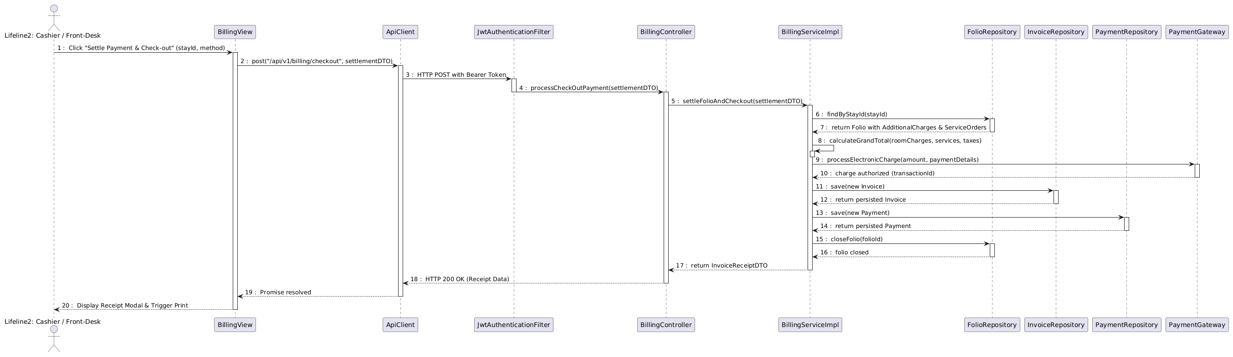
Figure 4-16: Sequence Diagram for UC-37 & UC-39 Check-out & Payment Settlement
Table 4-12: Interaction Steps for UC-37 & UC-39 Check-out & Payment Settlement
Step | Caller (From) | Callee (To) | Action / Method | Description
1 | Cashier | BillingView | Click 'Settle Payment & Check-out' | Cashier confirms final folio balance with guest.
2 | BillingView | ApiClient | post('/api/v1/billing/checkout', dto) | Dispatches HTTP POST request with Bearer JWT.
3 | ApiClient | JwtAuthenticationFilter | doFilterInternal() | Validates front-desk cashier token.
4 | JwtAuthenticationFilter | BillingController | processCheckOutPayment() | Invokes billing controller endpoint.
5 | BillingController | BillingServiceImpl | settleFolioAndCheckout() | Delegates settlement to transactional service.
6-7 | BillingServiceImpl | FolioRepository | findByStayId() | Loads Folio and itemized consumption records.
8 | BillingServiceImpl | BillingServiceImpl | calculateGrandTotal() | Computes room charges, services, taxes, and discounts.
9-10 | BillingServiceImpl | PaymentGateway | processElectronicCharge() | Authorizes charge with external Payment Gateway.
11-12 | BillingServiceImpl | InvoiceRepository | save(new Invoice) | Persists fiscal Invoice entity.
13-14 | BillingServiceImpl | PaymentRepository | save(new Payment) | Persists Payment record linked to invoice.
15-16 | BillingServiceImpl | FolioRepository | closeFolio() | Marks folio status as SETTLED/CLOSED.
17 | BillingServiceImpl | BillingController | return InvoiceReceiptDTO | Returns itemized receipt data.
18 | BillingController | ApiClient | HTTP 200 OK | REST API confirms transaction completion.
19 | ApiClient | BillingView | Display Receipt Modal | Renders invoice receipt and triggers receipt print.

4.6 Reviews, Audit & Reporting Management
The Reviews, Audit & Reporting subsystem oversees guest satisfaction feedback, automated audit logging of sensitive actions, and management operational intelligence reports covering room occupancy ratios, revenue per available room (RevPAR), and department revenue trends (UC-41 through UC-50). This section details UC-41 (Submit Room Review) and UC-46 (Revenue Analytics Report).

4.6.1 Screen Design
Figure 4-17 illustrates the executive revenue analytics dashboard (UC-46). Table 4-13 specifies the control definitions for the interface.
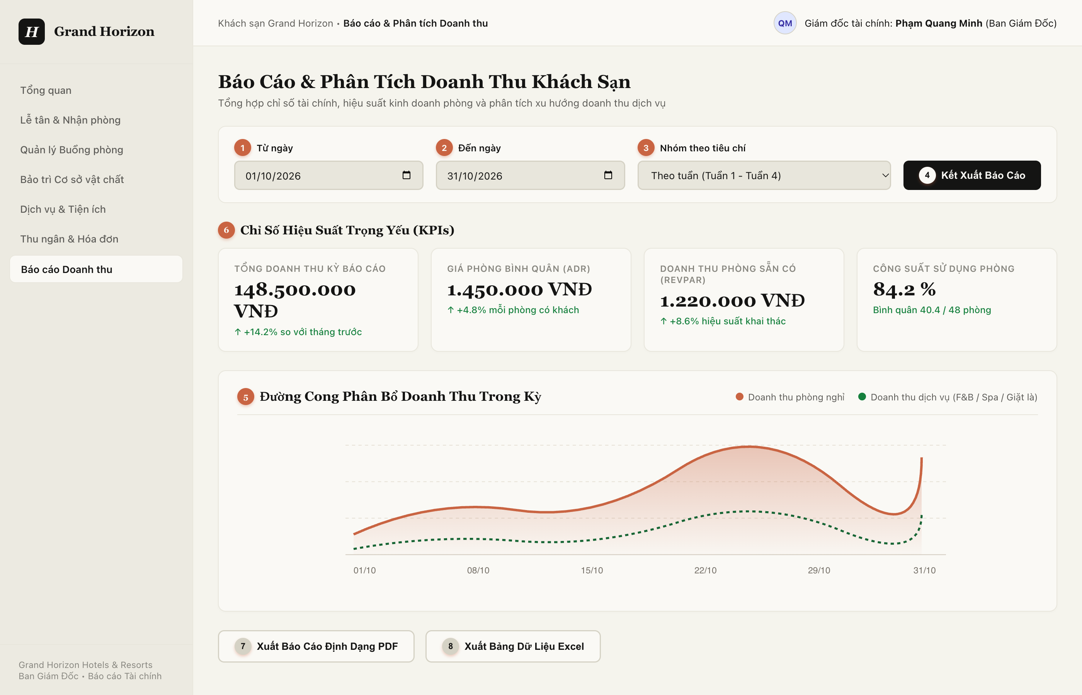
Figure 4-17: Screen Design of Management Revenue Analytics Dashboard (UC-46)
Table 4-13: Screen Definition for Management Revenue Analytics (UC-46)
No | Object/Control Name | Type | Required | Length | Description
(1) | dtFromDate | DatePicker | Yes | YYYY-MM-DD | Start date of analytics reporting period filter (*).
(2) | dtToDate | DatePicker | Yes | YYYY-MM-DD | End date of analytics reporting period filter (*).
(3) | cboReportGrouping | Dropdown | Yes | N/A | Temporal grouping criteria: Daily, Weekly, Monthly, or by Room Category.
(4) | btnGenerateReport | Button | Yes | Trigger API | Dispatches analytics query to backend; aggregates data from tbl_invoice, tbl_payment, and tbl_service_order.
(5) | chartRevenueTrend | Chart | Yes | Area / Line Chart | Renders graphical revenue curve comparing room tariff revenue vs ancillary service revenue.
(6) | kpiCards | KPICard / Display | Yes | Metrics | Executive summary metric cards: Gross Property Revenue, ADR, RevPAR, and Room Occupancy Rate.
(7) | btnExportPDF | Button | No | N/A | Exports current analytics view to structured executive PDF report.
(8) | btnExportExcel | Button | No | N/A | Exports raw transactional dataset to Microsoft Excel workbook.

4.6.2 Class/Component Design

4.6.2.1 Backend Class Diagram
Figure 4-18 illustrates the backend class structure for Reviews & Reporting. It uses flat layout with standard UML relationship arrows: Realization (..|>) for reporting services, Dependency (..>) for controller endpoints and query invocations, and Aggregation (o--) for repository injection and review entity associations.
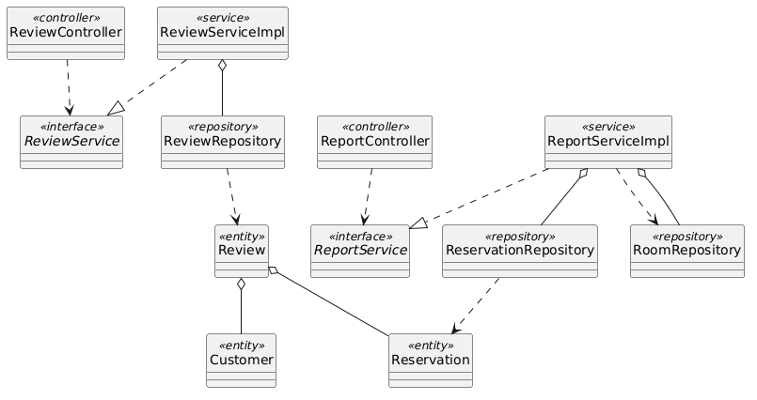
Figure 4-18: Backend Class/Component Structure Diagram for Reviews & Reporting

4.6.2.2 Classes/Component Description
4.6.2.2.1 ReportController Class
Class | ReportController
Description | REST controller exposing analytical endpoints for room occupancy and property revenue intelligence.
Base Class | None
Constructor | + ReportController(reportService: ReportService)
Prototype | @RestController @RequestMapping("/api/v1/reports") public class ReportController
Source File | com/hotel/hms/controller/ReportController.java
Namespace | com.hotel.hms.controller
Attributes | Name | Type | Description
 | reportService | ReportService | Service calculating analytical KPIs.
Methods | Name | Input | Output | Description
 | getRevenueReport | LocalDate from, LocalDate to | ResponseEntity<RevenueReportDTO> | Calculates total revenue, ADR, and RevPAR over time window.
 | getOccupancyReport | LocalDate from, LocalDate to | ResponseEntity<OccupancyReportDTO> | Calculates room occupancy percentages and turnover ratios.

4.6.2.2.2 ReportServiceImpl Class
Class | ReportServiceImpl
Description | Service aggregating multi-table relational data to produce executive business intelligence metrics.
Base Class | ReportService
Constructor | + ReportServiceImpl(resRepo: ReservationRepository, roomRepo: RoomRepository)
Prototype | @Service @Transactional(readOnly = true) public class ReportServiceImpl implements ReportService
Source File | com/hotel/hms/service/impl/ReportServiceImpl.java
Namespace | com.hotel.hms.service.impl
Attributes | Name | Type | Description
 | reservationRepository | ReservationRepository | Read-only access for booking revenue aggregation.
 | roomRepository | RoomRepository | Read-only access for total physical room capacity queries.
Methods | Name | Input | Output | Description
 | generateRevenueReport | LocalDate from, LocalDate to | RevenueReportDTO | Aggregates revenue, computes Average Daily Rate (ADR) and RevPAR.
 | compileSummaryKPIs | BigDecimal rev, Integer rooms | KPIOverviewDTO | Synthesizes high-level summary cards.

4.6.2.2.3 ReviewRepository Class
Class | ReviewRepository
Description | Spring Data JPA repository managing guest reviews and satisfaction ratings.
Base Class | JpaRepository<Review, Long>
Constructor | None (Spring Data JPA Interface)
Prototype | @Repository public interface ReviewRepository extends JpaRepository<Review, Long>
Source File | com/hotel/hms/repository/ReviewRepository.java
Namespace | com.hotel.hms.repository
Attributes | Name | Type | Description
 | None | - | Inherits Spring Data JPA persistence context.
Methods | Name | Input | Output | Description
 | findByCustomer_CustomerId | Long customerId | List<Review> | Queries reviews submitted by customer.
 | calculateAverageRating | void | Double | Calculates average property rating score across all reviews.

4.6.2.2.4 Review Class
Class | Review
Description | JPA entity mapped to table 'Review'. Stores star rating, feedback comment, and submission date.
Base Class | None
Constructor | + Review()
Prototype | @Entity @Table(name = "Review") public class Review
Source File | com/hotel/hms/entity/Review.java
Namespace | com.hotel.hms.entity
Attributes | Name | Type | Description
 | reviewId | Long | Primary key identifier of review.
 | rating | Integer | Rating score from 1 to 5 stars.
 | comment | String | Written feedback notes from guest.
 | reviewDate | LocalDateTime | Timestamp when review was submitted.
 | customer | Customer | Many-to-One reference to Customer entity.
 | guestStay | Guest_Stay | Many-to-One reference to completed hotel stay (mapped to Review.stay_id in Section 5).
Methods | Name | Input | Output | Description
 | getRating | void | Integer | Returns star rating.
 | getComment | void | String | Returns written feedback.

4.6.3 Object Interactions (Sequence Diagram)
Figure 4-19 depicts the runtime sequence flow for UC-46 Generate Revenue Analytics Report. Table 4-14 details each step.
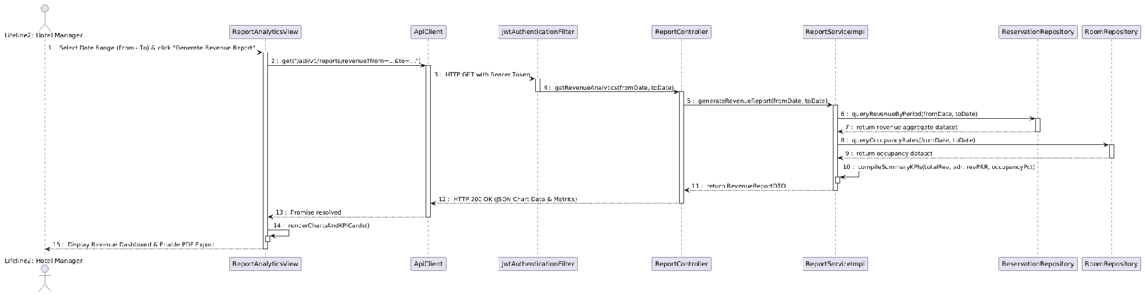
Figure 4-19: Sequence Diagram for UC-46 Generate Revenue Analytics Report
Table 4-14: Interaction Steps for UC-46 Generate Revenue Analytics Report
Step | Caller (From) | Callee (To) | Action / Method | Description
1 | Manager | ReportAnalyticsView | Select Date Range & click 'Generate Report' | Hotel Manager requests revenue intelligence metrics.
2 | ReportAnalyticsView | ApiClient | get('/api/v1/reports/revenue?from=...&to=...') | Dispatches authenticated HTTP GET request with Bearer JWT.
3 | ApiClient | JwtAuthenticationFilter | doFilterInternal() | Validates Manager role permissions.
4 | JwtAuthenticationFilter | ReportController | getRevenueAnalytics() | Invokes reporting controller endpoint.
5 | ReportController | ReportServiceImpl | generateRevenueReport() | Delegates analytical calculation to service layer.
6-7 | ReportServiceImpl | ReservationRepository | queryRevenueByPeriod() | Queries aggregated lodging revenue from SQL Server.
8-9 | ReportServiceImpl | RoomRepository | queryOccupancyRates() | Queries total available room inventory count.
10 | ReportServiceImpl | ReportServiceImpl | compileSummaryKPIs() | Calculates ADR, RevPAR, and occupancy percentage.
11 | ReportServiceImpl | ReportController | return RevenueReportDTO | Returns compiled statistical metrics and chart datasets.
12 | ReportController | ApiClient | HTTP 200 OK (JSON) | REST API responds with analytics payload.
13 | ApiClient | ReportAnalyticsView | Promise resolved | Frontend receives datasets.
14 | ReportAnalyticsView | Manager | Render Dashboard & Enable PDF Export | Renders charts, KPI summary cards, and enables export buttons.

5. Database Design

5.1 Database Design

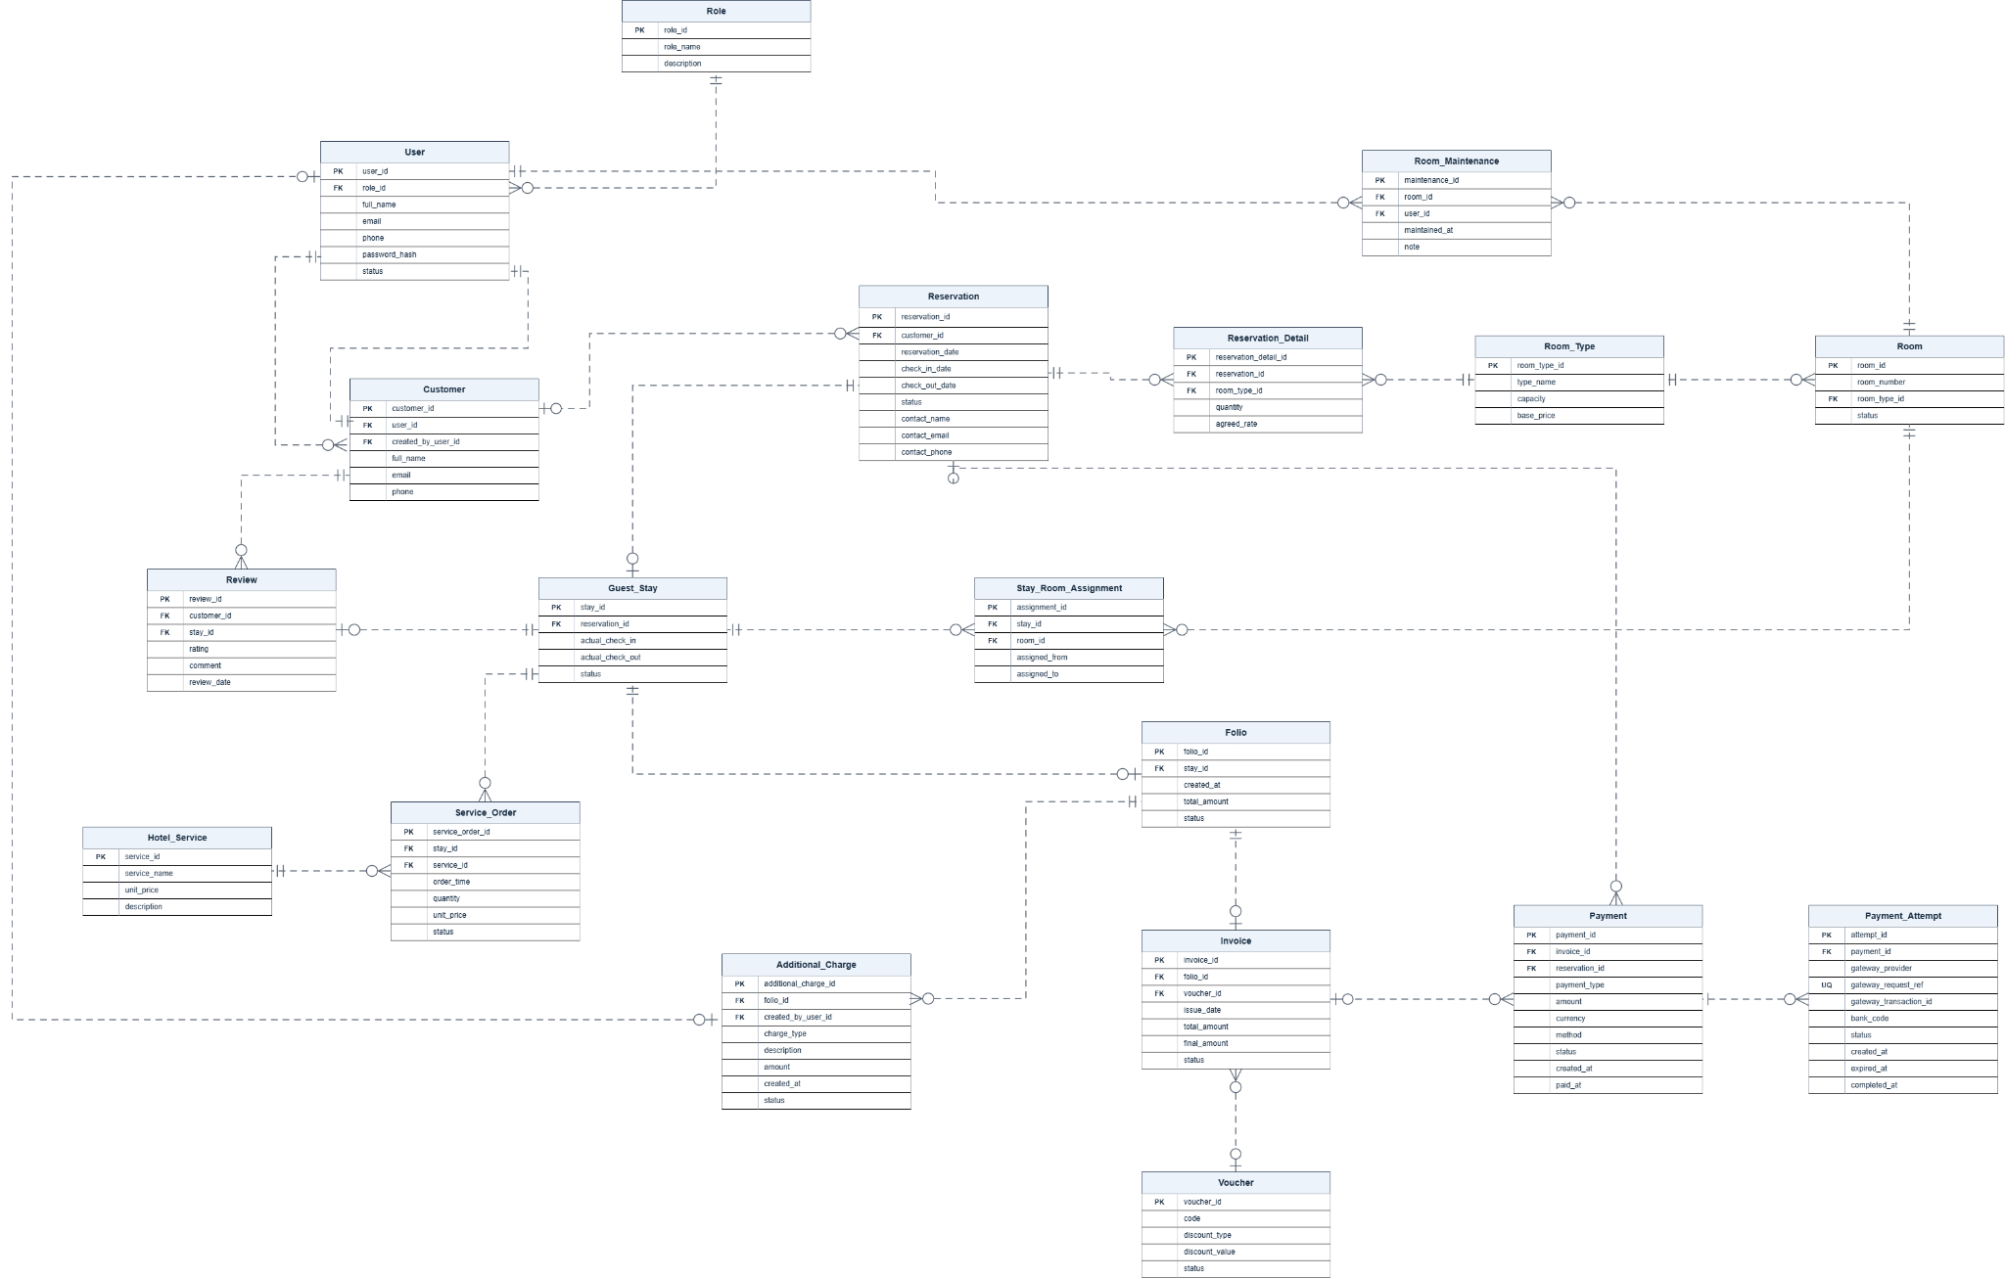

a. Role
Stores the system roles used for access control and user permissions.
# | Field name | Type | Size | Unique | Not Null | PK/FK | Notes
1 | role_id | INT | 4 | Yes | Yes | PK
2 | role_name | NVARCHAR | 100 | Yes | Yes
3 | description | NVARCHAR | 500 | No | No

b. User
Stores accounts for customers and hotel staff, including login credentials and access roles.
# | Field name | Type | Size | Unique | Not Null | PK/FK | Notes
1 | user_id | INT | 4 | Yes | Yes | PK
2 | role_id | INT | 4 | No | Yes | FK | References Role.role_id.
3 | full_name | NVARCHAR | 150 | No | Yes
4 | email | VARCHAR | 254 | Yes | Yes
5 | phone | VARCHAR | 20 | No | No
6 | password_hash | VARCHAR | 255 | No | Yes |  | Hashed password only; never store plaintext.
7 | status | VARCHAR | 30 | No | Yes

c. Room_Type
Defines room categories, guest capacity, and the standard rate for each category.
# | Field name | Type | Size | Unique | Not Null | PK/FK | Notes
1 | room_type_id | INT | 4 | Yes | Yes | PK
2 | type_name | NVARCHAR | 100 | Yes | Yes
3 | capacity | INT | 4 | No | Yes
4 | base_price | DECIMAL | 18,2 | No | Yes

d. Room
Represents a physical hotel room belonging to one room type.
# | Field name | Type | Size | Unique | Not Null | PK/FK | Notes
1 | room_id | INT | 4 | Yes | Yes | PK
2 | room_number | VARCHAR | 30 | Yes | Yes
3 | room_type_id | INT | 4 | No | Yes | FK | References Room_Type.room_type_id.
4 | status | VARCHAR | 30 | No | Yes

e. Reservation
Records hotel reservations, including the customer responsible for the booking, planned stay dates, reservation status, and contact information.
# | Field name | Type | Size | Unique | Not Null | PK/FK | Notes
1 | reservation_id | INT | 4 | Yes | Yes | PK
2 | customer_id | INT | 4 | No | Yes | FK | References Customer.customer_id.
3 | reservation_date | DATETIME2 | 8 | No | Yes
4 | check_in_date | DATE | 3 | No | Yes
5 | check_out_date | DATE | 3 | No | Yes
6 | status | VARCHAR | 30 | No | Yes
7 | contact_name | NVARCHAR | 150 | No | Yes
8 | contact_email | VARCHAR | 254 | No | No
9 | contact_phone | VARCHAR | 20 | No | Yes

f. Reservation_Detail
Records the room types, quantities, and agreed rates requested within each reservation.
# | Field name | Type | Size | Unique | Not Null | PK/FK | Notes
1 | reservation_detail_id | INT | 4 | Yes | Yes | PK
2 | reservation_id | INT | 4 | No | Yes | FK | References Reservation.reservation_id.
3 | room_type_id | INT | 4 | No | Yes | FK | References Room_Type.room_type_id.
4 | quantity | INT | 4 | No | Yes
5 | agreed_rate | DECIMAL | 18,2 | No | Yes

g. Guest_Stay
Records an actual hotel stay resulting from a reservation.
# | Field name | Type | Size | Unique | Not Null | PK/FK | Notes
1 | stay_id | INT | 4 | Yes | Yes | PK
2 | reservation_id | INT | 4 | Yes | Yes | FK | References Reservation.reservation_id.
3 | actual_check_in | DATETIME2 | 8 | No | Yes
4 | actual_check_out | DATETIME2 | 8 | No | No
5 | status | VARCHAR | 30 | No | Yes

h. Stay_Room_Assignment
Records the physical rooms assigned to a stay and the assignment periods.
# | Field name | Type | Size | Unique | Not Null | PK/FK | Notes
1 | assignment_id | INT | 4 | Yes | Yes | PK
2 | stay_id | INT | 4 | No | Yes | FK | References Guest_Stay.stay_id.
3 | room_id | INT | 4 | No | Yes | FK | References Room.room_id.
4 | assigned_from | DATETIME2 | 8 | No | Yes
5 | assigned_to | DATETIME2 | 8 | No | No

i. Room_Maintenance
Records room maintenance activities performed or logged by staff.
# | Field name | Type | Size | Unique | Not Null | PK/FK | Notes
1 | maintenance_id | INT | 4 | Yes | Yes | PK
2 | room_id | INT | 4 | No | Yes | FK | References Room.room_id.
3 | user_id | INT | 4 | No | Yes | FK | References User.user_id.
4 | maintained_at | DATETIME2 | 8 | No | Yes
5 | note | NVARCHAR | 500 | No | No

j. Review
Stores customer feedback associated with a completed stay.
# | Field name | Type | Size | Unique | Not Null | PK/FK | Notes
1 | review_id | INT | 4 | Yes | Yes | PK
2 | customer_id | INT | 4 | No | Yes | FK | References Customer.customer_id.
3 | stay_id | INT | 4 | No | Yes | FK | References Guest_Stay.stay_id.
4 | rating | INT | 4 | No | Yes
5 | comment | NVARCHAR | 500 | No | No
6 | review_date | DATETIME2 | 8 | No | Yes

k. Hotel_Service
Defines additional hotel services and their standard prices.
# | Field name | Type | Size | Unique | Not Null | PK/FK | Notes
1 | service_id | INT | 4 | Yes | Yes | PK
2 | service_name | NVARCHAR | 100 | No | Yes
3 | unit_price | DECIMAL | 18,2 | No | Yes
4 | description | NVARCHAR | 500 | No | No

l. Service_Order
Records services ordered during an active stay.
# | Field name | Type | Size | Unique | Not Null | PK/FK | Notes
1 | service_order_id | INT | 4 | Yes | Yes | PK
2 | stay_id | INT | 4 | No | Yes | FK | References Guest_Stay.stay_id.
3 | service_id | INT | 4 | No | Yes | FK | References Hotel_Service.service_id.
4 | order_time | DATETIME2 | 8 | No | Yes
5 | quantity | INT | 4 | No | Yes
6 | unit_price | DECIMAL | 18,2 | No | Yes
7 | status | VARCHAR | 30 | No | Yes

m. Folio
Maintains the running account of charges associated with a hotel stay.
# | Field name | Type | Size | Unique | Not Null | PK/FK | Notes
1 | folio_id | INT | 4 | Yes | Yes | PK
2 | stay_id | INT | 4 | Yes | Yes | FK | References Guest_Stay.stay_id.
3 | created_at | DATETIME2 | 8 | No | Yes
4 | total_amount | DECIMAL | 18,2 | No | Yes
5 | status | VARCHAR | 30 | No | Yes

n. Additional_Charge
Records additional charges applied to a guest's folio, such as property damage fees, late check-out fees, and other surcharges. Charges can be voided without deleting their history.
# | Field name | Type | Size | Unique | Not Null | PK/FK | Notes
1 | additional_charge_id | INT | 4 | Yes | Yes | PK
2 | folio_id | INT | 4 | No | Yes | FK | References Folio.folio_id.
3 | created_by_user_id | INT | 4 | No | Yes | FK | References User.user_id.
4 | charge_type | VARCHAR | 30 | No | Yes |  | DAMAGE, LATE_CHECKOUT, OTHER.
5 | description | NVARCHAR | 500 | No | Yes |  | Reason for the additional charge.
6 | amount | DECIMAL | 18,2 | No | Yes |  | Charge amount.
7 | created_at | DATETIME2 | 8 | No | Yes
8 | status | VARCHAR | 30 | No | Yes |  | ACTIVE, VOIDED.

o. Voucher
Stores promotional vouchers and their discount rules.
# | Field name | Type | Size | Unique | Not Null | PK/FK | Notes
1 | voucher_id | INT | 4 | Yes | Yes | PK
2 | code | VARCHAR | 30 | Yes | Yes
3 | discount_type | VARCHAR | 30 | No | Yes
4 | discount_value | DECIMAL | 18,2 | No | Yes
5 | status | VARCHAR | 30 | No | Yes

p. Invoice
Stores checkout billing information generated from a folio.
# | Field name | Type | Size | Unique | Not Null | PK/FK | Notes
1 | invoice_id | INT | 4 | Yes | Yes | PK
2 | folio_id | INT | 4 | Yes | Yes | FK | References Folio.folio_id.
3 | voucher_id | INT | 4 | No | No | FK | References Voucher.voucher_id.
4 | issue_date | DATETIME2 | 8 | No | Yes
5 | total_amount | DECIMAL | 18,2 | No | Yes
6 | final_amount | DECIMAL | 18,2 | No | Yes
7 | status | VARCHAR | 30 | No | Yes

q. Payment
Stores payments associated with either a reservation or an invoice.
# | Field name | Type | Size | Unique | Not Null | PK/FK | Notes
1 | payment_id | INT | 4 | Yes | Yes | PK
2 | invoice_id | INT | 4 | No | No | FK | References Invoice.invoice_id. Exactly one of these two references should be populated.
3 | reservation_id | INT | 4 | No | No | FK | References Reservation.reservation_id. Exactly one of these two references should be populated.
4 | payment_type | VARCHAR | 30 | No | Yes
5 | currency | CHAR | 3 | No | Yes |  | Currency code, e.g. VND
6 | amount | DECIMAL | 18,2 | No | Yes
7 | method | VARCHAR | 30 | No | Yes
8 | status | VARCHAR | 30 | No | Yes
9 | created_at | DATETIME2 | 8 | No | Yes |  | Time the payment obligation was created.
10 | paid_at | DATETIME2 | 8 | No | No |  | Time the payment was confirmed as paid.

r. Customer
Stores guest/customer profiles used for reservations and reviews. A profile may exist without a login account.
# | Field name | Type | Size | Unique | Not Null | PK/FK | Notes
1 | customer_id | INT | 4 | Yes | Yes | PK
2 | user_id | INT | 4 | Yes | No | FK | References User.user_id. Optional link to customer login; one customer profile per user.
3 | created_by_user_id | INT | 4 | No | No | FK | References User.user_id.
4 | full_name | NVARCHAR | 150 | No | Yes
5 | email | VARCHAR | 254 | No | No
6 | phone | VARCHAR | 20 | No | Yes

s. Payment_Attempt
Records each payment attempt made through an online payment gateway, including the gateway request reference, transaction identifier, processing status, and relevant timestamps.
# | Field name | Type | Size | Unique | Not Null | PK/FK | Notes
1 | attempt_id | INT | 4 | Yes | Yes | PK
2 | payment_id | INT | 4 | No | Yes | FK | References Payment.payment_id.
3 | gateway_provider | VARCHAR | 30 | No | Yes |  | E.g. VNPAY.
4 | gateway_request_ref | VARCHAR | 100 | Yes | Yes |  | Maps to vnp_TxnRef.
5 | gateway_transaction_id | VARCHAR | 100 | No | No |  | Maps to vnp_TransactionNo.
6 | bank_code | VARCHAR | 30 | No | No |  | Maps to vnp_BankCode.
7 | status | VARCHAR | 30 | No | Yes |  | PENDING, SUCCESS, FAILED, EXPIRED.
8 | created_at | DATETIME2 | 8 | No | Yes |  | Time the attempt was created.
9 | expired_at | DATETIME2 | 8 | No | No |  | Payment request expiration time.
10 | completed_at | DATETIME2 | 8 | No | No |  | Time the attempt reached a final state.

5.2 Data File Design
[File List, in the table format as below]
# | File Name | Type | Notes
1 | Class name1
2 | Class name2
3 | ..

