
Requirement & Design Specification
Classroom Facilities Management System (CFMS)
Version: 1.0
– Hanoi,January 2026 –
OEMS-SRS_v1.0 Page 1 / 20
Record of Changes
Version | Date | A*  M, D | In charge | Change Description
V1.0 | 7/1 | A | GiapND | Add System Context and External Entities
V1.0 | 9/1 | M | KhangND | Modified System Context (Redesign Context Diagram)
V1.0 | 9/1 | A | TungPV | Add Business Process
V1.0 | 10/1 | A | QuangDN | Add User Requirements
V1.0 | 11/1 | A | HieuVQ, KhangND | Add System Functionalities

*A - Added M - Modified D - Deleted

OEMS-SRS_v1.0 Page 2 / 20
Contents
Record of Changes........................................................................................................................................ 2
I. Overview....................................................................................................................................................5
1. System Context..................................................................................................................................... 5
2. External Entities....................................................................................................................................5
3. Business Processes............................................................................................................................... 5
3.1 Sale Process.................................................................................................................................... 6
3.2 Customer Support...........................................................................................................................6
4. User Requirements............................................................................................................................... 6
4.1 UCs for Guest.................................................................................................................................. 7
4.2 UCs for Student...............................................................................................................................7
4.3 …....................................................................................................................................................
5. System Functionalities.......................................................................................................................... 7
5.1 Screens Flow................................................................................................................................... 7
5.2 Screen Authorization...................................................................................................................... 8
5.3 Non-UI Functions............................................................................................................................ 8
II. Functional Requirements..........................................................................................................................9
1. Feature Name1..................................................................................................................................... 9
1.1 SubFeature Name1.1...................................................................................................................... 9
1.2 SubFeature Name1.2...................................................................................................................... 9
2. User Authentication..............................................................................................................................9
2.1 User Register...................................................................................................................................9
3. System Administration..........................................................................................................................9
3.1 Master Data.................................................................................................................................... 9
3.2 User Management........................................................................................................................ 10
III. System Design........................................................................................................................................11
1. Software Architecture.........................................................................................................................11
1.1 Overall Architectural Diagram................................................................................................... 11
1.2 Component Descriptions.............................................................................................................. 11
2. Code Package Design.......................................................................................................................... 11
2.1. Package Diagram..........................................................................................................................12
2.2 Package Descriptions.................................................................................................................... 12
3. Database Design................................................................................................................................. 12
3.1 Database Schema..........................................................................................................................13
3.2 Table Descriptions.........................................................................................................................13

GAMS-SRS_v1.0 Page 3 / 20

GAMS-SRS_v1.0 Page 4 / 20
I. Overview
1. System Context
[Gives the overall description about the product with some introduction and the context diagram. The context diagram presents the boundary and connections between the system you’re developing and everything else in the universe. This identifies external entities (or terminators – software, hardware, human components, and other systems) outside the system that interface to it in some way, as well as data, control, and material flows between the terminators and the system.]
<<Sample: The Cafeteria Ordering System is a new software system that replaces the current manual and telephone processes for ordering and picking up meals in the Process Impact cafeteria. The context diagram below illustrates the external entities and system interfaces for release 1.0. The system is expected to evolve over several releases, ultimately connecting to the Internet ordering services for several local restaurants and to credit and debit card authorization services.
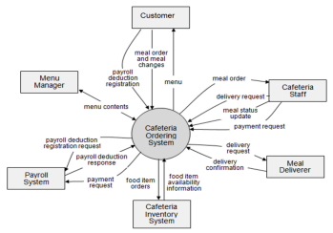
>>
2. External Entities
[Describe the external entities who/what might interact with your system as mentioned in the context diagram above, using the form of table as following]
# | Entity | Description
1 | Customer | Entity description here..
2 | Cafeteria Staff | ..
3 | …

3. Business Processes
[Provide business processes () using the swim-lane diagram(s) like sample below A business process a collection of activities that takes one or more kinds of input and creates an output that is of value to the customer. The customer for a business process may be a traditional external
GAMS-SRS_v1.0 Page 5 / 20
customer (the person who buys the finished product), or it may be an internal customer (such as a colleague in another department)]
3.1 Sale Process
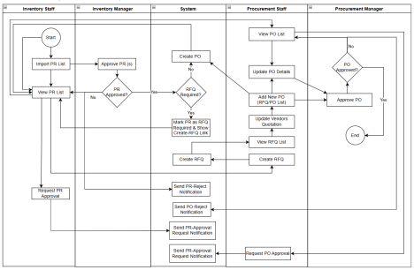
Process Description
Step  # | Step Name | Detailed Description | Role
1.
2.
3.

3.2 Customer Support
…
4. User Requirements
In this section, you need to provide the descriptions for all the use case (UC) you would have identified (in the form of table), and UC diagram(s) to show the actor-UCs and UC-UC relationships (like the sample below] – just one consolidated diagram or multiple diagrams for the system, each diagram is for one actor or one workflow]
ID | Use Case | Feature | Main Actor | Use Case Description

GAMS-SRS_v1.0 Page 6 / 20
01 | View Menu | Menu Browsing | Customer | Customer can browse the available meals, drinks, and combos with details like description, price, and availability
02 | …

4.1 UCs for Guest
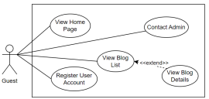
4.2 UCs for Student
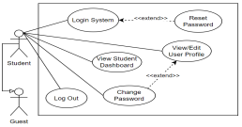
4.3 …
5. System Functionalities
[Provide functionality overview of software system: screen flow, screen descriptions, system user roles, screen authorization, non-screen functions, ERD]
5.1 Screens Flow
[This part shows the system screens and the relationship among screens. You can draw the Screens Flow for the system in the form of diagram as below.]
GAMS-SRS_v1.0 Page 7 / 20
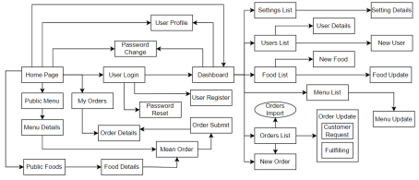5.2 Screen Authorization
[Provide the system roles authorization to the system features (down to screens, and event to the screen activities if applicable) in the table form as below – replace Role-Name1, Role-Name2,… with your specific system user role names]
Screen | Role-Name1 | Role-Name2 | Role-Name3 | …
<<Screen Name1>> | X |  | X | X
<<Screen Activity>> |  |  | X | X
<<Screen Name2>> | X |  | X
Query All Data | X
Query Own Data |  |  | X
Add New Data |  |  | X | X
Update All Data |  |  |  | X
Update Own Data |  |  |  | X
Delete Data
…

5.3 Non-UI Functions
[Provide the descriptions for the non-screen system functions, i.e batch/cron job, service, API, etc.]
# | Feature | System Function | Description
1 | <<Feature Name>> | <<Function Name1>> | <<Function Name1 Description>>
2 | …

GAMS-SRS_v1.0 Page 8 / 20
II. Functional Requirements
[Provide descriptions about the system’s functions/screens. The functions/screens are grouped by the system features, and even sub-features if needed. For the screens, you need to provide the screen layouts (mock-up screens) and relevant specifications if needed]
1. Feature Name1
1.1 SubFeature Name1.1
1.1.1 Screen/Function Name1
[Content #1: UI layout (Mockup screen prototype)]
[Content #2: brief descriptions of the screen/function, mapped to the relevant use cases] [Content #3: provide further descriptions for the screen’s components/fields using table format below]
Field Name | Description
Field Name1 | Field description: data type min/max length or value, initial data, etc.
Field Name2 | …
Field Group-Name1
Field Name3 | …
Field Name4 | …
Field Group-Name2
… | …

1.1.2 Screen/Function Name2
…
1.2 SubFeature Name1.2
…
2. User Authentication
2.1 User Register
…
3. System Administration
3.1 Master Data
3.1.1 Setting List
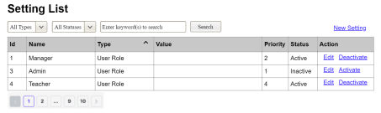
This screen allows the Administrator to:
● View Setting List: view list of current master data.
GAMS-SRS_v1.0 Page 9 / 20
● Filter Setting List: filter master data by data types, statuses
● Search Settings: enter keyword(s) to search master data by their names or values ● Sort Setting List: sort mater data list (ascending, descending) by clicking column headers On the screen, s/he can also
● Activate/Deactivate Setting: change status of a specific inactive/active master data ● Choose to go to the Setting Details screens for adding new or updating an existing master data by clicking the New Setting or Edit link.
Field Description
Field Name | Description
(1) | Initial values: all the active setting names with null or blank type  Hover the mouse to show the field name: “Setting Type”
(2) | Initial values: All Statuses, Active, Inactive (default value “All Status”) Hover the mouse to show the field name: “Setting Status”
(3) | The change-status action is Activate or Deactivate depending on the current status of the relevant setting (Inactive or Active, respectively).

3.1.2 Setting Details
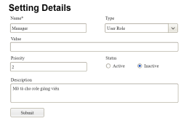
This screen allows the Administrator to:
● Add New Setting: add new master data.
● Update Setting Details: update details of a specific master data
Field Description
Field Name | Description
Name | Data type: non-digit string, max length of 20 characters
Type | Initial data values: all active setting names (with null or blank type)
Value | Data type: any string, max length of 100 characters
Priority | Data type: a positive integer
Description | Data type: any string, max length of 200 characters

3.2 User Management
3.2.1 User List
…
GAMS-SRS_v1.0 Page 10 / 20
III. System Design
1. Software Architecture
[The content of this section includes the overall architectural diagram which includes the sub-systems and/or components, the external systems (if any), and the relationships (communication messages) among them. You need also provide the explanation for each of the diagram components (modules, sub-systems, external systems, etc.)].
1.1 Overall Architecturural Diagram
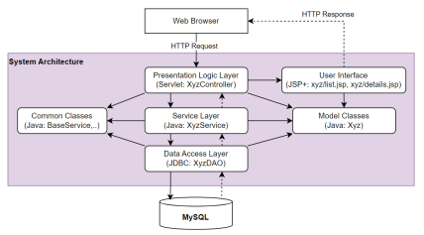1.2 Component Descriptions
No | Component | Description
01 | Presentation Logic Layer | <Description of the component>
02 | User Interface | <Description of the package>
03 | …

-
2. Code Package Design
[Provide the package diagram for each sub-system. The content of this section including the overall package diagram, the explanation, package and class naming conventions in each package. Please see the sample & description table format below]
GAMS-SRS_v1.0 Page 11 / 20
2.1 Package Diagram
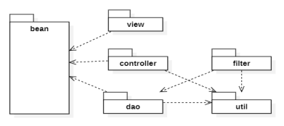2.2 Package Descriptions
No | Package | Description
01 | View | <Description of the package>
02 | bean | <Description of the package>
03 | …

3. Database Design
[Provide the files description, database table relationship & table descriptions like example below] 3.1 Database Schema
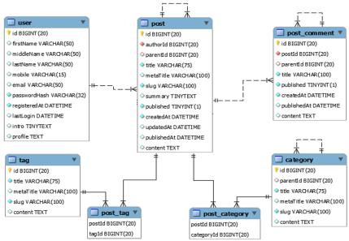GAMS-SRS_v1.0 Page 12 / 20
3.2 Table Descriptions
3.2.1 table_name1
[Provide brief description of the table here]
[Provide the detailed table fields description using below table format
* PK~Primary Key; FK~Foreign Key; UN~Unique; NN ~ not null
No | Field | PK | FK | UN | NN | Description
01 | <field_name1> |  |  |  |  | <Description of the field_name1>
02 | <field_name2> |  |  |  |  | …
..

3.2.2 table_name2
…
GAMS-SRS_v1.0 Page 13 / 20

