# Overview Use Case

Suggestion

Use case diagram

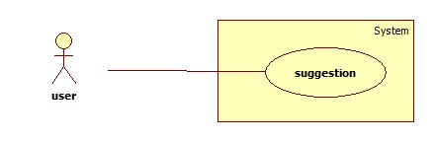

|  |  |  |  |  |
| --- | --- | --- | --- | --- |
| USE CASE | | | | |
| Use Case No. |  | Use Case Version |  | |
| Use Case Name |  | | | |
| Author |  | | | |
| Date |  | Priority | |  |
| **Actor:**  - Member.  **Summary:**  - This use case allows see suggestion the product.  **Goal:**  - see suggestion product.  **Triggers:**  **-**  When user input size or calculate size  **Preconditions:**  - User must login with member role and User inputted info size , address  **Post Conditions:**  **- Success:**  **+** Show suggestion table products.  + Show points of product.  + Show recommend as list of products.  - Fail: Show error message.  **Main Success Scenario:**   |  |  |  | | --- | --- | --- | | **Step** | **Actor Action** | **System Response** | | 1 | Member click one category of shoes ex : “Giày cao gót”  [Alternative 1,] | Navigate to “Giày cao got” page with contains:  - suggestion table with  information:  + Product which product’s store is nearly member address and which is category “Giày cao gót”.  + Show info : price , name .  + Show recommend as list of  products.  [Exception 1] | | 1 | Session time out. | Show error message:”Vui lòng đăng  nhập lại để được hỗ trợ nhiều hơn”.  Redirect to login page |   **Exceptions:**   |  |  |  | | --- | --- | --- | | **No** | **Actor Action** | **System Response** | | 1 | Cannot compare product due to database connection. | Show error message:”Thao tác thất bại xin hãy thử lại”. |   **Relationships**: Search  **Business Rules:**  Member clicks “GIày cao gót” button, “GIày cao gót” page will show in 2 situations:  **- Situation 1:**  + Show comparison table.  + Points of products.  + Show recommend as list of products that similar with products. | | | | |

# Overview Use Case

Search

Use case diagram

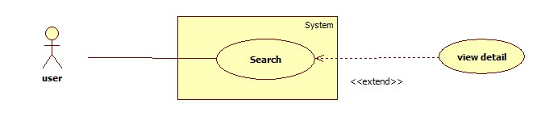

|  |  |  |  |  |
| --- | --- | --- | --- | --- |
| USE CASE | | | | |
| Use Case No. |  | Use Case Version |  | |
| Use Case Name |  | | | |
| Author |  | | | |
| Date |  | Priority | |  |
| **Actor:**  - Member.  **Summary:**  - This use case allows user to search and view product information.  **Goal:**  - A page detail of products will be shown to guest.  **Triggers:**   * Guest inputs to a blank textbox then clicks “Tìm kiếm” button. * Guest inputs URL of product or serial number then they search all products with relative URL or serial number which they inputted. The searching results will show product detail.   **Preconditions:**  - User must login with member role and User inputted info size , address  **Post Conditions:**  **Success:** Show search results as a page of product with URL or serial number that  guest inputted  **Fail**: Show an error message.  **Main Success Scenario:**   |  |  |  | | --- | --- | --- | | **Step** | **Actor Action** | **System Response** | | 1 | Guest inputs the  product’s URL or serial  number into textbox. | Show “Search” page with includes:  - Tìm bằng đường dẫn/ tìm bằng số seri: drop  down list.  - Search: textbox  - Tìm kiếm: button | | 2 | Guest clicks “Tìm  kiếm” button. | − System will show page detail product by product  URL or serial number.[Exception1] |   **Exceptions:**   |  |  |  | | --- | --- | --- | | **No** | **Actor Action** | **System Response** | | 1 | Search not found | Redirect to Not found page.  Show message:”Vui lòng đăng nhập để được hỗ trợ  nhiều hơn”. |   **Relationships**: Search  **Business Rules:**   * User search by URL or serial number of product * System will search all products in database. * If that product is existed, system will show detail page of that product. | | | | |