

Ho Chi Minh tour guide
Software Requirement Specification

Project Code: HTTPS
Document Code: HTTPS_SRS_v0.2

Ho Chi Minh City, January 2013.

Record of change

*A - Added M - Modified D - Deleted
Effective Date | Changed Items | A*  M, D | Change Description | New Version
01/14/2013 | Document | A | Create document | 0.1
01/15/2013 | Function requirement | M | Function | 0.2

SIGNATURE PAGE

ORIGINATOR: Hoang Trung Hieu 14th January, 2013
Project Leader

Bui Tien Tuan 14th January, 2013
Team member

Nguyen Hong Tuan 14th January, 2013
Team member

Tran Thanh Phong 14th January, 2013
Team member

Cao Van Sinh 14th January, 2013
Team member

REVIEWERS: Lam Huu Khanh Phuong 14th January, 2013
Project Manager

APPROVAL: Lam Huu Khanh Phuong 14th January, 2013
Project Manager
TABLE OF CONTENTS
1 Introduction 7
1.1 Purpose 7
1.2 Scope 7
1.3 Definitions, Acronyms, and Abbreviations 7
1.4 References 7
1.5 Overview 7
2 Overall Description 9
2.1 Product perspective 9
2.2 Product functions 9
2.3 User characteristics 9
2.4 Constraints 9
2.5 Assumptions and dependencies 9
2.6 Requirements subsets 9
3 FUNCTIONAL Requirements 11
3.1 Provide information 11
3.2 Play Vietnamese sound 11
3.3 Search information 12
3.4 Recommend topic 13
4 Uscase model 15
4.1 Use Cases Diagram 15
4.2 Use Cases’ Details 15
4.3 Functional Requirement one 15
5 NON-FUNCTIONAL Requirements 19
5.1 Usability 19
5.2 Reliability 19
5.3 Performance 19
5.4 Supportability 19
5.5 Design Constraints 20
5.6 On-line User Documentation and Help System Requirements 20
5.7 Purchased Components 20
5.8 Interfaces 21
5.9 Licensing Requirements 21
5.10 Legal, Copyright, and Other Notices 21
5.11 Applicable Standards 21
6 Supporting Information 22

Introduction
The first section of this document provides an introduction, general overview of “Ho Chi Minh tour guide”.

Purpose
Ho Chi Minh tour guide (HTTPS) helps foreign customers know more about Ho Chi Minh City.
This document is meant to delineate the features of HTTPS, so as to serve as a guide to the developers on one hand and a software verification document for prospective users.

Scope
This document defines essential user requirements with prototype included functions of the system.
- Give users information about famous place in Ho Chi Minh City.
- Play Vietnamese sound from English sentences.
- Search information from search text box, this is a quickly way to find information in database.
- Recommend topic, help users know more place, when they don't know any things.

Definitions, Acronyms, and Abbreviations
No. | Key word | The meanings
1 | HTTPS | Name of project

References
- Tourist HCM.
- Tourist book

Overview
The remaining of this document includes four chapters:
1. The 2nd chapter provides an overview description of the document. It lists product functions, user characteristics, constraints… of the application.
2. The 3rd chapter lists all the required functions from the users and required functions for the system.
3. The 4th chapter provides non-functional requirements, constrains of the system that shall be satisfied.
4. The final chapter lists some supporting and additional information.

Overall Description

Product perspective
The HTTPS provide help foreign easy to communicate with Vietnamese people, they can choose four functions to help them, and they will to know more place in Ho Chi Minh City.

Product functions
The AMS application allows users to do the following functions:
- Give users information about famous place in Ho Chi Minh City.
- Play Vietnamese sound from English sentences.
- Search information from search text box, this is a quickly way to find information in database.
- Recommend topic, help users know more place, when they don't know any things.

User characteristics
The system users are assumed to have the following characteristics:
- Users shall not be expected to learn a set of commands in order to start using the application.
- Users shall not be expected to remember a list of commands while using the software – these shall be provided via menus, tool palettes, or help screens.

Constraints
- Run any when.
- Run in Smart phone.

Assumptions and dependencies
N/A

Requirements subsets
N/A

FUNCTIONAL Requirements

Four function.

Provide information
- Users choose one button.
- Software will be display more information.
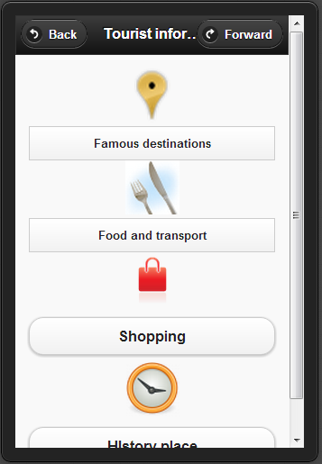

Play Vietnamese sound
- With one place, software suggest some sentence.
- Choose one sentence and software will read it.
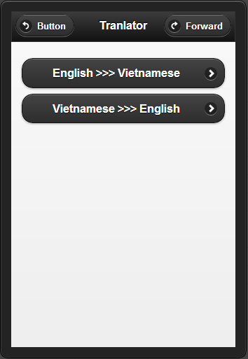

Search information
- You just enter any character.
- Software will display one sentence or one place in database.

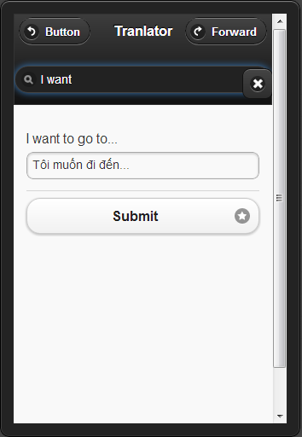

Recommend topic
- With one sentence or place, software will choose near place, this place no far from you.
- Choose this function and software will automatic run.
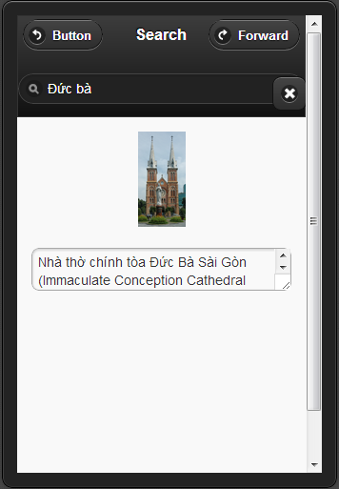

Uscase model

Use Cases Diagram
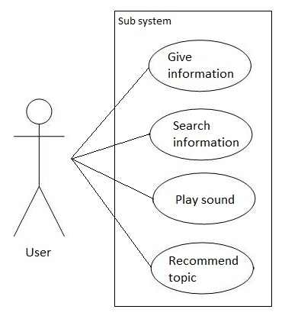

Use Cases’ Details
N/A

Functional Requirement one

Give information

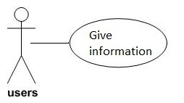
Use Case Name | Give information
Actors | Users
Description | Provide the detail Ho Chi Minh city tourist information
Requirement | Fields/Attributes must have validations on it
Pre-conditions | Choose this function
Post-conditions | Display
Basic Flow | Actor Actions:  1. Click “Information” button | System Response:  2. Display some famous location
Exception Flow | N/A

Play sound of Vietnamese communication sentences
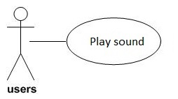
Use Case Name | Play sound
Actors | User
Description | Play sound of Vietnamese communication sentences from English sentences
Requirement | Fields/Attributes must have validations on it
Pre-conditions | Choose one sentence
Post-conditions | Information will be display
Basic Flow | Actor Actions:  1. Choose “Read” button  3. Choose one place  5. Choose one sentence | System Response:  2. Display some place  4. Display some sentences  6. Play this sound
Exception Flow | N/A

Search information and sentences by keyword
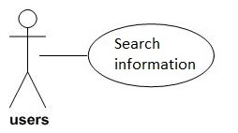
Use Case Name | Search information
Actors | User
Description | Search information about many function this software
Requirement | Fields/Attributes must have validations on it
Pre-conditions | Choose this function
Post-conditions | Result will be display
Basic Flow | Actor Actions:  1. Choose “Search” button  3. Enter text  5. Choose “->” button | System Response:  2. Display textbox  4. Display some suggestions  6. Display list results
Exception Flow | Can’t find any information. Display will be show “No result”

Recommend these topics related which user reading
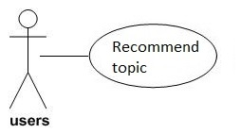
Use Case Name | Recommend topic
Actors | User
Description | Shows these topics have relationship with it by a recommendation engine.
Requirement | Fields/Attributes must have validations on it
Pre-conditions | Choose this function
Post-conditions | Information will be display
Basic Flow | Actor Actions:  1. Choose “Recommend” button | System Response:  2. Display result
Exception Flow | Display “No result” if can’t find any information

NON-FUNCTIONAL Requirements
This section describes the non-functional requirements of the HTTPS system.

Usability
- The system users are assumed to have very basic knowledge at using a smart phone.
- The HTTPS have clear and easy to use interface, the user can use at the first time.

Reliability
Maximum Bugs and Defect Rate: 0.3 bugs per thousand lines of code (0.3 bugs/KLOC).
Critical bugs:
+ Loss of all data: not any
+ Unable to use part of the system’s functionality: not any

Performance
Operating system:
- Android 2.3 or higher
- RIM 10
- IOS 4
- Windows phone 7 or Higher
Memory:
- 128 Megabyte of Ram.
Disk:
- 50 Megabyte
Connection:
- No Internet connection.

Supportability
N/A

Design Constraints
- JavaScript, CSS, HTML 5
- Phone gap
- Eclipse
- JDK 6

On-line User Documentation and Help System Requirements
The package of the application shall be included with a full help document for user.

Purchased Components
N/A

Interfaces
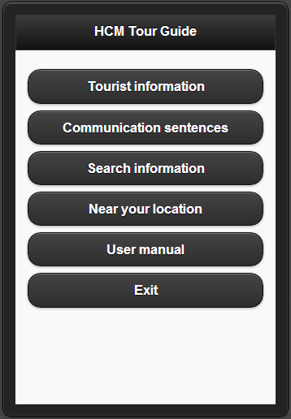

Licensing Requirements
No unauthorized copy of this application is allowed.

Legal, Copyright, and Other Notices
N/A

Applicable Standards
N/A

Supporting Information
The appendices or index is not necessary for this document.

