**Perceptual Losses for Real-Time Style Transfer and Super-Resolution**

<https://arxiv.org/pdf/1603.08155v1.pdf>

1. Residual: Contain two 3x3 Convolutional layers

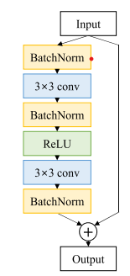

Introduction: <https://arxiv.org/pdf/1610.02915.pdf>

1. Downsampling and Upsampling
   1. Down

* Two stride 2, kernel = 3

*Note:

- Our network body consists of five residual blocks

- The first and last layers which use 9 × 9 kernels, all convolutional layers use 3 × 3 kernels.

- two stride-2 convolutions to downsample the input followed by several residual blocks and then two convolutional layers with stride 1/2 to upsample.

- . All non-residual convolutional layers are followed by spatial batch normalization [45] and ReLU nonlinearities with the exception of the output layer, which instead uses a scaled tanh to ensure that the output image has pixels in the range