
INTERNATIONAL SCHOOL

CAPSTONE PROJECT 1
CMU-SE 450

INTERFACE DESIGN DOCUMENT
Version 1.0
Date: 25/08/2021

RECRUITMENT MANAGEMENT SUPPORT SYSTEM

Submitted by: Group C1SE.43
Truong Dong Huy
Nguyen Quang Hieu
Nguyen Manh Vu
Nguyen Nam Hung

Approved by

Proposal Review Panel Representative:

Name Signature Date

Capstone Project 1- Mentor:
Name Signature Date

PROJECT INFORMATION
Project acronym | RMSS
Project Title | Recruitment Management Support System
Start Date | 17 Aug 2021 |  | End Date | 14 Dec 2021
Lead Institution | International School, Duy Tan University
Project Mentor | M.Sc Le Thanh Long
Scrum master / Project Leader & contact details | Hieu, Nguyen Quang  Email: hieunguyen.13092000@gmail.com  Tel: (+84)707960071
Partner Organization
Project Web URL
Team members | Name | Email |  | Tel
24211206538 | Huy, Dong Truong | huydongtruong@gmail.com |  | 0358040650
24211115193 | Hieu, Nguyen Quang | hieunguyen.13092000@gmail.com |  | 0707960071
24211216455 | Vu, Nguyen Manh | manhvu9368@gmail.com |  | 0853629334
24211206951 | Hung, Nguyen Nam | hunghunghung878@gmail.com |  | 0987994109

DOCUMENT INFORMATION
Document Title | Interface Design
Author(s) | Team C1SE.43
Role | [RMSS] Interface Design_v1.0
Date | 25- Aug - 2021 | File name | [RMSS] Interface Design_v1.0
URL
Access | Project and CMU Program

REVISION HISTORY

Version | Date | Comments | Author | Approval
1.0 | 25/08/2021 | Initial | Quang Hieu

- Introduction
  - Purpose
- This Interface Design Document of the RMSS system has the following purpose:
  - Documenting the user interface design of the RMSS system
  - Be the primary document driving the implementation of the user interfaces.
  - Introduce interface design for the reader. Including the background, content information display, command buttons.
  - Intended audience
- This IDD is intended for the following audiences:
  - Technical reviewers including:
    - Scrum Master
    - Product owner
  - Implementers, including:
    - Developers.
    - Testers.
  - Document Overview
- This IDD is organized into the following sections:
  - This document helps to better understand the interface of the Recruitment Management Support System, detailed specification components and function of the Application.
  - With this document, the development team can understand the structure and composition to create a consistent and complete system.
  - Overview of the stages and modules of the software and create a complete interface.
- Detailed Interface Design
  - Sprint 1
    - Login
    - Logout
    - Manage Homepage
    - Homepage
  - Sprint 2
    - Manage Jobs
    - Manage Recruitment Criteria
    - Choose a job
    - CEO manage account
  - Sprint 3
    - Apply for a job
    - View rankings of Candidates
    - View Candidates detail
    - Manage Candidates
  - Sprint 4
    - Search for Candidate
    - Suggest suitable job
    - Export Candidates information
    - View History
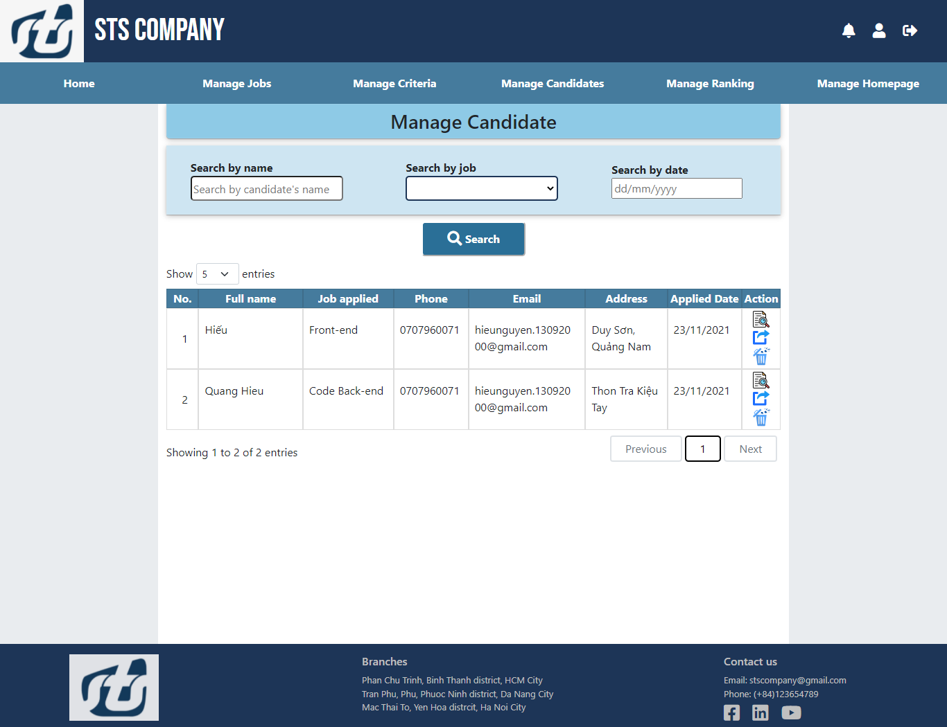
- Manage Candidates

Manage Candidates
No. | Field name | Type | Require | Target
1 | Title | H3 tag | width: 100%;  height: 50px;  background-color: #8ecae6;  border-radius: 0px 0px 5px 5px; | Show Candidate title
2 | Manage Candidate lable | Lable | font-weight: bold;
3 | Canididate name field | Input | width: 220px;  height: 36px;  border-radius: 5px; | Search by canididate name
4 | Job name select | Select | color: #888;  width: 220px;  height: 36px;  border-radius: 5px; | Search by job name
5 | Date field | input | width: 220px;  height: 36px;  border-radius: 5px;  min="1990-01-02" | Search by date
6 | Search button | Button | width: 150px;  height: 50px;  background-color: #2a6f97;  font-weight: bold;  color: #FFFFFF;  border-radius: 5px;  font-size: 16px;  border-color: white;  align-items: center;  padding: 0px;
7 | Candidate table | table | width: 100%; | Show a list of candidate
8 | Table header cell | Th | border: 1px solid rgba(24, 24, 24, 0.15);  background-color: #457b9d;  text-align: center;  color: white; | Header of the table
9 | Table cell | td | border: 1px solid rgba(24, 24, 24, 0.15);  padding-left: 1px; | Show details of each candidate in the table
10 | Table pagintion | Jquery dataTable | Custom:  ordering: false,  searching: false,  lengthMenu:[[5,10,15,20,-1],[5,10,15,20,"All"]],  Style:  color: black;  border: 2px silver solid;  margin: 0px 5px;  border-radius: 5px;  padding: 5px 20px; | Pagination for table

- Manage rankings
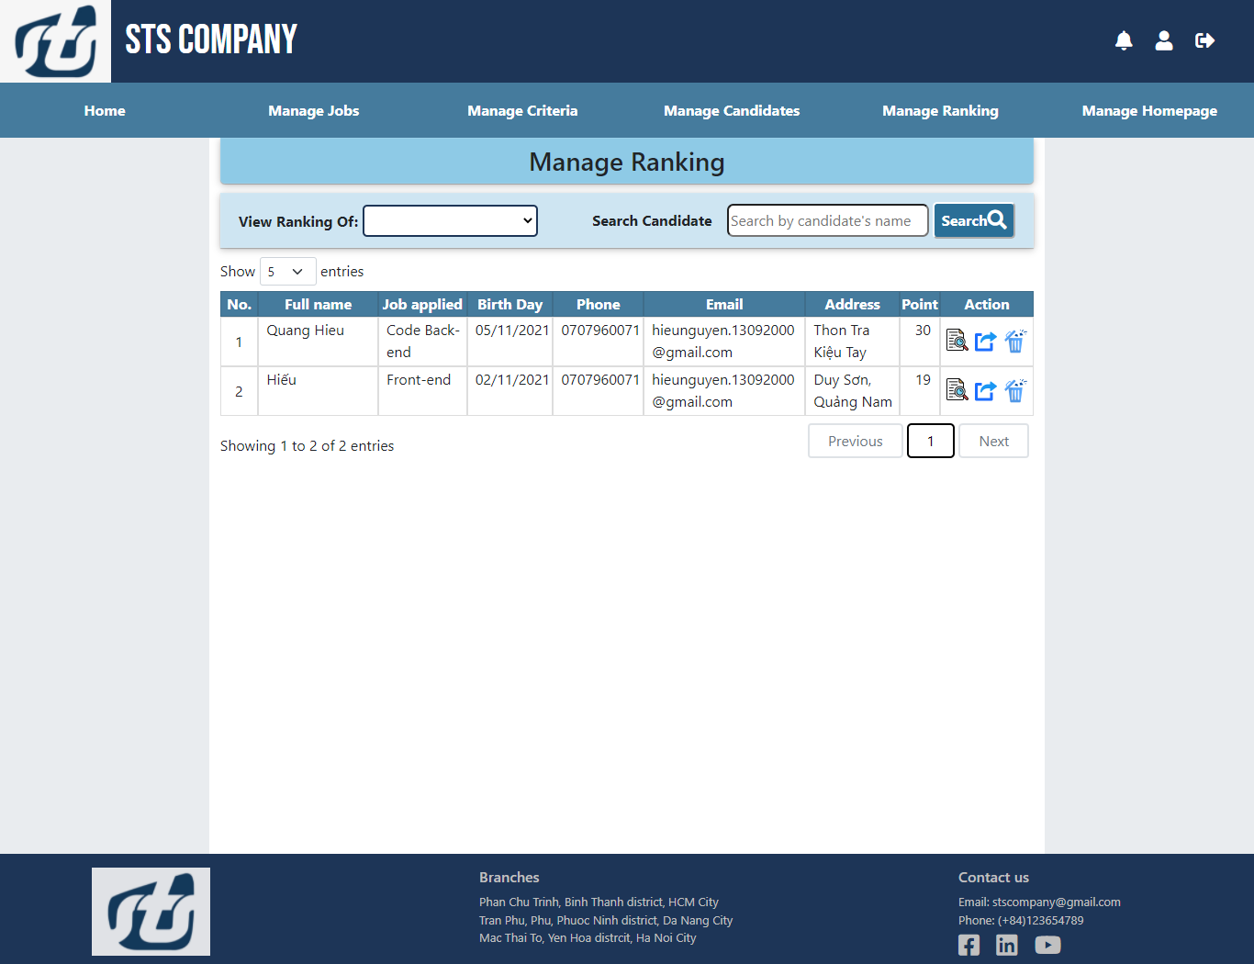

Manage rankings
No. | Field name | Type | Require | Target
1 | Title | H3 tag | width: 100%;  height: 50px;  background-color: #8ecae6;  border-radius: 0px 0px 5px 5px; | Show Ranking title
2 | Manage Ranking lable | Lable | font-size: 16px;  font-weight: bold;
3 | View Ranking select | select | height: 36px;  width: 220px;  margin-left: 12px;  border-radius: 7px;
4 | Canididate name field | input | height: 36px;  width: 220px;  margin-left: 12px;  border-radius: 7px; | Search by canididate name
5 | Search button | Button | width: 90px;  height: 40px;  background-color: #2a6f97;  font-weight: bold;  color: #FFFFFF;  border-radius: 5px;  font-size: 16px;  border-color: white;  align-items: center;  padding: 0px;
6 | Ranking table | table | width: 100%; | Show a list of raking
7 | Table header cell | Th | border: 1px solid rgba(24, 24, 24, 0.15);  background-color: #457b9d;  text-align: center;  color: white; | Header of the table
8 | Table cell | td | border: 1px solid rgba(24, 24, 24, 0.15);  padding-left: 1px; | Show details of each candidate in the table ranking
9 | Table pagintion | Jquery dataTable | Custom:  ordering: false,  searching: false,  lengthMenu:[[5,10,15,20,-1],[5,10,15,20,"All"]],  Style:  color: black;  border: 2px silver solid;  margin: 0px 5px;  border-radius: 5px;  padding: 5px 20px; | Pagination for table
- Manage Homepage
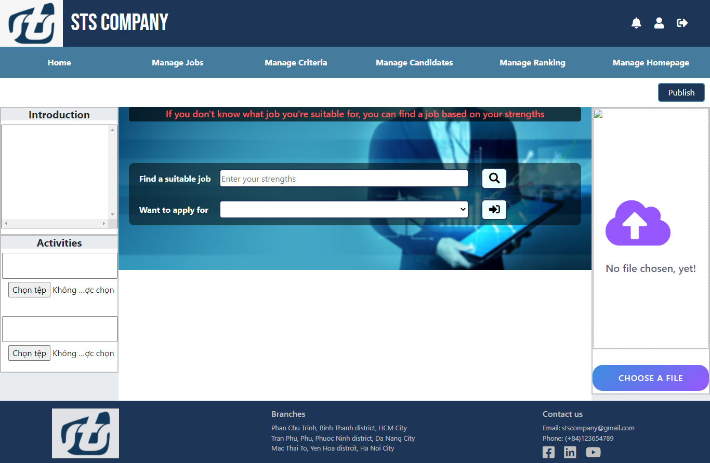

Manage Homepage
No. | Field name | Type | Require | Target
1 | Title | H5 tag | background-color: #99d6ea;  font-weight: bold;  text-align: center;  background-color: #e9ecef;
2 | Introduction text field | textarea | padding: 0px 10px;  text-align: justify;  width: 100%;  overflow: scroll;  height: 200px;  resize: none;
3 | Activities text field | textarea | width: 100%;  height: 50px;  resize: none;
4 | Activities img | Img | display: flex;  flex-direction: column;  justify-content: center;  height: auto;  margin-bottom: 12px;
5 | Advertisement img | img | position: absolute;  height: 100%;  width: 100%;  display: flex;  align-items: center;  justify-content: center;
6 | Advertisement button | Button | margin-top: 30px;  width: 100%;  height: 50px;  display: block;  border: none;  outline: none;  border-radius: 20px;  color: #fff;  font-size: 16px;  font-weight: 500;  letter-spacing: 1px;  text-transform: uppercase;  cursor: pointer;  background: linear-gradient(135deg,#3a8dde 0%, #9658fe 100%);
7 | Publish button | Button | width: 90px;  height: 36px;  color: black;  border: #457b9d 2px solid;  background-color: #1d3557;  border-radius: 5px;  color: white;  margin-right: 10px;

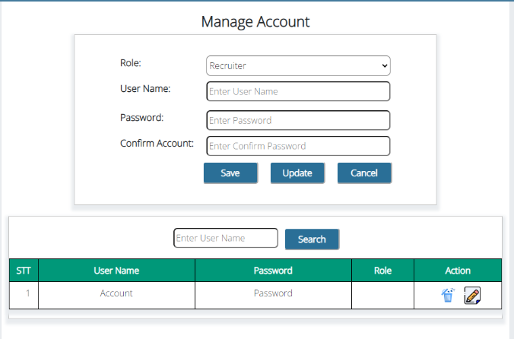
- Manage Account

Manage Account
No. | Field name | Type | Require | Target
1 | Manage account title | H4 tag | text-align: center;  font-weight: bold;  margin-top: 20px;  font-size: 26px;
2 | Name label | Label | width: 155px;  font-size: 17px;  font-weight: 700;
3 | Role select | Select | height: 36px;  width: 330px;  border-radius: 7px;
4 | Date field | Input | height: 36px;  width: 330px;  border-radius: 7px;  resize: none;
5 | Manage accouunt button | Button | margin: 10px;  width: 100px;  height: 40px;  background-color: #2a6f97;  font-weight: bold;  color: #FFFFFF;  border-radius: 5px;  font-size: 16px;  border-color: white;  align-items: center;  padding: 0px;
6 | Search name field | Input | height: 36px;  border-radius:7px;
7 | Search button | Button | margin: 0 0 0 10px;  width: 100px;  height: 40px;  background-color: #2a6f97;  font-weight: bold;  color: #FFFFFF;  border-radius: 5px;  font-size: 16px;  border-color: white;  align-items: center;  padding: 0px;
8 | Account table | Table | width: 100%;  height: 100%;
9 | Table header cell | Th | background-color: #009879;  color: #fff;  font-weight: bold;  word-wrap: break-word;  border: 1px solid black;
10 | Table | Cell | border: 1px solid black;

