
International School

CAPSTONE PROJECT 1
CMU-SE 450

PROJECT PROPOSAL DOCUMENT
Version 2.0
Date: 03/10/2021

RECRUITMENT MANAGEMENT SUPPORT SYSTEM

Submitted by: Group C1SE.43
Truong Dong Huy
Nguyen Quang Hieu
Nguyen Manh Vu
Nguyen Nam Hung

Approved by

Proposal Review Panel Representative:

Name Signature Date

Capstone Project 1- Mentor:
Name Signature Date

Le Thanh Long 03 – Oct - 2021

PROJECT INFORMATION
Project acronym | RMSS
Project Title | Recruitment Management Support System
Start Date | 17 Aug 2021 |  | End Date | 14 Dec 2021
Lead Institution | International School, Duy Tan University
Project Mentor | M.Sc Le Thanh Long
Scrum master / Project Leader & contact details | Hieu, Nguyen Quang  Email: hieunguyen.13092000@gmail.com  Tel: (+84)707960071
Partner Organization
Project Web URL
Team members | Name | Email |  | Tel
24211206538 | Huy, Dong Truong | huydongtruong@gmail.com |  | 0358040650
24211115193 | Hieu, Nguyen Quang | hieunguyen.13092000@gmail.com |  | 0707960071
24211216455 | Vu, Nguyen Manh | manhvu9368@gmail.com |  | 0853629334
24211206951 | Hung, Nguyen Nam | hunghunghung878@gmail.com |  | 0987994109

REVISION HISTORY

Version | Date | Comments | Author | Approval
1.0 | 19 Aug | Initial Release. | STS team | V
1.1 | 29 Aug | Discuss the problem, come up with a specific solution. | STS team | V
1.2 | 04 Sep | Complete the document Proposal | STS team | V
1.3 | 10 Sep | Edit and Update document | Quang Hieu | V
1.4 | 20 Sep | Review and Complete | STS team and Mentor | V
2.0 | 03 Oct | Add actor Admin, Update Sprint | STS team | V

CONTENTS
PROJECT INFORMATION 2
REVISION HISTORY 3
1. INTRODUCTION 5
2. PROBLEM DEFINITION 5
3. CURRENT STATUS OF ART 6
4. ENGINEERING APPROACH (Including Solution Alternatives) 7
4.1. Engineering Approach 7
4.2. System Context Diagram 7
4.3. Technical Constraints 8
5. TASKS AND DELIVERABLES 8
5.1. Tasks 8
5.2. Deliverables 8
6. PROJECT MANAGEMENT 8
6.1. Cost/Budget for Project 9
6.2. Tentative Schedule 9
7. PROJECT CONSTRAINTS 10
8. CONCLUSION 11
9. REFERENCES: 12
10. ATTACHMENT: 12

- INTRODUCTION
Nowadays, traditional recruitment meets so many inconvenient things like cost, time, human resources, etc. especially during the covid pandemic, when people can’t go out to do anything, so the online recruitment will be better in the future. The answer is building a website which can support a specific company to recruit online and support candidates to apply for the right position based on their strengths, it helps the recruitment more convenient, faster, less expensive, etc.

- PROBLEM DEFINITION
According to the actual survey,
- About the company, the recruiter has to advertise the job everywhere but that isn’t highly effective, and about the traditional process, their staff have to manage a huge number of candidates without any support tools: difficult to the management, they have to review each candidate: waste time. The traditional recruitment is very inconvenient.
- About the candidates, students after graduation from the university don’t know what job they suitable for, they find it difficult to find a suitable job, and after they find a suitable job, they still have difficulty to interact with the recruiter, there are too many documents to submit, it’s very hard to manage and after they find a suitable job, they still find it difficult to apply for a job because of a complex process of tradition recruitment.
Therefore, we will build the RMSS website to make the recruitment more convenient. In particular, on the candidate's side, the website helps candidates to find a job based on their strengths, and it helps the process of submitting job application information is easier, more convenient. On the recruiter’s side, it helps the recruiter to storage and rank candidates based on their strengths that suitable for company-specific criteria, so it helps the recruiter to manage a huge number of candidates easily, faster, and less expensive about money and human resources
In the future the recruitment is not just about reading a CV, it works through qualifications, character, morals, etc. In RMSS, we support everything and the recruiter is always proactive.

- CURRENT STATUS OF ART

Compare existing websites and RMSS
The existing websites (Viet Nam Works, Tim Viec Nhanh, MyWork, ITviec…) | Recruitment Management System  Using Deep Learning
- These are websites that supporting intermediary recruitment. However, companies may have difficulties in changing requirements posted in some recruitments.  -The company has difficulty when they want to change the company's recruitment style on the intermediary website because they have to follow the way the intermediary website works. | - RMSS is the company own website, it makes the company more proactive in recruiting, they can easily change the company's recruitment style
- The recruiters have difficulty in managing all the candidate's application information | - Recruiters have an easier time managing and selecting applicants since the system may rate candidates depending on the company's recruitment requirements.
- Candidates can search for jobs by area, company, and job-related factors like java, tester, developer..., | - Candidates can search for jobs quickly according to their own advantages, like analytical skills, carefulness, and communication… the website will display suitable job positions in the company.
- Candidates have difficulty applying for jobs because they have to go through many complicated steps and have to prepare a full application dossier. | - Candidates can easily apply for jobs by answering the company's recruitment criteria, instead of a perfect set of resumes.

The role of this project is to solve difficulties, waste time in registration, support candidates to register more easily, and the recruiters are proactive with interview questions and easily manage job applications.

- ENGINEERING APPROACH (Including Solution Alternatives)

  - Engineering Approach
This website has 3 actors: the Recruiters, the Candidates and Admin. The admin uses the system to manage Recruiter accounts, the Recruiter uses the website to create company-specific recruitment criteria and manage the recruitment better, the Candidates use the system to register for jobs more conveniently and quickly. In the function of recommending suitable jobs, we use the Deep Learning method: when the recruitment department creates the criteria for a job, they will enter the strengths suitable for that job and save all in the database, the system uses Deep Learning to learn the entire data recruitment criteria. After that, the system will predict suitable jobs for each candidate based on their strengths.

  - System Context Diagram

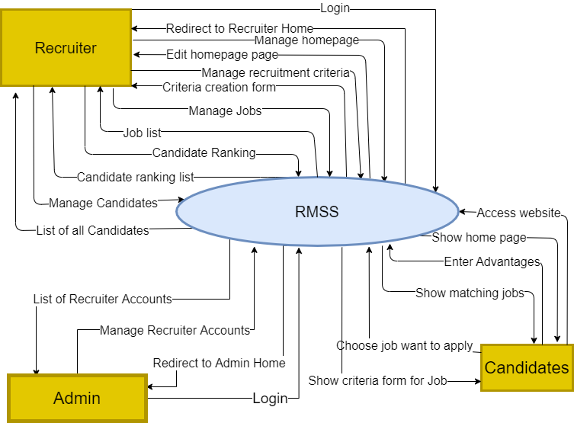

  - Technical Constraints
- Language:
  - Front-end: Html, Css, JavaScript, ReactJS.
    - Library: Bootstrap.
  - Back-end: C#
- Operating System: Chrome, Coc Coc, Edge.
- Database: SQL Server.

- TASKS AND DELIVERABLES

  - Tasks
- Preparation
- Data modeling
- Physical Database Design
- Setup Database
- Finding Data
- Data processing
- Setting up Tool & Environment
- Building API
- Building UI
- Testing
- Integrate
- Deploy
- Release

  - Deliverables
- Project Proposal
- Project Plan
- Product Backlog
- Architecture Document
- Database Design
- Interface Design
- Test Plan
- Test Case
- Sprint Backlog & Burndown Chart
- Technologies stack
- PROJECT MANAGEMENT
Scrum is an agile method, so it follows the principles of Agile Manifesto (see also Agile Manifesto). In addition, Scrum operates on three core values, also known as Scrip Scripps, including Scrutiny, Inspection and Adaptation.
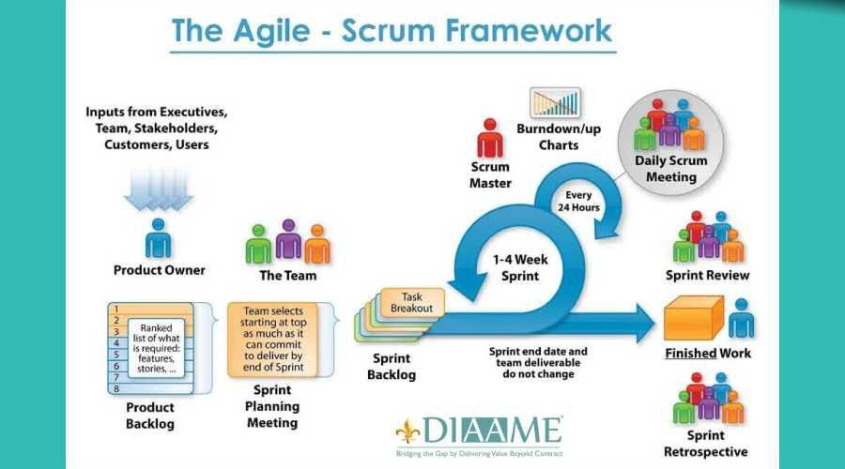

Based on the empirical process control theory, Scrum uses iterative and incremental algorithms to optimize efficiency and control risk. Scrum is simple, easy to learn and has wide applicability.

Our team has 4 people:
There is only a short amount of time to finish the project. So based on those constraints, we decided to choose SCRUM as the project lifecycle.

  - Cost/Budget for Project

Description | Amount | Unit
Number of members | 4 | Person
Number of working person day | 4 | Hour
The cost person hour | 2 | USD
The numbers of working days | 103 | Days
Table 1. Description Cost

No | Criteria | Price | Total (USD)
1 | Working Hours | 2 | 3296
2 | Other cost | 600 | 600
Total |  |  | 3896
Table 2. Total Cost Estimation

  - Tentative Schedule

WBS | Task | Start | End | Duration (Days)
1 | Initial | 17/08/2021 | 27/08/2021 | 10
2 | Development | 28/08/2021 | 11/12/2021 | 90
 | Sprint 1 | 28/08/2021 | 22/09/2021 | 21
 | Learn Database
 | Learn Code
 | Testing
 | Deploy
 | Release
 | Sprint 2 | 23/09/2021 | 20/10/2021 | 24
 | Building UI
 | Code UI
 | Code Function
 | Testing
 | Deploy
 | Release
 | Sprint 3 | 21/10/2021 | 17/10/2021 | 24
 | Building UI
 | Code UI
 | Code Function
 | Testing
 | Deploy
 | Release
 | Sprint 4 | 18/10/2021 | 11/12/2021 | 21
 | Setting up Tool & Environment
 | Building UI
 | Code
 | Testing
 | Deploy
 | Release
3 | Project Meeting | 12/12/2021 | 13/12/2021 | 2
4 | Final Release | 14/12/2021 | 14/12/2021 | 1
Total |  |  |  | 103

- PROJECT CONSTRAINTS

Constraint | Constraints Description | Guidelines for Acceptance
Economic | The system operation is simple, low cost.  The cost for the design and maintenance is lower than what you do manually. | Elements for consideration are design costs, production costs, maintenance costs, operating costs, and sales price.
Environmental | none | Impact of the design on the environment as well as impact of the environment (e.g. temperature range, humidity, vibration, electromagnetic interference immunity, and shock) on the design should be considered. Design for recycling and design to use recycled materials should also be considered.
Ethical | none | Ethical considerations can be broad. Areas that are typically addressed include intellectual property, reverse- engineering, privacy, security, and the conflict between cost and safety.
Public health, safety, and welfare | Designed to make it easier and more convenient for everyone during the Covid pandemic, easy to apply at home, ensure health. | Includes safety standards as well as impact of the design on users (for example, electrical or physical hazards)
Social and Global | The system will help solve the problems of recruiting and applying for jobs. During the Covid epidemic situation, the product will be accepted and used because of its effectiveness. | Addresses aspects such as benefits, risks, the man-machine interface, the acceptance of products by the intended user or by society at large, global and socially responsible engineering.
Cultural | none | Which cultural characteristics could influence the approach?  How do the design from different cultures differ?
Sustainability | The system has an easy-to-use interface, a very high level of suitable job offers, high reliability. | Refers to sustainability of resources, including material, energy, supplies, manufacturing techniques, personnel, operation, and the need for additional infrastructure, as well as sustainability of the design including reliability, lifetime, durability, reusability, maintainability.

- CONCLUSION

The project will be completed after 106 days and divided into 4 sprints. This will be an extremely convenient and useful website for companies in recruiting personnel. In addition, it is also convenient for candidates to apply for the company's job. The difficulty in managing candidates, the delay and complexity in applying for jobs will no longer be a concern.

- REFERENCES:
- The Scrum Guide
https://www.scrum.org/resources/scrum-guide
- Draw tool:
https://www.draw.io
https://excalidraw.com/
Template document Proposal
https://bitly.com.vn/r1mr3t

ATTACHMENT: Description of Product Requirements Form

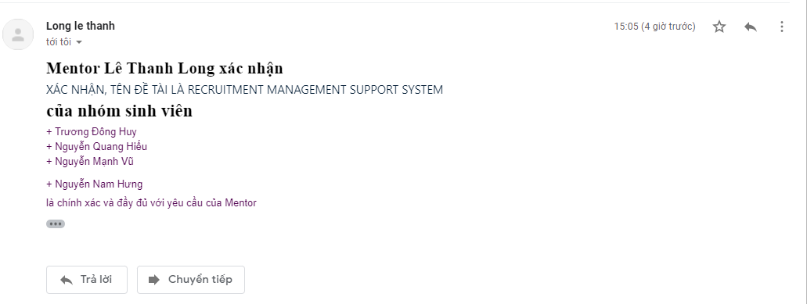
Figure 1. Mentor Verify

