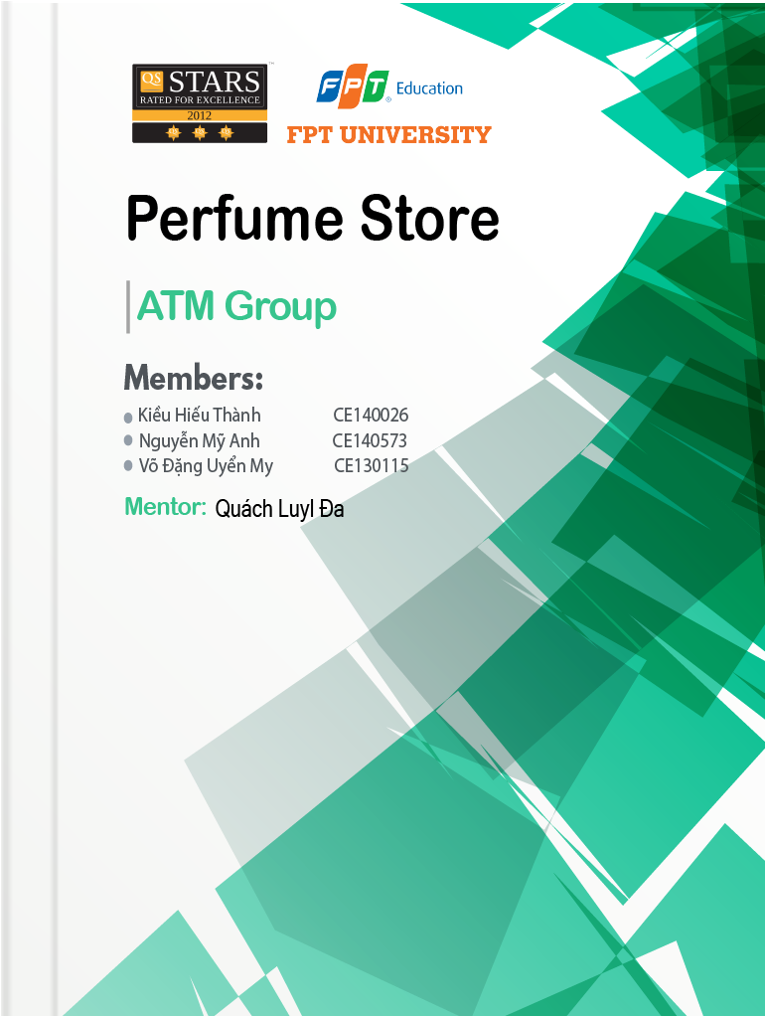

Table of Contents

1. I.Problem Definition 4

1. Purpose 4

2. Project Scope and Product Features 5

1. II.User Requirements 10

1. Functions 10

a) User account: 10

b) Moderator account: 10

c) Income manager account: 11

d) Administrators account: 11

2. System Requirements 13

1. III.Schedule and Roles 14

1. Project Plan and Role 14

2. Specific Schedule 15

1. IV.Design Pattern 16

1. System Organization 16

a. Use-case Diagram 16

2. Database 17

a. Database Diagram 17

b. Table Structure 18

3. Diagrams 19

a. Class Diagram 19

b. Sequence Diagram 23

1. V. Interface 24

1. Admins and Moderators Interface 24

2. Client Interface 25

1. VI. Maintenance and Updating 26

1. Maintenance 26

2. Updating 26

1. VII. Check List 27

# Problem Definition

## Purpose

Body odor is a big turn off for people. So, people like to wear their favorite perfume for crucial meeting, hang out with friends or just merely walking around. Well, if you can relate to the above situations, it means you love fragrance!

Perfumes and deodorants are popular today because not only do they help you fight body odor, but also boost your morale and perfume has several other benefits too.

This website is opened to give customers the world of perfume, to bring information about people favorite fragrances, with over 100 perfumes and 20 top perfume brands in the world.

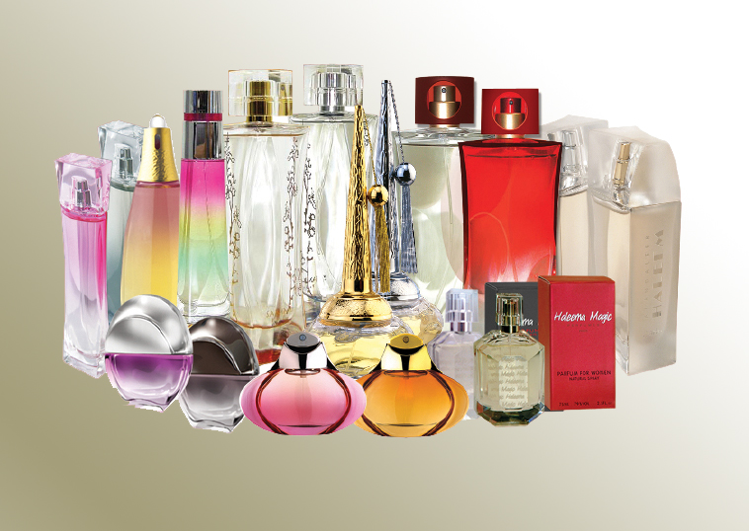

Figure 1 perfumes

## 2. Project Scope and Product Features

|  |  |  |
| --- | --- | --- |
| No | Function | Description |
| 1 | Design the theme. | - Beautiful interface design  - Elegant, simple and friendly presentation  - The color according to the color tone requested by the Client or the logo color of the Perfume store.  - Main menu bar of Perfume website |
| 2 | Company introduction module | - General introduction about the owner of the Perfume store.  - Purpose, main function of the Perfume website.  - The content displays as posts, can insert illustrations.  - Unlimited categories. |
| 3 | Candidate Module | - This function uses the public, allowing visitors to the website to see perfume and all relevant information of perfume.  - Allows searching for perfume information.  - Let see products and brands.  - Manage the list of applications  - Create an application file  - Can cancel the application  - Change personal information  - Change the password |
| 4 | Employer Module | - This function uses the public, allowing visitors to the website to see all perfume information.  The communication section (External pages of the website):  Display the list of perfume of the website  - Registration information in the form provided by the customer  - There is a request for activation by registered e-mail  - Allows searching for perfume.  Utilities section (Utility pages after logging in):  - Allows creating perfume information  - Employment information in the form provided by customers  - Perfume information management  - Edit perfume information  - Delete perfume information  - Change registration information  - Change the password  - Download images / logos  - Put / unfollow on interested records  The content displays as the article. |
| 5 | Perfumes Module | - Display the list of posted perfumes  - Provide perfume search tools  - Search and display criteria provided by customers.  The content displays as the article. |
| 6 | Information module | Interface:  - Presenting the latest information of perfume  - Presentation of hot perfume, brand.  - Presentation of the list of perfume  The communication section (External pages of the website):  - Allow members to search for information about perfume, brand.  - Training information is displayed in the form of articles with illustrations.  - Also presents the latest perfume in the same industry, the same brand, the latest perfume ...  - Information of the perfume including detailed introduction and illustrations.  The content displays as articles, can insert illustrations. |
| 7 | Search module | - Allows finding information on the website with related keywords. |
| 8 | Contact Module | - Provide an online form that allows customers to send their requests and comments to the company.  - The form includes information: Full name, email, title, contact content.  - Information will be sent to the Administrator's email. |
| 9 | SEO optimization | - Your website will be designed according to SEO standards of the search engines (Google, Yahoo, Bing ...), the URLs are search engine friendly to each character, with this website feature. it is easy to achieve a high position in search results that help businesses increase traffic, increase customers and sales. |
| 10 | Web maintenance | - Free website maintenance for a period of 1 year |
| 11 | Language | - English |

# User Requirements

## Functions

### **User account:**

When user log into the site, they will have a page that content certain functions, rights and actions include:

* Login, logout
* Create, view and update user’s profile
* Change password
* View, search and choose product
* Manage cart: add product to cart or delete product from cart
* Track order
* View favorite list, add or delete favorite product

### **Moderator account:**

When user log into the site, they will have a page that content certain functions, rights and actions like what user have and include more:

* Login, logout
* Create, view and update user’s profile
* Change password
* View, search and choose product
* Manage cart: add product to cart or delete product from cart
* Track order
* View favorite list, add or delete favorite product
* Manage product: add, update, delete product
* Manage delivery
* Manage bill: income and outcome

### Income manager account:

Income manager is a person who can control the revenue of the shop, he is provided with the same functions, rights and actions as a moderator and more rights to manage include:

* Login, logout
* Create, view and update user’s profile
* Change password
* View, search and choose product
* Manage cart: add product to cart or delete product from cart
* Track order
* View favorite list, add or delete favorite product
* Manage product: add, update, delete product
* Manage delivery
* Manage bill: income and outcome
* View income report: monthly, quarterly, yearly
* View product report: best sell, unmarketable
* Print report

### Administrators account:

When Administrators logged into the site to post their perfume product. The page will include some functions as looking, rating, choose and purchasing perfume. All functions, rights and actions include:

* Login, logout
* Create, view and update user’s profile
* Change password
* View, search and choose product
* Manage cart: add product to cart or delete product from cart
* Track order
* View favorite list, add or delete favorite product
* Manage product: add, update, delete product
* Manage delivery
* Manage bill: income and outcome
* View income report: monthly, quarterly, yearly
* View product report: best sell, unmarketable
* Print report
* Browse, Search for perfume
  + Create accounts for other users
  + Can access/update all information of non-admin account (except account’s password)
  + Manage database

## System Requirements

|  |  |  |
| --- | --- | --- |
|  | **Client-side** | **Server-side** |
| **Hardware Requirement** | **+ CPU:** IntelPentium 2 266 MHz  **+ RAM:** 128 MB  **+ Storage:** 128 MB of free disk space | **+ CPU:** Intel Core i9 9900K 3.6 GHz  **+ RAM:** 16 GB  **+ Storage:** 1GB of free disk space |
| **Software Requirement** | **+ OS:** Window 7 or higher  **+ Browser:** Chrome, Firefox, Safari, Microsoft Edge and Microsoft Explorer 11 | **+ Database:** SQL Server  **+ OS:** Windows Server 2016 or higher |

# Schedule and Roles

## Project Plan and Role

* Start time: 09/1/2020
* Deadline: 21/3/2020

|  |  |  |
| --- | --- | --- |
| **Role** | **Member** | **Responsibilities** |
| Leader | ThanhKH | Creating Schedule and Check List, Assigning assignments to team members |
| Secretary | AnhNM | Taking note |
| Analyze & Design | ThanhKH, AnhNM, MyVDU | Table of content, Problem Defining, User Requirement.  Interface Designing |
| Coder | ThanhKH, AnhNM, MyVDU | Programing all functions for applications |
| Tester | MyVDU, ThanhKH, AnhNM | Testing all functions |
| Maintenance | AnhNM, MyVDU | Checking and backup data |

## Specific Schedule

|  |  |  |  |  |  |
| --- | --- | --- | --- | --- | --- |
| **No.** | **Assignment** | **Member** | **Start Time** | **ETF[1] (hrs)** | **Deadline** |
| 1 | Problem Definition | ThanhKH, AnhNM, MyVDU | 10/01/2020 | 3 | 16h  10/01/2020 |
| 2 | User Requirement and System Requirement | AnhNM, MyVDU | 10/01/2020 | 5 | 20h  10/01/2020 |
| 3 | User Requirement Analysis | ThanhKH | 11/01/2020 | 24 | 23h50  11/01/2019 |
| 4 | Database Diagram | ThanhKH | 12/01/2020 | 3 | 12h  12/01/2020 |
| 5 | Class Diagram | AnhNM, MyVDU | 12/01/2020 | 12 | 23h50  12/01/2020 |

# ­Design Pattern

## System Organization

### Use-case Diagram

## Database

### Database Diagram

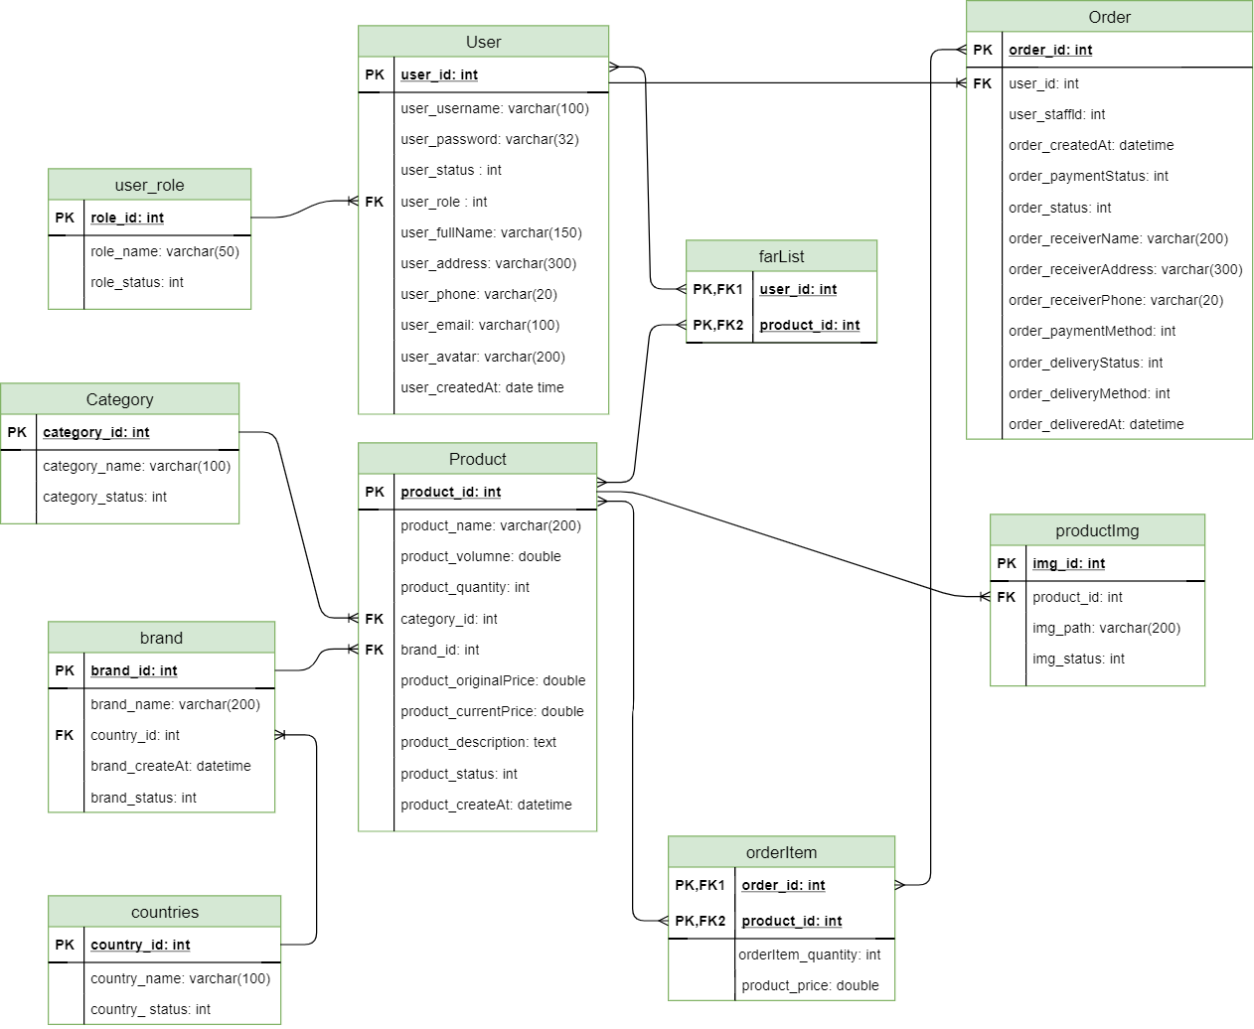

### Table Structure

## Diagrams

### Class Diagram

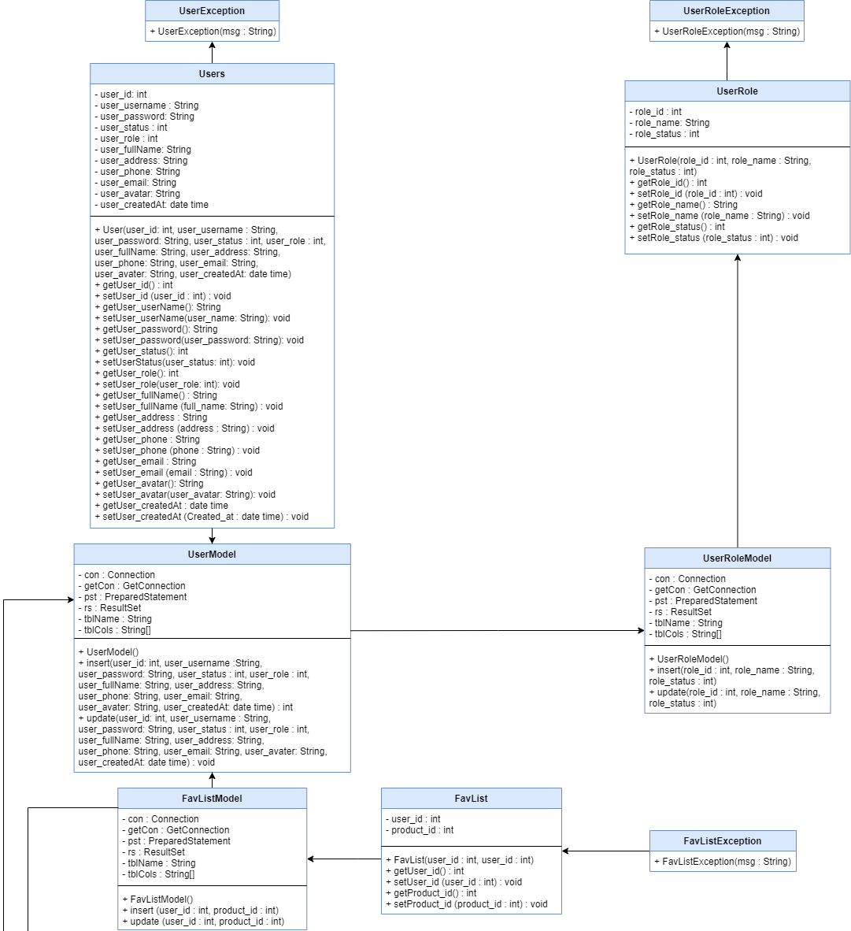

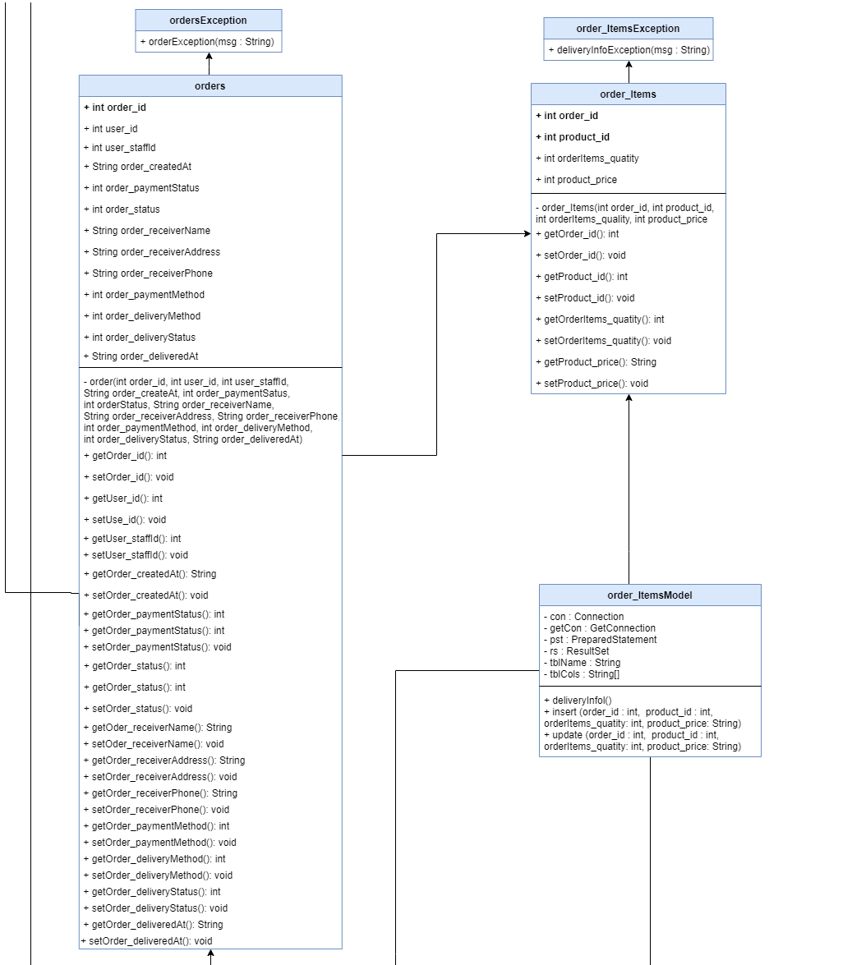

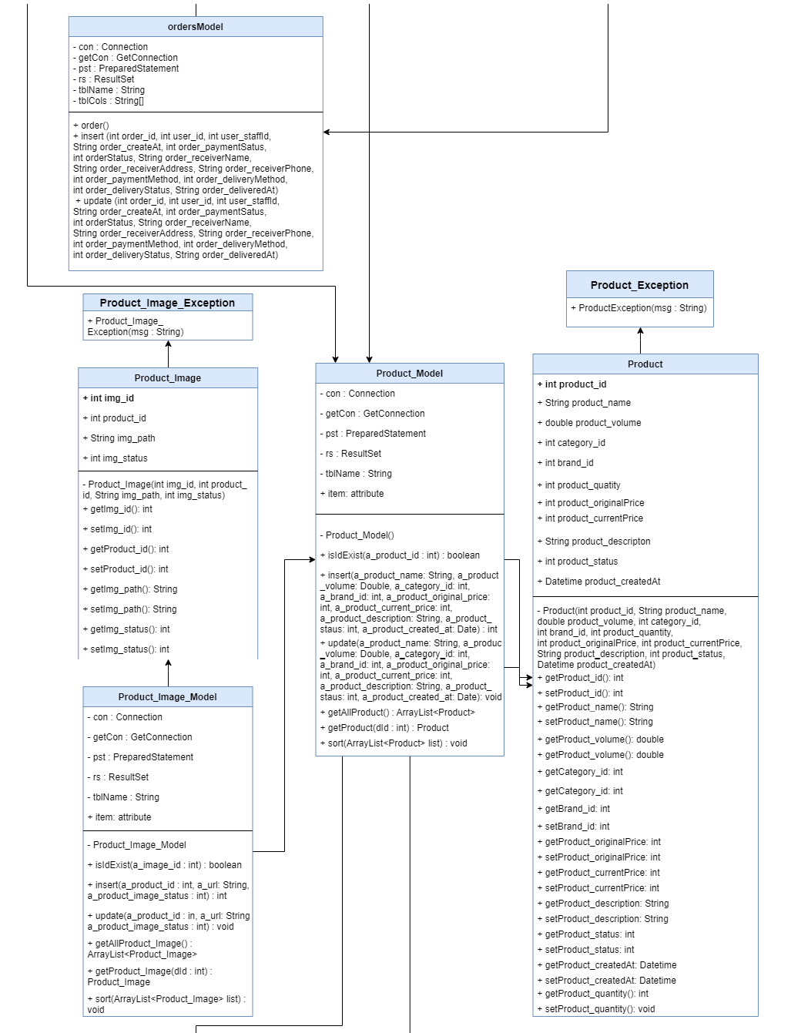

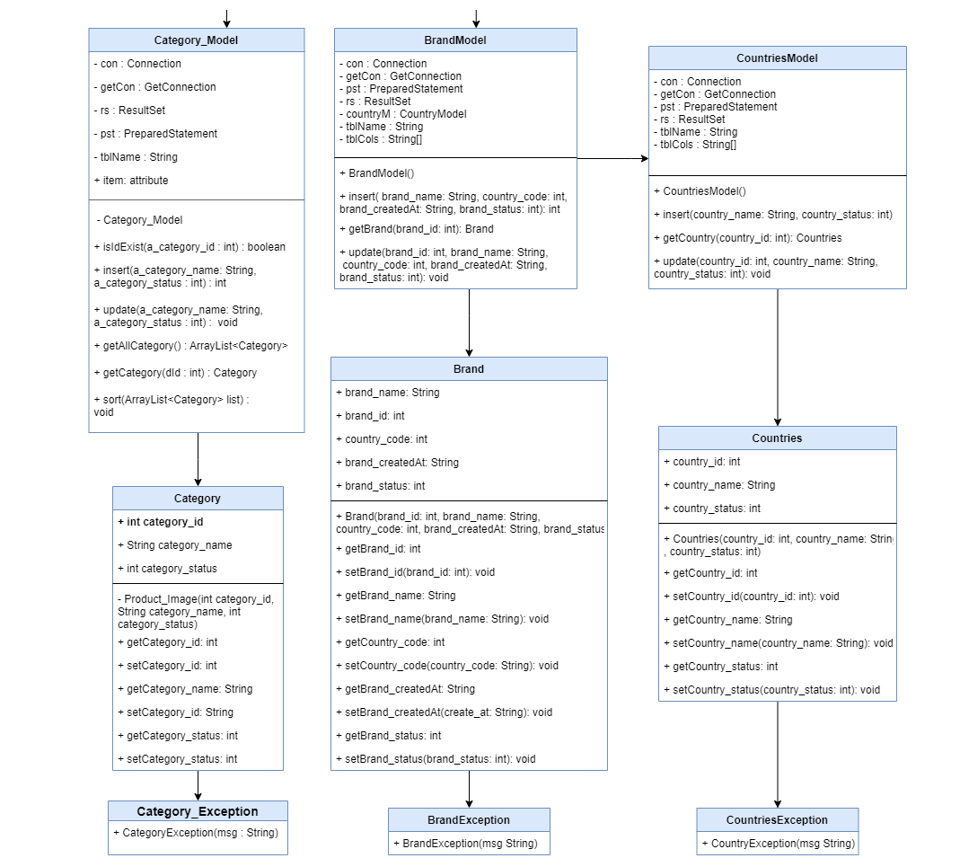

### Sequence Diagram

# Interface

## Admins and Moderators Interface

## Client Interface

# Maintenance and Updating

## Maintenance

* Official project will be stored mainly on our group’s chat box on Facebook
* We also back up our project to other cloud services like Google Drive, OneDrive every week.
* Functions that are under coding will be stored on group’s members devices.
* Using GitHub to upload source code and save them.
* Split into 2 branchs on GitHub: “master” stores official source code and “up-code-len-day” stores developing code. Only leader has permission to merge into “master”.

 *Figure 21 cloud services for backing up*

## Updating

* There are three kinds of update: Big ones, small ones and patches.
  + Big updates: new function(s) or big changes in algorithms.
  + Small ones: include UI update or patches.
  + Patches: bugs fix.
* Our official project will be updated whenever a new version released.
* New functions will only be added to main project when it’s has been tested carefully by our group’s testers.
* Changes also written in a log file so that members can track all the changes

# Check List

|  |  |  |  |  |  |  |
| --- | --- | --- | --- | --- | --- | --- |
| **Assignment** | **Member** | **Actual Start Time** | **ETF[2] (hrs)** | **Actual End time** | **Work hours (hrs)** | **Note** |
| Problem Definition | ThanhKH, AnhNM, MyVDU | 14h  10/01/2020 | 3 | 15h  10/01/2020 | 1 | Completed |
| User Requirement and System Requirement | AnhNM, MyVDU | 15h  10/01/2020 | 5 | 16h  10/01/2020 | 1 | Completed |
| User Requirement Analysis | ThanhKH | 16h  10/01/2020 | 24 | 17h  11/01/2019 | 12 | Completed |
| Database Diagram | ThanhKH | 8h  12/01/2020 | 3 | 12h  12/01/2020 | 4 | Completed |
| Class Diagram | AnhNM, MyVDU | 8h  12/01/2020 | 12 | 17h  12/01/2020 | 8 | Completed |

1. Estimate Time to Finish
2. Estimate Time to Finish