Table of Contents
About 1
Setting up your Dev Environment 2
Install the clients & launch the network 2
How Applications Interact with the Network 3
Enrolling the Admin User 3
Register and Enroll user1 4
Querying the Ledger 4
Updating the Ledger 4
Summary 5
Additional Resources 5

About
https://hyperledger-fabric.readthedocs.io/en/latest/write_first_app.html#

In this section we’ll be looking at a handful of sample programs to see how Fabric apps work. These apps (and the smart contract they use) – collectively known as fabcar – provide a broad demonstration of Fabric functionality. Notably, we will show the process for interacting with a Certificate Authority and generating enrollment certificates, after which we will leverage these identities to query and update a ledger.

We’ll go through three principle steps:
1. Setting up a development environment. Our application needs a network to interact with, so we’ll download one stripped down to just the components we need for registration/enrollment, queries and updates:
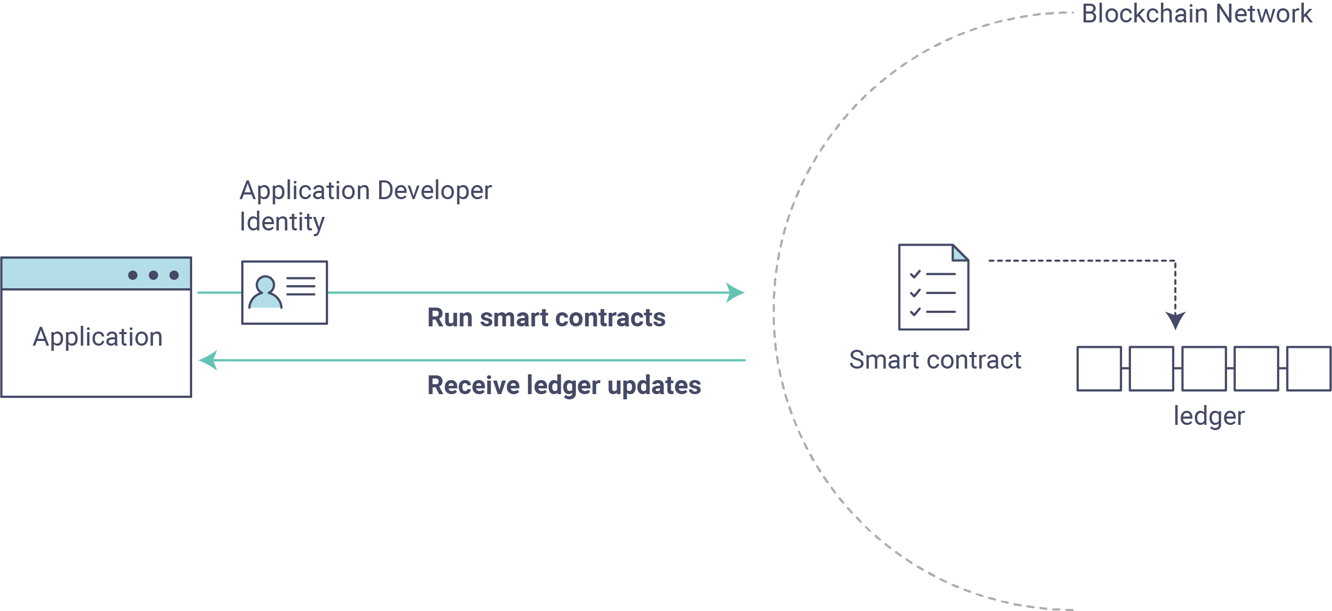
2. Learning the parameters of the sample smart contract our app will use. Our smart contract contains various functions that allow us to interact with the ledger in different ways. We’ll go in and inspect that smart contract to learn about the functions our applications will be using.
3. Developing the applications to be able to query and update assets on the ledger. We’ll get into the app code itself (our apps have been written in Javascript) and manually manipulate the variables to run different kinds of queries and updates.
After completing this tutorial you should have a basic understanding of how an application is programmed in conjunction with a smart contract to interact with the ledger (i.e. the peer) on a Fabric network.

Setting up your Dev Environment

After running BYFN, you will have a development environment. To run this tutorial, you need to do now is tear down any existing network by run

./byfn.sh -m down

If you don’t have a development environment, return to this tutorial once you have cloned the fabric-samples repository, and downloaded the latest stable Fabric images and available utilities.
At this point everything should be installed. Navigate to the fabcar subdirectory within your fabric-samples repository and take a look at what’s inside:
cd fabric-samples/fabcar && ls
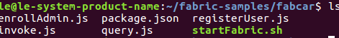

Before starting we also need to do a little housekeeping. Run the following command to kill any stale or active containers:

docker rm -f $(docker ps -aq)

Clear any cached networks:

# Press 'y' when prompted by the command

docker network prune

And lastly if you’ve already run through this tutorial, you’ll also want to delete the underlying chaincode image for the fabcar smart contract. If you’re a user going through this content for the first time, then you won’t have this chaincode image on your system:

docker rmi dev-peer0.org1.example.com-fabcar-1.0-5c906e402ed29f20260ae42283216aa75549c571e2e380f3615826365d8269ba

Install the clients & launch the network

Note

The following instructions require you to be in the fabcar subdirectory within your local clone of the fabric-samples repo. Remain at the root of this subdirectory for the remainder of this tutorial.

Run the following command to install the Fabric dependencies for the applications. We are concerned with fabric-ca-client which will allow our app(s) to communicate with the CA server and retrieve identity material, and with fabric-client which allows us to load the identity material and talk to the peers and ordering service.

npm install
Launch your network using the startFabric.sh shell script. This command will spin up our various Fabric entities and launch a smart contract container for chaincode written in Golang:

./startFabric.sh

You also have the option of running this tutorial against chaincode written in Node.js. If you’d like to pursue this route, issue the following command instead:

./startFabric.sh node

Alright, now that you’ve got a sample network and some code, let’s take a look at how the different pieces fit together.

How Applications Interact with the Network

For a more in-depth look at the components in our fabcar network (and how they’re deployed) as well as how applications interact with those components on more of a granular level, see Understanding the Fabcar Network.

Developers more interested in seeing what applications do – as well as looking at the code itself to see how an application is constructed – should continue. For now, the most important thing to know is that applications use a software development kit (SDK) to access the APIs that permit queries and updates to the ledger.

Enrolling the Admin User

Note

The following two sections involve communication with the Certificate Authority. You may find it useful to stream the CA logs when running the upcoming programs.

To stream your CA logs, split your terminal or open a new shell and issue the following:

docker logs -f ca.example.com

Now hop back to your terminal with the fabcar content…

Send the admin enroll call to the CA server:

node enrollAdmin.js

This program will invoke a certificate signing request (CSR) and ultimately output an eCert and key material into a newly created folder – hfc-key-store – at the root of this project. Our apps will then look to this location when they need to create or load the identity objects for our various users.

Register and Enroll user1
With our newly generated admin eCert, we will now communicate with the CA server once more to register and enroll a new user. This user – user1 – will be the identity we use when querying and updating the ledger. It’s important to note here that it is the admin identity that is issuing the registration and enrollment calls for our new user (i.e. this user is acting in the role of a registrar). Send the register and enroll calls for user1:

node registerUser.js

Similar to the admin enrollment, this program invokes a CSR and outputs the keys and eCert into the hfc-key-store subdirectory. So now we have identity material for two separate users – admin & user1. Time to interact with the ledger…

Querying the Ledger
This is a representation of how a query works:
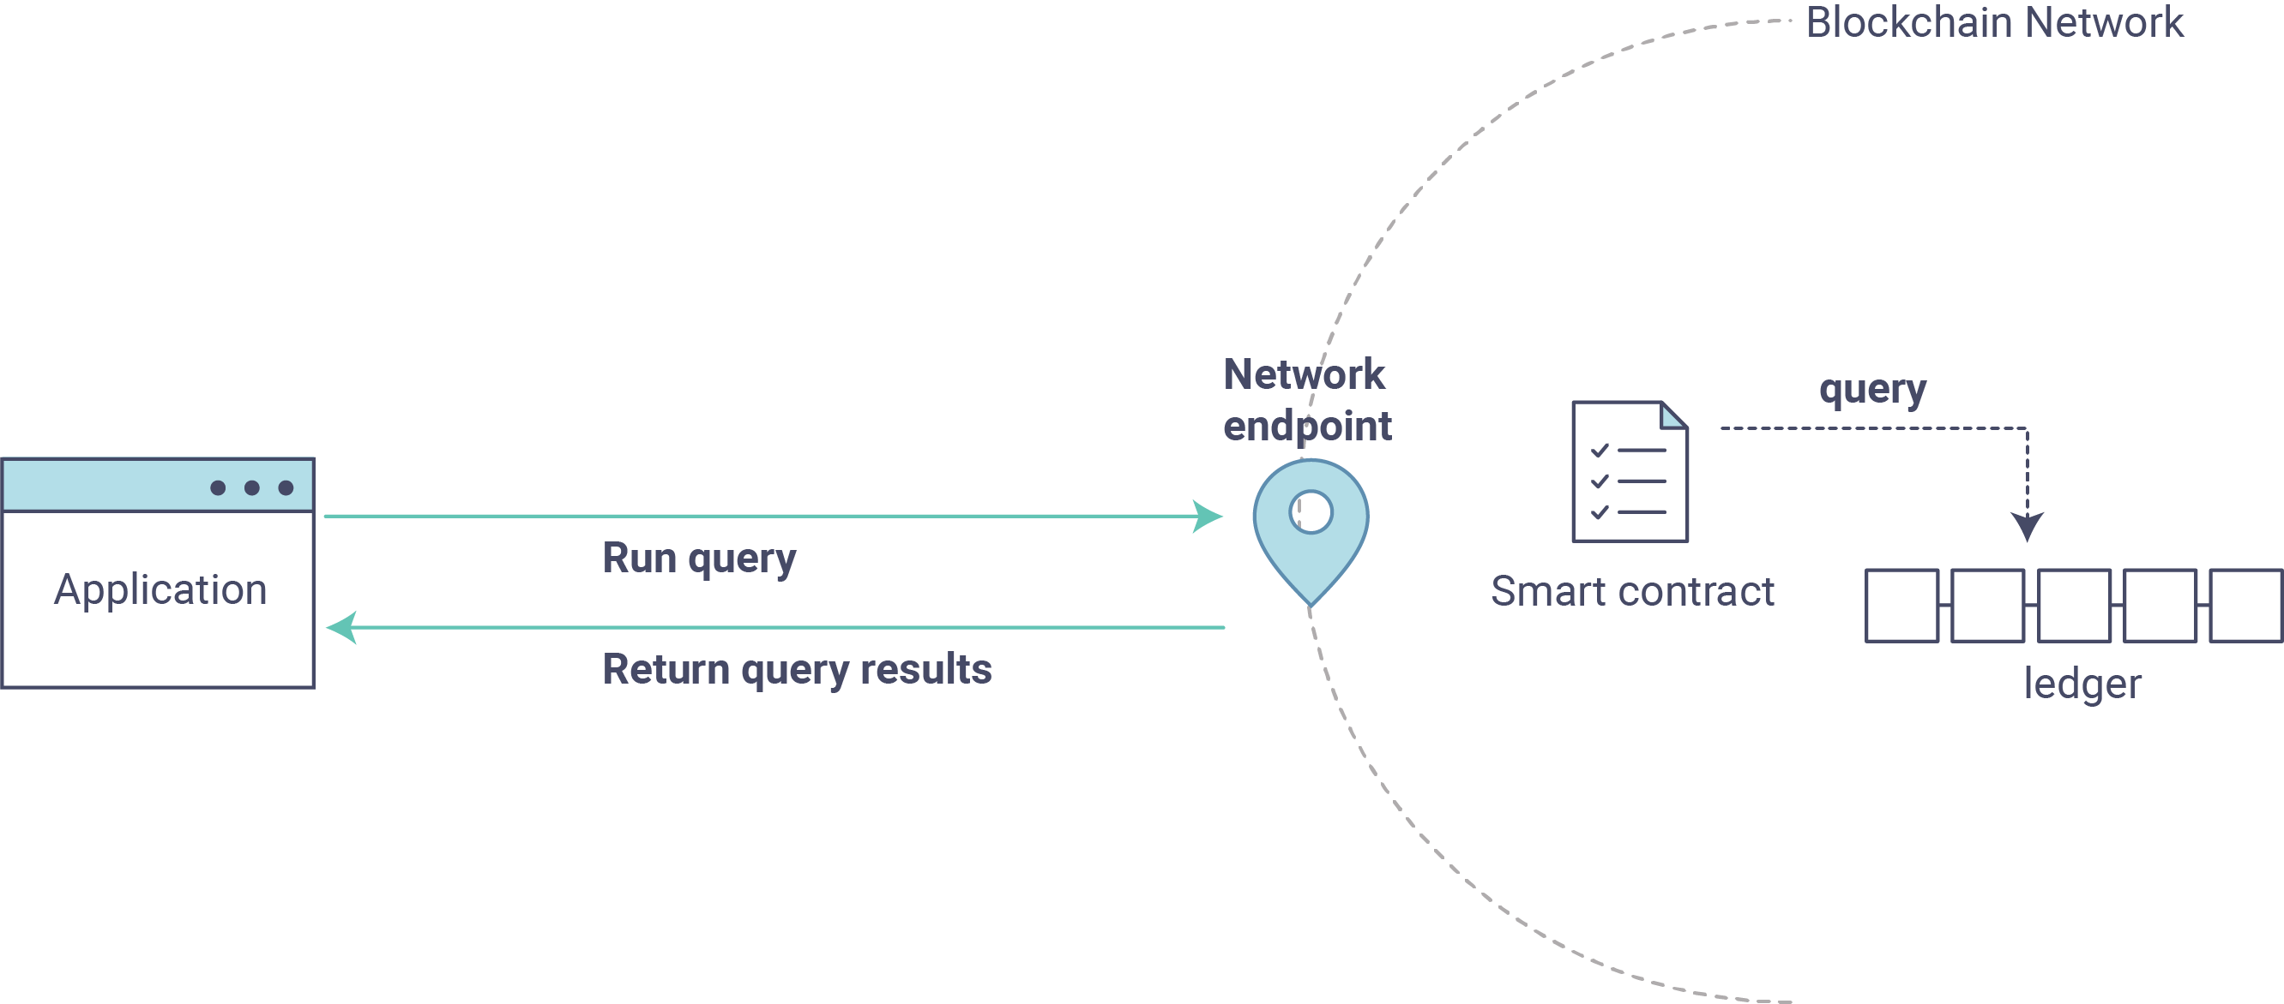
First, let’s run our query.js program to return a listing of all the cars on the ledger. We will use our second identity – user1 – as the signing entity for this application. The following line in our program specifies user1 as the signer:

fabric_client.getUserContext('user1', true);

Updating the Ledger

Now that we’ve done a few ledger queries and added a bit of code, we’re ready to update the ledger. There are a lot of potential updates we could make, but let’s start by creating a car.

Below we can see how this process works. An update is proposed, endorsed, then returned to the application, which in turn sends it to be ordered and written to every peer’s ledger:
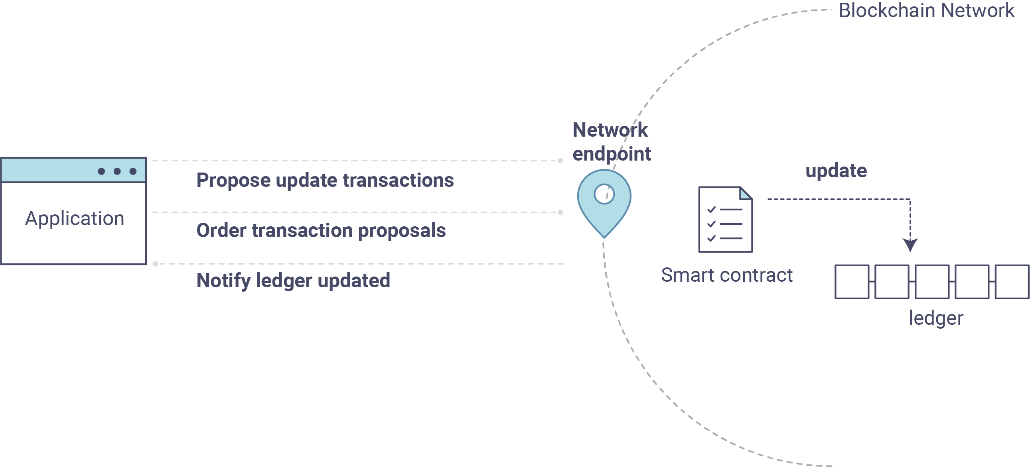

Summary

Additional Resources

Elements
fabcar

Resources
Understanding Fabcar Network

